Supplementary material
Child Marriage and Climatic Factors: Evidence from Survey Data in Kenya
SI.1. Descriptive and bivariate analysis
Table SI.1.1: Variable definitions (Includes only variables included in the final model)
Variables | Definition | Source | Year
Child marriage | Percent of women aged 20+ who were married before 18 years | Kenya DHS dataset | 2014/15, 2022
Education attainment | Percent of women who had no education, primary, secondary or higher education | Kenya DHS dataset | 2014/15, 2022
Employment | Percent of women who worked in the last 12 months | Kenya DHS dataset | 2014/15, 2022
Age | Women aged 15-49 years divided into 5-year age groups. Analysis focused on those 20+ years | Kenya DHS dataset | 2014/15, 2022
First sex by 15 years | Percent of women aged 20+ years who had their first sex before 15 years of age | Kenya DHS dataset | 2014/15, 2022
Media Exposure | This included reading a newspaper/magazine, listening to radio or watching TV, categorised into three: not at all, less than once a week and at least a week | Kenya DHS dataset | 2014/15, 2022
Currently using modern FP | Percent of women who reported current use of modern contraceptive methods | Kenya DHS dataset | 2014/15, 2022
Household wealth | Percent of women living in households in each of the 5 quintiles of wealth calculated based on ownership of assets: poorest, poorer, middle, richer, richest | Kenya DHS dataset | 2014/15, 2022
Ethnicity | Percent of women affiliated to each ethnic group in the survey | Kenya DHS dataset | 2014/15, 2022
Religion | Percent of women reporting none, Christian, Muslim or other religions | Kenya DHS dataset | 2014/15, 2022
Place of residence | Percent of women living in urban or rural areas | Kenya DHS dataset | 2014/15, 2022
Region | Percent of women living in any of the 47 counties in Kenya | Kenya DHS dataset | 2014/15, 2022
Number of children below 5 years within household | Number of children aged 5 years and below residing in the same household | Kenya DHS dataset | 2014/15, 2022
Temperature | Average annual land surface temperature for the year of survey divided into four categories:  0—19.999 = Below 20 degrees, 20.0—24.999 = Between 20 and 25 degrees, 25.0—29.99 = Between 25 and 30 degrees, 30.0+ = More than 30 degrees | Data sourced from Hulley and Hook (2021) and further standardised and processed by WorldPop at 100 meters | 2015, 2022

Table SI.1.2: Socio-demographic and background characteristics of women, and bivariate association with child marriage
Variable | 2014 |  |  | 2022
 | % (weighted) /mean | Bivariate association | N (un-weighed) | % (weighted) /mean | Bivariate association | N (un-weighed)
Child marriage
no | 72.60 |  | 17,117 | 77.60 |  | 19,197
yes | 27.40 |  | 7,758 | 22.40 |  | 6,556
Education attainment***
No education | 8.10 | 0.53 | 3,821 | 6.30 | 0.51 | 3,481
primary | 50.30 | 0.38 | 12,369 | 37.40 | 0.39 | 9,602
secondar | 28.50 | 0.13 | 6,097 | 33.00 | 0.12 | 7,912
Higher | 13.10 | 0.02 | 2,588 | 22.80 | 0.02 | 4,757
5-year age groups***
20-24 | 22.70 | 0.23 | 5,388 | 23.00 | 0.13 | 5,762
25-29 | 24.10 | 0.28 | 5,902 | 21.80 | 0.20 | 5,443
30-34 | 17.80 | 0.29 | 4,431 | 17.30 | 0.27 | 4,561
35-39 | 14.90 | 0.26 | 3,851 | 16.50 | 0.30 | 4,354
40-44 | 11.40 | 0.31 | 2,968 | 11.80 | 0.26 | 3,100
45-49 | 8.90 | 0.32 | 2,335 | 9.60 | 0.25 | 2,532
First sex by 15 years***
no | 85.40 | 0.24 | 21,211 | 83.20 | 0.18 | 20,935
yes | 14.60 | 0.44 | 3,664 | 16.80 | 0.43 | 4,814
Currently using modern FP**
no | 54.00 | 0.27 | 14,381 | 50.70 | 0.21 | 14,130
yes | 46.00 | 0.28 | 10,494 | 49.30 | 0.24 | 11,622
Employment*a
working | 11.10 | 0.28 | 3,315 | 30.50 | 0.22 | 9,288
Not working | 36.00 | 0.27 | 8,505 | 69.50 | 0.22 | 16,464
Household wealth***
poorest | 15.00 | 0.46 | 5,702 | 14.50 | 0.39 | 5,427
poorer | 16.80 | 0.36 | 4,616 | 16.30 | 0.34 | 4,306
middle | 18.60 | 0.31 | 4,619 | 18.30 | 0.25 | 4,966
richer | 21.50 | 0.23 | 4,875 | 23.20 | 0.17 | 5,999
richest | 28.10 | 0.13 | 5,063 | 27.70 | 0.11 | 5,054
Sex of household head***
male | 64.00 | 0.29 | 15,614 | 62.20 | 0.24 | 16,955
female | 36.00 | 0.25 | 9,261 | 37.80 | 0.20 | 9,797
Ethnicity***
Kalenjin | 11.70 | 0.28 | 3,441 | 14.00 | 0.23 | 4,032
Kamba | 11.40 | 0.19 | 2,334 | 11.40 | 0.14 | 2,254
kikuyu | 23.10 | 0.17 | 4,263 | 19.20 | 0.14 | 3,735
Luhya | 14.50 | 0.29 | 2,842 | 16.00 | 0.23 | 3,213
Luo | 10.80 | 0.41 | 2,403 | 11.10 | 0.29 | 2,562
other | 28.40 | 0.33 | 9,592 | 28.40 | 0.29 | 9,956
Religion***
Christian | 91.60 | 0.26 | 21,124 | 88.70 | 0.22 | 20,977
Islam | 6.40 | 0.41 | 3,212 | 6.80 | 0.32 | 3,673
no religion | 1.70 | 0.49 | 444 | 1.10 | 0.29 | 304
other | 0.30 | 0.18 | 95 | 3.40 | 0.26 | 798
Place of residence***
urban | 42.90 | 0.20 | 9,631 | 43.50 | 0.15 | 10,374
rural | 57.10 | 0.33 | 15,244 | 56.50 | 0.28 | 15,378
Media Exposure***
not at all | 12.10 | 0.44 | 4,427 | 11.20 | 0.34 | 4,524
less than once a week | 10.40 | 0.32 | 2,859 | 9.50 | 0.26 | 2,556
at least once a week | 77.60 | 0.24 | 17,589 | 79.30 | 0.20 | 18,672
Number of children below 5 years within household***^ | 0.96 | 1.14 | 24,875 | 0.83 | 0.95 | 25,752
Region***
Mombasa | 3.10 | 0.21 | 509 | 3.10 | 0.20 | 638
Kwale | 1.90 | 0.37 | 528 | 1.50 | 0.37 | 548
Kilifi | 3.10 | 0.39 | 634 | 2.70 | 0.34 | 571
Tana River | 0.60 | 0.58 | 523 | 0.50 | 0.42 | 529
Lamu | 0.30 | 0.35 | 466 | 0.30 | 0.28 | 511
Taita Taveta | 0.70 | 0.20 | 403 | 0.80 | 0.21 | 422
Garissa | 0.80 | 0.42 | 445 | 0.80 | 0.41 | 444
Wajir | 0.70 | 0.50 | 426 | 0.40 | 0.37 | 527
Mandera | 0.60 | 0.38 | 425 | 0.60 | 0.39 | 555
Marsabit | 0.30 | 0.44 | 439 | 0.40 | 0.35 | 446
Isiolo | 0.30 | 0.47 | 504 | 0.40 | 0.30 | 503
Meru | 3.70 | 0.29 | 570 | 3.00 | 0.31 | 487
Tharaka-Nithi | 0.90 | 0.20 | 429 | 0.90 | 0.20 | 465
Embu | 1.50 | 0.16 | 522 | 1.20 | 0.16 | 510
Kitui | 2.30 | 0.25 | 581 | 2.30 | 0.23 | 543
Machakos | 2.90 | 0.18 | 590 | 3.10 | 0.11 | 575
Makueni | 2.00 | 0.19 | 562 | 2.00 | 0.13 | 567
Nyandarua | 1.50 | 0.21 | 477 | 1.20 | 0.21 | 462
Nyeri | 2.20 | 0.19 | 603 | 1.60 | 0.12 | 453
Kirinyaga | 1.60 | 0.19 | 486 | 1.60 | 0.15 | 529
Murang'a | 2.40 | 0.17 | 513 | 2.10 | 0.15 | 449
Kiambu | 5.80 | 0.16 | 539 | 7.00 | 0.14 | 583
Turkana | 1.10 | 0.46 | 423 | 1.10 | 0.26 | 531
West Pokot | 0.90 | 0.35 | 454 | 1.20 | 0.32 | 594
Samburu | 0.40 | 0.45 | 480 | 0.50 | 0.49 | 501
Trans Nzoia | 2.30 | 0.32 | 533 | 2.00 | 0.23 | 559
Uasin Gishu | 2.60 | 0.21 | 571 | 3.20 | 0.14 | 611
Elgeyo-Marakwet | 0.80 | 0.20 | 501 | 0.80 | 0.16 | 506
Nandi | 2.00 | 0.24 | 586 | 1.90 | 0.19 | 583
Baringo | 1.00 | 0.25 | 458 | 1.10 | 0.19 | 546
Laikipia | 1.10 | 0.27 | 500 | 1.00 | 0.19 | 454
Nakuru | 5.10 | 0.23 | 613 | 5.30 | 0.20 | 642
Narok | 2.10 | 0.44 | 570 | 2.10 | 0.38 | 571
Kajiado | 2.20 | 0.23 | 534 | 3.00 | 0.20 | 586
Kericho | 1.80 | 0.32 | 514 | 2.30 | 0.23 | 638
Bomet | 2.20 | 0.36 | 572 | 1.90 | 0.34 | 609
Kakamega | 3.40 | 0.32 | 577 | 3.70 | 0.23 | 610
Vihiga | 1.10 | 0.24 | 465 | 1.00 | 0.21 | 504
Bungoma | 3.50 | 0.31 | 601 | 3.20 | 0.25 | 632
Busia | 1.60 | 0.42 | 521 | 1.80 | 0.30 | 597
Siaya | 1.80 | 0.37 | 509 | 1.60 | 0.32 | 514
Kisumu | 2.50 | 0.34 | 544 | 2.40 | 0.31 | 615
Homa Bay | 2.50 | 0.53 | 565 | 1.90 | 0.38 | 546
Migori | 2.00 | 0.59 | 606 | 2.00 | 0.45 | 597
Kisii | 2.70 | 0.30 | 614 | 2.40 | 0.31 | 553
Nyamira | 1.10 | 0.31 | 516 | 0.90 | 0.35 | 488
Nairobi | 13.10 | 0.15 | 874 | 14.50 | 0.13 | 848
Total | 100.00 | 0.27 | 24,875 | 100.00 | 0.22 | 25,752
Contextual Variables
Mean land surface temperature***
Below 20 degrees | 3.60 | 0.27 | 818 | 5.70 | 0.22 | 1,322
Between 20 and 25 degrees | 43.10 | 0.23 | 9,386 | 54.20 | 0.20 | 11,298
Between 25 and 30 degrees | 36.40 | 0.29 | 7,987 | 26.00 | 0.25 | 6,475
More than 30 degrees | 16.90 | 0.35 | 6,684 | 14.10 | 0.30 | 6,657
p-values are produced using Pearson’s Chi-square test, with a significance level of 0.05. “Svy” command used to account for weighting and sampling design.
* p < 0.05, ** p < 0.01, *** p < 0.001; ª2014 value is sign. while 2022 is not; ^{b}2022 value is sign. while 2014 is not
^ calculated using a t-test for equality of means. “Svy” command used to account for weighting and sampling design

SI.2 Multivariate multilevel modelling
Table SI.2.1: Multivariate multilevel modelling of child marriage and its associated factors in Kenya
Odds ratios and 95% confidence intervals from the two-level logistic regression model child marriage in 2014 and 2022.
Variable | R1 2014 | CI | R2 2022 | CI
Education level, ref: None
Primary | 0.643 | [0.54,0.77]*** | 0.548 | [0.46,0.66]***
Secondary | 0.180 | [0.15,0.22]*** | 0.134 | [0.11,0.17]***
Higher | 0.0346 | [0.02,0.05]*** | 0.024 | [0.02,0.03]***
Age, ref: 15-19
20-24 | 0.592 | [0.50,0.69]*** | 0.664 | [0.55,0.80]***
25-29 | 0.817 | [0.69,0.96]* | 1.092 | [0.92,1.30]
30-34 | 0.793 | [0.67,0.94]** | 1.333 | [1.11,1.60]**
35-39 | 0.592 | [0.50,0.70]*** | 1.435 | [1.20,1.71]***
40-44 | 0.799 | [0.67,0.95]* | 1.200 | [1.00,1.44]*
45-49 | 1 | [1.00,1.00] | 1 | [1.00,1.00]
Employed, ref: No
Yes | 1.111 | [0.96,1.28] | 1.227 | [1.08,1.39]**
Sexually active by age 15, ref: No
yes | 2.127 | [1.90,2.38]*** | 2.853 | [2.54,3.21]***
Current use of any modern contraceptive, ref: No
Yes | 1.318 | [1.19,1.46]*** | 1.217 | [1.09,1.36]***
Religion, ref: Christian
Islam | 1.374 | [1.07,1.76]* | 1.059 | [0.81,1.38]
No religion | 1.190 | [0.89,1.59] | 0.914 | [0.62,1.35]
Ethnicity, ref: Kalenjin
Kamba | 1.047 | [0.70,1.57] | 0.527 | [0.33,0.83]**
kikuyu | 1.116 | [0.81,1.53] | 0.974 | [0.69,1.37]
Luhya | 1.402 | [1.09,1.81]** | 0.912 | [0.68,1.23]
Luo | 1.948 | [1.37,2.78]*** | 1.243 | [0.84,1.83]
other | 1.208 | [0.90,1.62] | 1.037 | [0.76,1.41]
Number of children under 5 in household | 1.021 | [0.97,1.07] | 1.042 | [0.99,1.10]
Sex of household head, ref: male
female | 0.804 | [0.73,0.88]*** | 0.805 | [0.73,0.89]***
Household wealth quintile, ref: poorest
poorer | 0.950 | [0.83,1.09] | 1.178 | [1.02,1.37]*
middle | 0.972 | [0.83,1.13] | 1.122 | [0.95,1.32]
richer | 0.826 | [0.69,0.98]* | 0.951 | [0.78,1.16]
richest | 0.625 | [0.49,0.79]*** | 1.051 | [0.81,1.36]
Place of residence, ref: urban
rural | 0.980 | [0.87,1.11] | 1.119 | [0.95,1.32]
Media exposure, ref: not at all
less than once a week | 0.901 | [0.78,1.05] | 0.989 | [0  .82,1.19]
at least once a week | 0.980 | [0.86,1.11] | 1.165 | [1.00,1.36]
Average annual land surface temperature, ref: Below 20 degrees
Between 20 and 25 degrees | 0.785 | [0.57,1.09] | 1.230 | [0.95,1.60]
Between 25 and 30 degrees | 0.807 | [0.58,1.13] | 1.340 | [0.95,1.89]*
More than 30 degrees | 0.869 | [0.59,1.27] | 1.570 | [1.04,2.36]*
County; Ref: Mombasa
Kwale | 1.215 | [0.78,1.89] | 1.595 | [1.11,2.30]*
Kilifi | 1.574 | [1.06,2.33]* | 1.396 | [1.06,1.83]*
Tana river | 2.457 | [1.69,3.58]*** | 1.638 | [1.18,2.27]**
Lamu | 1.310 | [0.86,2.00] | 0.979 | [0.73,1.31]
Taita Taveta | 0.901 | [0.60,1.36] | 1.035 | [0.67,1.60]
Garissa | 1.162 | [0.73,1.85] | 1.592 | [1.01,2.51]*
Wajir | 1.328 | [0.88,2.00] | 0.830 | [0.54,1.27]
Mandera | 0.88 | [0.57,1.49] | 0.946 | [0.65,1.37]
Marsabit | 1.561 | [1.06,2.31]* | 0.887 | [0.64,1.22]
Isiolo | 1.940 | [1.34,3.01]*** | 1.227 | [0.86,1.74]
Meru | 1.038 | [0.69,1.56] | 1.419 | [0.86,2.35]
Tharaka-Nithi | 0.691 | [0.46,1.05] | 0.871 | [0.55,1.37]
Embu | 0.597 | [0.38,0.94]* | 0.777 | [0.46,1.32]
Kitui | 0.884 | [0.54,1.46] | 2.114 | [1.28,3.48]**
Machakos | 0.827 | [0.49,1.39] | 1.045 | [0.62,1.75]
Makueni | 0.815 | [0.52,1.29] | 0.936 | [0.52,1.70]
Nyandarua | 0.995 | [0.59,1.69] | 1.314 | [0.77,2.24]
Nyeri | 1.130 | [0.71,1.79] | 0.869 | [0.45,1.66]
Kirinyaga | 0.698 | [0.44,1.10] | 0.671 | [0.37,1.20]
Murang'a | 0.801 | [0.49,1.30] | 0.612 | [0.33,1.14]
Kiambu | 1.234 | [0.80,1.90] | 1.241 | [0.75,2.06]
Turkana | 1.613 | [0.85,3.06] | 0.686 | [0.46,1.03]
West Pokot | 1.589 | [0.99,2.54] | 1.407 | [0.85,2.32]
Samburu | 1.996 | [1.29,3.09]** | 2.404 | [1.57,3.69]***
Trans-Nzoia | 1.429 | [0.92,2.22] | 1.437 | [0.84,2.46]
Uasin Gishu | 1.197 | [0.73,1.97] | 1.118 | [0.67,1.86]
Elgeyo Marakwet | 1.129 | [0.69,1.86] | 1.014 | [0.53,1.95]
Nandi | 1.064 | [0.67,1.69] | 0.880 | [0.49,1.56]
Baringo | 1.170 | [0.76,1.80] | 0.684 | [0.42,1.11]
Laikipia | 1.247 | [0.72,2.17] | 1.001 | [0.61,1.64]
Nakuru | 1.410 | [0.93,2.15] | 1.484 | [0.87,2.53]
Narok | 2.617 | [1.67,4.11]*** | 1.999 | [1.19,3.37]**
Kajiado | 1.431 | [0.99,2.07] | 1.322 | [0.85,2.05]
Kericho | 2.108 | [1.31,3.40]** | 1.108 | [0.65,1.89]
Bomet | 2.311 | [1.42,3.75]*** | 2.506 | [1.43,4.39]**
Kakamega | 1.373 | [0.87,2.17] | 1.257 | [0.76,2.08]
Vihiga | 0.928 | [0.59,1.45] | 1.254 | [0.74,2.12]
Bungoma | 1.337 | [0.85,2.09] | 1.448 | [0.81,2.59]
Busia | 1.855 | [1.14,3.02]* | 1.125 | [0.70,1.82]
Siaya | 1.284 | [0.81,2.03] | 1.126 | [0.68,1.86]
Kisumu | 1.571 | [1.00,2.46]* | 1.516 | [0.94,2.45]
Homa bay | 2.371 | [1.54,3.66]*** | 1.734 | [1.02,2.94]*
Migori | 3.027 | [2.01,4.56]*** | 2.323 | [1.45,3.71]***
Kisii | 2.056 | [1.29,3.28]** | 2.112 | [1.20,3.70]**
Nyamira | 2.060 | [1.32,3.21]** | 2.575 | [1.56,4.26]***
Nairobi | 1.155 | [0.78,1.72] | 1.062 | [0.58,1.94]
Constant | 0.757 | [0.41,1.39] | 0.280 | [0.15,0.52]***
Cluster Level Variance | 0.453 | [0.40,0.52]*** | 0.685 | [0.56,0.83]***
Observations | 24,875 |  | 25,749
Exponentiated coefficients; 95% confidence intervals in brackets
* p < 0.05, ** p < 0.01, *** p < 0.001
Figure SI.2.1: Multilevel modelling for individual 5-year age groups

Figure SI.2.1a 20-24 years
Sample size: 5,388 (2014); 5,762 (2022)
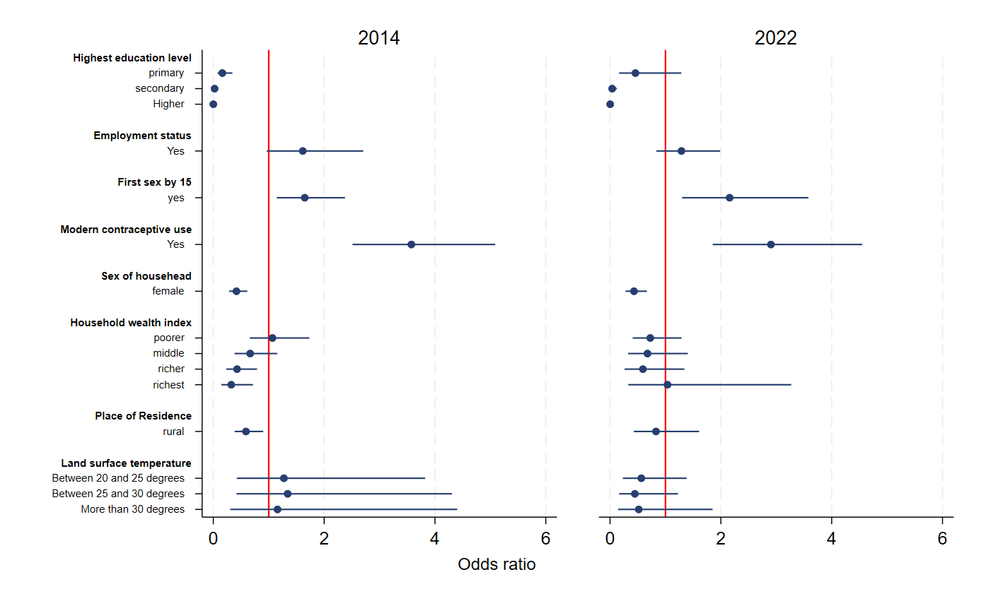

Figure SI.2.1b 25-29 years
Sample size: 5,902 (2014), 5,443 (2022)
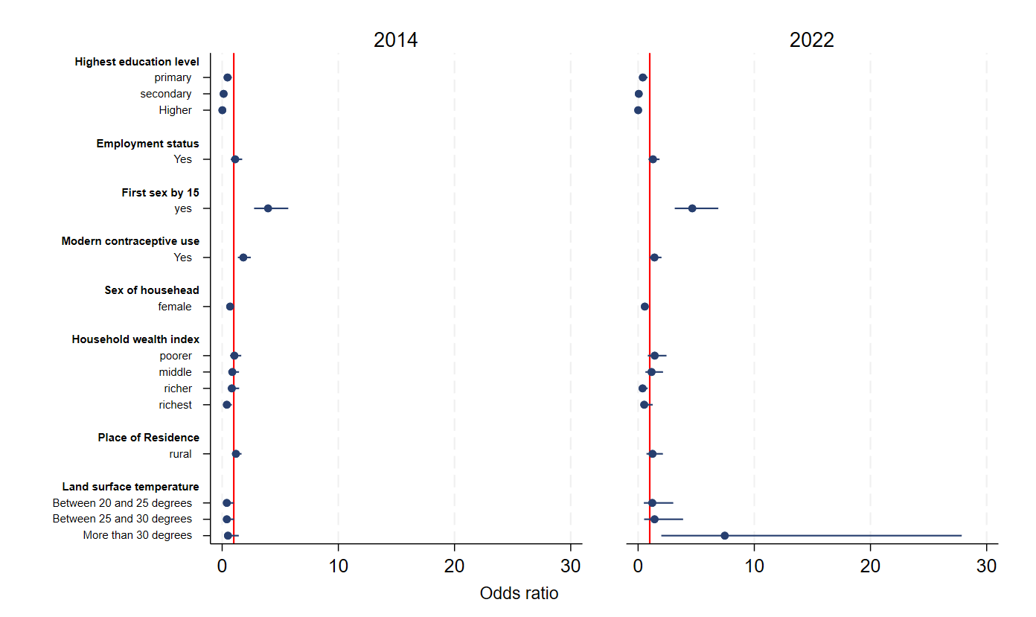

Figure SI.2. 1c 30-34 years
Sample size: 4,431 (2014), 4,561 (2022)
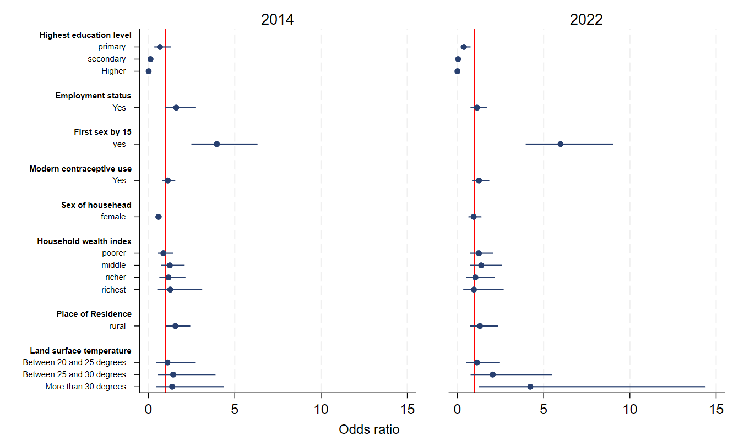

Figure SI.2.1d 35-39 years
Sample size: 3,851 (2014), 4,354 (2022)
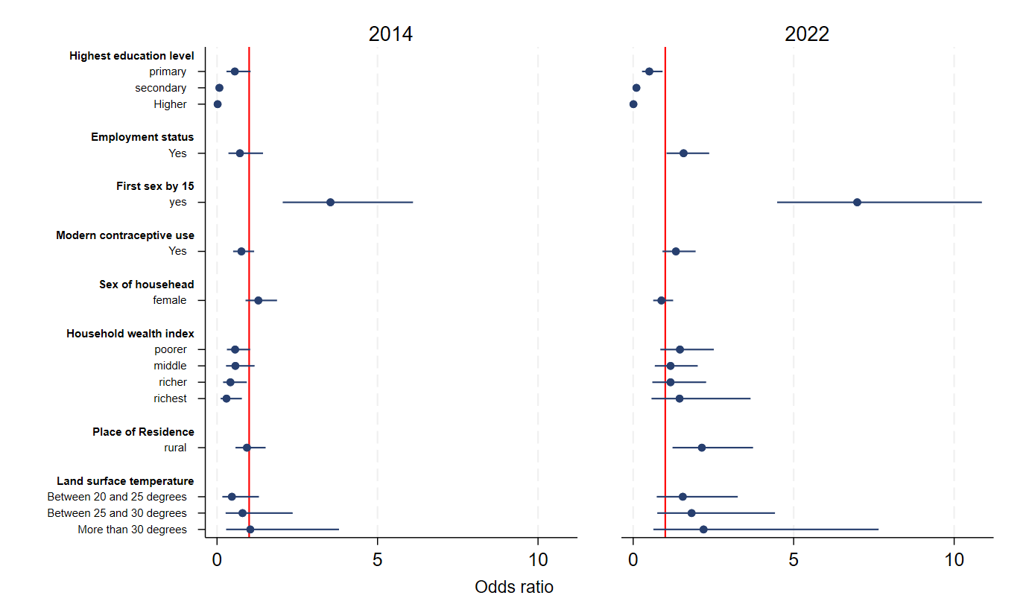

Figure SI.2.1e 40-44 years
Sample size: 2,968 (2014), 3,100 (2022)

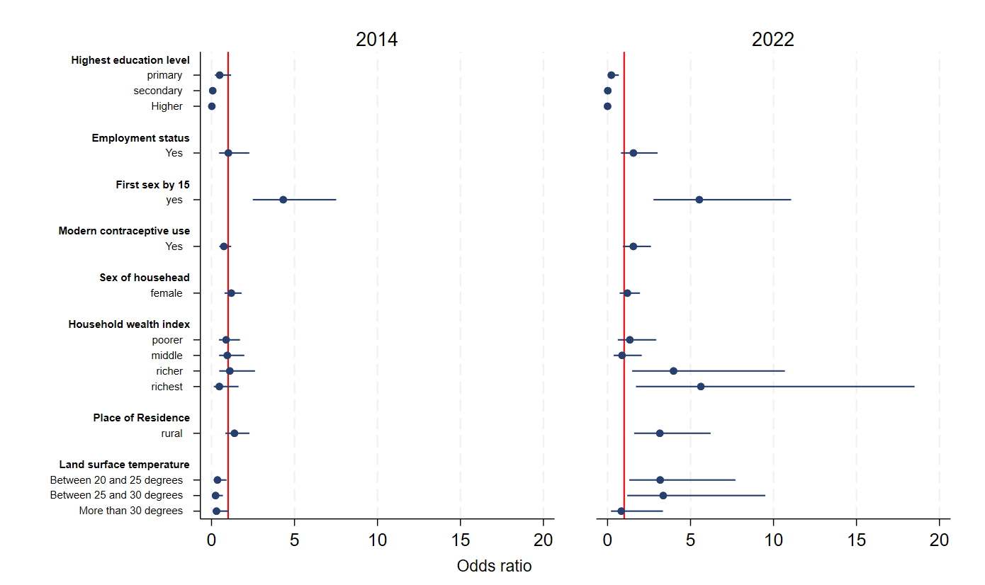

Figure SI.2.1f 45-49 years
Sample size: 2,335 (2014), 2,532 (2022)
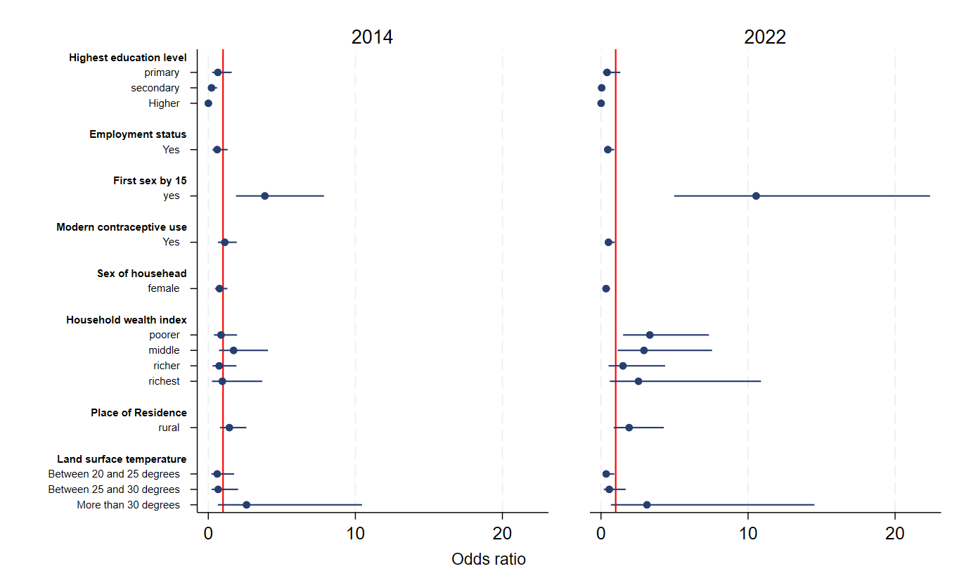

SI.3: Sub- County level high resolution maps
Table SI.3.1. List of covariates
Full list | Covariate | Description | Year | Source
built_volume | Built Volume | Built-up volume (in m3). GHSL BUILT-V data are combined with Microsoft Building Footprints, Google Open Buildings footprints and World Settlement Footprint. Missing built-up pixels in GHSL but existing built-up pixels in Microsoft Building footprints, Google Building footprints and/or World Settlement Footprint were transformed to building volumes through the help of interpolated GHSL BUILT-H data and added to the base GHSL layer. | 2020 | Pesaresi, M. and Politis, P. (2023) GHS-BUILT-V R2023A – GHS built-up volume grids derived from joint assessment of Sentinel2, Landsat, and global DEM data, multitemporal (1975-2030).European Commission, Joint Research Centre (JRC)  PID: http://data.europa.eu/89h/ab2f107a-03cd-47a3-85e5-139d8ec63283, doi:10.2905/AB2F107A-03CD-47A3-85E5-139D8EC63283  Pesaresi, M. and Politis, P. (2023) GHS-BUILT-H R2023A – GHS building height, derived from AW3D30, SRTM30, and Sentinel2 composite (2018). European Commission, Joint Research Centre (JRC)  PID: http://data.europa.eu/89h/85005901-3a49-48dd-9d19-6261354f56fe, doi:10.2905/85005901-3A49-48DD-9D19-6261354F56FE  Microsoft (2023). GlobalMLBuildingFootprints. https://github.com/microsoft/GlobalMLBuildingFootprints. [Accessed July 2023].  Sirko, W. et al. (2021). Continental-Scale Building Detection from High Resolution Satellite Imagery. arXiv:2107.12283. https://ui.adsabs.harvard.edu/abs/2021arXiv210712283S.  German Aerospace Center (DLR) (2021). World Settlement Footprint (WSF) 2019. https://doi.org/10.15489/twg5xsnquw84
distance_coastline | Distance to Coastline | Distance (in kilometres) from its centre to the nearest open-water coastline | 2021 | Zanaga, D., Van De Kerchove, R., Daems, D., De Keersmaecker, W., Brockmann, C., Kirches, G., Wevers, J., Cartus, O., Santoro, M., Fritz, S., Lesiv, M., Herold, M., Tsendbazar, N.E., Xu, P., Ramoino, F., Arino, O., 2022. ESA WorldCover 10 m 2021 v200. https://doi.org/10.5281/zenodo.7254221
distance_conflict | Distance to Conflict | Distance (in kilometers) to points of conflict provided by ACLED as XY coordinates for 3 years prior to each survey year - e.g. - 01/01/2007 - 31/12/2009 for 2010. | 2007-2009; 2018-2020 | Armed Conflict Location & Event Data Project (ACLED); www.acleddata.com
distance_cultivated | Distance to Cultivated Areas | Distance (in kilometres) to landcover classed as cultivated. | 2010, 2021 | ESA (European Space Agency) CCI (Climate Change Initiative) Land Cover project 2017. "Land Cover CCI Product - Annual LC maps from 2000 to 2015 (v2.0.7)." http://maps.elie.ucl.ac.be/CCI/viewer/  Defourny, P. et al. (2019). C3S - Product User Guide and Specification ICDR Land Cover 2016 to 2018, v1.2, https://datastore.copernicus-climate.eu/documents/satellite-land-cover/D3.3.12-v1.2_PUGS_ICDR_LC_v2.1.x_PRODUCTS_v1.2.pdf  Copernicus Climate Change Service, Climate Data Store, (2019): Land cover classification gridded maps from 1992 to present derived from satellite observation. Copernicus Climate Change Service (C3S) Climate Data Store (CDS). DOI: 10.24381/cds.006f2c9a (Accessed on 20-02-2023)
distance_protected | Distance to Protected Areas | Distance to IUCN strict nature reserve and wilderness area edges [km] | 2010, 2021 | UNEP-WCMC & IUCN (2023), Protected Planet: The World Database on Protected Areas (WDPA) and World Database on Other Effective Area-based Conservation Measures (WD-OECM) [Online], January 2023, Cambridge, UK: UNEP-WCMC and IUCN. Available at: www.protectedplanet.net.
distance_roads | Distance to Roads | Distance to Microsoft Roads [km] | 2020-2022 | Licensed by Microsoft under the Open Data Commons Open Database License (ODbL). https://github.com/microsoft/RoadDetections?tab=readme-ov-file
distance_water | Distance to Inland Water | Distance (in km) to the nearest inland water body based on a 75% water coverage threshold. | 2021 | Zanaga, D., Van De Kerchove, R., Daems, D., De Keersmaecker, W., Brockmann, C., Kirches, G., Wevers, J., Cartus, O., Santoro, M., Fritz, S., Lesiv, M., Herold, M., Tsendbazar, N.E., Xu, P., Ramoino, F., Arino, O., 2022. ESA WorldCover 10 m 2021 v200. https://doi.org/10.5281/zenodo.7254221
elevation | Elevation | Elevation (in metres) above sea level | ~2007 | Yamazaki D., D. Ikeshima, R. Tawatari, T. Yamaguchi, F. O'Loughlin, J.C. Neal, C.C. Sampson, S. Kanae & P.D. Bates. A high accuracy map of global terrain elevations. Geophysical Research Letters, vol.44, pp.5844-5853, 2017 doi: 10.1002/2017GL072874
nighttime_lights | Night-time Lights | VIIRS night-time annual average radiance (in nW/cm2/sr), with Flares and Volcanoes filtered out. | 2015-2022 | This product was made utilizing Annual average-masked VNL 2.1/2.2 data produced by the Earth Observation Group, Payne Institute for Public Policy, Colorado School of Mines: Elvidge, C.D.; Zhizhin, M.; Ghosh, T.; Hsu, F.-C.; Taneja, J. Annual Time Series of Global VIIRS Nighttime Lights Derived from Monthly Averages: 2012 to 2019. Remote Sens. 2021, 13, 922. https://doi.org/10.3390/rs13050922
slope | Slope | Topographic slope (in degrees) | ~2007 | Yamazaki D., D. Ikeshima, R. Tawatari, T. Yamaguchi, F. O'Loughlin, J.C. Neal, C.C. Sampson, S. Kanae & P.D. Bates. A high accuracy map of global terrain elevations. Geophysical Research Letters, vol.44, pp.5844-5853, 2017 doi: 10.1002/2017GL072874
travel_time_health | Travel Time to health Facilities | Motorised and walking time (minutes) to health facilities as provided by Malaria Atlas Project based on respective friction surfaces. | 2019 | Malaria Atlas Project; https://malariaatlas.org/research-project/accessibility-to-healthcare/
travel_time_urban | Travel Time to Urban Areas | Travel time (minutes) to edge of urban centres (SMOD class = 30) | 2020 | GHSL; https://ghsl.jrc.ec.europa.eu/download.php?ds=smod

SI.4 Geographical association between Temperature and Child Marriage
SI.4.1. Assessing the Influence of Poverty in the Spatial Analysis of Child Marriage and Temperature
In GeoDa, the primary objective was to control for poverty when analyzing the spatial association between temperature and child marriage for both years. An Ordinary Least Squares (OLS) regression was conducted, with child marriage (CM_1 and CM_2) as the dependent variable and temperature (TM_1 and TM_2) and poverty (Poverty_rates) as independent variables, to assess the effect of poverty on child marriage and diagnose spatial dependence. An interaction term between poverty and temperature was tested to determine whether the relationship between temperature and child marriage varied at different poverty levels. However, the interaction term was not significant, and margins plots in STATA showed parallel trends across poverty quartiles, indicating no justification for including an interaction effect. Variance Inflation Factor (VIF) tests confirmed that multicollinearity was not a concern (VIF < 5).
Although poverty was a significant predictor of child marriage in the OLS model, spatial diagnostics indicated strong spatial dependence at both time points. Additionally, a comparison of log-likelihood (LL) values between OLS and the Spatial Error Model (SEM) showed that SEM had a higher LL, suggesting a better model fit. Given that Moran’s I and other spatial dependence tests were significant, a spatial model was required. To determine the most appropriate spatial model, Robust Lagrange Multiplier (LM) tests were used. Since the Robust LM (Error) test was consistently stronger than the Robust LM (Lag) test, the Spatial Error Model (SEM) was selected for both time points. Results from the SEM showed that poverty was no longer a significant predictor of child marriage, whereas temperature remained significant. This suggests that after accounting for spatial dependencies, temperature still has an effect on child marriage, while the influence of poverty diminishes.
Table SI.4.1.1 Model Diagnostics: Evaluating the Fit and Assumptions of the SEM and OLS Models Testing the Effect of Temperature on Child Marriage, Controlling for Poverty, for round 1 (2014) and round 2 (2022) for 335 sub-counties in Kenya.

OLS model |  | Round 1 | Round 2
 | R-squared | 0.353207 | 0.425684
 | Log likelihood | 296.488 | 343.889
 | DIAGNOSTICS FOR SPATIAL DEPENDENCE
 | Moran's I - Value (Prob) | 22.9386 (0.00000) | 21.5005 (0.00000)
 | Lagrange Multiplier (lag) - Value (Prob) | 491.35 (0.00000) | 443.7201 (0.00000)
 | Robust LM (lag) - Value (Prob) | 12.93 (0.00032) | 20.8735 (0.00000)
 | Lagrange Multiplier (error) - Value (Prob) | 501.65 (0.00000) | 439.9673 (0.00000)
 | Robust LM (error) - Value (Prob) | 23.24 (0.00000) | 17.1206 (0.00000)
SEM model |  | Round 1 | Round 2
 | R-squared | 0.909253 | 0.892286
 | Log likelihood | 571.485856 | 573.526793
 | Lag coeff. (Lambda) - Coeff (Prob) | 0.955431 (0.00000) | 0.941591 (0.00000)

Table SI.4.1.2 Structural Equation Model (SEM) Output: Effect of Temperature on Child Marriage, Controlling for Poverty for round 1 (2014), at sub-county level in Kenya.
Variable | Coefficient | Std.Error | z-value | Probability
CONSTANT | 0.120109 | 0.054499 | 2.20386 | 0.02753
TM_R1 | 0.005184 | 0.001181 | 4.38997 | 0.00001
Poverty_rates | -3.48E-05 | 0.000178 | -0.19582 | 0.84475
LAMBDA | 0.955431 | 0.013689 | 69.7944 | 0

Table SI.4.1.3 Structural Equation Model (SEM) Output: Effect of Temperature on Child Marriage, Controlling for Poverty for round 2 (2022), at sub-county level in Kenya.

Variable | Coefficient | Std.Error | z-value | Probability
CONSTANT | 0.148043 | 0.046072 | 3.2133 | 0.00131
TM_R2 | 0.003918 | 0.001213 | 3.23108 | 0.00123
Poverty_rates | -2.66E-05 | 0.000179 | -0.14889 | 0.88164
LAMBDA | 0.941591 | 0.01636 | 57.5536 | 0

SI.4.2. Univariate and Bivariate Spatial Analyses
Figure SI.4.2.1: Moran’s I (Univariate Global MI’s). Panel a) Child marriage Round 1 (CM_ 1); Panel b) Child Marriage Round 2 (CM_2); Panel c) Land Surface Temperature Round 1 (TM_1) and Panel d) Land Surface Temperature Round 2 (TM_2).
We first assessed the degree of global spatial autocorrelation, or the degree to which one spatial unit shares similar or different characteristics with its neighbouring spatial unit, by using the Moran's I statistic (using n=999 permutations yielding a pseudo p value of 0·001). [CM= child marriage (below 18); TM= average temperature]
CM_1 = 0.864  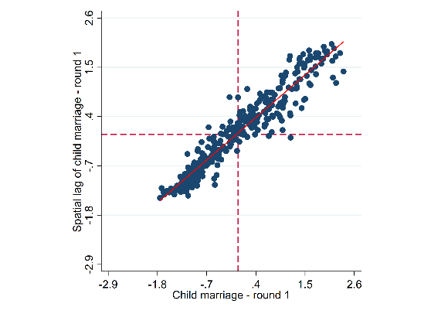  a) | CM_2 = 0.856  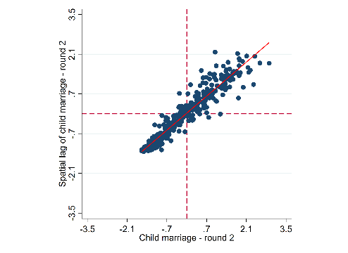  b)
TM_R1 = 0.842  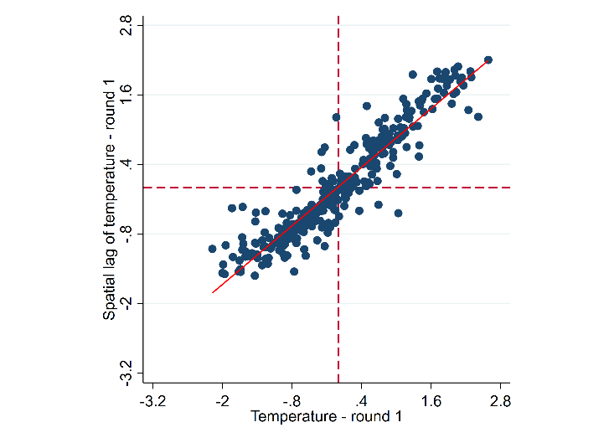  c) | TM_R2 = 0.862  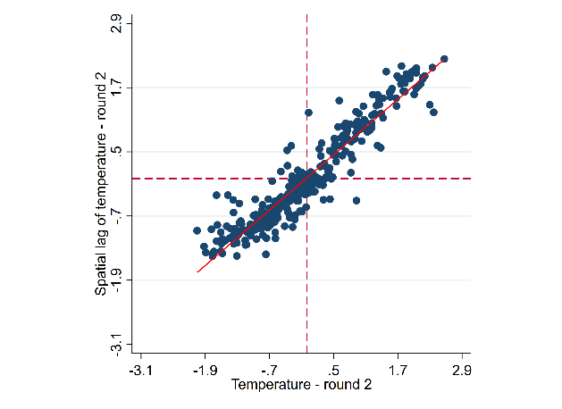  d)

SI.4.3: Spatial Analyses (LISA and BiLISA Cluster Maps) and Significance Maps
Figure SI.4.3.1 LISA Cluster maps for a) Child Marriage at Round 1 and b) Child Marriage at Round 2
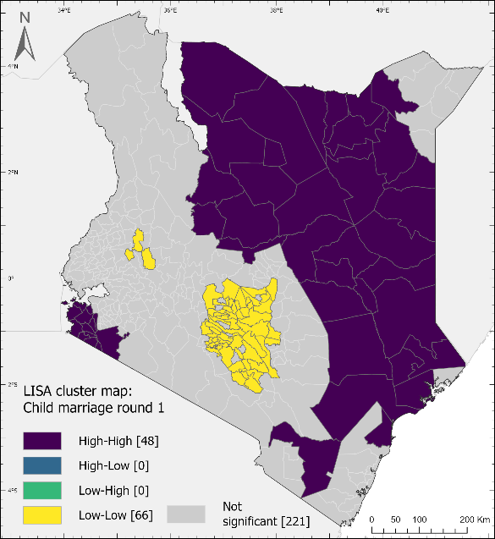  a) | 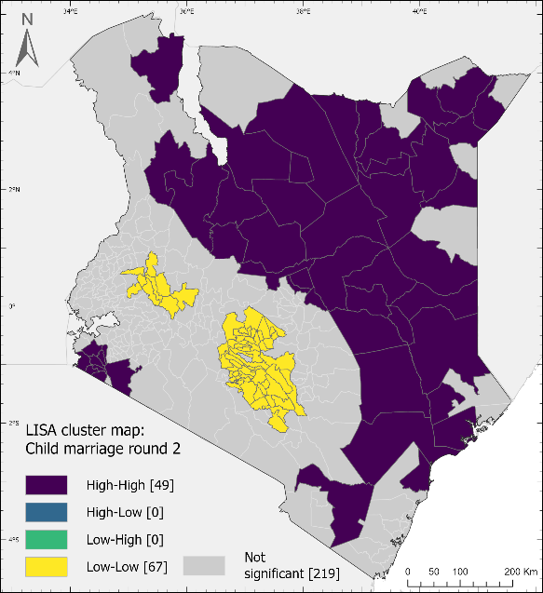  b)

Figure SI.4.3.2 Significance maps for Panel a) Child Marriage at Round 1; Panel b) Child Marriage at Round 2
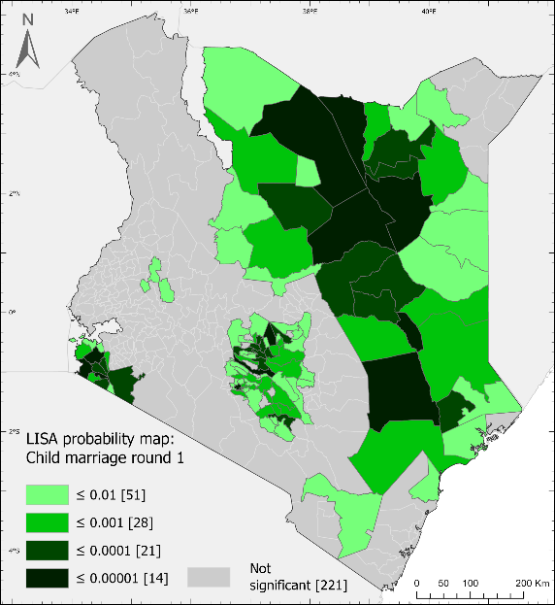  a) | 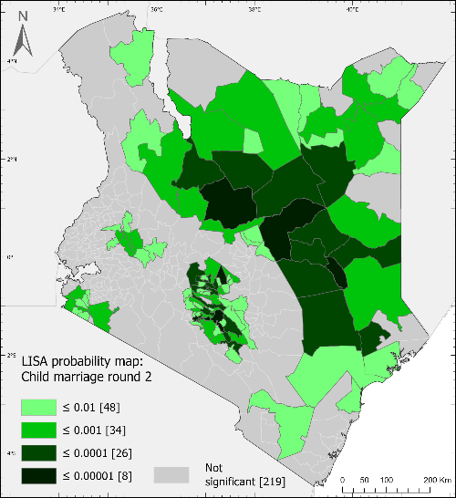  b)

Figure SI.4.3.3 LISA Cluster maps for a) Temperature at Round 1 and b) Temperature at Round 2
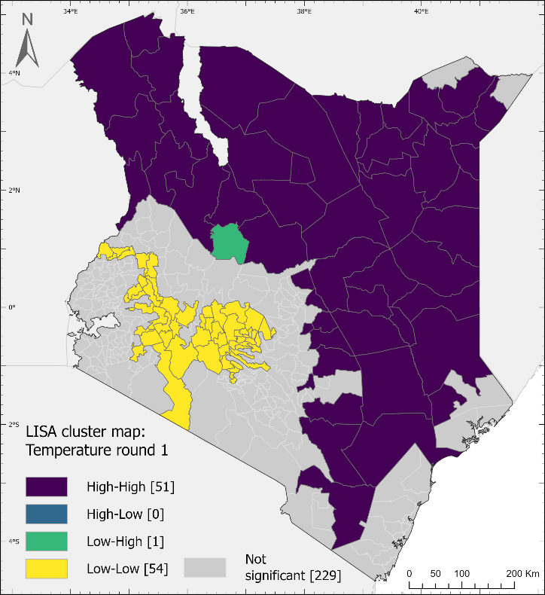  a) | 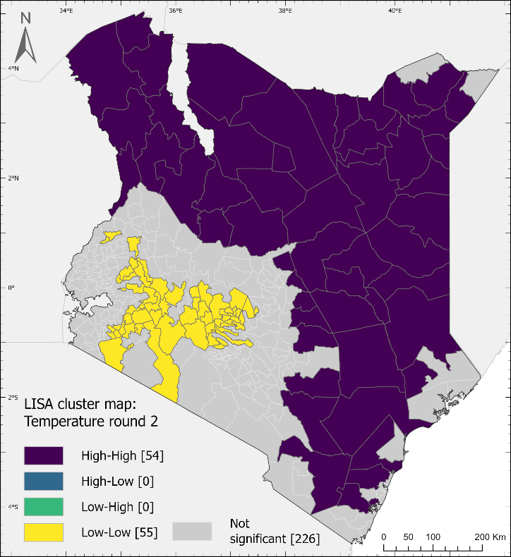  b)

Figure SI.4.3.4 Significance Maps for Panel a) Temperature Round 1 and Panel b) Temperature Round 2
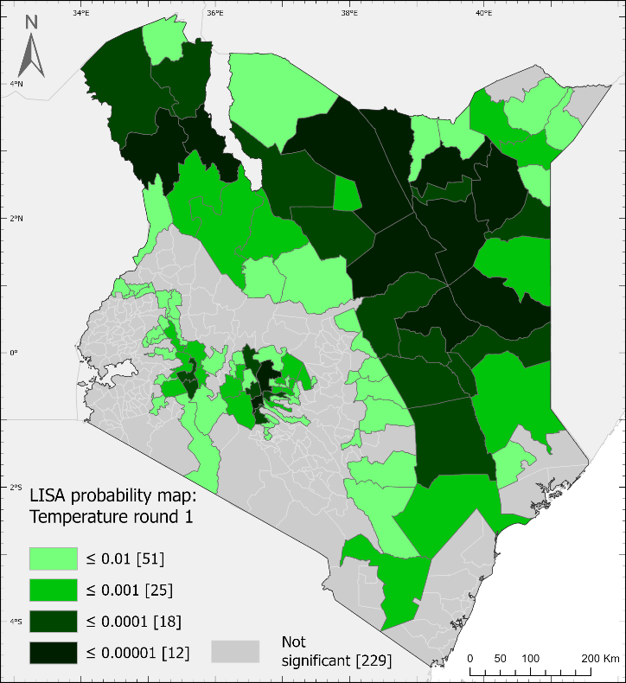  a) | 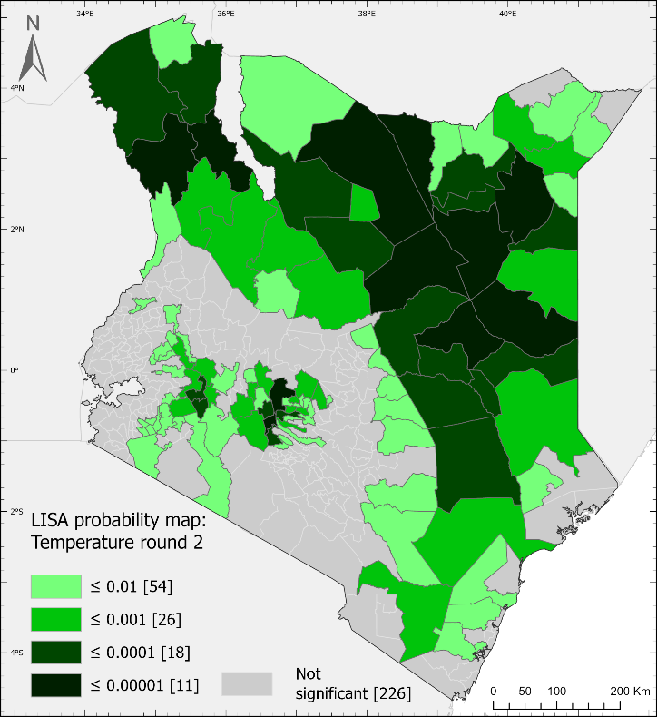  b)

Figure SI.4.3.5 BiLisa significance maps for Panel a) CM_R1/TM_R1 and Panel b) CM_R2/TM_R2
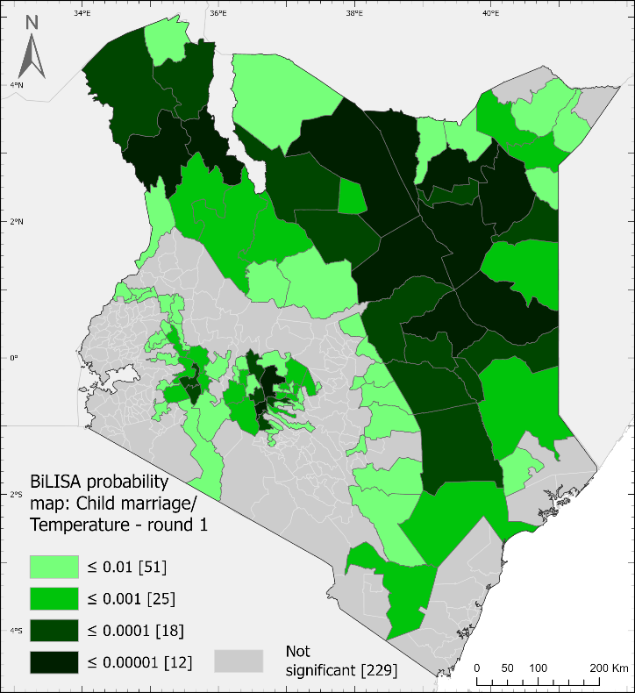  a) | 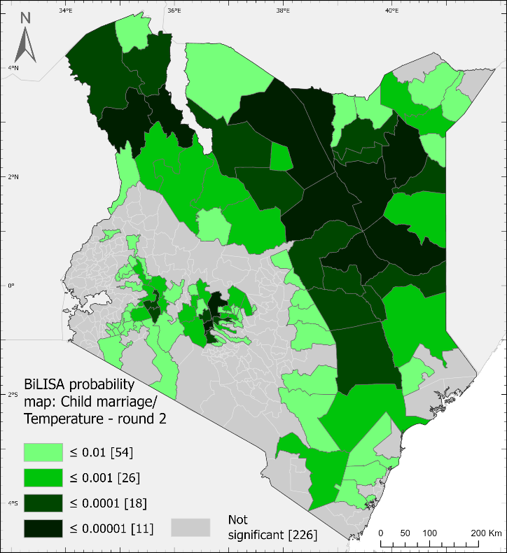  b)

