Supplementary Material
TableS1 The edge-weight matrix of the Network.
Itims | PHY1 | PHY2 | PHY3 | PHY4 | PHY5 | PHY6 | PHY7 | PHY8 | PSY1 | PSY2 | PSY3 | PSY4 | SOC1 | SOC2 | SOC3
PHY1
PHY2 | 0.389
PHY3 | 0.684 | 0
PHY4 | 0.234 | 0 | 2.019
PHY5 | 0.361 | 0 | 0.542 | 0
PHY6 | 0 | 0 | 0 | 0 | 0
PHY7 | 0 | 0 | 0.958 | 0 | 0 | 0.552
PHY8 | 1.033 | 0 | 0.643 | 0 | 0 | 0.659 | 0.694
PSY1 | 0 | 0 | 0.347 | 0 | 0.340 | 0 | 0 | 0.666
PSY2 | 0.281 | 0 | 0 | 0 | 0 | 0 | 0 | 0 | 0
PSY3 | 0.276 | 0 | 0 | 0 | 0 | 0 | 0 | 0.168 | 0.379 | 2.315
PSY4 | 0.593 | 0 | 0.193 | 0.745 | 0.245 | 0.341 | 0.436 | 0.458 | 0.191 | 0.476 | 0
SOC1 | 0 | 0 | 0 | 0 | 0 | 0 | 0 | 0 | 0 | 0 | 0 | 0
SOC2 | 0.025 | 0 | 0.406 | 0 | 0 | 0.261 | 0.491 | 0.256 | 0 | 0.497 | 0.405 | 0.167 | 0.880
SOC3 | 0.213 | 0 | 0 | 0 | 0 | 0 | 0 | 0 | 0 | 0 | 0 | -0.762 | 1.232 | 0.201
Note:

TableS2 Differences in edge connectivity in networks across age groups

Item1 | Item2 | P-Value | statistic E
PHY5 | PHY6 | 0.010 | 0.633
PHY6 | PHY7 | 0.030 | 1.193
PHY1 | PHY8 | 0.010 | 0.942
PHY3 | PSY1 | 0.020 | 0.689
PHY6 | PSY1 | 0.010 | 0.482
PHY7 | PSY4 | 0.040 | 1.086
PSY1 | PSY4 | 0.050 | 0.403
PHY6 | SOC2 | 0.020 | 0.865

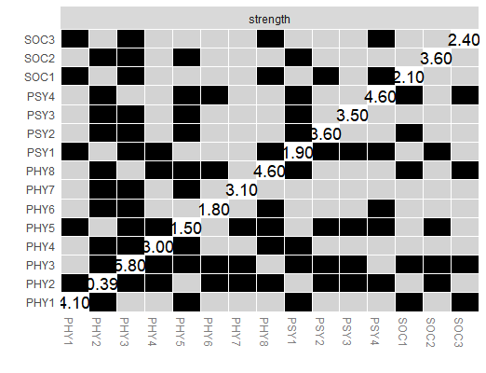
Fig S1 Nonparametric bootstrapped difference test for expectedinfluence
Note: Grey boxes indicate no significant difference, whereas black boxes indicate a statistically significant difference (p < 0.05). The number in the white boxes (i.e., diagonal line) represent the value of node strengths.

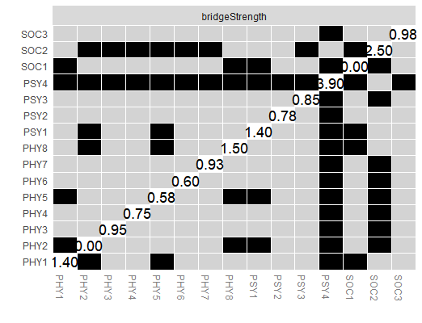
Fig.S2. Bootstrapped difference test for node’s bridge strength.
Note: Grey boxes indicate no significant difference, whereas black boxes indicate a statistically significant difference (P < 0.05).
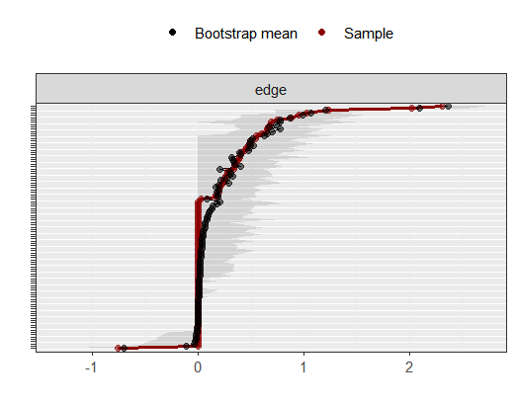
Fig.S3. Nonparametric bootstrapped confidence intervals of estimated edges.
Note: Each horizontal line represents one edge of the network. The red dots represent the sample estimates of the edge, and the black dots represent the bootstrap means of the edge. The grey areas represent the 95% confidence intervals for the edges, and narrower grey lines means better accuracy for the edges.

