SUPPLEMENTARY FIGURES AND FIGURE LEGENDS
Supplementary Figure 1
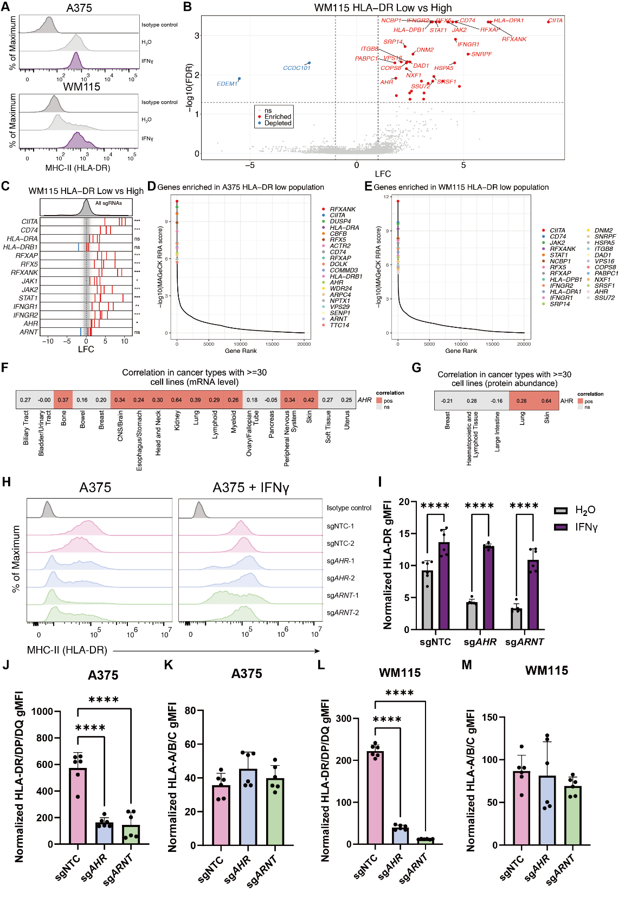
Supplementary Figure 1. Genome-wide CRISPR screens identify AHR and ARNT as positive regulators of MHC-II expression.
(A) Surface expression of MHC-II (HLA-DR) in A375 and WM115 cells treated with or without 100 ng/mL IFN-γ for 72 hours. Representative flow cytometry plots from three independent experiments.
(B) Scatterplot showing the top 25 enriched (red) and depleted (blue) sgRNAs in the MHC-II (HLA-DR) low population compared to the MHC-II high population in WM115.
(C) Log₂ fold change values of individual sgRNAs plotted in (B), showing the effect of gene perturbations on HLA-DR expression.
(D-E) Rank plots showing top 20 genes enriched in A375 HLA-DR^{low} population (D) and top 25 genes enriched in WM115 HLA-DR^{low} population (E).
(F-G) Heatmaps showing Pearson correlation coefficients between AHR and MHC-II expression at the mRNA level (F) and protein level (G) across cancer types with more than 30 cell lines in the CCLE.
(H) Surface MHC-II (HLA-DR) expression in A375-Cas9 cells transduced with sgRNAs targeting AHR, ARNT, or control sgRNAs, with or without IFN-γ treatment (100 ng/mL, 72 h). Representative plots from three independent experiments.
(I) Mean geometric mean fluorescence intensity (gMFI) of surface MHC-II (HLA-DR) expression in AHR- and ARNT-deficient A375 cells, with or without IFN-γ treatment (100 ng/mL, 72 h), across six independent experiments (normalized to isotype controls).
(J-M) Mean gMFI of surface MHC-II (HLA-DR/DP/DQ) (J, L) and MHC-I (HLA-A/B/C) (K, M) in AHR- and ARNT-deficient A375 (J-K) and WM115 (L-M) cells across six independent experiments (normalized to unstained controls).
Data are represented as mean ± SD (I-M). Statistical analysis by two-way ANOVA (I) and one-way ANOVA (J-M); *p < 0.05, **p < 0.01, ***p < 0.001, ****p < 0.0001.
Supplementary Figure 2
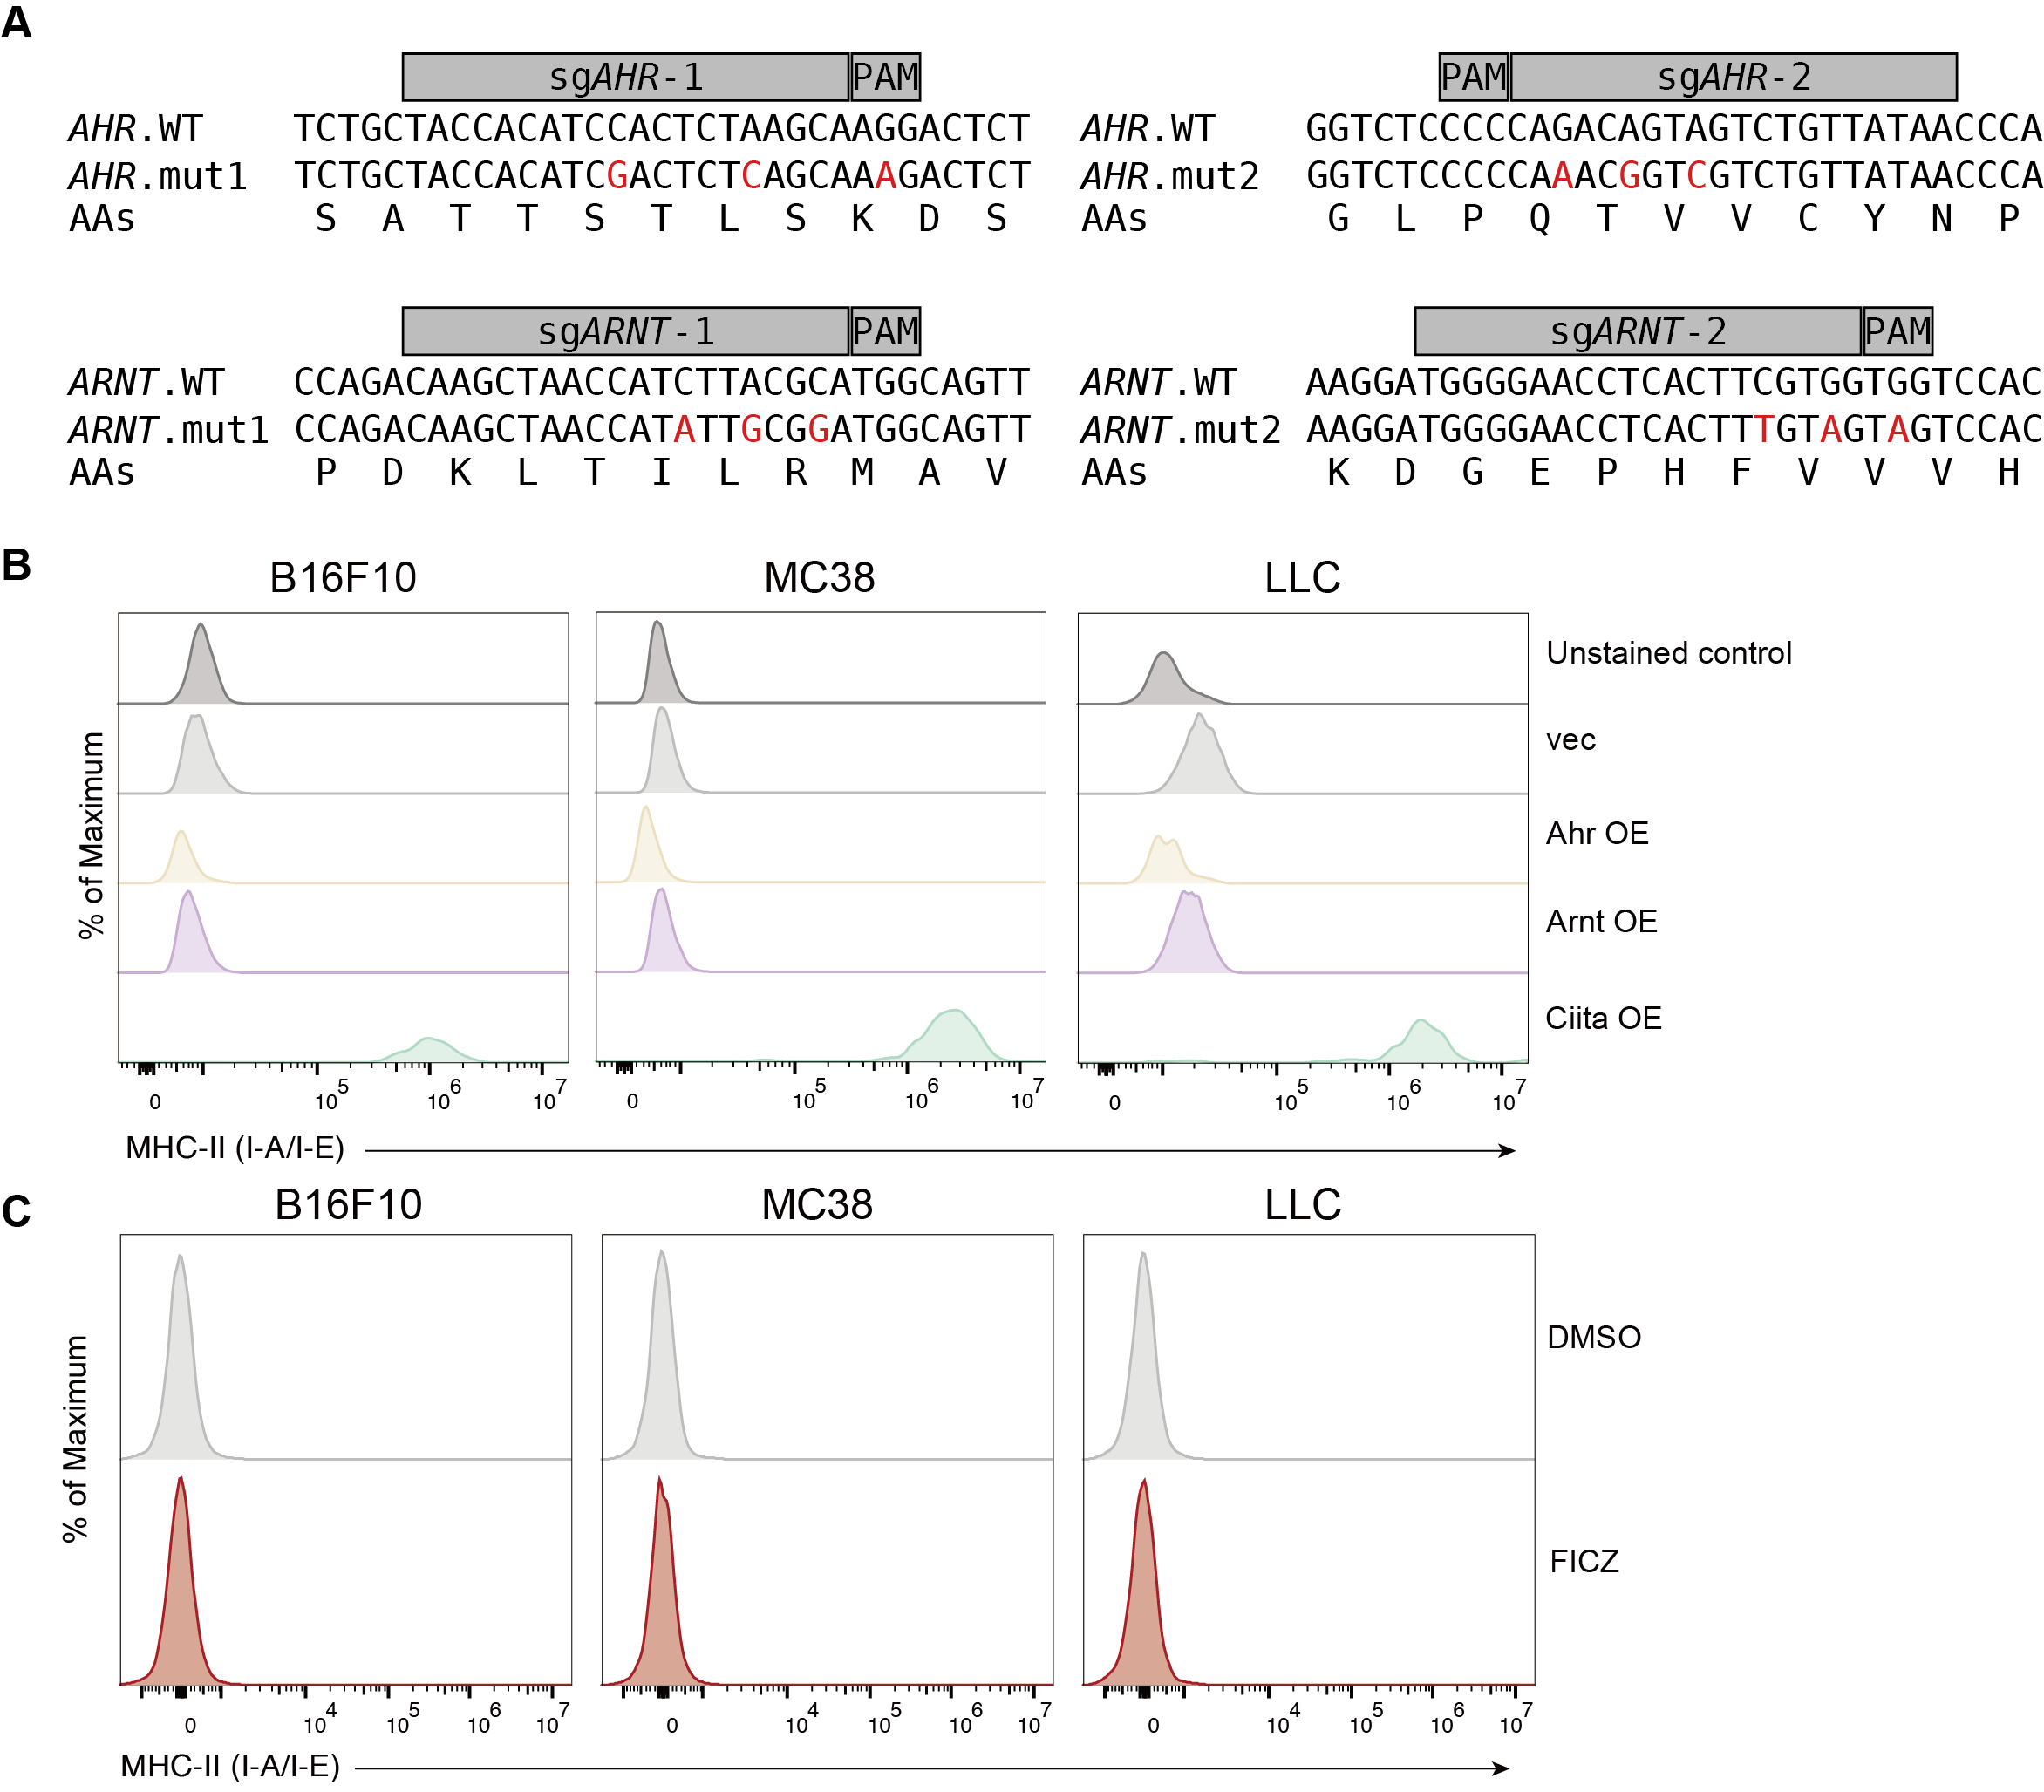
Supplementary Figure 2. Overexpression of AHR or ARNT upregulates MHC-II expression in human melanoma cells.
(A) Schematic showing the introduction of three nonconsecutive synonymous nucleotide substitutions into the sgRNA target site and adjacent PAM sequence of AHR and ARNT, used to enable re-expression in knockout backgrounds without re-targeting.
(B) Surface MHC-II (I-A/I-E) expression in murine tumor cell lines (B16F10, LLC, and MC38) following overexpression of Ahr, Arnt, or Ciita. Empty vector (vec) used as control. Representative plots from three independent experiments.
(C) Surface MHC-II (I-A/I-E) expression in murine tumor cell lines (B16F10, LLC, and MC38) treated with 1 μM FICZ or 0.1% DMSO (vehicle control) for 72 hours. Representative plots from three independent experiments.
Supplementary Figure 3
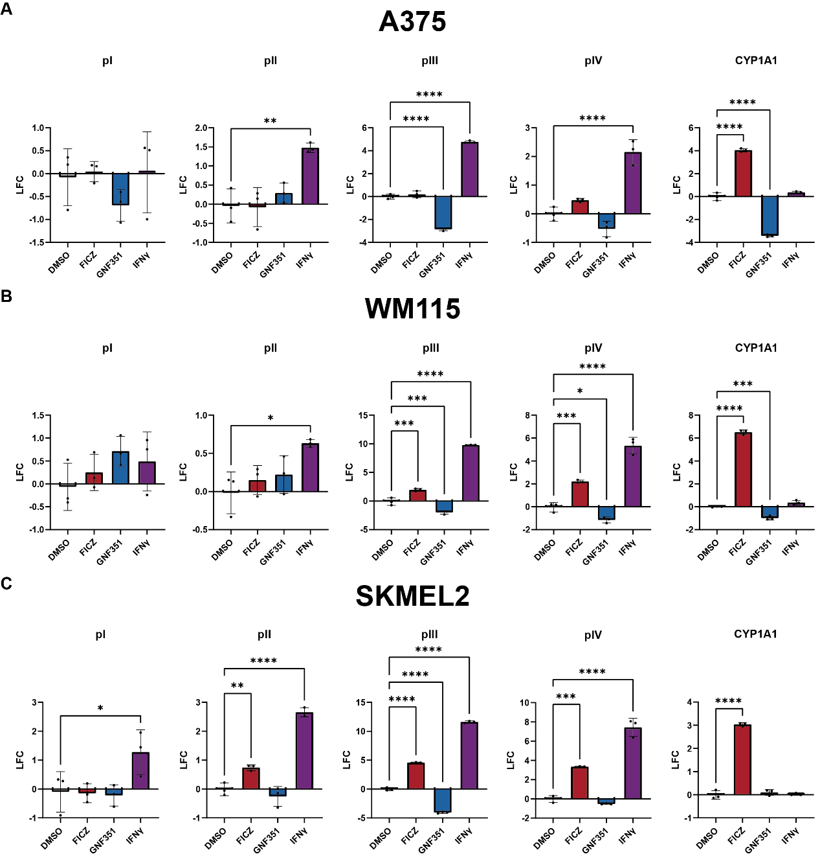
Supplementary Figure 3. AHR‒ARNT activation induces transcription of type II, III and IV CIITA mRNA isoforms.
(A-C) RT-qPCR analysis of isoform-specific CIITA transcripts and CYP1A1 in A375 (A), WM115 (B), and SKMEL2 (C) cells following 72-hour treatment with, 1 μM FICZ (AHR agonist), 2.5 μM GNF351 (AHR antagonist), 100 ng/mL IFN-γ, or 0.1% DMSO as vehicle control. Gene expression levels were normalized to GAPDH and are presented as log2 fold change (LFC) relative to the DMSO group.
Data are represented as mean ± SD (A-C). Each dot represents one technical replicate from triplicate wells (A-C). Statistical analysis by one-way ANOVA (A-C); *p < 0.05, **p < 0.01, ***p < 0.001, ****p < 0.0001.
SUPPLEMENTARY TABLES
Table S1. Summary of sgRNA sequences used in this study.
sgRNA name | Sequence (5’-3’)
sgNTC-1 | AACGCTGTCGTACGTGTATA
sgNTC-2 | AAACCTAGCCCCAATACTTA
sgAHR-1 | TACCACATCCACTCTAAGCA
sgAHR-2 | TTATAACAGACTACTGTCTG
sgARNT-1 | CAAGCTAACCATCTTACGCA
sgARNT-2 | TGGGGAACCTCACTTCGTGG

Table S2. Summary of ChIP-qPCR primer sequences used in this study.
Primer name | Sequence (5’-3’)
CIITA-AHRE-ChIP-F | CCTCTGACTCTACTTTGTTG
CIITA-AHRE-ChIP-R | AGAGGGAGCCTTTGTTCTGT

Table S3. Summary of type-specific primer sequences for RT-qPCR used in this study.
Primer name | Sequence (5’-3’)
CIITA-pI-F | CACTGCACTCTGCTCCATGAG
CIITA-pII-F | TGGCGTCTGAGGCAACCACAAGC
CIITA-pIII-F | GCTGGGATTCCTACACAATGC
CIITA-pIV-F | GAGCTGGCGGGAGGGAG
CIITA-exon2-R | TCTCCAGCCAGGTCCATCTG
GAPDH-F | GTCTCCTCTGACTTCAACAGCG
GAPDH-R | ACCACCCTGTTGCTGTAGCCAA
CYP1A1-F | GATTGAGCACTGTCAGGAGAAGC
CYP1A1-R | ATGAGGCTCCAGGAGATAGCAG

