- DSC results
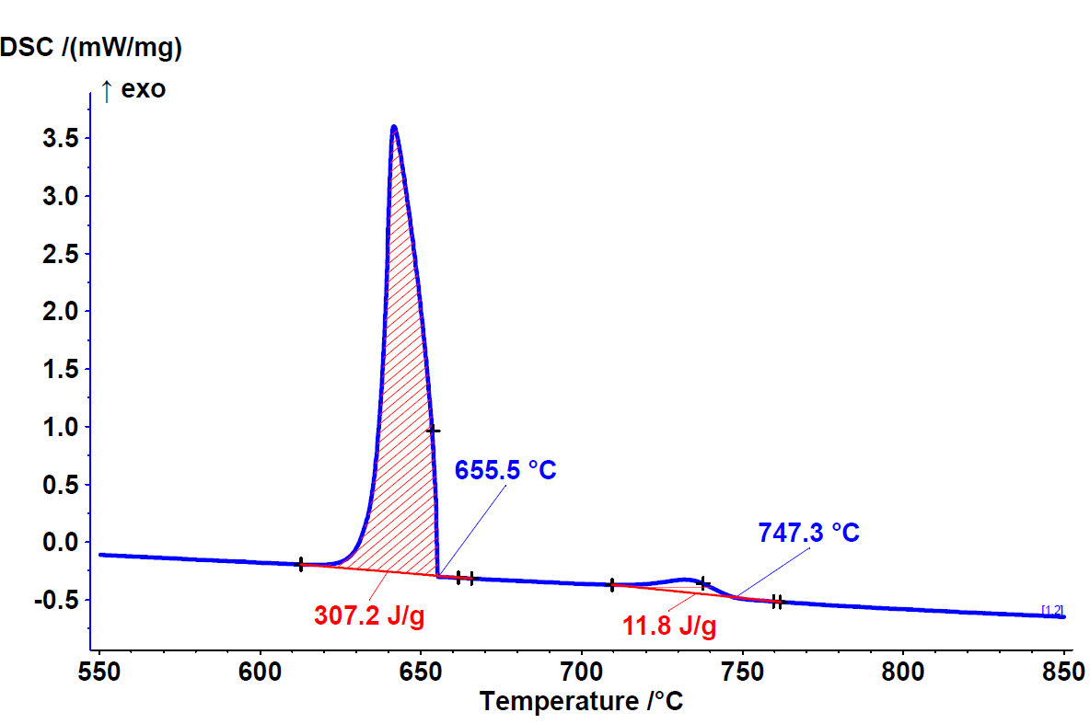
Fig. 1 Sample A
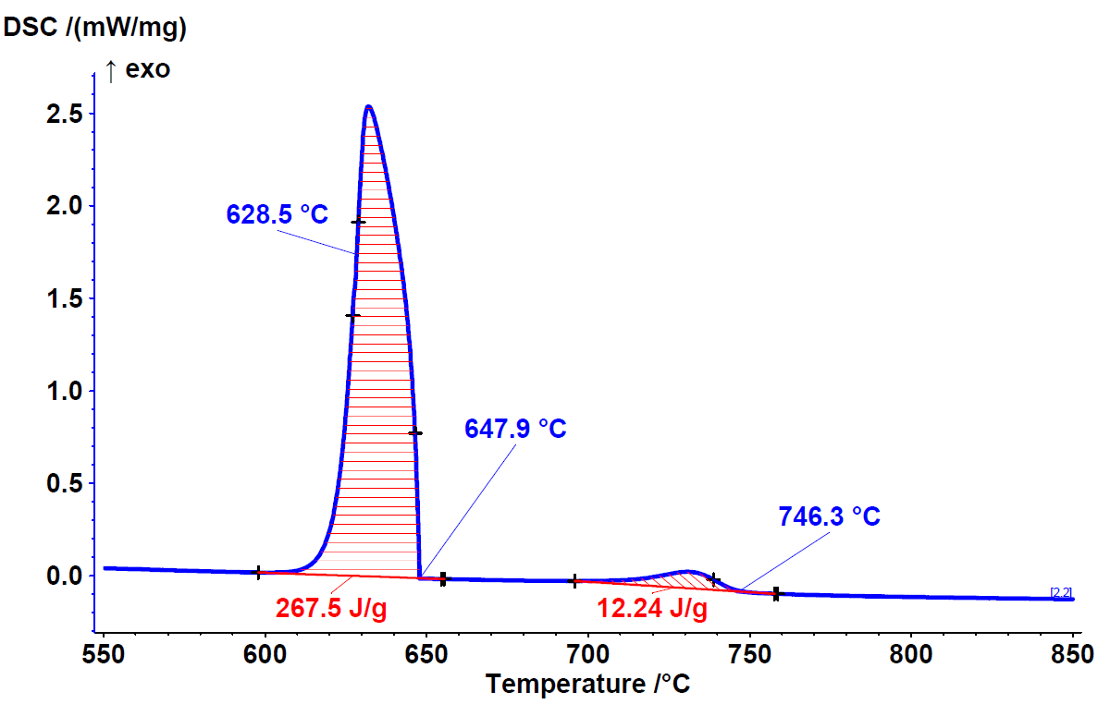
Fig. 2 Sample B
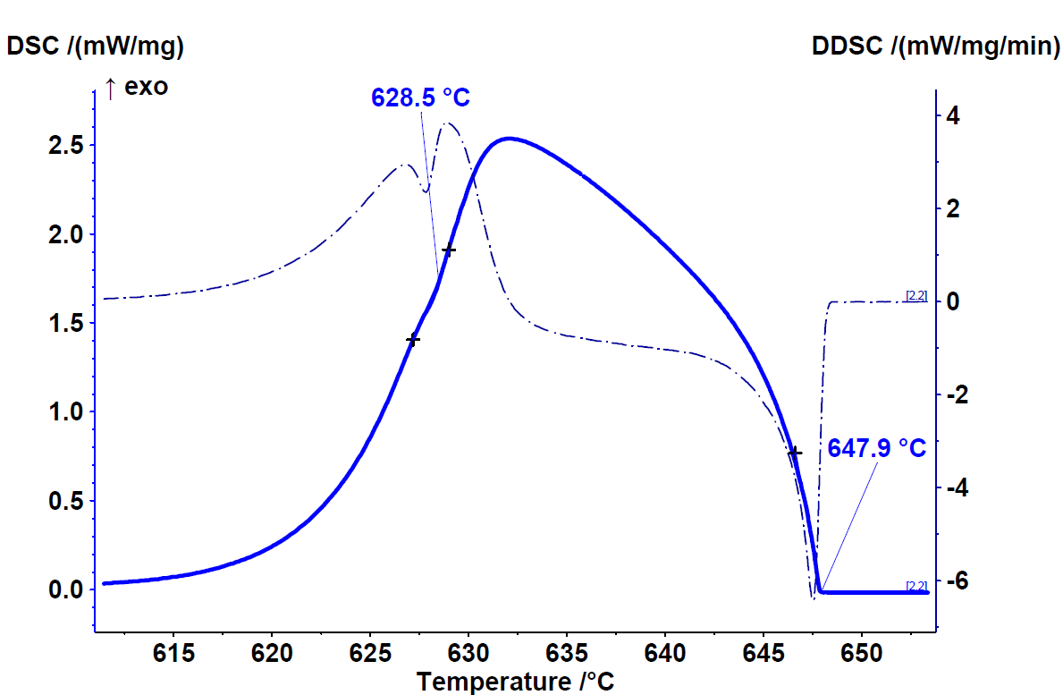
Fig. 3 Sample B (magnification of the low temperature peak)
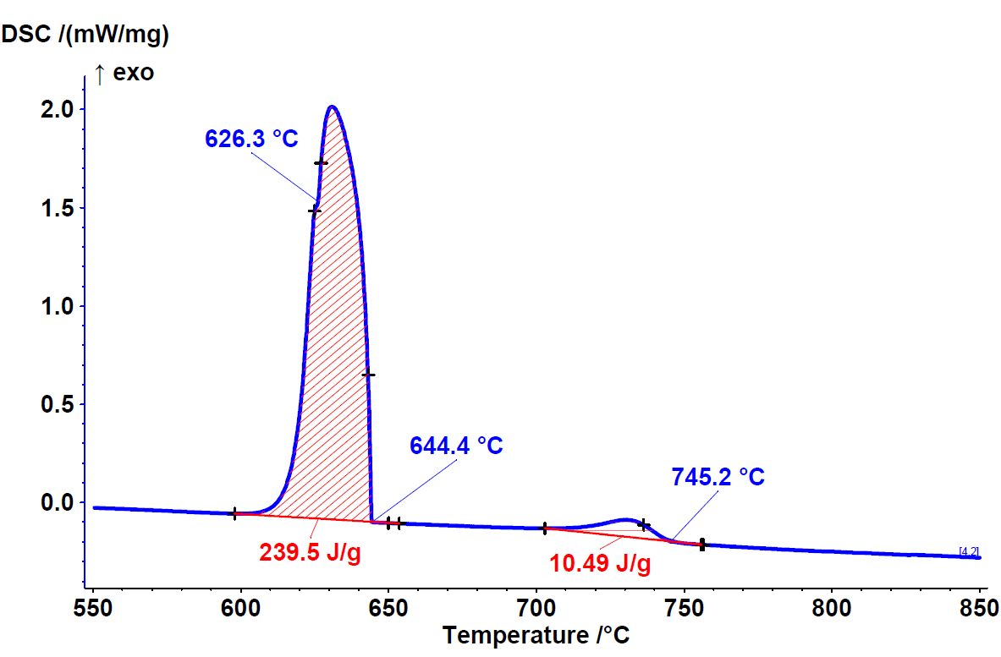
Fig. 4 Sample D
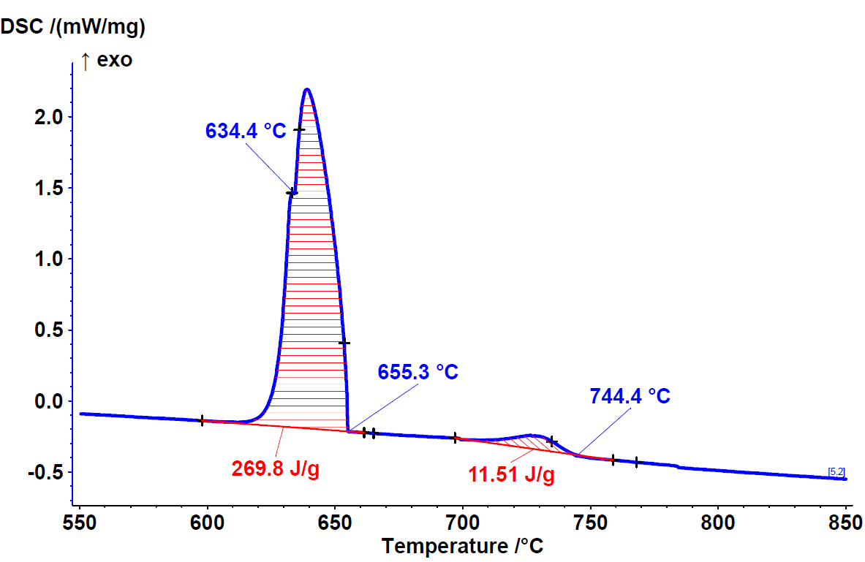
Fig. 5 Sample E
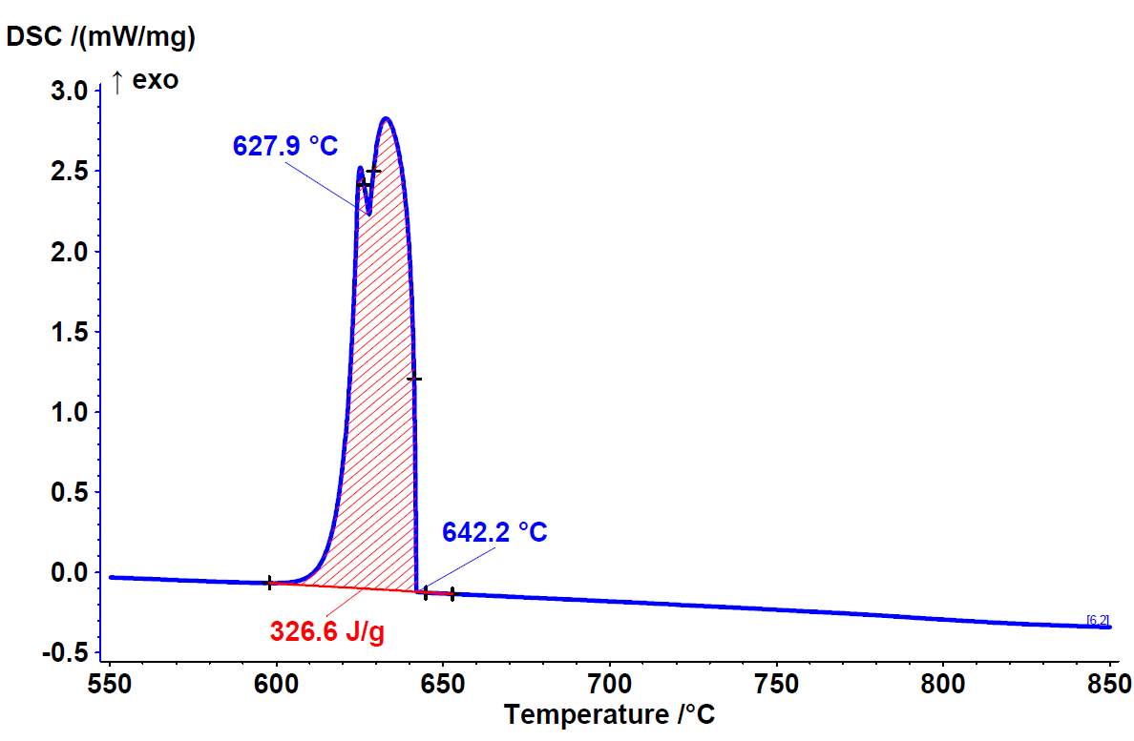
Fig. 6 Sample F
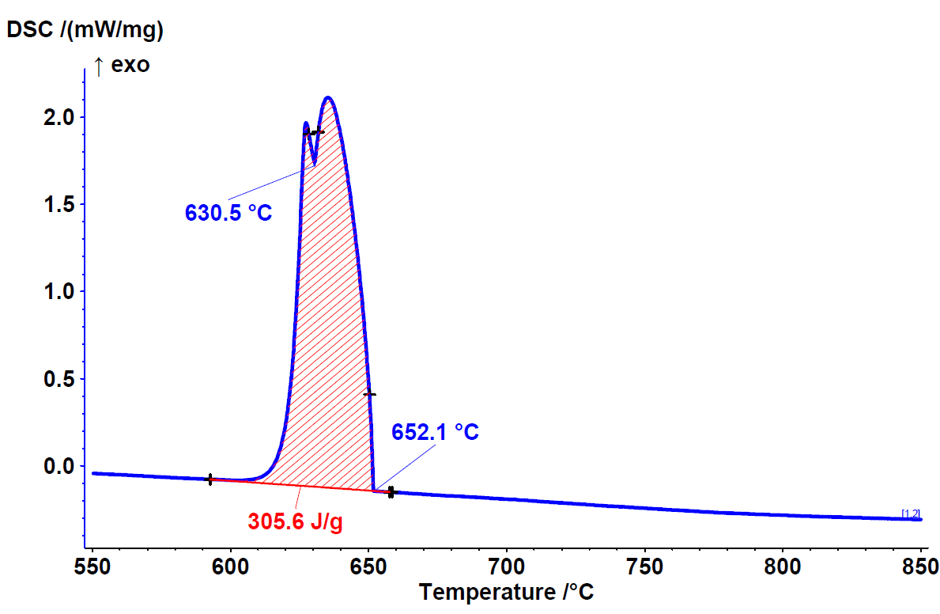
Fig. 7 Sample G
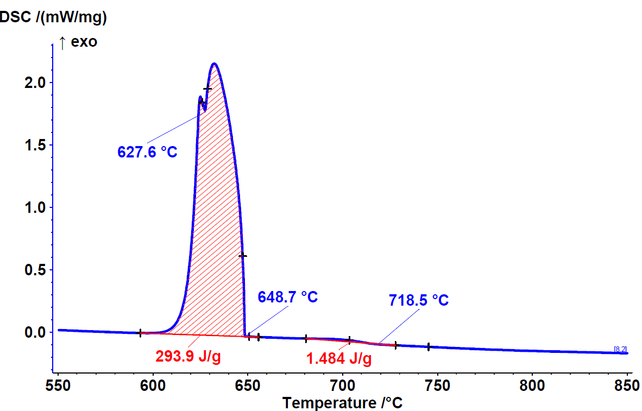
Fig. 8 Sample H
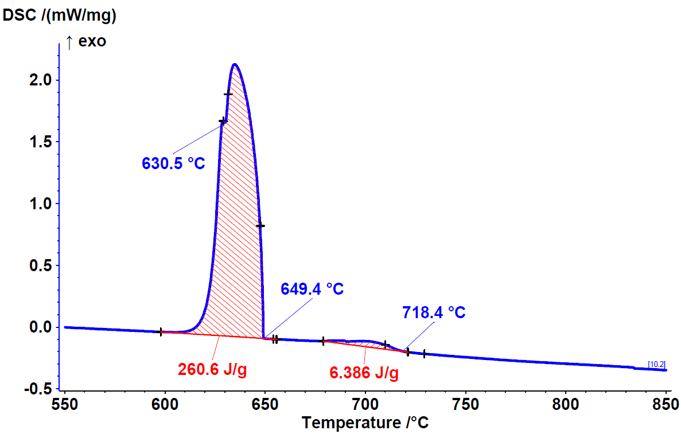
Fig. 9 Sample J
- SEM results
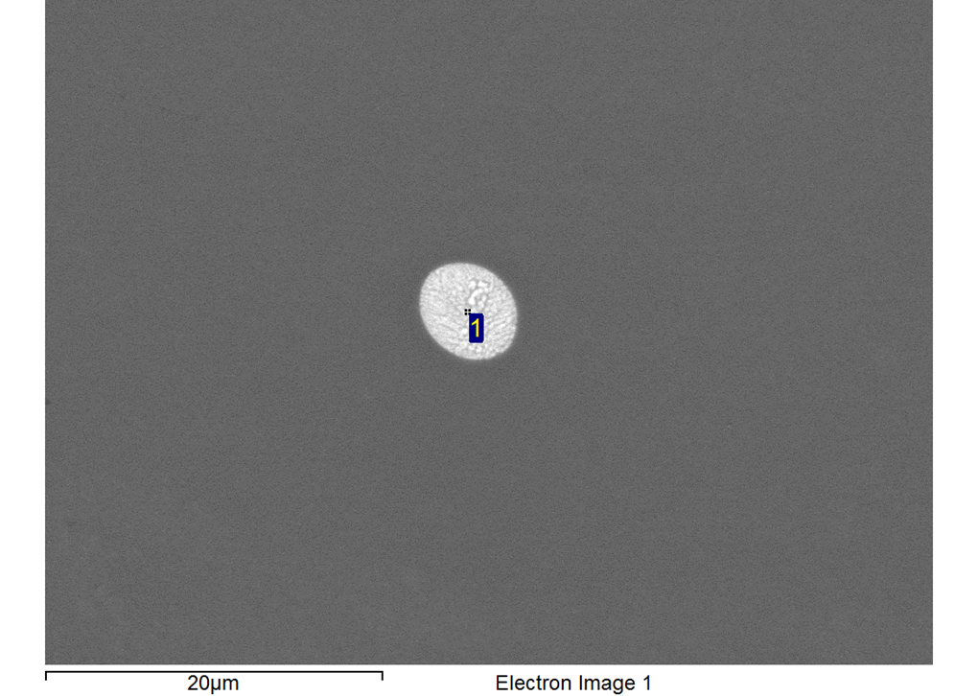
Fig. 10 Drop of mixture (Al) + Al₁₁La₃ in the microstructure of sample A
Table 1. EDS analysis of the Spectrum 1 in figure 10
 | at.%
Spectrum | Al | Cr | La
1 | 90.8 | 1.7 | 7.5

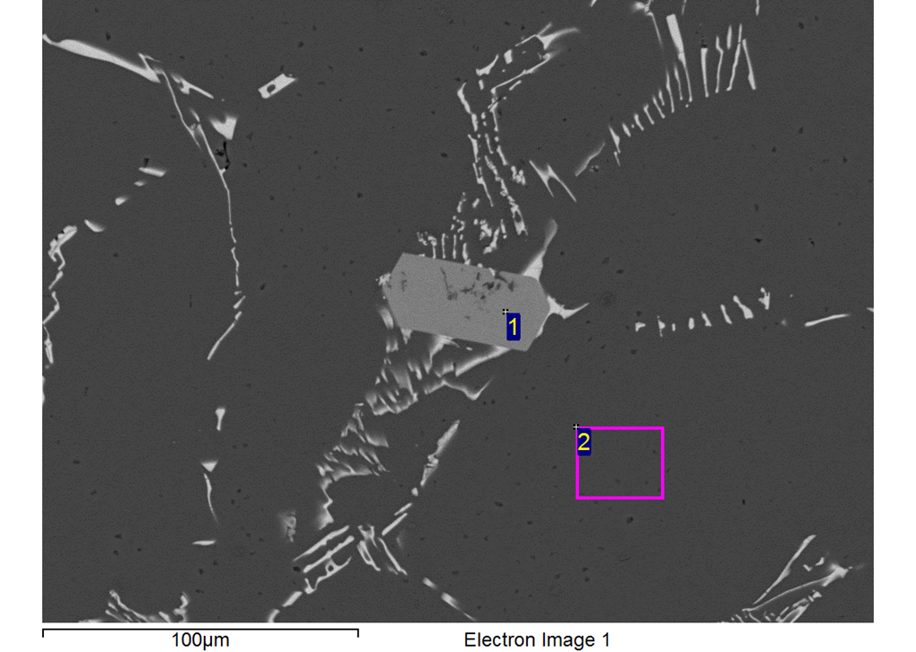
Fig. 11 Microstructure of sample G (just to prove that ternary LaCr₂Al₂₀ phase (Spectrum 1) is present in the microstructure)
Table 2. EDS analysis of the Spectrum 1 and 2 in figure 11
 | at.%
Spectrum | Al | Cr | La
1 | 87.4 | 8.0 | 4.6
2 | 99.8 | 0.2 | /

Microstructure of samples H to J (to prove that the proportion of the ternary phase LaCr₂Al₂₀ increases from H to J). Sharp-edged dark grey phases are ternary LaCr₂Al₂₀ phases.
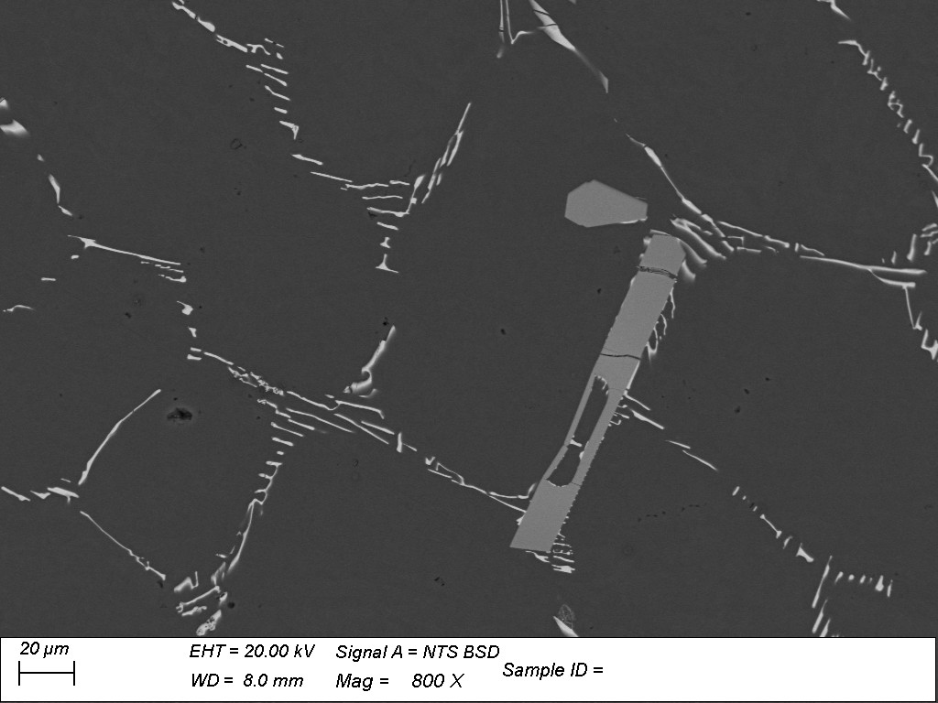
Fig. 12 Microstructure of sample H
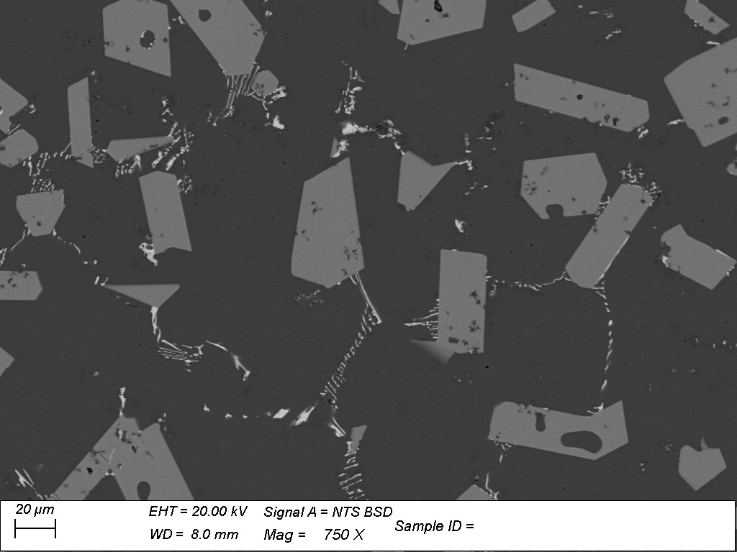
Fig. 13 Microstructure of sample I
Fig. 14 Microstructure of sample J

