Table S1 Cluster membership formed using hierarchical clustering and K means clustering for grouping rice varieties
Cluster name | Cluster size | Genotypes
I | 6 | CO 51, Improved White Ponni, WGL 20471, Jeeragasamba, ADT 41 and VGD 1
II | 17 | Improved Samba Mahsuri, RNR 15048, WGL 32100, MDU 6, ASD 16, ADT 37, TKM 13, Improved Pusa Basmati, JGL 3844, Sona Mahsuri, ADT 49, CO 52, NLR 34449, CR Dhan 310, CB 13543, CB 14740, Kodai

Table S2 Analysis of variance for combining ability for grain quality traits
Source of Variation | Mean squares
Source of Variation | df | HP | MP | HRR | KL | KB | KLBR | KLAC | LER | AC | GC | ASV
Crosses | 20 | 31.774** | 32.107** | 29.257** | 1.554** | 0.116** | 0.704** | 1.705** | 0.083** | 6.239** | 266.553** | 0.231**
Lines | 6 | 43.656* | 36.571 | 39.996** | 2.171** | 0.309** | 1.149** | 3.183* | 0.105 | 10.998* | 268.105 | 0.543**
Testers | 2 | 87.746** | 103.107** | 62.296* | 5.117** | 0.055 | 1.917** | 1.556** | 0.154 | 4.130* | 304.587 | 0.116
L×T interaction | 12 | 16.504** | 18.042** | 18.382** | 0.652** | 0.030** | 0.280** | 0.990** | 0.059** | 4.212** | 259.439** | 0.094**
Error | 40 | 0.089 | 0.195 | 0.289 | 0.022 | 0.001 | 0.008 | 0.013 | 0.002 | 0.099 | 3.069 | 0.030

** Significant at 1 % level, * Significant at 5 % level
HP - Hulling percentage, MP - Milling percentage, HRR - Head rice recovery, KL - Kernel length, KB - Kernel breadth,
KLBR - Kernel L/B ratio, KLAC - Kernel length after cooking, LER - Linear elongation ratio, AC - Amylose content,
GC - Gel consistency, ASV - Alkali spreading value

Table S3 Magnitude of genetic variance for grain quality traits
Characters | σ² GCA | σ² SCA | σ² A | σ² D | σ² A : σ² D
Hulling percentage | 0.40 | 15.09 | 0.80 | 15.09 | 0.053
Milling percentage | 0.37 | 16.26 | 0.74 | 16.26 | 0.046
Head rice recovery | 0.28 | 12.40 | 0.56 | 12.40 | 0.045
Kernel length | 0.02 | 0.80 | 0.04 | 0.80 | 0.050
Kernel breadth | 0.002 | 0.04 | 0.004 | 0.04 | 0.100
Kernel L/B ratio | 0.01 | 0.33 | 0.02 | 0.33 | 0.061
Kernel length after cooking | 0.02 | 0.57 | 0.04 | 0.57 | 0.070
Linear Elongation Ratio | 0.0006 | 0.03 | 0.0012 | 0.03 | 0.040
Amylose content | 0.05 | 1.95 | 0.10 | 1.95 | 0.051
Gel consistency | 0.19 | 91.16 | 0.38 | 91.16 | 0.004
Alkali spreading value | 0.004 | 0.07 | 0.008 | 0.07 | 0.114

σ²GCA - Variance due to GCA, σ²SCA - Variance due to SCA, σ²A - additive genetic variance, σ²D - dominance genetic variance

Table S4 Mean performance of parents for grain quality traits
Parents | HP (%) | MP  (%) | HRR  (%) | KL  (mm) | KB  (mm) | KLBR | KLAC  (mm) | LER | AC (%) | GC  (mm) | ASV
Lines
RNR 15048 | 72.11 | 63.06 | 56.20 | 5.15 | 1.42** | 3.62** | 6.61 | 1.48 | 20.88 | 86.67* | 3.00
ADT 37 | 77.68** | 72.52** | 55.05 | 4.64 | 2.34 | 1.99 | 7.31 | 1.79** | 23.59** | 81.67 | 3.00
WGL 20471 | 70.73 | 62.06 | 54.43 | 5.57 | 1.84 | 3.02 | 6.65 | 1.38 | 22.82** | 98.00** | 3.00
MDU 6 | 82.57** | 75.37** | 58.53** | 6.83** | 1.97 | 3.46** | 8.52** | 1.39 | 20.45 | 71.00 | 6.00**
CO 51 | 80.08** | 70.81** | 56.49** | 5.79* | 1.83 | 3.16 | 6.92 | 1.37 | 20.05 | 93.33** | 4.00**
I. Samba Mahsuri | 72.69 | 64.54 | 55.40 | 5.71 | 1.63** | 3.50** | 6.99 | 1.40 | 20.32 | 80.00 | 3.00
I. White Ponni | 76.23* | 66.43 | 55.31 | 5.75 | 1.91 | 3.02 | 8.18** | 1.59** | 21.87** | 86.00 | 2.00
Mean | 76.01 | 67.83 | 55.92 | 5.64 | 1.85 | 3.11 | 7.31 | 1.49 | 21.43 | 85.24 | 3.43
Sed | 0.11 | 0.17 | 0.21 | 0.06 | 0.02 | 0.03 | 0.05 | 0.02 | 0.12 | 0.67 | 0.07
CD (0.05) | 0.22 | 0.34 | 0.42 | 0.12 | 0.04 | 0.06 | 0.10 | 0.04 | 0.24 | 1.35 | 0.14
CD (0.01) | 0.30 | 0.46 | 0.57 | 0.16 | 0.05 | 0.08 | 0.14 | 0.05 | 0.32 | 1.81 | 0.19
Testers
J. samba | 73.96** | 63.49 | 56.26** | 4.07 | 1.71** | 2.38 | 5.12 | 1.50 | 20.61 | 76.33 | 3.00
ADT 41 | 74.34** | 64.84** | 53.64 | 7.08** | 1.85 | 3.84** | 8.92** | 1.40 | 20.42 | 93.67** | 4.00**
VGD 1 | 72.85 | 63.37 | 56.34** | 4.24 | 1.71** | 2.48 | 5.87 | 1.62** | 21.05** | 77.33 | 3.00
Mean | 73.71 | 63.90 | 55.41 | 5.13 | 1.76 | 2.90 | 6.63 | 1.51 | 20.70 | 82.44 | 3.33
Sed | 0.08 | 0.11 | 0.14 | 0.04 | 0.01 | 0.02 | 0.03 | 0.01 | 0.08 | 0.44 | 0.04
CD (0.05) | 0.16 | 0.22 | 0.28 | 0.08 | 0.02 | 0.04 | 0.06 | 0.02 | 0.16 | 0.89 | 0.08
CD (0.01) | 0.22 | 0.30 | 0.38 | 0.11 | 0.03 | 0.05 | 0.08 | 0.03 | 0.22 | 1.19 | 0.11
** Significant at 1 % level, *Significant at 5% level

Table S5 Mean performance of hybrids for grain quality traits
Crosses | HP (%) | MP (%) | HRR (%) | KL (mm) | KB (cm) | KLBR | KLAC (mm) | LER | AC (%) | GC (mm) | ASV
RNR 15048 × J .samba | 82.86** | 72.85** | 55.20 | 5.82 | 1.85** | 3.15** | 6.60 | 1.31 | 20.93 | 76.00 | 3.00
RNR 15048 × ADT 41 | 72.51 | 64.65 | 55.26 | 6.36** | 1.82** | 3.49** | 7.14 | 1.28 | 20.05 | 97.00** | 3.00
RNR 15048 × VGD 1 | 80.41** | 71.15** | 62.94** | 5.86 | 1.73** | 3.39** | 6.46 | 1.28 | 22.48** | 92.00** | 2.00
ADT 37× J. samba | 81.41** | 73.60** | 57.17 | 4.95 | 2.36 | 2.10 | 6.24 | 1.46 | 23.57** | 68.67 | 3.00
ADT 37 × ADT 41 | 75.56 | 69.18 | 57.54 | 6.10** | 2.15 | 2.84 | 7.61** | 1.41 | 20.75 | 95.00** | 3.00
ADT 37 × VGD 1 | 79.12** | 74.58** | 57.77* | 5.08 | 2.55 | 1.99 | 7.93** | 1.76** | 23.98** | 70.33 | 5.00**
WGL 20471 × J. samba | 78.79** | 70.30** | 63.44** | 6.20** | 1.94 | 3.20** | 7.18 | 1.32 | 20.32 | 73.67 | 4.00**
WGL 20471 × ADT 41 | 76.22 | 67.56 | 54.43 | 6.41** | 1.85** | 3.46** | 8.19** | 1.44 | 22.74** | 70.67 | 4.00**
WGL 20471 × VGD 1 | 81.02** | 75.51** | 64.15** | 4.94 | 2.02 | 2.44 | 7.05 | 1.63** | 20.14 | 78.67 | 4.00**
MDU 6 × J. samba | 76.59 | 71.21** | 55.52 | 6.86** | 1.94 | 3.54** | 7.69** | 1.27 | 21.27 | 73.00 | 6.00**
MDU 6 × ADT 41 | 72.29 | 65.56 | 54.49 | 6.82** | 2.04 | 3.34** | 8.76** | 1.43 | 23.89** | 71.33 | 6.00**
MDU 6 × VGD 1 | 71.08 | 65.58 | 57.18 | 5.08 | 2.08 | 2.44 | 7.36** | 1.65** | 23.40** | 78.00 | 5.00**
CO 51 × J. samba | 77.94 | 67.45 | 56.34 | 6.86** | 2.05 | 3.35** | 7.41** | 1.23 | 22.82** | 92.33** | 6.00**
CO 51 × ADT 41 | 78.46** | 69.56 | 55.44 | 6.40** | 1.92 | 3.33** | 7.68** | 1.36 | 23.02** | 88.67** | 5.00**
CO 51 × VGD 1 | 75.52 | 70.36** | 59.48** | 5.92 | 1.83** | 3.24** | 7.20 | 1.39 | 23.70** | 71.00 | 4.00**
I. Samba Mahsuri × J. samba | 78.89** | 69.25 | 55.68 | 4.82 | 1.90* | 2.54 | 7.52** | 1.77** | 20.78 | 73.33 | 3.00
I. Samba Mahsuri × ADT 41 | 75.09 | 65.29 | 57.10 | 5.33 | 1.75** | 3.04** | 6.17 | 1.35 | 20.21 | 72.00 | 3.00
I. Samba Mahsuri × VGD 1 | 74.85 | 65.14 | 55.19 | 4.90 | 1.84** | 2.66 | 6.27 | 1.49* | 20.20 | 79.67 | 3.00
I. White Ponni × J. samba | 80.44** | 72.28** | 54.48 | 5.10 | 1.94 | 2.63 | 6.15 | 1.40 | 20.28 | 82.00* | 2.00
I. White Ponni × ADT 41 | 78.18** | 66.51 | 52.78 | 6.43** | 1.82** | 3.54** | 6.32 | 1.14 | 21.00 | 91.00** | 4.00**
I. White Ponni × VGD 1 | 81.29** | 70.64 | 54.41 | 5.17 | 1.93 | 2.68 | 6.12 | 1.38 | 22.08 | 70.33 | 2.00
Mean | 77.55 | 69.44 | 56.95 | 5.78 | 1.97 | 2.97 | 7.10 | 1.42 | 21.79 | 79.27 | 3.81
SEd | 0.20 | 0.29 | 0.36 | 0.10 | 0.03 | 0.02 | 0.08 | 0.03 | 0.21 | 1.17 | 0.04
CD (0.05) | 0.40 | 0.59 | 0.73 | 0.20 | 0.06 | 0.04 | 0.16 | 0.06 | 0.42 | 2.36 | 0.08
CD (0.01) | 0.54 | 0.78 | 0.97 | 0.27 | 0.08 | 0.05 | 0.22 | 0.08 | 0.57 | 3.16 | 0.11
** Significant at 1 % level, *Significant at 5% level
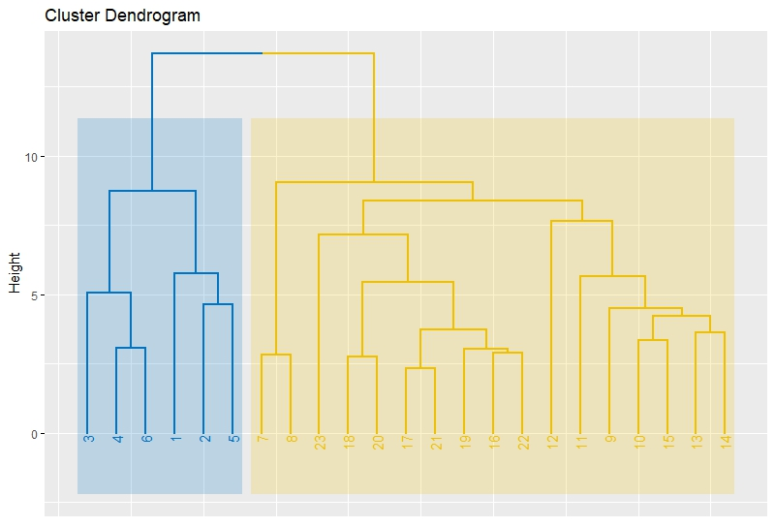
Fig. S1 Dendrogram formed using hierarchical clustering for 23 rice varieties

Fig. S2 Plot formed using K means clustering of rice genotypes
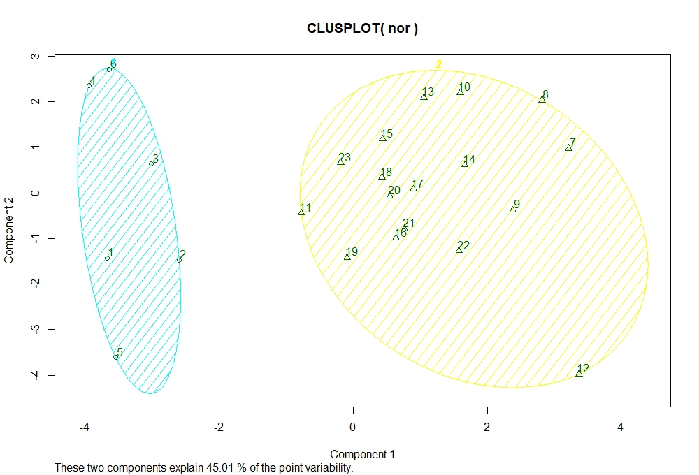

Fig. S3 Shape of unhulled rice varieties, Improved White Ponni, Jeeragasamba and their F₁
