Benchmark source
Medical Information Mart for Intensive Care IV (MIMIC IV) version 2.2 is a publicly available hospital database containing over 65,000 de-identified patient records from the Beth Israel Deaconess Medical Center in Boston [1-2]. Over 13 tables were used for this analysis, including “admissions_table”, “d_icd_diagnoses”, “d_icd_procedures”, “d_labitems”, “diagnoses_icd”, “drgcodes”, “hpcsevents”, “labevents”, “patients_table”, “ICU_stays” and “datetimeevents”.

Cohort selection in benchmark source
Eligible patients with HF were identified based on principal diagnostic information and selected according to the following inclusion and exclusion criteria:
- Patients are eligible if they were
  - first ever diagnosed with cardiovascular disease on inpatient hospital admission with ICD-10 code I50 during 2008-2019 (the index stay).
  - aged 18 years and over who were alive beyond the selected window of days after the first HF hospital separation
  - readmitted is unplanned
- Patients were excluded if they:
  - died during the index hospital episode of care or within vulnerable period after discharged from the index hospital admission.
  - identified their gender other than females or males.
  - contained records with invalid or missing medical coding or temporal information
  - readmitted for planned hospital services

Group definition and Outcome ascertainment in benchmark source
As date and times were shifted randomly into the future using an offset measured in days in MIMIC, yet the data for a single patient are internally consistent [1]. Eligible participants were categorized into three groups:
- within 30 days (early vulnerable period)
- 30 to 90 days (intermediate vulnerable period)
- 90 to 180 days (late vulnerable period).
Patients with HF who have at least one subsequent all-cause hospitalization within the selected window have been identified into readmission group. Non-readmitted patients were defined as those who had no subsequent hospital revisits but were alive for at least a year. Age and sex often served as confounding factors in comparisons. Therefore, the matched non-readmission group was extracted at a case-to-control ratio of 1:2.

Table S1. Assessment results of MIMIC IV version 2.0 data source quality.
Dimension | Assessment results
Currency | MIMIC IV contained all medical record numbers corresponding to patients admitted to an ICU or the emergency department between 2008-2019. However, to balance public utilisation and ethical configuration, the date and times were shifted randomly into the future using an offset measured in days. The data for a single patient are internally consistent yet is incomparable cross the people [1-2].
Completeness | One of the challenges in studying unplanned hospital readmissions is that a patient is likely to be readmitted to a different hospital, which may not be captured by a single hospital's information system. Based on the Bureau of health information June 2015 to June 2018 report, 18% of heart failure patients readmitted to a different hospital in Australia [3]. MIMIC is a single-site hospital database at Beth Israel Deaconess Medical Center (BIDMC). Consequently, readmissions following a patient's first heart failure stay at the index hospital tend to be underestimated, potentially leading to biased conclusions.  Patients’ records have been linked to state death registration to acquire in-hospital and one-year mortality, which provides survival information. The collection in this data set contained de-identified patient-level EHR from emergency, inpatient and outpatient hospital visits, which included information on various aspects of patient cares, e.g. diagnoses, family history, and clinical pathology.
Correctness | Data are acquired from the BIDMC data warehouse. To support analysis, additional information has been further acquired and calculated from external resources (e.g. ICD code labelling, Charlson Comorbidity Index, SOFA index). Data have been than merge and stored at SQL database to enable enquiry. The extraction was done in a cooperation team with multidisciplinary background [4].
Concordance | In MIMIC, data transformation was performed using a single, reproducible build script. The data integrity, consistency, and deidentification has been assessed during validation process. Unit tests were implemented to apply these checks during development. Integrity checks ensured the structural consistency of the database, revealing a 1% inconsistency in the icustays table[4].  Kurniati et al. assessed the consistency of patients’ information by investigating data element agreement which compared two or more elements in the database to see if they report the same or compatible information[5]. They noted that prescription table and admission table have different temporal granularity, where all prescriptions were only recorded with time 00:00 in the prescriptions table.
Plausibility | In 2019, Kurniati et al. conducted validity check of MIMIC by querying data in each table and between related tables [5]. Duplication and missing diagnosis or procedure coding labels (i.e. d_icd_diagnoses and d_icd_procedures) were two key issues impact plausibility identified from their study. They noted that “there are duplicates between different tables, such as datetimeevents and admissions table, labevents and chartevents tables.”

Table S2. Baseline characteristics of patients with heart failure by readmission group in MIMIC.
Baseline characteristics | Early vulnerable period  (30-day group) |  | Intermediate vulnerable period  (90-day group) |  | Late vulnerable period  (180-day group)
Baseline characteristics | Readmission group | Comparison group | Readmission group | Comparison group | Readmission group | Comparison group
Patient, n (%)
Females | 28  (28.3%) | 56  (28.3%) | 44  (29.7%) | 88  (29.7%) | 61  (34.1%) | 122  (34.1%)
Males | 71  (71.7%) | 142  (71.7%) | 104  (70.3%) | 208  (70.3%) | 118  (65.9%) | 236  (65.9%)
Age Group, n (%)
18-59 | 22  (22.2%) | 44  (22.2%) | 37  (25.0%) | 74  (25.0%) | 44  (24.6%) | 88  (24.6%)
60-69 | 24  (24.2%) | 48  (24.2%) | 31  (20.9%) | 62  (20.9%) | 39  (21.8%) | 78  (21.8%)
70-79 | 30  (30.3%) | 60  (30.3%) | 42  (28.4%) | 84  (28.4%) | 48  (26.8%) | 96  (26.8%)
80-89 | 14  (14.1%) | 28  (14.1%) | 22  (14.9%) | 44  (14.9%) | 26  (14.5%) | 52  (14.5%)
90+ | 9  (9.1%) | 18  (9.1%) | 16  (10.8%) | 32  (10.8%) | 22  (12.2%) | 44  (12.2%)
Charlson comorbidity score, mean (std) | 7.3  (2.78) | 6.7  (2.59) | 7.1  (2.65) | 6.7  (2.63) | 7.0  (2.63) | 6.7  (2.39)
Hospital length of stay in days, mean (std) | 10.0  (10.57) | 7.8  (7.98) | 9.1  (9.94) | 7.2  (6.69) | 8.0  (7.90) | 7.2  (6.21)
270-day restricted mean survival time, days | 207.0 | 223.7 | 215.9 | 233.4 | 218.3 | 231.8
Laboratory findings
Troponin T (ng/L),  median (std) | 15.6  (27.01) | 25.3  (74.5) | 13.1  (22.90) | 32.1  (146.4) | 19.0  (39.59) | 16.9  (47.14)
Nt-ProBNP Levels (pg/mL), median (std) | 7665.8  (9265.01) | 7428.9  (8346.42) | 6205.0  (7138.68) | 5971.6  (9299.2) | 6442.0  (7767.74) | 6955.2  (8711.63)
Note: The sum of the proportions in the table may not equal 100.0% due to cell rounding.
Table S3. Baseline characteristics and event log quality of Sepsis log from a Dutch hospital [6-7].
Measure | Sepsis log
Total number of events | 15,214
Baseline log characteristics
Total number of process instances | 846
Total number of event classes | 16
Event per case,  Median (min, max) | 13 (3,185)
Average trace length | 14.49
Event quality
Species Richness (D0) | 16
Expected Shannon Entropy (D1) | 11.5
Inverse Simpson Diversity (D2) | 10.8
Completeness (C0) | 100%
Coverage(C1) | 100%

Table S4. Concept-level entity-relationship (E-R) diagram of the DREAM database.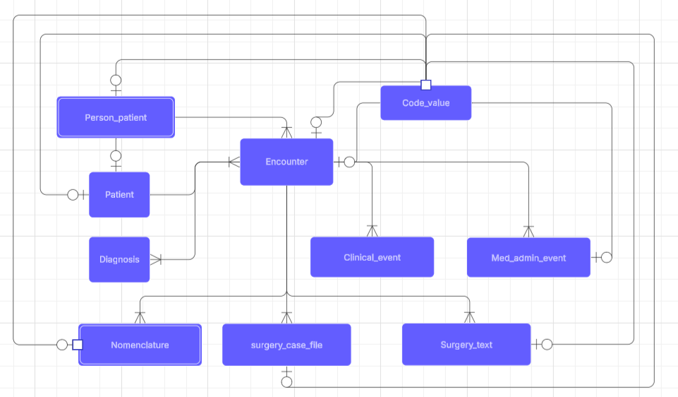

References
- Johnson, A., Bulgarelli, L., Pollard, T., Horng, S., Celi, L. A., & Mark, R. (2023a). MIMIC-IV (version 2.2). PhysioNet. https://doi.org/10.13026/6mm1-ek67.
- Johnson, A.E.W., Bulgarelli, L., Shen, L. et al. MIMIC-IV, a freely accessible electronic health record dataset. Sci Data 10, 1 (2023b). https://doi.org/10.1038/s41597-022-01899-x
- The Bureau of health information. Readmission and returns to acute care following hospitalisation for eight clinical conditions. Sydney(AU);17 June 2020.
- Johnson AE, Bulgarelli L, Shen L, Gayles A, Shammout A, Horng S, Pollard TJ, Hao S, Moody B, Gow B, Lehman LW. MIMIC-IV, a freely accessible electronic health record dataset. Scientific data. 2023 Jan 3;10(1):1.
- Kurniati AP, Rojas E, Hogg D, Hall G, Johnson OA. The assessment of data quality issues for process mining in healthcare using Medical Information Mart for Intensive Care III, a freely available e-health record database. Health informatics journal. 2019 Dec;25(4):1878-93.
- Mannhardt F, Blinde D. Analyzing the trajectories of patients with sepsis using process mining. InRADAR+ EMISA 2017 2017 (pp. 72-80). CEUR-ws. org. doi:10.4121/uuid:915d2bfb-7e84-49ad-a286-dc35f063a460.
- Kabierski M, Richter M, Weidlich M. Quantifying and relating the completeness and diversity of process representations using species estimation. Information Systems. 2025 Apr 1;130:102512.

