HIPK2 exhibits context dependent dualistic effects and combinatorial inhibition of HIPK2-NLK-MAPK11 axis manifests synergism against gastric cancer.
Aathithya Rangarajan ª, Thirumoorthi Natarajan ^{b}, Sujatha Lakshminarayanan ^{b} , Shirley Sunder Singh ^{c}, Jayavelu Subramani ª, Priya Ramanathan ª ,Ramakrishnan Ayloor Seshadri^{d}, Gopal Gopisetty*ª
Supplementary Fig.1
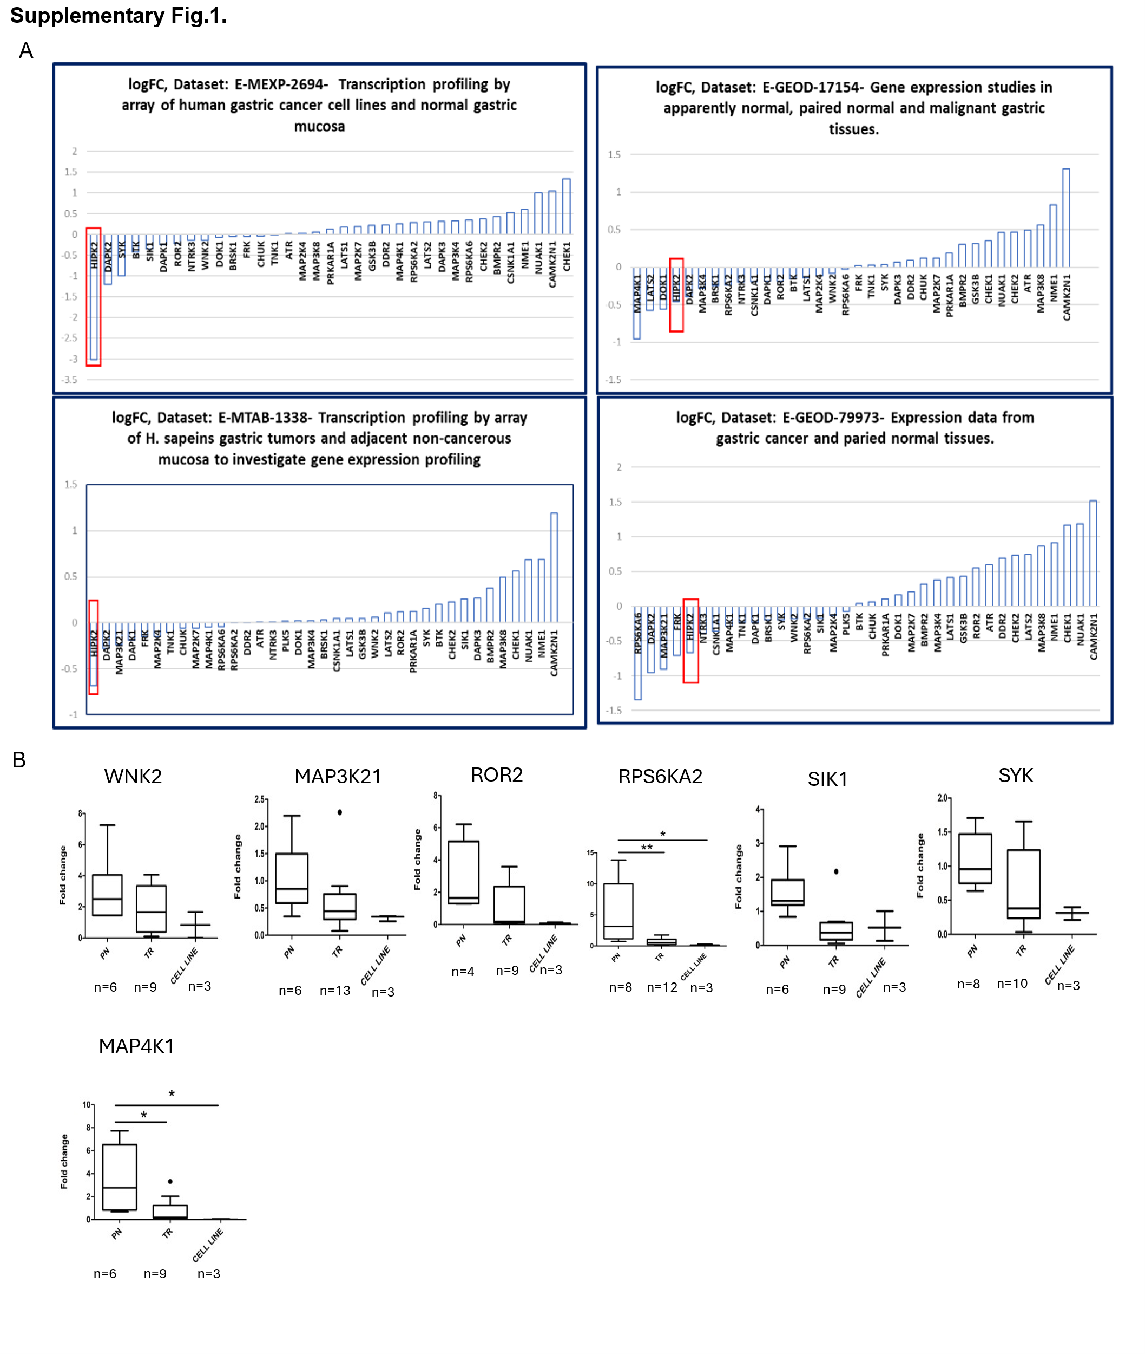

Supplementary Fig.1(A) HIPK2 expression was found to be downregulated in Four datasets derived using different gene expression analysis platforms :(E-MEXP-2694-Agilent array, E-GEOD-17154- Stanford array, E-MTAB-1338- Illumina HumanHT-12 V4.0 expression beadchip- Transcription profiling by array, E-GEOD-79973-Affymatrix Expression array.(B) Validation of downregulated tumour suppressor kinases by quantitative real-time PCR. Fold change was determined relative to apparent normal samples. PN: paired normal; TR: tumour tissues. Asterisks indicate statistical significance between PN and TR/cell lines (p<0.05-*, p<0.01-**).
Supplementary Table.1:
E-GEOD-17154 | E-GEOD-79973 | E-MTAB-1338 | E-MEXP-2694
HIPK2 | RPS6KA6 | HIPK2 | HIPK2
MAP4K1 | DAPK2 | DAPK2 | DAPK2
DAPK2 | MAP3K21 | MAP3K21 | SYK
BRSK1 | FRK | DAPK1 | BTK
NTRK3 | HIPK2 | FRK | SIK1
DAPK1 | NTRK3 | MAP2K4 | DAPK1
ROR2 | CSNK1A1 | TNK1 | ROR2
LATS1 | MAP4K1 | CHUK | NTRK3
MAP2K4 | TNK1 | MAP2K7 | WNK2
RPS6KA2 | DAPK1 | MAP4K1 | DOK1
WNK2 | BRSK1 | RPS6KA6 | BRSK1
RPS6KA6 | SYK | RPS6KA2 | FRK
 | WNK2 | DDR2 | CHUK
 | RPS6KA2 |  | TNK1
 | SIK1
 | MAP2K4
 | PLK5

Supplementary Table.1: Downregulated kinases in Four datasets derived using different gene expression analysis platforms.

Supplementary Fig.2
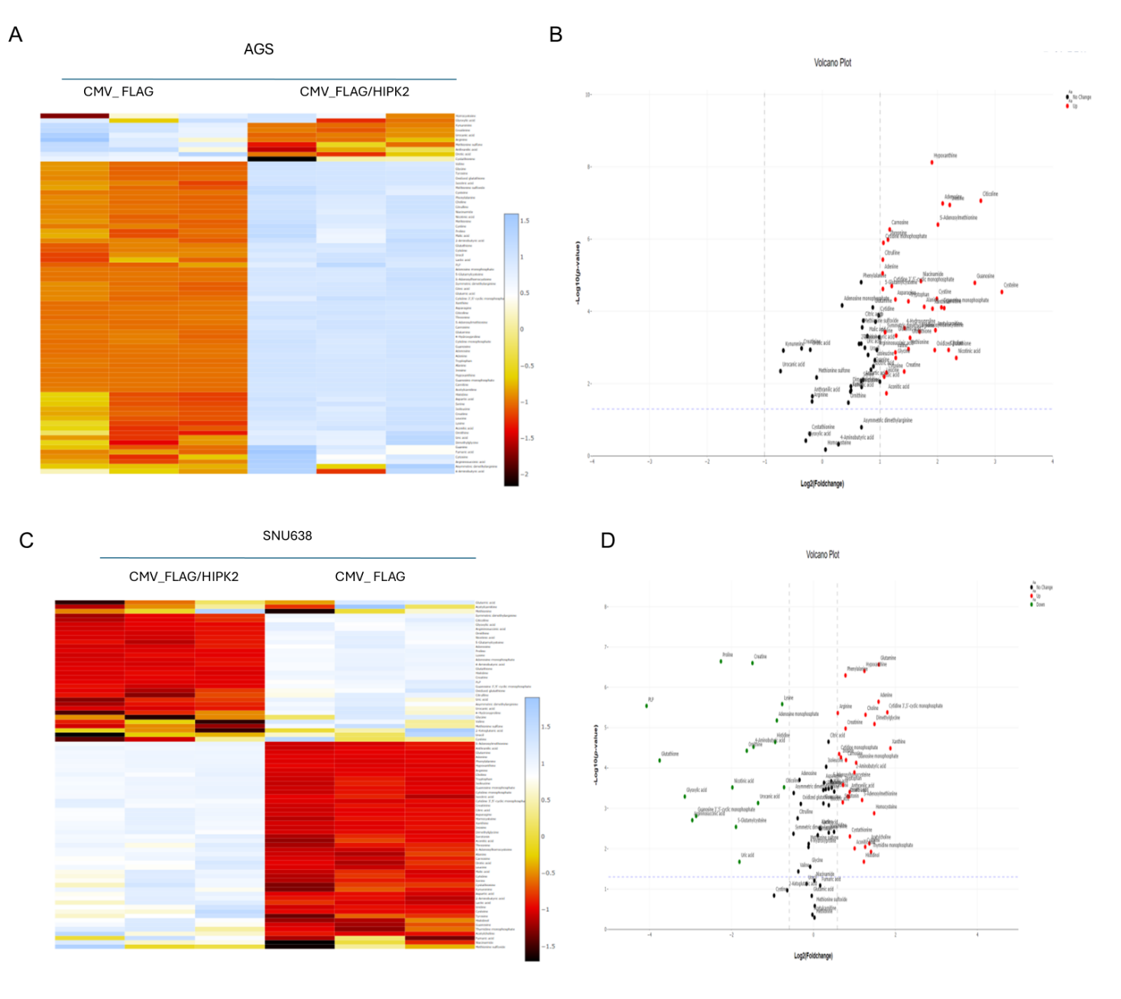Supplementary Fig.2 HIPK2 expression induces differential response in the metabolite’s levels in AGS and SNU638 cells. After 48 hrs of transient transfection, 1x10^6 cells of FLAG/FLAG HIPK2 transfected AGS and SNU638 cells were analysed for 143 metabolomic components by LC-MS based targeted metabolomics. (A-D) Heat map and volcano plot for metabolites which shows significant changes in FLAG-HIPK2 when compared to FLAG control in AGS and SNU638 cells.
Supplementary Table.2:
S.no | AGS METABOLITES | P-value | Log2(Foldchange) | Standard deviation
 | AMINO ACID/PEPTIDES/AMINO ACID DERIVATIVES
1 | 4-Hydroxyproline | 0.000288 | 1.42 | 0.035
2 | Alanine | 7.43E-05 | 1.76 | 0.024
3 | Asparagine | 4.65E-05 | 1.26 | 0.011
4 | Carnitine | 8.08E-05 | 2.11 | 0.027
5 | Citrulline | 3.68E-06 | 1.05 | 0.029
6 | Cysteine | 2.89E-05 | 3.11 | 0.081
7 | Cystine | 4.45E-05 | 1.98 | 0.093
8 | Glutamic acid | 0.000469 | 1.28 | 0.038
9 | 5-Glutamylcysteine | 2.39E-05 | 1.05 | 0.017
10 | Glycine | 0.001925 | 1.27 | 0.064
11 | Leucine | 0.006395 | 1.07 | 0.095
12 | Methionine | 0.001098 | 1.49 | 0.083
13 | S-Adenosylhomocysteine | 0.00036 | 1.69 | 0.032
14 | S-Adenosylmethionine | 3.95E-07 | 2.00 | 0.024
15 | Symmetric dimethylarginine | 0.000377 | 1.09 | 0.044
16 | Threonine | 1.03E-06 | 1.14 | 0.019
17 | Tryptophan | 5.24E-05 | 1.49 | 0.016
18 | Valine | 0.00136 | 1.26 | 0.065
19 | Oxidized glutathione | 0.001171 | 1.95 | 0.069
20 | Glutathione | 0.000536 | 1.52 | 0.065
21 | Glutamine | 7.74E-05 |  | 0.012
  0.87
S.no | AGS METABOLITES | P-value | Log2(Foldchange) | Standard deviation
22 | Carnosine | 5.39E-07 | 1.17 | 0.017
 | LIPID
23 | Acetylcarnitine | 0.000329 | 1.96 | 0.042
 | ORGANIC ACID
24 | Aconitic acid | 0.018436 | 1.11 | 0.156
25 | Creatine | 0.004594 | 1.42 | 0.110
26 | Nicotinic acid | 0.00193 | 2.32 | 0.129
 | CHOLINE
27 | Choline | 0.001162 | 2.19 | 0.107
 | NUCLEOSIDE/NUCLEOTIDE/PURINE DERIVATIVES
28 | Adenine | 8.79E-06 | 1.04 | 0.008
29 | Adenosine | 1.03E-07 | 2.09 | 0.021
30 | Citicoline | 8.64E-08 | 2.75 | 0.019
31 | Cytidine 3',5'-cyclic monophosphate | 1.98E-05 | 1.20 | 0.050
32 | Cytidine monophosphate | 1.26E-06 | 1.06 | 0.022
33 | Cytosine | 0.00492 | 1.11 | 0.189
34 | Guanosine | 1.61E-05 | 2.64 | 0.017
35 | Guanosine monophosphate | 7.68E-05 | 2.06 | 0.024
36 | Hypoxanthine | 7.49E-09 | 1.90 | 0.011
37 | Inosine | 1.13E-07 | 2.21 | 0.009
38 | Xanthine | 8.39E-05 | 1.91 | 0.023
 | VITAMIN
39 | Niacinamide | 1.44E-05 | 1.71 | 0.065
Supplementary Table.2: Metabolites which exhibits significant fold change upon HIPK2 transient ectopic expression (48hrs) in AGS cells analysed with LC-MS.
Supplementary Table.3:
S.no | SNU638 METABOLITES | P-value | Log2(Foldchange) | Standard Deviation
 | AMINO ACID/PEPTIDES/AMINO ACID DERIVATIVES
1 | 2-Aminobutyric acid | 0.000128572 | 0.99 | 0.0617
2 | 4-Aminobutyric acid | 2.98E-05 | -1.46 | 0.045
3 | 5-Glutamylcysteine | 0.002879623 | -1.89 | 0.143
4 | Arginine | 4.33E-06 | 0.59 | 0.009
5 | Aspartic acid | 0.000502169 | 0.83 | 0.040
6 | Cystathionine | 0.004954202 | 0.88 | 0.139
7 | Carnosine | 6.35E-05 | 0.79 | 0.042
8 | Cysteine | 0.008985554 | 1.26 | 0.122
9 | Dimethylglycine | 8.12E-06 | 1.48 | 0.048
10 | Glutamine | 2.72E-07 | 1.59 | 0.015
11 | Glutathione | 6.50E-05 | -3.75 | 0.042
12 | Histidine | 2.26E-05 | -0.93 | 0.015
13 | Histidinol | 0.020978309 | 1.23 | 0.210
S.no | SNU638 METABOLITES | P-value | Log2(Foldchange) | Standard Deviation
14 | Homocysteine | 0.001322719 | 1.48 | 0.094
15 | Leucine | 0.000324 | 0.36 | 0.023
16 | Lysine | 2.61E-06 | -0.76 | 0.017
17 | Ornithine | 3.73E-05 | -1.62 | 0.054
18 | Phenylalanine | 5.07E-07 | 0.78 | 0.010
19 | Proline | 2.28E-07 | -2.25 | 0.027
20 | S-Adenosylmethionine | 0.000621672 | 1.18 | 0.045
21 | Serotonin | 0.000708271 | 0.71 | 0.048
22 | Tryptophan | 0.000263334 | 0.72 | 0.024
 | LACTAM
23 | Creatinine | 1.05E-05 | 0.78 | 0.028
 | ORGANIC ACID
24 | Aconitic acid | 0.009839999 | 1.00 | 0.102
25 | Anthranilic acid | 0.000391596 | 0.88 | 0.025
26 | Argininosuccinic acid | 0.001963036 | -2.95 | 0.179
27 | Creatine | 2.51E-07 | -1.48 | 0.020
28 | Glyoxylic acid | 0.00050954 | -3.13 | 0.150
29 | Nicotinic acid | 0.000302673 | -1.97 | 0.094
30 | Orotic acid | 0.000508533 | 0.86 | 0.077
31 | Urocanic acid | 0.000736841 | -1.35 | 0.091
 | CO ENZYME
32 | PLP | 2.89E-06 | -4.07 | 0.097
 | CHOLINE
33 | Acetylcholine | 0.007397657 | 1.36 | 0.142
34 | Choline | 4.79E-06 | 1.27 | 0.036
 | NUCLEOSIDE/NUCLEOTIDE/PURINE DERIVATIVES
35 | Adenine | 2.27E-06 | 1.58 | 0.006
36 | Adenosine monophosphate | 6.62E-06 | -0.89 | 0.020
37 | Citicoline | 0.00030007 | -0.71 | 0.047
38 | Cytidine 3',5'-cyclic monophosphate | 4.17E-06 | 1.80 | 0.050
39 | Cytidine monophosphate | 4.48E-05 | 0.62 | 0.020
40 | Guanosine 3',5'-cyclic monophosphate | 0.001543663 | -2.86 | 0.162
41 | Guanosine monophosphate | 7.41E-05 | 1.04 | 0.029
42 | Hypoxanthine | 3.93E-07 | 1.24 | 0.019
43 | Inosine | 5.44E-05 | 0.67 | 0.019
44 | Thymidine monophosphate | 0.011954134 | 1.40 | 0.265
45 | Uric acid | 0.021101536 | -1.80 | 0.318
46 | Xanthine | 3.25E-05 | 1.87 | 0.056
47 | Guanosine | 0.000754 | 0.24 | 0.025
Supplementary Table.3: Metabolites which exhibits significant fold change upon HIPK2 transient ectopic expression(48hrs) in SNU638 cells analysed with LC-MS.
Supplementary Fig.3
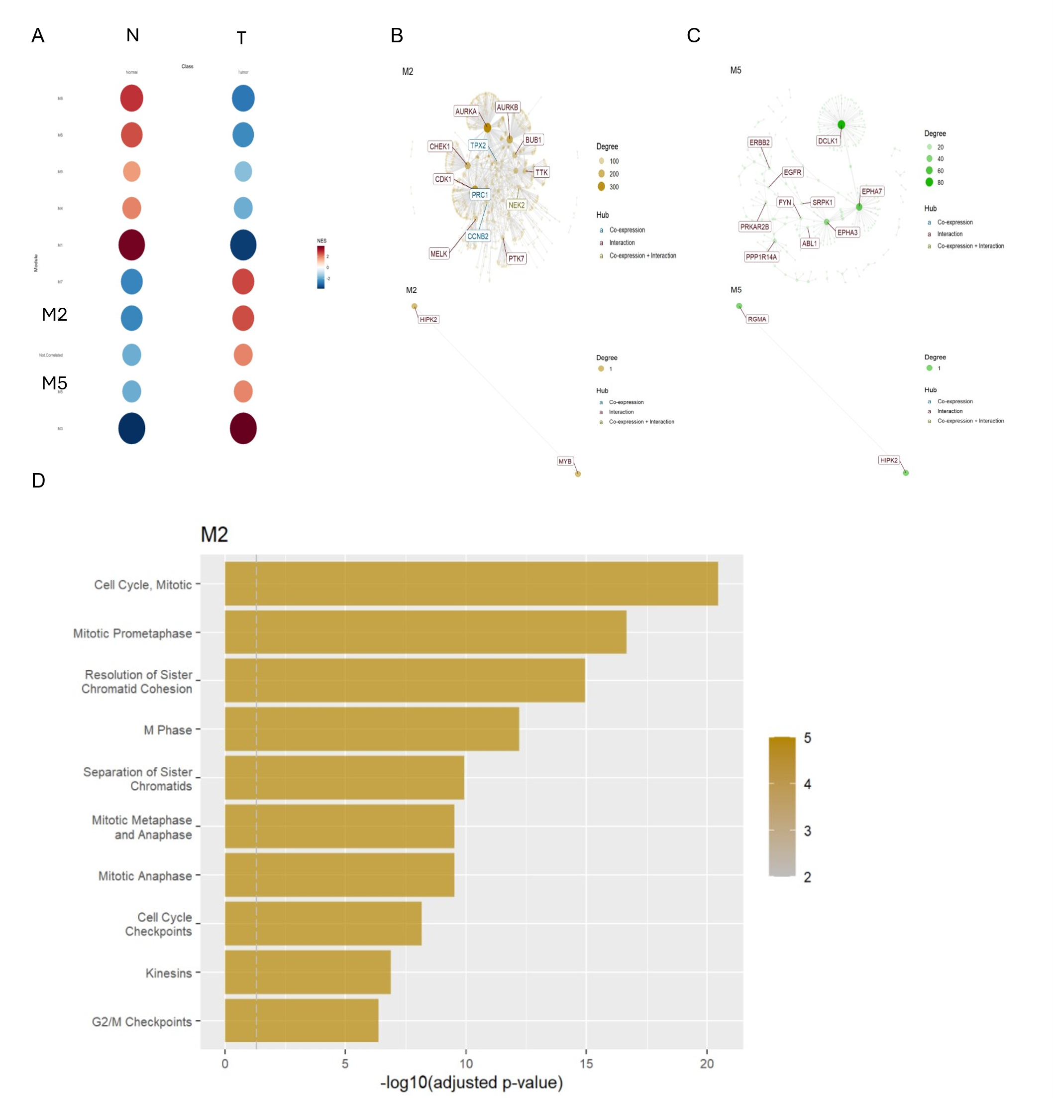
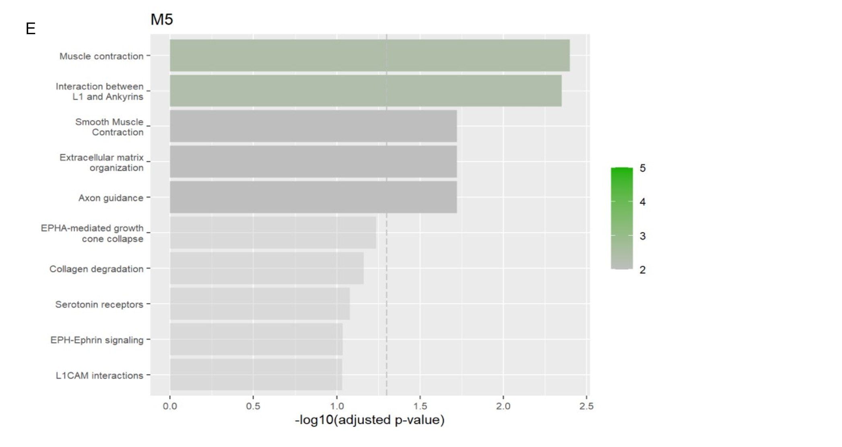Supplementary Fig.3(A-C) Differential gene expression analysis of EGEOD-79973 expression data set comprising of gastric cancer and paired normal tissues. A total of 227 kinase genes were found to have positive Log 2 fold change in gene expression (range = 0.001985 - 2.037072). The gene expression files along with phenotype data were assessed in CEMi tools to identify the gene expression modules differentiating cancer and normal gene expression profiles. The protein-protein interactions for the shortlisted expressed kinase genes and HIPK2 were extracted from PPI database. The interactions were assessed exclusively for the kinase gene set and HIPK2 along with the gene expression and phenotype files. The analysis yielded a subset of interactions by mapping the PPI’s to gene expression. The gene set enrichment analysis revealed 9 modules and HIPK2 interactions mapped to two modules M2 (HIPK2-MYB) and M5 (HIPK2-RGMA),(D-E) Over Representation Analysis of the gene set comprising the module M2 showed that they can affect cell proliferation functions like cell cycle and module M5 showed functions like muscle contraction and interactions between L1 and Ankyrins.

Supplementary Fig.4
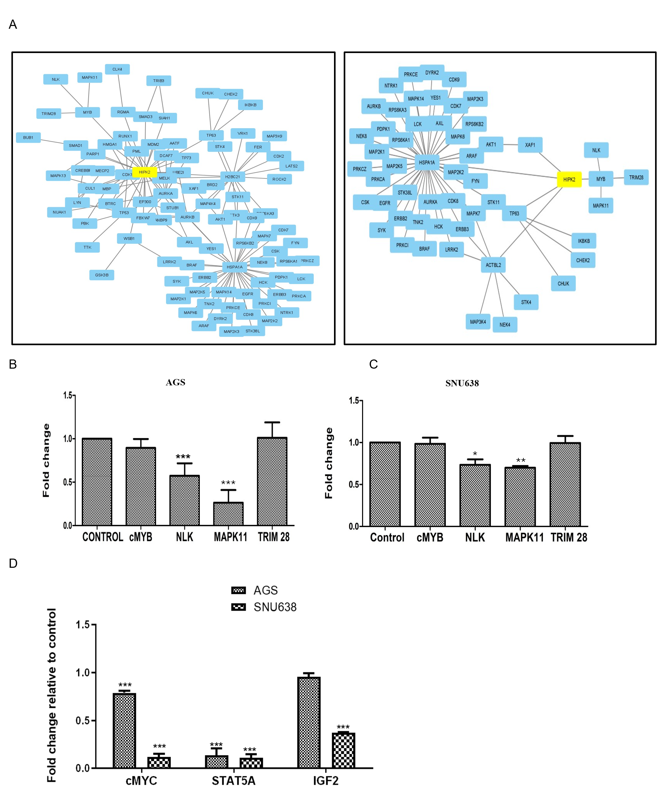
Supplementary Fig.4. (A)CEMi tool analysis from additional Datasets E-MEXP-2694, E-MTAB-1338 also identifies HIPK2- PPI axis comprising HIPK2, NLK, MAPK11 and TRIM28. (B-C) Quantitative real-time PCR analysis showing that ectopic expression of HIPK2 downregulates NLK and MAPK11 gene expression, with no significant changes observed in MYB and TRIM28 levels. “CONTROL” refers to cells transfected with the pCMV3-N-FLAG empty vector. (p<0.05-*,p<0.01-**,p<0.001***). (D)By real time PCR it was determined that ectopic expression of HIPK2 decreases the levels of MYB downstream targets: cMYC, STAT5A, IGF2(p<0.001).
Supplementary Fig.5
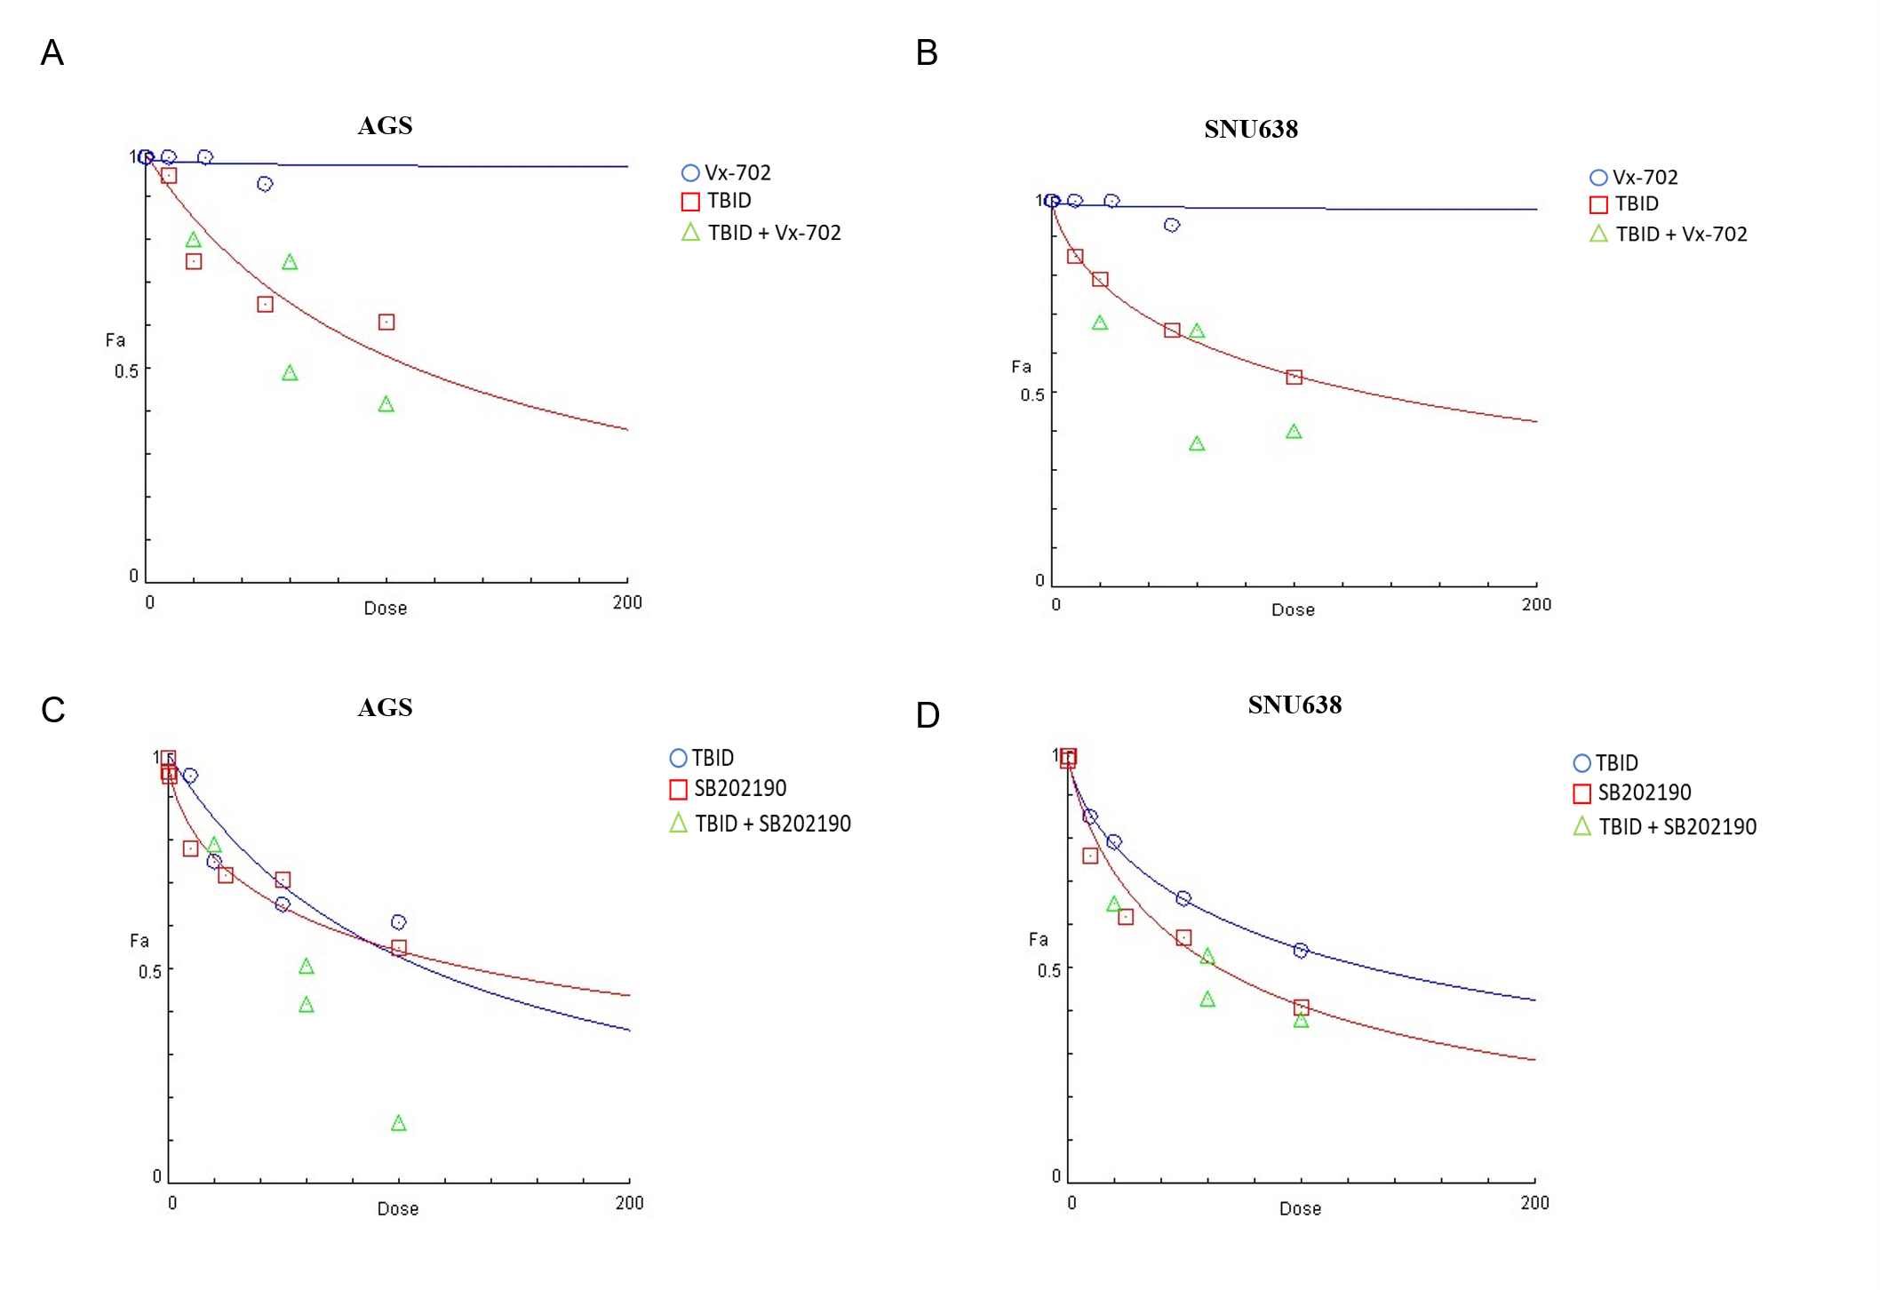
Supplementary Fig.5(A-D)Dose effect curve for the combinations of TBID and SB202190/Vx-702 in AGS and SNU638 cells.

Supplementary Fig.6
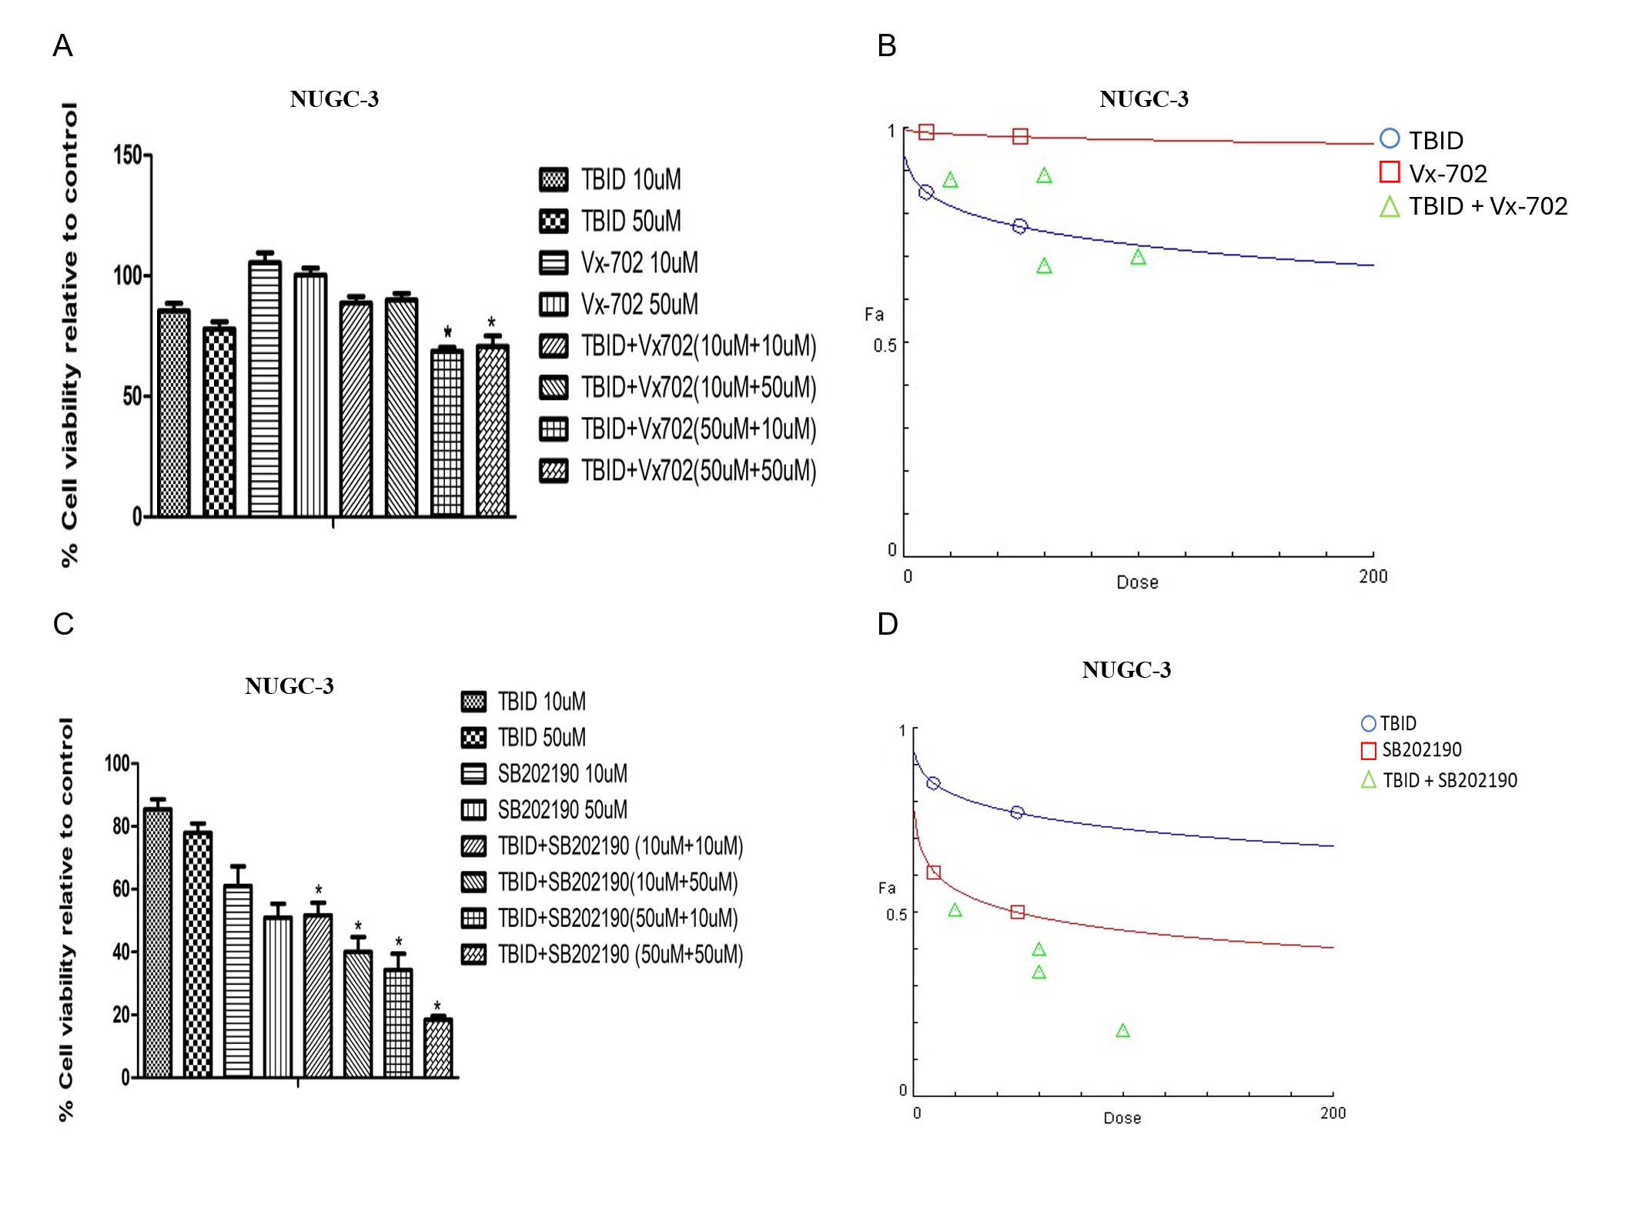Supplementary Fig.6(A,C) For combinatorial inhibitor treatment cell proliferation assay, 2*10^3 NUGC-3 cells were treated with either TBID,Vx-702 ,SB202190 and combinations of TBID and Vx-702/SB202190 inhibitor for 24 hrs and compusyn software was employed to determine whether the combinational treatment exhibits synergy(CI<1), additive(CI=1) and antagonistic(CI>1) effect.”*” indicates synergistic effect.(B,D) Dose effect curve for the combinations of TBID and Vx-702/SB202190 in NUGC-3 cells.
Supplementary Table.4
TBID  (uM) | Vx-702(uM) | % cell viability | CI
10.0 | 10.0 | 88 | 2.20
10.0 | 50.0 | 89 | 2.98
50.0 | 10.0 | 68 | 0.24
50.0 | 50.0 | 70 | 0.33

Supplementary Table.4 CI values for TBID+Vx-702 Inhibitor treated NUGC-3 cells
Supplementary Table.5:
TBID  (uM) | SB202190  (uM) | % cell viability | CI
10.0 | 10.0 | 51 | 0.23
10.0 | 50.0 | 40 | 0.23
50.0 | 10.0 | 34 | 0.02
50.0 | 50.0 | 18 | 0.004
Supplementary Table.5:CI values for TBID+SB202190 Inhibitor treated NUGC-3 cells
Supplementary Fig.7
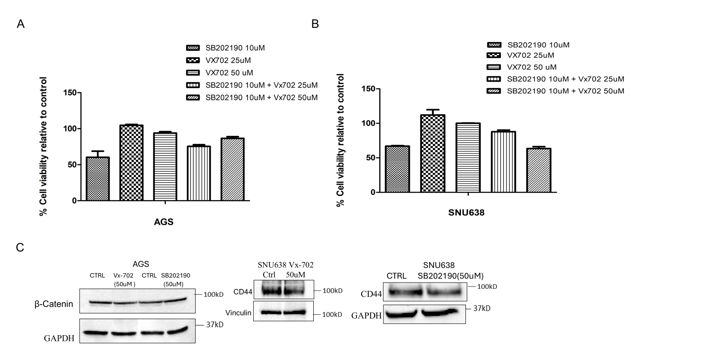

Supplementary Fig.7 (A-B) AGS and SNU638 cells (2 × 10³ cells/well) were treated with SB202190, VX-702, or a combination of both inhibitors. Cell viability was assessed after 72 hours using the AlamarBlue assay. (c) 3 × 10⁵ AGS and SNU638 cells were treated with Vx-702, SB202190 inhibitors for 24 hrs , the protein lysates were analysed for the expression levels of CD44, β catenin by western blotting.
Supplementary Table.6:
Cell line | SB202190 (uM) | Vx-702  (uM) | Effect | CI
AGS | 10.0 | 25.0 | 0.75 | 2.24
AGS | 10.0 | 50.0 | 0.86 | 4.24
SNU638 | 10.0 | 25.0 | 0.87 | 69.70
SNU638 | 10.0 | 50.0 | 0.63 | 3.32

Supplementary Table.6 CI values calculated using Compusyn software for the combinations of SB202190 and Vx-702 inhibitors.

.

