eTable 1. Definitions of the Study Medication, Diagnosis, and Non-pharmacologic Interventions for BPSD.
Diagnosis and Non-pharmacologic Interventions | Definition / Coding system
Alzheimer’s disease | ICD-10: G30
Vascular dementia | ICD-10: F01
Dementia in other diseases classified elsewhere | ICD-10: F02
Unspecified dementia | ICD-10: F03
Alzheimer’s medications
Donepezil | RxNorm: 135447
Rivastigmine | RxNorm: 183379
Galantamine | RxNorm: 4637
Memantine | RxNorm: 6719
Atypical antipsychotics
Olanzapine | RxNorm: 61381
Quetiapine | RxNorm: 51272
Clozapine | RxNorm: 2626
Risperidone | RxNorm: 35636
Aripiprazole | RxNorm: 89013
Ziprasidone | RxNorm: 115698
Asenapine | RxNorm: 784649
Paliperidone | RxNorm: 679314
Iloperidone | RxNorm: 73178
Lurasidone | RxNorm: 1040028
Brexpiprazole | RxNorm: 1658314
Non-pharmacologic interventions
reality orientation | SNOMED: 228547007
art therapy | SNOMED: 65153003
music therapy | SNOMED: 21065008
Activity therapy (≥45 min per session) | HCPCS: G0176
aromatherapy | SNOMED: 394615007
light therapy | SNOMED: 31394004
Individual psychotherapy (Interpersonal) | ICD-10-PCS: GZ53ZZZ / GZ53
Individual psychotherapy (Cognitive) | ICD-10-PCS: GZ52ZZZ / GZ52
Counseling (Cognitive, Interpersonal, Psychoeducation, CBT) | ICD-10-PCS: HZ30, HZ34, HZ36, HZ32, HZ52
Caregiver training (communication skills) | ICD-10-PCS: F0FZJZZ
Dementia management | SNOMED: 386257007
Brain stimulation | SNOMED: 362997005
Cognitive and behavioral therapy | SNOMED: 228557008
Physical exercise therapy | SNOMED: 183301007; ICD-10-PCS: F07H6ZZ
Therapeutic massage | ICD-10-PCS: 8E0KX1Z
Acupuncture (initial 15 min) | CPT: 97810
Acupuncture (additional 15 min) | CPT: 97811
Acupuncture, unspecified | CPT: 1013552, 1013553

eTable 2. Covariable Definitions in this Study.
Covariable  (ascertained in the 365 days prior to index event) | Definition / Coding system
Age | TriNetX demographic variable: Age at Index
Sex | TriNetX demographic variable: Sex
Race (White, Black or African American, Asian, Other, Unknown) | TriNetX demographic variable: Race (LOINC codes: 2106-3, 2054-5, 2028-9, 2131-1, UNK)
Nicotine dependence | ICD-10: F17
Alcohol abuse | ICD-10: F10.1
Obesity, unspecified | ICD-10: E66.9
Essential (primary) hypertension | ICD-10: I10
Type 2 diabetes mellitus | ICD-10: E11
Hyperlipidemia, unspecified | ICD-10: E78.5
Ischemic heart disease | ICD-10: I20–I25
Atrial fibrillation and flutter | ICD-10: I48
Heart failure | ICD-10: I50
Other peripheral vascular diseases | ICD-10: I73
Angina pectoris | ICD-10: I20
Cerebral infarction | ICD-10: I63
Transient cerebral ischemic attacks and related syndromes | ICD-10: G45
Chronic kidney disease (CKD) | ICD-10: N18
Other chronic obstructive pulmonary disease (COPD) | ICD-10: J44
Sleep apnea | ICD-10: G47.3
Hepatic fibrosis | ICD-10: K74.0
Malignant (primary) neoplasm, unspecified | ICD-10: C80.1

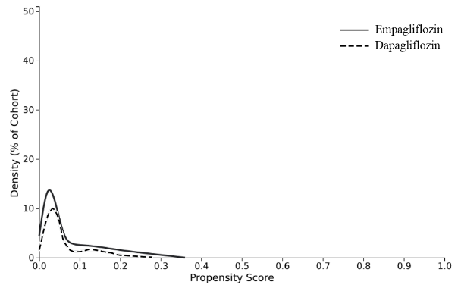 | 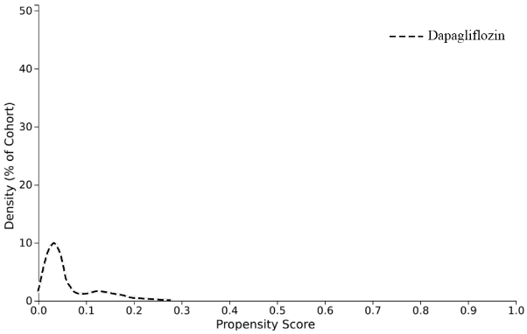
- Before matching | - After matching
eFig. 1 Propensity score density function - Before and after matching.

