Supplementary Information for

Whole-Brain c-Fos Connectomics Reveals Biphasic Integration-Distribution Architecture in Valence-Specific Emotional Processing

Hanglei Lin^{1,*}, Mingyi Huang^{2,*}, Ningyuan Fu^{1,*}, Jinsen Xi^{1,*}, Kaiying Zhang¹, Yuanjun Yang¹, Zonglei Zhou ^{3,#}, Zhili Huang^{4,5,#}, Yuguo Yu^{2,5,6,#}, Xiangshan Yuan^{1,5,#}

1 Department of Anatomy and Histoembryology, School of Basic Medical Sciences, Fudan University, Shanghai, China;
2 Research Institute of Intelligent Complex Systems, Institute of Science and Technology for Brain-Inspired Intelligence, Fudan University, Shanghai, China;
3 Center for Medical Research and Innovation and Pudong Medical Center, Shanghai Pudong Hospital, Fudan University, Shanghai, China
4 Department of Pharmacology, School of Basic Medical Sciences, Fudan University, Shanghai, China;
5 State Key Laboratory of Medical Neurobiology, Institutes of Brain Science and Collaborative Innovation Center for Brain Science, Fudan University, Shanghai, China;
6 Shanghai Artificial Intelligence Laboratory, Shanghai, China.

* These authors contributed equally to this work.
# Corresponding author. Email: zonglei_zhou@fudan.edu.cn (Zonglei Zhou); huangzl@fudan.edu.cn (Zhili Huang); yuyuguo@fudan.edu.cn (Yuguo Yu); yuanxiangshan1999@163.com (Xiangshan Yuan);
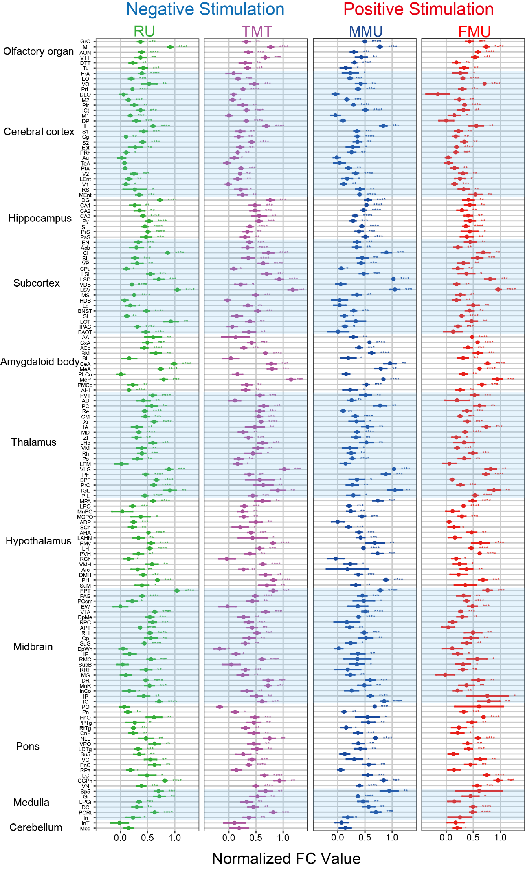
Supplementary Figure 1. Distinct emotional stimuli induce c-Fos expression in the whole brain.
Comparative analysis of c-Fos expression across 150 distinct nuclei relative to the control group. The Normalized FC Values represent the normalized levels of c-Fos expression within each experimental group. Statistical significance was determined using t-test analysis across the five experimental groups (*P < 0.05, **P < 0.01, ***P < 0.001, ****P < 0.0001), with n = 5 per group. The nuclei are systematically categorized into major anatomical subdivisions, which are indicated on the left side of the graph. MMU: Male mouse urine, FMU: Female mouse urine, RU: Rat urine.
Supplementary Data 1. Raw data and calculated Normalized FC Values for each group.

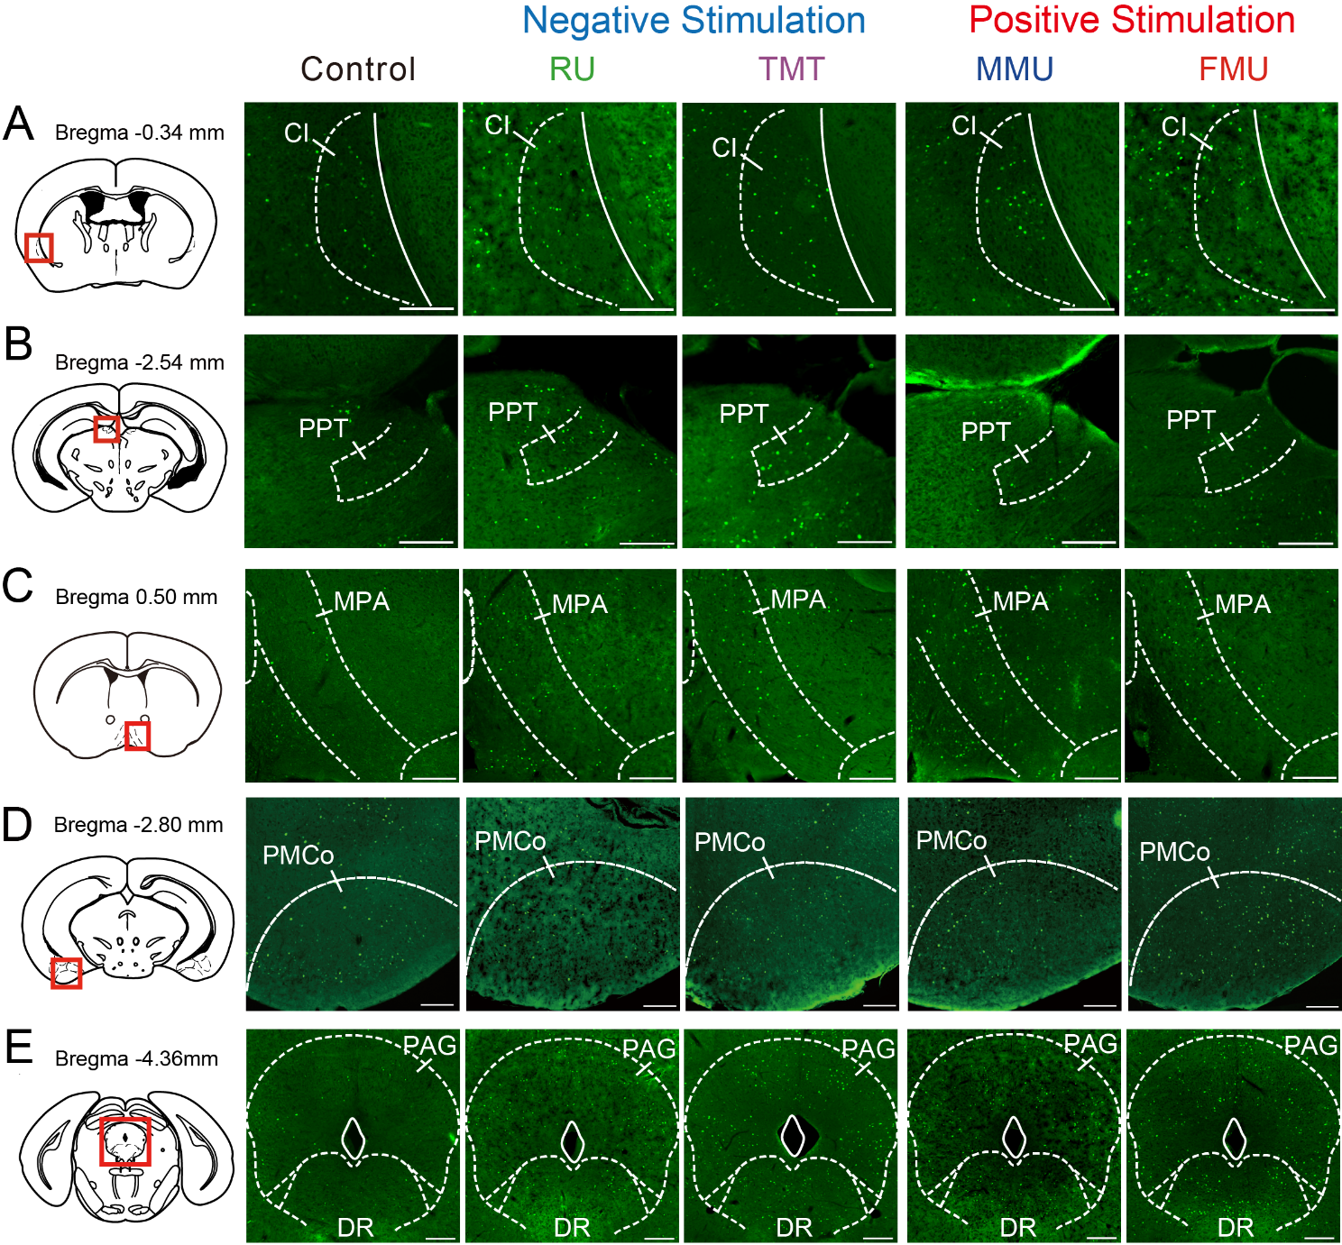
Supplementary Figure 2. Representative c-Fos expression in shared and stimulus-specific nuclei.
Panels show c-Fos expression under different emotional stimuli. (A-C) Nuclei co-activated by both positive and negative stimuli: A. Cl; B. PMV; C. PPT. (D-F) Nuclei selectively activated by individual stimuli: D. MPA (MMU); E. PMCo (FMU); F. DR and PAG (TMT). Scale bar = 200 μm.
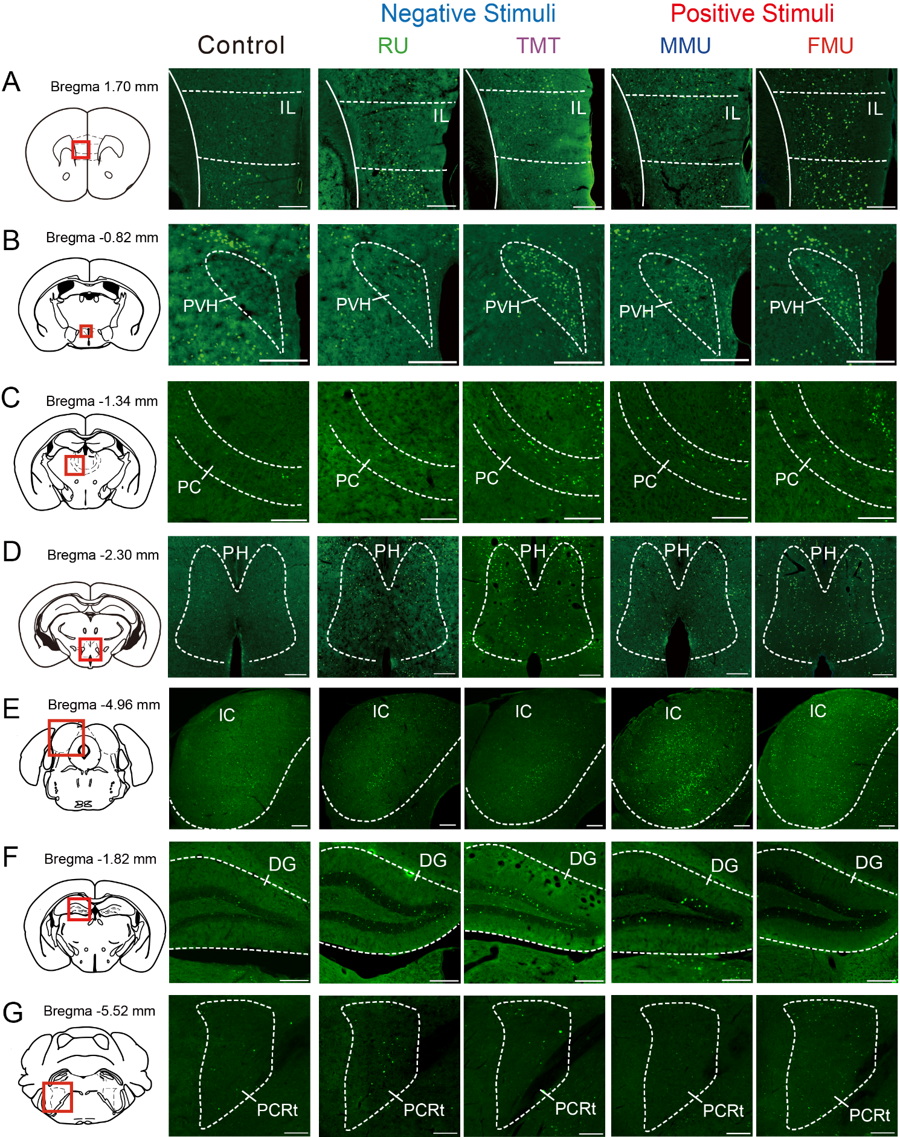
Supplementary Figure 3. Representative c-Fos expression in nuclei selectively activated by either negative or positive stimuli.
Fluorescent immunohistochemistry images show c-Fos expression under different emotional stimuli. (A-E). Nuclei significantly activated by positive stimuli (MMU & FMU): A. IL; B. PVH; C. PC; D. PH; E. IC. (F-G). Nuclei significantly activated by negative stimuli (RU & TMT): F. DG; G. PCRt. Bregma coordinates are indicated for each brain region. Scale bar = 200 μm.

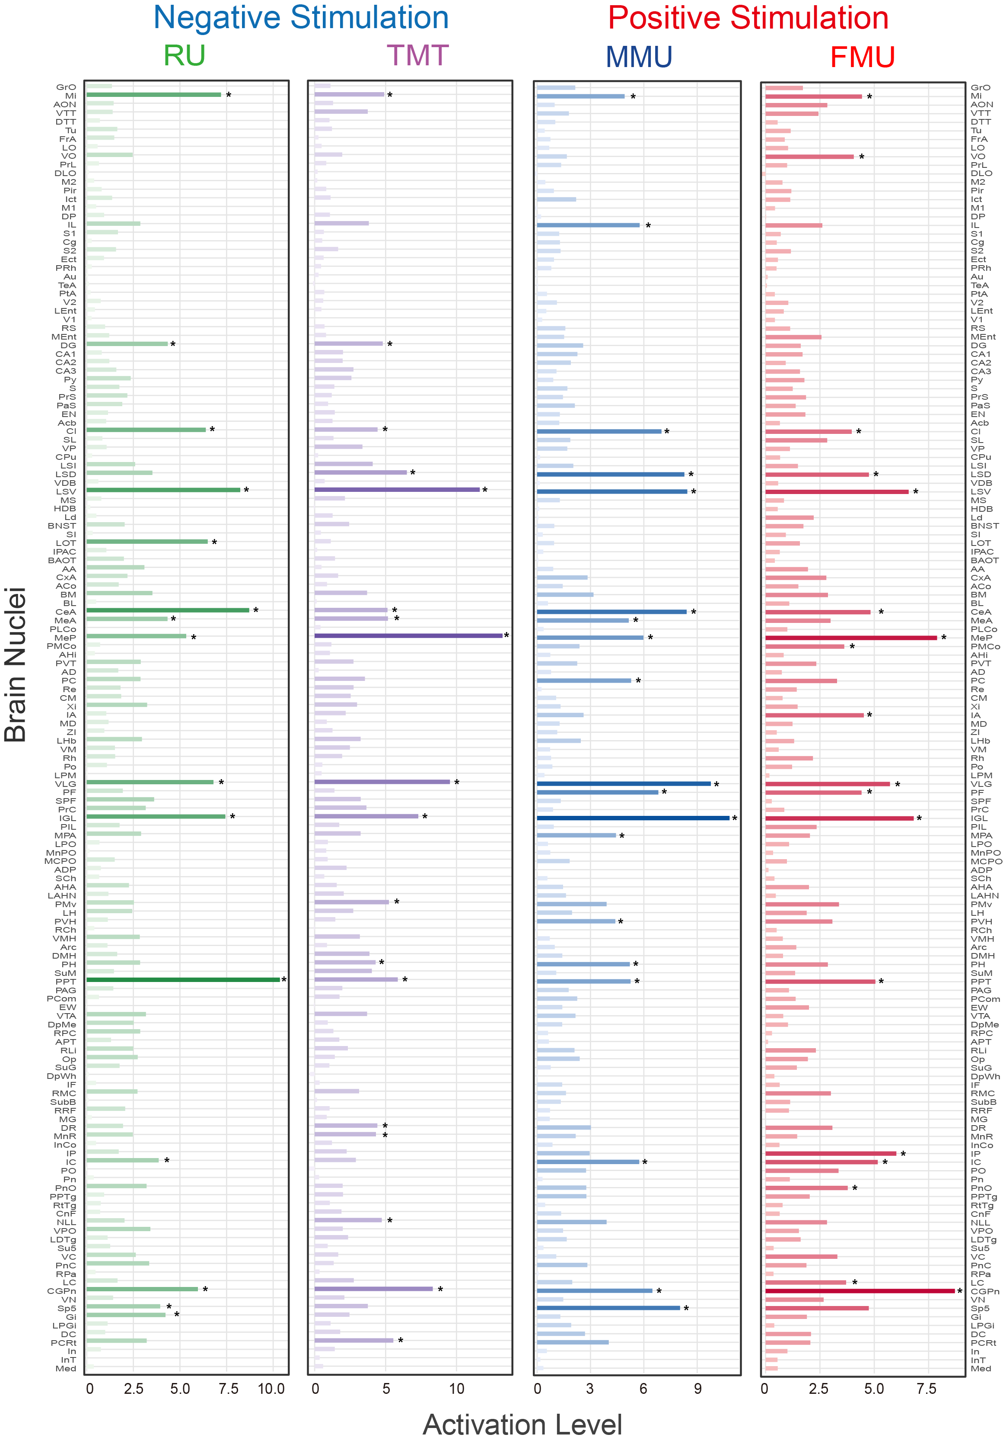
Supplementary Figure 4. Brain activation patterns across four experimental conditions.
Each panel shows the activation levels of brain regions under one of the four stimuli: RU (green), TMT (purple), MMU (blue), and FMU (red). Activation level is quantified by the activation ratio relative to control. Brain regions showing significant activation (R > μ + σ) are marked with asterisks (*). MMU: Male mouse urine; FMU: Female mouse urine; RU: Rat urine; TMT: 2,4,5-trimethylthiazoline (fox odor).

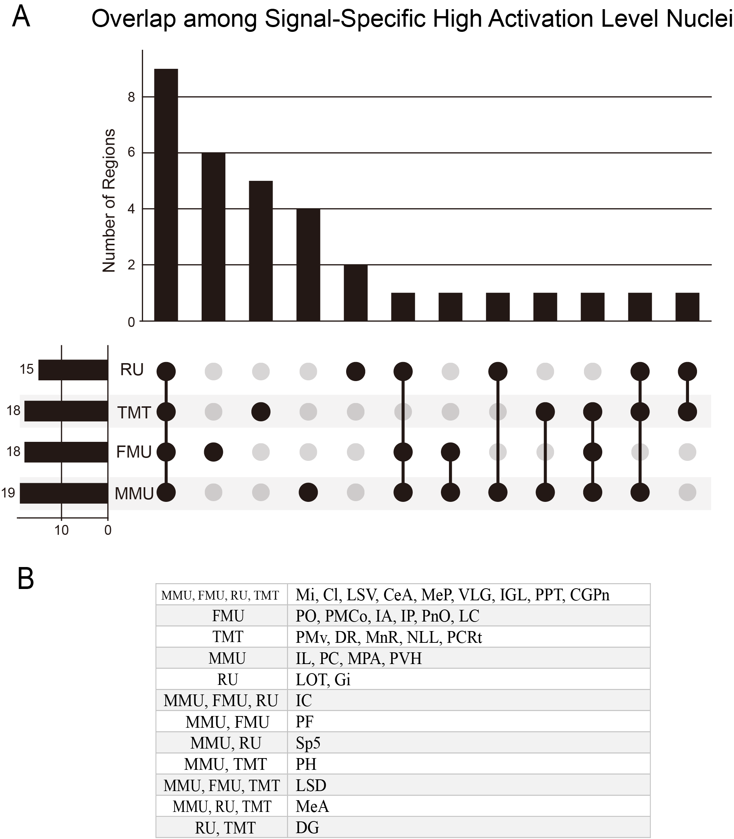
Supplementary Figure 5. Overlap analysis of significantly activated brain regions across four emotion-inducing conditions.
This figure illustrates the overlap of high activation level nuclei identified under four distinct emotional stimuli. (A) The upper bar chart shows the number of overlapping regions for each combination of conditions; the central matrix highlights the corresponding condition sets; (B) The lower table lists the specific nuclei associated with each overlap.

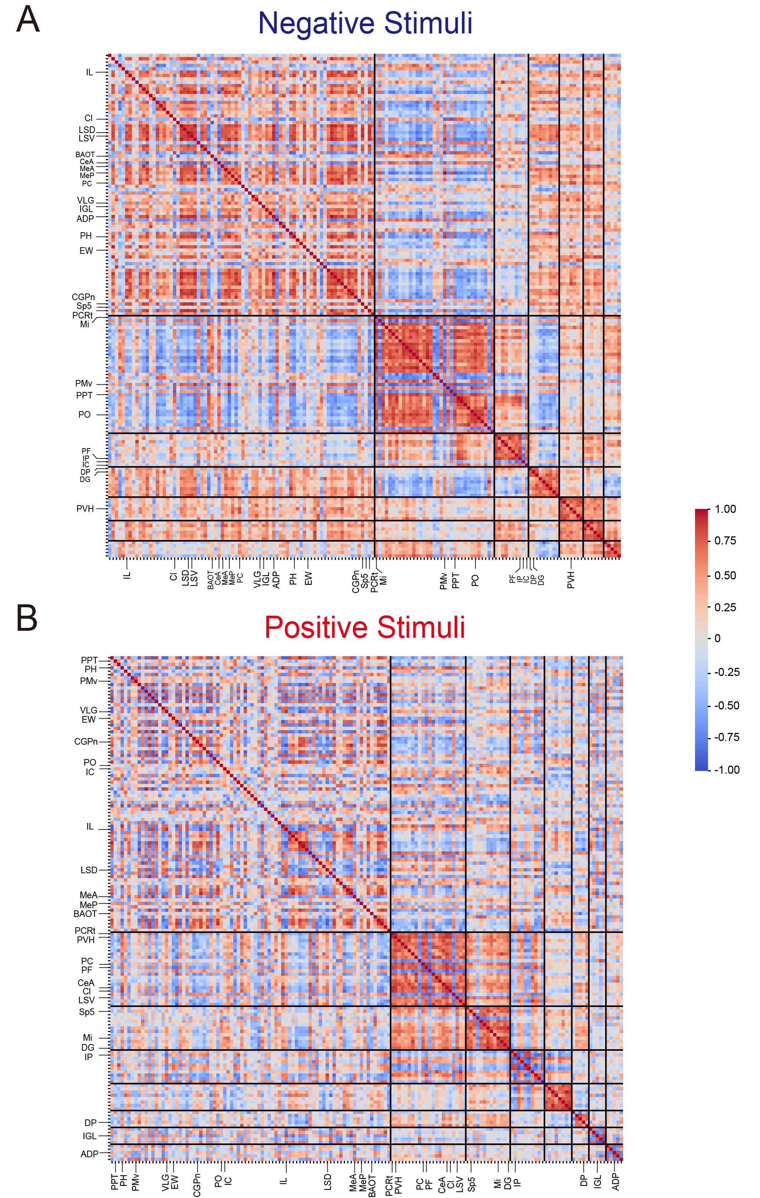
Supplementary Figure 6. Correlation structure of activated nuclei under emotional stimuli.
Correlation matrices of significantly activated brain regions under negative (A) and positive (B) stimuli. Brain nuclei are ordered by community identity, and community boundaries are outlined in black. Color indicates correlation strength (blue: negative, red: positive).

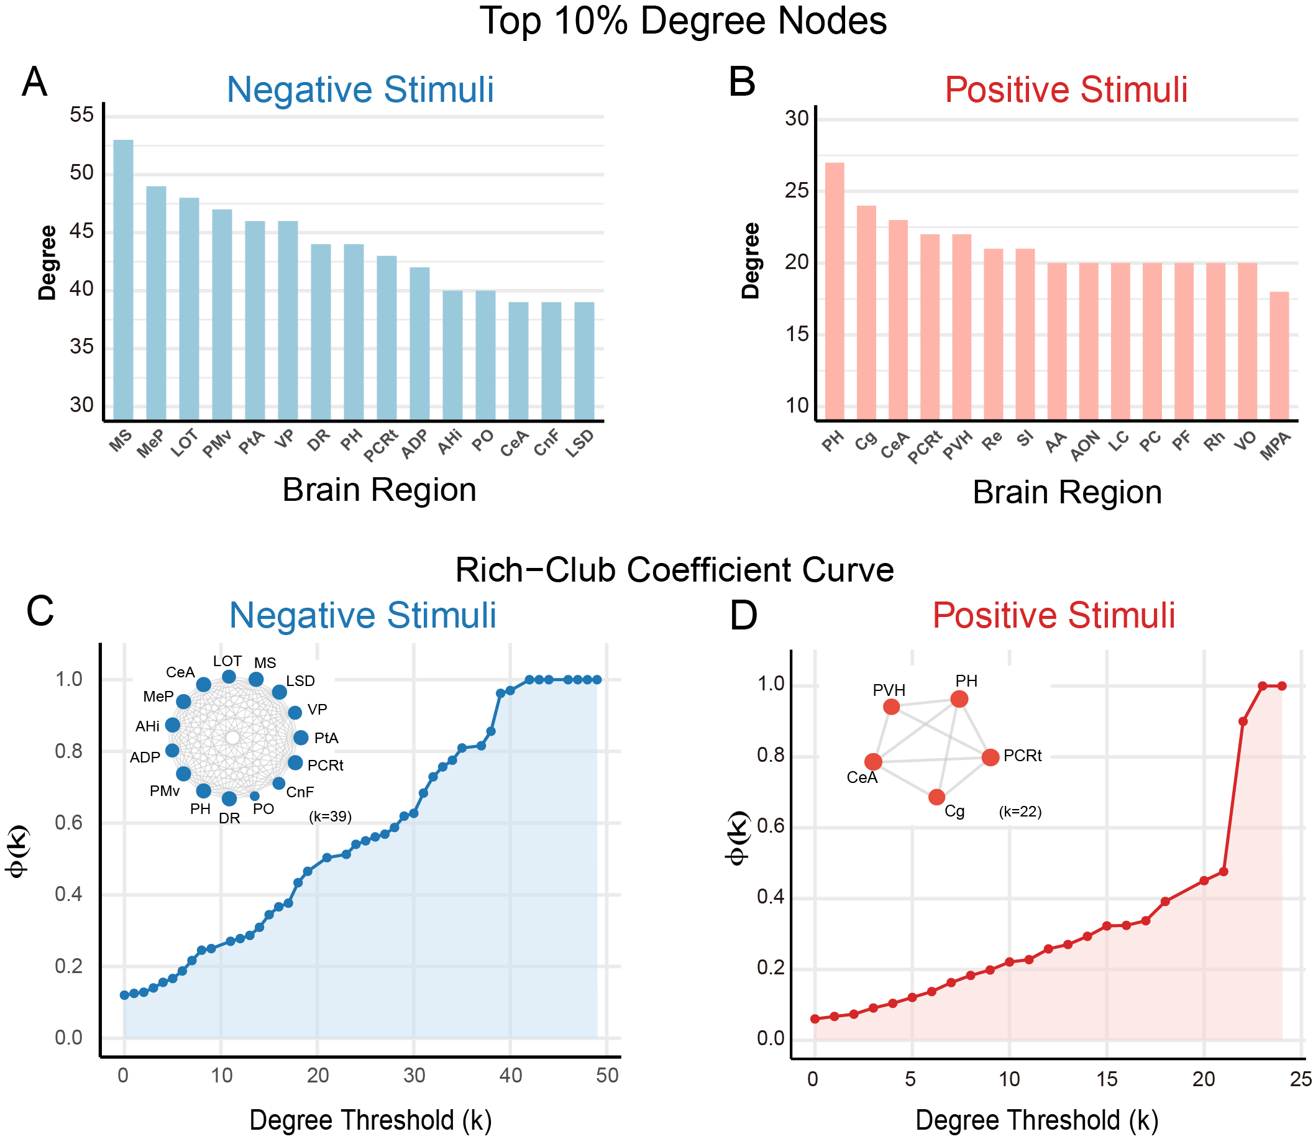
Supplementary Figure 7. Topological features of emotion-responsive brain networks.
(A-B) Bar plots show the top 10% highest-degree brain nuclei under negative (A) and positive (B) stimuli. (C-D) Rich-club coefficient curves (φ(k)) under negative (C) and positive (D) conditions. Insets display the rich-club subnetworks extracted at key degree thresholds (negative: k = 39; positive: k = 22).

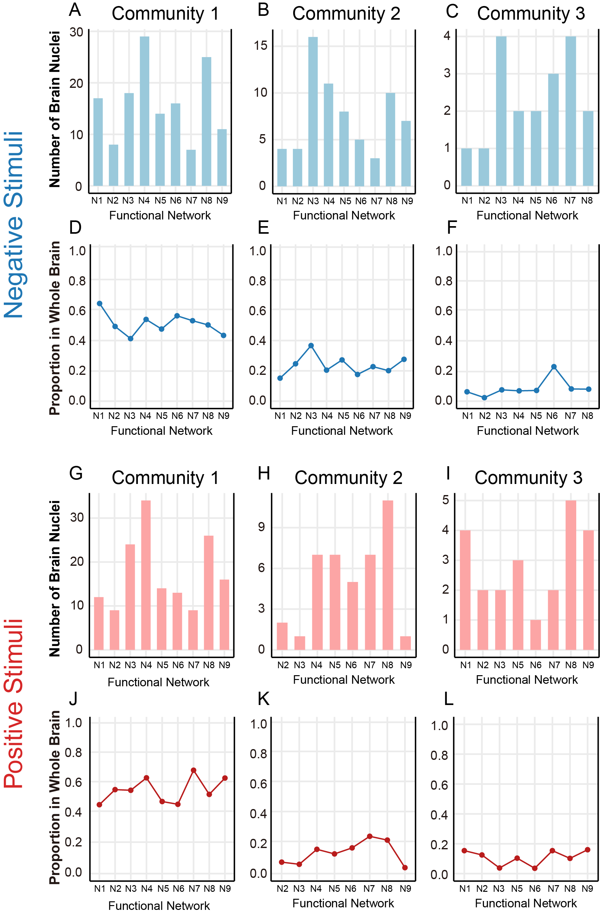
Supplementary Figure 8. Functional network composition of the top three communities under negative (A-F) and positive (G-L) stimuli. Bar plots indicate the number of nuclei from each functional network contained in each community (A-C, G-I). Line plots represent the fraction of each functional network covered by the community (D-F, J-L).

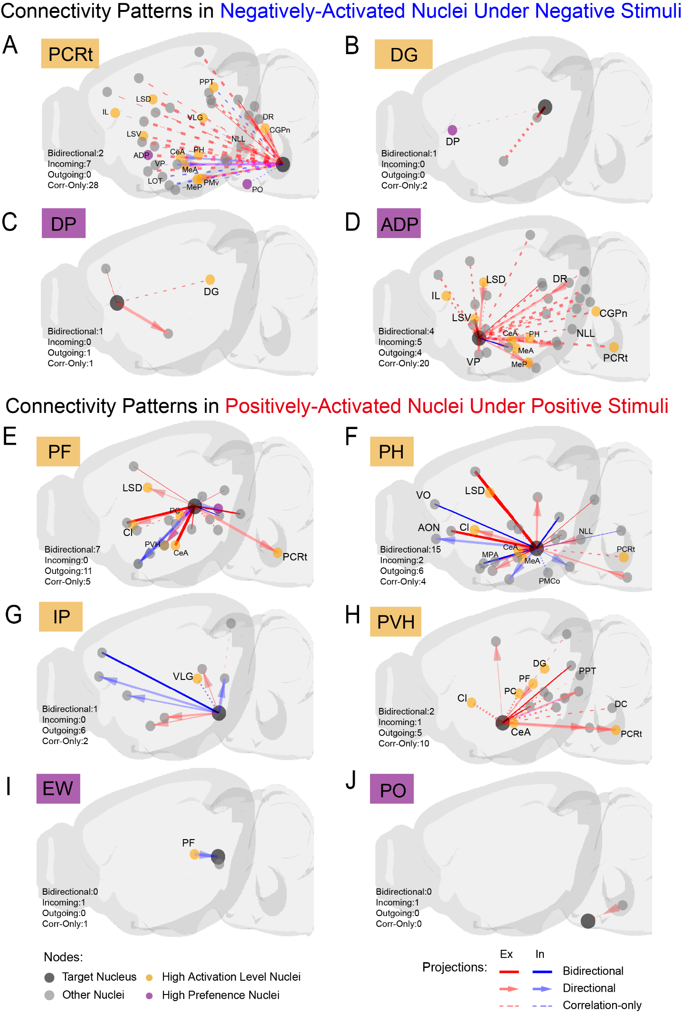
Supplementary Figure 9. Anatomical projections of condition-specific nuclei under negative and positive emotional stimuli.
Panels show structural and functional connectivity patterns of high-activation and high-preference nuclei identified under negative (A-D) and positive (E-J) olfactory stimuli.
Solid red and blue lines indicate known bidirectional projections, with red representing positive (excitatory-like) correlations and blue representing negative (inhibitory-like) correlations. Arrows denote unidirectional anatomical projections. Dashed lines indicate correlation-only functional connections without confirmed structural pathways. Node color indicates functional relevance: yellow nodes represent high activation level nuclei, purple nodes indicate high preference nuclei, and gray nodes mark additional anatomically connected targets.
(A-D) Projection profiles of PCRt, DG, DP, and ADP under negative stimuli.
(E-J) Projection profiles of PF, PH, IP, PVH, EW, and PO under positive stimuli.
Quantitative summaries of connection types (bidirectional, incoming, outgoing, correlation-only) are provided in each panel.

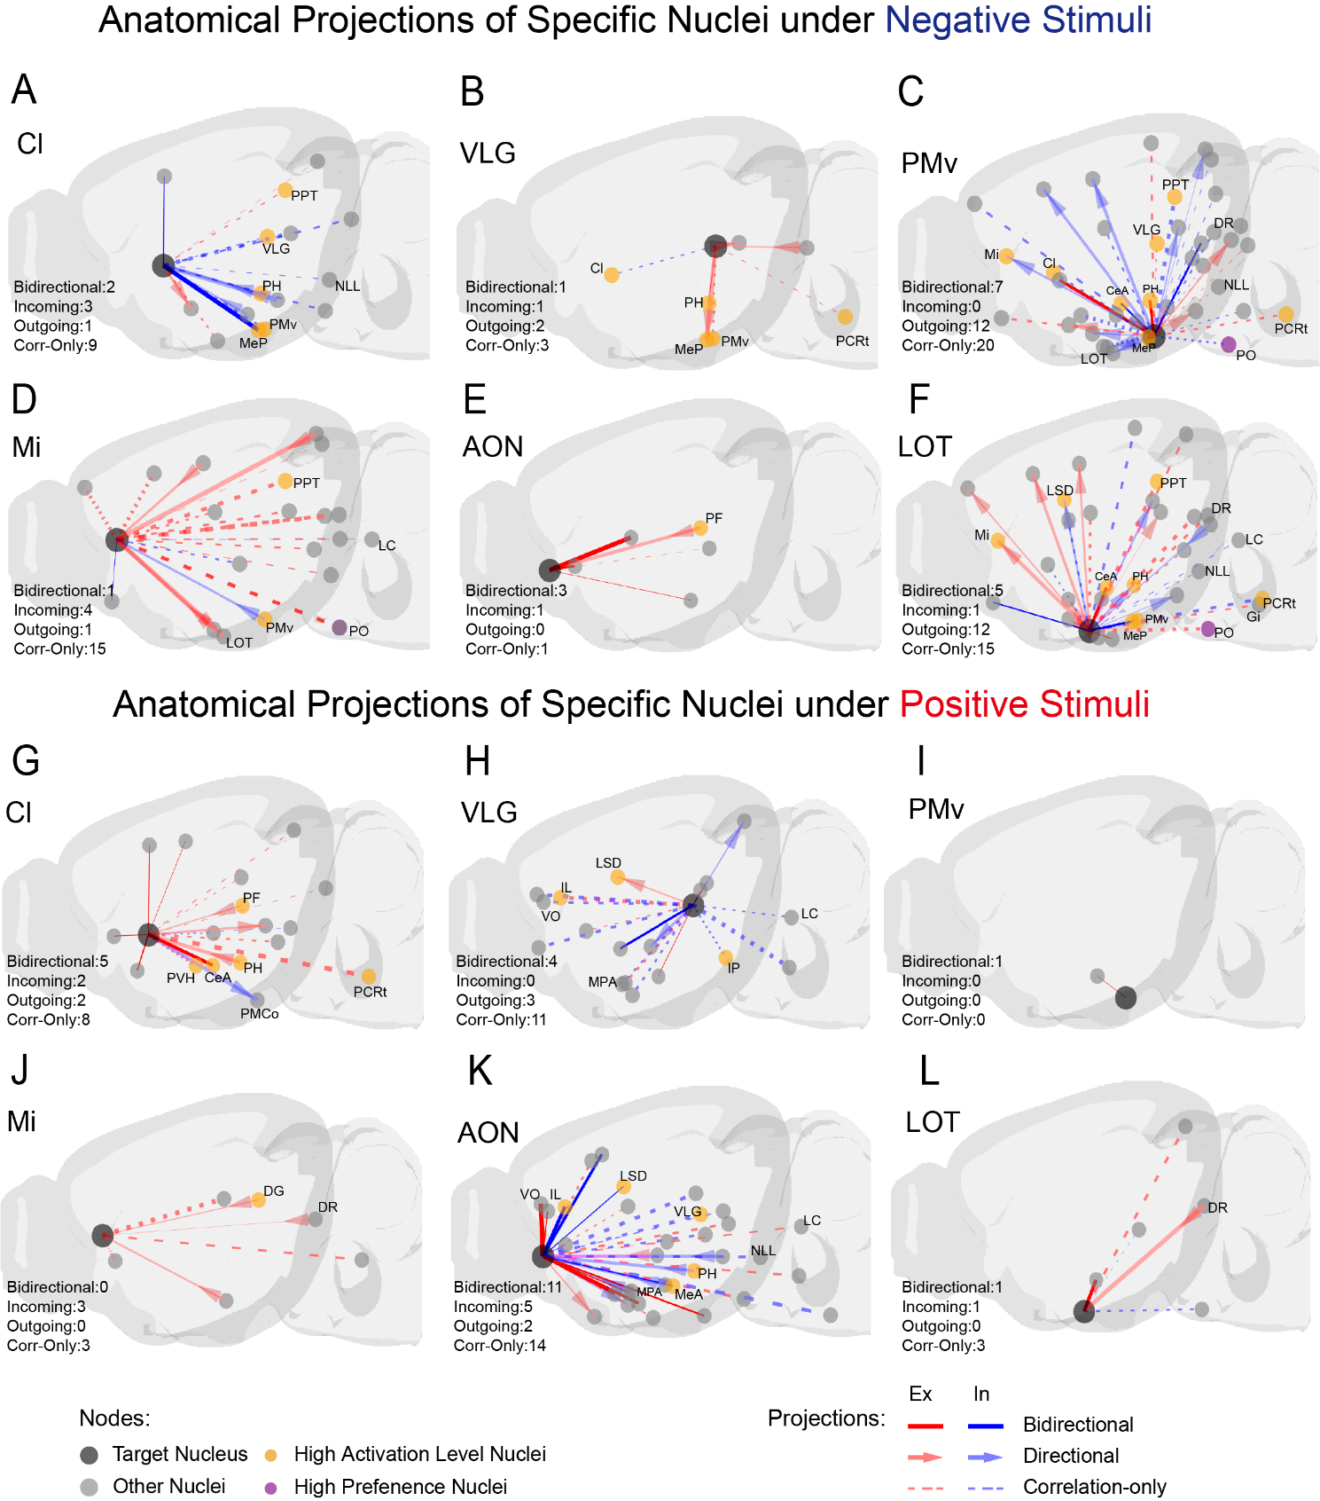
Supplementary Figure 10. Anatomical projections of po-activated and plfactory-related Nuclei under negative and positive olfactory stimuli.
Panels show the projection profiles of representative emotion-responsive nuclei identified under negative (A-F) and positive (G-L) olfactory conditions, based on integration of functional connectivity and anatomical projection data from the Allen Mouse Brain Connectivity Atlas.
Solid red and blue lines indicate known bidirectional projections, with red representing positive (excitatory-like) correlations and blue representing negative (inhibitory-like) correlations. Arrows denote unidirectional anatomical projections. Dashed lines indicate correlation-only functional connections without confirmed structural pathways. Node color indicates functional relevance: yellow nodes represent high activation level nuclei, purple nodes indicate high preference nuclei, and gray nodes mark additional anatomically connected targets. (A-F) Projection patterns of Cl, VLG, PMv, Mi, AON, and LOT under negative stimuli. (G-L) Projection patterns of the same nuclei under positive stimuli. Quantitative summaries of connection types (bidirectional, incoming, outgoing, correlation-only) are provided in each panel.

Supplementary Table 1
ID | Name | Label | Group
1 | GrO | granular cell layer of the olfactory bulb | Olfactory organ
2 | Mi | mitral cell layer of the olfactory bulb | Olfactory organ
3 | AON | anterior olfactory nucleus | Olfactory organ
4 | VTT | ventral tenia tecta | Olfactory organ
5 | DTT | dorsal tenia tecta | Olfactory organ
6 | Tu | olfactory tubercle | Olfactory organ
7 | FrA | frontal association cortex | Cerebral cortex
8 | LO | lateral orbital cortex | Cerebral cortex
9 | VO | ventral orbital cortex | Cerebral cortex
10 | PrL | prelimbic cortex | Cerebral cortex
11 | DLO | dorsolateral orbital cortex | Cerebral cortex
12 | M2 | secondary motor cortex | Cerebral cortex
13 | Pir | piriform cortex | Cerebral cortex
14 | Ict | Insular leaf | Cerebral cortex
15 | M1 | primary motor cortex | Cerebral cortex
16 | DP | Dorsal peduncular area | Cerebral cortex
17 | IL | infralimbic cortex | Cerebral cortex
18 | S1 | primary somatosensory cortex | Cerebral cortex
19 | Cg | cingulate cortex | Cerebral cortex
20 | S2 | secondary somatosensory cortex | Cerebral cortex
21 | Ect | ectorhinal cortex | Cerebral cortex
22 | PRh | perirhinal cortex | Cerebral cortex
23 | Au | primary auditory cortex | Cerebral cortex
24 | TeA | temporal association cortex | Cerebral cortex
25 | PtA | parietal association cortex | Cerebral cortex
26 | V2 | secondary visual cortex | Cerebral cortex
27 | LEnt | lateral entorhinal cortex | Cerebral cortex
28 | V1 | primary visual cortex | Cerebral cortex
29 | RS | retrosplenial cortex | Cerebral cortex
30 | MEnt | medial entorhinal cortex | Cerebral cortex
31 | DG | dentate gyrus | Hippocampus
32 | CA1 | field CA1 of hippocampus | Hippocampus
33 | CA2 | field CA2 of hippocampus | Hippocampus
34 | CA3 | field CA3 of hippocampus | Hippocampus
35 | Py | pyramidal cell layer of the hippocampus | Hippocampus
36 | S | subiculum | Hippocampus
37 | PrS | presubiculum | Hippocampus
38 | PaS | parasubiculum | Hippocampus
39 | EN | endopiriform nucleus | Subcortex
40 | Acb | accumbens nucleus | Subcortex
41 | Cl | claustrum | Subcortex
42 | SL | semilunar nucleus | Subcortex
43 | VP | ventral pallidum | Subcortex
44 | CPu | caudate putamen | Subcortex
45 | LSI | lateral septal nucleus, intermediate part | Subcortex
46 | LSD | lateral septal nucleus, dorsal part | Subcortex
47 | VDB | nucleus of the vertical limb of the diagonal band | Subcortex
48 | LSV | lateral septal nucleus, ventral part | Subcortex
49 | MS | medial septal nucleus | Subcortex
50 | HDB | nucleus of the horizontal limb of the diagonal band | Subcortex
51 | Ld | lambdoid septal zone | Subcortex
52 | BNST | bed nucleus of the stria terminalis | Subcortex
53 | SI | substantia innominata | Subcortex
54 | LOT | nucleus of the lateral olfactory tract | Subcortex
55 | IPAC | interstitial nucleus of the posterior limb  of the anterior commissure | Subcortex
56 | BAOT | bed nucleus of the accessory olfactory tract | Subcortex
57 | AA | anterior amygdaloid area | Amygdaloid body
58 | CxA | cortex-amygdala transition zone | Amygdaloid body
59 | ACo | anterior cortical amygdaloid nucleus | Amygdaloid body
60 | BM | basomedial amygdaloid nucleus | Amygdaloid body
61 | BL | basolateral amygdaloid nucleus | Amygdaloid body
62 | CeA | central amygdaloid nucleus | Amygdaloid body
63 | MeA | medial amygdaloid nucleus, anterior part | Amygdaloid body
64 | PLCo | posterolateral cortical amygdaloid nucleus | Amygdaloid body
65 | MeP | medial amygdaloid nucleus, posterior part | Amygdaloid body
66 | PMCo | posteromedial cortical amygdaloid nucleus | Amygdaloid body
67 | AHi | amygdalohippocampal area | Amygdaloid body
68 | PVT | thalamic paraventricular nucleus | Thalamus
69 | AD | anterodorsal thalamic nucleus | Thalamus
70 | PC | paracentral thalamic nucleus | Thalamus
71 | Re | reuniens thalamic nucleus | Thalamus
72 | CM | central medial thalamic nucleus | Thalamus
73 | Xi | xiphoid thalamic nucleus | Thalamus
74 | IA | interanterior thalamic nucleus | Thalamus
75 | MD | mediodorsal thalamic nucleus | Thalamus
76 | ZI | zona incerta | Thalamus
77 | LHb | lateral habenular nucleus | Thalamus
78 | VM | ventromedial thalamic nucleus | Thalamus
79 | Rh | rhomboid thalamic nucleus | Thalamus
80 | Po | posterior thalamic nuclear group | Thalamus
81 | LPM | lateral posterior thalamic nucleus | Thalamus
82 | VLG | ventral lateral geniculate nucleus | Thalamus
83 | PF | parafascicular thalamic nucleus | Thalamus
84 | SPF | subparafascicular thalamic nucleus | Thalamus
85 | PrC | precommissural nucleus | Thalamus
86 | IGL | intergeniculate leaf | Thalamus
87 | PIL | posterior intralaminar thalamic nucleus | Thalamus
88 | MPA | medial preoptic area | Hypothalamus
89 | LPO | lateral preoptic area | Hypothalamus
90 | MnPO | medial preoptic nucleus | Hypothalamus
91 | MCPO | magnocellular preoptic nucleus | Hypothalamus
92 | ADP | anterodorsal preoptic nucleus | Hypothalamus
93 | SCh | suprachiasmatic nucleus | Hypothalamus
94 | AHA | anterior hypothalamic area | Hypothalamus
95 | LAHN | lateroanterior hypothalamic nucleus | Hypothalamus
96 | PMv | premammillary nucleus, ventral part | Hypothalamus
97 | LH | lateral hypothalamic area | Hypothalamus
98 | PVH | paraventricular hypothalamic nucleus | Hypothalamus
99 | RCh | retrochiasmatic area | Hypothalamus
100 | VMH | ventromedial hypothalamic nucleus | Hypothalamus
101 | Arc | arcuate hypothalamic nucleus | Hypothalamus
102 | DMH | dorsomedial hypothalamic nucleus | Hypothalamus
103 | PH | posterior hypothalamic area | Hypothalamus
104 | SuM | supramammillary nucleus | Hypothalamus
105 | PPT | posterior pretectal nucleus | Midbrain
106 | PAG | periaqueductal gray | Midbrain
107 | PCom | nucleus of the posterior commissure | Midbrain
108 | EW | Edinger-Westphal nucleus | Midbrain
109 | VTA | ventral tegmental area | Midbrain
110 | DpMe | deep mesencephalic nucleus | Midbrain
111 | RPC | red nucleus, parvicellular part | Midbrain
112 | APT | anterior pretectal nucleus | Midbrain
113 | RLi | rostral linear nucleus of the raphe | Midbrain
114 | Op | optic nerve layer of the superior colliculus | Midbrain
115 | SuG | superficial gray layer of the superior colliculus | Midbrain
116 | DpWh | deep white layer of the superior colliculus | Midbrain
117 | IF | interfascicular nucleus | Midbrain
118 | RMC | red nucleus, magnocellular part | Midbrain
119 | SubB | subbrachial nucleus | Midbrain
120 | RRF | retrorubral field | Midbrain
121 | MG | medial geniculate nucleus | Midbrain
122 | DR | dorsal raphe nucleus | Midbrain
123 | MnR | median raphe nucleus | Midbrain
124 | InCo | intercollicular nucleus | Midbrain
125 | IP | interpeduncular nucleus | Midbrain
126 | IC | inferior colliculus | Midbrain
127 | PO | periolivary region | Pons
128 | Pn | pontine nuclei | Pons
129 | PnO | pontine reticular nucleus, oral part | Pons
130 | PPTg | pedunculopontine tegmental nucleus | Pons
131 | RtTg | reticulotegmental nucleus of the pons | Pons
132 | CnF | cuneiform nucleus | Pons
133 | NLL | nucleus of the lateral lemniscus | Pons
134 | VPO | ventral periolivary nucleus | Pons
135 | LDTg | laterodorsal tegmental nucleus | Pons
136 | Su5 | supratrigeminal nucleus | Pons
137 | VC | ventral cochlear nucleus | Pons
138 | PnC | pontine reticular nucleus, caudal part | Pons
139 | RPa | raphe pallidus nucleus | Pons
140 | LC | locus coeruleus | Pons
141 | CGPn | central gray of the pons | Pons
142 | VN | vestibular nucleus | Pons
143 | Sp5 | spinal trigeminal nucleus | Medulla
144 | Gi | gigantocellular reticular nucleus | Medulla
145 | LPGi | lateral paragigantocellular nucleus | Medulla
146 | DC | dorsal cochlear nucleus | Medulla
147 | PCRt | parvicellular reticular nucleus | Medulla
148 | In | intercalated nucleus of the medulla | Medulla
149 | InT | interposed cerebellar nucleus | Cerebellum
150 | Med | medial (fastigial) cerebellar nucleus | Cerebellum

Supplementary Table 1. A list of 150 nuclei from 11 brain regions showing varying difference of c-Fos expression. The table includes the 150 brain regions showing significant c-Fos expression under various stimulus, showing their abbreviations, full names, and the macroscopic brain region they belong to, as referenced from the Mouse Brain in Stereotaxic Coordinates (2nd edition).

Supplementary Table 2
Network ID | Functional Network | Description
N1 | Olfactory Network | Processes olfactory input and links to limbic system.
N2 | Limbic Network | Regulates emotion, motivation, reward, and social behavior.
N3 | Salience Network | Detects environmental salience and modulates attention.
N4 | Executive Control Network | Controls cognitive functions, executive decision-making, and goal-directed behavior.
N5 | Default Mode Network | Supports self-referential thinking, mind-wandering, and introspection.
N6 | Motor Network | Regulates motor control, movement coordination, balance, and execution.
N7 | Memory Network | Involved in learning, spatial navigation, and memory formation.
N8 | Sensory Network | Processes sensory inputs from multiple modalities, including touch, vision, audition, and proprioception.
N9 | Autonomic Network | Regulates autonomic functions like heart rate, thermoregulation, stress responses, and circadian rhythms.

Supplementary Table 2. Functional Annotation of Identified Brain Networks.
This table summarizes the functional attributes of nine major brain networks identified in the current study, each labeled from N1 to N9. These networks were annotated based on their known roles in sensory processing, emotion regulation, cognitive control, motor coordination, memory, and autonomic functions. Descriptions reflect canonical functions established in previous literature and were used to interpret community structures in the functional network analysis.

