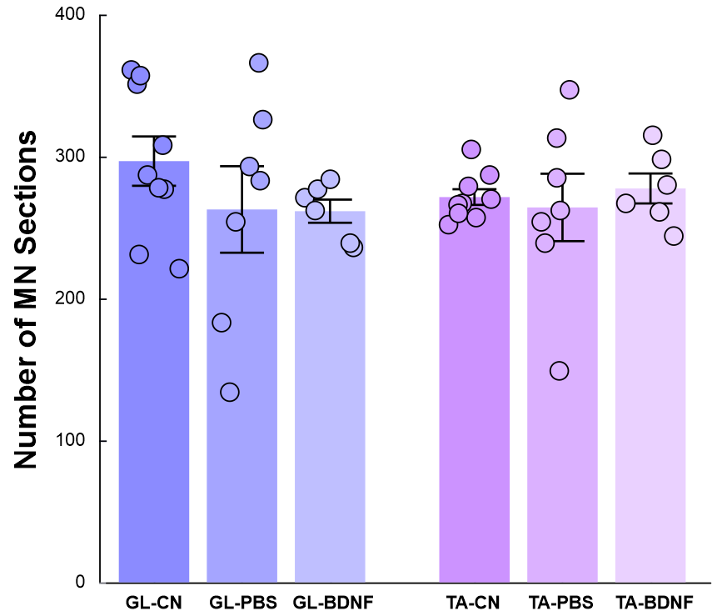

Fig S1. The number of GL and TA MNs isolated from the CN (N=9), SCT-PBS (N=7) and SCT-BDNF (N=6) groups of rats. Data are presented as mean +/- SEM. Differences between groups are non-significant (One-way ANOVA with Tukey's post-hoc test).

Table 1. List of used probes and primers
Gene  symbol | Name of coded protein | Accession number | Roche  UPL No. | Forward primer  (5’–3’) | Reverse Primer  (5’–3’) | Amplicon length/nt
Gria1 | AMPAR GluA1 | NM_031608.1 | 69 | tcccttgaccataaccttgg | actcatgaatggcttggagaa | 61
Gria2 | AMPAR GluA2 | NM_017261.2; NM_001083811.1 | 67 | ggaggtgattccaaggaaaag | cccccgacaaggatgtaga | 77
Gria3 | AMPAR GluA3 | NM_032990.2; NM_001112742.1 | 94 | ccaagaatgcaccactgaag | ctgcgggagacatccact | 109
Grin1 | NMDAR GluN1 | NM_001270602.1 | 95 | cctacacagctggcttctacag | cgaaggaaactcaggtggat | 94
Grin2a | NMDAR GluN2A | NM_012573.3 | 94 | cgtcatggtctccaggagtaa | cactgaagggttcgaggaaa | 62
Grin2b | NMDAR GluN2B | NM_012574.1 | 106 | tcctgcagctgtttggagat | gctgctcatcacctcattctt | 95
Gabra2 | GABA_{A}R α2 | NM_001135779.2 | 94 | gacagacttctggatggttacga | ggtcacatagatgttggtggag | 87
Gabra3 | GABA_{A}R α3 | NM_017069.3 | 129 | cctacttgccatgtatcatgactg | ggtcatggtgagaacagtggt | 113
Gabrb3 | GABA_{A}R β3 | NM_017065.1 | 80 | atcgagctcccacagttctc | tcaatgagagtcgagggtagg | 91
Gabrg2 | GABA_{A}R γ2 | NM_183327.1 | 75 | ttgaagtgggagacacaaggt | cggacataaccacatagtcacc | 111
Glra1 | GlyR α1 | NM_013133.1 | 69 | ccggcaacacaaggaact | tctccaccctcatcatcctt | 69
Glrb | GlyR β | NM_053296.1 | 29 | ggatctattcaagagacaacaatgg | gcttgagtctggggtcgtt | 79
Slc12a4 | KCC1 | NM_019229.2 | 101 | acagagcgggatcgagag | ctctggtccatgtcatctgg | 130
Slc12a5 | KCC2 | NM_134363.1 | 75 | ttctggacaaccaccctca | ggcagaagcccttcacct | 84
Slc12a6 | KCC3 | NM_001109630.1 | 124 | gcgtcttacctgggtagtgg | tggagatggcagttaacattgta | 95
Scn1a | Nav1.1 | NM_030875.2 | 67 | agaaccaggccacattggag | gttctgatgctgttgctgcc | 120
Scn8a | Nav1.6 | NM_019266.3 | 67 | agagcaaaaagaggccgagt | tcttcaatggcgtcttccga | 120
Scn9a | Nav1.7 | NM_133289.2 | 129 | ggtcatggtgattgggaacc | ttgtttgcatcggtgtcttcc | 111
Cacna1b | Cav2.2 | NM_001195199.1  NM_147141.1 | 73 | cggcactggagatcaagc | gcagattagcccacacagaag | 96
Cacna1d | Cav1.3 | NM_001389225.2 | 69 | cccttatccaccctgcgatg | agattcttcgaggacgggga | 98
Kcnn2 | SK2 (K_{Ca}2.2) | NM_001309404.1; NM_019314.2 | 113 | gcgttttgttatgaagactttaatga | gtgacatcctgttgatcatggta | 132
Kcnn3 | SK3 (K_{Ca}2.3) | NM_019315.2 | 69 | ttcagggctcccaattca | atttagctggctgccttgc | 72
Kcnma1 | KCa1.1 | NM_031828.1 | 56 | cctcacacagccctttgc | gggtgaggatattgtcattgaag | 95
Grm1a | mGluR1A | NM_017011.1 | 101 | caccgaagaagatgaattgga | gaatcctcaggggtcagctt | 69
Grm5 | mGluR5 | NM_017012.1 | 82 | tccagcagcctagtcaacct | gattttccgttggagcttagg | 71
Chrm2 | M2R | NM_031016.2 | 64 | ccaccttcagactgtcaacaatta | catggagaaaacacctatgatgag | 76
Htr2a | 5-HTR2A | NM_017254.1 | 69 | agcactcgagccaaactagc | tggaagagcttttctgatgaca | 71
Htr2b | 5-HTR2B | NM_017250.2 | 129 | cgcggtaataatccccacca | ccaccgccaaggacattaga | 110
Htr2c | 5-HTR2C | NM_012765.3 | 69 | aagaaggtgttcgttggcct | ccgtttctcgtctagctgcc | 106
Adra1a | NAα1A | NM_017191.2 | 50 | gcgtctgggtgctttctttg | ggctcctcattgatctggca | 100
Adra1d | NAα1D | NM_024483.2 | 129 | tgtgctggttccccttcttc | agcgggttcacacagctatt | 124
GAPDH | GAPDH | NM_017008.4 | * | ctgcaccaccaactgcttag | tgatggcatggactgtgg | 92
*sequence: tttggcatcgtg. Synthesized by Institute of Biochemistry and Biophysics, Polish Academy of Sciences, Warsaw, Poland

Table 2. List of probes used for RNAscope method
Probe | cat. no | Target description
Rn-Ngfr | 406351 | Rattus norvegicus nerve growth factor receptor (Ngfr), mRNA
Rn-Ntrk2-C2 | 317531-C2 | Rattus norvegicus neurotrophic tyrosine kinase receptor type 2 (Ntrk2) transcript variant 1 mRNA
Rn-BDNF | customer designed, produced by ACDBio | Brain-derived neurotrophic factor (bdnf), mRNA BC087634.1
Polr2A C1 - positive control  PPIB C2 - positive control  UBC C3 - positive control | 320891 | DNA-directed RNA polymerase II subunit RPB1  cyclophilin B  ubiquitin C
DapB (C1, C2, C3)  – negative control | 320871 | DapB gene (enzyme from Bacillus subtilis)

Table 3. Primary and secondary antibodies for immunofluorescence
Target | Host | Cat. no | Dilution | Producer
C-Myc tag | Mouse | 9B11 | 1:500 | Cell Signaling Technology, Danvers, MA, USA
Brain-derived neurotrophic factor (BDNF) | Rabbit | ANT-010 | 1:200 | Alomone Labs, Jerusalem, Israel
Anti-Mouse, conjugated with Alexa Fluor 488 | Donkey | A21202 | 1:500 | Invitrogen, Carlsbad,  CA, USA
Anti-Rabbit, conjugated with Alexa Fluor 568 | Donkey | A-10042 | 1:500 | Thermo Fisher Scientific, Waltham, MA, USA

