Supplementary Information

A new sintering mechanism, “silver-zipping”, for low-temperature sintering of oxide solid electrolytes
Dong-Hee Kim^{1,2+}, Sehwa Cheon^{1,3+}, Youngoh Kim^{1,2}, Suhyeon Lim¹, Doohun Kim^{1,2} Heon-Cheol Shin^{3*}, Jun-Woo Park ^{1,2**} Heetaek Park^{1***}
¹Next Generation Battery Research Center, Battery Research Division, Korea Electrotechnology Research Institute (KERI),12, Jeongiui-gil, Seongsan-gu, Changwon-si, Gyeongsangnam-do, 51543, Republic of Korea
²Department of Electro-Functional Materials Engineering, University of Science and Technology (UST), Daejeon 34113, Republic of Korea
³Department of Materials Science & Engineering, Pusan National University, 46241, Republic of Korea

⁺ These authors contributed equally to this work
*Corresponding Authors:
*Heon-Cheol Shin; hcshin@pusan.ac.kr, **Jun-Woo Park; jwpark@keri.re.kr, , ***Heetaek Park; htpark@keri.re.kr
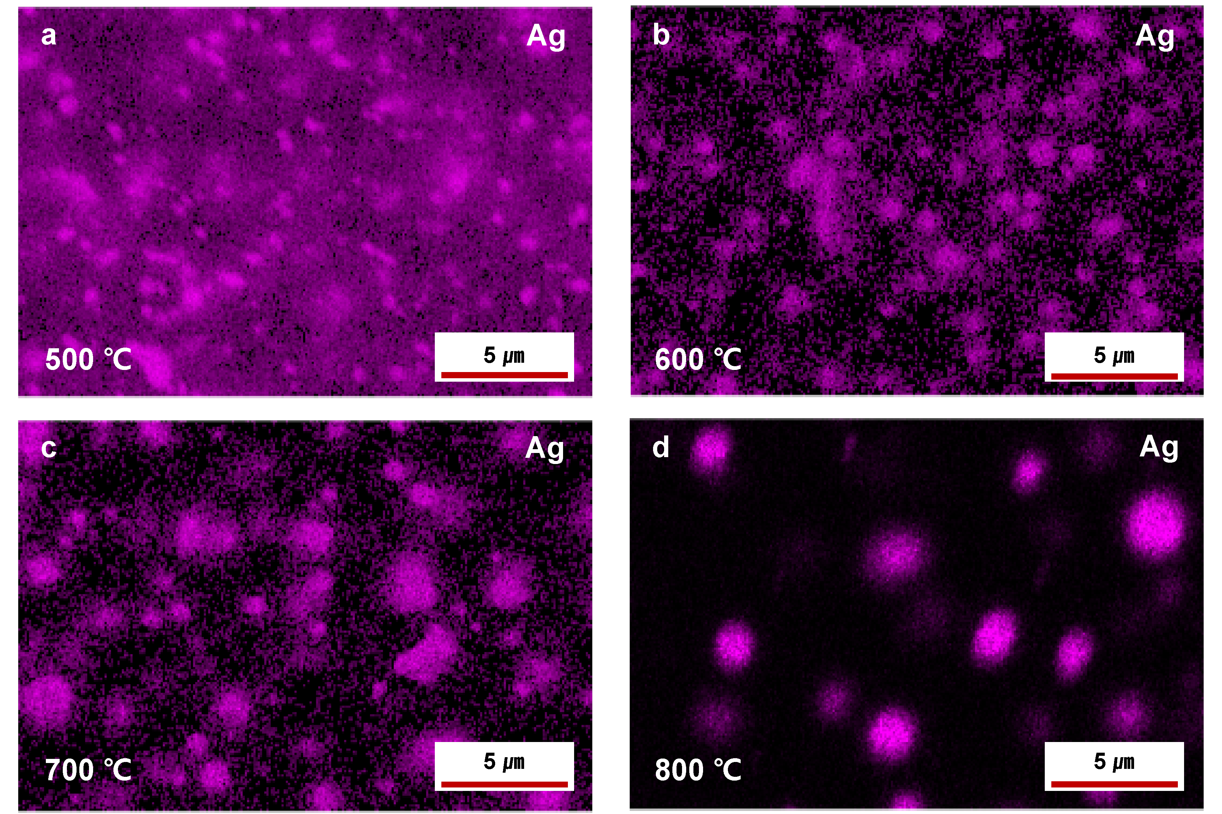
Fig. S1. Cross-sectional EDS elemental mapping of Pristine and Ag-added samples after sintering. (a) Sample sintered at 500 °C, (b) 600 °C, (c) 700 °C, and (d) 800 °C.

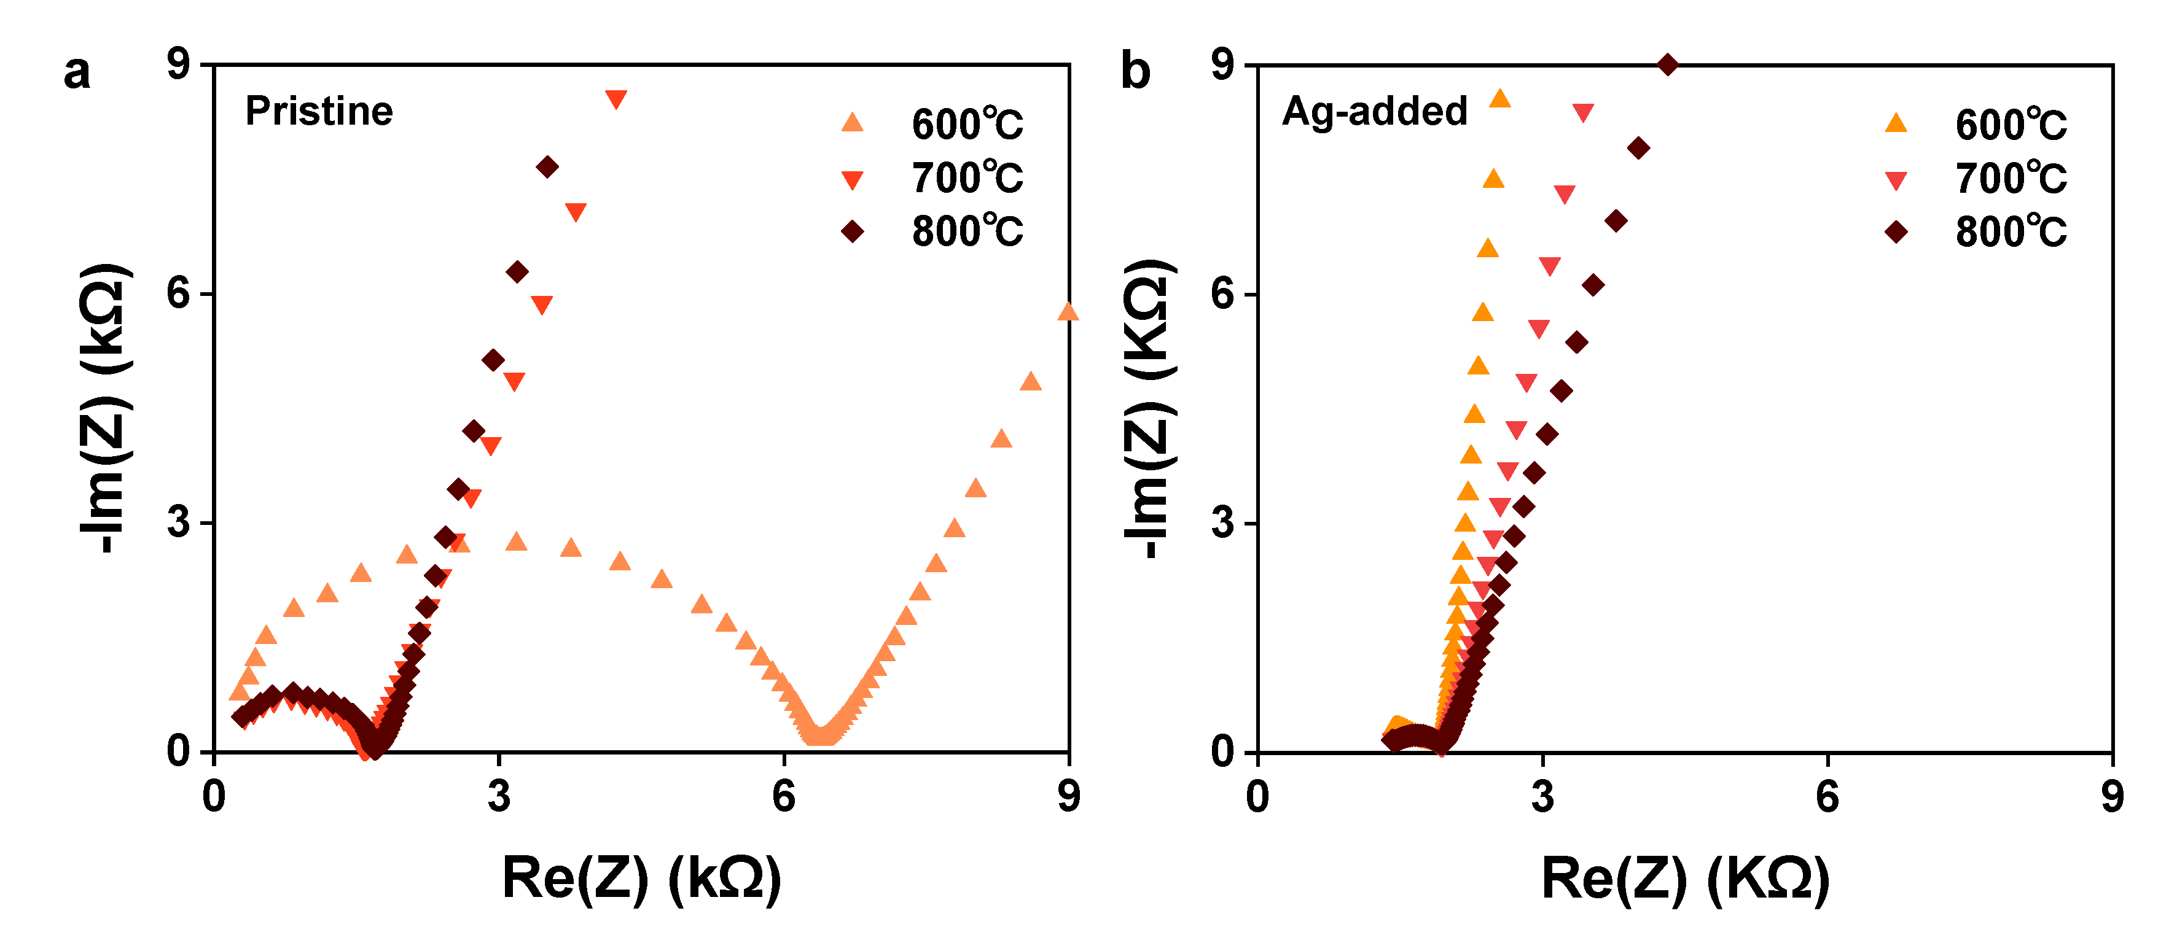
Fig. S2. Ionic conductivity measurements by electrochemical impedance spectroscopy. a-b, Nyquist plots of (a) pristine and (b) Ag-added SEs sintered at 600-800°C.

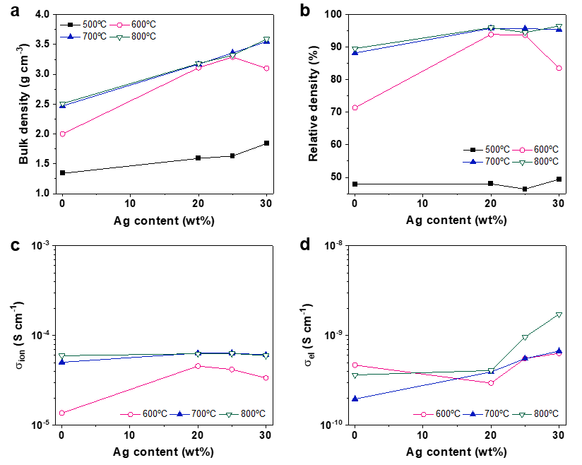
Fig. S3. Sinterability and electrical properties of LISICON SEs with varied Ag content. a-b, (a) Bulk and (b) relative densities of LISICON SEs as a function of Ag content. c-d, (c) Ionic and (d) electronic conductivities over the same Ag ratios. The compositions were LISICON: Ag = (80–x):(20+x) wt%, which correspond to 20 wt%, 25 wt%, and 30 wt% Ag for x = 0, 5, and 10, respectively.

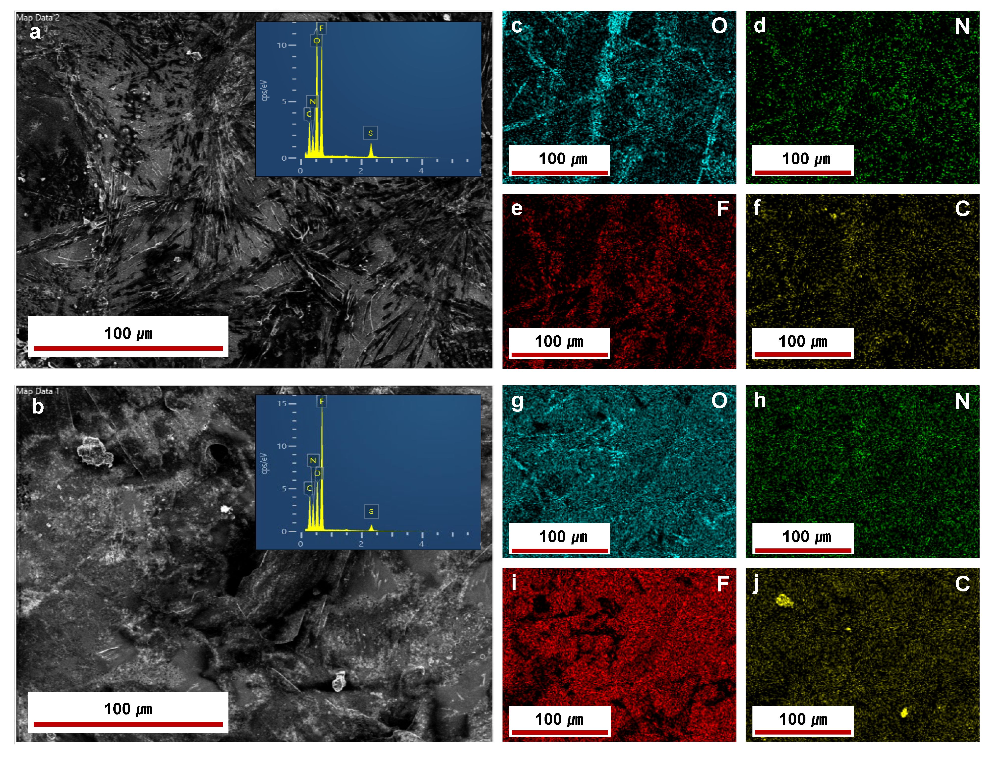
Fig. S4. Verification of Ag⁺ conduction through Ag-added SEs using a DC-biased Li | liq.+PE | Ag-added SE | liq.+PE | Li symmetric cell. a-b, SEM images of the Li-metal electrode surfaces after the CA test (see Fig. 2g in the manuscript): (a) top side and (b) bottom side. c-f, EDS elemental maps (O, N, F, C) of the top Li-metal surface: g-j, EDS elemental maps (O, N, F, C) of the bottom Li-metal surface. We note that no Ag signal was detected on either Li electrode, indicating that Ag⁺ conduction through Ag-added SEs didn’t occur.

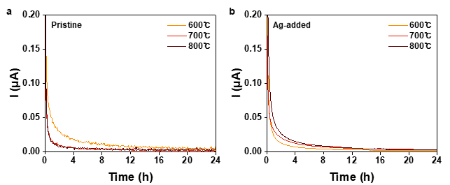
Fig. S5. Electronic conductivity measurements of LISICON SEs. a-b, DC polarization curve of (a) pristine and (b) Ag-added pellets sintered at 600-800°C.

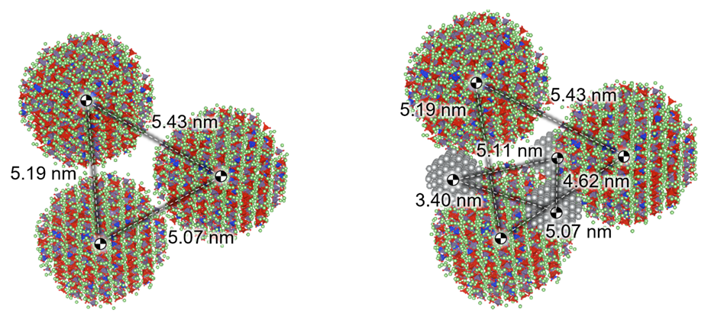
Fig. S6. LISICON SE and Ag particle stacking structure in the cell boxes

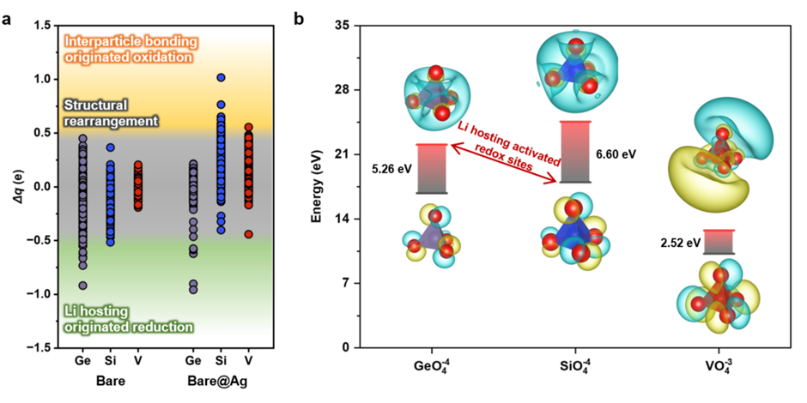
Fig. S7. Redox reactions analysis of LISICON during Ag-assisted sintering process. a, Evolution of cation charge states during Ag-catalyzed sintering. b, Molecular orbital analysis of GeO₄⁴⁻, SiO₄⁴⁻, and VO₄³⁻ anions. Highest occupied molecular orbital and lowest unoccupied molecular orbitals are only depicted for visibility.

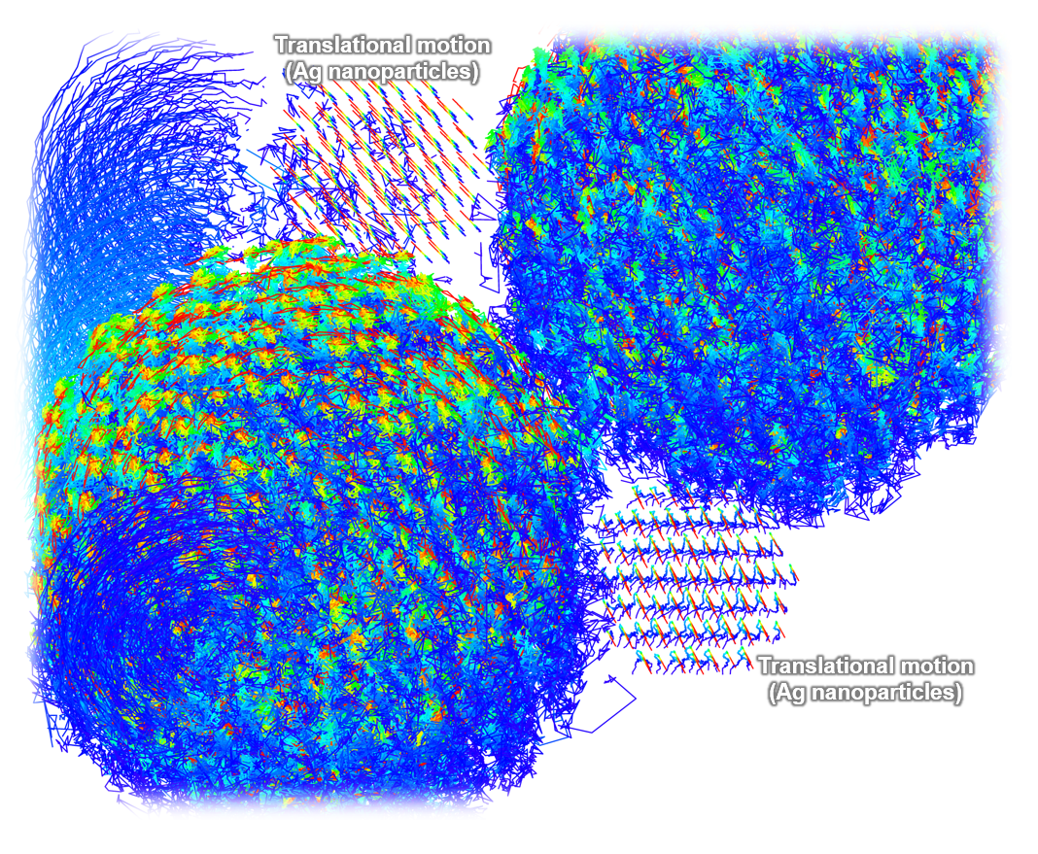
Fig. S8. Atomic trajectory during particle rearrangement. Trajectories are represented in blue - green - red as the sintering simulation progresses

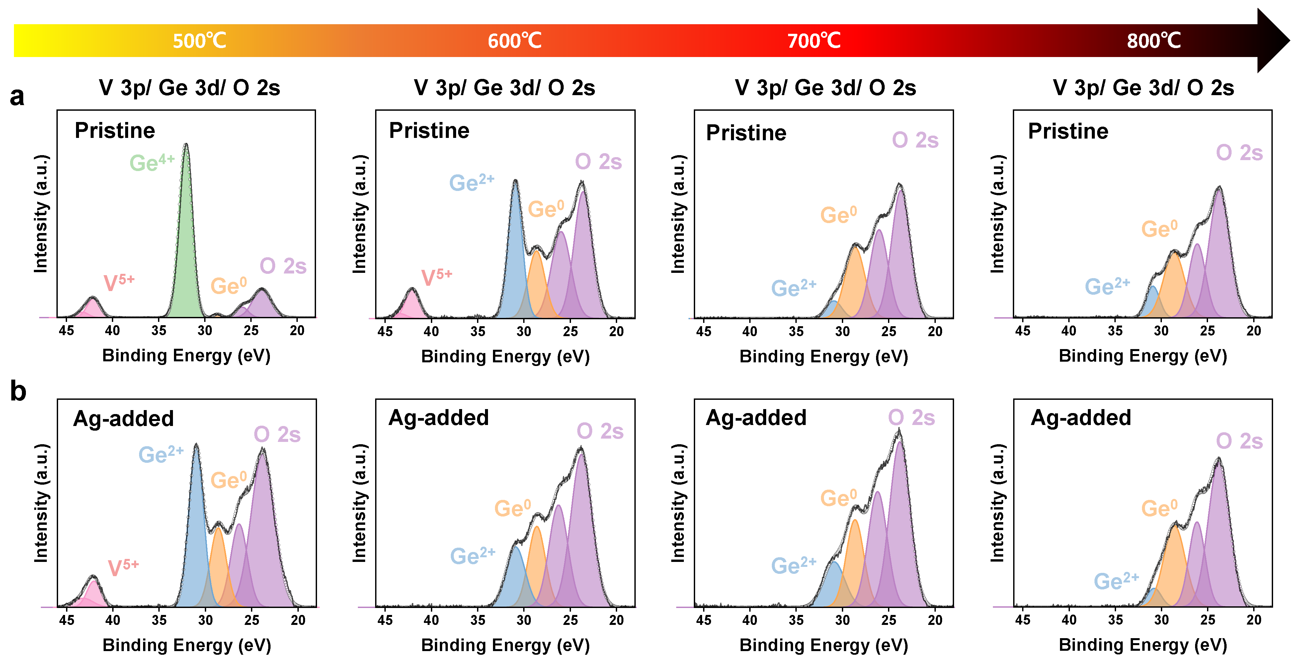
Fig. S9. Reduction behavior of Ge at LISICON surface due to Li hosting behavior captured by simulations. a-b, XPS spectra of (a) pristine and (b) Ag-added samples sintered at 500–800 °C..

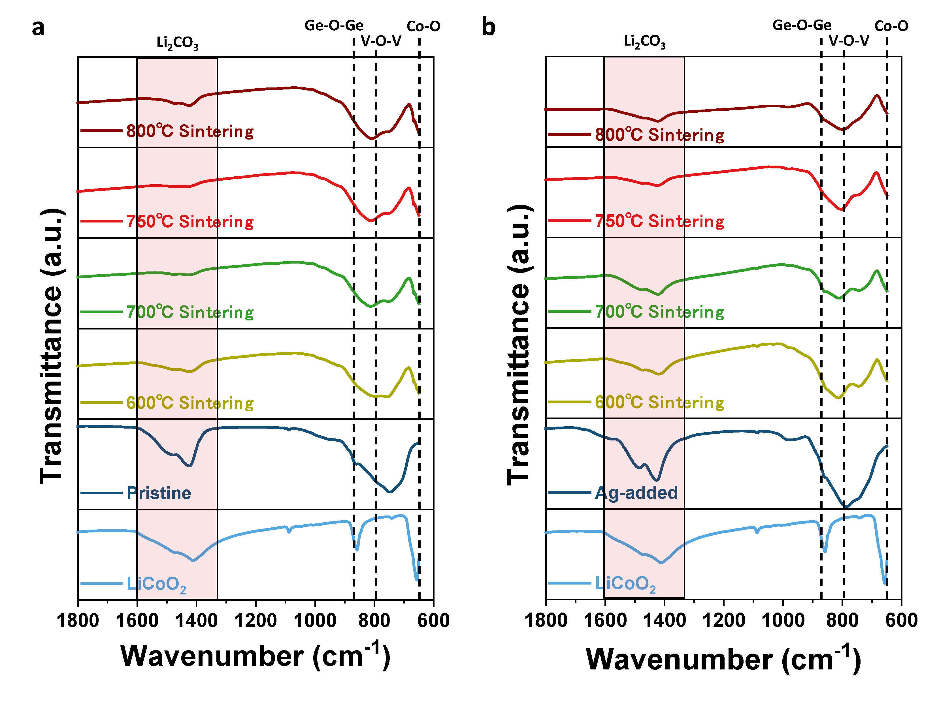
Fig. S10. Evaluation of thermal compatibility between LISICON SEs and LiCoO₂ during co-sintering. a-b, FTIR spectra of (a) pristine and (b) Ag-added composites co-sintered at 600–800 °C.

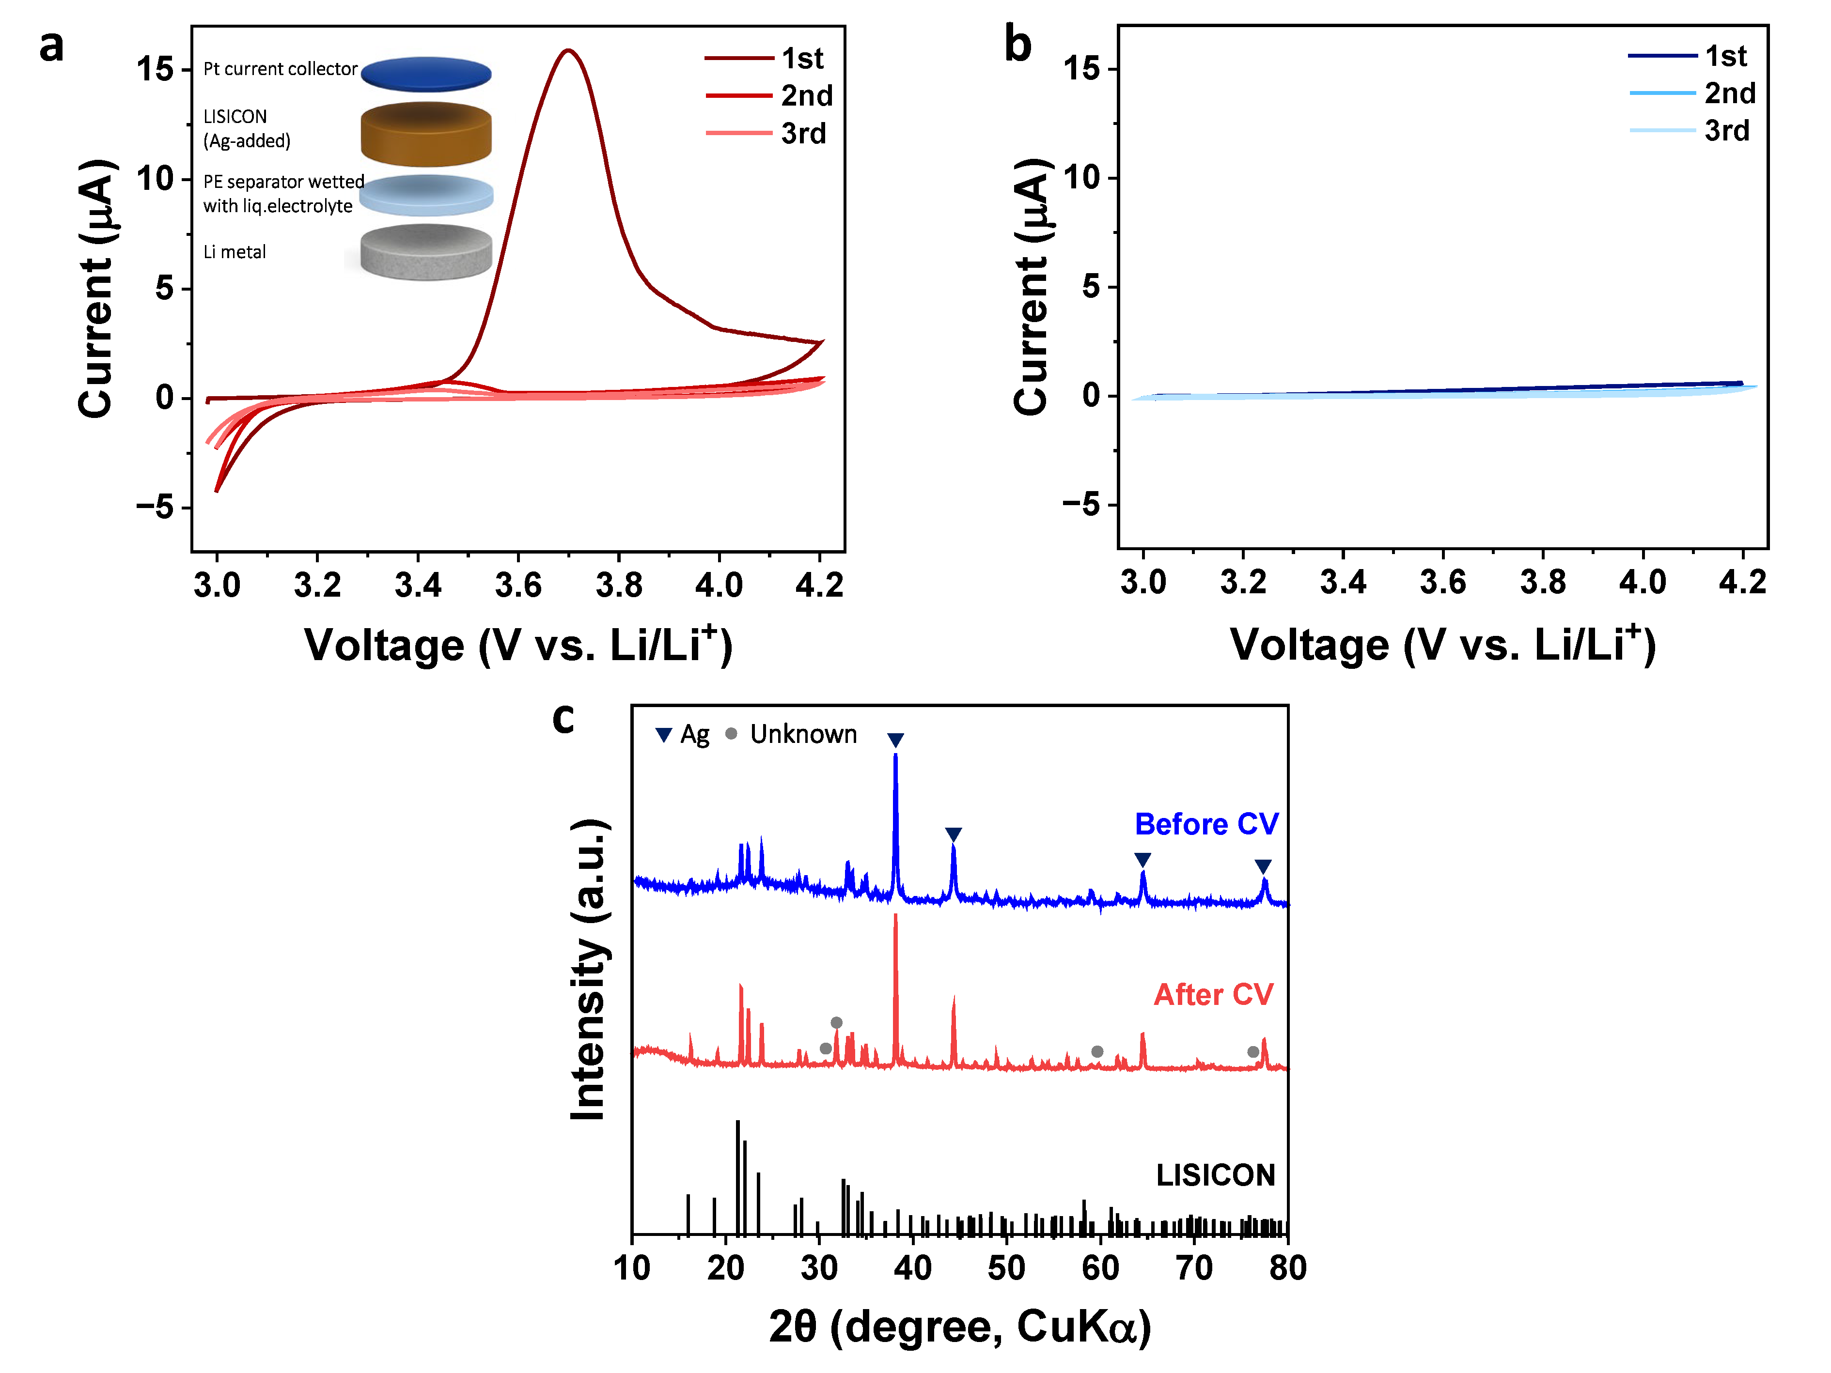
Fig. S11. Origin of irreversible reaction at ~3.5V observed in ASSBs with Ag-added SEs. a-b, Cyclic voltammetry (CV) curves of (a) Ag-added and (b) pristine LISICON SEs, measured to assess electrochemical stability in the high-voltage range (3.0–4.2 V). (Inset: Cell configuration for the CV test) c, XRD patterns of cathode side of Ag-added LISICON before and after CV test. We note that Pt current collector was polished prior to XRD.

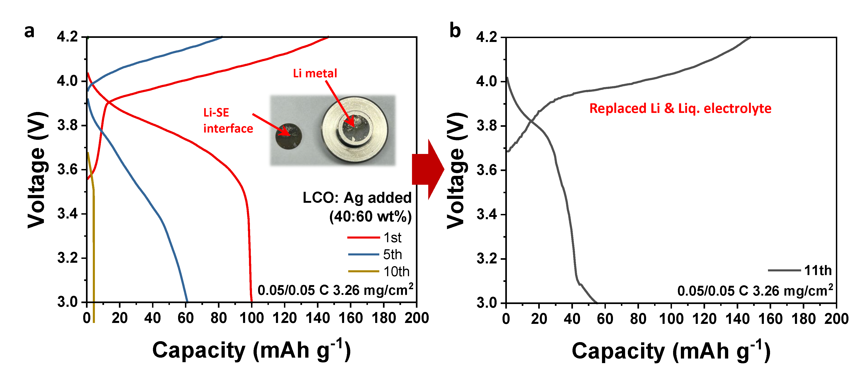
Fig. S12. Verification of anode-interface contribution to cell performance degradation. a, Voltage profiles of the Li | liquid electrolyte-infused PE separator | Ag-added LISICON | LCO+SE | Pt cell, cycled at 0.05 C between 3.0–4.2 V (Inset: Optical image of the Li metal anode after cycling; blackening at the Li metal and Li-SE interface indicates interfacial degradation.). b, Voltage profiles after replacing Li metal and liquid electrolyte, showing partial recovery consistent with anode interfacial degradation.

