Supplementary Figure S6: Uncropped Western Blots

Accompanies Figure 5
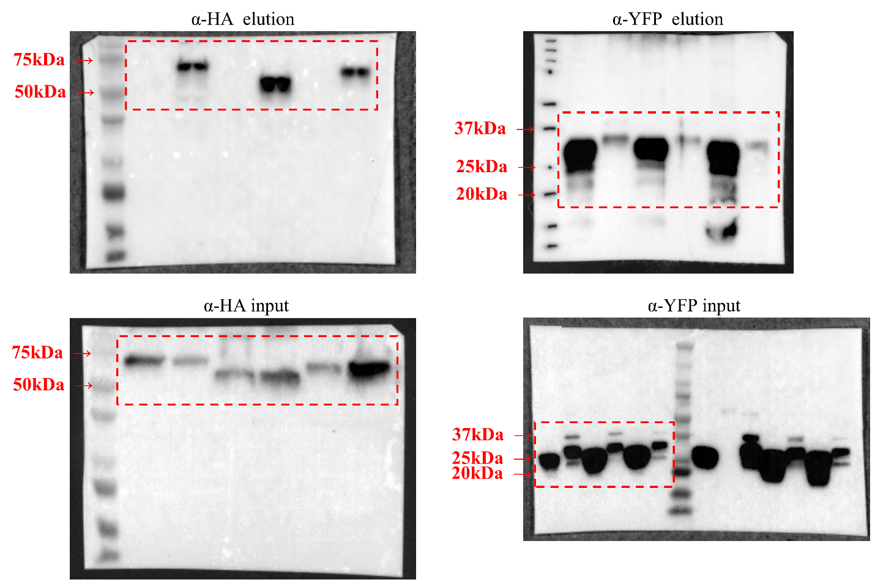

Accompanies Figure 6c
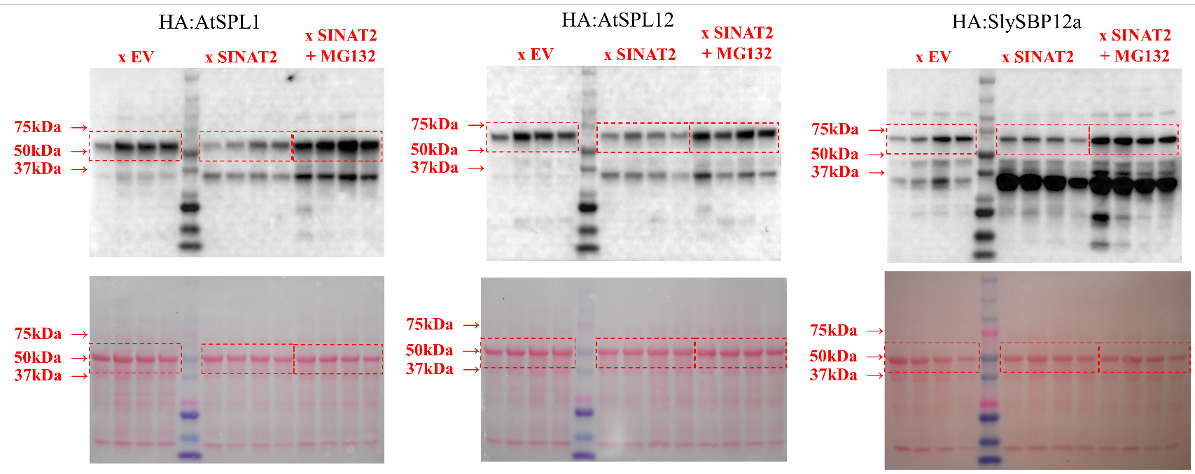

Accompanies Figure 7c
