Supplementary Material
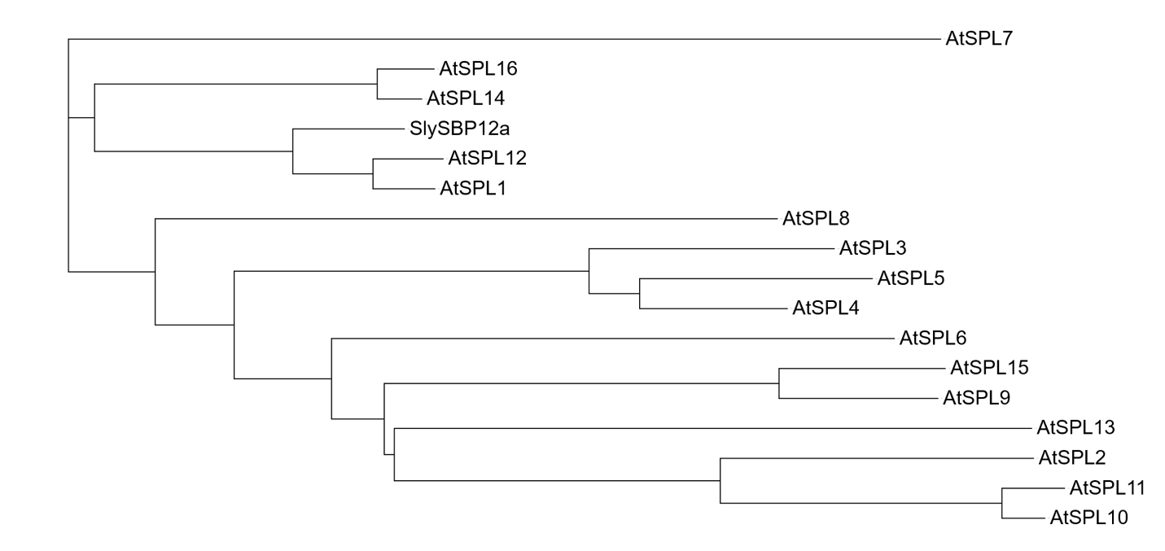
Supplementary Fig. S1: SlySBP12a homology to AtSPL family
Phylogenetic tree showing relationship between SlySBP12a and Arabidopsis thaliana SPL family protein. Tree generated by IQTREE2 and visualized with interactive Tree of Life. Sequences retrieved from Plant Transcription Factor Database.

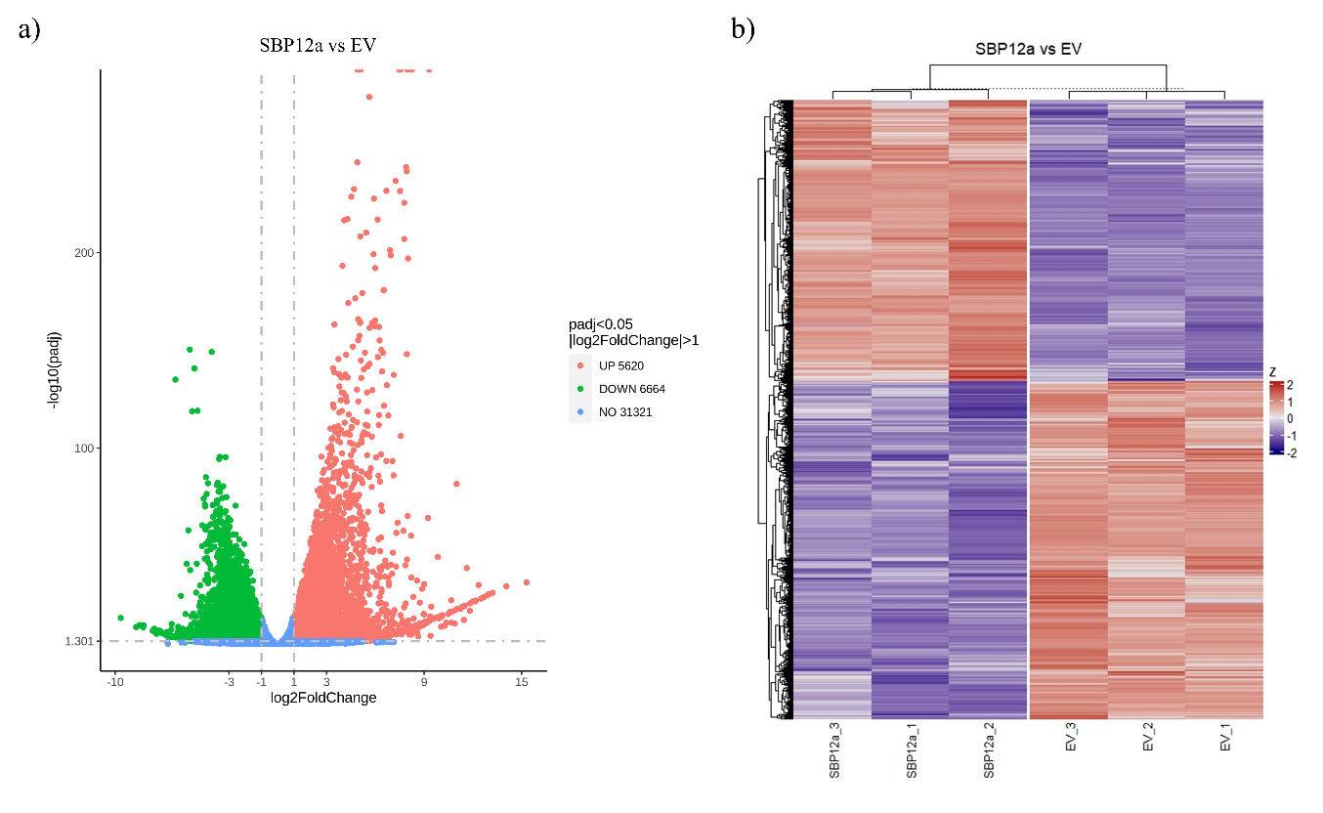
Supplementary Fig S2: RNA sequencing of SlySBP12a(ΔTMD) overexpression in N. benthamiana (a) Volcano plot showing differentially expressed genes (DEGs) in the comparison of SBP12a to the EV control. The x-axis displays log₂ fold change (SBP12a/EV) and the y-axis shows −log₁₀ adjusted P value. Genes passing the significance thresholds (FDR < 0.05 and |log₂FC| ≥ 1) are colored red for up-regulated and blue for down-regulated; non-significant genes are shown in gray. Vertical dashed lines denote the log₂FC cutoff and the horizontal dashed line marks the FDR threshold. (b) Summary heat map showing differentially expressed genes (DEGs) in the comparison of SBP12a to the EV control. Columns are biological replicates grouped by treatment; rows are DEGs passing FDR < 0.05 and |log₂FC| ≥ 1. Values are variance-stabilized expression scaled as row-wise Z-scores. Red indicates higher expression and blue indicates lower expression relative to each gene’s mean; dendrograms show hierarchical clustering.

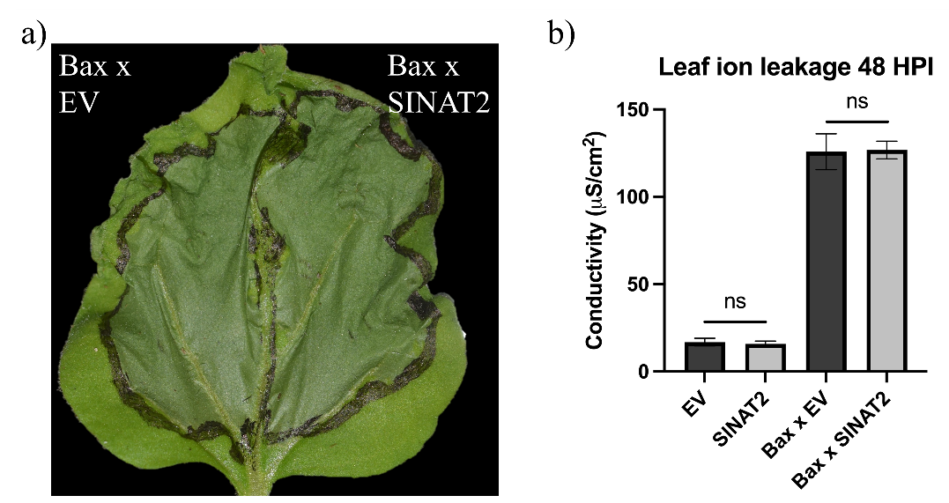
Supplementary Fig. S3: SINAT2 does not inhibit cell death induced by Bax (a) Nicotiana benthamiana leaves infiltrated with Agrobacterium tumefaciens. The left half of each leaf was co-infiltrated with the cell death inducing protein Bax and empty vector at a 1:1 ratio while the right half was transformed with Bax and SINAT2 at a 1:1 ratio. Images were taken 3 days post‐transformation. (b) Electrolyte leakage assay used to quantify cell death. Data is presented as mean ± SEM (n=6).

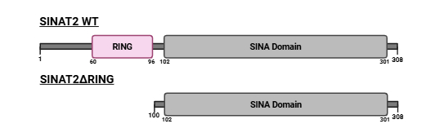
Supplementary Fig. S4: SINAT2ΔRING truncation design Domain structure of wildtype SINAT2 and truncated SINAT2ΔRING. Sequences retrieved from Uniprot and domains predicted with SMART.

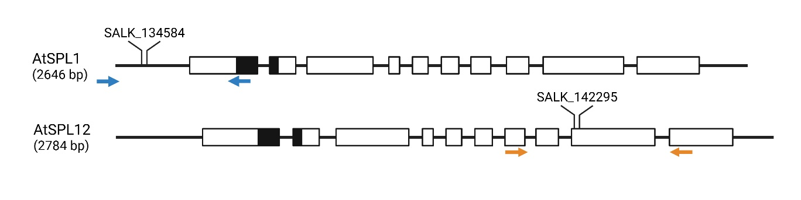
Supplementary Fig. S5: Schematic of Arabidopsis thaliana SPL1 (AT2G47070) and SPL12 (AT3G60030) mutants Diagram of AtSPL1 and AtSPL12 genomic structure, with exons shown as white boxes and introns/UTRs shown as a line. The sequence for the SBP box domain is shown as black filled in box on the exons. Inserts depict the T-DNA insertions in the mutant strains atspl1 (SALK_134584) and atspl12 (SALK_142295), and colored arrows show the locations of genotyping primers used to screen the mutants.

Supplementary Table S1
Target Gene | Primer Sequence | Purpose
AtSPL1 | fwd: 5'-ATGGAAGCTAGAATTGATGAAGG-3' rev: 5'-TCAGCTTGTTCCATAGTCCAATAAC-3' | Overexpression in N. benthamiana, Co-IP, subcellular localization
AtSPL1  (ΔTMD) | fwd: AtSPL1 fwd primer rev: 5'-TCATGTGATCTCCAAGG-3' | Overexpression in N. benthamiana, Co-IP, subcellular localization
AtSPL12 | fwd: 5'-ATGGAAGCTAGAATTGAAGGTG-3' rev: 5'-CTAGCTTGTTCCATACTCAAG -3' | Overexpression in N. benthamiana, Co-IP, subcellular localization
AtSPL12  (ΔTMD) | fwd: AtSPL12 fwd primer rev: 5'-TCATGTTATCTCCAAGCTTG-3' | Overexpression in N. benthamiana, Co-IP, subcellular localization
SINAT2 | fwd: 5'-ATGGCTCCTGGAGGCAGTGCTTTG-3' rev: 5'-TTACTCCTCTTTCCAGATTCG-3' | Overexpression in N. benthamiana, Co-IP
SINAT2  (ΔRING) | fwd: 5'-ATAAGATGCTTAGCTCTTG-3' rev: 5'-SINAT2 rev primer-3' | Overexpression in N. benthamiana
Ser2 | fwd: 5'-ATGTGTTGTTTTCGCCTGCC-3' rev: 5'-TCACAAAGGTTGATGAGC-3' | Overexpression in N. benthamiana
Ser3 | fwd: 5'-ATGAAATTGATCAATCAAACTG-3' rev: 5'-TTAGGATAATTTGCCTTGAG-3' | Overexpression in N. benthamiana
Ser31 | fwd: 5'-ATGGATATCGTATCAAGGATTATG-3' rev: 5'-TTAGTTTCGGTGGAAAGGAAG-3' | Overexpression in N. benthamiana
MMP1 | fwd: 5'-ATGCCTTTGACATTCAATTGG-3' rev: 5'-TCATAAACATAAGGAAAAGATCAAAG-3' | Overexpression in N. benthamiana
MMP2 | fwd: 5'-ATGTCTACGTTTCCAAGTT-3' rev: 5'-TCATAAACATAAAGAAAAGATC-3' | Overexpression in N. benthamiana
Subt | fwd: 5'-ATGAAGAATCGTAACTTTGTAG-3' rev: 5'-TTATGCGGAAGCTGCTGC-3' | Overexpression in N. benthamiana
CathB | fwd: 5'-ATGGCCTTGACCCTGAAG-3' rev: 5'-TCAAAAATAGGCAAATCTTGCG-3' | Overexpression in N. benthamiana
atspl1 LB | 5'-AAAGCCCAGACCATAATGACC-3' | Arabidopsis mutant genotyping PCR
atspl1 RB | 5'-GGAAAAACTGACGTCCCCTAG-3' | Arabidopsis mutant genotyping PCR
atspl12 LB | 5'-CGAGAAGTGACCTCGTAAACG-3' | Arabidopsis mutant genotyping PCR
atspl12 RB | 5'-AAAGCCCAGACCATAATGACC-3' | Arabidopsis mutant genotyping PCR
LBb1.3 | 5'-ATTTTGCCGATTTCGGAAC-3' | Arabidopsis mutant genotyping PCR
attB1 adapter | 5’-GGGGACAAGTTTGTACAAAAAAGCAGGCTGG-3’ | Gateway Cloning
attB2 adapter | 5’-GGGGACCACTTTGTACAAGAAAGCTGGGTG-3’ | Gateway Cloning
NbCathB | fwd: 5'-CCACCCCAAAGTGTCAGAGG-3' rev: 5'-GGAGACCTCGACTGGTCCAT-3' | RT-qPCR probes
NbEF1α | fwd: 5'-AGCTTTACCTCCCAAGTCATC-3' rev: 5'-AGAACGCCTGTCAATCTTGG-3' | RT-qPCR probes

Supplementary Table 2 – Protease list with gene ID and fold change
Gene ID | Log2FC vs EV | Gene Description | Gene Code
Niben101Scf00180g07005 | 7.26 | Serine carboxypeptidase-like 31 | ser31
Niben101Scf06662g02015 | 6.80 | matrix metalloproteinase | mmp1
Niben101Scf00317g04009 | 6.46 | matrix metalloproteinase | mmp2
Niben101Scf02976g00006 | 4.35 | Cathepsin B | cathbA
Niben101Scf07497g01009 | 3.41 | Serine carboxypeptidase-like 2 | ser2
Niben101Scf04560g03001 | 2.63 | Serine carboxypeptidase 3 | ser3
Niben101Scf12205g02009 | 2.11 | subtilisin-like serine protease 2 | subt2

