Table 1. Industrial challenges addressed by selected Industrial Symbiosis interventions
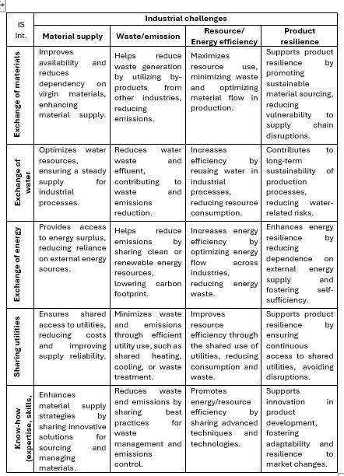
Source: Own Elaboration based on Domenech et al. (2019, Fraccascia (2019) and Vahidzadeh (2021)
Table 2. Quantification of Industrial Symbiosis implementation in identified case studies
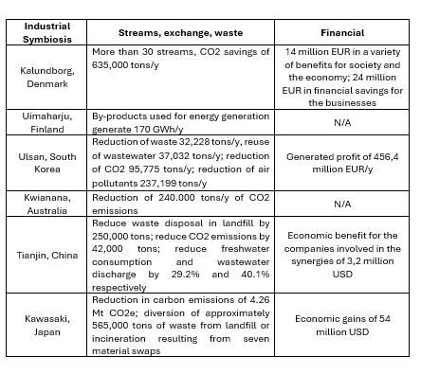
Source: Erceg et al., 2024

