Reduced REM sleep fast theta power suggests early circuit vulnerability in a GBA1 mouse model of prodromal synucleinopathy
Running Title: GBA1 mouse and sleep

Veronica Munday^{1,9†}, Cigdem Gelegen^{1†}, Gemma Deegan^{1,2†}, Katarina Ilic^{1,2}, Alessio Delogu³, Nazanin Biabani¹, Andrew O’Keefe⁴, Clive Ballard⁵, Huiling Tan⁶, Diana Cash², Carlos Schenk⁷, Peter J Goadsby⁸, Phillip Holland^{9†}, Samuel Cooke^{9†}, Ivana Rosenzweig^{1,10†}*
  - †joint authors
*corresponding author

SUPPLEMENTARY DATA

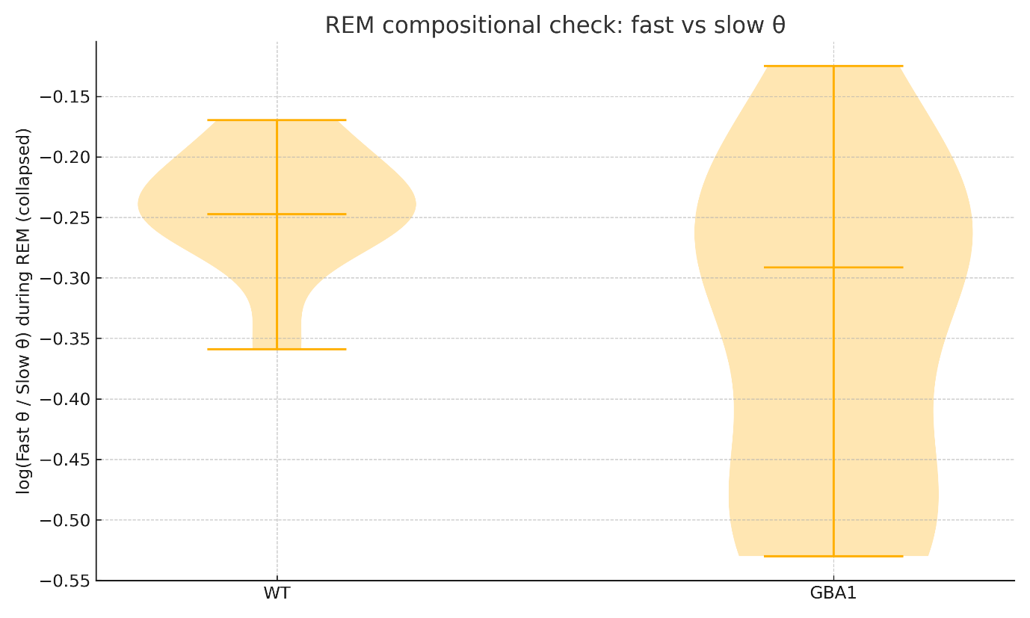
Supplementary Figure S1. Compositional balance within theta during rapid eye movement sleep. Violin plots show the per‑mouse log‑ratio ln(fast theta / slow theta) computed from rapid eye movement values collapsed across Lights‑On and Lights‑Off. Lower values indicate a relative shift toward slower theta components. Group differences were evaluated with Mann–Whitney and with ordinary least squares using cluster‑robust (HC1) standard errors at the animal level. Results: WT ln(fast/slow)=−0.243±0.053 versus GBA1=−0.342±0.139; Δ=−0.099 (95% CI −0.193 to −0.006); Mann–Whitney p=0.051; OLS (HC1) p=0.024.
Abbreviations: OLS, ordinary least squares; HC1, heteroskedasticity‑consistent covariance (type 1); WT, wild‑type; GBA1, D409V/WT glucocerebrosidase heterozygous mutant; IQR, interquartile range.

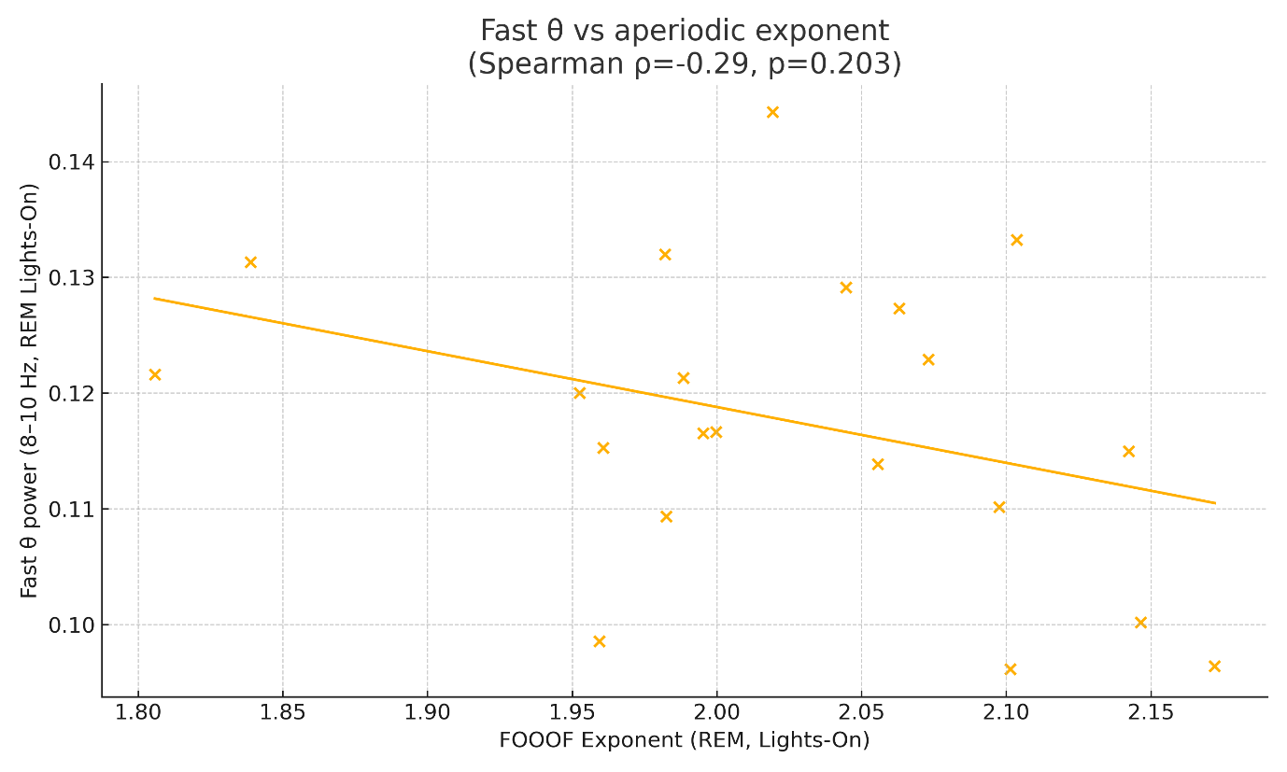
Supplementary Figure S2. Independence of rapid eye movement fast‑theta from the aperiodic background. Scatterplot relates fast‑theta power during rapid eye movement sleep (Lights‑On) to the FOOOF Exponent; line shows least‑squares fit. Spearman correlation indicated no clear association (ρ=−0.29, p=0.203). A similar lack of association was observed for Offset (ρ=0.08, p=0.733; not shown).
Abbreviations: FOOOF, fitting oscillations and one‑over‑f; WT, wild‑type; GBA1, D409V/WT glucocerebrosidase heterozygous mutant.

Supplementary Table S1. Per‑phase REM band comparisons (Lights On/Off).

Band | Phase | WT mean | GBA1 mean | U | p | q (within band) | Cohen d | rank‑biserial r
Delta (1–4 Hz) | On | 0.2144 | 0.2286 | 39.0 | 0.3027 | 0.3028 | 0.6642 | 0.2778
Delta (1–4 Hz) | Off | 0.2228 | 0.2392 | 39.0 | 0.3028 | 0.3028 | 0.5347 | 0.2778
Fast Theta (8–10 Hz) | On | 0.1249 | 0.1122 | 83.0 | 0.0428 | 0.0816 | -1.1061 | -0.5370
Fast Theta (8–10 Hz) | Off | 0.1292 | 0.1145 | 79.0 | 0.0816 | 0.0817 | -0.9712 | -0.4629
Slow Theta (5–7 Hz) | On | 0.1668 | 0.1634 | 60.0 | 0.6959 | 0.9151 | -0.2104 | -0.1111
Slow Theta (5–7 Hz) | Off | 0.1576 | 0.1547 | 52.0 | 0.9151 | 0.9151 | -0.1912 | 0.0370
Theta (5–10 Hz) | On | 0.3959 | 0.3681 | 72.0 | 0.2136 | 0.3373 | -0.7011 | -0.3333
Theta (5–10 Hz) | Off | 0.3866 | 0.3572 | 68.0 | 0.3373 | 0.3373 | -0.6787 | -0.2593

Legend: WT vs GBA1 within each band and phase using Mann–Whitney. q-values control the within‑band family (two phases).
Abbreviations: WT, wild‑type; GBA1, D409V/WT heterozygous; q, BH‑FDR within band.

Supplementary Table S2. Collapsed per‑animal.
Band | WT mean | WT SD | GBA1 mean | GBA1 SD | U | p | q (across bands) | Cohen d | rank‑biserial r
Delta (1–4 Hz) | 0.2186 | 0.0242 | 0.2339 | 0.0258 | 40.0 | 0.3374 | 0.4498 | 0.6086 | 0.2593
Fast Theta (8–10 Hz) | 0.1271 | 0.0120 | 0.1134 | 0.01321 | 81.0 | 0.0597 | 0.2387 | -1.0803 | -0.5
Slow Theta (5–7 Hz) | 0.1623 | 0.0179 | 0.1591 | 0.0131 | 57.0 | 0.8589 | 0.8589 | -0.2096 | -0.0556
Theta (5–10 Hz) | 0.3913 | 0.0510 | 0.3627 | 0.0309 | 72.0 | 0.2136 | 0.4272 | -0.7055 | -0.3333

Legend: Per‑animal averages across Lights On and Off; Mann–Whitney per band. q-values control the four‑band family. Cohen’s d and rank‑biserial r are reported.

Supplementary Table S3. Cluster‑robust OLS sensitivity.

Band | β_Geno (robust OLS) | SE (HC1) | t | p | q (across bands)
Delta (1–4 Hz) | 0.0142 | 0.0098 | 1.4586 | 0.1447 | 0.1929
Fast Theta (8–10 Hz) | -0.0128 | 0.0049 | -2.5613 | 0.0104 | 0.0417
Slow Theta (5–7 Hz) | -0.0035 | 0.0077 | -0.4471 | 0.6548 | 0.6548
Theta (5–10 Hz) | -0.0279 | 0.0186 | -1.498 | 0.1341 | 0.1929

Legend: OLS with Value ~ 1 + Genotype + Phase + Genotype×Phase; HC1 cluster‑robust SEs per-animal. q-values across bands for the Genotype effect.
Abbreviations: HC1, heteroskedasticity‑consistent covariance (type 1).

Supplementary Table S4. Bayesian bootstrap posterior summaries.

Band | Posterior mean Δ (GBA1−WT) | 95% CrI low | 95% CrI high | P(Δ<0)
Delta (1–4 Hz) | 0.01520 | -0.00351 | 0.03484 | 0.0571
Fast Theta (8–10 Hz) | -0.0137 | -0.02385 | -0.00421 | 0.9974
Slow Theta (5–7 Hz) | -0.0032 | -0.01593 | 0.00935 | 0.6932
Theta (5–10 Hz) | -0.0287 | -0.06378 | 0.00360 | 0.9574

Legend: Non‑parametric Bayesian bootstrap on per‑animal collapsed values; posterior for Δ = μ_GBA1 − μ_WT with 95% credible interval and tail probability P(Δ<0).
Abbreviations: CrI, credible interval.

Supplementary Data S1 (Excel). Per-mouse REM aperiodic parameters (Offset, Exponent) and aggregated spectral metrics underlying Fig. 5 and Table 2. (File: Supplementary Data S1.xlsx.)

