Supplementary Information

Structural basis for selective remdesivir addition by SARS-CoV-2 polymerase, and S759A resistance
Calvin J. Gordon^{1,#}, Mizar F. Oliva^{2,#}, Hery W. Lee¹, Brent De Wijngaert², Matthias Götte^{1,*}, and Kalyan Das^{1,2,*}
¹Department of Medical Microbiology and Immunology, University of Alberta, Edmonton AB T6G 2T9, Canada.
²Molecular Structural and Translational Virology, Department of Microbiology, Immunology and Transplantation, Rega Institute for Medical Research, KU Leuven, 3000 Leuven, Belgium.
# Equal contributions
*Correspondence emails: kalyan.das@kuleuven.be; gotte@ualberta.ca

Table S1 - Single particle cryo-EM data and structure analysis statistics.
 | WT-AMP  (EMD-54695)  (PDB 9SAR) | WT-RMP  (EMD-54693)  (PDB 9SAP) | S759A-AMP  (EMD-54694)  (PDB 9SAQ) | S759A-RMP  (EMD-54692)  (PDB 9SAO)
Data collection and processing
Magnification | 130,000x | 130,000x | 130,000x | 130,000x
Voltage (kV) | 200 | 200 | 200 | 200
Electron exposure (e-/Å²) | 40 | 40 | 40 | 40
Defocus range (um) | -0.6 to -1.8 | -0.6 to -1.8 | -0.6 to -1.8 | -0.6 to -1.8
Pixel size | 0.9 | 0.9 | 0.9 | 0.9
Symmetry imposed | C1 | C1 | C1 | C1
Initial particle images (no.) | 654,460 | 1,237,567 | 1,002,711 | 738,355
Final particle images (no.) | 109,207 | 145,169 | 93,716 | 167,051
Map resolution (Å) | 2.8 | 2.9 | 3.1 | 2.9
FSC threshold | 0.143 | 0.143 | 0.143 | 0.143
Local resolution estimation (Å) | 6.2 to 2.8 | 6.3 to 2.9 | 6.2 to 3.1 | 6.5 to 2.9
Refinement
initial model used (PDB ID) | 7DOK | 9SAR | 9SAR | 9SAR
Model resolution (Å) | 3.0 | 2.6 | 2.7 | 2.8
FSC threshold | 0.143 | 0.143 | 0.143 | 0.143
Model resolution range (Å) | 100 to 3.0 | 100 to 2.6 | 100 to 2.7 | 100 to 2.8
Map sharpening B factor (Å²) | -94 | -98 | -82 | -105
Model composition
Non-hydrogen atoms | 9330 | 8663 | 9305 | 8697
Protein residues | 1084 | 1007 | 1082 | 1011
Nucleotide residues | 31 | 25 | 31 | 25
Ligands | Zn:2 | F86:3  Zn:2 | Zn:2 | F86:3  Zn:2
B factors (Å²)
Protein | 74.86 | 45.04 | 25.78 | 54.58
Nucleotide | 109.08 | 43.81 | 75.59 | 54.18
Ligands | 82.91 | 19.27 | 26.64 | 17.24
R.m.s. deviations
Bond lengths (Å) | 0.007 | 0.005 | 0.006 | 0.004
Bond angles (°) | 0.937 | 0.793 | 0.873 | 0.618
Validation
MolProbity score | 1.42 | 1.78 | 1.75 | 1.80
Clash score | 4.30 | 5.46 | 3.21 | 5.97
Poor rotamers (%) | 0.42 | 2.13 | 3.67 | 2.24
Ramachandran plot
Favored (%) | 96.65 | 96.48 | 96.74 | 96.70
Allowed (%) | 3.17 | 3.52 | 3.26 | 3.30
Disfavored (%) | 0.19 | 0.00 | 0.00 | 0.00

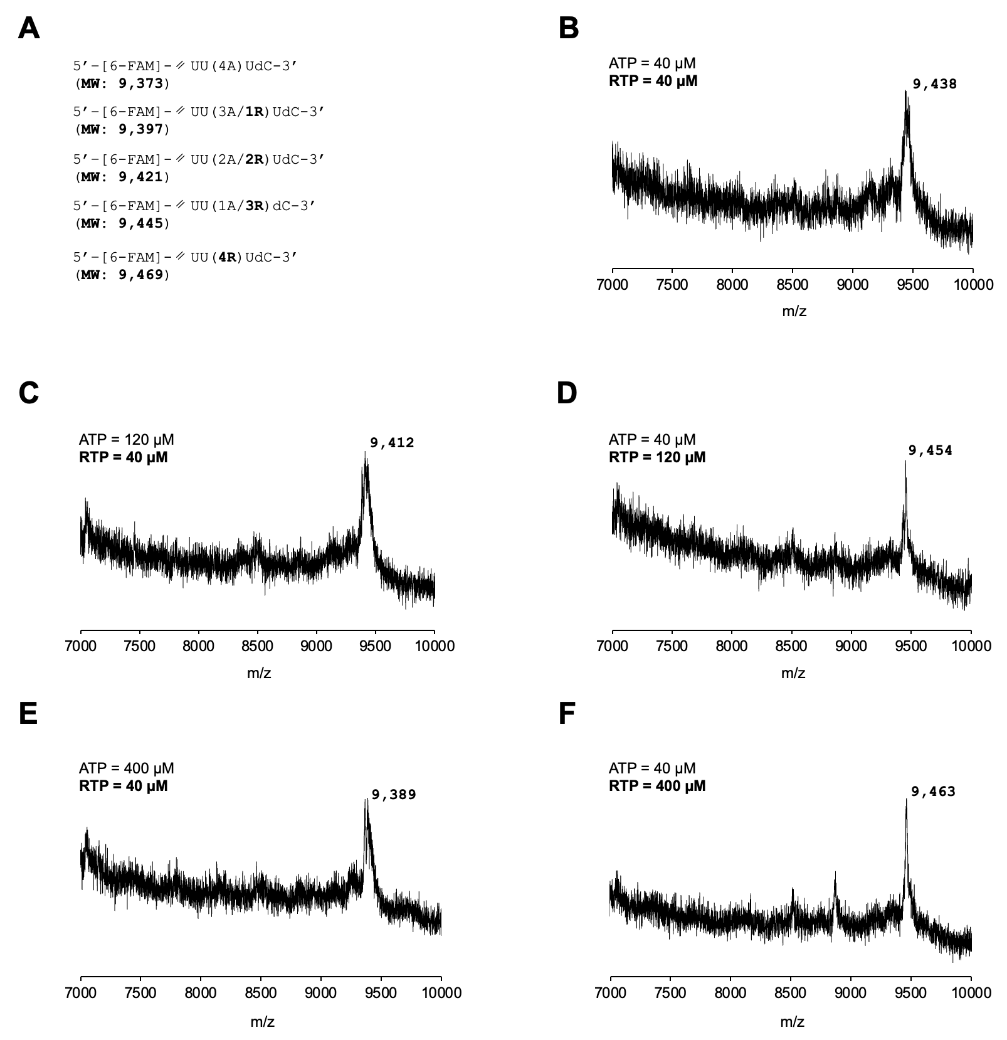
Figure S1: MALDI-TOF mass spectra for the RNA product generated by SARS-CoV-2 RdRp complex under different ratios of ATP to RTP. A, the potential sequence outcomes and their predicted molecular mass are shown in brackets below. B-F are the RNA MALDI-TOF mass spectra that resulted from different concentrations of ATP and RTP, which are shown above each graph.
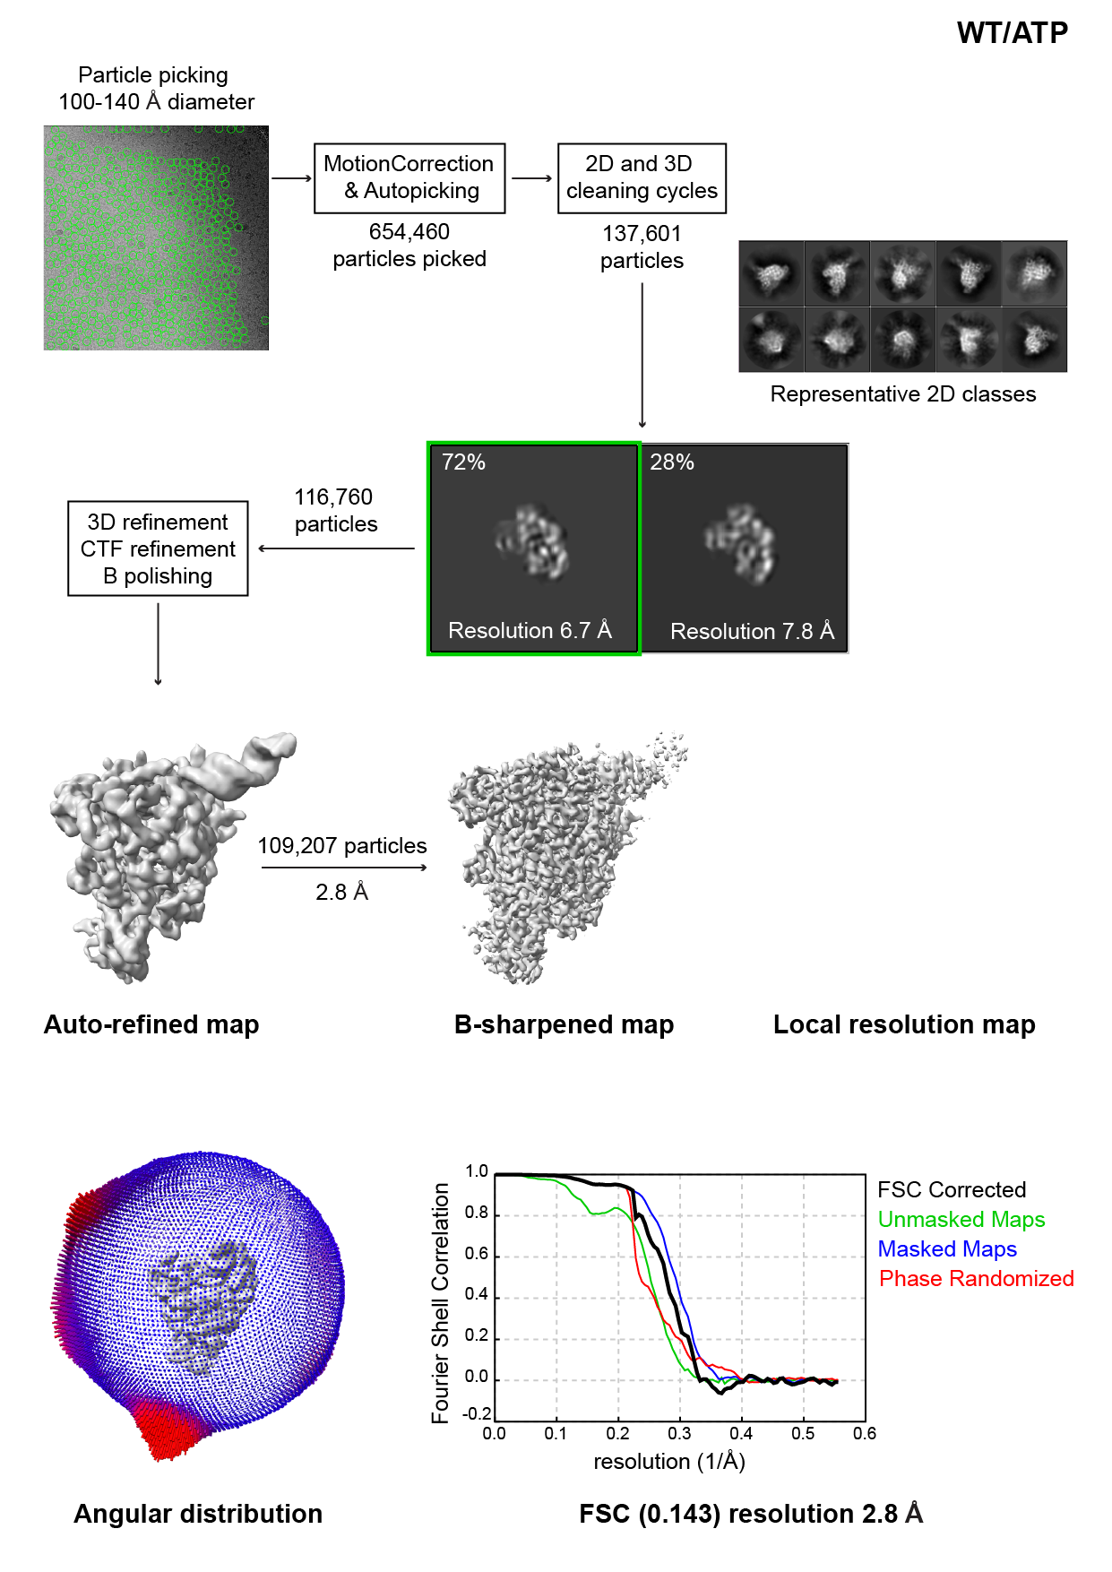
Figure S2A: Cryo-EM image processing flowcharts summarizing the data processing and the density map quality, particle distribution and resolution of WT-AMP structure.

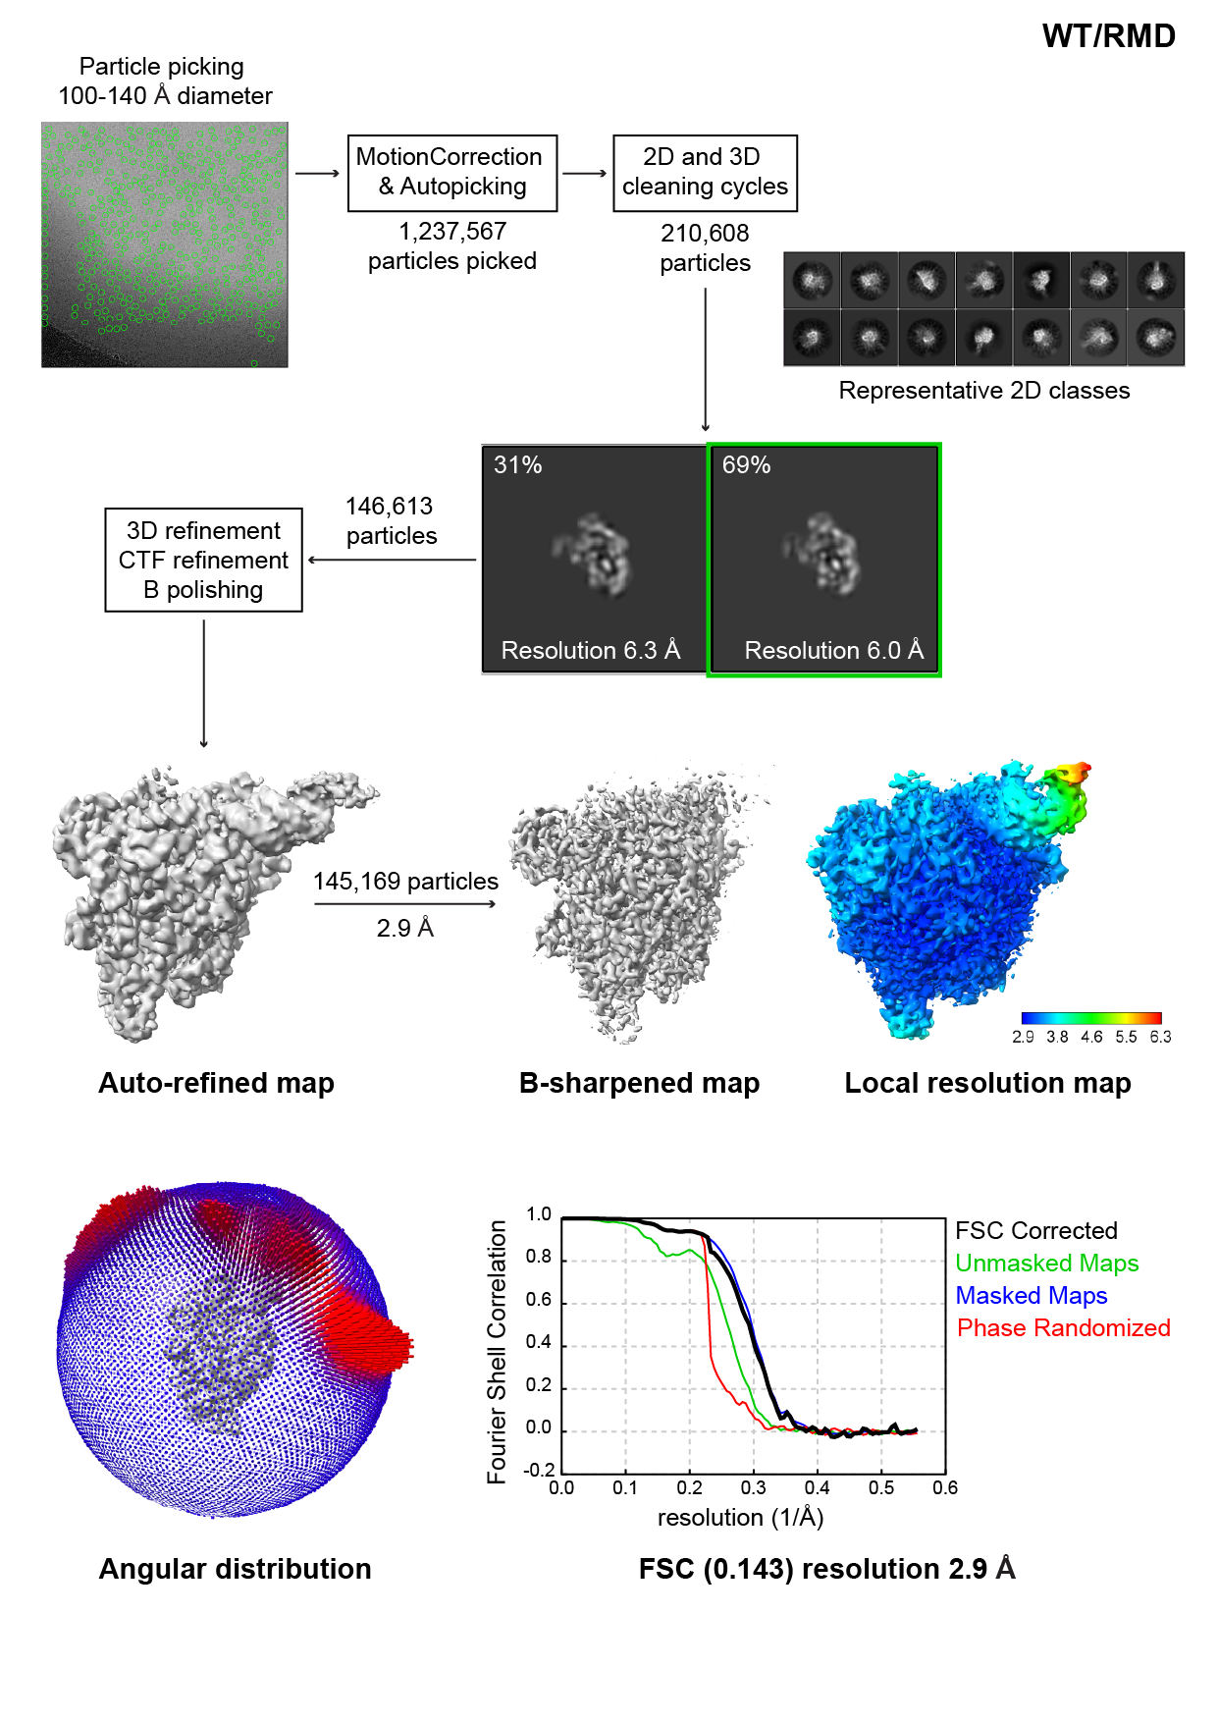
Figure S2B: Cryo-EM image processing flowcharts summarizing the data processing and the density map quality, particle distribution and resolution of WT-RMP structure.

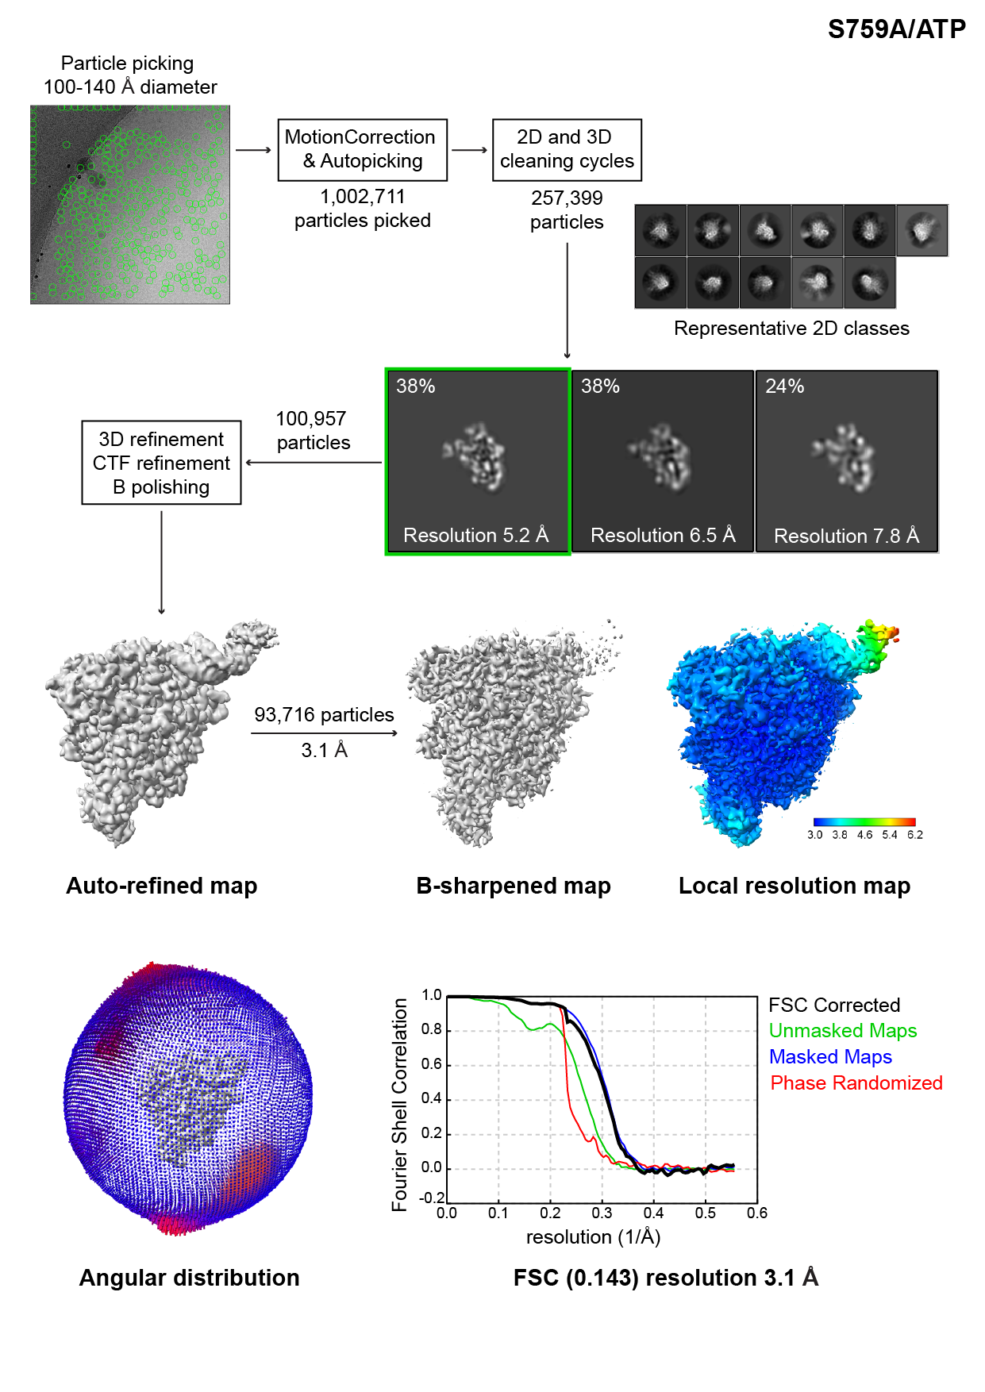
Figure S2C: Cryo-EM image processing flowcharts summarizing the data processing and the density map quality, particle distribution and resolution of S759A-AMP structure.

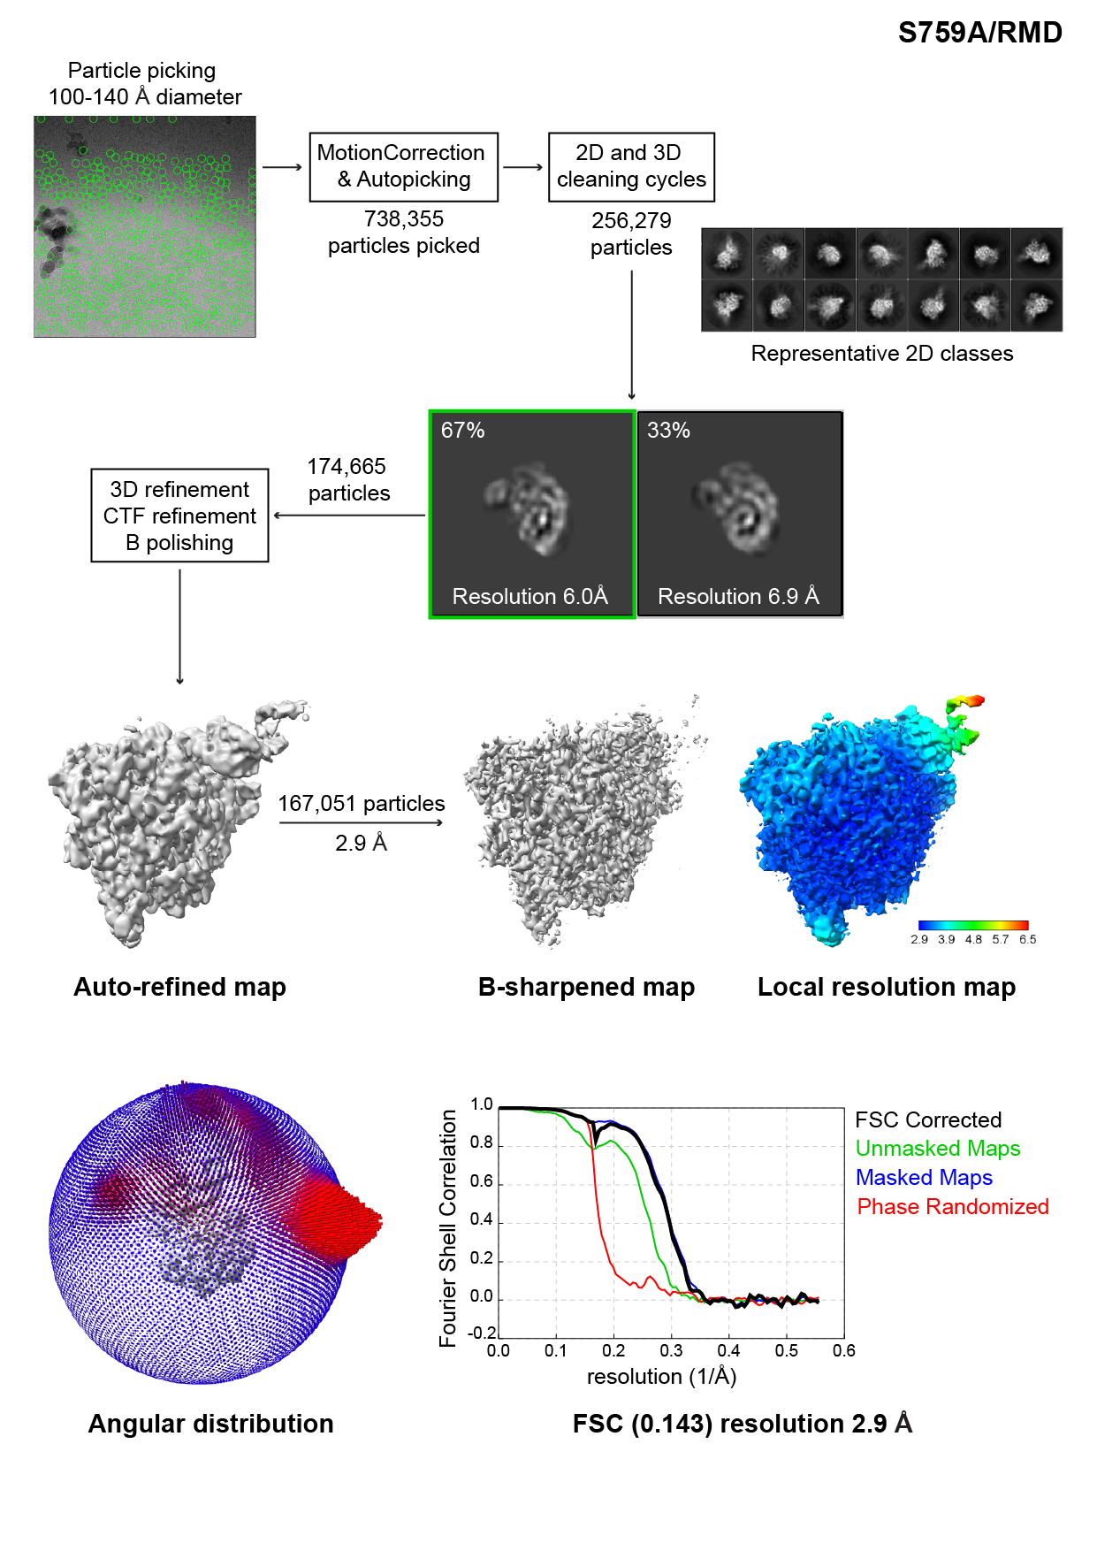
Figure S2D: Cryo-EM image processing flowcharts summarizing the data processing and the density map quality, particle distribution and resolution of S759A-RMP structure.

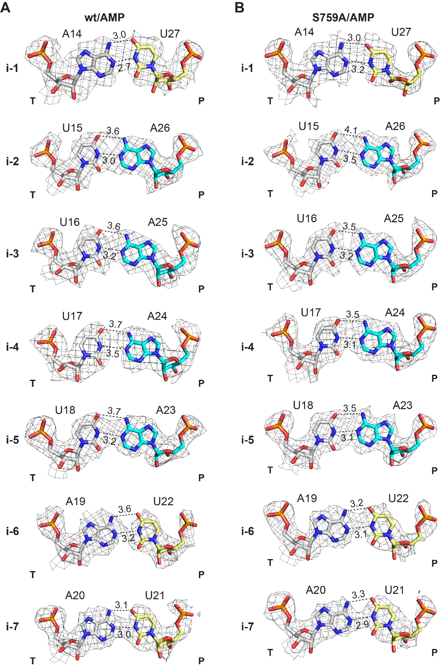
Figure S3: ATP incorporation in WT and S759A RdRp complexes. Atomic model and electron density of different positions of the RNA template(T):primer(P) strands. Bases are shown as sticks, colored following the scheme of Figure 1 and density maps are contoured at 3.0 σ. A, WT-AMP complex bps at positions i-7 to i-1 (from bottom to top). B, S759A-AMP complex bps modelled at positions i-1 to i-7 (from top to bottom).

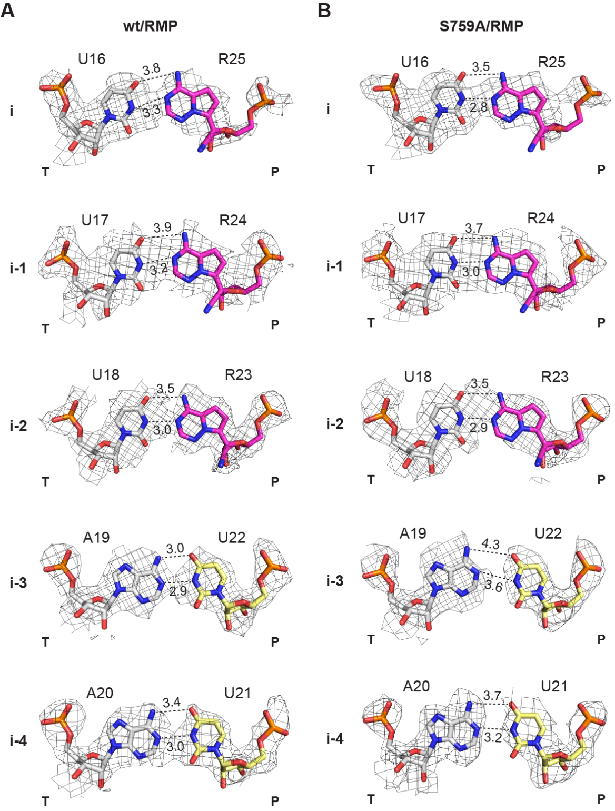
Figure S4: RDV incorporation in WT and S759A RdRp complexes. Atomic model and electron density of different positions in the RNA template(T):primer(P) strands. Bases are shown as sticks, colored as in Figure 1, density maps are contoured at 3.0 σ. A WT-RMP complex bpss modelled at positions i-4 to i (from bottom to top). B S759A-RMP complex bps modelled at positions i-4 to i (from bottom to top).

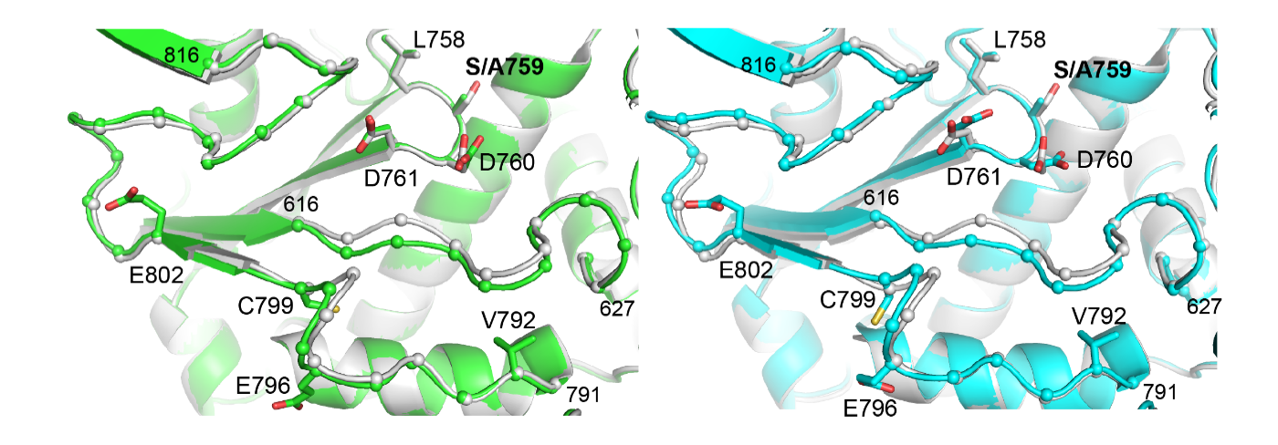
Figure S5: Shift of the palm domain loops in the S759A structures. Overlap of the palm domain segments between the WT-AMP (gray), S759A-RMP (cyan) and S759A-RMP (green). Residues of the LS(A)DD domain are labelled and shown as sticks. The loops showing largest movements are depicted with the C⍺ represented as spheres with only the residues at the extremities numbered for simplicity.

