Supplementary Table 1. Cortical parcels corresponding to selected brain ROIs
Cortical Parcel
L dPFC | R dPFC
17 Networks_LH_ContA_PFCd_1 | 17 Networks_RH_ContB_PFCld_1
17 Networks_LH_ContB_PFCd_1 | 17 Networks_RH_ ContB _PFCld_2
 | 17 Networks_RH_ ContB _PFCld_3
L dPFC Sup | R dPFC Sup
17 Networks_LH_DefaultB_PFCd_2 | 17 Networks_RH_DefaultA_PFCd_1
17 Networks_LH_DefaultB_PFCd_3 | 17 Networks_RH_DefaultA_PFCd_2
17 Networks_LH_DefaultB_PFCd_4 | 17 Networks_RH_DefaultB_PFCd_2
ROI = region of interest; L = left; R = right; dPFC = dorsal prefrontal cortex; Sup = Superior.

Effective Connectivity Statistical Analysis—Path Presence
Methods
To determine whether the presence of a specific subgroup-level path within the models were associated with group, we conducted a chi-square test comparing the frequency of the path across subgroups. A logistic regression was then performed for each subgroup-level path generated across the three models (HC vs. SZ: paths = 3; negative symptom severity: paths = 1; positive symptom severity: paths =1) among participants in whom the path was present, to assess whether subgroup membership (i.e. HC vs. SZ or mild vs. severe) predicted path presence while accounting for potential confounding variables (age, sex, and mean framewise displacement, illness-to-life ratio, and Olanzapine equivalency scores).
Results
There was no significant difference in the frequency of occurrence of the subgroup-level paths between groups in the HC vs. SZ. Subgroup membership was not a significant predictor of path presence for any of the paths tested, with the exception of the model defined by positive symptom severity, which showed a significant association (OR = -2.576, p = 0.015).
Supplementary Table 2: Summary of symptom and group effects on path presence and strength
Path | Test Type | Variable | Estimate | p-value
RH dlPFC superior → RH dlPFC lagged | Presence (GLM) | Group (SZ vs HC) | OR = -0.226 | 0.556
RH dlPFC superior → RH dlPFC lagged | Strength (r) | Positive Symptoms | r = 0.160 | 0.358
RH dlPFC superior → RH dlPFC lagged | Strength (r) | Negative Symptoms | r = 0.022 | 0.901
RH dlPFC superior → RH dlPFC lagged | Strength (r) | Composite Score | r = 0.102 | 0.560
RH dlPFC → Cerebellum 13 | Presence (GLM) | Group (SZ vs HC) | OR = -0.472 | 0.231
RH dlPFC → Cerebellum 13 | Strength (r) | Positive Symptoms | r = -0.103 | 0.557
RH dlPFC → Cerebellum 13 | Strength (r) | Negative Symptoms | r = 0.002 | 0.992
RH dlPFC → Cerebellum 13 | Strength (r) | Composite Score | r = -0.079 | 0.653
Cerebellum 13 → Cerebellum 17 | Presence (GLM) | Group (SZ vs HC) | OR = 0.072 | 0.844
Cerebellum 13 → Cerebellum 17 | Strength (r) | Positive Symptoms | r = -0.217 | 0.257
Cerebellum 13 → Cerebellum 17 | Strength (r) | Negative Symptoms | r = -0.195 | 0.312
Cerebellum 13 → Cerebellum 17 | Strength (r) | Composite Score | r = 0.017 | 0.931
LH dlPFC superior → RH dlPFC superior lagged | Presence (GLM) | Group (Mild vs. Severe) | OR = -2.576 | 0.015*
LH dlPFC superior → RH dlPFC superior lagged | Strength (r) | Positive Symptoms | r = -0.258 | 0.088
LH dlPFC superior → RH dlPFC superior lagged | Strength (r) | Negative Symptoms | r = -0.045 | 0.770
LH dlPFC superior → RH dlPFC superior lagged | Strength (r) | Composite Score | r = -0.159 | 0.296
* p > 0.05
Static Connectivity
Methods
Static atlas-based connectivity matrices for the Schaefer combined atlas were calculated using HALFpipe. Connectivity values are correlations between BOLD signals of each ROI from the Schaefer combined atlas across a time-series calculated using nilearn’s connectivity measure. The connectivity analysis data was then filtered in R to only include the desired brain regions (bilateral putamen, bilateral caudate, bilateral accumbens area, cerebellum, bilateral dlPFC, and bilateral superior dlPFC). The dlPFC areas of interest consisted of several atlas regions and any correlates from these areas were combined into a single averaged data point, which was used in the regression. Several regressions were run with the PANSS total negative symptoms scores, PANSS total positive symptoms, and PANSS composite scores as predictors and the brain regions of interest as dependent variables. The covariates in all PANSS regressions were age, gender, total Olazapine equivalent dose, and framewise displacement. A group-level comparison regression was also completed in R between healthy controls and individuals with schizophrenia. In this regression, group is a predictor, brain regions of interest are dependent variables, and age, gender, and framewise displacement are covariates. BH-corrected p-values were added to results for all regressions to account for multiple comparisons. The results are presented in the figures below: Supplemental Figure 1 shows the connectivity matrices filtered at an uncorrected p < .05, reflecting reduced connectivity in SZ relative to HC, on the left. An exception was the correlation between left DLPFC and cerebellum network 8 where SZ > HC. The heatmap on the right shows the general pattern of increased connectivity related to increased symptom scores.

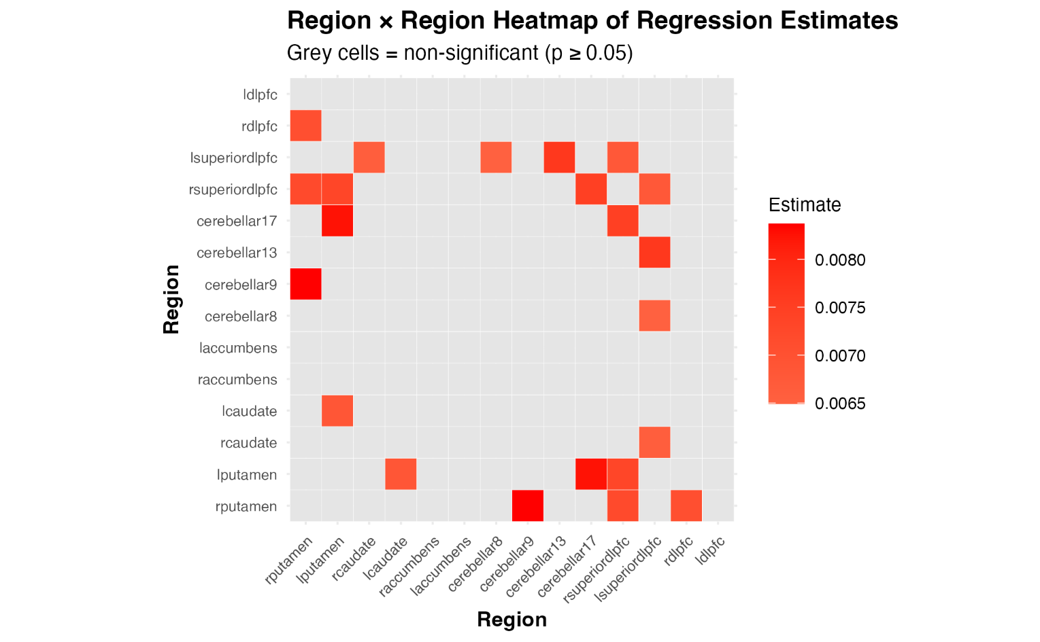
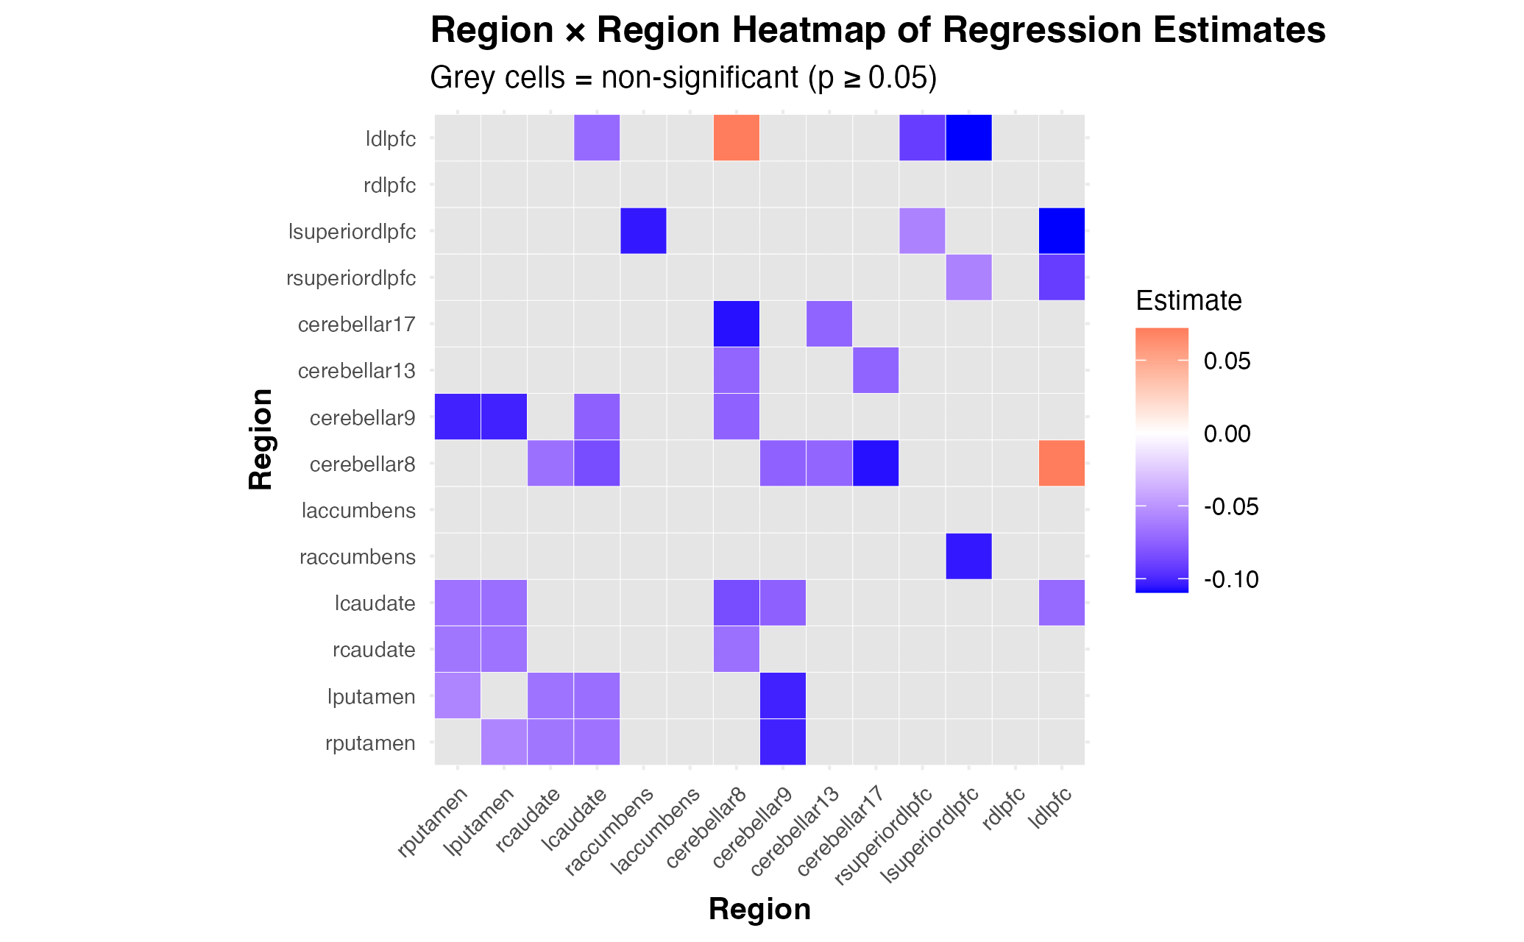
Supplementary Figure 1: Heatmaps representing ROI × ROI static connectivity of regression estimates
A
B
Heatmaps representing ROI × ROI static connectivity of regression estimates for A) healthy control vs. individuals with schizophrenia, with blue indicating hypoconnectivity in SZ relative to HC and B) individuals with schizophrenia only, with brighter red indicating a higher composite PANSS score, or positive symptom predominance. *Right Putamen × Left Putamen (HC vs. SZ): Bonferroni corrected p = 0.0246. All other static connections did not pass Bonferroni correction (uncorrected p ≤ 0.05).

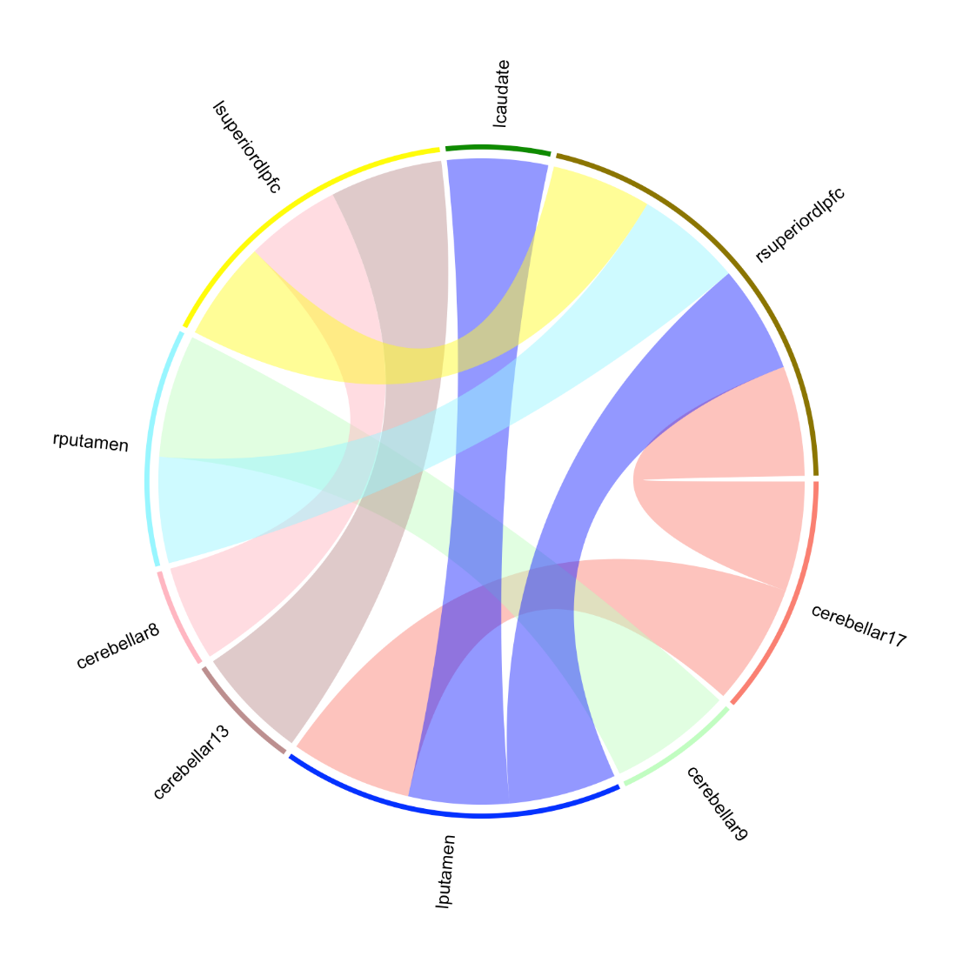
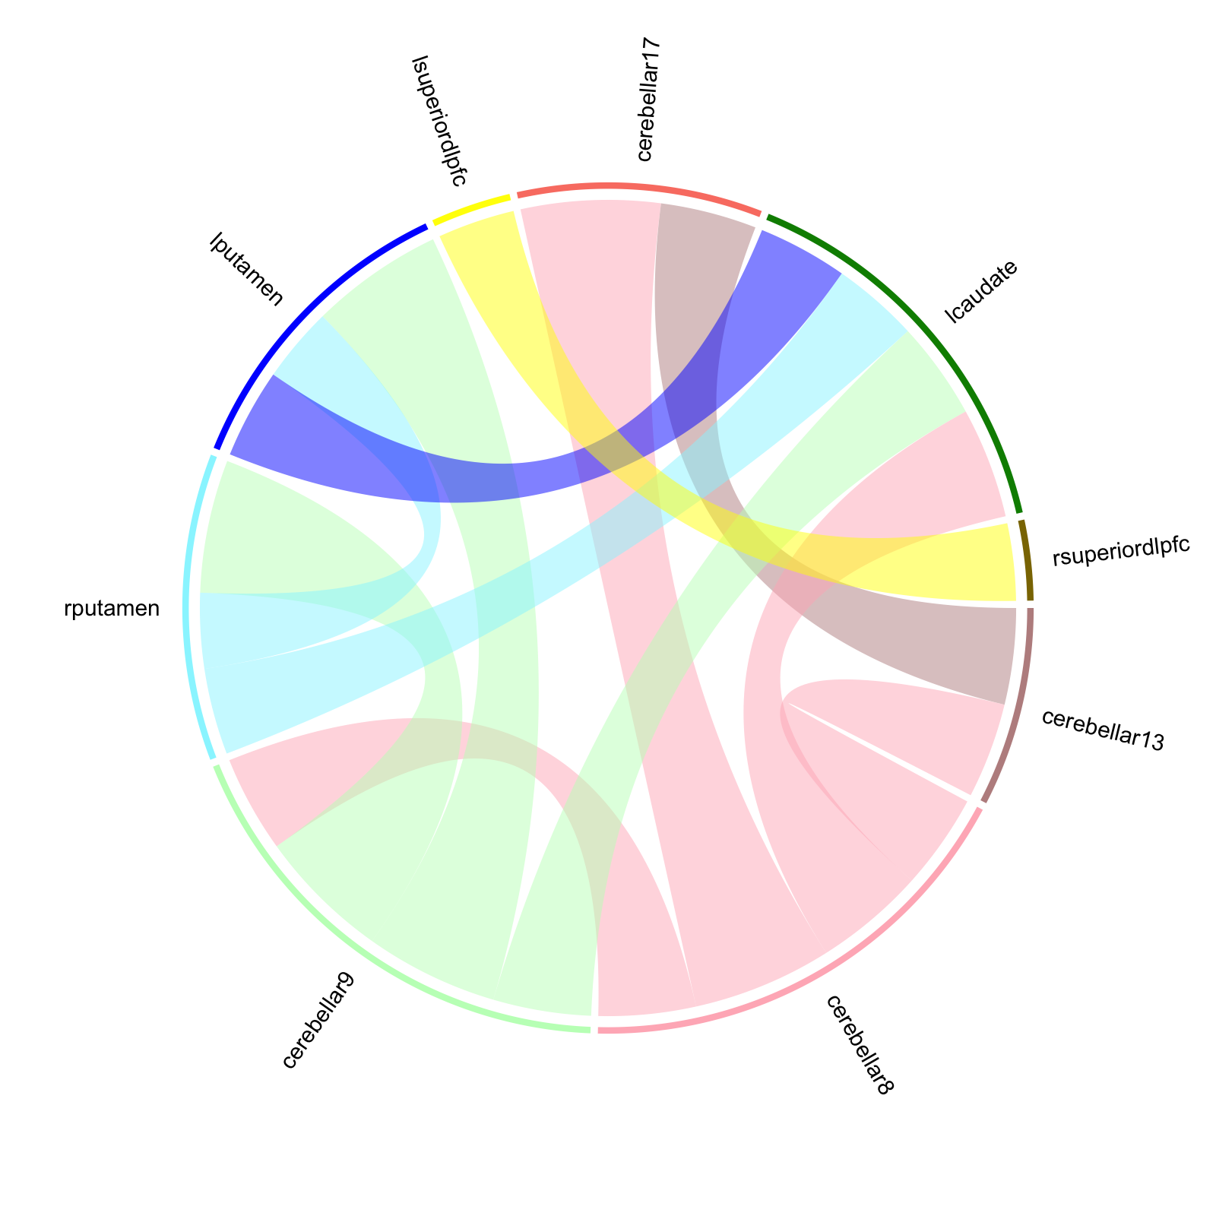
Supplemental Figure 2: Regression-based static connectivity patterns in healthy controls and individuals with schizophrenia
A
B

Significant connections at the uncorrected p < 0.05 level between regions included in the GIMME models (bilateral putamen, left caudate, bilateral superior dlPFC, cerebellar 8, cerebellar 9, cerebellar 13, cerebellar 17) for A) healthy controls vs. schizophrenia and B) schizophrenia-only by composite PANSS score. The ROIs included in these graphs are connections that appear in both the static and effective connectivity analyses. The thickness of each cord connecting the regions represents the strength of the regression estimate of the connection.
Supplemental Table 3: Group-level path coefficient analysis
Path | Predictor | β coefficient | stderr | t | p | CI Lower | CI Higher | p (FDR)
HC vs SZ
Cerebellum 13 Cerebellum 8 | Group | -0.137 | 0.053 | -2.612 | 0.010 | -0.241 | -0.033 | 0.261
Cerebellum 8 Cerebellum 9 | Group | -0.118 | 0.052 | -2.272 | 0.025 | -0.221 | -0.015 | 0.298
Left Putamen Left Putamen lag | Group | -0.072 | 0.035 | -2.095 | 0.038 | -0.141 | -0.004 | 0.298
Right Caudate Right Caudate lag | Group | -0.039 | 0.019 | -2.016 | 0.046 | -0.077 | -0.001 | 0.298
Left superior dlPFC Left superior dlPFC lag | Age | -0.005 | 0.001 | -4.241 | 0.000 | -0.008 | -0.003 | 0.001**
Right dlPFC Right dlPFC lag | Age | -0.004 | 0.001 | -2.885 | 0.005 | -0.007 | -0.001 | 0.040*
Left Putamen Right Putamen | Age | -0.005 | 0.001 | -4.034 | 0.000 | -0.008 | -0.003 | 0.001**
Negative Symptom Severity
Left superior dlPFC Cerebellum 17 | Group | 0.106 | 0.039 | 2.691 | 0.010 | 0.027 | 0.186 | 0.283
Left superior dlPFC Left superior dlPFC lag | Age | -0.009 | 0.002 | -4.056 | 0.000 | -0.013 | -0.005 | 0.005**
Left Putamen Right Putamen | Age | -0.010 | 0.003 | -3.144 | 0.003 | -0.016 | -0.004 | 0.041*
Positive Symptom Severity
Right superior dlPFC Right superior dlPFC lag | Group | -0.117 | 0.047 | -2.498 | 0.016 | -0.212 | -0.023 | 0.463
Cerebellum 9 Cerebellum 9 lag | Group | 0.091 | 0.045 | 2.046 | 0.046 | 0.002 | 0.181 | 0.535
Left superior dlPFC Left superior dlPFC lag | Age | -0.008 | 0.002 | -3.819 | 0.000 | -0.013 | -0.004 | 0.011*
Left superior dlPFC Cerebellum 17 | Age | -0.006 | 0.002 | -3.241 | 0.002 | -0.010 | -0.002 | 0.027*
Left Putamen Right Putamen | Age | -0.010 | 0.003 | -3.153 | 0.003 | -0.016 | -0.004 | 0.027*
Left dlPFC Left dlPFC lag | FD | -0.546 | 0.165 | -3.300 | 0.002 | -0.878 | -0.213 | 0.044*
Cerebellum 13 Cerebellum 17 | FD | 0.804 | 0.268 | 2.999 | 0.004 | 0.265 | 1.342 | 0.044*
Cerebellum 8 Cerebellum 13 | FD | 0.685 | 0.230 | 2.975 | 0.005 | 0.222 | 1.148 | 0.044*
* p > 0.05; ** p > 0.01
Supplemental Figure 3: Distribution of Predicted Connectivity Estimates for Healthy Controls and Persons with Schizophrenia
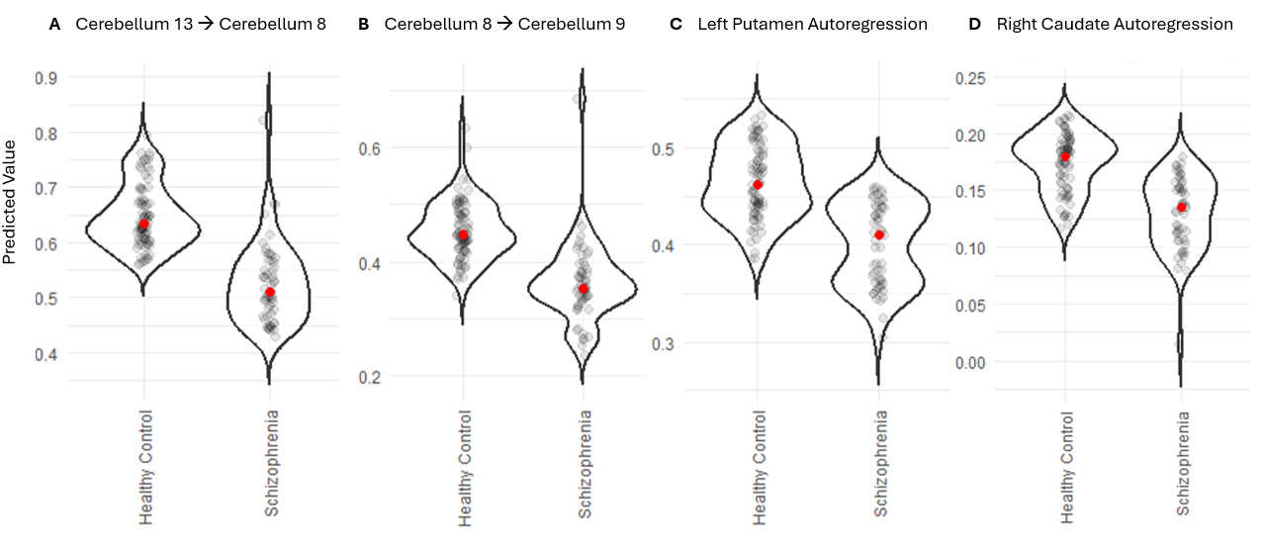

Predicted values of contemporaneous and regional temporal autocorrelation estimates by diagnostic group after controlling for age, gender, and average framewise displacement.

Supplemental Figure 4: Distribution of Predicted Connectivity Estimates for Persons with Schizophrenia by Positive and Negative Symptom Severity
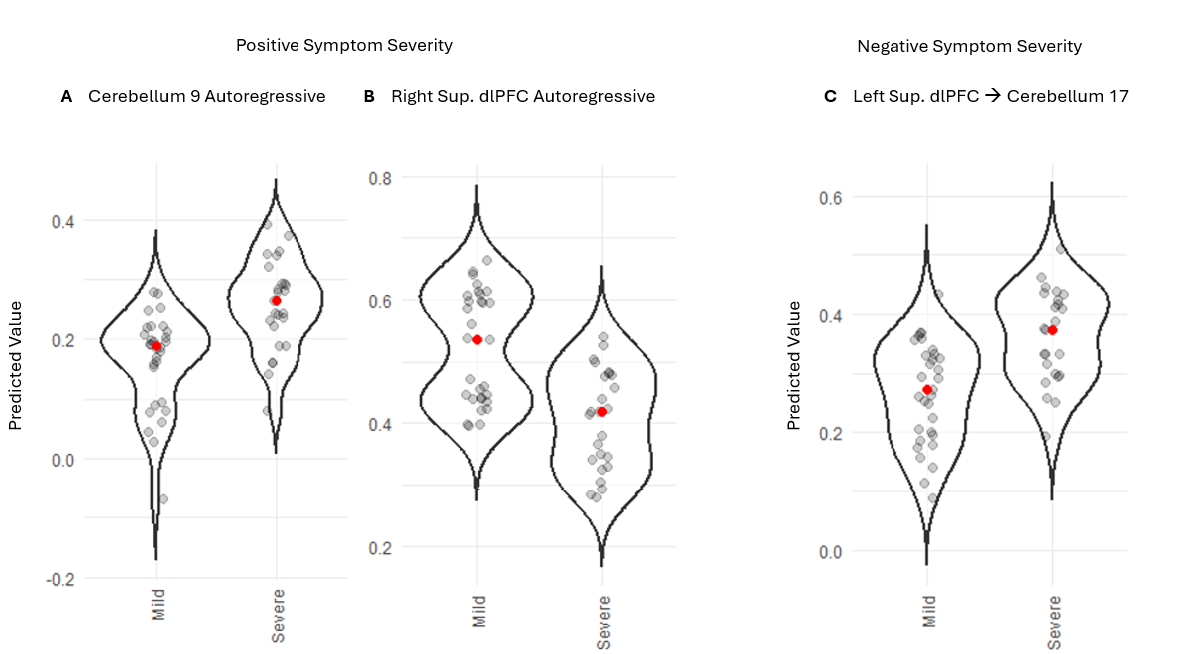
Predicted values of regional temporal autocorrelation estimates by A, B) positive symptom severity and contemporaneous values by C) negative symptom severity after controlling for age, gender, average framewise displacement, and Olanzapine equivalency scores. dlPFC = dorsolateral prefrontal cortex

