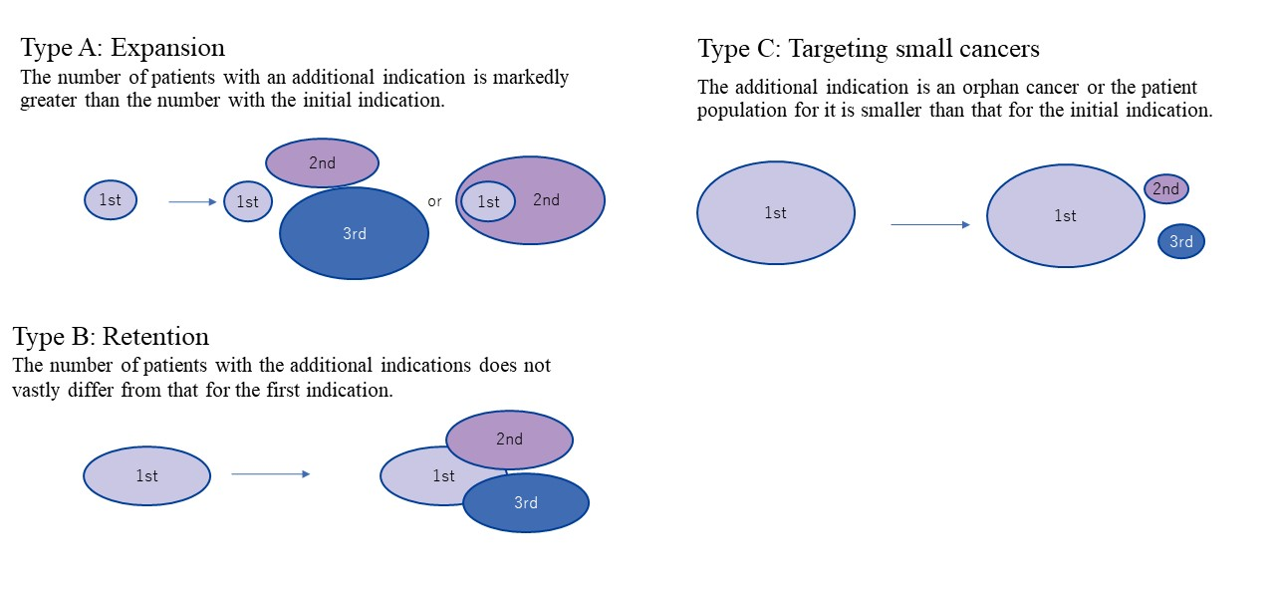

Online Resource 1. Types of methods for additional indications in the development strategies of anticancer drugs

