Supplementary materials

Supplementary information for machine learning approaches
Logistic regression
Logistic regression, a widely used model in healthcare diagnostics, was employed in this study to establish a baseline for longitudinal analysis. Specifically, the model was applied to each patient’s last available sample—defined as the most recent biomarker data for controls and the final pre-diagnosis sample for cases. This approach provides a benchmark for evaluating the predictive benefits of using only the latest information. The model was implemented using the function LogisticRegression, from the Python module, sklearn (version 1.0), with the liblinear solver. The regularization parameter was tuned on the training set using the Python module, Optuna (version 4.2.1).
Bidirectional long short-term memory recurrent neural network
Recurrent neural networks (RNNs) were designed to process sequential data and have gained substantial attention in recent years. They incorporate forward and recurrent connections to capture temporal dependencies. Among these, long short-term memory (LSTM) networks have demonstrated strong predictive performance in healthcare applications, thanks to their ability to retain information over long sequences via a gated cell architecture. In this study, biomarker values for each subject were input into a bidirectional LSTM RNN in chronological order. For the simplicity of the input data, we adopted a single hidden layer. The model was implemented using the PyTorch library (version 1.11.0) in Python. LSTM RNNs involve several tunable parameters that can significantly impact performance. Therefore, we applied Optuna (version 4.2.1) on the training set to select optimal values for the number of hidden units, output layer dropout rate, batch size, and number of training epochs.
Bayesian change-point
In this work, we utilized a full parametric Bayesian model for screening with multiple biomarkers proposed in (Tayob et al., 2018). They developed a joint model for multiple biomarker trajectories that can effectively account for missing data and irregular visits. The full detail of the model is available in (Tayob et al., 2018) and the model was implemented in R (version 4.4.1). The parameter values were determined by the Markov Chain Monte Carlo algorithm.

Supplementary tables
Table S1: Protocols for the choice of control participants.
Age group | Population | Proportion(%) | Number selected
50-54 | 2,313,392 | 18.5674058 | 28
55-59 | 2,000,046 | 16.05247433 | 24
60-64 | 1,787,098 | 14.34334249 | 22
65-69 | 1,859,641 | 14.92557642 | 22
70+ | 4,499,248 | 36.11120096 | 54
Total | 12,459,425 | 100 | 150

Table S2: Frequency table of the top 12 proteins for the whole dataset.
CEACAM5(100) | MUC-16(100) | CXL17(95) | WFDC2(95) | hK14(95) | CPE(92)
TXLNA(87) | Gal-1(85) | CAIX(75) | SYND1(74) | IGF1R(69) | CYFRA21-1(69)

Table S3: Frequency table of the top 12 proteins for smokers.
MUC-16(99) | CEACAM5(98) | LY9(95) | Gal-1 (94) | CPE(91) | WFDC2 (89)
TXLNA(76) | SCF(76) | SYND1(76) | CXCL13(73) | CAIX(68) | TLR3 (66)

Table S4: Summary of similar biomarker studies for lung cancer screening data. Unavailable metrics are denoted by -. If there are multiple scores reported under different conditions for the same metric, we included the best one.
Study | Number of cases/controls | ROC AUC | Sensitivity | Specificity
Davies et al., 2023 | 131/237 | 0.76–0.90 | - | -
Fahrmann et al., 2022 | 552/2193 | 0.85 | 0.835 | 0.693
Jett et al., 2014 | 61/1638 | - | 0.37 | 0.91
Montani et al., 2015 | 48/1067 | 0.85 | 0.78 | 0.75
Haber et al., 2024 | 248/134 | - | 0.84 | 0.53

Supplementary figures
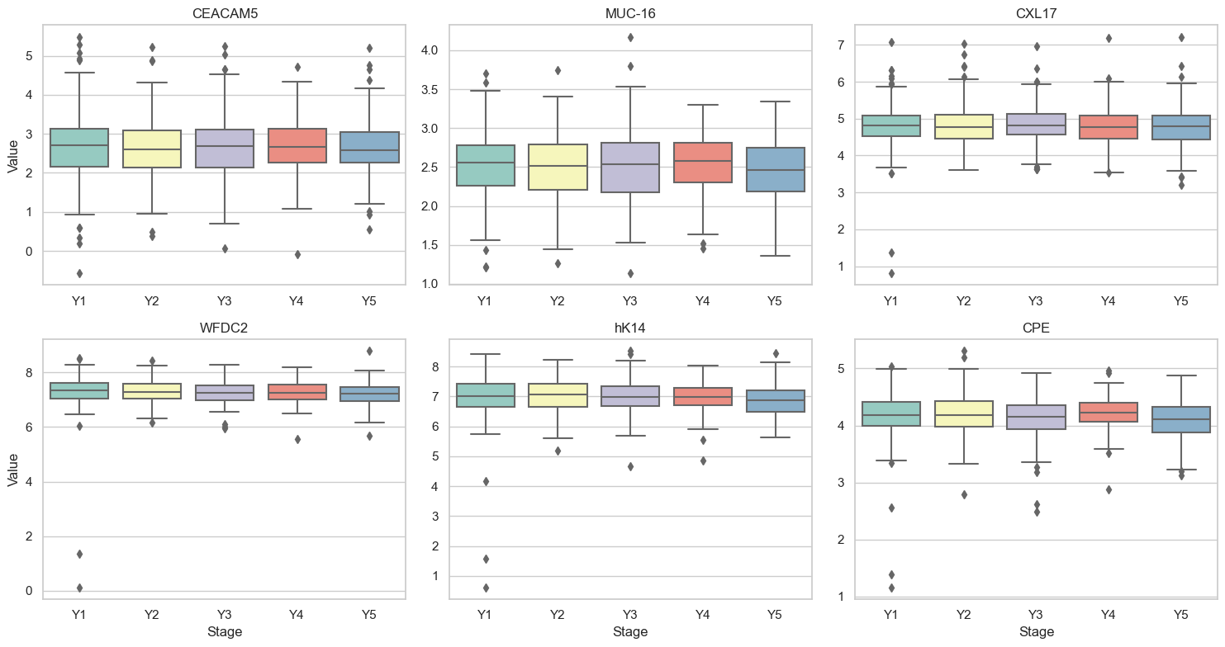
Figure S1: Box plots for the top 6 biomarkers of controls in the whole dataset. In each subfigure, the y-axis denotes the biomarker values. On the x-axis, ‘Y1’ represents the distribution of all biomarker values taken between 0-1 years before the most recent available samples, ‘Y2’ represents between 1-2, Y3 between 2-3, Y4 between 3-4 and Y5 between 4-5 years prior to the most recent sample in any control.

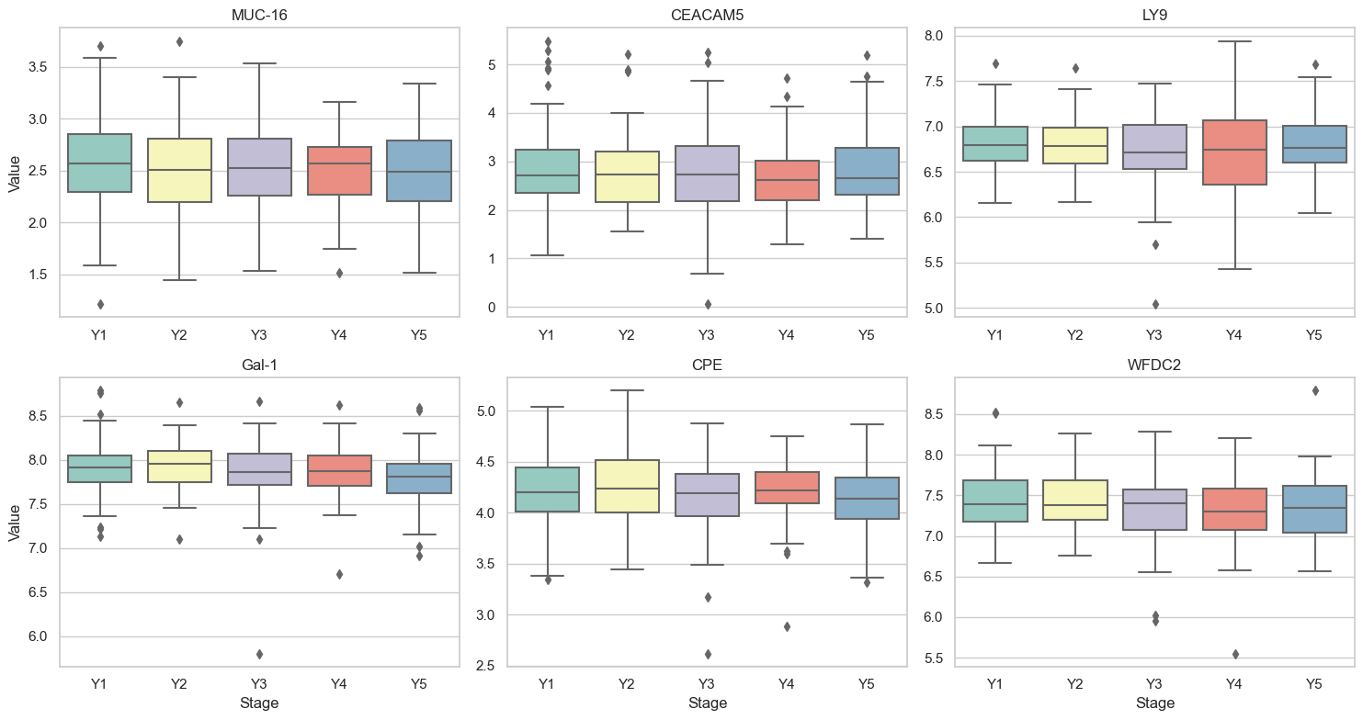
Figure S2: Box plots for the top 6 biomarkers of controls in smokers. In each subfigure, the y-axis denotes the biomarker values. On the x-axis, ‘Y1’ represents the distribution of all biomarker values taken between 0-1 years before the most recent available samples, ‘Y2’ represents between 1-2, Y3 between 2-3, Y4 between 3-4 and Y5 between 4-5 years prior to the most recent sample in any control.

