Supplementary Information for

Green Chitosan:Thiourea Dioxide Cleaning Gel for Manganese Stains on Granite and Glass Substrates

Bruno Campos, Alexandra Marco, Guilhermina Cadeco, David M. Freire-Lista, Joaquin Silvestre-Albero, Manuel Algarra, Eduarda Vieira, Manuela Pintado, Patrícia Moreira

FIGURES
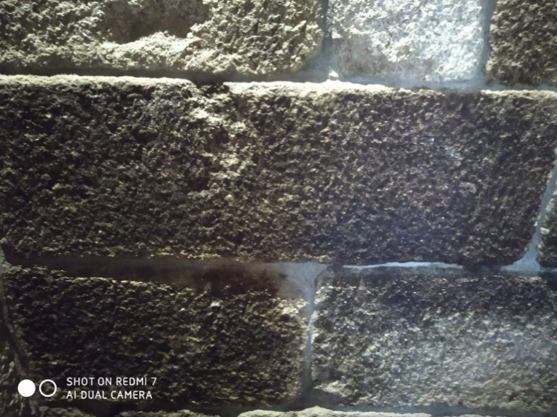
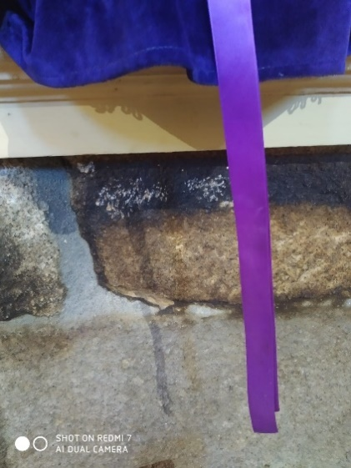
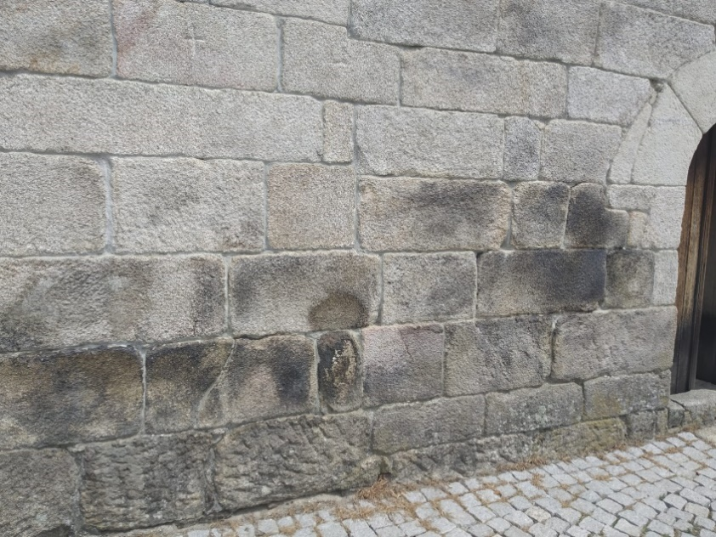

Sta. Marinha church
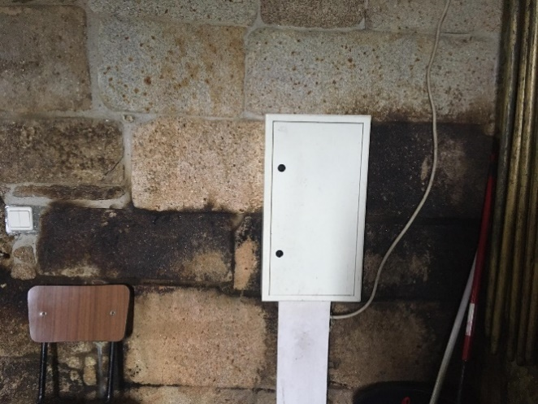
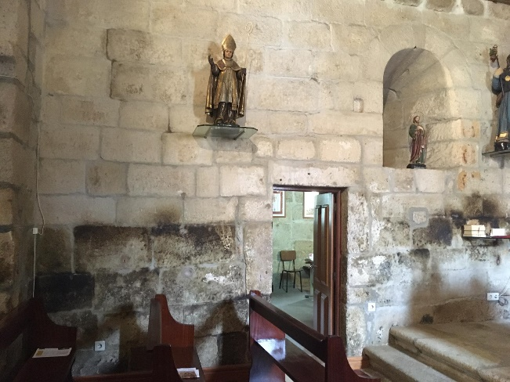

St. Tiago church

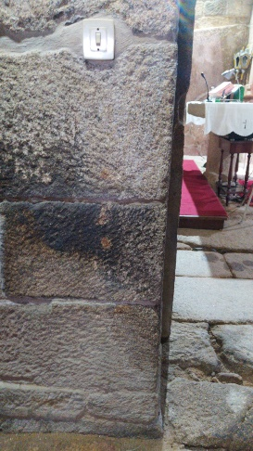
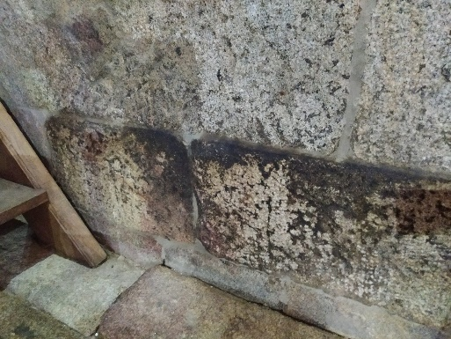
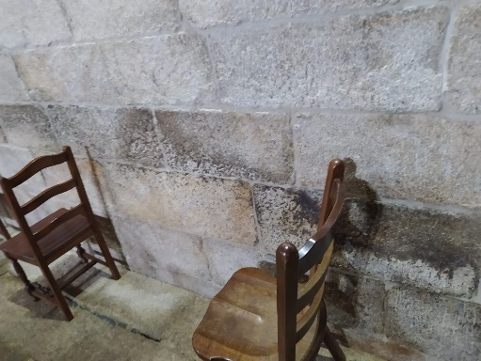

N. S. Guadalupe church
Figure SI1. Areas of XRF analyses represented by yellow circles. Cleaning assays in situ are represented by dashed circles.
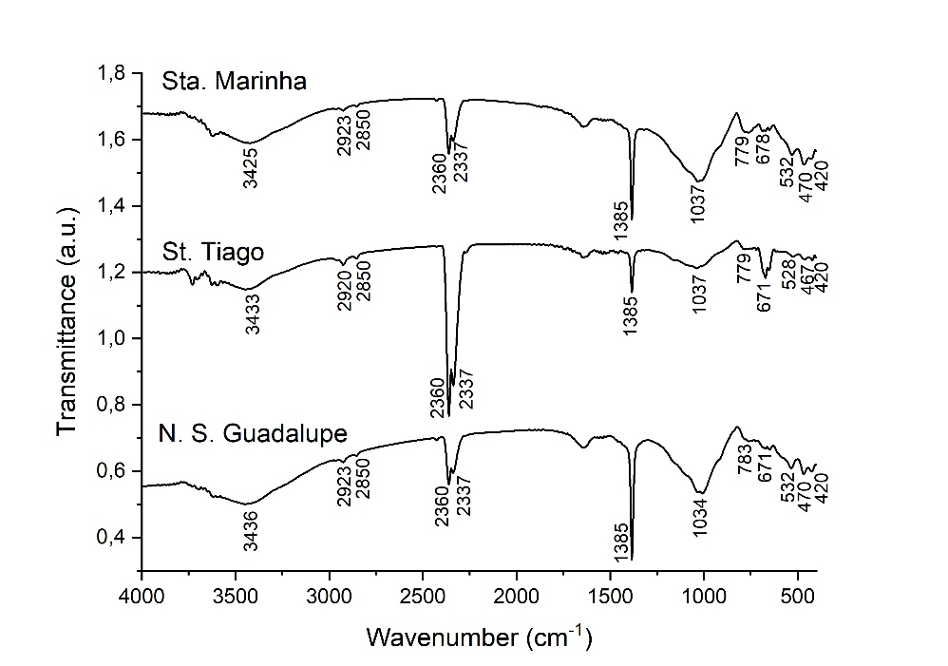

Figure SI2. FTIR spectra of black-blue stains on granite churches.

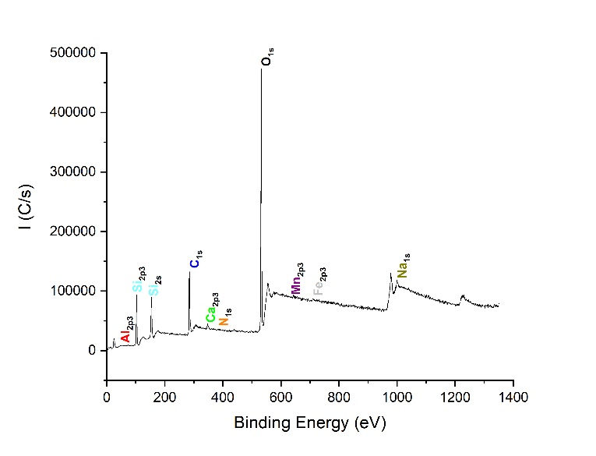
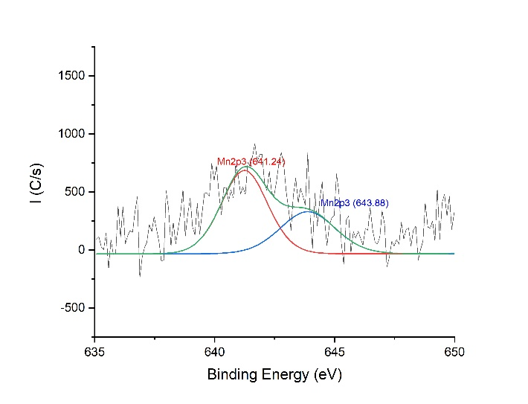
b
a

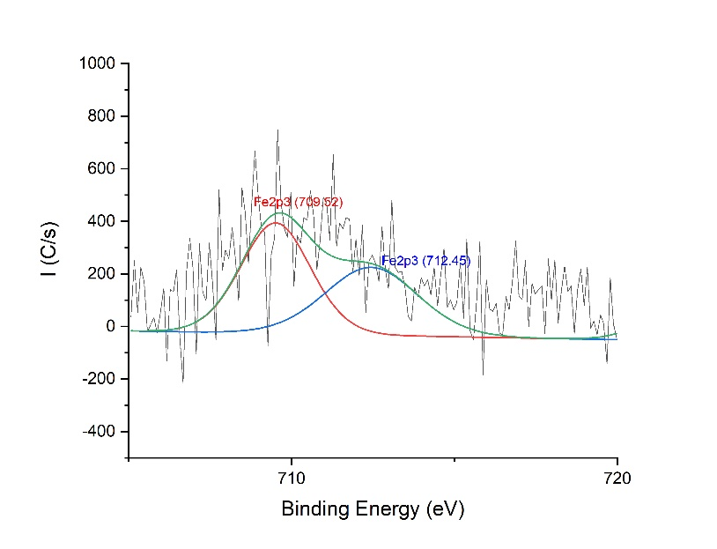
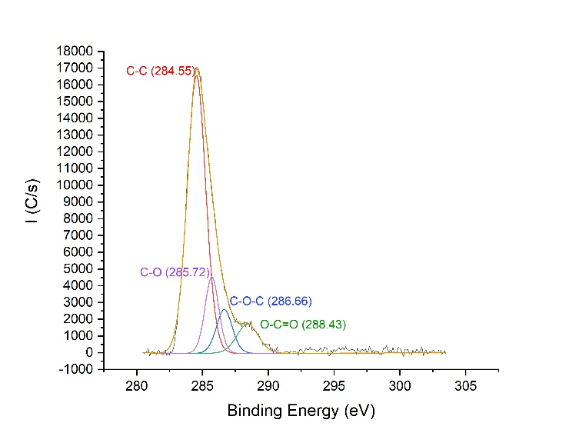
d
c

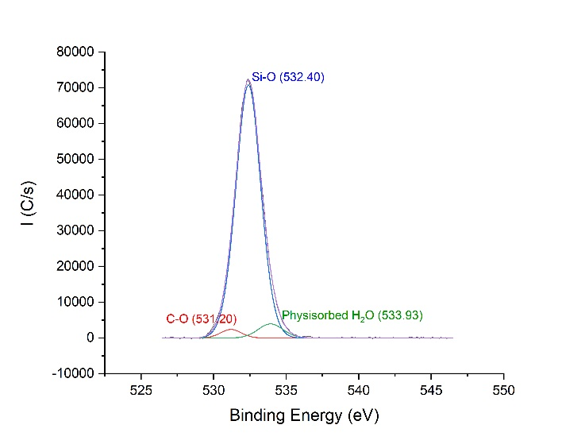
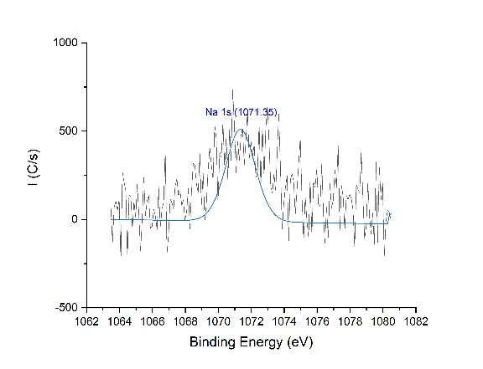
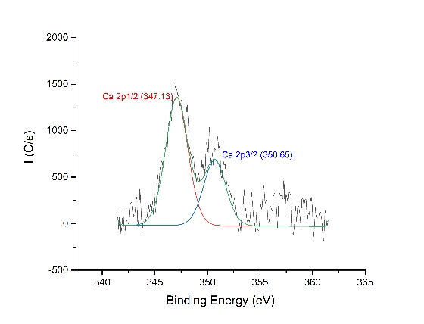
e
j
i
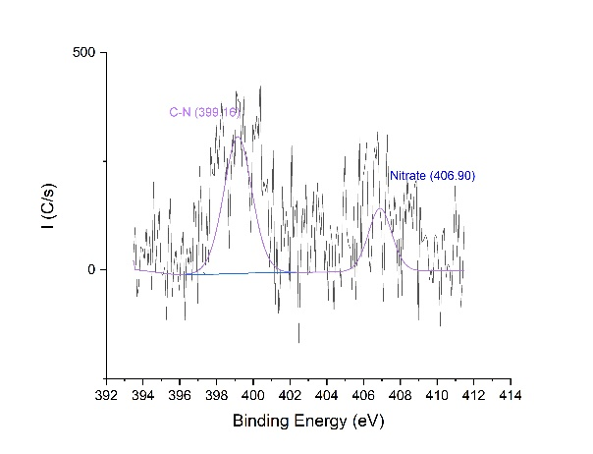
f

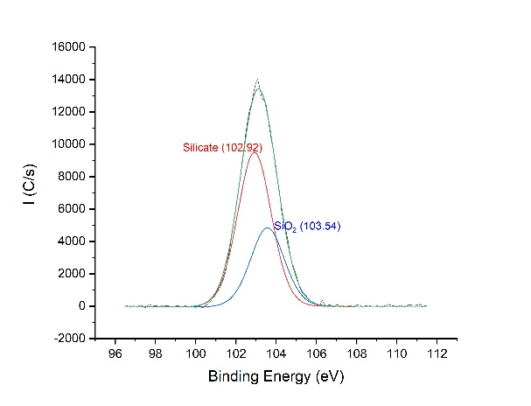
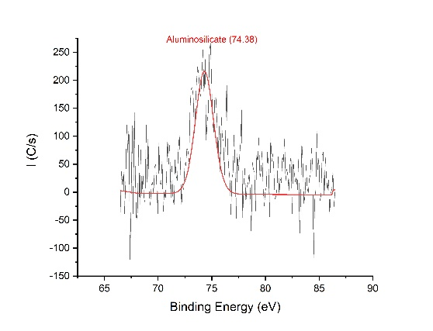
g
h

i
j

Figure SI3. (a) XPS survey spectra of black-blue stain at Sta. Marinha church; high resolution spectra of (b) Mn 2p3; (c) Fe 2p3; (d) C 1s. (e) O 1s. (f) N 1s. (g) Si 2p3. (h) Al 2p3; (i) Ca 2p3 and (j) Na 1s.

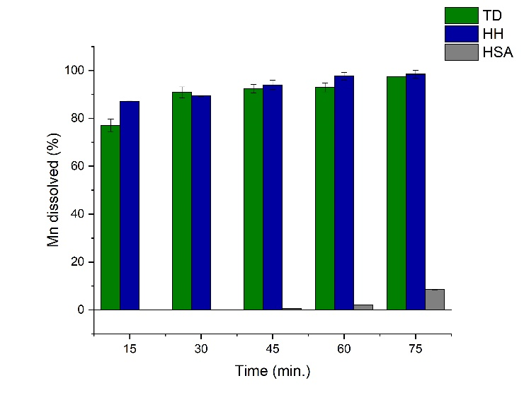

Figure SI4. Percentage of Mn dissolved with different reductants, in function of time.

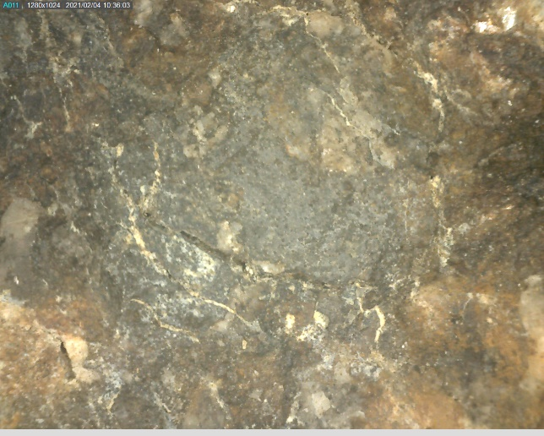
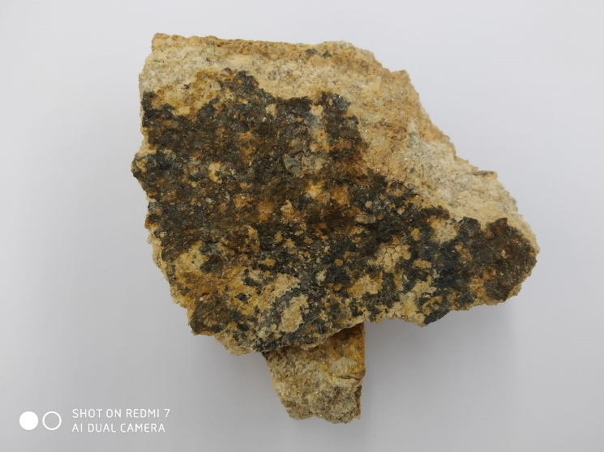
A2
A1

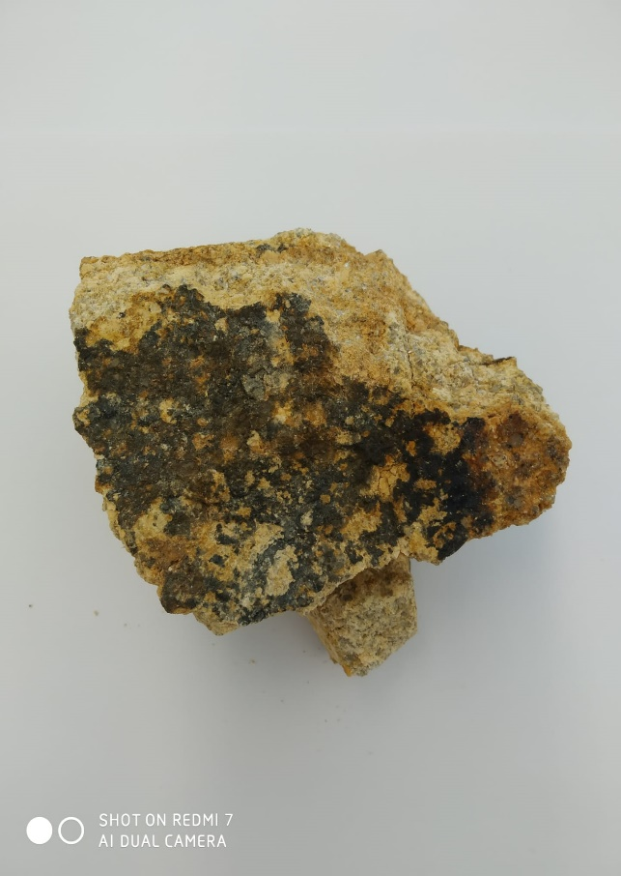
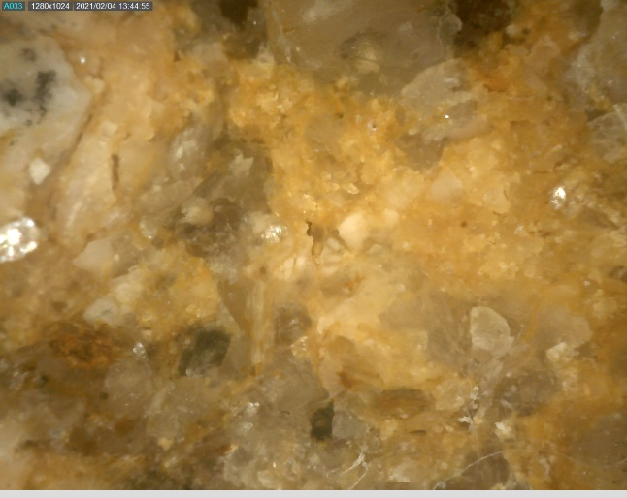
B1
B2

Sample II

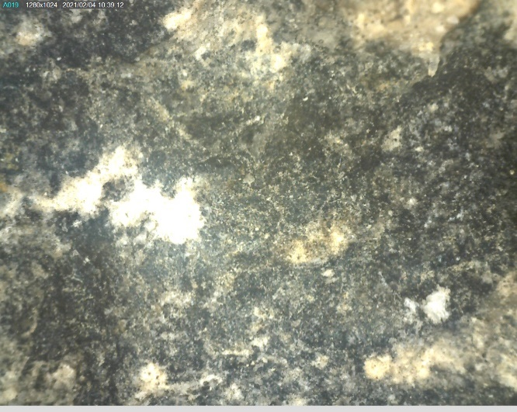
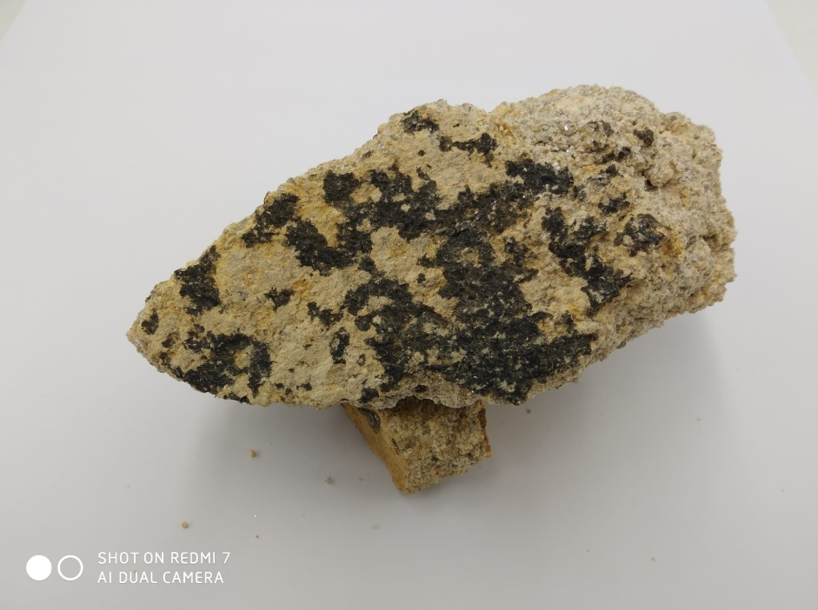
A2
A1

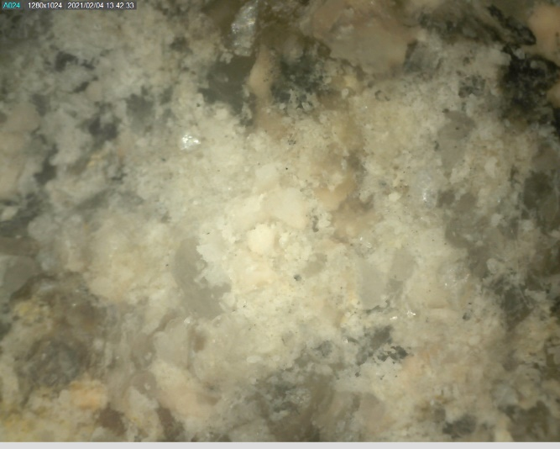
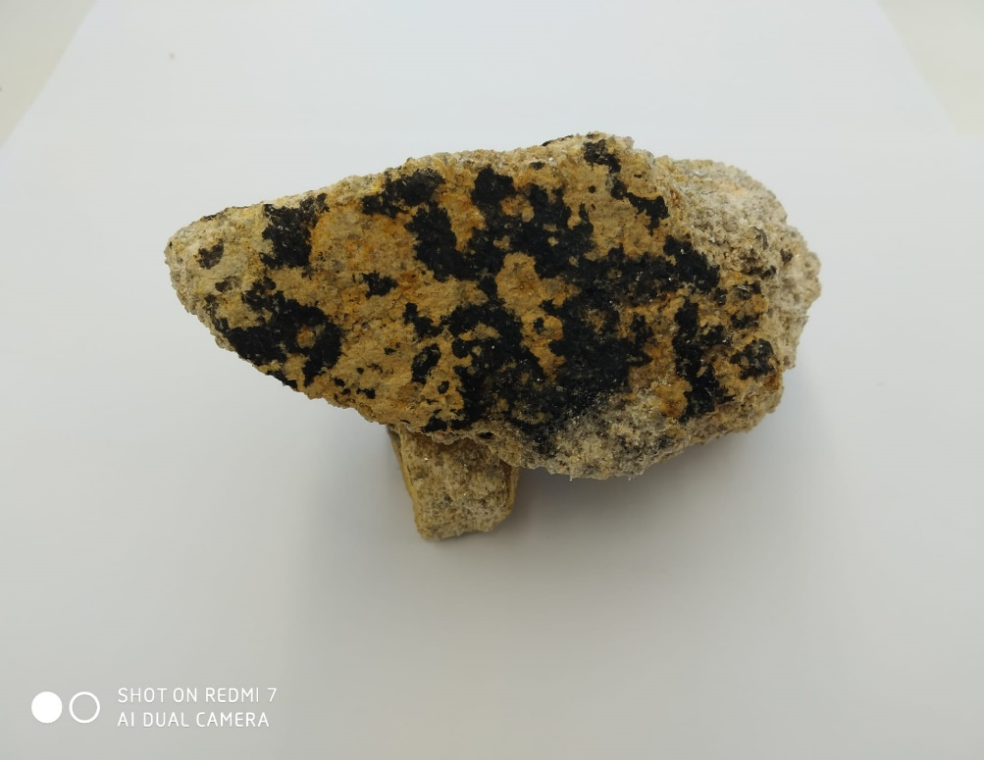
B2
B1

Sample III

Figure SI5. Cleaning assay performed on stained granite samples II and III. Assays were done inside the labelled yellow marks; A1 and A2 are images of stained granite; B1 and B2 are images of removed stain. A2 and B2 images were taken by Dino-lite (435x magnification).

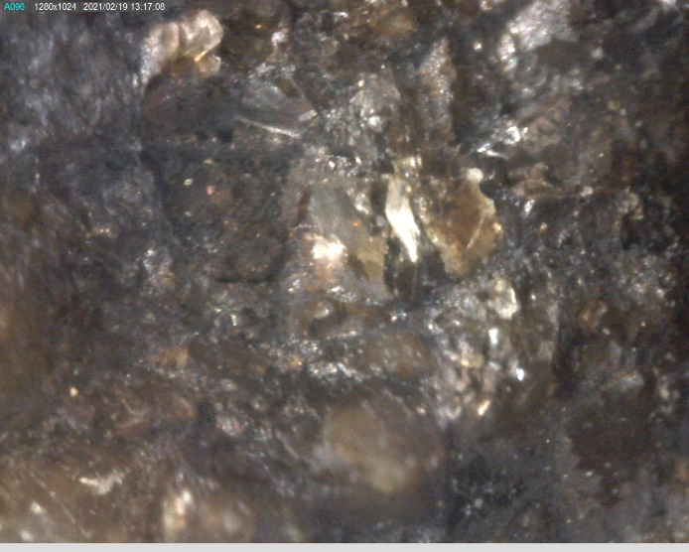
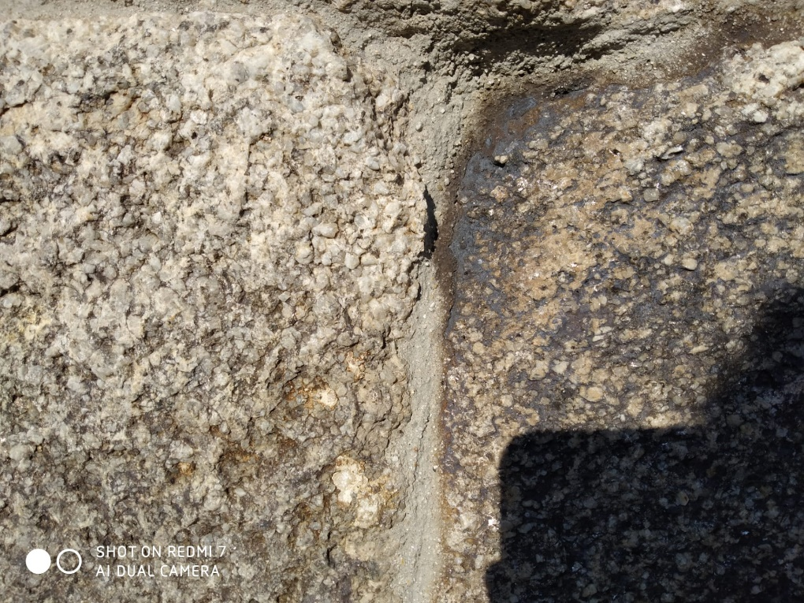
A2
A1

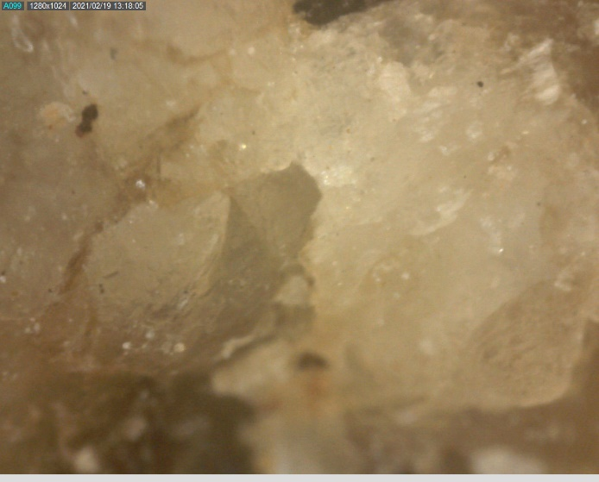
B2
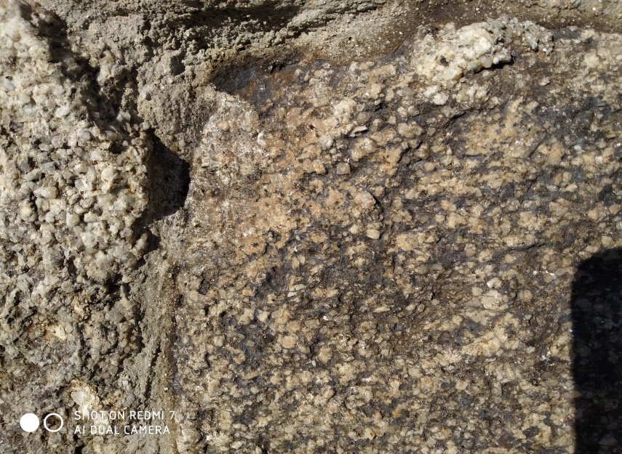
B1

Sta. Marinha church

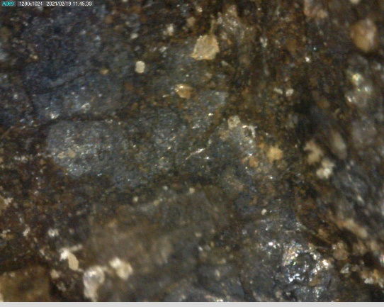
A2
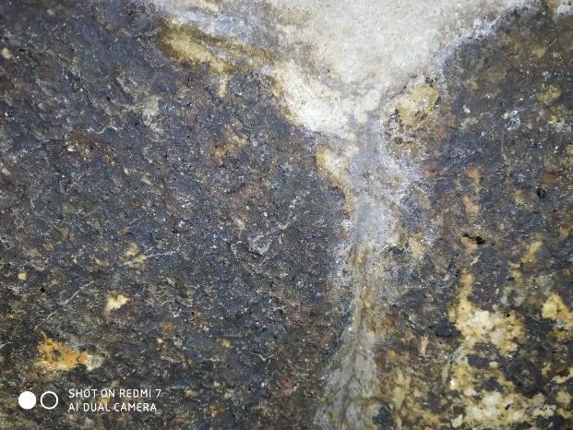
A1

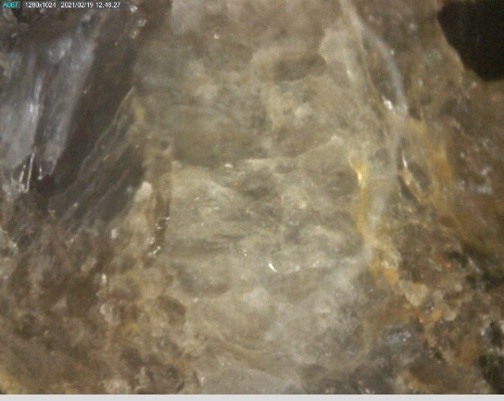
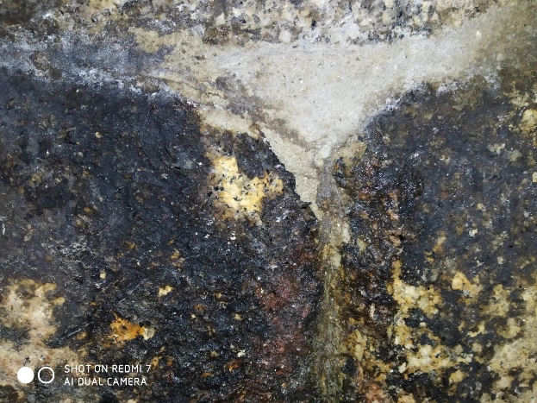
B2
B1

N.S. Guadalupe church

Figure SI6. Cleaning assay performed on stained granite at Sta. Marinha and N.S. Guadalupe churches. Assays were done inside the labelled yellow marks; A1 and A2 are images of stained granite; B1 and B2 are images of removed stain. A2 and B2 images were taken by Dino-lite (435x magnification).

TABLES

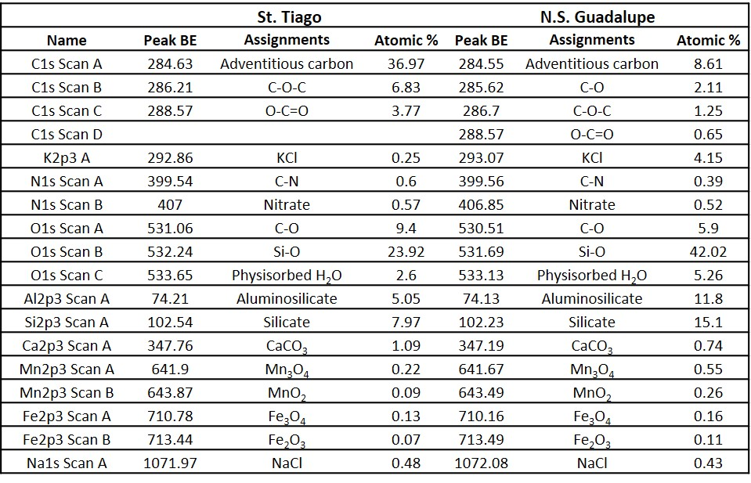

Table SI1. Assignments attributed to XPS peaks for St. Tiago and N.S. Guadalupe black-blue samples.

