Table S1. Alpha diversity indices in Saryu river water metagenome.
Index | Genus | Species
ACE | 76,345.83 | 4,66,707.44
Chao1 | 9,15,246 | 1,91,28,361
Shannon index | 4.095 | 5.437
Shannon evenness | 0.529 | 0.602
Simpson index | 0.794 | 0.902

Table S2. Identified VF genes in Saryu river metagenome
VF category and gene | % abundance | VF category and gene | % abundance | VF category and gene | % abundance | VF category and gene | % abundance
Adherence | 33.47 | hcpA | 0.11 | gmd | 6.81 | PA3348 | 0.11
chpA | 0.73 | hsiA1 | 0.04 | gmhA | 0.04 | PA3349 | 0.04
chpD | 0.04 | hsiB1/vipA/tssB | 0.23 | hasC | 0.08 | pseB | 0.04
fapC | 0.04 | hsiC1/vipB/tssC | 0.69 | kdsA | 0.11 | tlpA | 1.84
fapE | 0.23 | hsiG1/tssF | 0.08 | KP1_RS17280 | 0.04 | tlpB | 0.11
fapF | 0.11 | hsiH1/tssG | 0.04 | LPG_RS03710 | 0.08 | tlpC | 0.34
fbpC | 0.04 | hsiJ1 | 0.08 | LPG_RS03830 | 0.11 | tsr | 2.45
fimL | 0.04 | icmF1/tssM1 | 0.34 | manC | 0.73 | Nutritional/Metabolic-factor | 6.35
fimV | 0.11 | icmH/tssL | 0.08 | manCcore | 0.04 | barB | 0.04
fimX | 0.04 | icmK/dotH | 0.08 | mas | 0.04 | carA | 0.04
groEL | 0.61 | icmO/dotL | 0.08 | pgm | 0.42 | carB | 2.64
htpB | 3.25 | lasA | 0.04 | ppsA | 0.08 | ccmF | 0.19
mshE | 0.04 | lasB | 0.15 | ppsB | 0.04 | entB | 0.04
mshM | 0.04 | lspE | 0.04 | pseB | 0.34 | fepA | 0.04
pilA | 0.11 | PA1663 | 0.11 | rfaD | 0.04 | fptA | 0.08
pilB | 0.54 | PA1665 | 0.08 | rfbA | 0.04 | narG | 0.15
pilC | 0.04 | PA2359 | 0.04 | rfbB | 0.04 | narH | 0.19
pilD/vcpD | 0.19 | pcrD | 0.11 | rfbD | 0.15 | PA2383 | 0.04
pilE/pilA | 0.08 | pcrH | 0.08 | rfbG | 0.04 | PA4218 | 0.04
pilF | 0.46 | pldA/tle5a | 0.19 | rfbK1 | 0.11 | pchA | 0.15
pilG | 0.11 | pldB/tle5b | 0.08 | rhlA | 0.11 | pchE | 0.15
pilI | 0.08 | popB | 0.08 | rhlB | 0.04 | pchF | 0.11
pilJ | 0.15 | popD | 0.04 | rhlC | 0.08 | pchG | 0.04
pilM | 0.08 | ppkA | 0.11 | tviB | 0.61 | pchH | 0.19
pilO | 0.04 | pppA | 0.11 | ugd | 0.27 | pchI | 0.04
pilQ | 0.11 | pscC | 0.23 | waaA | 0.04 | pchR | 0.08
pilT | 1.49 | pscD | 0.08 | waaC | 0.19 | phzB2 | 0.04
pilT2 | 0.34 | pscG | 0.04 | waaF | 0.04 | phzC1 | 0.08
pilU | 0.19 | pscJ | 0.04 | waaG | 0.19 | phzE1 | 0.15
pilX | 0.04 | pscR | 0.04 | waaP | 0.08 | phzF1 | 0.04
pilY1 | 0.04 | pscT | 0.04 | wbpA | 0.15 | phzG1 | 0.08
pilZ | 0.04 | rvhB11 | 0.04 | wbpE | 0.04 | phzH | 0.08
rpoS | 0.31 | stk1 | 0.04 | wbpM | 0.04 | phzM | 0.11
tapB | 0.08 | STM0272 | 0.15 | wbtE | 0.11 | phzS | 0.04
tapT | 2.56 | STM0274 | 0.04 | wbtF | 0.04 | ptxR | 0.11
tcpI | 0.27 | stp1 | 0.04 | wbtL | 0.46 | pvcA | 0.04
tufA | 20.73 | tagF/pppB | 0.04 | wcbK | 0.19 | pvcB | 0.04
vfr | 0.08 | tagQ | 0.08 | wzt | 0.08 | pvcC | 0.04
Antimicrobial-activity/Competitive-advantage | 1.30 | tagR | 0.08 | YE_RS15425 | 0.15 | pvdH | 0.04
acrB | 1.30 | tagS | 0.08 | Motility | 17.64 | pvdI | 0.50
Biofilm | 2.22 | tse1 | 0.04 | cheA | 0.15 | pvdJ | 0.04
adeG | 0.27 | tse3 | 0.08 | cheA-2 | 0.04 | pvdL | 0.46
alg44 | 0.15 | tse5/rhsP1 | 0.11 | cheB | 0.08 | pvdM | 0.08
algA | 0.19 | tse6 | 0.04 | cheD | 2.52 | pvdN | 0.04
algB | 0.04 | tssA | 0.27 | cheV | 0.04 | pvdP | 0.04
algC | 0.11 | tssB | 0.15 | cheV3 | 0.77 | pvdY | 0.08
algD | 0.08 | tssC | 0.15 | cheW | 0.08 | Others | 0.38
algF | 0.08 | tssC-5 | 0.04 | cheY | 0.92 | acfB | 0.15
algG | 0.04 | tssF | 0.15 | flaB | 0.11 | icl | 0.19
algI | 0.04 | tssG | 0.04 | fleN | 0.08 | pcaA | 0.04
algJ | 0.15 | tssH | 0.34 | fleQ | 0.31 | Regulation | 6.77
algK | 0.04 | tssH-5/clpV | 0.15 | fleR | 0.11 | bvrR | 0.54
algL | 0.19 | tssI | 0.15 | fleS | 0.04 | bvrS | 0.04
algR | 0.04 | tssK | 0.04 | flgC | 0.11 | csrA | 0.04
algU | 0.08 | tssM | 0.42 | flgE | 0.23 | devR/dosR | 0.27
algW | 0.11 | vasE/tssK | 0.04 | flgG | 0.19 | fur | 0.04
algX | 0.15 | vasH | 0.04 | flgI | 0.11 | ideR | 0.11
mucA | 0.04 | vgrG | 0.08 | flgJ | 0.15 | mprA | 0.42
mucD | 0.19 | vgrG/tssI | 0.04 | flgK | 0.11 | mprB | 0.11
mucP | 0.11 | vgrG1a | 0.19 | flgL | 0.04 | phoP | 0.08
rhlI | 0.08 | vgrG1b | 0.15 | flgM | 0.08 | relA | 1.45
rhlR | 0.04 | vgrG2b | 0.15 | flgN | 0.08 | rpoS | 0.27
effector-delivery-system | 12.28 | vipA/tssB | 0.04 | flhA | 0.80 | sigA/rpoV | 2.87
ascN | 0.11 | vipB | 0.04 | flhB | 0.04 | sigE | 0.42
atsH | 0.04 | vipB/tssC | 0.04 | flhF | 0.08 | sigH | 0.11
bcrD | 0.11 | xcpQ | 0.04 | fliA | 0.08 | Stress-survival | 5.24
bscN | 0.08 | xcpR | 0.23 | fliC | 0.04 | clpC | 2.03
cdsN | 0.04 | xcpS | 0.04 | fliE | 0.04 | clpE | 0.04
clpB | 0.11 | xcpX | 0.11 | fliF | 0.23 | clpP | 0.04
clpV/tssH | 0.57 | xcpY | 0.04 | fliH | 0.04 | katA | 0.50
clpV1 | 2.41 | xcpZ | 0.04 | fliI | 2.30 | katB | 2.07
coxFIC1 | 0.04 | yscN | 0.04 | fliK | 0.08 | katG | 0.46
dotB | 0.04 | yst1E | 0.04 | fliM | 0.15 | sodA | 0.04
dotC | 0.04 | Exoenzyme | 0.11 | fliN | 1.03 | ureG | 0.08
dotU1 | 0.08 | aprA | 0.11 | fliP | 0.31 | Grand Total | 100.00
eccA3 | 0.04 | Exotoxin | 0.27 | fliQ | 0.04
eccC3 | 0.04 | cesA | 0.15 | fliR | 0.04
epsE | 0.08 | plcH | 0.11 | flmH | 0.04
espR | 0.11 | Immune-modulation | 13.81 | flrA | 0.04
essC | 0.04 | ACICU_RS00485 | 0.04 | flrB | 0.04
exeE | 0.04 | acpXL | 0.46 | lfhA | 0.08
exoT | 0.08 | bplC | 0.19 | motB | 0.15
exoU | 0.11 | bplD | 0.19 | motC | 0.08
exoY | 0.19 | bplL | 0.04 | motD | 0.19
fha1 | 0.08 | cps4I | 0.11 | motY | 0.08
gspE | 0.08 | cps4J | 0.11 | nueA | 0.04
gspE2 | 0.11 | embC | 0.31 | PA1458 | 0.15
hcp1 | 0.08 | galE | 0.08 | PA1459 | 0.19

Table S3. Identified VF category in Saryu river metagenome
Row Labels | % of VF category
Adherence | 33.47
Motility | 17.64
Immune-modulation | 13.81
effector-delivery-system | 12.43
Regulation | 6.77
Nutritional/Metabolic-factor | 6.35
Stress-survival | 5.24
Biofilm | 2.22
Antimicrobial-activity/Competitive-advantage | 1.30
Others | 0.38
Exotoxin | 0.27
Exoenzyme | 0.11

Table S4. Identified VF genes associated pathogenic organism in Saryu river metagenome
Pathogenic organism | % abundance
Francisella-tularensis-subsp.-tularensis-SCHU-S4 | 24.14
Pseudomonas-aeruginosa-PAO1 | 22.30
Mycobacterium-tuberculosis-H37Rv | 7.61
Legionella-pneumophila-subsp.-pneumophila-str.-Philadelphia-1 | 6.85
Burkholderia-pseudomallei-K96243 | 6.27
Yersinia-enterocolitica-subsp.-enterocolitica-8081 | 5.55
Klebsiella-pneumoniae-subsp.-pneumoniae-NTUH-K2044 | 5.39
Brucella-melitensis-bv.-1-str.-16M | 3.48
Helicobacter-pylori-26695 | 3.37
Aeromonas-hydrophila-ML09-119 | 3.33
Acinetobacter-baumannii-ACICU | 2.75
Listeria-monocytogenes-EGD-e | 2.10
Neisseria-meningitidis-MC58 | 1.42
Campylobacter-jejuni-subsp.-jejuni-NCTC-11168 | 0.77
Vibrio-cholerae-O1-biovar-El-Tor-str.-N16961 | 0.65
Bordetella-pertussis-Tohama-I | 0.61
Clostridium-difficile-630 | 0.61
Salmonella-enterica-subsp.-enterica-serovar-Typhimurium-str.-LT2 | 0.50
Bartonella-henselae-str.-Houston-1 | 0.42
Aeromonas-salmonicida-subsp.-salmonicida-A449 | 0.31
Aeromonas-hydrophila-subsp.-hydrophila-ATCC-7966 | 0.23
Streptococcus-pneumoniae-TIGR4 | 0.23
Salmonella-enterica-subsp.-enterica-serovar-Typhi-str.-CT18 | 0.19
Bacillus-cereus-AH187 | 0.15
Haemophilus-influenzae-Rd-KW20 | 0.11
Pseudomonas-aeruginosa-UCBPP-PA14 | 0.11
Shigella-dysenteriae-Sd197 | 0.08
Streptococcus-pyogenes-M1-GAS | 0.08
Vibrio-cholerae-O395 | 0.08
Bartonella-bacilliformis-KC583 | 0.04
Chlamydia-trachomatis-D/UW-3/CX | 0.04
Coxiella-burnetii-RSA-493 | 0.04
Escherichia-coli-CFT073 | 0.04
Rickettsia-typhi-str.-Wilmington | 0.04
Shigella-sonnei-Ss046 | 0.04
Staphylococcus-aureus-subsp.-aureus-MW2 | 0.04
Yersinia-pestis-CO92 | 0.04

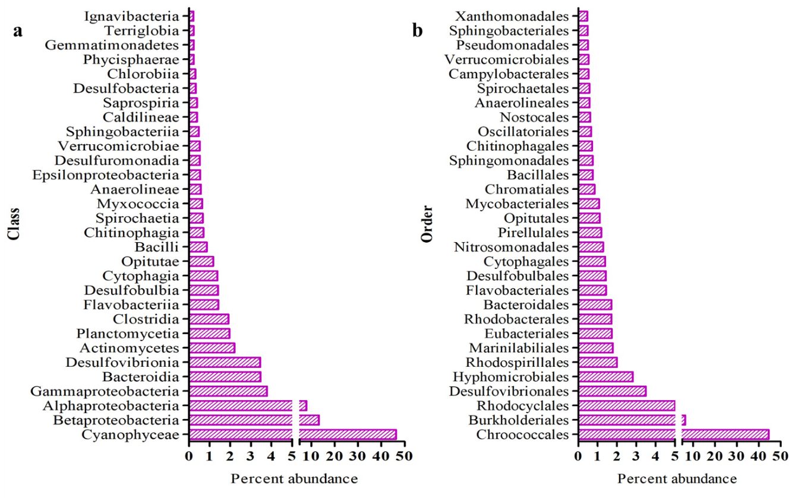
Fig. S1. Bacterial class and order rank taxonomy classification of Saryu river water metagenome.

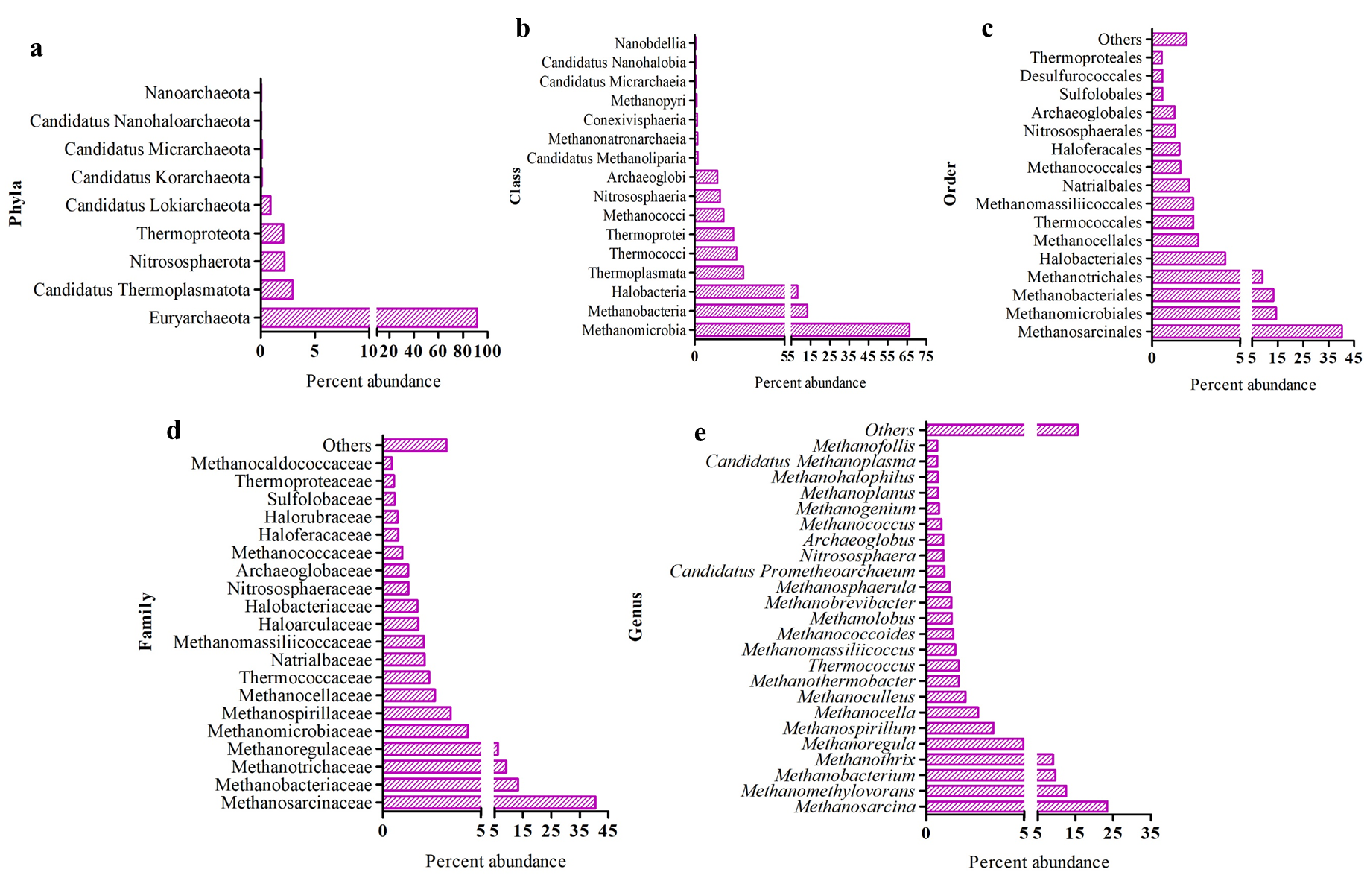
Fig. S2. Archaeal community taxonomy classification of Saryu river water metagenome. Figures a –e depicts, A (Phyla), b (Class), c (Order), d (Family), and e (genus), respectively.

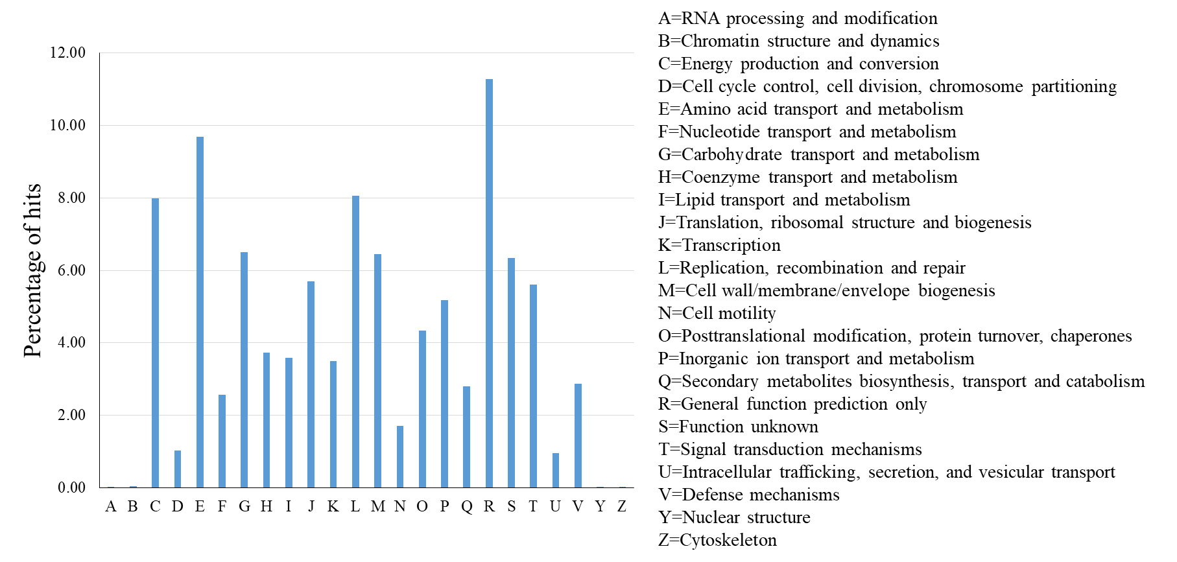
Fig. S3. COG databased functional classification in Saryu river water metagenome.

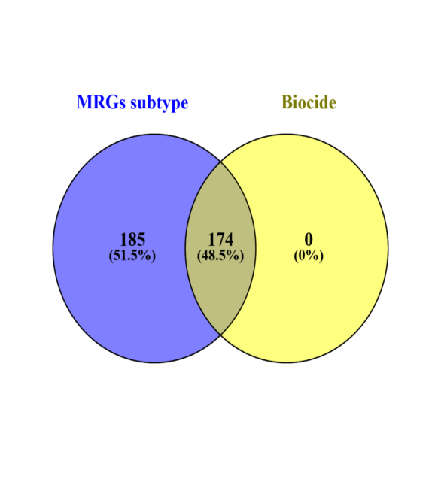
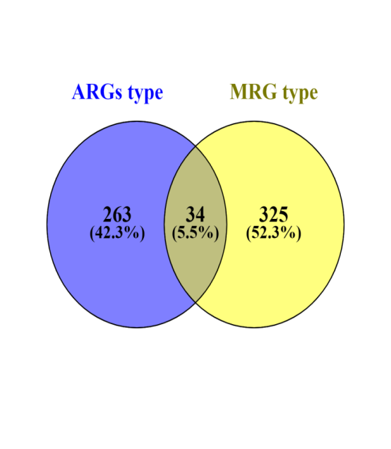
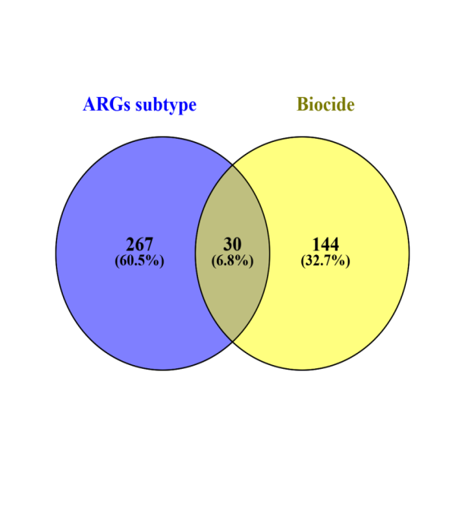
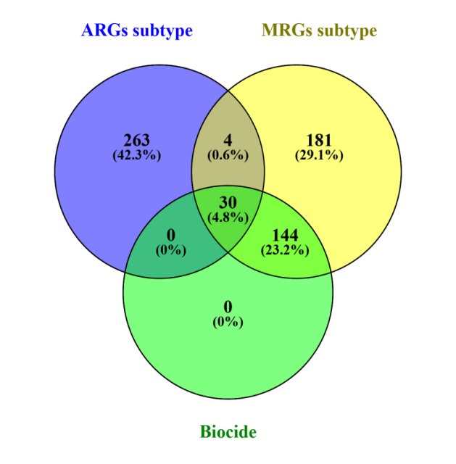
A
B
C
D

Fig. S4. Common and unique ARGs, MRGs and biocide in Saryu river water

