Supplementary Appendix

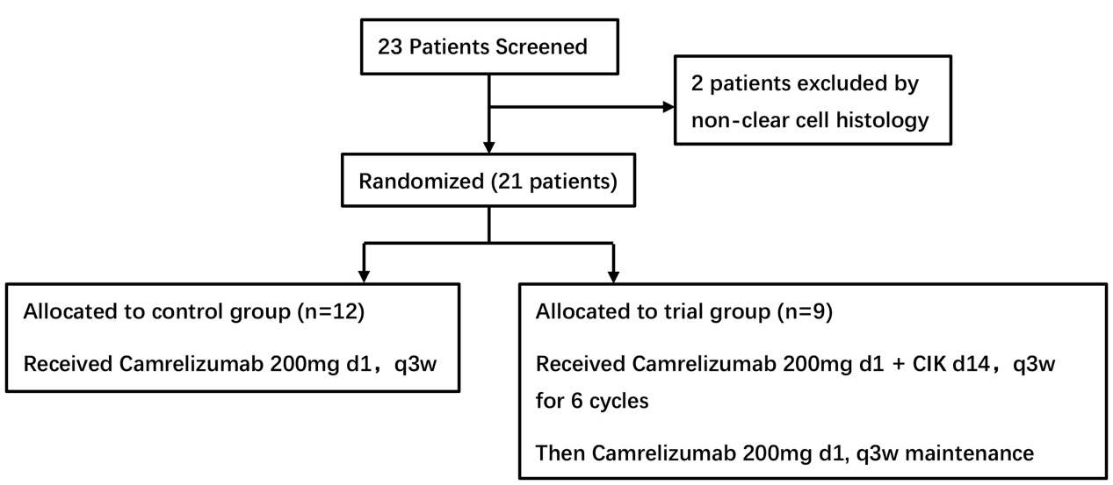
Figure S1. CONSORT Diagram.
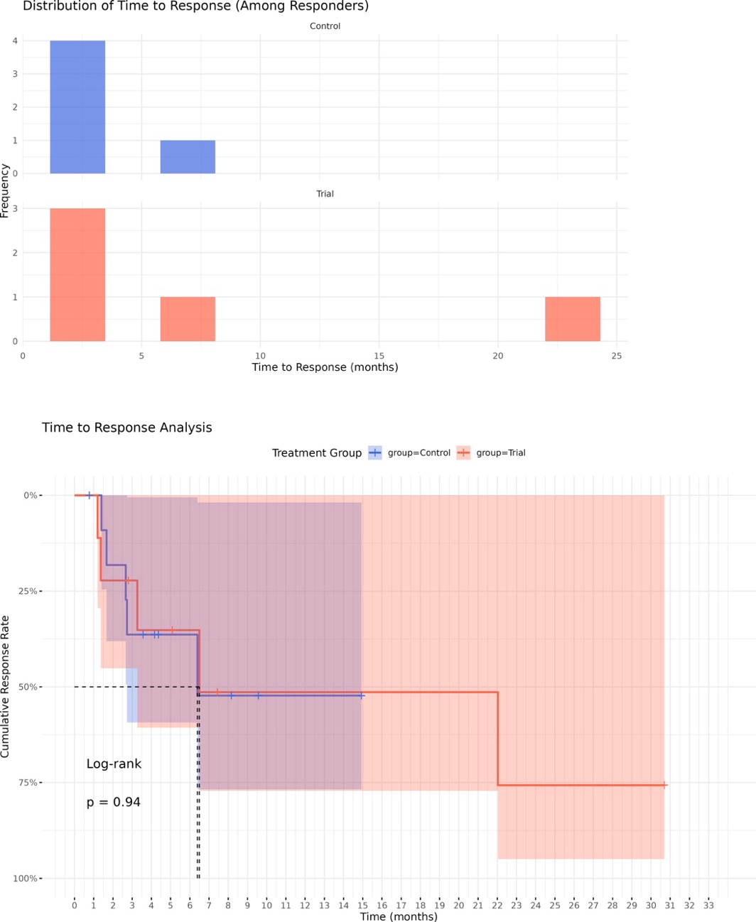
Figure S2. Analysis of time to response among the treatment groups. A. Distribution of time to response among patients exhibiting objective response. One patient had delayed imaging assessment, which may have affected time-to-response data. Sensitivity analysis excluding this case showed similar results (median TTR: 6.4 vs 6.5 months, p=0.84). B. Kaplan-Meier analysis of time to response. No statistically significant differences were detected.
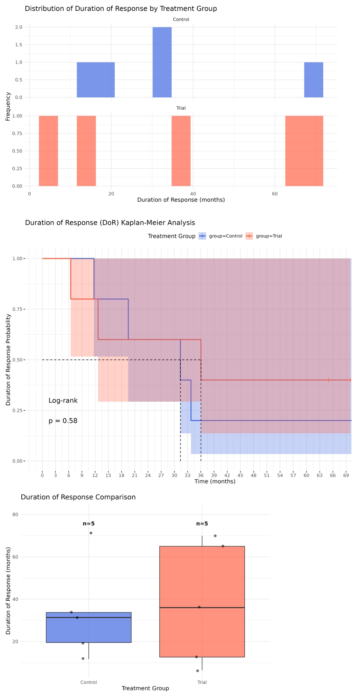
Figure S3. Analysis of response duration among the treatment groups. A. Distribution of response duration among patients exhibiting objective response. B. Kaplan-Meier analysis of response duration, indicating no statistical significance. C. Box plot illustrating response duration analysis. Patients in the trial group with an objective response demonstrated a tendency toward a longer response duration, although this was not statistically significant.
Table S4. Detailed information on the enrolled patients.
Patient ID | Sex | Age | Treatment Group | MSKCC Risk | Previous Nephrectomy | Previous Treatment | Best Response | PFS Months | Progression Status | OS Months | Status
P1 | Female | 68 | Control | Favorable | Yes | Anlotinib | PR | 74.07 | No | 74.07 | Alive
P2 | Male | 64 | Control | Intermediate | Yes | Sunitinib | SD | 4.17 | Yes | 48.70 | Alive
P3 | Male | 63 | Control | Favorable | Yes | Sorafenib | PR | 20.93 | Yes | 41.00 | Alive
P4 | Male | 64 | Control | Poor | Yes | Sunitinib–Axitinib | SD | 4.37 | Yes | 9.03 | Dead
P5 | Female | 59 | Control | Favorable | Yes | Sunitinib-Pazopanib | SD | 8.17 | Yes | 62.17 | Alive
P6 | Female | 63 | Control | Intermediate | Yes | Sunitinib | PR | 13.40 | Yes | 48.27 | Alive
P7 | Male | 49 | Control | Favorable | Yes | Anlotinib-Vorolanib | SD | 2.73 | Yes | 18.73 | Dead
P8 | Male | 58 | Control | Intermediate | Yes | Sorafenib | PR | 34.03 | Yes | 61.07 | Alive
P9 | Male | 68 | Control | Intermediate | No | Sunitinib | PD | 1.53 | Yes | 17.07 | Dead
P10 | Male | 57 | Control | Intermediate | Yes | Cytokine-Sorafenib-Pazopanib-Anlotinib | PR | 40.17 | Yes | 57.47 | Dead
P11 | Male | 62 | Control | Intermediate | No | Sunitinib | SD | 9.57 | Yes | 30.70 | Dead
P12 | Female | 51 | Control | Poor | No | Sunitinib | PD | 0.77 | Yes | 1.07 | Dead
P13 | Male | 72 | Tiral | Intermediate | Yes | Cytokine-Vorolanib | SD | 5.07 | Yes | 37.10 | Dead
P14 | Male | 53 | Tiral | Intermediate | Yes | Sunitinib-Axitinib | CMR | 65.93 | No | 65.93 | Alive
P15 | Male | 59 | Tiral | Favorable | Yes | Cytokine-Sorafenib | PR | 39.30 | Yes | 65.97 | Alive
P16 | Male | 66 | Tiral | Poor | Yes | Cytokine-Sunitinib | PR | 19.17 | Yes | 60.77 | Alive
P17 | Female | 74 | Tiral | Favorable | No | Axitinib | SD | 4.17 | Yes | 15.20 | Dead
P18 | Male | 61 | Tiral | Favorable | Yes | Pazopanib-Vorolanib-Axitinib | PR | 71.33 | No | 71.33 | Alive
P19 | Male | 73 | Tiral | Favorable | Yes | Sorafenib-Axitinib | SD | 10.83 | Yes | 48.83 | Alive
P20 | Male | 68 | Tiral | Intermediate | Yes | Sunitinib | PR | 28.50 | Yes | 49.77 | Dead
P21 | Male | 62 | Tiral | Favorable | Yes | Cytokine | SD | 60.33 | No | 60.33 | Dead
PFS, progression-free survival; OS, overall survival; CMR, complete metabolic response; PR, partial response; SD, stable disease; PD, progressive disease.

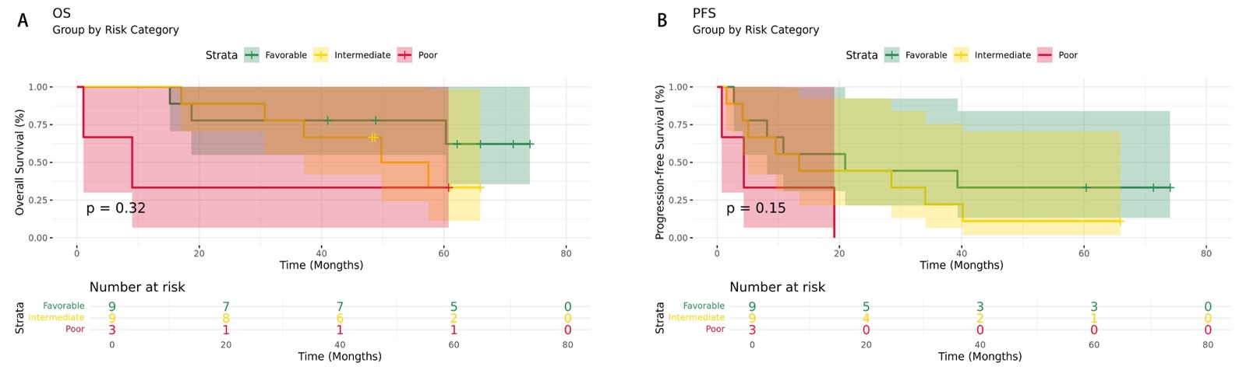
Figure S5. Kaplan-Meier analysis of overall survival and progression-free survival by MSKCC risk category. A. Overall survival analysis in all patients presented by favorable, intermediate, and poor-risk groups. B. Progression-free survival analysis in all patients, presented by favorable, intermediate, and poor-risk groups. OS, overall survival; PFS, progression-free survival.
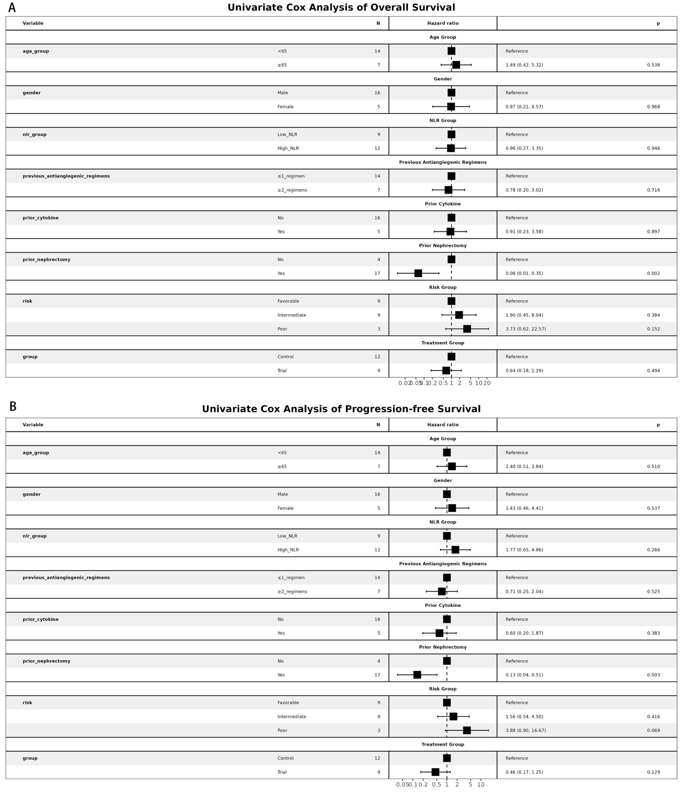
Figure S6. Forest plot of univariate Cox analysis. A. Univariate Cox analysis for overall survival. B. Univariate Cox analysis for progression-free survival. Only prior nephrectomy shows statistical significance.
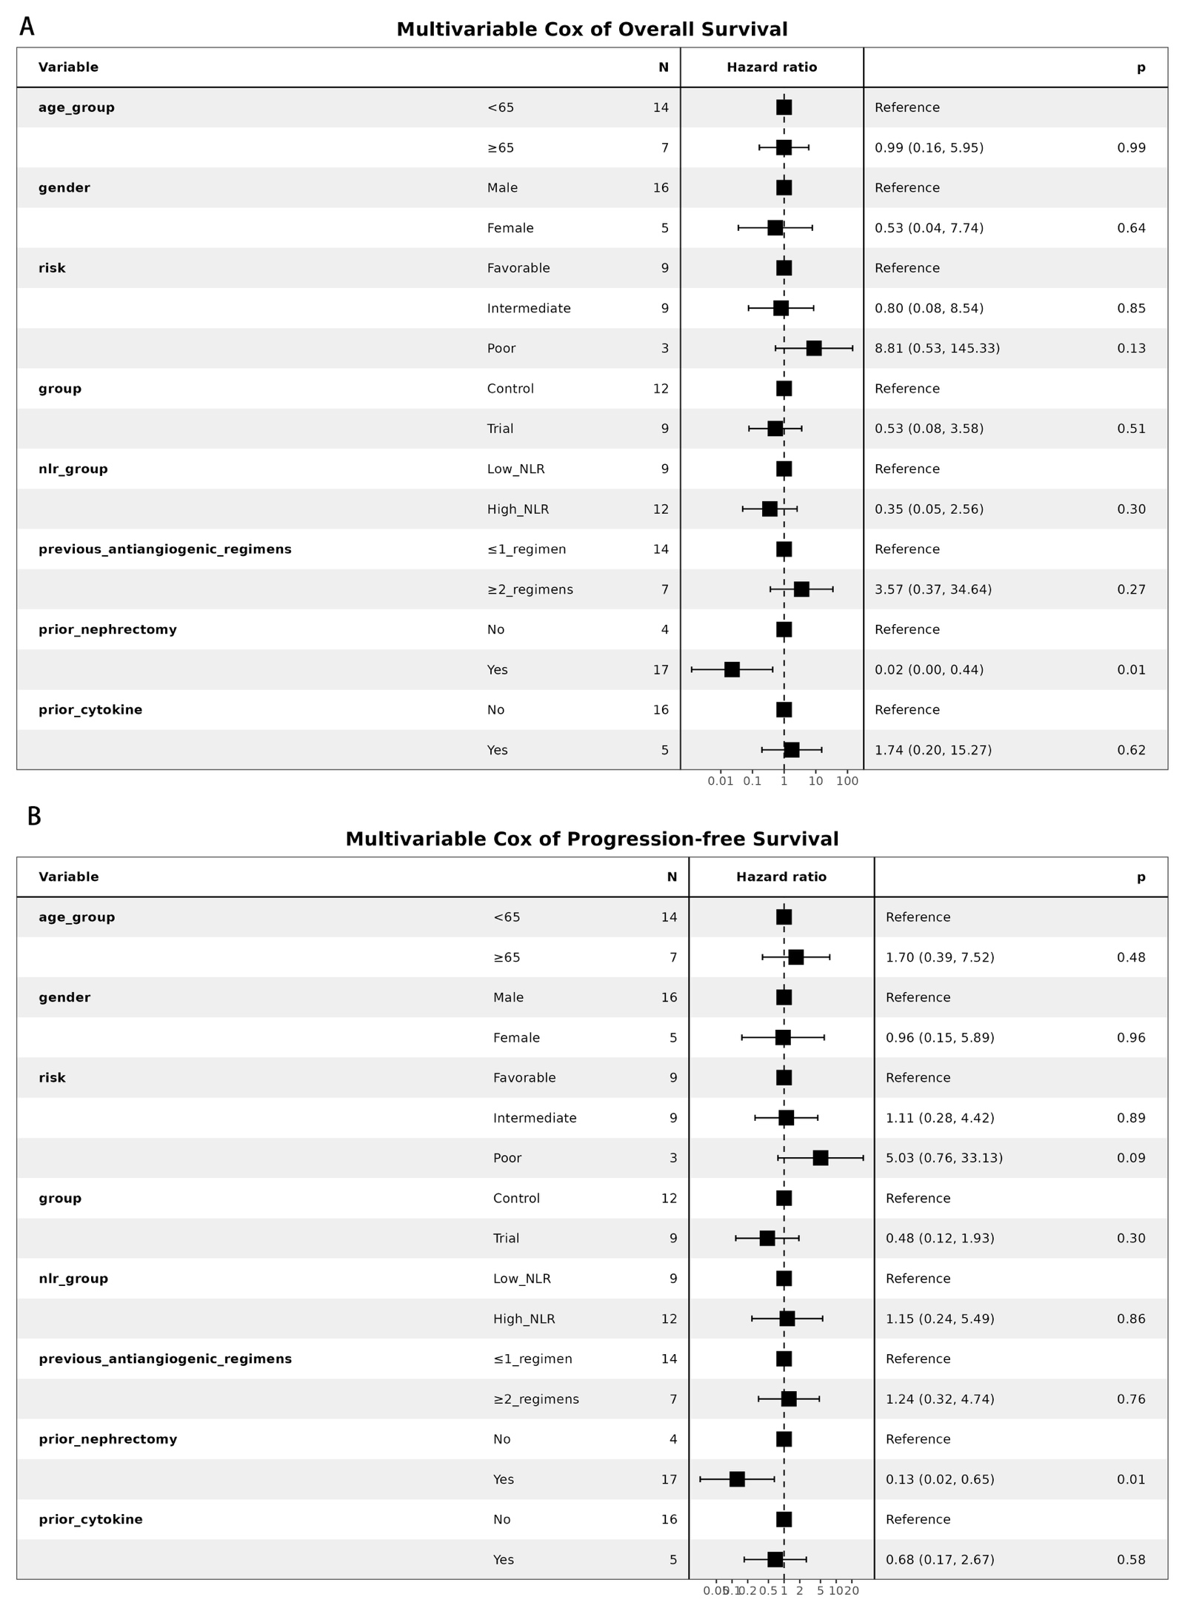
Figure S7. Forest plot of multivariate Cox analysis. A. Multivariate Cox analysis for overall survival. B. Multivariate Cox analysis for progression-free survival. Only prior nephrectomy shows statistical significance.

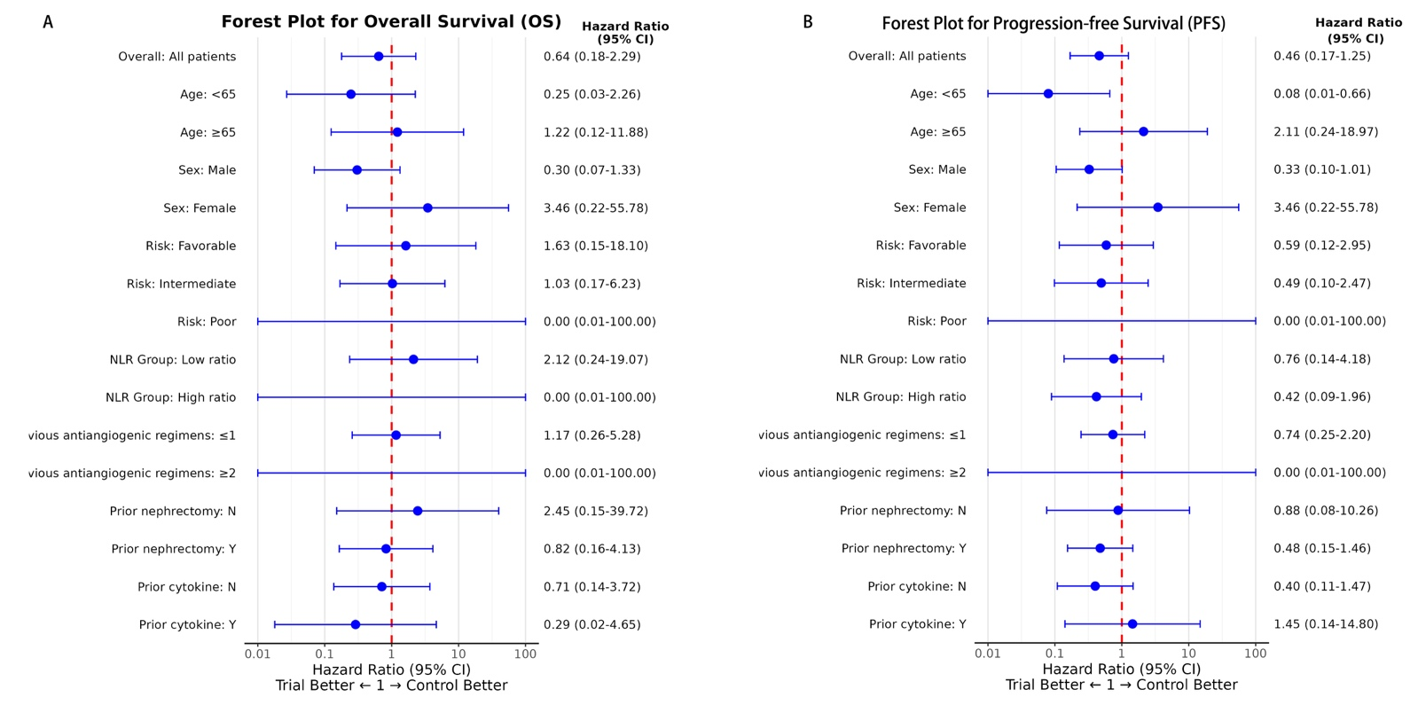
Figure S8. The forest plot for the subgroup analysis. A. Subgroup analysis of overall survival. B. Subgroup analysis of progression-free survival. Both may not be an accurate reference due to a small sample size.
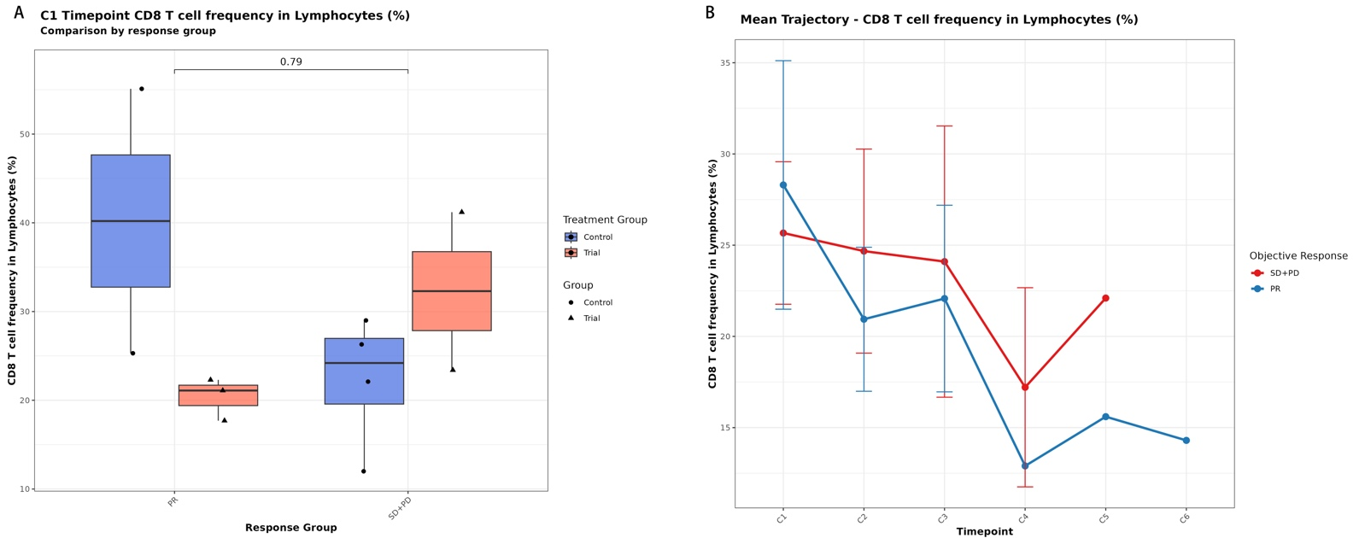
Figure S9. CD8⁺ T cell frequency in peripheral blood at baseline and its trajectory during treatment. A. Baseline CD8⁺ T cell frequency in peripheral blood revealed no significant differences among the treatment groups. B. Trajectory changes in CD8⁺ T cell frequency in peripheral blood are presented according to objective response. C1~C6 on the x-axis of Figure B represent Cycle 1~Cycle 6.
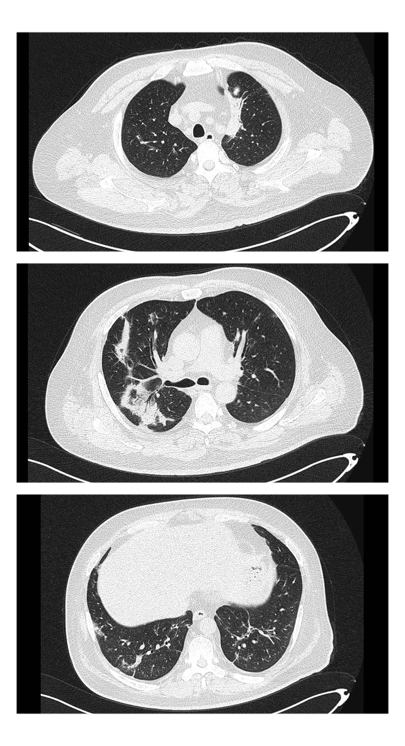
Figure S10. Chest computed tomography (CT) present remission of the interstitial pneumonia.

