Table S1. Baseline Characteristics by Sex in CHARLS and CHNS
 | China Health and Retirement Longitudinal Study (CHARLS) |  |  |  | China Health and Nutrition Survey (CHNS)
 | Female (n=3933) | Male (n=3552) | P value |  | Female (n=2560) | Male (n=2228) | P value
Age, years, mean (SD) | 56.97 (7.90) | 58.26 (7.99) | <0.001 |  | 57.45 (8.29) | 57.36 (8.17) | 0.72
45-54 | 1595 (40.55) | 1236 (34.80) |  |  | 1047 (40.90) | 912 (40.93)
55-64 | 1587 (40.35) | 1496 (42.12) |  |  | 949 (37.07) | 835 (37.48)
65-75 | 751 (19.09) | 820 (23.09) |  |  | 564 (22.03) | 481 (21.59)
Rural residence, n (%) | 2566 (65.24) | 2358 (66.39) | 0.30 |  | 1736 (67.81) | 1538 (69.03) | 0.37
High school or above, n (%) | 276 (7.02) | 484 (13.63) | <0.001 |  | 418 (16.33) | 570 (25.58) | <0.001
Married, n (%) | 3239 (82.35) | 3166 (89.13) | <0.001 |  | 2172 (84.84) | 2052 (92.10) | <0.001
Drinking, n (%) | 514 (13.07) | 2103 (59.21) | <0.001 |  | 227 (8.87) | 1358 (60.95) | <0.001
Smoking, n (%) | 211 (5.36) | 2182 (61.43) | <0.001 |  | 129 (5.04) | 1267 (56.87) | <0.001
Body mass index, kg/m², mean (SD) | 23.90 (3.62) | 22.90 (3.31) | <0.001 |  | 23.88 (3.39) | 23.48 (3.28) | <0.001
Waist circumference, cm, mean (SD) | 84.16 (12.43) | 83.68 (11.76) | 0.088 |  | 83.44 (9.79) | 85.28 (10.02) | <0.001
Systolic BP, mmHg, mean (SD) | 129.37 (21.81) | 129.68 (20.08) | 0.52 |  | 128.47 (19.59) | 129.01 (17.76) | 0.32
Diastolic BP, mmHg, mean (SD) | 75.29 (11.91) | 76.34 (12.36) | <0.001 |  | 81.47 (11.21) | 83.48 (11.38) | <0.001
Glucose (mg/dl), mean (SD) | 109.29 (36.86) | 109.71 (35.41) | 0.62 |  | 99.04 (25.85) | 101.20 (31.39) | 0.009
LDL cholesterol (mg/dl), mean (SD) | 119.92 (33.86) | 112.07 (33.28) | <0.001 |  | 124.74 (36.48) | 116.16 (35.47) | <0.001
Triglycerides (mg/dl), median (IQR) | 110.63 (78.76, 156.65) | 96.46 (69.03, 145.14) | <0.001 |  | 120.90 (83.26, 181.58) | 116.03 (77.95, 186.89) | 0.091
HDL cholesterol (mg/dl), mean (SD) | 51.94 (14.30) | 51.06 (16.22) | 0.013 |  | 57.09 (18.95) | 55.10 (21.93) | <0.001
Count of MS criteria, n (%) |  |  | <0.001 |  |  |  | 0.003
0 | 569 (14.47) | 625 (17.60) |  |  | 396 (15.47) | 336 (15.08)
1 | 1099 (27.94) | 1145 (32.24) |  |  | 837 (32.70) | 806 (36.18)
2 | 1074 (27.31) | 1051 (29.59) |  |  | 703 (27.46) | 634 (28.46)
3 or 4 | 1191 (30.28) | 731 (20.58) |  |  | 624 (24.38) | 452 (20.29)
BP=blood pressure, MS=metabolic syndrome, LDL= low density lipoprotein, HDL=high density lipoprotein, SD=standard deviation, IQR=interquartile range,

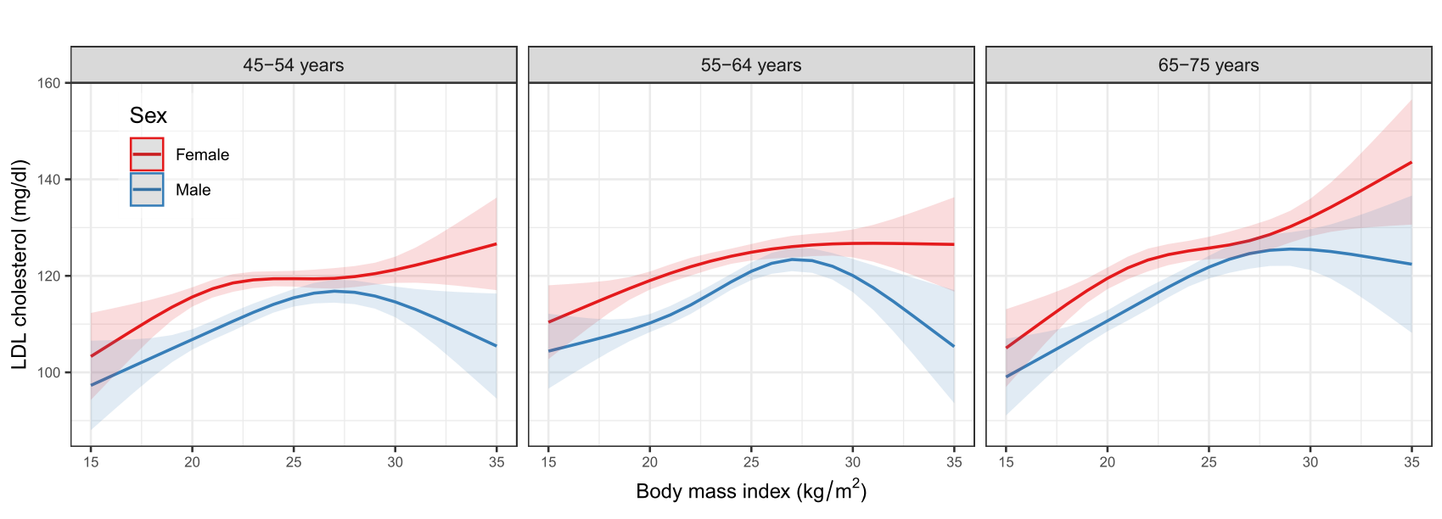
Figure S1. The nonlinear relationship between BMI and LDL-C in female and male using generalized additive models with the factor-smooth interaction terms for sex*BMI, stratiﬁed by the age-groups (45-54, 55-64, 65-75 years)

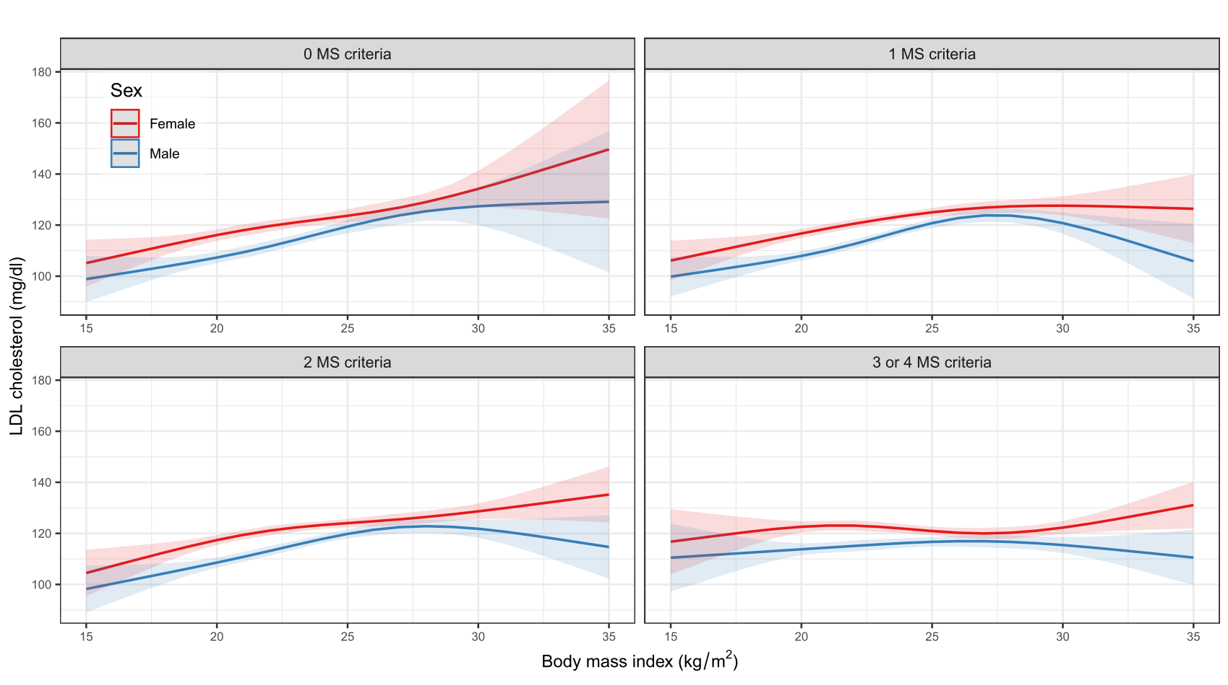
Figure S2. The nonlinear relationship between BMI and LDL-C in female and male using generalized additive models with the factor-smooth interaction terms for sex*BMI, stratiﬁed by the number of MS criteria (excluding the WC criterion) (0, 1, 2, 3 or 4 MS criteria)

