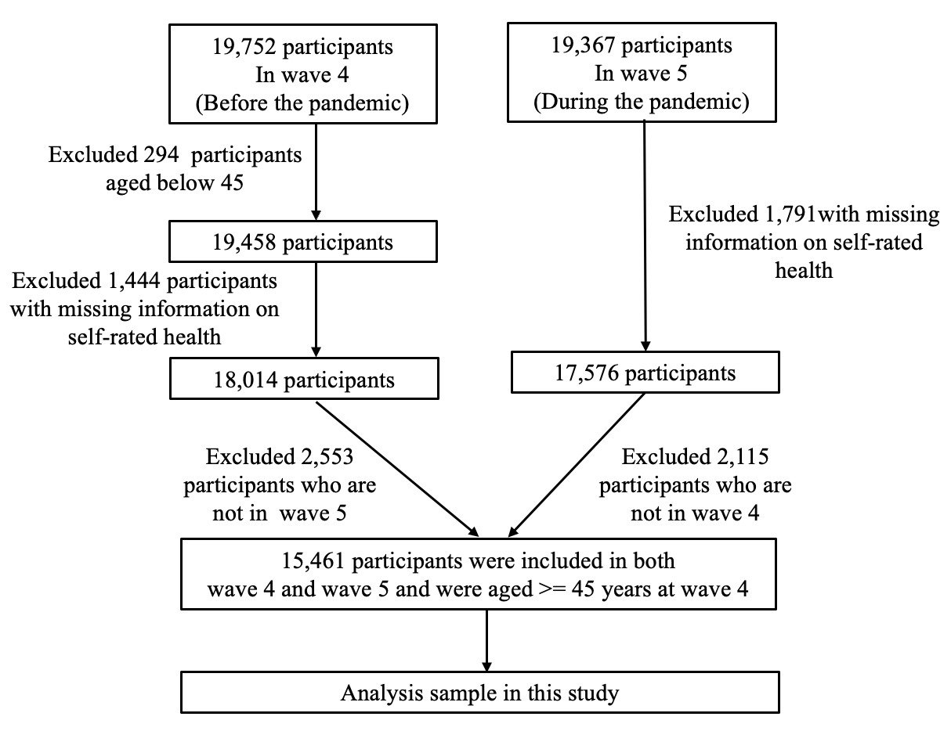
Supplementary Figure 1. Flowchart of the analytic sample

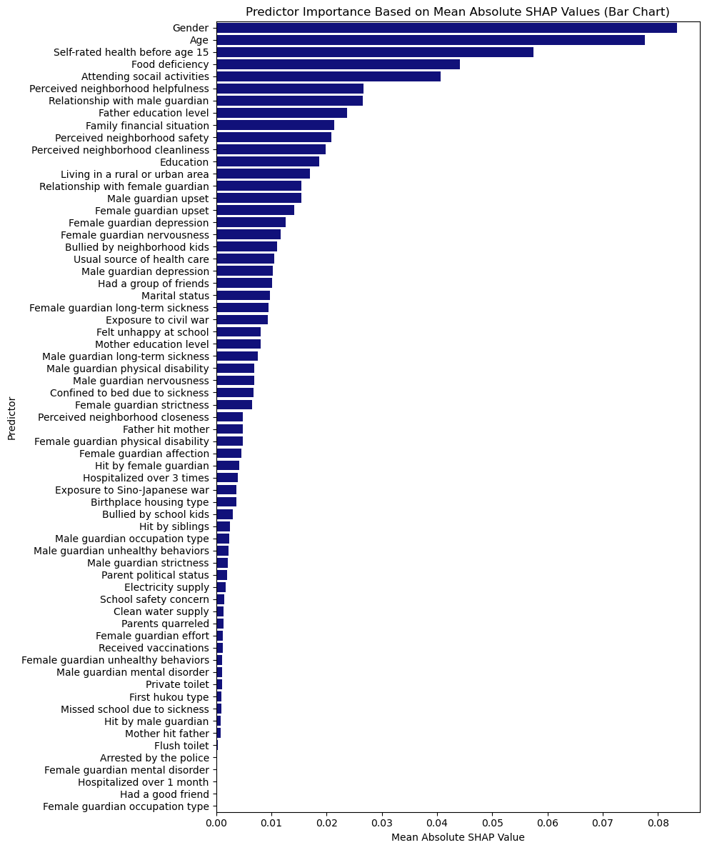

Supplementary Figure 2. Importance of all predictors in CatBoost using the CHARLS wave 4 data
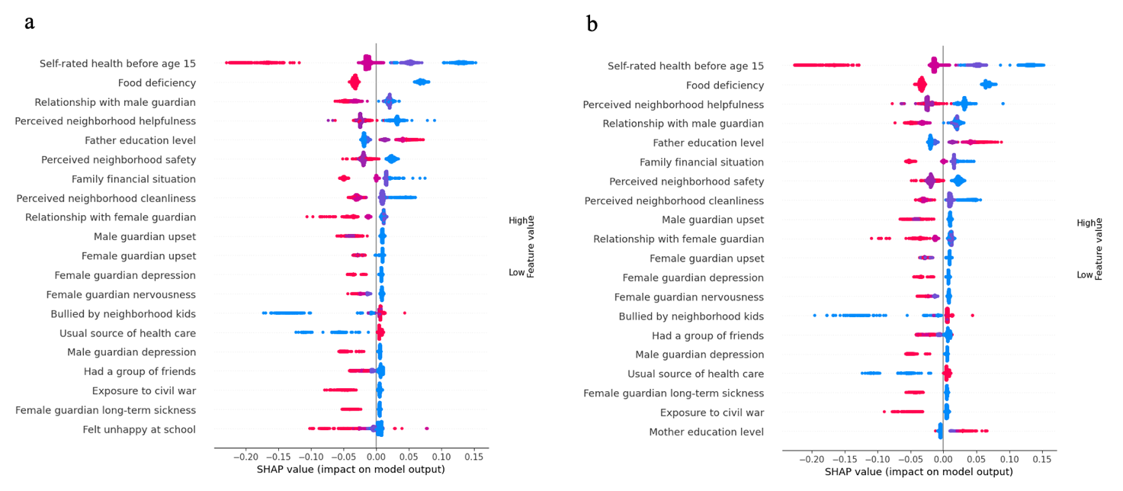
Supplementary Figure 3. Predictors for later-life self-rated health by gender
Note: ‘a’ represents men, ‘b’ represents women.

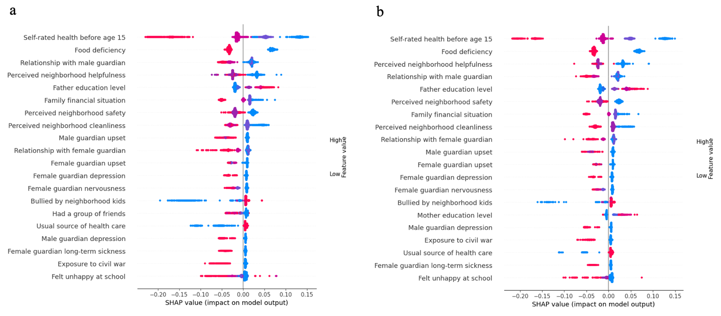
Supplementary Figure 4. Predictors for later-life self-rated health by rural–urban areas
Note: ‘a’ represents rural residents, ‘b’ represents urban residents.

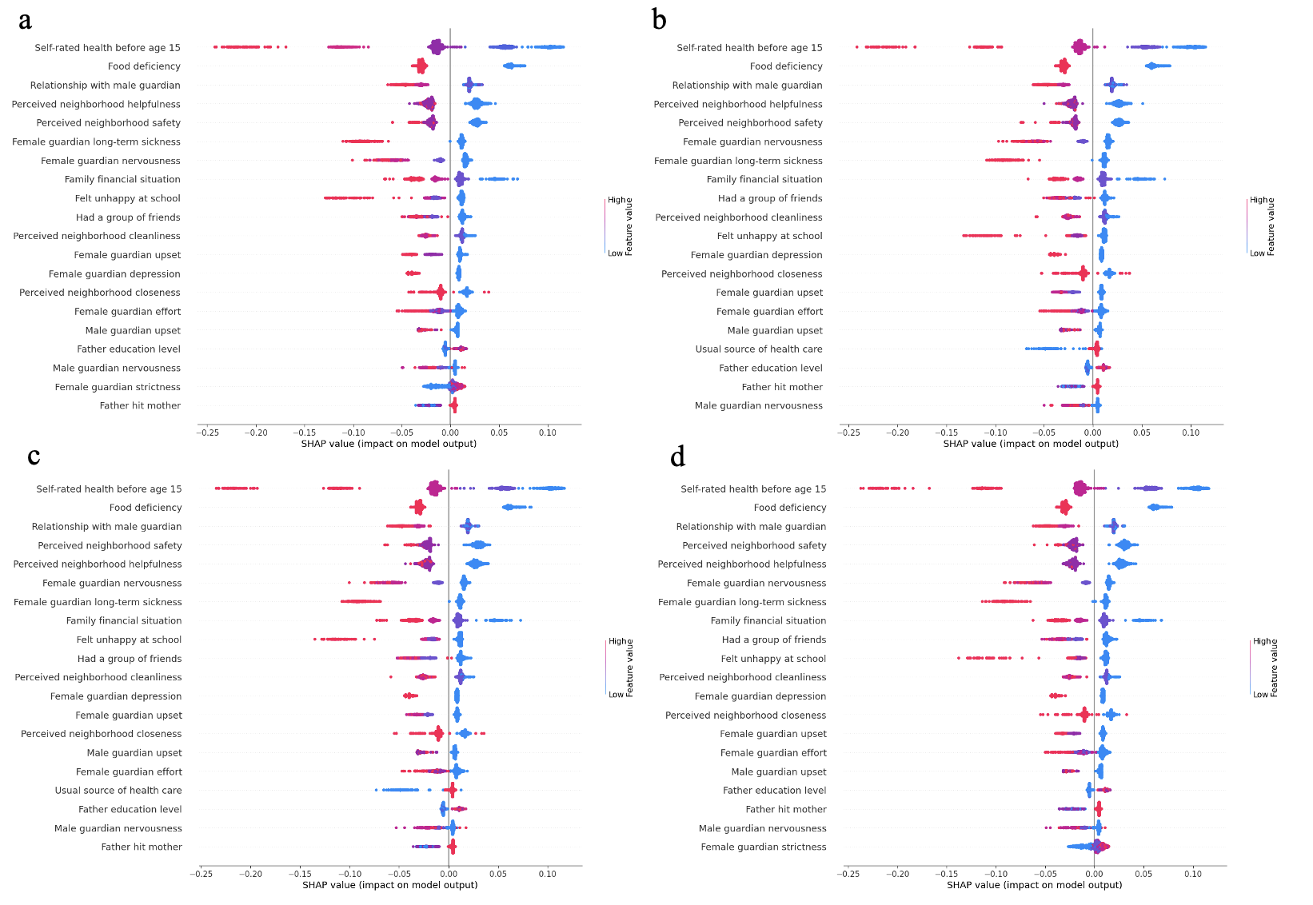
Supplementary Figure 5. Predictors for later-life self-rated health by levels of strict COVID-19 measures
Note: ‘a’ represents low levels of strict COVID-19 measures, ‘b’ represents moderately low levels of strict COVID-19 measures, ‘c’ represents moderately high levels of strict COVID-19 measures, ‘d’ represents high levels of strict COVID-19 measures.

Supplementary Table 1: Detailed description of childhood living conditions.
Domains | Predictors | Meaning of predictors
Childhood family socioeconomic status | Mother education level | The education level of the participant’s biological mother  1. No formal education (illiterate)  2. Did not finish primary school but capable of reading or writing  3. Sishu/home school  4. Elementary school  5. Middle school  6. High school  7. Vocational school  8. Two/Three Year College/Associate’s degree  9. Four Year College/Bachelor’s degree  10. Post-graduate, Master’s degree  11. Post-graduate (PhD)
 | Father education level | The education level of the participant’s biological father  1. No formal education (illiterate)  2. Did not finish primary school but capable of reading or writing  3. Sishu/home school  4. Elementary school  5. Middle school  6. High school  7. Vocational school  8. Two/Three Year College/Associate’s degree  9. Four Year College/Bachelor’s degree  10. Post-graduate (Master)  11. Post-graduate (PhD)
 | Female guardian occupation type | The usual occupation of the participant’s female guardian in childhood before participant was age 17  0. Non-Agricultural  1. Farming
 | Male guardian occupation type | The usual occupation of the participant’s male guardian in childhood before participant was age 17  0. Non-Agricultural  1. Farming
 | First hukou type | The first hukou (a system of household registration used) type of the participant  0. Non-agricultural hukou, non-agricultural hukou  1. Agricultural hukou
 | Family financial situation | Family’s financial situation compared to the average family in the same community or village, when the participant was a child before age 17  1. A Lot Better off  2. Somewhat Better off  3. Same as Others  4. Somewhat Worse off  5. A Lot Worse off
 | Food deficiency | Whether there was ever a time when the family did not have enough food to eat when the participant was a child before age 17  0. No  1. Yes
 | Parent political status | Whether one of the participant’s parents is (was) a China Communist Party member  1. Not of them  0. Biological mother, step mother, adoptive mother, biological father, step father, adoptive father, female dependent, or male dependent
Childhood individual health and healthcare | Self-rated health before age 15 | Childhood health status compared to other children of the same age before the participant was 15 years old (including 15 years old)  1. Much Healthier  2. Somewhat Healthier  3. About Average  4. Somewhat Less Healthy  5. Much Less Healthy
 | Missed school due to sickness | Whether the participant ever missed school for a month or more because of a health condition before the participant was 15 years old (including 15 years old)  0. No, or never had any education during the childhood  1. Yes
 | Confined to bed due to sickness | Whether the participant was ever confined to the bed or home for a month or more because of a health condition before the participant was 15 years old (including 15 years old)  0. No  1. Yes
 | Hospitalized over 1 month | Whether the participant was ever hospitalized for a month or more because of a health condition before the participant was 15 years old (including 15 years old)  0. No  1. Yes
 | Hospitalized over 3 times | Whether the participant was ever hospitalized more than three times within a 12-month period before the participant was 15 years old (including 15 years old)  0. No  1. Yes
 | Received vaccinations | Whether the participant had received any vaccinations before the participant was 15 years old (including 15 years old)  0. No  1. Yes
 | Usual source of health care | Whether the participant has always had a usual source of care, that is, a particular person or a place that the participant went to when the participant was sick or needed advice about health  0. No  1. Yes
Childhood exposure to wars | Exposure to civil war | Whether the participant was born between 1946 and 1949  0. No  1.Yes
 | Exposure to Sino-Japanese war | Whether the participant was born between 1937 and 1945  0. No  1. Yes
Childhood abuse | Bullied by neighborhood kids | How often the participant was picked on or bullied by kids in your neighborhood when the participant was a child  1. Often  2. Sometimes  3. Not very often  4. Never
 | Felt unhappy at school | How often the participant felt happy at school when the participant was a child  1. Often  2. Sometimes  3. Not very often  4. Never
 | School safety concern | How often the participant was worried about his/her physical safety at school when the participant was a child  1. Often  2. Sometimes  3. Not very often  4. Never
 | Arrested by the police | Whether the participant was arrested or taken into custody by the police before the participant was age 17  1. Yes  0. No
 | Bullied by school kids | How often the participant was picked on or bullied by kids in school when the participant was a child  1. Often  2. Sometimes  3. Not very often  4. Never
 | Hit by female guardian | How often the participant was hit by a female guardian when the participant was growing up  1. Often  2. Somewhat  3. Rarely  4. Never
 | Hit by male guardian | How often the participant was hit by male guardian when the participant was growing up  1. Often  2. Somewhat  3. Rarely  4. Never
 | Hit by siblings | How often the participant was hit by a brother or sister when the participant was growing up  1. Often  2. Somewhat  3. Rarely  4. Never
 | Parents quarreled | How often the participant’s parents quarreled  1. Often  2. Sometimes  3. Not very often  4. Never
 | Father hit mother | Whether the participant’s father ever beat up his/her mother in childhood  1. Often  2. Sometimes  3. Not very often  4. Never
 | Mother hit father | Whether the participant’s mother ever beat up his/her father in childhood  1. Often  2. Sometimes  3. Not very often  4. Never
Childhood social relationships | Had a group of friends | How often the participant had a group of friends that he/she felt comfortable spending time with in the participant’s childhood  1. Often  2. Sometimes  3. Rarely  4. Never
 | Had a good friend | Whether the participant had a good friend in childhood  0. No  1. Yes
 | Relationship with female guardian | How the participant rated the relationship with female guardian in childhood  1. Excellent  2. Very good  3. Good  4. Fair  5. Poor
 | Female guardian affection | How much the participant’s female guardian gave love and affection in childhood  1. Often  2. Sometimes  3. Rarely  4. Never
 | Female guardian effort | How much effort the participant’s female guardian put into watching over the participant  1. A lot  2. Some  3. A little  4. Not at all
 | Female guardian strictness | How often female guardian was strict with the participant  1. Very  2. Somewhat  3. A little  4. Not at all
 | Male guardian strictness | How often male guardian was strict with the participant  1. Very  2. Somewhat  3. A little  4. Not at all
 | Relationship with male guardian | How the participant would rate his/her relationship with male guardian in childhood  1. Excellent  2. Very good  3. Good  4. Fair  5. Poor
Childhood residential conditions | Birthplace housing type | Architectural type of residence when the participant was born  0. Concrete structure, built with bricks and wood or Adobe house  1. Wood house/Thatched houses, cave, Mongolian yurt, Boat house or others
 | Clean water supply | Whether there was a clean water supply in the accommodation before the participant was born  0. Clean water supply  1. No clean water supply
 | Flush toilet | Whether there was a water closet in the accommodation before the participant was born  0. Water closet  1. No water closet
 | Private toilet | Whether there was a private closet in the accommodation before the participant was born  0. Private closet  1. No private closet
 | Electricity supply | Whether there was an electricity supply in the accommodation before the participant was born  0. Electricity supply  1. No electricity supply
Childhood neighborhood quality | Perceived neighborhood safety | Was it safe being out alone at night in the neighborhood where the participant lived as child before age 17?  1. Very safe  2. Somewhat safe  3. Not very safe  4. Not safe at all
 | Perceived neighborhood helpfulness | Were the neighbors of the place where the participant lived as a child willing to help each other out before age 17?  1. Very willing  2. Somewhat willing  3. Not very willing  4. Not willing to at all
 | Perceived neighborhood closeness | Were the neighbors of the place where the participant lived as a child very close-knit before age 17?  1. Very close-knit  2. Somewhat close-knit  3. Not very close-knit  4. Not close-knit at all
 | Perceived neighborhood cleanliness | Was the neighborhood of the place where you lived as a child before age 17 very clean and attractive?  1. Very Clean and attractive  2. Somewhat clean and attractive  3. Not Very clean and attractive  4. Not clean and attractive at all
Childhood parental health | Female guardian unhealthy behaviors | Whether the participant’s female guardian ever have a problem with alcoholism, smoking, drugs or gambling, during the years the participant was growing up  0. No  1. Yes
 | Male guardian unhealthy behaviors | Whether the participant’s male guardian ever have a problem with alcoholism, smoking, drugs or gambling, during the years the participant was growing up  0. No  1. Yes
 | Female guardian nervousness | How often female guardian felt nervous and anxious during the participant’s childhood  1. A Little of the time  2. Some of the time  3. Good part of the time  4. Most of the time
 | Female guardian upset | How often female guardian got upset easily or felt panicky during the participant’s childhood  1. A Little of the time  2. Some of the time  3. Good part of the time  4. Most of the time
 | Female guardian depression | Whether female guardian showed continued signs of sadness or depression that lasted 2 weeks or more, during the years the participant was growing up  0. No  1. Yes
 | Male guardian nervousness | How often male guardian felt nervous and anxious during the participant’s childhood  1. A Little of the time  2. Some of the time  3. Good part of the time  4. Most of the time
 | Male guardian upset | How often male guardian got upset easily or felt panicky during the participant’s childhood  1. A Little of the time  2. Some of the time  3. Good part of the time  4. Most of the time
 | Male guardian depression | Whether male guardian showed continued signs of sadness or depression that lasted 2 weeks or more, during the years the participant was growing up  0. No  1. Yes
 | Female guardian long-term sickness | Whether female guardian had a long time of being sick on bed during the participant’s childhood  0. No  1. Yes
 | Female guardian physical disability | Whether female guardian had a serious deformity during the participant’s childhood  0. No  1. Yes
 | Female guardian mental disorder | Whether female guardian had an abnormality of mind during the participant’s childhood  0. No  1. Yes
 | Male guardian long-term sickness | Whether male guardian had a long time of being sick on bed during the participant’s childhood  0. No  1. Yes
 | Male guardian physical disability | Whether male guardian had a serious deformity during the participant’s childhood  0. No  1. Yes
 | Male guardian mental disorder | Whether male guardian had an abnormality of mind during the participant’s childhood  0. No  1. Yes

Supplementary Table 2. Detailed description of sociodemographic predictors
Domains | Predictors | Meaning of predictors
Demographic predictors | Gender | The participant’s gender  0. Woman  1. Man
 | Age | The participant’s age at interview  1. 45–55 years old  2. 55–64 years old  3. 65–74 years old  4. 75+ years old
 | Marital status | The participant’s marital status  0. Married or registered partnership  1. Separated, divorced, widowed, never married
 | Education | The participant’s education level  1. Less than upper secondary education  2. Upper secondary and vocational training  3. Tertiary education
 | Living in a rural or urban area | Whether the participant lives in a rural or urban area  0. Living in an urban area  1. Living in a rural area
 | Attending social activities | Whether the participant has done any social activities in the past month  (Social activities include: Interacted with friends; Played Ma-jong, played chess, played cards, or went to community club; Went to a sport, social, or other kind of club; Took part in a community-related organization; Did volunteer or charity work; Attended an educational or training course)  0. No  1. Yes
Strict COVID-19 measures were calculated as the mean score of nine metrics: school closures; workplace closures; cancellation of public events; restrictions on public gatherings; closures of public transport; stay-at-home requirements; public information campaigns; restrictions on internal movements; and international travel controls (Mathieu et al., 2020). The higher the index score, the stricter the response.

Supplementary Table 3. Tuned hyperparameters
Model | Best Parameters | Parameter range
Lasso | 'max_iter': 1000,  'alpha': 0.001 | 'max_iter': [1000, 5000, 10000],  'alpha': [0.0001, 0.001, 0.01, 0.1, 1, 10]
Ridge | 'solver': 'saga',  'alpha': 206.913808111479 | 'solver': ['svd', 'cholesky', 'lsqr', 'sparse_cg', 'sag', 'saga']  'alpha': np.logspace(-4, 4, 20)
K-nearest neighbors | 'weights': 'uniform',  'n_neighbors': 25,  'metric': 'manhattan' | 'weights': ['uniform', 'distance'],  'n_neighbors': [5, 10, 15, 20, 25],  'metric': ['euclidean', 'manhattan']
Decision tress | 'min_samples_split': 20,  'min_samples_leaf': 6,  'max_features': 'sqrt',  'max_depth': 10 | 'min_samples_split': [2, 5, 10, 20],  'min_samples_leaf': [1, 2, 4, 6],  'max_features': [None, 'sqrt', 'log2'],  'max_depth': [None, 10, 20, 30, 40, 50]
Random forest | 'n_estimators': 300,  'min_samples_split': 5,  'min_samples_leaf': 4,  'max_depth': 10,  'bootstrap': True | 'n_estimators': [100, 200, 300, 400],  'min_samples_split': [2, 5, 10],  'min_samples_leaf': [1, 2, 4],  'max_depth': [10, 20, 30, 40],  'bootstrap': [True, False]
Gradient boosting regressor | 'subsample': 0.8,  'n_estimators': 200,  'min_samples_split': 5,  'min_samples_leaf': 4,  'max_depth': 3,  'learning_rate': 0.05 | 'subsample': [0.8, 0.9, 1.0],  'n_estimators': [50, 100, 200, 300],  'min_samples_split': [2, 5, 10],  'min_samples_leaf': [1, 2, 4],  'max_depth': [3, 5, 7, 9],  'learning_rate': [0.01, 0.05, 0.1, 0.2]
XGBoost | 'subsample': 0.9,  'n_estimators': 200,  'max_depth': 3,  'learning_rate': 0.05,  'colsample_bytree': 0.8 | 'subsample': [0.8, 0.9, 1.0],  'n_estimators': [50, 100, 200, 300],  'max_depth': [3, 5, 7, 9],  'learning_rate': [0.01, 0.05, 0.1, 0.2],  'colsample_bytree': [0.8, 0.9, 1.0]
CatBoost | 'subsample': 0.9,  'learning_rate': 0.05,  'iterations': 200,  'depth': 5,  'colsample_bylevel': 0.8 | 'subsample': [0.8, 0.9, 1.0],  'learning_rate': [0.01, 0.05, 0.1, 0.2],  'iterations': [50, 100, 200, 300],  'depth': [3, 5, 7, 9],  'colsample_bylevel': [0.8, 0.9, 1.0]

Supplementary Table 4. Machine learning (ML) model predictive performance
ML model | MSE | RMSE
Lasso | 0.959 | 0.980
Ridge | 0.959 | 0.979
K-nearest neighbors | 1.017 | 1.009
Decision tress | 1.062 | 1.031
Random forest | 0.971 | 0.985
Gradient boosting regressor | 0.958 | 0.979
XGBoost | 0.956 | 0.978
CatBoost | 0.955 | 0.977
Note: MSE indicates mean squared error, and RMSE indicates root mean squared error. Lower values indicate better model performance.

