Additional file 1:
Potential of Megathrust Earthquakes along the Southern Ryukyu Trench Inferred from GNSS Data
Masayuki Kano, Aoi Ikeuchi, Takuya Nishimura, Shin’ichi Miyazaki and Takeshi Matsushima

Text S1: Checkerboard resolution test
To investigate the spatial resolution, we conducted the checkerboard test. Fig. S1a represents the assumed slip deficit rate (SDRs) with values of 2 or 0 cm/yr. The synthetic vertical velocities and distance changes were then calculated by summing up the contributions of SDR due to all subfaults (Fig. S1c, d). The synthetic data was then inverted to the SDRs using the same inversion scheme as mentioned in the main text. The synthetic observations were well explained by the SDR distribution in both vertical velocities and distance changes (Fig. S1c, e, f). The obtained SDR distributions in Fig. S1b indicated that the checkerboard pattern around the Iriomote and the Ishigaki Islands were well reproduced, while the resolutions in the shallow plate interface were poor as expected from the spatial coverage of the GNSS stations.

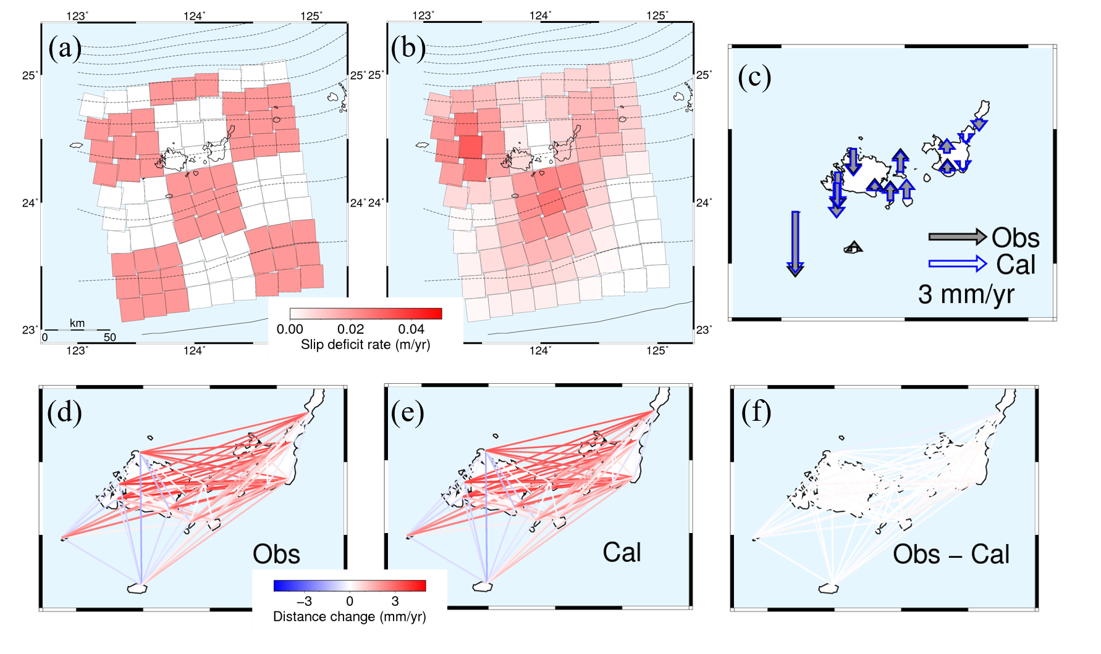
Figure S1: Checkerboard test. (a) Assumed checkerboard pattern of SDR and (b) the estimated SDR distribution. (c) Comparison between observed (black arrows) and calculated vertical velocities (blue arrows). (d) Observed, (e) calculated, and (f) residual distance changes.

