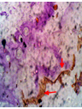
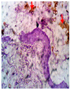
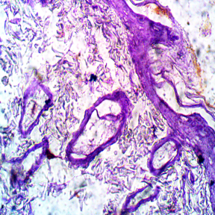
46

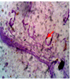
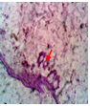
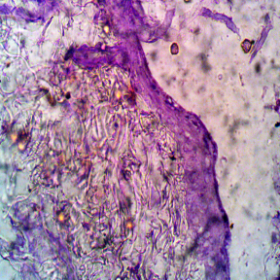
Cw
C
Cm

400 µL ME
200 µL ME
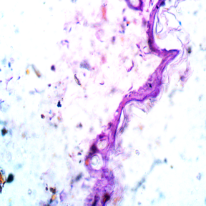
200 µL AE

H5
H6
H7

400µl ME

400 µL AE
Plate 1: Expression of serotonin in skin (X40). *AE- Aqueous extract. ME- Methanolic extract. C- control. Cw- control water. Cm- control methanol

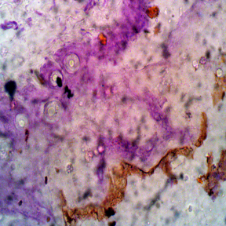
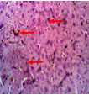
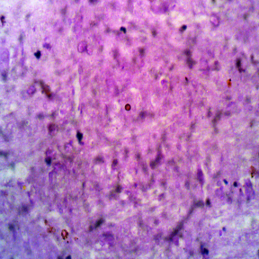
200µl ME
45

Cw
Cm
C
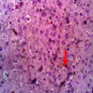
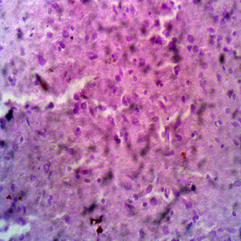
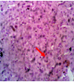

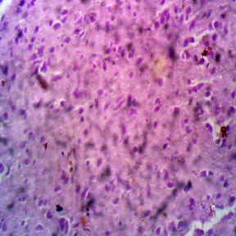
200 µL ME
400 µL ME
200 µL AE

400 µL AE
Plate 2: Expression of serotonin in brain (X40). *AE- Aqueous extract. ME- Methanolic extract. C- control. Cw- control water. Cm- control methanol

