Table 1. Drugs used by competitors during the competition preparation cycle. q.wk. - once a week, q.o.d. - every other day, q.d. - every day, d. in p. æ. - divided into equal parts, b.d.s. - twice daily.
Name | Structure | Literature Reference | Month:  1–5 | Month:  6
Testosterone propionate | 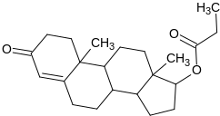 | ^{16,17} | 100–150 mg q.o.d. | 100 mg q.o.d.
Drostanolone propionate (Masteron) | 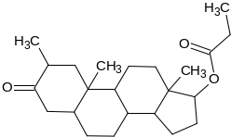 | Nan | 100–150 mg q.o.d. | X
Trenbolone acetate | 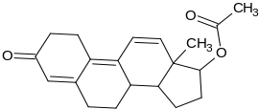 | Nan | 75–100 mg q.o.d. | X
Oxandrolone (Anavar) | 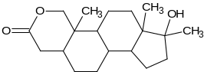 | ¹⁸⁻²⁰ | 50–75mg q.d. | X
Stanozolol (Winstrol) | 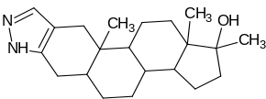 | ²¹ | 50–100 mg q.d | X
Boldenone undecylenate | 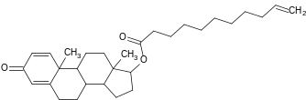 | NaN | 500–600mg q.wk. | X
Triiodothyronine (t3) | 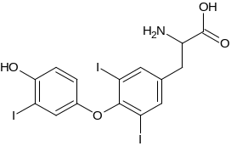 | ²² | x | 10–25mg q.d.
Clenbuterol | 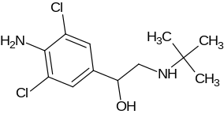 | ^{23,24} | 0.08–0.04mg b.d.s. | 0.02 mg d. in p. æ.
Mesterolone (Proviron) | 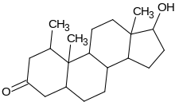 | ²⁵ | 20–25mg q.d. | X
Tamoxifen citrate (Nolvadex) | 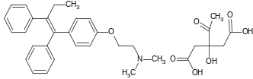 | ²⁶ | 20–30 mg b.d.s. | 20 mg q.d.
Human growth hormone (HGH) | 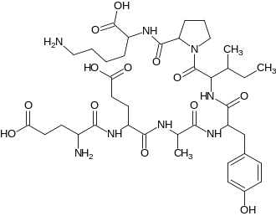 | ²⁷ | 2 x 3UI–4IU q.d. | 2 x 2UI–3IU q.d.
2,4-Dinitrophenol (2,4-DNP) | 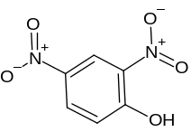 | ²⁸ | x | 100–200mg q.d. ( 7th day off)

