Supporting Information

Homologous and mitochondrial targeting synergistic induction of apoptosis and ferroptosis enhanced PDT performance against osteosarcoma HOS
Yang Wang¹, Liang Zhang², Guosheng Zhao³, Yuan Zhang⁴, Fangbiao Zhan¹, Zhiyu Chen¹, Tao He¹, Yang Cao⁵, Lan Hao⁵, Zhigang Wang⁵, Zhengxue Quan¹*, Yunsheng Ou¹*

1. Department of Orthopedic Surgery, The First Affiliated Hospital of Chongqing Medical University, Chongqing 400016, People's Republic of China.
2. Department of Ultrasound, The First Affiliated Hospital of Chongqing Medical University Chongqing 400016, China.
3. Department of Orthopedic Surgery, The Second Affiliated Hospital of Chongqing Medical University, Chongqing 400016, People's Republic of China.
4. Department of Orthopedic Surgery, Children’s Hospital of Chongqing Medical University, Ministry of Education Key Laboratory of Child Development and Disorders, Key Laboratory of Pediatrics in Chongqing, China International Science and Technology Cooperation Base of Child Development and Critical Disorders, Chongqing 400014, People's Republic of China.
5. Department of Ultrasound Imaging, Second Affiliated Hospital of Chongqing Medical University, Chongqing, 400014, People's Republic of China.
*Correspondence to: Professor Yunsheng Ou and Professor Zhengxue Quan.
Yunsheng Ou: ouyunsheng2001@163.com
Zhengxue Quan: quanzx18@126.com
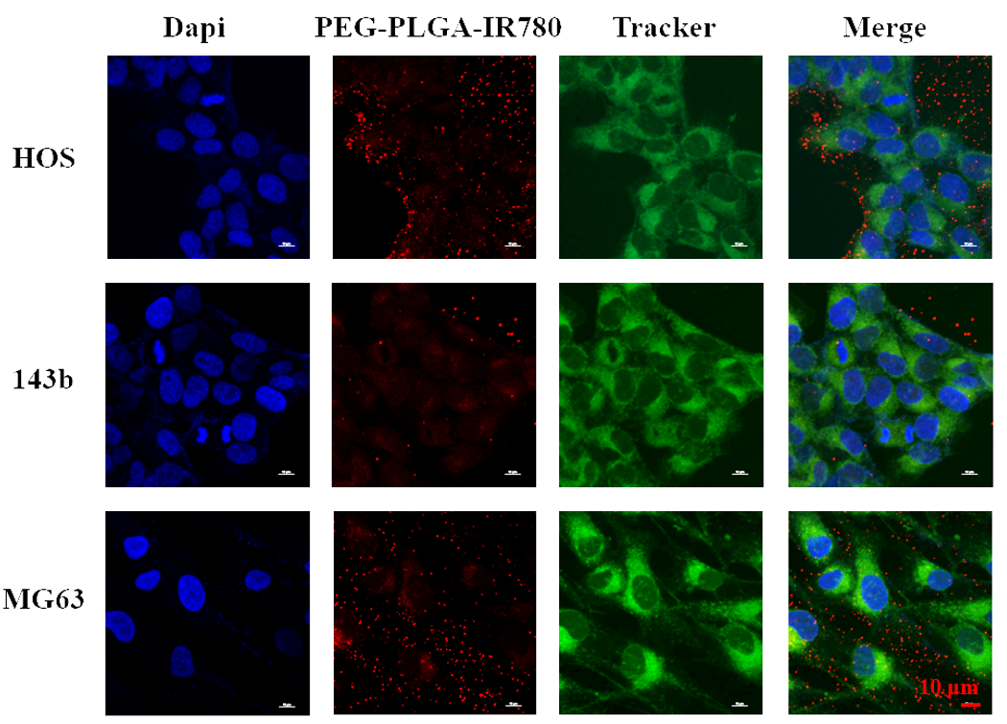
Figure S1. PEG-PLGA-IR780 NPs (labeled with DiI) colocalized with mitochondria (stained with MitoTracker) as observed by CLSM. The scale bars are 10 µm.

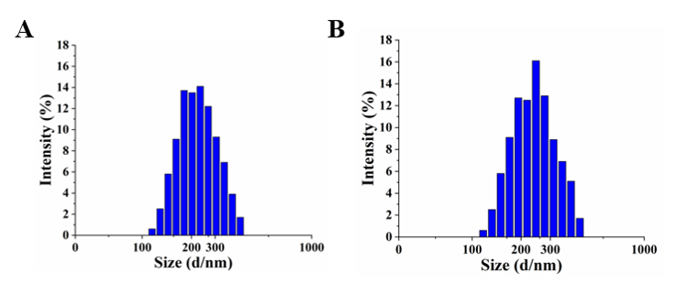
Figure S2. Size distribution of (A) PEG-PLGA NPs and (B) PEG-PLGA-IR780 NPs as measured by DLS.

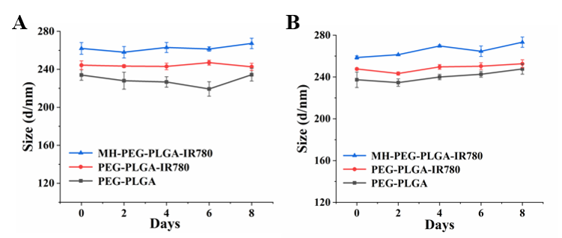
Figure S3. The dynamical change of the size of various NPs (PEG-PLGA NPs, PEG-PLGA-IR780 NPs, MH-PEG-PLGA-IR780 NPs) in the (A) DMEM (10% serum) or (B) PBS with the prolonged time points at 4°C under 5% CO₂.

Figure S4. The relative absorbance intensity of IR780 was determined via UV–vis spectrum at the wavelength of 798 nm and the standard curve of IR780 was drawn.

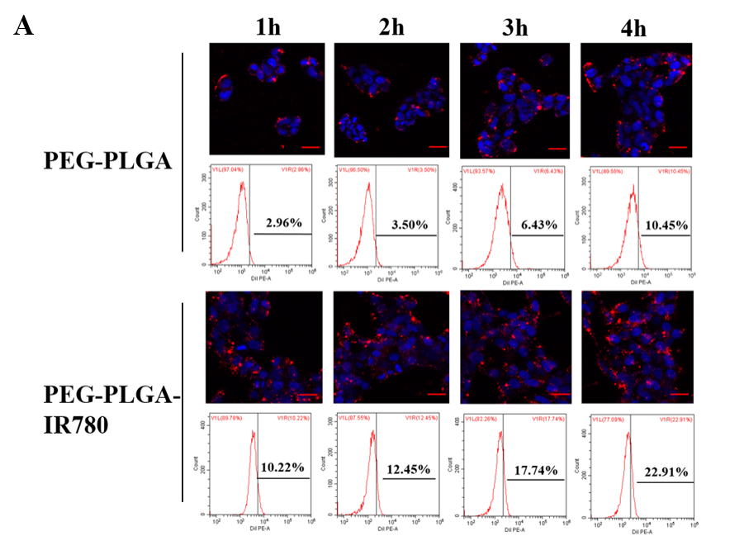
Figure S5. (A) Intracellular uptake of the PEG-PLGA NPs and PEG-PLGA-IR780 NPs as observed by CLSM and quantified by FC. The scale bars are 50 µm.

Figure S5. (B) Statistical analyses of the intracellular uptake of the three NPs. (The data are
presented as the mean ± SD, n = 3, *p < 0.05, **p < 0.01).

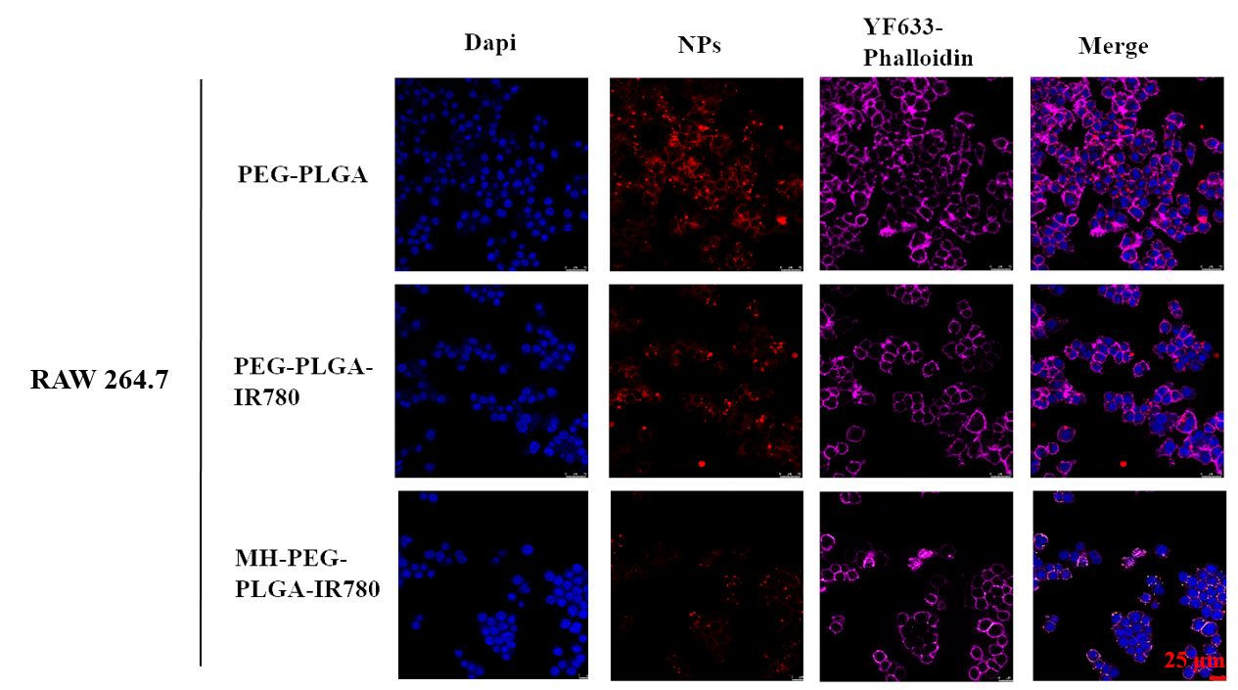
Figure S6. CLSM images of RAW 264.7 cells after 4 h co-incubation of various NPs (PEG-PLGA NPs, PEG-PLGA-IR780 NPs and MH-PEG-PLGA-IR780 NPs). The scale bars are 25 µm.

Figure S7. The standard curve of ATP was measured by luminometer with multimode reader.

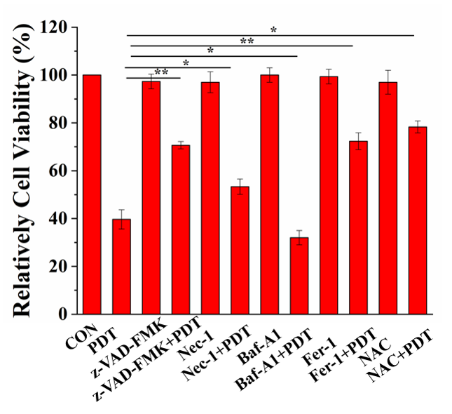
Figure S8. The relative cell viability (%) of HOS cells of PDT via the pretreatment of various cell death inhibitors (apoptosis inhibitors (z-VAD-FMK, 20 μM), necrosis inhibitors (Nec-1, 20 μM), autophagy inhibitors (Baf-A1, 100nM), ferroptosis inhibitors (Fer-1, 20 μM) and a general ROS scavenger (NAC, 10 μM)). (The data are presented as the mean ± SD, n = 3, *p < 0.05, **p < 0.01). PDT: laser+MH-PEG-PLGA-IR780 NPs.

Figure S9. Representative HOS tumor-bearing mice by different treatments before sacrifice.

Figure S10. The body-weight of mice were recorded during the therapeutic period of the six group.

Figure S11. (A-B) Xenograft tumors followed by different treatments were sectioned and stained with Ki67 and PCNA via IHC. (C-D) Statistical analyses of the expression of Ki67 and PCNA. (The data are presented as the mean ± SD, n = 5, *p < 0.05)

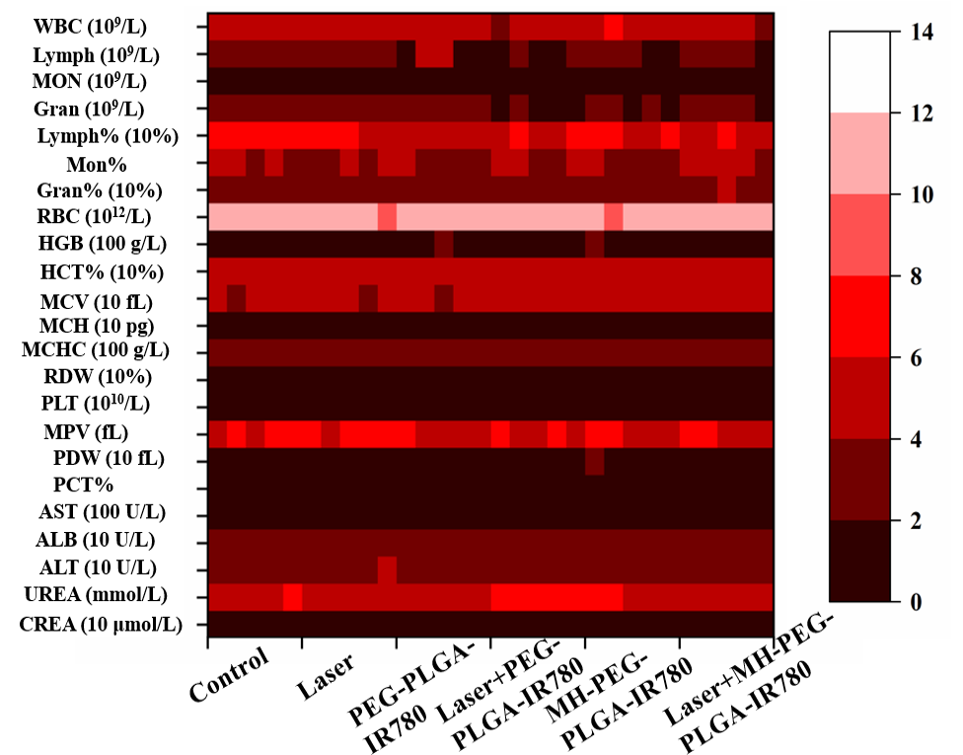
Figure S12. Assay of blood index (routine blood and biochemistry) after different therapies (n=5).

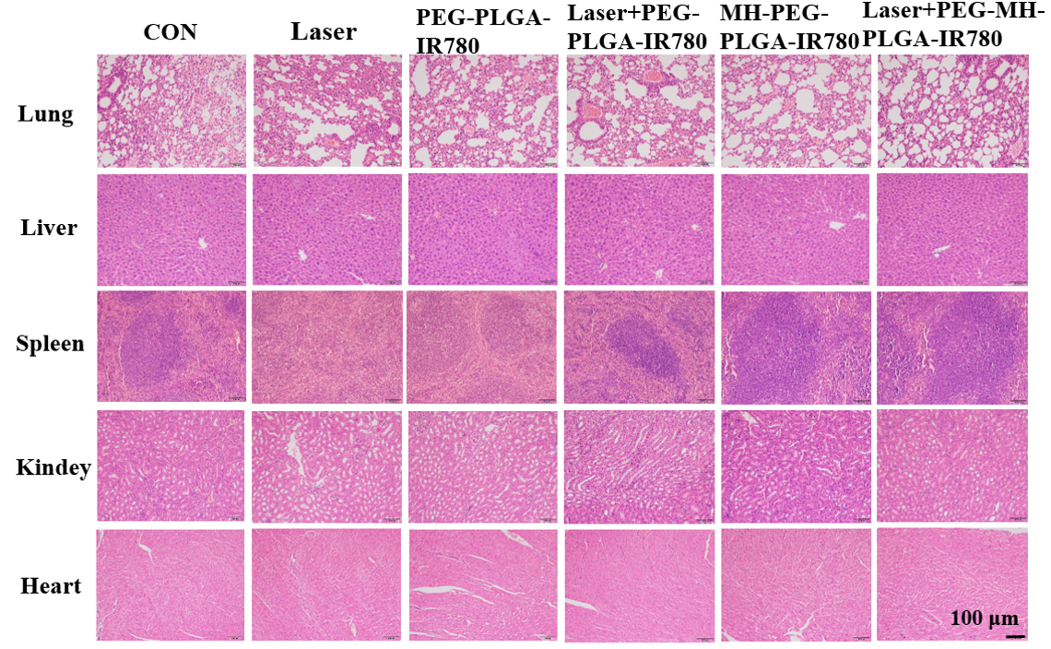
Figure S13. H&E images of major organs after various treatments. The scale bars are 100 µm.

Figure S14. (A-B) CLSM images and FC analyses of the intracellular Fe²⁺ with the pretreatment of DFO before PDT treatment. The scale bars are 100 µm. (C) Statistical analyses of the intracellular Fe²⁺ by different treatments. (The data are presented as the mean ± SD, n = 3, *p < 0.05, **p < 0.01). PDT: laser+MH-PEG-PLGA-IR780 NPs.

