Supporting information

Sequential drug delivery by injectable macroporous hydrogels for combined photodynamic-chemotherapy
Yuanyuan Zhong^{a†}, Li Zhang^{a†}, Shian Sun^{c}, Zhenghao Zhouª, Yunsu Maª, Hao Hong^{b}*, Dongzhi Yangª*
ª Jiangsu Key Laboratory of New Drug Research and Clinical Pharmacy, Xuzhou Medical University, Xuzhou, Jiangsu 221004, China
^{b} Medical School, Nanjing University, Nanjing, Jiangsu 210093, China
^{c} Xuzhou Air Force College, Xuzhou, Jiangsu 221000, China

† These authors contributed equally to this work.

*Corresponding author:
Dongzhi Yang (dongzhiy@xzhmu.edu.cn)
Hao Hong (haohong@nju.edu.cn)

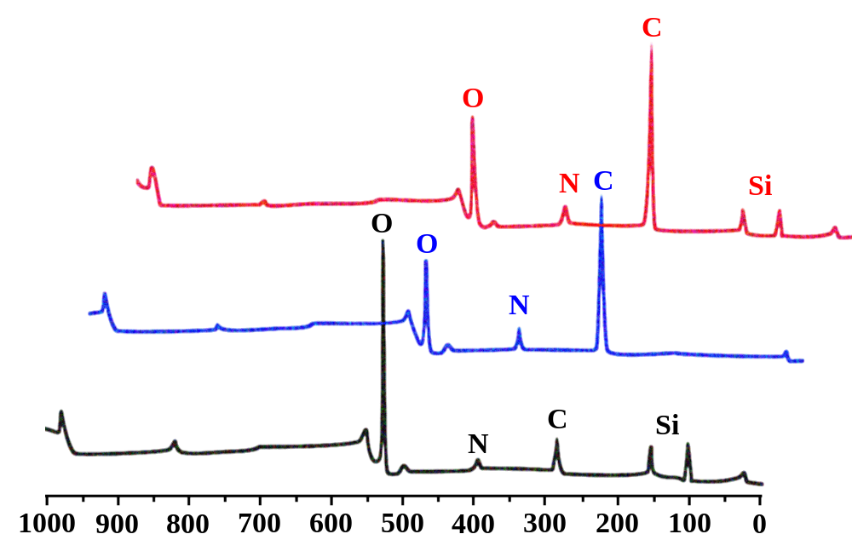Figure S1 XPS survey spectra of hMSN, Gel and CA4P-DOX@Gel

Figure S2 Fluorescence images of 4T1 cells after incubation with Gel with irradiation assistance (red-dead cells, green-live cells). Scale bar: 100 μm.

Figure S3 Cells viability of 4T1 cells after incubated with Gel with irradiation assistance. *p<0.05, **p<0.01, and ***p<0.001

Figure S4 Body weight variation of mice during

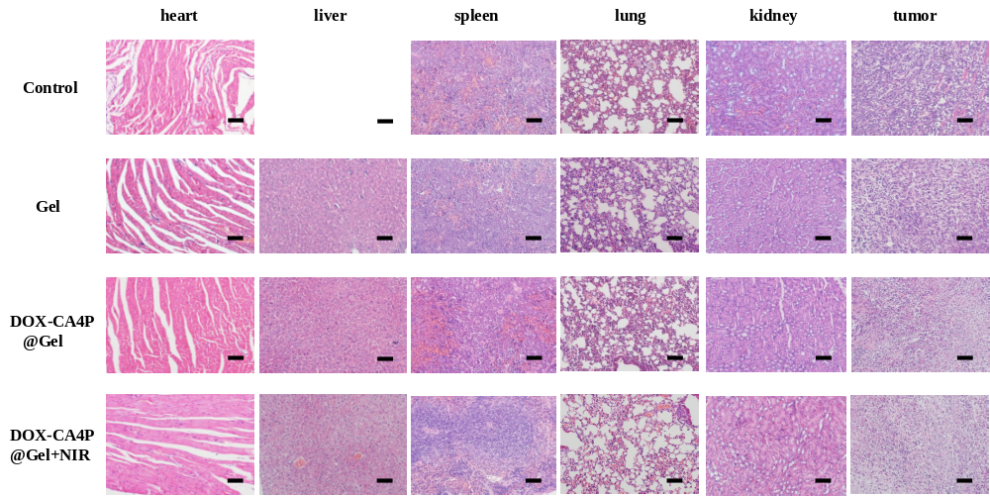

Figure S5 Histolodical analysis of the major orangs of mice treated with various drug formulations at day 21 (scale bar is 100 μm)

