Magnetically-Targeted Nanoparticle-Guided M2 Macrophage Polarization for Fracture Healing Promotion
Wu Zhou^{a,b,1}, Ze Lin^{a,b,1}, Yuan Xiong^{a,b,1}, Hang Xue^{a,b}, Wen Song^{c}, Tao Yu^{d}, Lang Chen^{a,b}, Yiqiang Hu^{a,b}, Adriana C. Panayi^{e}, Yun Sun^{f}, Faqi Cao^{a,b}, Guodong Liu^{g}, Liangcong Hu^{a,b}, Chenchen Yan^{a,b}, Xudong Xie^{a,b}, Wenxiu Qiu^{c,*}, Bobin Mi^{a,b,*}, Guohui Liu^{a,b,*}
Figure S1. FT-IR spectra of (A) CTAB@MMSNPs. (B) MMSNPs, (C) MMSNPs-SH, (D) MMSNPs-SS-Alkyne, (E) BCL@MMSNPs-SS-CD, (F) BCL@MMSNPs-SS-CD, (G) BCL@MMSNPs-SS-CD-NW.

Figure S2. (A) The cell morphology of BMDMs. Scale bar = 100 μm. Identification of the BMDMs proportion from C57BL/6 mice femoral bone marrow via FCM. Identification of (B) M1 and (C) M2 macrophages by using FCM method.
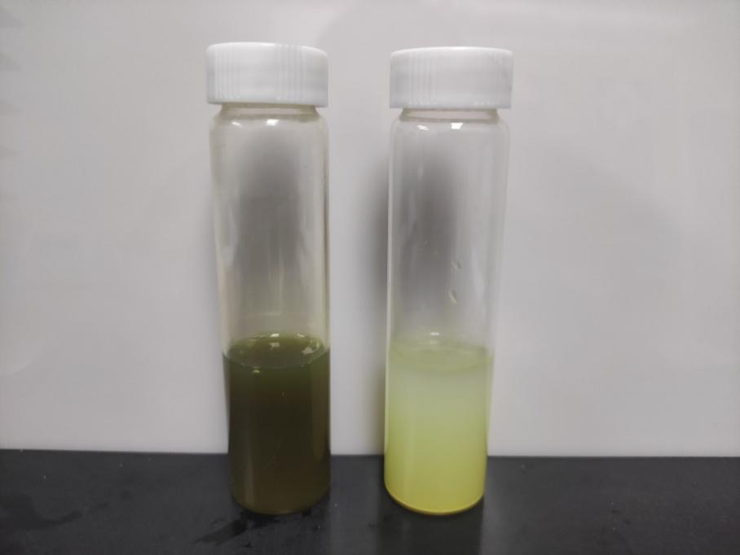
Figure S3. Left: BCL loaded in mesoporous nanoparticles. Right: free BCL. The concentration of the BCL is 1mg/mL
Figure S4. The diameter of MMSNPs-SS-CD-NW nanoparticles in H2O, DMEM and PBS with 10% fetal bovine serum in 48 hours.
Figure S5. The Zeta potential of MMSNPs-SS-CD-NW nanoparticles in H2O, DMEM and PBS with 10% fetal bovine serum in 48 hours.

