Supporting Information

Photoclick Reaction Programming Glutathione-Responsive System for Granuloma-Tracking and Anti-Tuberculosis

Jundun Zheng^{[b],+}, Xun Long ^{[a]+}, Hao Chen^{[c]}, Zhishen Ji^{[d]}, Bowen Shu^{[b]}, Rui Yue^{[b]}, Yechun Liao^{[a]}, Kun Qiao*^{[f]}, Ying Liu*^{[a]} & Yuhui Liao*^{[b], [e]}

[a] Department of Science and Education, the Third People’s Hospital of Bijie, Bijie, 551700 (P.R. China)

[b] Molecular Diagnosis and Treatment Center for Infectious Diseases, Dermatology Hospital, Southern Medical University Guangzhou 510091 (P.R. China)

[c] Division of Gastrointestinal Surgery, Department of General Surgery, Nanfang Hospital, Southern Medical University, Guangzhou 510091 (P.R. China)

[d] Department of Orthopedics, the First Affiliated Hospital of Jinan University
Jinan University, Guangzhou 510630 (P.R. China)

[e] Department of Infectious Disease, the Fifth Affiliated Hospital, Sun Yat-sen University, Guangzhou 510091 (P.R. China)

[f] Department of Thoracic Surgery, The Second Affiliated Hospital of Southern University of Science and Technology, Shenzhen Third People’s Hospital, Shenzhen 518000 (P.R. China)

- mail: szqiaokun@163.com (Q. Kun), liuying1036@foxmail.com (Y. Liu) and liaoyh8@mail.sysu.edu.cn (Y. Liao)

[+] These authors contributed equally to this work.

- Experimental Section
1-(3-Dimethylaminopropyl)-3-ethylcarbodiimide hydro (EDC), N-Hydroxy succinimide (NHS), Cystine (Cys), hyaluronic acid (HA), methacryloylchloride (MA) were purchased from Aladdin Reagent, Ltd. (Shanghai, China). All chemicals used in this study were of analytical and reagents were used without further purification. Dulbecco’s modified Eagles medium (DMEM) cell culture medium, fetal bovine serum, streptomycin, and penicillin were purchased from Thermo Fisher Scientific Co., Ltd. (China). All aqueous solutions were prepared using ultrapure deionized water (DI water), which was obtained through a Millipore Milli-Q water purification system (Billerica, USA) and had an electric resistance > 18.2 MΩ.
- Materials and Methods
The UV–vis absorption spectra were recorded on a UV–vis spectrometer (Lambda 35 UV–vis spectrometer, Perkin-Elmer, USA) at room temperature. The sizes of micelle nanoparticles were measured using ZEN3690 zetasizer (Malvern instruments, Zetasizer Nano-ZS) at room temperature.
- Granuloma-Bearing Mouse Models
All animal experiments were approved by the Institutional Animal Ethics Committee at Southern Medical University, and the experiments were performed in compliance with the National Institutes of Health (NIH) guidelines for the Care and Use of Laboratory Animals of Southern Medical University. The granuloma-bearing mouse models was in accordance with the previous model reported by our group.¹ Briefly, female C57BL/6 (B6) mice (8-12 weeks old) were purchased from Guangdong Medical Laboratory Animal Center (Guangdong, China). To establish the granuloma-bearing mouse models, mycobacterium marinum (M.m) were first grown in 7H9 broth media for 7-10 days in a bacterial shaking incubator. When mid-log phase (OD600 = 0.7±0.2) was achieved, the bacteria were collected and washed, and then passed 20 times through a needle to disrupt bacterial aggregates. After that, the supernatants were transferred to new tubes and diluted in sterile PBS to a final concentration of 2×10⁸ C.F.U. mL-1. Two hundred microliters of the M.m suspension were intravenously injected into mice using a insulin syringe. The bacteria infection-induced tail granulomas were successfully formed after 2 weeks.

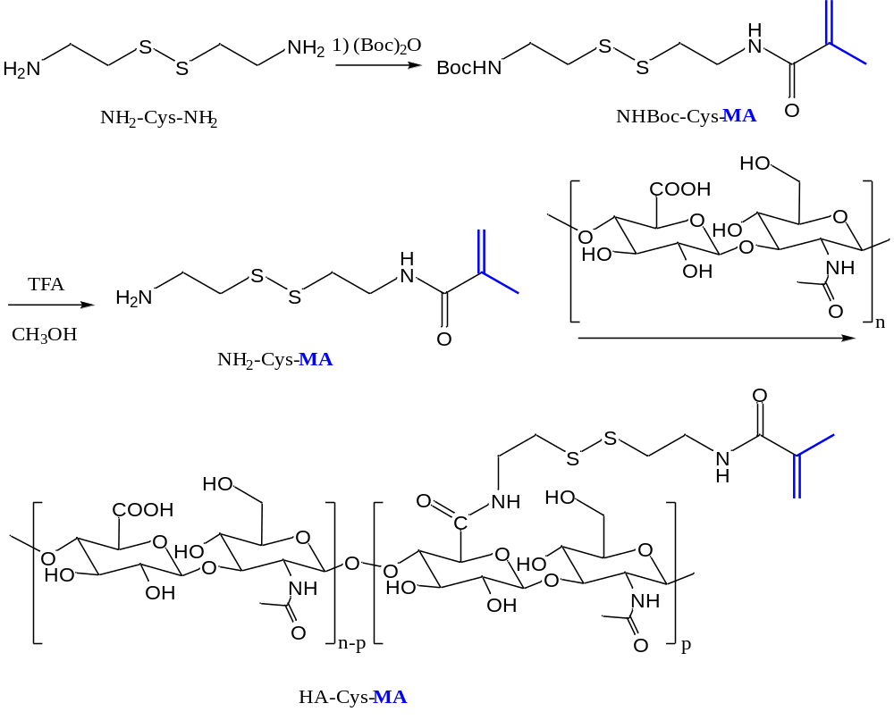
Figure S1. Synthetic route of HA-Cys-MA.

Figure S2. Synthetic route of HA-Lys-Tet.

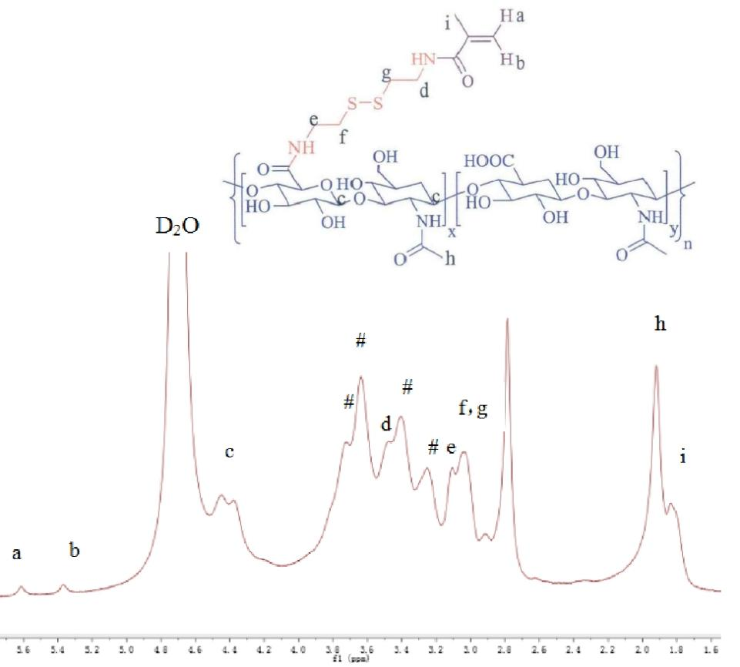
Figure S3. The 1H-NMR of HA-Cys-MA.

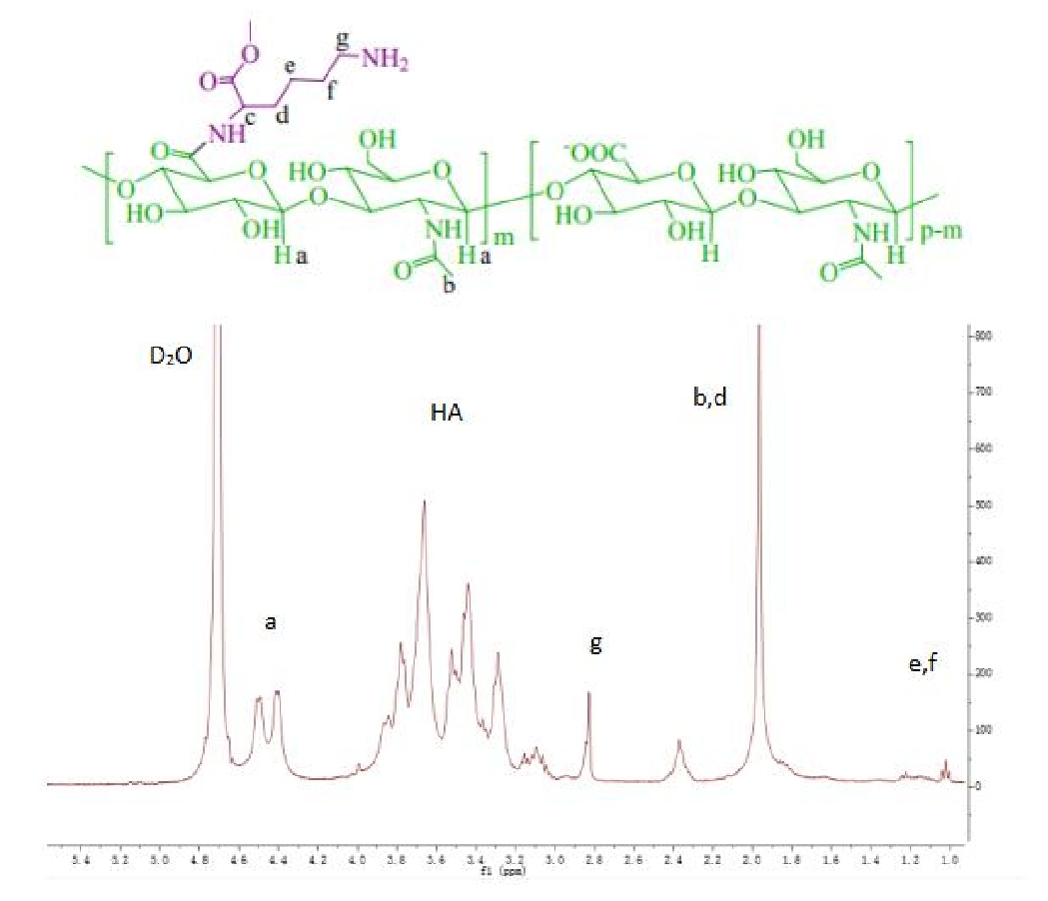
Figure S4. The 1H-NMR of HA-Lys-NH₂.

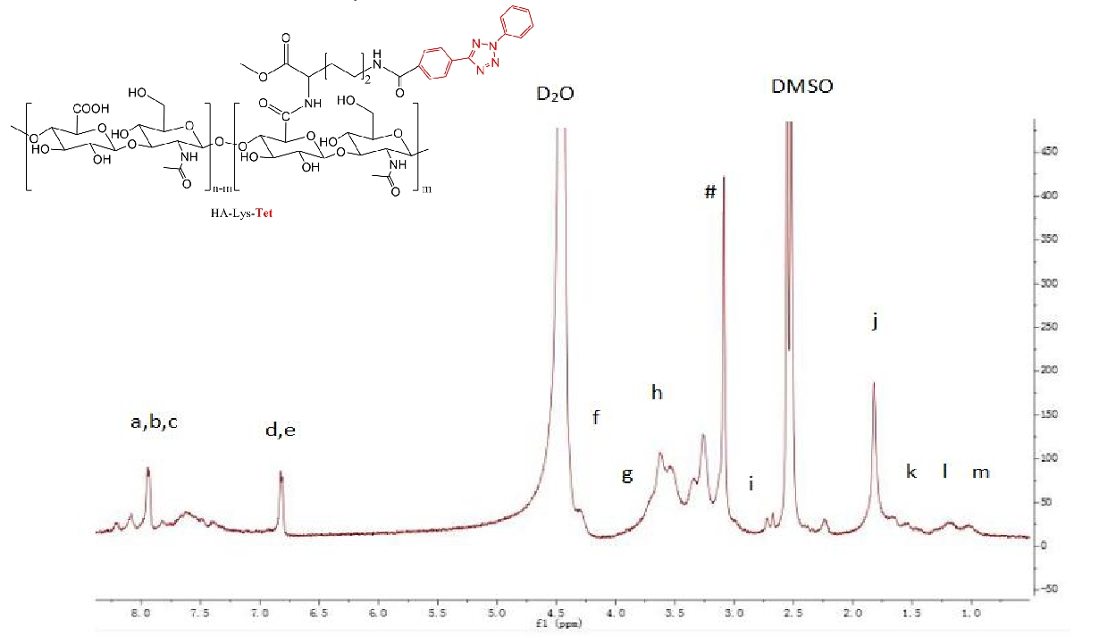
Figure S5. The 1H-NMR of HA-Lys-Tet.

Reference

[1] Y. Liao, B. Li, Z. Zhao, Y. Fu, Q. Tan, X. Li, W. Wang, J. Yin, H. Shan, B. Z. Tang, X. Huang, ACS Nano 2020, 14, 8046-8058

