Supplementary Materials for

Self-assembled Epitaxial Ferroelectric Oxide Nano-spring with Super-scalability

Guohua Dong^{1, #}, Yue Hu^{2, #} , Changqing Guo^{3, #}, Haijun Wu⁴, Haixia Liu¹, Ruobo Peng¹, Dan Xian⁵, Qi Mao⁵, Yongqi Dong⁶, Yanan Zhao¹, Bin Peng¹, Zhiguang Wang¹, Zhongqiang Hu¹, Junwei Zhang², Xueyun Wang³, Jiawang Hong³, Zhenlin Luo⁶, Wei Ren¹, Zuo-Guang Ye^{1,7}, Zhuangde Jiang⁵, Ziyao Zhou^{1★}, Houbing Huang^{3★}, Yong Peng^{2★}, Ming Liu^{1★}

*Correspondence to: mingliu@xjtu.edu.cn; ziyaozhou@xjtu.edu.cn; hbhuang@bit.edu.cn; pengy@lzu.edu.cn.

Materials and Methods
Thin Film Deposition: BaTiO₃ (BTO), La_{0.7}Sr_{0.3}MnO₃ (LSMO), and Sr₃Al₂O₆ (SAO) targets were prepared by the conventional solid-state method. These targets were used to fabricate the LSMO/BTO/SAO/STO (001) heterostructures by a pulsed laser deposition (PLD) system with a KrF excimer laser of 248 nm wavelength. Base pressure was below 1×10⁻⁶ Torr. The target-substrate distance was fixed at 50 mm. Firstly, 30 - 40 nm SAO thin films were deposited as a sacrificial layer with an energy density of 1.8 J cm⁻², repetition rate of 3 Hz, and substrate temperature of 800° C. Then, the BTO and LSMO films were grown at 750 °C and 2 Hz. During the growth of BTO and LSMO, oxygen gas partial pressures were maintained at 100 and 200 mTorr, respectively. After deposition, the samples were in situ annealed at 750 °C for 10 min and then slowly cooled to room temperature.
Fabrication of LSMO/BTO Nano-spring: The SAO sacrificial layer was completely and quickly removed in de-ionized water at room temperature. The polydimethylsiloxane (PDMS) as a supporting layer should be coated on the LSMO/BTO heterostructures during etching SAO. While the LSMO/BTO heterostructures are transferred on PDMS, they were broken and self-assembled into regular nanostripes along [110] crystal direction of BTO. The dynamic releasing process is shown in Supplementary movie 1. After that, with desorption from the PDMS, LSMO/BTO nanostripes coil themselves up into nano-springs due to the large lattice mismatch between LSMO and BTO.
Structure and Performance Characterizations: The reciprocal space mapping (RSM) of the films was investigated using a high-resolution synchrotron X-ray, which was recorded with the 14B beamline of the Shanghai Synchrotron Radiation Facility (SSRF). XRD measurements were performed using a PANalytical Empyrean diffractometer. The morphology was characterized by atomic force microscopy (Bruker, Dimension Icon). Cross-sectional samples for TEM observations were prepared by the focused ion beam technique (FIB, Tescan MIRA 3). Meanwhile, the in situ SEM experiments were conducted by the double beam system in FIB. In situ TEM experiments of nano-spring were performed F30 (FEI Tecnai) with in situ mechanical sample holder (PI-95, HYSITRON, USA). Moreover, the microstructure of films and springs was imaged using a probe aberration-corrected scanning transmission electron microscopy (Cs-STEM, Themis Z G2 300kV, FEI).
Phase-field Simulations:
Phase-field simulations are performed to investigate the ferroelectric polarization distributions in the LSMO/BTO nano-spring. The time-dependent Ginzburg–Landau equation describes the temporal evolution of the polarization:
where ${\text{P}}_{i}\text{(}\text{r}\text{, t}\text{)}$ is polarization, r is the spatial coordinate, t is the evolution time, L is the kinetic coefficient, and F is the total free energy that includes the contributions from the Landau energy, the gradient energy, the elastic energy and the electric energy(1):
The Landau energy density ${\text{f}}_{\text{Land}}$ is given by,
where ${\text{α}}_{\text{ij}}\text{,} {\text{α}}_{\text{ijkl}}\text{,} {\text{α}}_{\text{ijklmn}}$ are the Landau energy coefficients.
The gradient energy density ${\text{f}}_{\text{grad}}$ is described as follows,
where ${\text{G}}_{\text{ijkl}}$ are the gradient energy coefficients, and ${\text{P}}_{\text{i,j}}\text{=}\frac{\text{∂}{\text{P}}_{\text{i}}}{\text{∂}{\text{x}}_{\text{j}}}$.
The elastic energy density ${\text{f}}_{\text{elastic}}$ is given by,
where ${\text{C}}_{\text{ijkl}}$ is the elastic stiffness tensor, ${\text{ε}}_{\text{ij}}$ and ${\text{ε}}_{\text{ij}}^{\text{0}}$ are the total local strain and eigenstrain, respectively. And ${\text{ε}}_{\text{ij}}^{\text{0}}\text{=}{\text{Q}}_{\text{ijkl}}{\text{P}}_{\text{k}}{\text{P}}_{\text{l}}$, where ${\text{Q}}_{\text{ijkl}}$ are the electrostrictive coefficients.
The electric energy density ${\text{f}}_{\text{ele}}$ is expressed as,
where ${\text{E}}_{\text{i}}$ is the electric field component, ${\text{ε}}_{\text{0}}$ is the vacuum permittivity, and ${\text{κ}}_{\text{ij}}$ is the dielectric constant.
The flexoelectric coupling energy ${\text{f}}_{\text{flexo}}$ is given by,
where ${\text{f}}_{\text{ijkl}}$ is the flexoelectricity tensor. There are three independent flexoelectric coupling coefficients for a material of cubic point group: the longitudinal coupling coefficient ${\text{f}}_{\text{11}}$, the transversal coupling coefficient ${\text{f}}_{\text{12}}$, and the shear coupling coefficient ${\text{f}}_{\text{44}}$. Here, ${\text{f}}_{\text{11}}$, ${\text{f}}_{\text{12}}$, and ${\text{f}}_{\text{44}}$ are the Voigt form of the flexoelectricity tensor components ${\text{f}}_{\text{1111}}$, ${\text{f}}_{\text{1122}}$, and ${\text{f}}_{\text{1212}}$, respectively.
In this work, the height of a periodic structure of LSMO/BTO nano-spring is 100 nm, the outer diameter is 80 nm, and the width is 18 nm. The BTO layer thickness is 8 nm, the thickness of the LSMO layer is set to 7 nm, where the BTO layer is thicker than the LSMO layer. The open-circuit condition is applied in simulation, and the temperature is 300 K. The parameters in the simulation are listed in Table S2(2, 3). The phase-field modeling of the domain evolution of an LSMO/BTO nano-spring under compression and elongation test is shown in Figure S11, the vortex domain can be observed in the initial state and disappears after the compression (elongation) test. After releasing the nano-spring, the vortex domain will be obtained again. The simulated results indicate that these nano-springs present good elasticity and recovery capability under both elongation and compression. The corresponding domain evolution shows that the polarization has a strong coupling with the bending strain. Furthermore, the vortex domain structure disappears and generates during the compression and elongation test, which indicates the vortex structure plays a significant role in enhancing the elasticity and recovery capability.
To analyze the coupling relationship between strain and polarization of the BTO nano-springs. The coordinate system is converted into the natural coordinate system, as shown in fig. S15(a), the φ-axis is perpendicular to the BTO layer outward, and the r-axis and θ-axis within the BTO layer. The direction of the r-axis is upward from the bottom of the nano-spring along the helix of the nano-spring, while the θ-axis is always perpendicular to the r-axis and points to the top of the nano-spring.
The flexoelectric effect is considered in the phase-field simulation, As shown in fig. S16, the influence of flexoelectric effect is not obvious during the uniaxial tensile (compression) deformation of BTO nano-springs.

Supplementary Figures
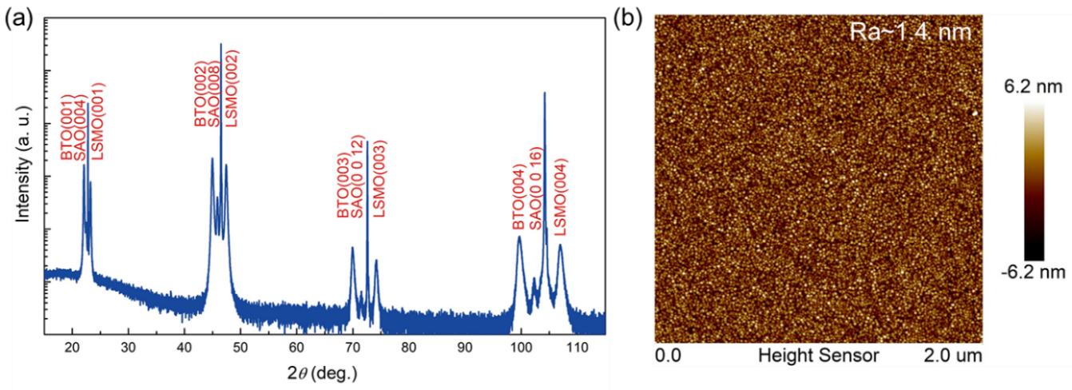
Figure S1 Epitaxial growth of LSMO/BTO/SAO heterostructure. (a) X-ray diffraction pattern of the LSMO/BTO/SAO/STO heterostructures. (b) AFM image of LSMO/BTO/SAO/STO.
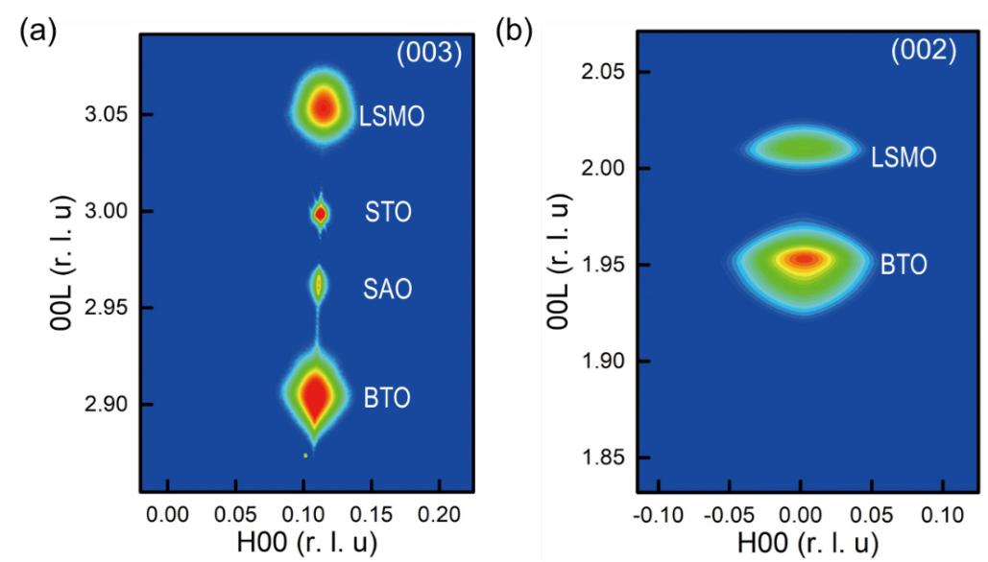
Figure S2 (a) RSM of LSMO/BTO/SAO/STO around the 003-BTO Bragg peaks. (b) RSM of LSMO/BTO around the 002-BTO Bragg peaks.
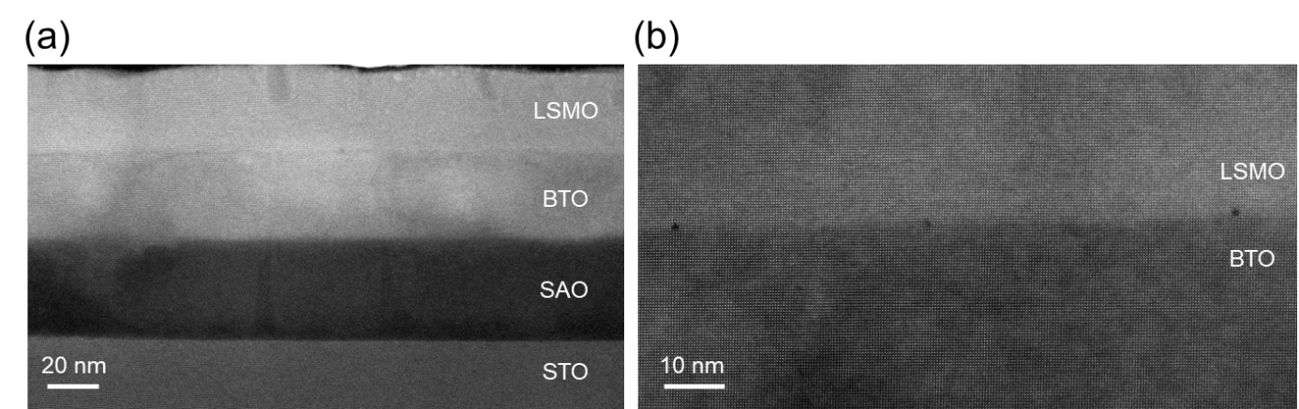
Figure S3 STEM-HAADF images of (a) the LSMO/BTO/SAO/STO heterostructure, and (b) the interface of LSMO/BTO.

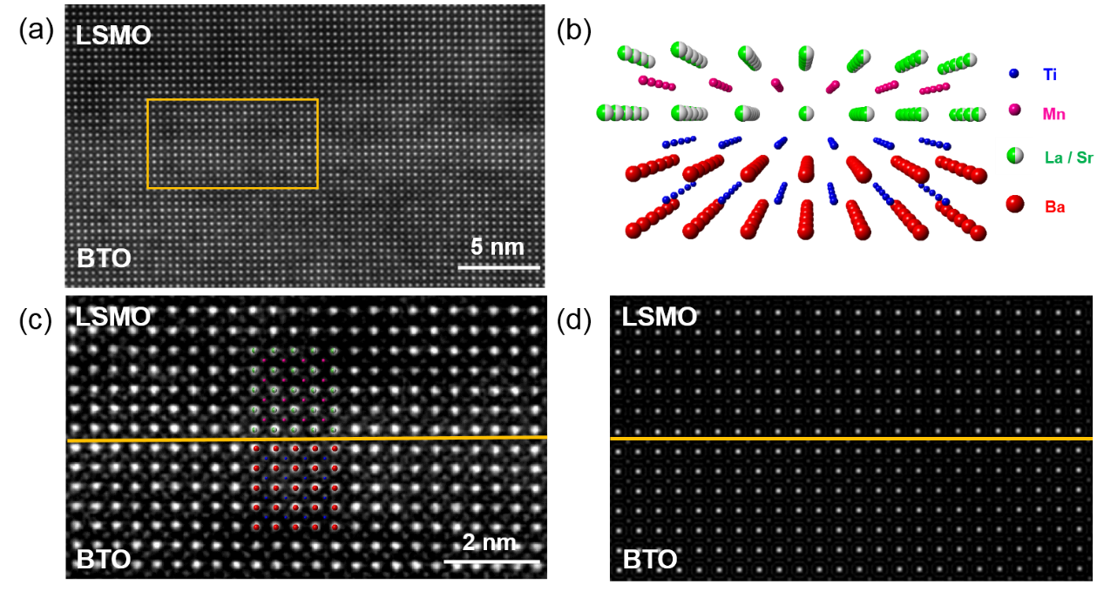
Figure S4 (a) Atomic-resolution HAADF-STEM image of the cross-sectional specimen, showing an obvious interface structure of the BTO/LSMO. (b) Crystal models of the well-epitaxial BTO/LSMO interface. (c) Magnified the image of the yellow box area in (a). The schematic atoms (same colors as depicted in (a) indicate the occupancies of La/Sr, Mn, Ba and Ti atoms. (d) Atomic columns of the heterostructural interface simulated by using QSTEM software.
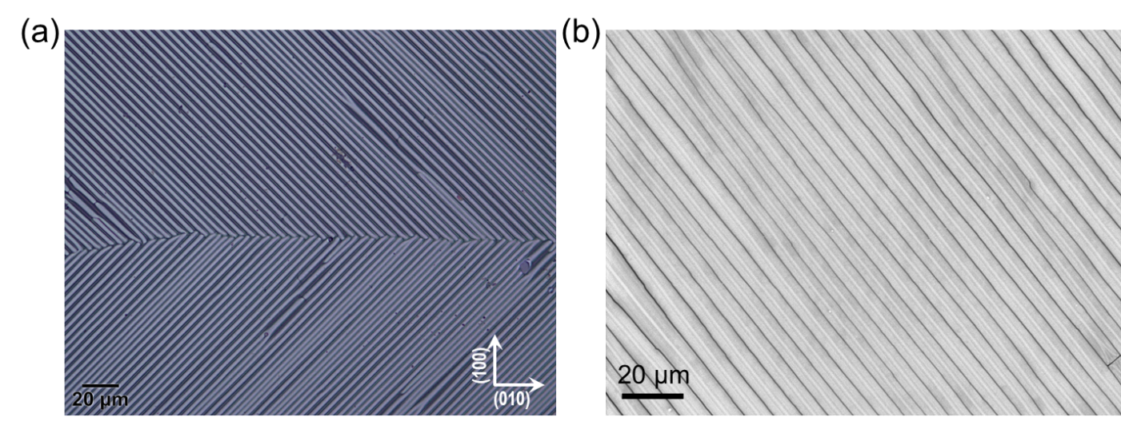
Figure S5 (a) Optical image of LSMO/BTO/PDMS. (b) SEM image of LSMO/BTO nanostripes on PDMS.

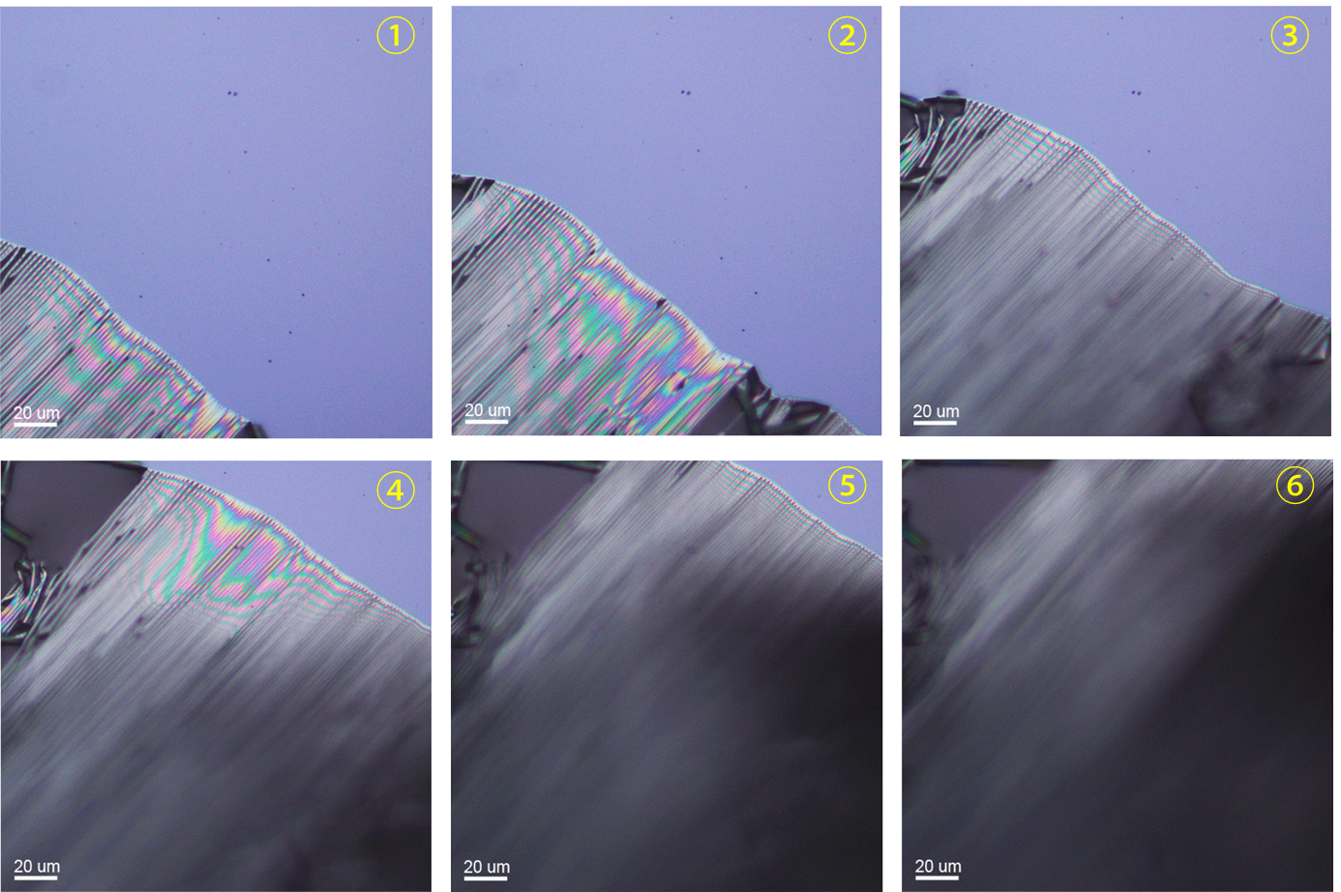
Figure S6 Optical images of LSMO/BTO/SAO/STO during the peel-off process in water.

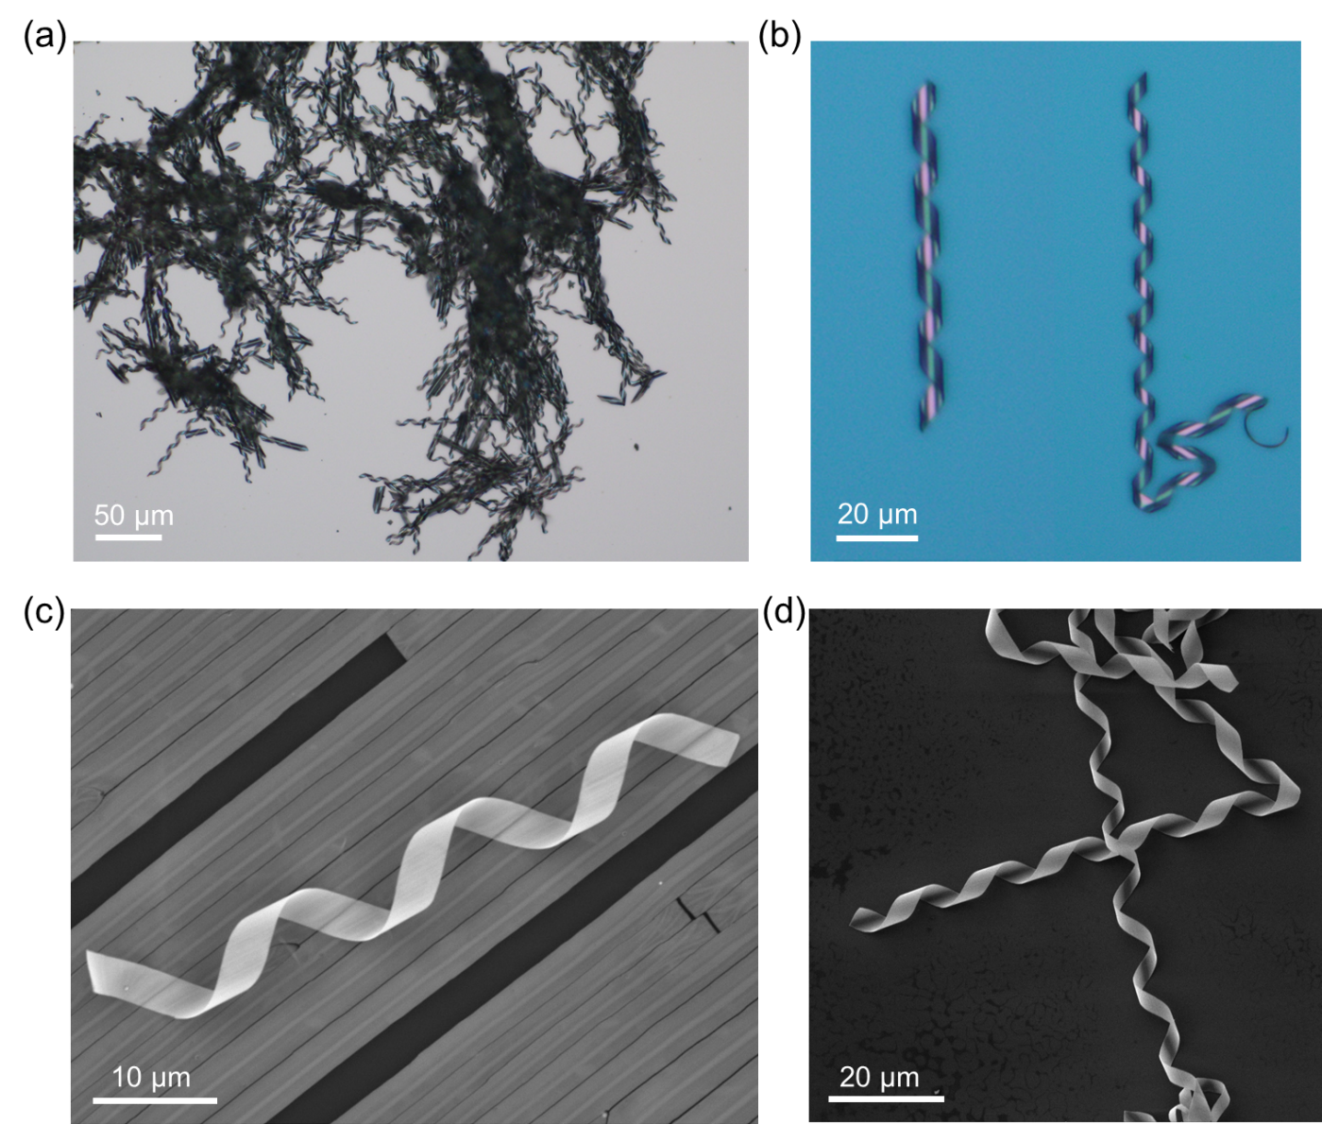
Figure S7 (a) and (b) Optical images of LSMO/BTO springs on STO. (c) SEM image of LSMO/BTO nanostripes and spring. (d) SEM image of LSMO/BTO springs.

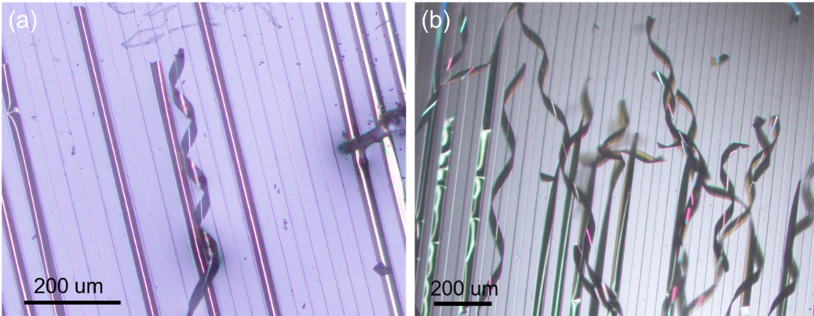
Figure S8 Optical images of MZFO/BTO (a) and MZFO/PMN-PT (b) springs.

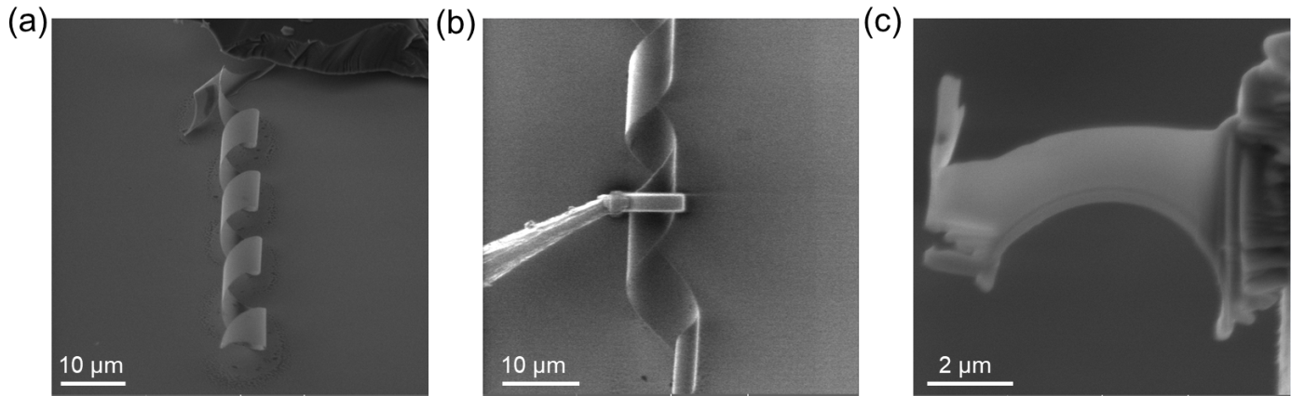
Figure S9 (a) SEM image of a LSMO/BTO spring in FIB. (b) SEM image showing the TEM sample preparation via FIB. (c) SEM image showing the cross-sectional TEM sample.

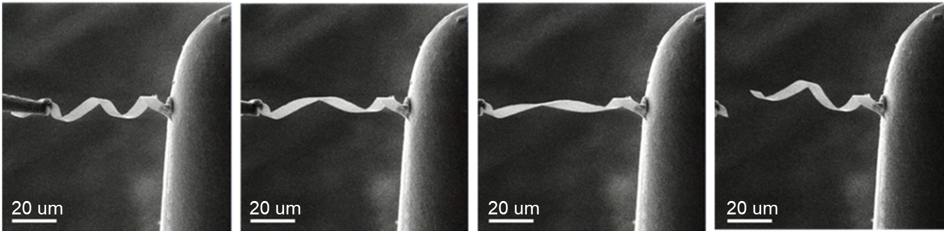
Figure S10 In situ SEM image of LSMO/BTO spring

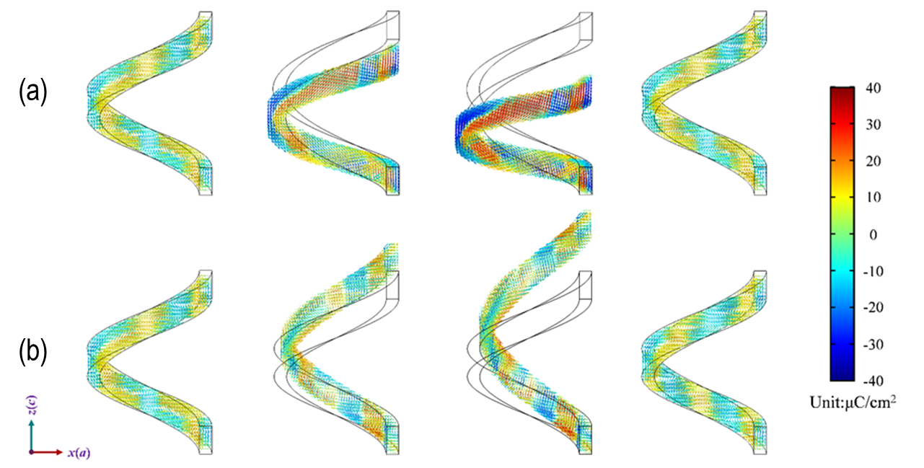
Figure S11 The LSMO/BTO nano-spring ferroelectric domain evolution from phase-field simulation under (a) compression and (b) elongation tests.

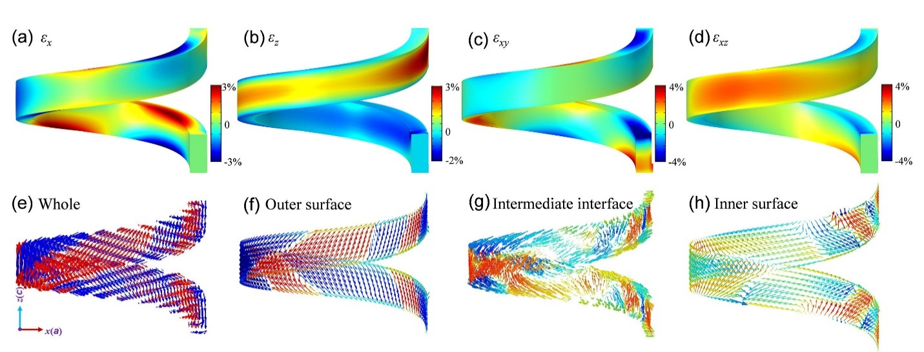
Figure S12 The distribution of strain and polarization in BTO nano-spring under compressive deformation (compressive displacement z=50 nm). (a-d) The distribution of strain components ε_{x}, ε_{z}, ε_{xy}, and ε_{xz}. (e-h) The polarization distribution of the (e) whole, (f) outer surface, (g) intermediate interface, and (h) inner surface of nano-spring.

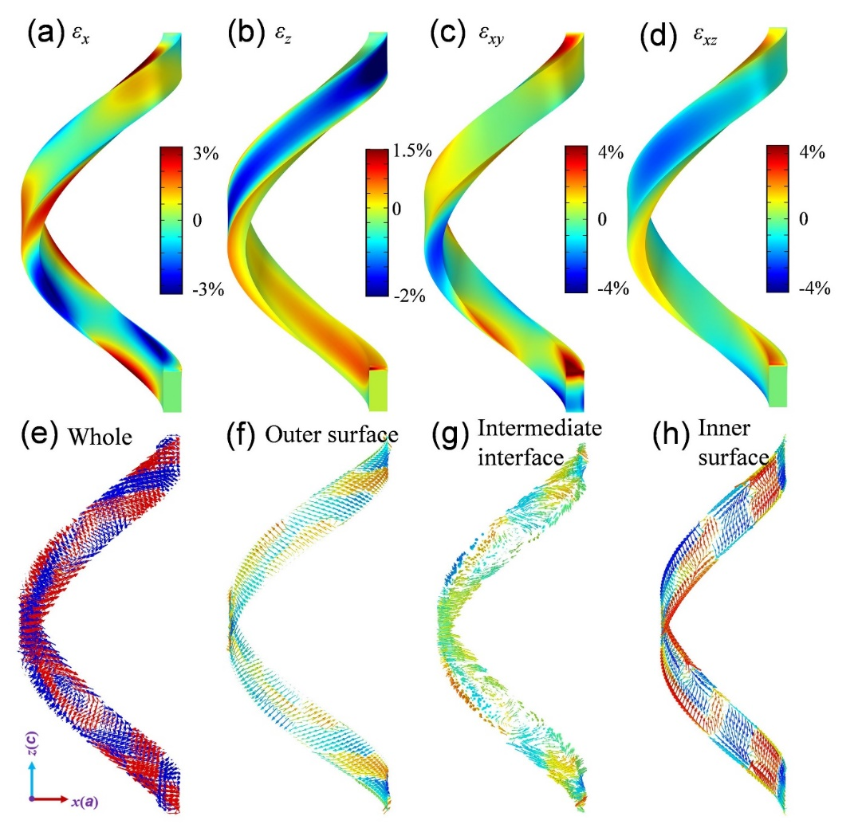
Figure S13 The distribution of strain and polarization in BTO nano-spring under tensile deformation (tensile displacement z=50 nm). (a-d) The distribution of strain components ε_{x}, ε_{z}, ε_{xy}, and ε_{xz}. (e-h) The polarization distribution of the (e) whole, (f) outer surface, (g) intermediate interface, and (h) inner surface of nano-spring.

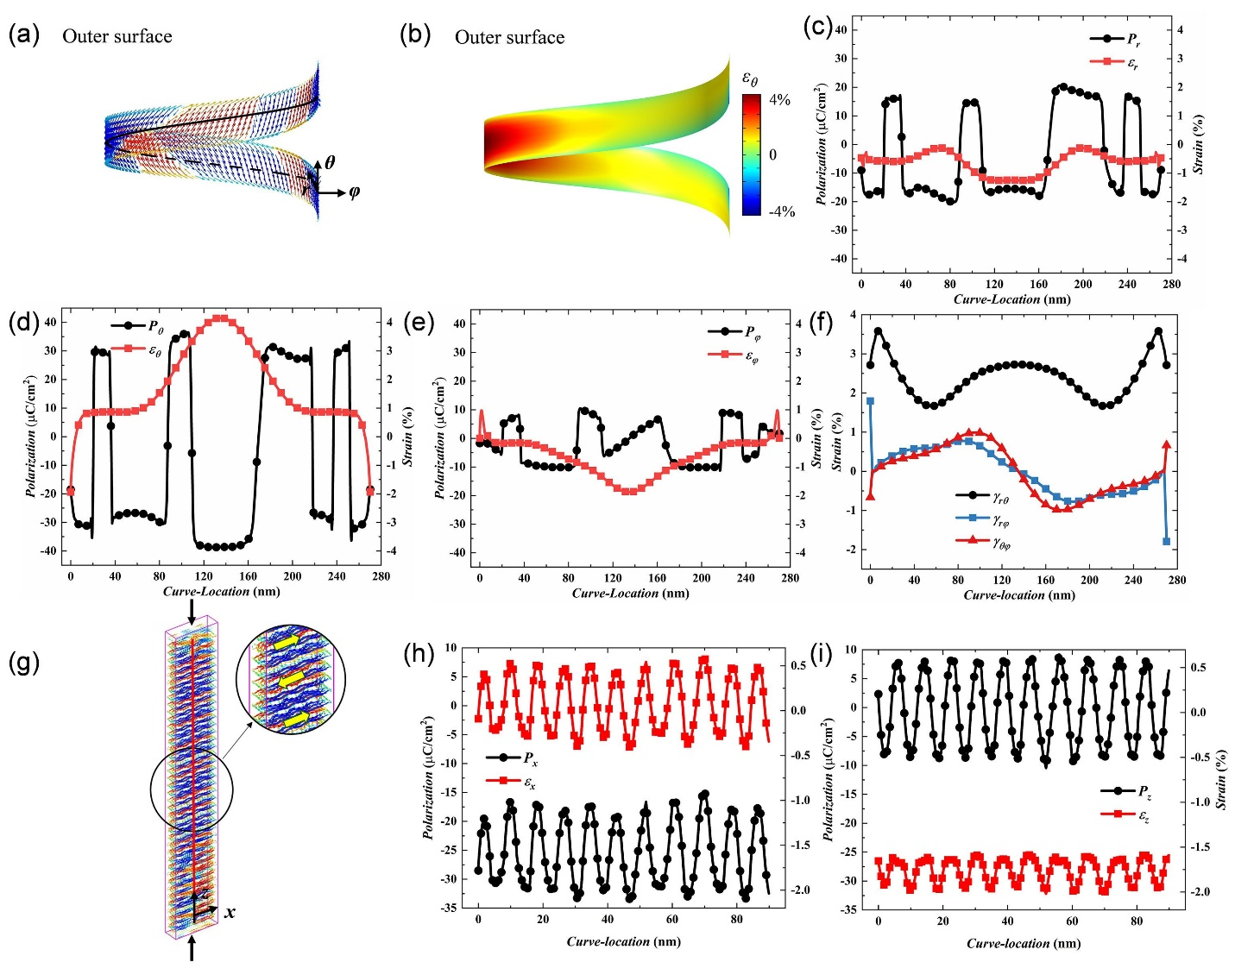
Figure S14 The distribution of polarization and strain on the outer surface of the BTO nano-spring and thin film under compressive deformation. (a-b) The distribution of (a) polarization and (b) strain ε_{θ} on the outer surface of the nano-spring. (c-e) The distribution of (c) P_{r}–ε_{r}, (d) P_{θ}–ε_{θ}, and (e) P_{φ}–ε_{φ} on the middle line of the outer surface of BTO nano-spring. (f) The distribution of shear strain γ_{rθ}, γ_{rφ}, and γ_{θφ} on the center line of the outer surface of nano-spring. (g) The distribution of polarization of the thin film. (h-i) The distribution of (h) P_{x}–ε_{x} and (i) P_{z}–ε_{z} on the middle line of the outer surface of BTO thin film under compressive deformation.

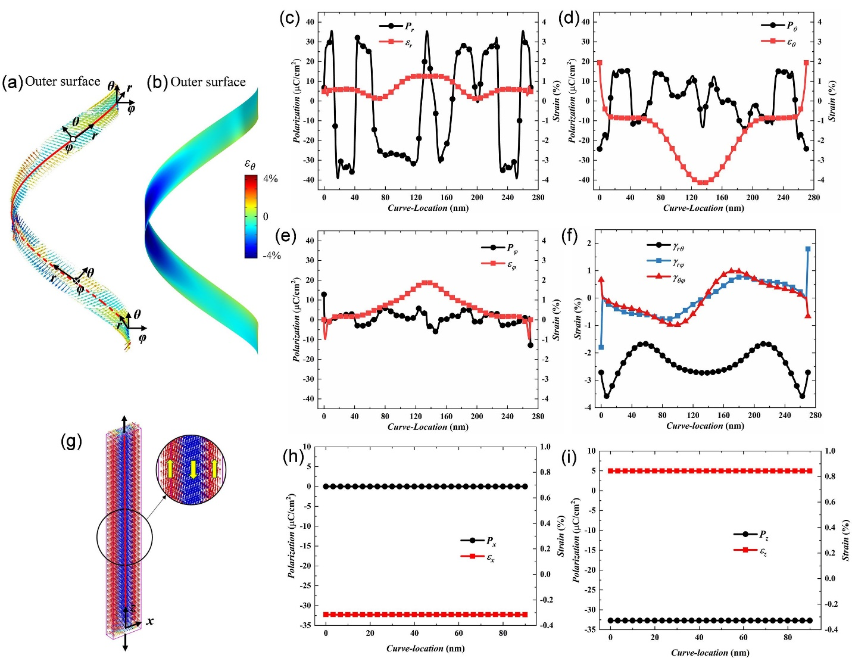
Figure S15 The distribution of polarization and strain on the outer surface of the BTO nano-spring and thin film under tensile deformation. (a-b) The distribution of (a) polarization and (b) strain ε_{θ} on the outer surface of the nano-spring. (c-e) The distribution of (c) P_{r}–ε_{r}, (d) P_{θ}–ε_{θ}, and (e) P_{φ}–ε_{φ} on the middle line of the outer surface of BTO nano-spring. (f) The distribution of shear strain γ_{rθ}, γ_{rφ}, and γ_{θφ} on the center line of the outer surface of nano-spring. (g) The distribution of polarization of the thin film. (h-i) The distribution of (h) P_{x}–ε_{x} and (i) P_{z}–ε_{z} on the middle line of the outer surface of BTO thin film under tensile deformation.

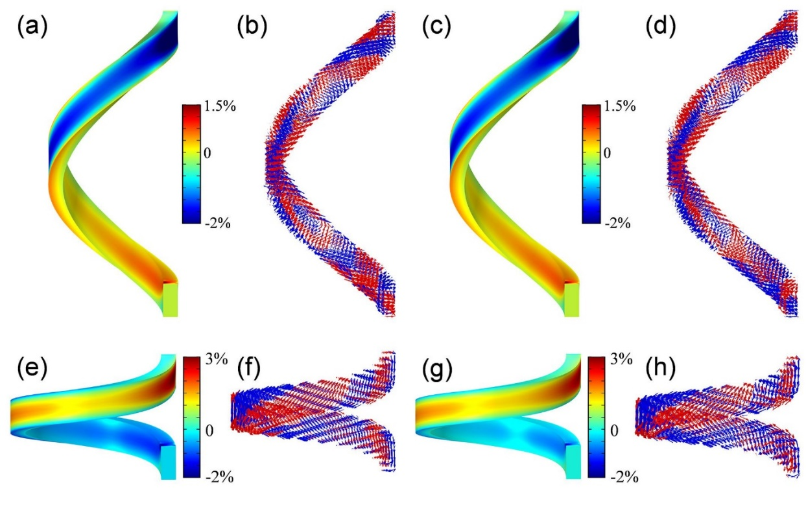
Figure S16 The flexoelectric effect on BTO nano-spring under mechanical deformation (the deformation displacement z=50 nm). (a-b) The distribution of strain ε_{z} and polarization under tensile deformation without flexoelectric effect. (c-d) The distribution of strain ε_{z} and polarization under tensile deformation with flexoelectric effect. (e-f) The distribution of strain ε_{z} and polarization under compression deformation without flexoelectric effect. (g-h) The distribution of strain ε_{z} and polarization under under compression deformation with flexoelectric effect.

Table S1
Lattice parameters of the LSMO/BTO/SAO heterostructures
Layer | c (Å) | a (Å)
LSMO | 3.830 | 3.924
BTO | 4.033 | 3.986
SAO | 3.956 | 3.980

Table S2
Values of parameters used in this work (SI units and T at 300 K).
Parameter | Value | Parameter | Value
$${\text{α}}_{\text{1}}\text{(}\text{J∙m}\text{∙}{\text{C}}^{\text{-2}}\text{)}$$ | $$\text{-2.7104×}{\text{10}}^{\text{7}}$$ | $${\text{Q}}_{\text{12}}({\text{m}}^{\text{4}}\text{∙}{\text{C}}^{\text{-2}})$$ | -0.0452
$${\text{α}}_{\text{11}}\text{(J∙}{\text{m}}^{\text{5}}\text{∙}{\text{C}}^{\text{-4}}\text{)}$$ | $$\text{-6.3887×}{\text{10}}^{\text{8}}$$ | $${\text{Q}}_{\text{44}}({\text{m}}^{\text{4}}\text{∙}{\text{C}}^{\text{-2}})$$ | 0.0578
$${\text{α}}_{\text{12}}\text{(J∙}{\text{m}}^{\text{5}}\text{∙}{\text{C}}^{\text{-4}}\text{)}$$ | $$\text{3.23×}{\text{10}}^{\text{8}}$$ | $${\text{G}}_{\text{11}}(\text{N∙}{\text{m}}^{\text{4}}\text{∙}{\text{C}}^{\text{-2}})$$ | $$\text{5.1×}{\text{10}}^{\text{-10}}$$
$${\text{α}}_{\text{111}}(\text{J∙}{\text{m}}^{\text{9}}\text{∙}{\text{C}}^{\text{-6}})$$ | $$\text{7.9019×}{\text{10}}^{\text{9}}$$ | $${\text{G}}_{\text{12}}\text{(}\text{N∙}{\text{m}}^{\text{4}}\text{∙}{\text{C}}^{\text{-2}}\text{)}$$ | $$\text{-2×}{\text{10}}^{\text{-11}}$$
$${\text{α}}_{\text{112}}(\text{J∙}{\text{m}}^{\text{9}}\text{∙}{\text{C}}^{\text{-6}})$$ | $$\text{4.47×}{\text{10}}^{\text{9}}$$ | $${\text{G}}_{\text{44}}/{\text{G}}_{\text{44}}^{\text{'}}(\text{N∙}{\text{m}}^{\text{4}}\text{∙}{\text{C}}^{\text{-2}})$$ | $$\text{2×}{\text{10}}^{\text{-11}}$$
$${\text{α}}_{\text{123}}(\text{J∙}{\text{m}}^{\text{9}}\text{∙}{\text{C}}^{\text{-6}})$$ | $$\text{4.91×}{\text{10}}^{\text{9}}$$ | $${\text{κ}}_{\text{b}}\text{(1)}$$ | 7.35
$${\text{c}}_{\text{11}}(\text{J∙}{\text{m}}^{\text{-3}})$$ | $$\text{2.75×}{\text{10}}^{\text{11}}$$ | $${\text{f}}_{\text{11}}\text{(V)}$$ | -18.2
$${\text{c}}_{\text{12}}(\text{J∙}{\text{m}}^{\text{-3}})$$ | $$\text{1.79×}{\text{10}}^{\text{11}}$$ | $${\text{f}}_{\text{12}}\text{(V)}$$ | -23.6
$${\text{c}}_{\text{44}}(\text{J∙}{\text{m}}^{\text{-3}})$$ | $$\text{5.43×}{\text{10}}^{\text{10}}$$ | $${\text{f}}_{\text{44}}\text{(V)}$$ | 0
$${\text{Q}}_{\text{11}}({\text{m}}^{\text{4}}\text{∙}{\text{C}}^{\text{-2}})$$ | $$\text{0.1104}$$

References:
1. L.-Q. Chen, Phase-Field Method of Phase Transitions/Domain Structures in Ferroelectric Thin Films: A Review. J. Am. Ceram. Soc. 91, 1835-1844 (2008).
2. T. Sluka, A. K. Tagantsev, D. Damjanovic, M. Gureev, N. Setter, Enhanced electromechanical response of ferroelectrics due to charged domain walls. Nat. Commun. 3, 748 (2012).
3. B. Wang, Y. Gu, S. Zhang, L.-Q. Chen, Flexoelectricity in Solids: Progress, Challenges, and Perspectives. Prog. Mater Sci., (2019).

