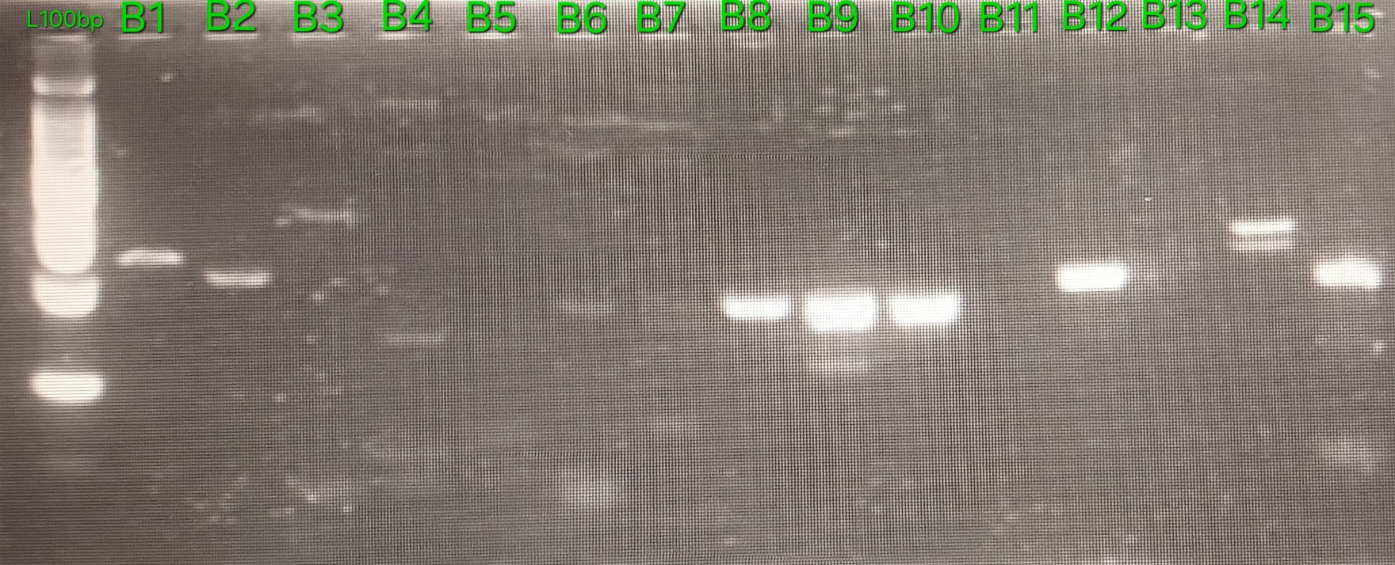
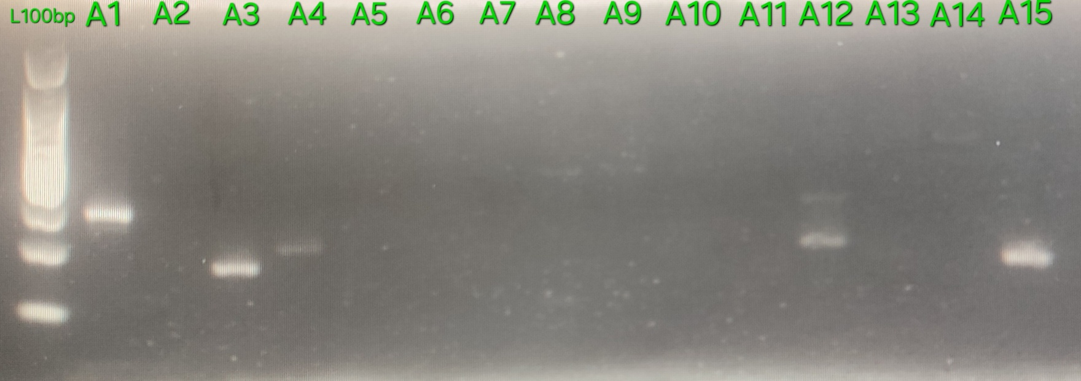

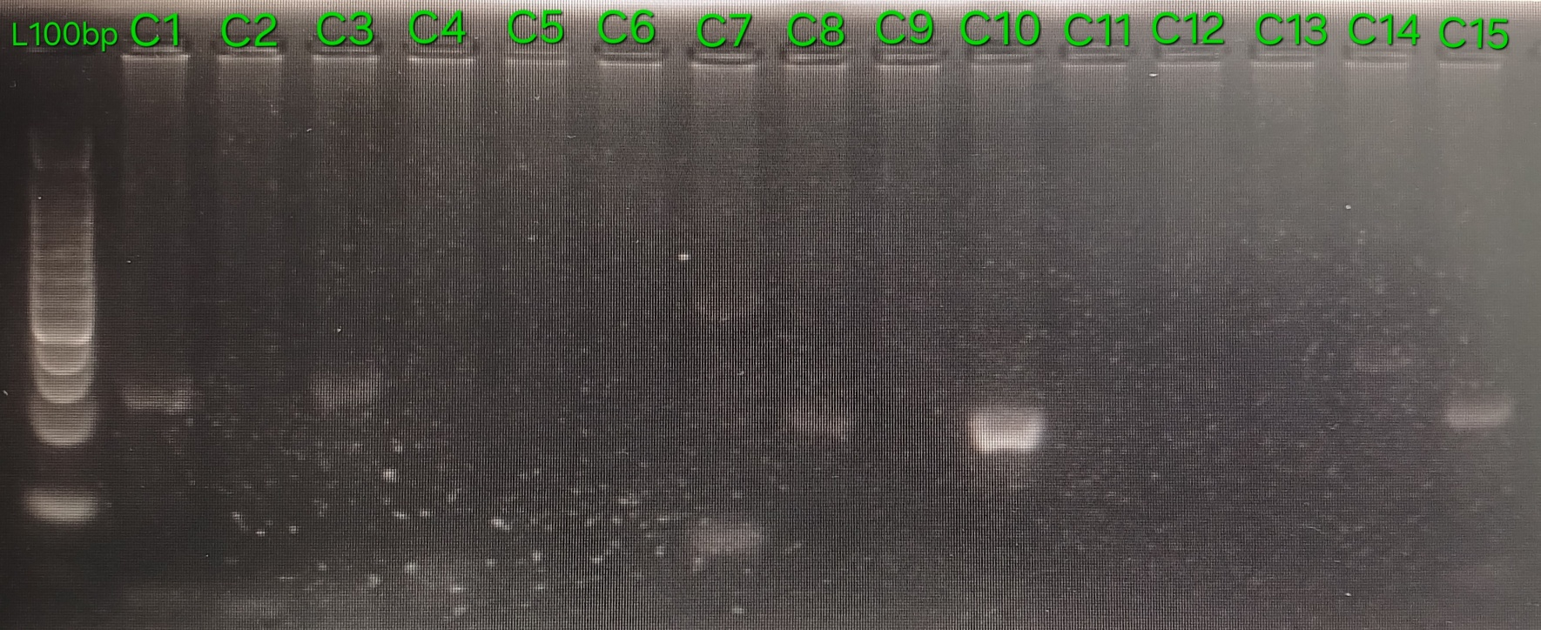

Supplementary Fig. 1 Cross-Transferability of SSR Markers Profiles in Alocasia cucullata (A), Xanthosoma undipes (B), and Metroxylon sagu (C). (L100bp= 100 bp DNA ladder; 1-15=EST-SSR markers)

