Supplementary Material
p75 Neurotrophin Receptor Shapes the Dynamics of Adult Hippocampal Neurogenesis in Alzheimer's Disease.

Figures
Confirmation of the lack of p75NTR expression in the 2 months old p75NTR ko mice in the Basal Forebrain

Supplementary Figure S1. p75NTR expression in 2 months old p75NTR ko mice in the Basal Forebrain
p75NTR expression at the basal forebrain of wild type and knock out mice. Coronal sections 40μm from 2-months-old mice after immunostaining with anti-p75 antibody and Hoechst for nuclear staining (WT, wild type; KO, knock out, scale bar: 100μm).

Dcx area of processes in 2 months old WT vs p75NTR ko mice
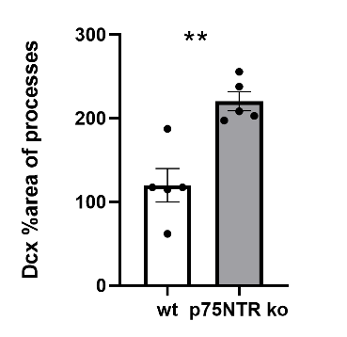
A
B

Supplementary Figure S2. Dcx area of processes in 2 months old WT vs p75NTR ko mice
Α Coronal section of DG from 2-months-old wild type & p75NTR ko mice. Image depicts DcX (red) immunostained immature neurons. Β Quantification of Dcx area of processes in p75NTR ko & wild type mice of 2 months old (n=5 ko, n=5 wt, unpaired t-test, **p<0,005). DcX, doublecortin.

qRT-PCR for the detection of p75NTR Intracellular Domain

Supplementary Figure S3. qRT-PCR was performed in RNA samples
Total RNA from biological triplicates (hippocampal specimens of p75NTR ko, 5xFAD/p75NTR ko and WT mice of 2 months old, that have been dissected after the BrdU injections) was extracted using Trizol reagent. qRT-PCR was performed in RNA samples and the results are expressed as the logarithmic fold change (logFC) normalized to the WT control. p75NTR exon III deletion, strongly upregulates Ngfr mRNA expression levels on p75NTR ko, 5xFAD/p75NTR ko. (n = 3 for each mouse model. * p < 0.05, ** p < 0.01; unpaired t-test).

Gene Set Enrichment Analysis

Supplementary Figure S4. GSEA of RNA-seq data showing enrichment of selected GO_BP categories genes in p75NTR ko vs WT mice
GO for the Neural Precursor Cell Proliferation, GO for the regulation of neuron differentiation and GO for the regulation of apoptotic signaling pathway. Gene sets were obtained from MSigDB. Normalized enrichment scores (NES) (y-axis) and false discovery rate (FDR) were calculated by GSEA based on 1,000 permutations.

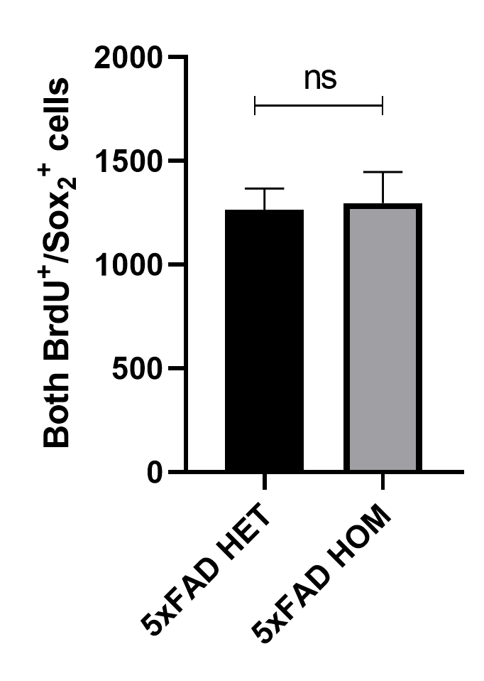
Number of BrdU⁺ and Sox₂⁺ cells in 5xFAD heterozygous mice vs 5xFAD homozygous mice
B
A

Supplementary Figure S5. Number of BrdU⁺ and Sox₂⁺ cells in 5xFAD heterozygous mice vs 5xFAD homozygous mice
A Coronal sections of DG, from 2-months-old wild type and 5xFAD mice injected with BrdU for 5 days. Sections were co-immunostained for BrdU (red) and Sox₂ (green). Scale bar, 100 μm B Quantification of BrdU⁺ and Sox₂⁺ cells in injected mice. (5 5xFAD heterozygous & 5 5xFAD homozygous, unpaired t-test ns; no significant). BrdU, 5-bromo-2′-deoxyuridine; Sox₂, SRY-Box Transcription Factor 2 (Leica SP8, inverted confocal).

Gene Set Enrichment Analysis revealed genes implicated in p75NTR-dependent effects under AD
Supplementary Figure S6. Volcano plot and GSEA analysis of RNA-seq data
Volcano plot and GSEA analysis of RNA-seq data derived from the comparison between 5xFAD vs 5xFAD/p75NTR ko mice. A) Volcano plot showing the number of Up (5) & Down (1) regulated genes (p adj < 0.05). B) GSEA analysis of RNA-seq data showing enrichment of selected GO_BP categories genes in 5xFAD vs 5xFAD/p75NTR ko mice (functions which are enriched in 5xFAD/p75NTR ko samples). C) GSEA analysis of RNA-seq data showing enrichment of selected GO_BP categories genes in 5xFAD vs 5xFAD/p75NTR ko mice (functions which are enriched in 5xFAD samples). Gene sets were obtained from MSigDB. Normalized enrichment scores (NES) (y-axis) and false discovery rate (FDR) were calculated by GSEA based on 1,000 permutations.

p75NTR expression and function on human induced pluripotent stem cells (hiPSCs)-derived NSCs
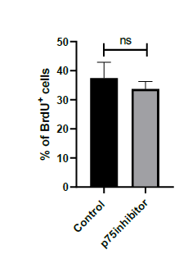
A
B

Supplementary Figure S7. Inhibition of p75NTR has no effect in proliferation of human NSCs
A Proliferative hNSCs (green) after BrdU pulses, with or without treatment with p75inhibitor (50μm scale bar). B Graph showing the percentage of proliferating cells (BrdU⁺ cells/total number of HOECHST⁺ cells) upon inhibition of p75NTR (n=3 different NSC lines (841,856), unpaired t-test, no significant).

