A novel preclinical human salivary gland cancer model established using organoid culture and patient-derived xenografting

Yoshihiro Aizawa et al.,

- Supplementary Figures S1-S4
- Supplementary Tables S1 and S3

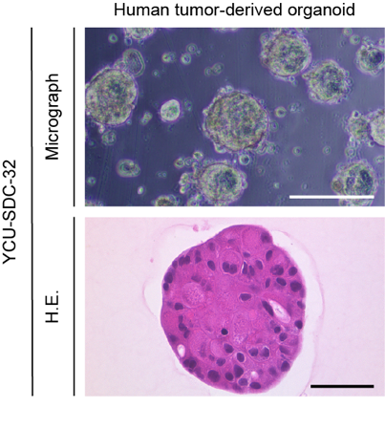
Supplementary Figure S1. Bright-field images and hematoxylin and eosin (H&E) staining of YCU-SDC-32
Similar to the other two salivary gland carcinoma (SDC)-derived organoids, the primary organoids derived from YCU-SDC-32 showed a cyst-like structure. Scale bars represent 50 µm for bright-field images and 20 µm for H&E staining.
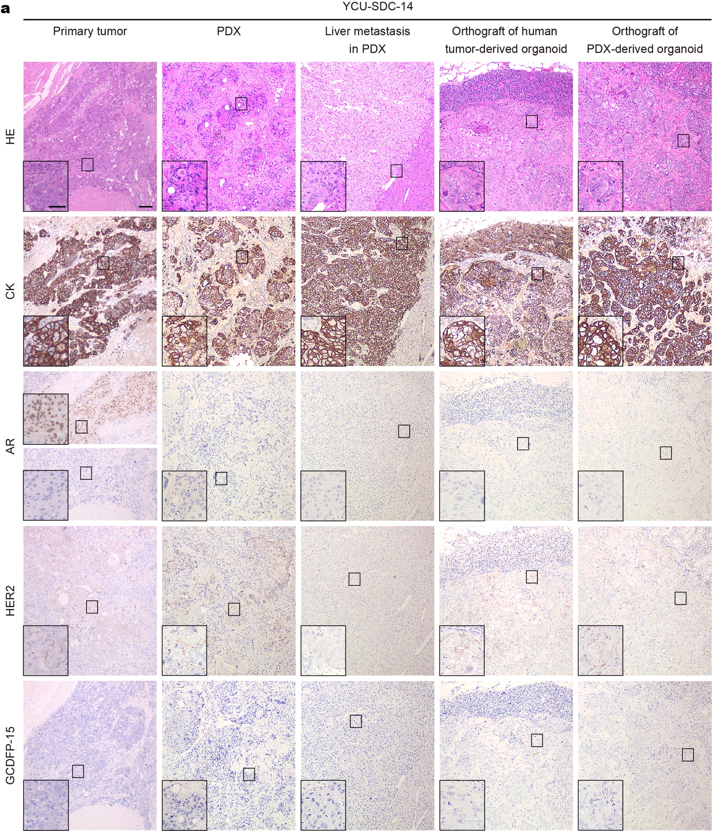
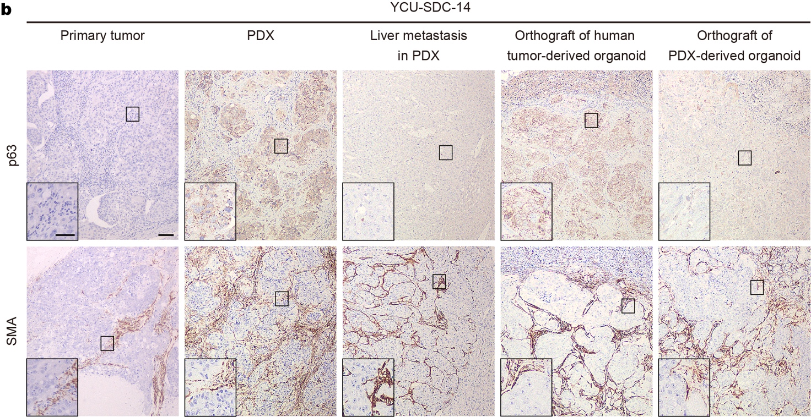

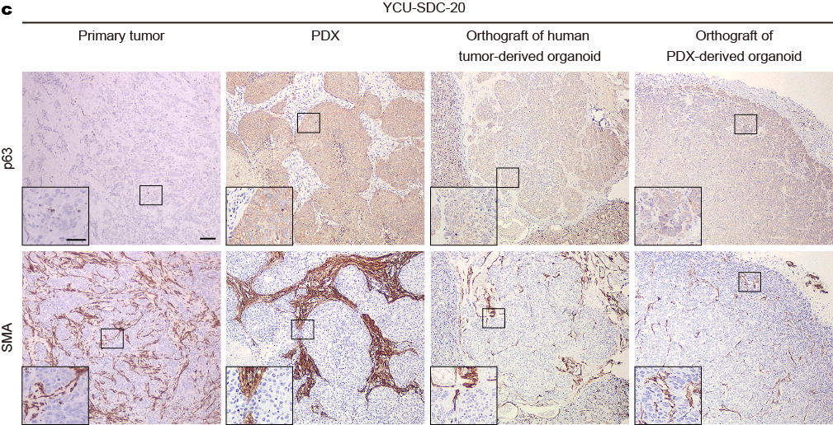
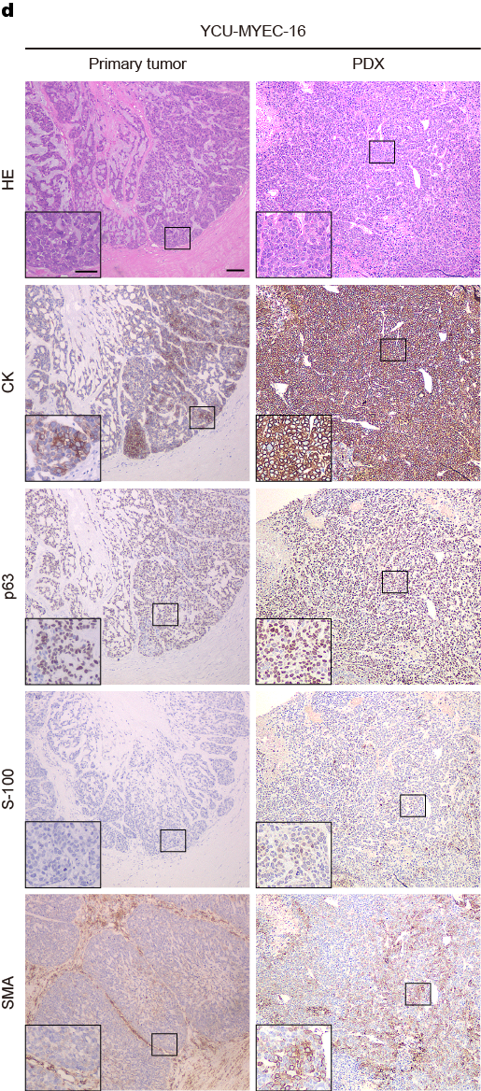

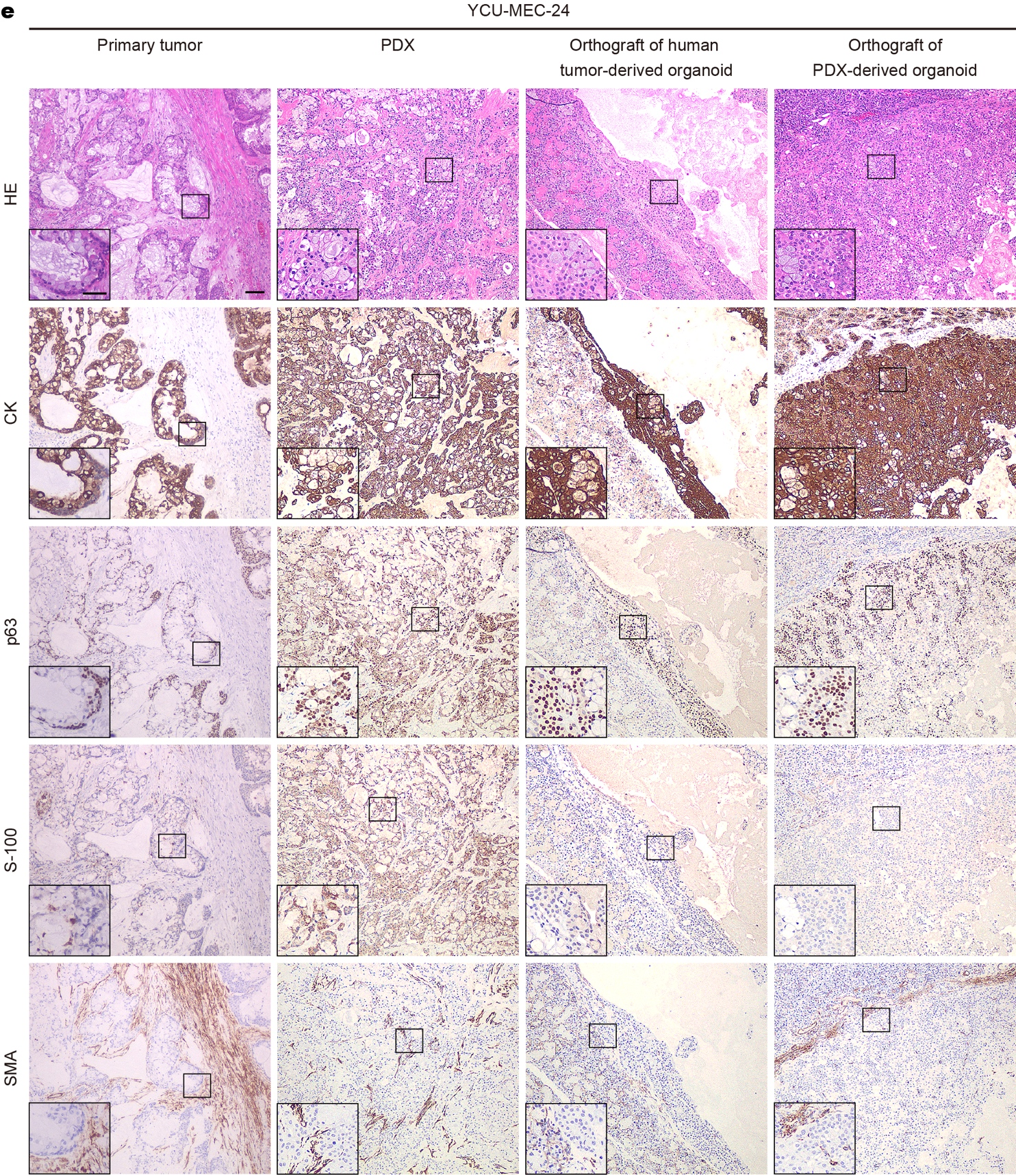

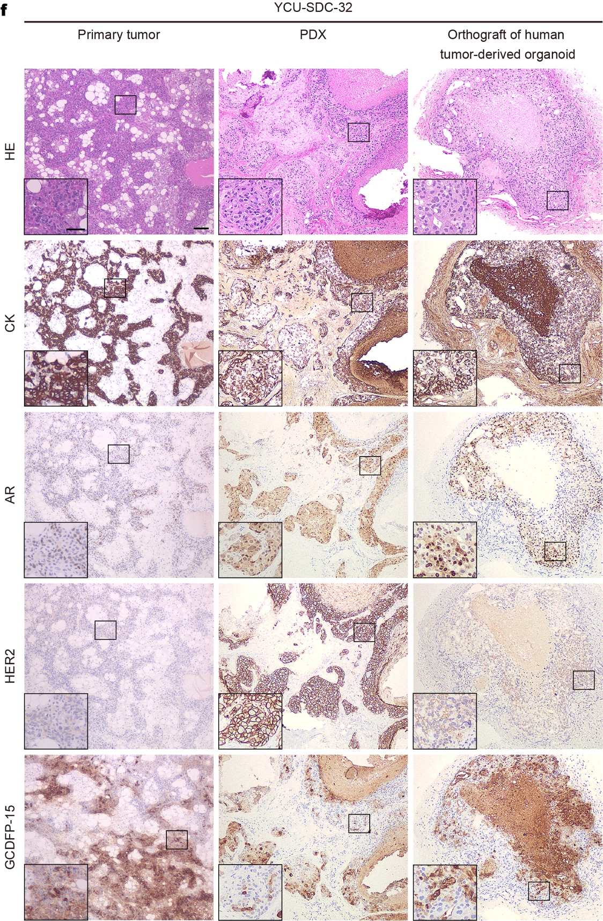

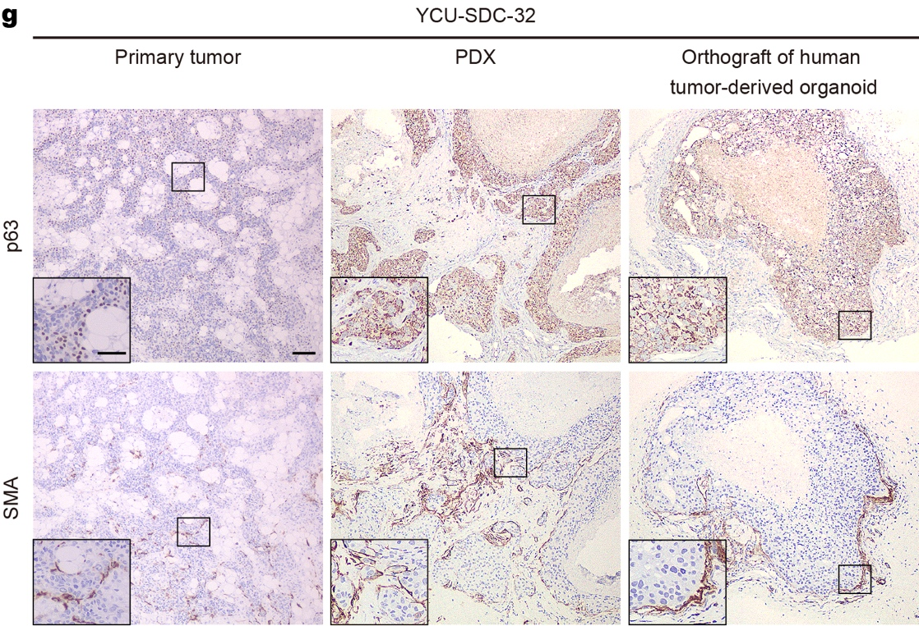

Supplementary Figure S2. Histology and IHC staining
a-b YCU-SDC-14 series. c YCU-SDC-20 d YCU-MYEC-16 series. e YCU-MEC-24 series. f-g YCU-SDC-32 series. The primary tumor of YCU-SDC-14 had both AR-positive and AR-negative areas. Scale bars in a large frame represent 10 µm, and those in a small frame represent 5 µm.
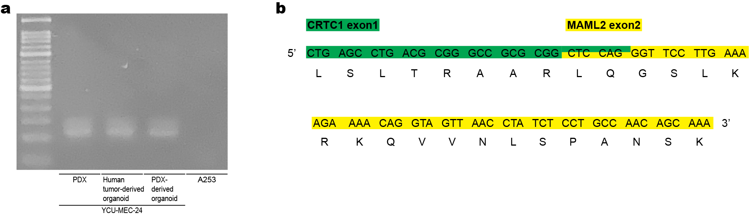

Supplementary Figure S3. CRTC1-MAML2 fusion gene in YCU-MEC-24
a RT-PCR. b sangar sequence.
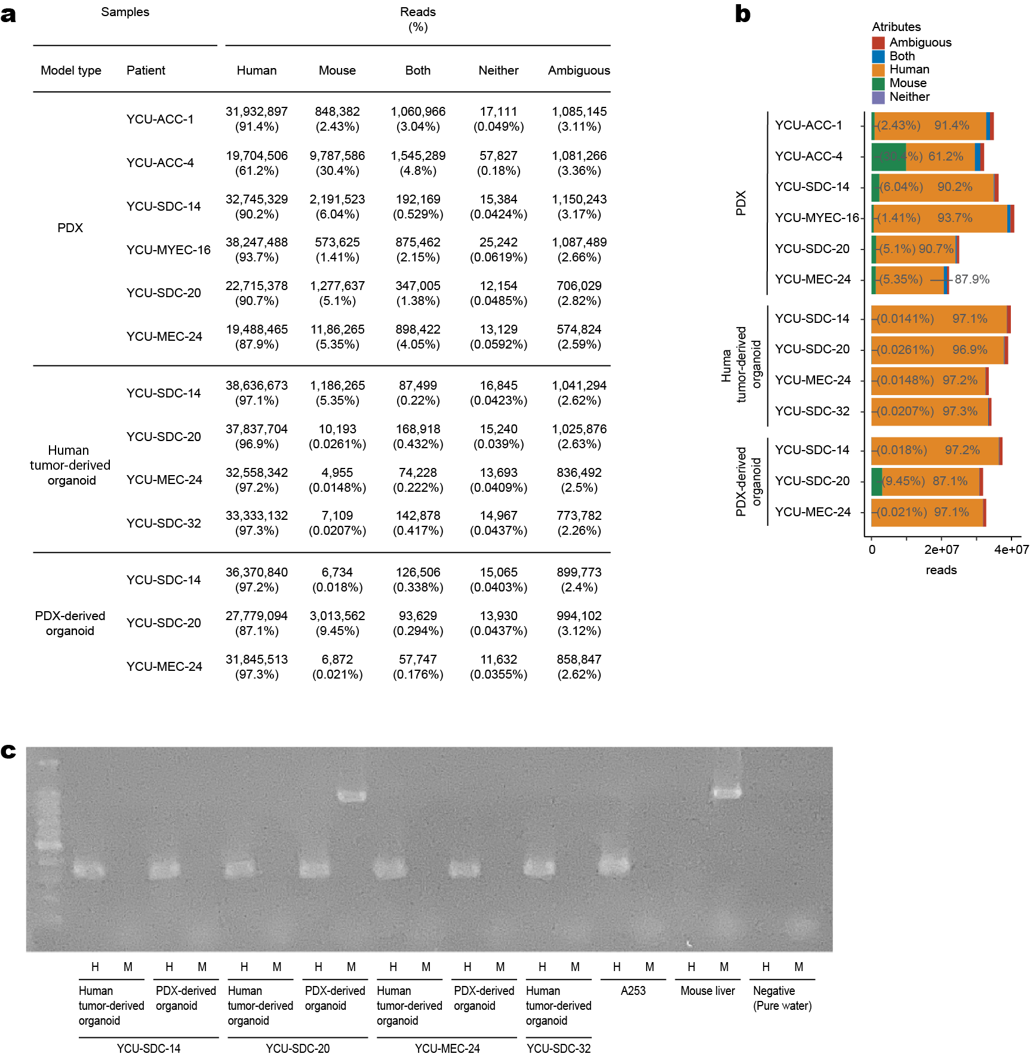

Supplementary Figure S4. Contamination of mouse cells in each patient-derived xenograft (PDX) and organoid
a Distinguishing human and mouse reads from RNA-seq data using xenome. b is summarized in the bar graph. c Identification of animal species by PCR of mitochondrial DNA sequences. H, using a set of primers targeting human mitochondrial DNA sequences. M, using a set of primers targeting mouse mitochondrial DNA sequences. A253 cells were used as a positive control in humans, and mouse livers were used as a positive control in mice. The PDX-derived organoid of YCU-SDC-20 was positive in both humans and mice, indicating a mixture of both cell types.
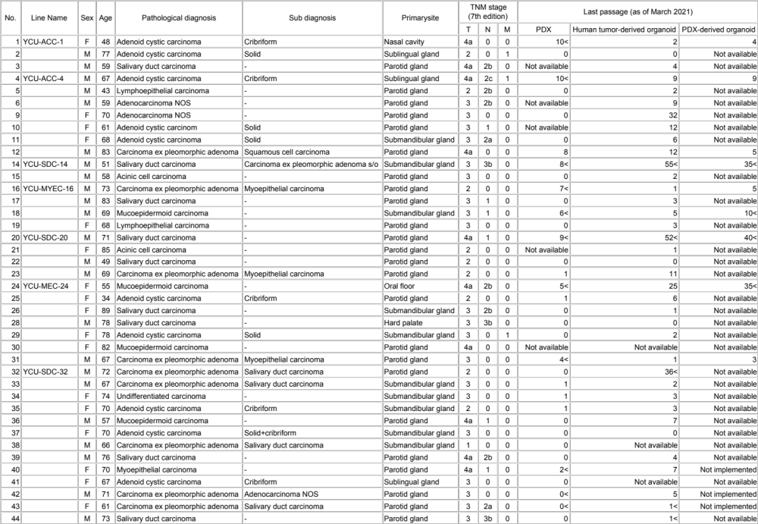
Supplementary Table S1. Summary of patient-derived xenograft (PDX) and organoid lines, corresponding clinical data.
The clinical stage of the tumor was at the time of the first treatment, not during the entire clinical course of the patient. Although PDXs derived from patients No. 12, 18, and 31 formed tumors in mice and were maintained for more than two passages, they were not considered to have been successfully established in the current study because histological confirmation of recurrent salivary gland carcinoma (SGC) was not yet available as of March 2021.
Name | Forward / Reverse | Primer sequence (5’-3’) | Usage
CRTC1_outer | Forward | AAGATCGCGCTGCACAATCA | RT-PCR, nested PCR  (Detection of fusion gene)
CRTC1_inner | Forward | GGAGGAGACGGCGGCCTTCG | RT-PCR, nested PCR  (Detection of fusion gene)
MAML2_outer | Reverse | GGTCGCTTGCTGTTGGCAGG | RT-PCR, nested PCR  (Detection of fusion gene)
MAML2_inner | Reverse | TTGCTGTTGGCAGGAGATAG | RT-PCR, nested PCR  (Detection of fusion gene)
S31_Human_F2 | Forward | CTCCTATTCTTGCACGAAAC | Genomic PCR  (Identification of species)
S53_Human_R7 | Reverse | GATGGGGATTATTGCTAGGATG | Genomic PCR  (Identification of species)
S07_Mouse_F | Forward | GCACTGAAAATGCTTAGATGGATAATTG | Genomic PCR  (Identification of species)
S08_Mouse_R | Reverse | CCTCTCATAAACGGATGTCTAG | Genomic PCR  (Identification of species)
Supplementary Table S3. Primer information list

