Appendix I: Works illustrated in Fig. 1
owner*: SG=Staatsgalerie Stuttgart; PC=Stuttgart Academy conservation program
no. | artist | date  (ca.) | CIELAB mean values  (3 spots) |  |  | owner* | accession no.
 |  |  | L* | a* | b*
1 | Albrecht Dürer | 1503 | 97,47 | 0,62 | 14,02 | SG | A3642
2 | Albrecht Dürer | 1521 | 96,68 | 1,61 | 14,62 | SG | A3639
3 | Albrecht Dürer | 1511 | 95,53 | 1,16 | 15,43 | SG | A1952/1214
4 | Albrecht Dürer | 1511 | 94,59 | 0,94 | 16,26 | SG | A3793
5 | ledger paper, blank | 1850 | 94,16 | -1,45 | 12,22 | PC | -
6 | ledger paper, blank | 1850 | 94,04 | -1,53 | 11,81 | PC | -
7 | Torchiana | 1850 | 93,45 | -0,27 | 7,10 | SG | A2015/8725
8 | Basq. | 1850 | 92,83 | -0,38 | 8,10 | SG | A2015/8726
9 | anonymous | 1824 | 92,31 | 0,52 | 8,33 | SG | A2015/8731
10 | Pierre-Antoine Poiteau | 1820 | 92,21 | 0,89 | 10,38 | PC | -
11 | Panier | 1805 | 91,83 | 0,24 | 8,48 | SG | A2015/8727
12 | Stefano della Bella (light-exp.) | 1680 | 91,45 | 1,05 | 11,28 | PC | -
13 | Jean-François Janinet | 1785 | 91,24 | -0,13 | 8,85 | SG | A1980/5888
14 | Jean-Honoré Fragonard | 1765 | 91,23 | 0,08 | 12,51 | SG | A39302
15 | German Bible, leaf CLXI | 1498 | 90,79 | -0,92 | 13,71 | PC | -
16 | Joseph Friedrich Leopold | 1806 | 90,79 | 0,35 | 8,82 | SG | A2015/8728
17 | Charles Gosselin | 1850 | 90,70 | 0,28 | 9,41 | PC | -
18 | German Bible, leaf CCCCCLXXIII | 1498 | 90,64 | -0,56 | 14,24 | PC | -
19 | German Bible, leaf CCCCLVIII | 1498 | 90,61 | -0,46 | 14,95 | PC | -
20 | Giovanni Benedetto Castiglione (light-prot.) | 1660 | 90,48 | 0,67 | 9,76 | PC | -
21 | Francesco Bartolozzi | 1780 | 90,46 | 1,33 | 11,55 | PC | -
22 | Pierre-Antoine Poiteau | 1820 | 90,45 | 0,90 | 15,30 | PC | -
23 | Georg Ebnersche Kunsthandlung | 1824 | 90,10 | 0,36 | 14,06 | SG | A2015/8729
24 | Albrecht Dürer | 1503 | 90,07 | 0,28 | 11,28 | SG | 1965/GL892
25 | anonymous | 1850 | 89,91 | 0,87 | 10,08 | SG | A2015/8732
26 | Basle Master around 1500 | 1495 | 89,87 | -0,01 | 13,28 | SG | A10598
27 | German Bible, leaf CXXVIII | 1498 | 89,84 | -0,10 | 13,34 | PC | -
28 | German Bible, leaf CXV | 1498 | 89,80 | -0,18 | 14,01 | PC | -
29 | Grutsch and Rupp | 1850 | 89,80 | 0,68 | 10,89 | SG | A2015/8734
30 | Charles Gosselin | 1850 | 89,52 | 0,44 | 10,57 | PC | -
31 | Pierre-Antoine Poiteau | 1820 | 89,49 | 1,28 | 14,96 | PC | -
32 | Gustave Leheutre | 1898 | 89,38 | 1,16 | 15,20 | SG | A1909/112
33 | C Schule | 1816 | 89,26 | 0,12 | 11,96 | SG | A2015/8724
34 | Claude Lorrain | 1633 | 89,19 | 0,72 | 13,30 | SG | A1085/6204
35 | Schelte à Bolswert | 1640 | 89,15 | 0,33 | 11,14 | SG | A19956
36 | Basle Master around 1500 | 1500 | 89,12 | 0,38 | 13,54 | SG | A64/2701b
37 | Stefano della Bella (light-exp.) | 1680 | 89,09 | 1,89 | 13,71 | PC | -
38 | Castiglione (light exp.) | 1660 | 89,04 | 1,49 | 12,97 | PC | -
39 | Schelte à Bolswert | 1640 | 88,89 | 0,49 | 11,47 | SG | A19956
40 | Giovanni Battista Tiepolo | 1753 | 88,75 | 0,54 | 12,28 | SG | A1983/6158
41 | Master of the Die | 1540 | 88,66 | 0,21 | 10,48 | SG | A53/1463
42 | Pierre-Antoine Poiteau | 1820 | 88,64 | 1,48 | 17,91 | PC | -
43 | German Bible, leaf CLIX | 1498 | 88,64 | 0,68 | 16,78 | PC | -
44 | Conrad Defet | 1850 | 88,49 | 0,93 | 11,73 | SG | A2015/8736
45 | handmade paper, blank | 1850 | 88,41 | -0,30 | 13,09 | PC | -
46 | Schelte à Bolswert | 1640 | 88,34 | 0,68 | 12,86 | SG | A19953
47 | German Bible, leaf CXXX | 1498 | 88,28 | -0,16 | 16,51 | PC | -
48 | anonymous | 1780 | 88,27 | -0,48 | 12,94 | PC | -
49 | anonymous | 1475 | 88,26 | 0,68 | 15,07 | SG | A8932
50 | Christophano di Michele  da Robetta | 1500 | 88,17 | 0,26 | 12,06 | SG | A24031
51 | Georg Lebrecht | 1920 | 88,12 | 1,38 | 21,52 | SG | A1913/22
52 | anonymous | 1850 | 87,98 | -0,71 | 13,16 | SG | A2015/8715
53 | anonymous | 1475 | 87,80 | 0,96 | 14,02 | SG | A8937
54 | Charles Leandre | 1910 | 87,72 | -0,02 | 9,10 | SG | A1912/33
55 | Fragonard | 1764 | 87,64 | 0,54 | 14,27 | SG | A29609
56 | Schelte à Bolswert | 1640 | 87,57 | 0,32 | 12,17 | SG | A199560
57 | Cham | 1860 | 87,55 | 1,74 | 13,15 | PC | -
58 | Carlo Carloni | 1750 | 87,47 | 0,74 | 13,62 | SG | A27548c
59 | anonymous | 1837 | 87,35 | 1,10 | 13,15 | SG | A2015/8733
60 | Marcantonio Raimondi | 1510 | 87,33 | 0,99 | 14,32 | SG | A1953/1361
61 | Schelte à Bolswert | 1640 | 87,32 | 0,15 | 11,42 | SG | A19955
62 | Gustave Leheutre | 1898 | 87,30 | 0,82 | 16,98 | SG | A1911/112
63 | anonymous | 1740 | 87,20 | 1,91 | 18,26 | PC | -
64 | François Boucher | 1727 | 87,17 | 0,21 | 11,52 | SG | A31240
65 | Joseph Friedrich Leopold | 1736 | 86,89 | 0,42 | 13,67 | SG | A2015/8720
66 | anonymous | 1485 | 86,88 | 1,66 | 16,09 | SG | A8905
67 | P. Schäfers | 1850 | 86,74 | 1,89 | 13,48 | SG | A2015/8735
68 | anonymous | 1475 | 86,73 | 1,43 | 15,98 | SG | A8935
69 | Theodor van Thulden | 1640 | 86,68 | 0,65 | 14,31 | SG | A19853
70 | Meister der Bergmannschen  Offizin | 1495 | 86,66 | 0,90 | 14,98 | SG | A9073
71 | anonymous | 1475 | 86,45 | 1,37 | 15,03 | SG | A8934
72 | Jean Duvet | 1520 | 86,44 | 1,04 | 15,18 | SG | A1983/6129
73 | Meister der Bergmannschen  Offizin | 1495 | 86,43 | 0,91 | 14,90 | SG | A9074
74 | Simon Vouet | 1640 | 86,42 | 1,58 | 13,15 | PC | -
75 | anonymous | 1490 | 86,40 | 1,02 | 14,86 | SG | A8921
76 | Morin nach van Dyck | 1630 | 86,36 | 1,77 | 16,77 | PC | -
77 | Wilhelm Legler | 1906 | 86,18 | 1,37 | 18,62 | SG | A1910/57
78 | Basler Meister um 1500 | 1500 | 86,05 | 0,41 | 14,90 | SG | A1922/232
79 | anonymous | 1475 | 85,96 | 1,23 | 15,91 | SG | A8936
80 | Albrecht Dürer | 1518 | 85,91 | 1,34 | 14,87 | SG | A3434
81 | anonymous | 1850 | 85,84 | 0,91 | 14,57 | SG | A2015/8740
82 | Carlo Carloni | 1750 | 85,71 | 1,19 | 13,86 | SG | A27548b
83 | Lucas Vorstermann | 1638 | 85,61 | 0,98 | 15,84 | SG | A19927
84 | Carlo Carloni | 1750 | 85,59 | 1,36 | 15,17 | SG | A27548d
85 | Carlo Carloni | 1750 | 85,49 | 1,30 | 13,99 | SG | A27548a
86 | anonymous | 1475 | 85,45 | 1,72 | 16,54 | SG | A8933
87 | Anthonis van Dyck | 1640 | 85,44 | 0,79 | 15,26 | PC | -
88 | anonymous | 1475 | 85,37 | 1,82 | 17,04 | SG | A8931
89 | Albrecht Dürer | 1519 | 85,35 | 2,27 | 15,04 | SG | A1965/4273
90 | Marantonio Raimondi | 1510 | 85,23 | 0,83 | 15,40 | SG | A53/1358
91 | Schelte à Bolswert | 1640 | 85,19 | 0,90 | 16,34 | SG | A199565
92 | Georg Lebrecht | 1920 | 84,97 | 2,01 | 19,13 | SG | A1909/25
93 | Lucas van Uden | 1640 | 84,89 | 0,65 | 15,66 | SG | A19968
94 | Albrecht Dürer | 1512 | 84,85 | 1,02 | 13,33 | SG | A3648
95 | Franz Anton Maulbertsch | 1795 | 84,80 | 0,99 | 12,20 | SG | A70/4937
96 | Giorgio Ghisi | 1550 | 84,73 | 0,94 | 14,45 | SG | A1965/GL919
97 | Marcantonio Raimondi | 1510 | 84,63 | 0,56 | 12,00 | SG | A23958
98 | anonymous | 1860 | 84,39 | 1,54 | 16,37 | SG | A2015/8739
99 | anonymous | 1850 | 84,34 | 0,59 | 12,82 | SG | A2015/8718
100 | Schelte à Bolswert | 1640 | 84,33 | 0,67 | 14,04 | SG | A19954
101 | anonymous | 1475 | 84,32 | 2,20 | 16,63 | SG | A8938
102 | anonymous | 1475 | 84,22 | 1,76 | 17,13 | SG | A8939
103 | Schelte à Bolswert | 1640 | 84,21 | 0,74 | 15,46 | SG | A19948
104 | Anthonis van Dyck | 1680 | 84,10 | 0,91 | 15,36 | PC | -
105 | Gilles Demarteau | 1770 | 84,08 | 2,72 | 16,81 | PC | -
106 | Jacques Bellange | 1610 | 84,07 | 1,42 | 15,59 | SG | A36888
107 | Lucas Vorsterman | 1640 | 83,97 | 2,12 | 17,69 | SG | A19285
108 | Augsburg Master of the 15th c. | 1481 | 83,86 | 1,06 | 14,51 | SG | A9208
109 | anonymous | 1490 | 83,83 | 0,42 | 17,60 | SG | A8912
110 | anonymous | 1485 | 83,81 | 2,44 | 17,35 | SG | A8907
111 | Basler Meister um 1500 | 1500 | 83,78 | 1,34 | 19,42 | SG | A1920/38
112 | anonymous | 1475 | 83,57 | 1,98 | 16,45 | SG | A8930
113 | Albrecht Dürer | 1496 | 83,24 | 0,89 | 13,65 | SG | A3416
114 | anonymous | 1850 | 83,21 | 1,52 | 14,71 | SG | A2015/8716
115 | Carlo Carloni | 1750 | 83,05 | 1,39 | 13,38 | SG | A2005/7343
116 | Schelte à Bolswert | 1640 | 83,01 | 0,99 | 17,08 | SG | A19947
117 | Agostino Carracci | 1581 | 82,97 | 2,01 | 15,98 | SG | A27158
118 | van Dyck Wolf | 1790 | 82,77 | 2,80 | 16,50 | PC | -
119 | anonymous | 1480 | 82,75 | 1,74 | 16,54 | SG | A8911
120 | Basler Meister um 1500 | 1500 | 82,61 | 2,37 | 19,59 | SG | A9093
121 | anonymous | 1475 | 82,59 | 1,61 | 16,97 | SG | A8940
122 | Albrecht Dürer | 1518 | 82,49 | 0,90 | 16,68 | SG | A3431
123 | Lucas Vorstermann | 1640 | 82,33 | 0,59 | 12,72 | SG | A19931
124 | Augsburg Master around 1497 | 1497 | 82,23 | 1,61 | 15,82 | SG | A9416
125 | Daniel Hopfer | 1550 | 82,00 | 1,49 | 13,18 | PC | -
126 | da Brescia | 1520 | 81,92 | 1,46 | 15,38 | SG | A21926
127 | Augsburg Master around 1497 | 1497 | 81,82 | 2,04 | 17,64 | SG | A9424
128 | Peter Paul Rubens | 1640 | 81,69 | 0,91 | 13,53 | SG | A19934
129 | Schelte à Bolswert | 1640 | 81,64 | 1,76 | 17,61 | SG | A199562
130 | Schelte à Bolswert | 1640 | 81,61 | 1,13 | 16,21 | SG | A19949
131 | Claude Lorrain | 1635 | 81,57 | 2,89 | 17,96 | SG | A 39355
132 | anonymous | 1493 | 81,52 | 1,94 | 17,46 | SG | A8908
133 | Augsburg Master around 1497 | 1497 | 81,25 | 2,12 | 17,96 | SG | A9412
134 | Albrecht Dürer | 1514 | 81,21 | 2,45 | 17,41 | SG | A3423
135 | Christophano di Michele  da Robetta | 1490 | 81,11 | 1,10 | 13,65 | SG | A31788
136 | Basle Master around 1500 | 1500 | 80,92 | 2,79 | 20,40 | SG | A9100
137 | Heinrich Schönfeld | 1655 | 80,68 | 1,45 | 16,03 | SG | A2000/7074
138 | Albrecht Dürer | 1524 | 80,63 | 2,41 | 15,01 | SG | GL901
139 | Lucas Vorsterman | 1640 | 80,56 | 1,18 | 16,74 | SG | A19828
140 | Giulio Campagnola | 1505 | 80,54 | 0,91 | 11,94 | SG | A1965/GL920
141 | Domenico di Pace Beccafumi | 1530 | 79,72 | 2,18 | 15,44 | SG | 21443
142 | Gustave Leheutre (light-prot.) | 1890 | 79,37 | 3,28 | 18,62 | PC | -
143 | Franz Anton Maulbertsch | 1785 | 79,23 | 0,48 | 16,64 | SG | A1939/2
144 | Georg Ebnersche Kunsthandlung | 1820 | 79,09 | 3,92 | 21,04 | SG | A2015/8712
145 | Master of the Die | 1540 | 79,03 | 1,70 | 17,59 | SG | A53/1460
146 | Basle Master around 1500 | 1500 | 78,81 | 3,53 | 24,49 | SG | A9075
147 | Heinrich Schönfeld | 1650 | 78,79 | 2,53 | 18,27 | SG | A1982/6095
148 | anonymous | 1475 | 78,64 | 2,47 | 17,95 | SG | A8929
149 | anonymous | 1850 | 77,92 | 3,45 | 19,70 | SG | A2015/8721
150 | Nicolas Poussin | 1690 | 77,30 | 1,90 | 14,86 | PC | -
151 | Jan de Vißcher | 1640 | 76,71 | 1,60 | 15,81 | SG | A9210
152 | Augsburg Master of the 15th c. | 1500 | 76,57 | 2,65 | 18,53 | SG | A9210
153 | Benedetto Montagna | 1500 | 76,49 | 4,22 | 20,52 | SG | A057326
154 | Francesco Roselli | 1480 | 76,12 | 1,57 | 14,59 | SG | A21678
155 | Benedetto Montagna | 1510 | 75,75 | 1,65 | 17,63 | SG | A31786
156 | Augsburg Master around 1497 | 1497 | 75,74 | 2,51 | 20,28 | SG | A9414
157 | Johannes Widhoeck | 1640 | 75,66 | 2,59 | 19,94 | SG | A19935
158 | Paulus Pontius | 1642 | 75,03 | 3,10 | 19,68 | SG | A19909
159 | School of Andrea Mantegna | 1500 | 74,60 | 2,25 | 16,52 | PC | -
160 | Schelte à Bolswert | 1640 | 74,46 | 1,71 | 16,04 | SG | A19929
161 | Albrecht Dürer | 1505 | 71,46 | 1,59 | 12,45 | SG | A3429
162 | Marcantonio Raimondi | 1510 | 71,44 | 1,42 | 14,84 | SG | A53/1365
163 | anonymous | 1640 | 71,10 | 4,18 | 21,32 | SG | A19879
164 | anonymous | 1640 | 69,78 | 5,12 | 23,63 | SG | A19876
165 | Girolamo Mocetto | 1508 | 67,98 | 4,68 | 22,26 | SG | A31787
166 | Currier & Ives | 1870 | 64,84 | 9,33 | 26,88 | PC | -
167 | Albrecht Dürer | 1515 | 64,18 | 6,16 | 21,53 | SG | A3403
168 | Gustave Leheutre (light-exp.) | 1900 | 61,34 | 8,6 | 20,21 | SG | -
169 | Gustave Leheutre (light-exp.) | 1890 | 51,80 | 7,92 | 19,86 | SG | -

Appendix II: CIELAB values for historical papers in correlation to the century of production and the printing technique

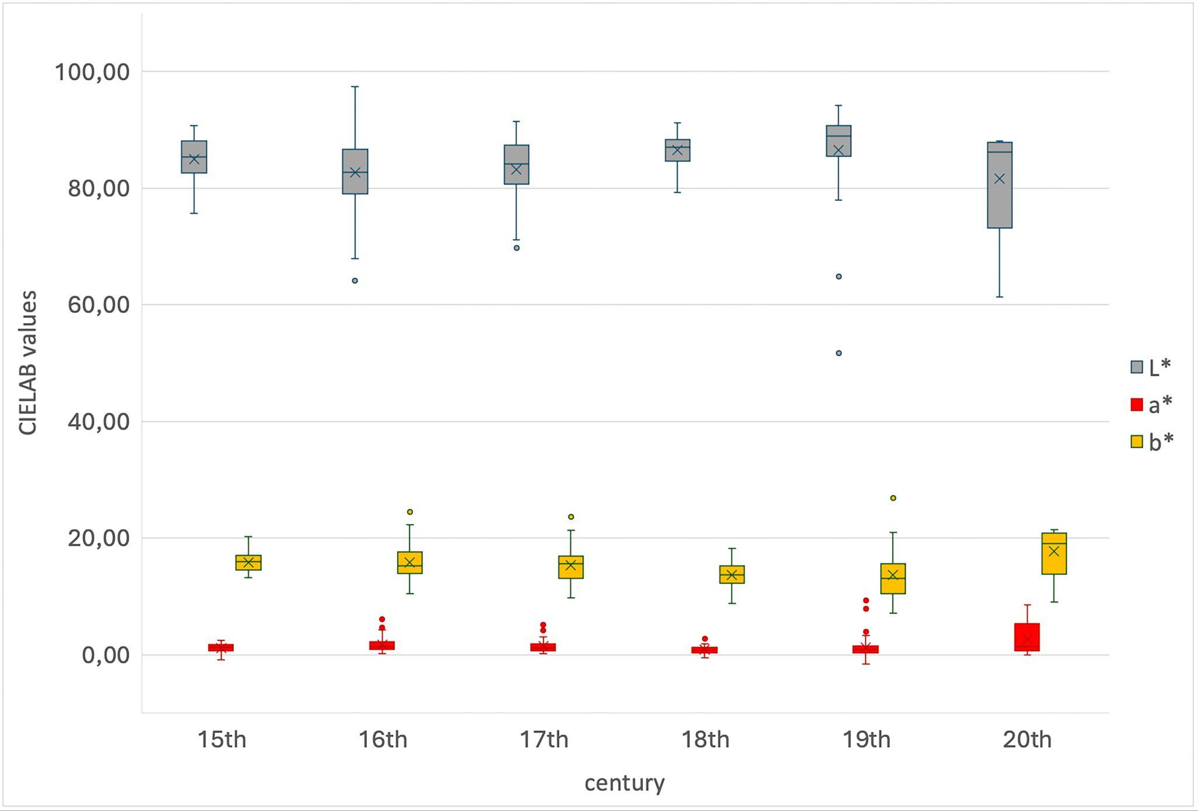
CIELAB values for papers in Fig. 1, sorted by century

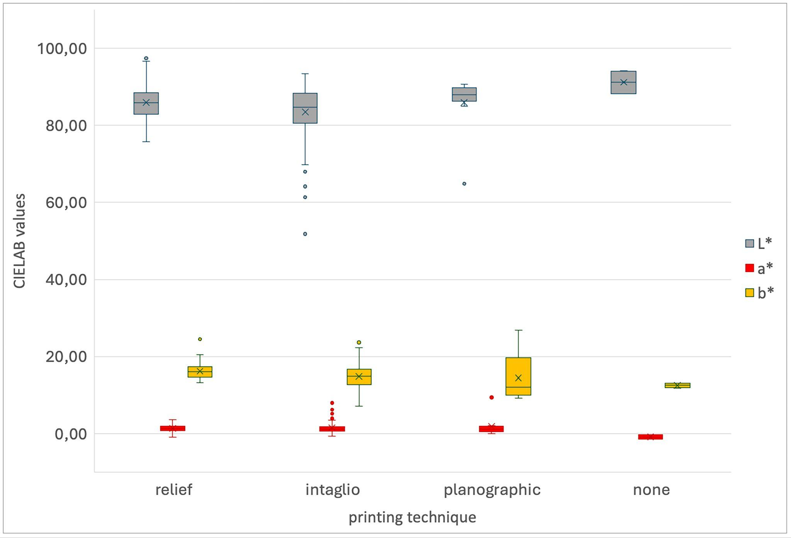
CIELAB values for papers in Fig. 1, sorted by printing technique

Appendix III: Materials and instruments relevant for sections 3 and 4
material | source
2,5-DHAP (2,5-dihydroxyacetophenone), DHBQ (2,5-dihydroxy-1,4-benzoquinone), DHNQ (5,8-dihydroxy-1,4-naphthoquininone) | Sigma Aldrich  https://www.sigmaaldrich.com/germany.html
blotting paper | KLUG-CONSERVATION  Zollstraße 2, 87509 Immenstadt  www.klug-conservation.de
cardboard (acid free) | Regis GmbH, Albert-Einstein-Straße 11,  53561 Grafschaft-Gelsdorf
Colorchecker X-Rite | www.xrite.com
Colorimeter i1 Pro SN 1075068 | www.xrite.com
demineralised water, Herco water treatment unit | Herco Wassertechnik GmbH  Planckstraße 26, 71691 Freiberg
sigital SLR camera: CANON EOS 60D | www.canon.de
eucalyptus fibres, pre-prepared pulp | Enno Lehmann, ABK Stuttgart
filter paper, type MN 260 | Macherey Nagel GmbH & Co. KG  Valencienner Str. 11, 52355 Düren  sales@mn-net.com
Gelita photogelatin, 210 Bloom, type B, 19233 | Gabi Kleindorfer  Aster Straße 9, 84186 Vilsheim  www.gmw-gabikleindorfer.de/shop/
Heraeus Climate Chamber HC 0020 | Vötsch Industrietechnik GmbH, Stuttgart
iron(III)sulfate hydrate [Fe₂(SO₄)₃] | Merck Darmstadt KgaA
kaliumaluminiumsulfate dodecahydrate KAl(SO₄)₂ | Sigma Aldrich  https://www.sigmaaldrich.com/germany.html
Marvelseal® Aluminium composite film | Long Life for Art, Christoph Waller  Hauptstraße 47, 79356 Eichstetten  http://www.cwaller.de/deutsch.htm
Melinex® polyesterfilm | Anton Glaser, Theodor-Heuss-Straße 34a,  70174 Stuttgart
N,N-dimethylacetamide/ lithium chloride (DMAc/LiCl) | Sigma Aldrich  https://www.sigmaaldrich.com/germany.html
papermaking mould | Eifeltor Mühle – paper making equipment  https://www.eifeltor-muehle.de/
pins, nails | commercial
polypropylene felt | Gabi Kleindorfer  Aster Straße 9, 84186 Vilsheim  www.gmw-gabikleindorfer.de/shop/
reproduction system: Diflex 8060 (große) | Manfred Mayer  Universitätsstraße 15, 8010 Graz (A)
Q-Sun Xenon Test Chamber Xe-1-BC  Window-Q Filter | Q-Lab Deutschland GmbH  http://www.q-lab.com/de-de
silkscreen | Sericol GmbH, Adolf-Heim-Straße 11,  74321 Bietigheim-Bissingen
SpectraShop 5 Software | http://www.rmimaging.com/spectrashop.html
Vivak® PET-G transparent, thickness 2 mm ,  50 x 100 cm | Friedrich Römer GmbH  Bothmerstraße 11 und 13  80634 München  www.Friedrich-Roemer.de

Appendix IV – Preparation of the laboratory papers and their analyses relevant for section 3

Fiber source: We chose a bleached eucalyptus fiber pulp. The raw material was prepared using tap water in the Hollander beater of the Fine Arts Department at the Stuttgart Academy.

Contaminants: For contamination of the laboratory papers, iron(III)sulfate hydrate [Fe₂(SO₄)₃] and alum (aluminum potassium sulfate dodecahydrate) [KAl(SO₄)₂] were chosen. The contamination was carried out during sheet formation on selected sheets.

Sheet formation: Each paper sheet received 100 g hydrated pulp in 1 L of demineralized water, and was mixed by hand. The fiber slurry was of a relatively concentrated consistency so that the sheets formed would be thick and sufficiently opaque to enable subsequent color measurement on single sheets. The sheets were formed on a wove mould (dimensions: 148 x 210 mm) which was set up floating on the surface of a water bath in a plastic basin. For easier removal of the lab sheets, the mould was covered with a polyester screen fabric. To optimize formation with limited pulp supply and without the use of a manual laboratory sheet former (e.g. TAPPI P41523), we prepared a rectangular Vivak® (copolyester, PETg) frame of 30 cm height that fitted the screen opening of the papermaking mould and was kept stationary by the surrounding deckle. The pulp was poured in from the top while a strip polyester film rested on the mould surface to prevent premature pulp spillage. The strip was then pulled away sideways, the mould plus frame was lifted the water surface; both actions stimulated quick and even water drainage in a process inspired by a leaf casting system [33]. The sheets were repeatedly pressed for liquid water removal between cotton towels and then fully dried between blotters. It should be noted that the actual concentrations of iron ions and alum in the finished model papers are lower than those given in the table, as the fibers had a water content and a certain amount of water-soluble metal salts could be rinsed out during sheet formation.

Gelatin sizing: A high-purity photograph grade gelatin (Type B, Bloom value 210 representing a relatively firm gel) was prepared in a 3% w/v solution, which averages concentrations calculated from historical sources [34]. The sizing solution was warmed slightly (ca. 30°C) in a double tray. The dry sheets were immersed briefly, were stacked between polyester fabric, pressed to remove excess sizing, and dried.

Gelatin sizing with added alum: In one portion of the sizing solution, 10% alum (w/w dry gelatin) was added to the sizing solution. The sizing was applied in a warmed solution by brief immersion. The sheets were dried as described above.

Light aging: Samples were aged according to DIN EN ISO 105-B02:1999 in a Q-Sun Xenon Test Chamber (Model Xe-1B/S, Q-Lab Deutschland GmbH). A filtering Q-window glass that mimics indoor light conditions with filtered natural sun light was used, blocking radiation below 310 nm (Q-Lab Corporation 2007). The black body temperature was calibrated at 50°C and regulated via air stream. The samples were secured with needles on a museum board covered with aluminum foil. A set of Blue Wool Standards was aged together with the paper samples. The light-aged and light- followed by climate-aged groups were treated separately using the same settings. The samples that underwent combined aging were exposed for 192 hours (= 8 days), the exclusively light-aged samples twice as long for 384 hours (=16 days).

Climate aging: Dynamic aging was carried out in a Heraeus Vötsch HC 0020 climatic test chamber with fluctuating temperatures every three hours 20 and 80 °C with an equalization phase of one hour and a duration of 31 days. The papers were set up by stacking them between blotters on either side and separating them by barrier films (Marvelseal®). The sample stacks were preconditioned in the test chamber for 24 hours at 20°C and 60% RH and were then sealed in barrier film. In the closed system, the temperature changes during testing and causes a movement of moisture between the air and the paper, while the absolute amount of water in the package remains constant.

Colorimetry: CIELAB values were measured using an X-Rite i1Pro UV/VIS spectrophotometer (SN 1075068, tungsten light source and UV-LED, ring illumination, 45/0° measuring geometry) with an instrumental error of 0.1 ΔE00 (mean of 10 consecutive measurements on white standard). For filter papers containing chromophore mixtures (section 4), the average value was calculated based on five repeats per spot on three spots per paper. For historical prints (sections 2 and 5), three spots in representative areas of the blank white paper were measured, excluding areas of local staining or, in the case of intaglio prints, plate tone or printed areas. In all cases, only the measuring head without the detachable base was used for marking positions, so that the contact area was limited to a circle 8 mm wide. The data were averaged. Standard deviations were below 1 and therefore insignificant which is why they were excluded in Figs. 1, 3, and 4. On the lab sheets discussed in section 3, three measuring points were selected on each sample and marked with a graphite pencil. Each measuring point was measured three times and averaged. The three measuring points were also averaged.

GPC-MALLS-RI combined with fluorescence labelling: The CCOA (Carbazole-9-Carbonyl-Oxy-Amine) labelling of carbonyl groups in cellulose was performed as described by Röhrling et al. [34] (2002). In brief, 20 mg of each sample was removed with a scalpel from the light exposed side and the rear side of the samples in duplicate. After the labeling of the samples, dissolution in N,N-dimethylacetamide/ lithium chloride 9 % (w/v) (DMAc/LiCl) was achieved via solvent exchange at room temperature. Measurements were performed by gel permeation chromatography followed by fluorescence, multi-angle laser light scattering and refractive index detection that allow the determination of molar mass moments and the molar mass distribution of the cellulose in addition to the number and distribution of oxidized groups. The GPC system consists of a TSP FL2000 fluorescence detector for monitoring the CCOA label, a multi-angle laser light scattering detector (MALLS) (Wyatt Dawn DSP with argon ion laser; λ0 = 488 nm), and a refractive index detector (Shodex RI-71). Four serial GPC columns (Polymer Laboratories—current Agilent/ Varian—PLgel-mixedA LS, 20 µm, 7.5 x 300 mm) were used as the stationary phase. A degasser (Dionex DG-2410), an autosampler (HP 1100), a pump (Kontron 420), and a column oven (Gynkotek STH 585) were also part of the system. GPC was performed according to the following conditions: 1.00 ml/min flow rate, 100 µl injection volume, 45-minute run time, λex = 290 nm, and λem = 340 nm for the fluorescence detection of the CCOA label. DMAc/LiCl (0.9%, w/v) after filtering through a 0.02 µm filter was used as the mobile phase. Data evaluation was performed with standard Chromeleon, Astra, and GRAMS/32 software.

Appendix V - Preparation of the laboratory papers and analyses relevant for section 4

Filter paper (16 x 22 cm) without further pre-treatment was doped with a mixture of the three cellulose-derived key chromophores 2,5-DHAP(2,5-dihydroxyacetophenone), DHBQ (2,5-dihydroxy-1,4-benzoquinone), and DHNQ (5,8-dihydroxy-1,4-naphthoquininone) in the following concentrations:

 | mass [mg]* | molar mass [g/mol]
2,5-DHAP | 24.9 mg | 152.15
DHBQ | 15.5 mg | 140.09
DHNQ | 12.2 mg | 190.15
* dissolved in 50 mL solvent

The water used as solvent was adjusted to pH 10 with Ca(OH)₂ conc. (checked with pH indicator paper). The three types of chromophores were mixed together in one beaker. All powdery residues that remained due to the limited solubility of the chromophores were transferred from the beaker with several water rinses to the spray bottle, which was then filled up with more water to 50 ml. The labeled side of the filter papers was sprayed within one hour after preparing the chromophore solution. The undissolved chromophore particles regularly blocked the nozzle of the spray bottle, making intermediate cleaning necessary. To apply the chromophore solution to the papers, they were each placed separately on a clean blotting paper and sprayed until evenly saturated, which required 75–85 pumping actions each. About 10–15 ml of chromophore solution was applied per sheet. The doped samples were air-dried by hanging them from metal clamps.

The concentrations used in our study were considerably higher than those used by Krainz et al. [27]. Also, the color shades we achieved with the respective chromophores differed from the brownish ones of Krainz et al.. The same was true for additional chromophore-doped samples prepared according to Krainz et al. in methanol, applied to filter paper and to eucalyptus pulp.

Appendix VI: Information on the paper objects discussed in section 5
ID of paper object (descriptors) | information | fiber | gelatin | Fe
historical writing paper (gelatin) | Blank sheet of writing paper, possibly as early as 16th century, as indicated by a water mark (bull´s head, detached, with sign above, with rod consisting in one line, cross (consisting in one line), without further additional motif, transverse bar horizontal, with eyes and nostrils) https://www.wasserzeichen-online.de/wzis/struktur.php?klassi=002007002002004001001003001&anzeigeIDMotif=11991. The sheet has been in the study collection for more than 30 years, origin unknown. | bast | yes | none
historical printing paper (gelatin) | Single leaf from a book, which stems from Frédéric Barbier, III. Le voyage de Grèce, first published 1778. The leaf has been in the study collection for more than 30 years, origin unknown | bast | yes | none
19th-century etching (cellulose) | After Francesco Hayez (1791–1882), Valenza Gradenigo before the Inquisition, steel engraving, ca. 1850, machine-made unsized paper | bast | none | none
20th-century etching (cellulose) | Aquatint, made during a workshop on printing technique at the Stuttgart State Academy’s intaglio printing atelier. The print predates 2000, and was selected from a large group of similar prints left as study items at the paper conservation program. | chemical pulp | none | none
19th-century etching (iron ions) | Gustave Leheutre (1861– Paris, 1932), The Bridge at Grounay-sur-Marne, in profile, 1895, etching on machine-made laid paper; purchased 2021 on Ebay in the present light-damaged condition as an example of iron-ion related light aging in our light-aging study funded by the Germany Research Foundation (2021–2024). | rag mix | none | yes
20th-century drawing (iron ions) | Drawing of the castle in Esslingen near Stuttgart, India ink on machine-made wove paper, purchased on a flea market in Stuttgart in the present light-damaged condition. The purchase was made by a former student for the paper conservation department at the Stuttgart State Academy. The print is now featured in the Kulturgut-Lab that explains conservation to the public. | rag/  chemical pulp | none | yes

