Supplementary Material

Table S1: Autoantibodies dataset and full name

Autoantibodies dataset | Full name
G protein-coupled receptors
AT1R | angiotensin II receptor type 1
AT2R | angiotensin II receptor type 2
ADRB2 | beta-2 adrenergic receptor
ADRA1A | alpha-1 adrenergic receptor
CXCR3 | chemokine (C-X-C motif receptor 3
ETAR or EDNRA | endothelin receptor type A
ETBR or EDNRB | endothelin receptor type B
MAS1 | mitochondrial assembly protein 1
M5 or CHRM5 | cholinergic receptor muscarinic 5
PAR1 | Protease-activated receptor 1
PAR2 | Protease-activated receptor 2
BDKRB1 | Bradykinin receptor B1
Scavenger receptors (transmembrane receptors)
STAB1 | stabilin-1 receptor
ANXA2R | annexin A2 receptor
Proteins
ACE2 | angiotensin converting enzyme 2
ANXA2 | annexin A2

Table S2: Fluorochrome coupled antibodies and fluorescent dye for analysis of CXCR3+ T cells

Antibodies or fluorescent dye | Fluorochrome | Source | Cat. Nr.
Fixable Viability-Dye | eFluor780 | eBioscience | 65-0865-14
anti CD3 (clone OKT3) | BV785 | BioLegend | 317330
anti CD4 (clone OKT4) | A700 | BioLegend | 317426
anti CD8 (clone RPA-T8) | V500 | BD Biosciences | 560775
anti CD183 (CXCR3) (clone G025H7) | BV605 | BioLegend | 353728

Figure S1. Comparison of anti-GPCR Aab among adults and children. Analysis of anti-GPCR Aab concentrations of both study groups. Scatterplots show line at median. Unpaired data were compared with Mann-Whitney-test. p<0.05 was considered significant, only significant p values are documented in the figures.

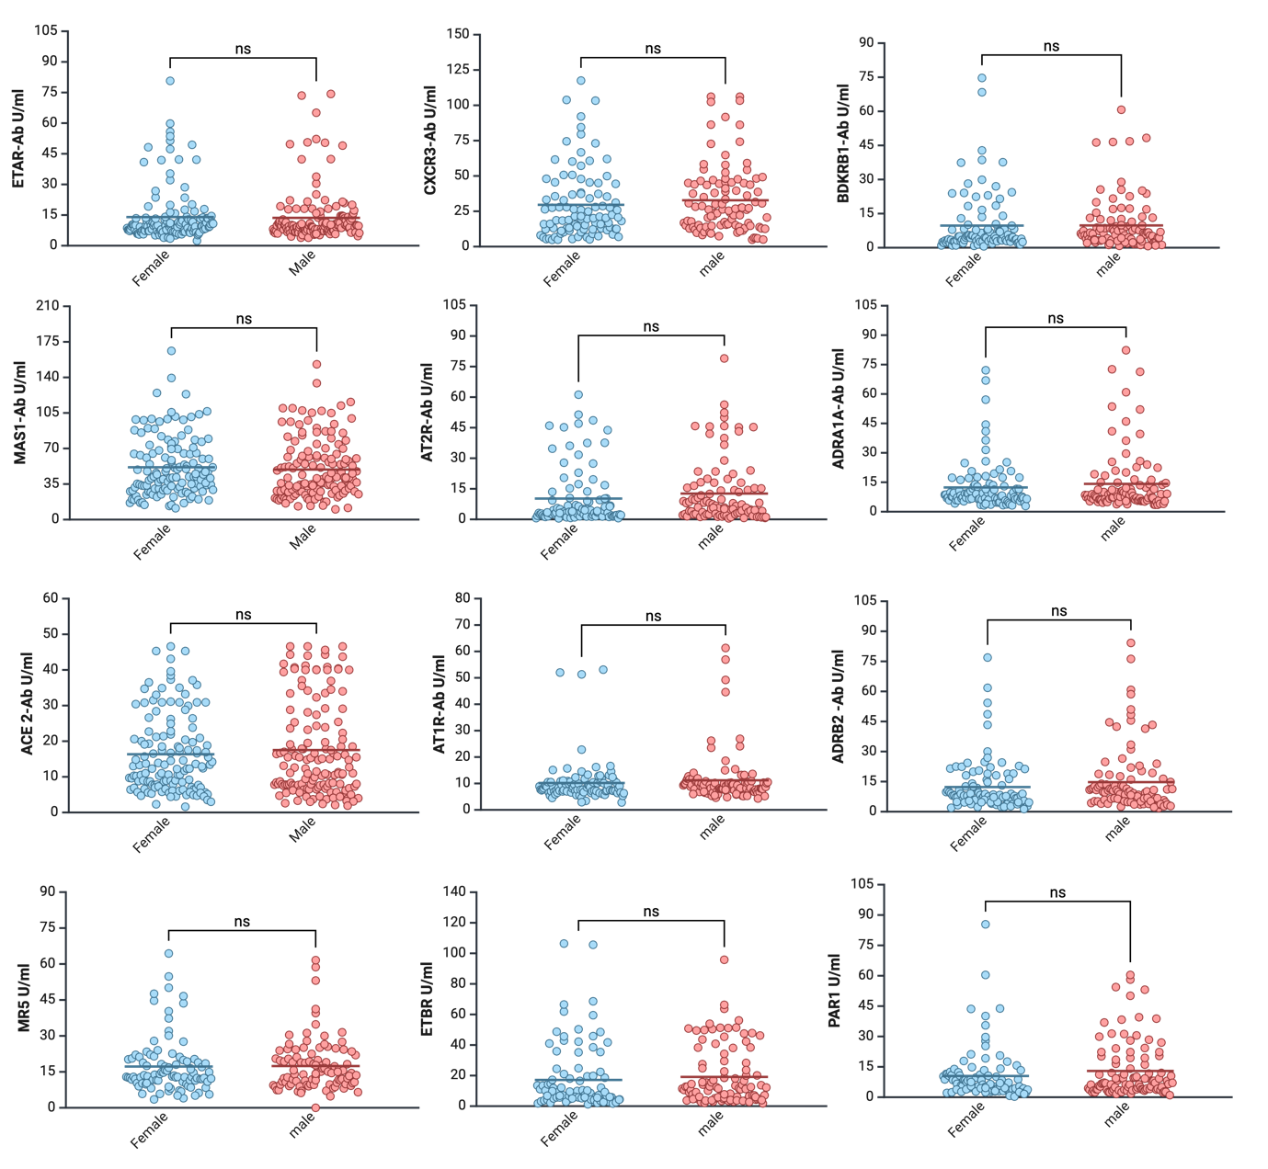
Figure S2. Comparison of anti-GPCR Aab among female and male participants. Analysis of anti-GPCR Aab concentrations of both study groups. Scatterplots show line at median. Unpaired data were compared with Mann-Whitney-test. p<0.05 was considered significant, only significant p values are documented in the figures.

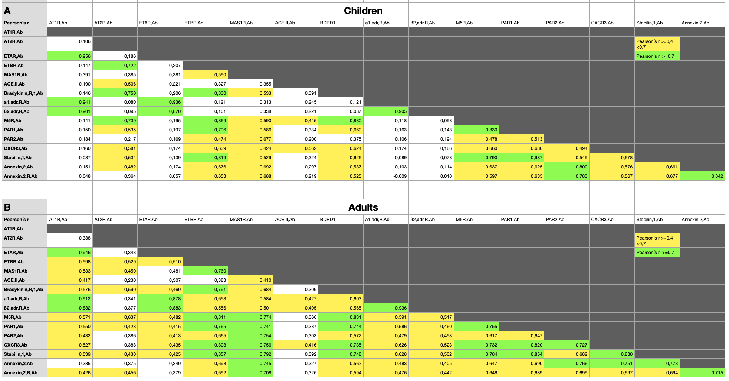

Figure S3. Correlation of diverse anti-GPCR Aab based on chronological age.
A. Correlations of diverse anti-GPCR Aab among children. B. Correlations of diverse anti-GPCR Aab among children. Moderate correlations are shown in yellow, while strong correlations are shown in green.
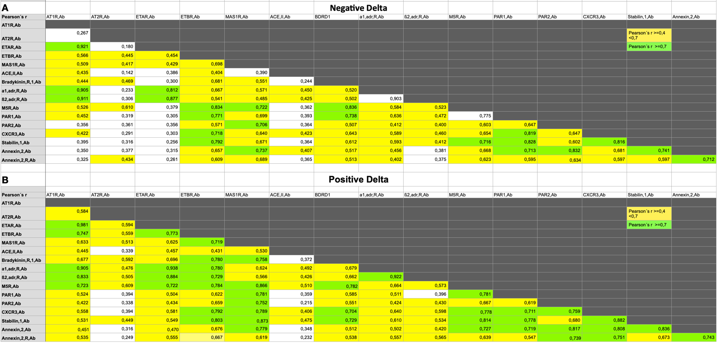
Figure S4. Correlation of diverse anti-GPCR Aab based on age gap (Δ age).
A. Correlations of diverse anti-GPCR Aab among adults with negative Δ age. B. Correlations of diverse anti-GPCR Aab among adults with positive Δ age. Moderate correlations are shown in yellow, while strong correlations are shown in green.

