Figure 1: Flowchart showing inclusion criteria for primary TKA procedures included in the study.
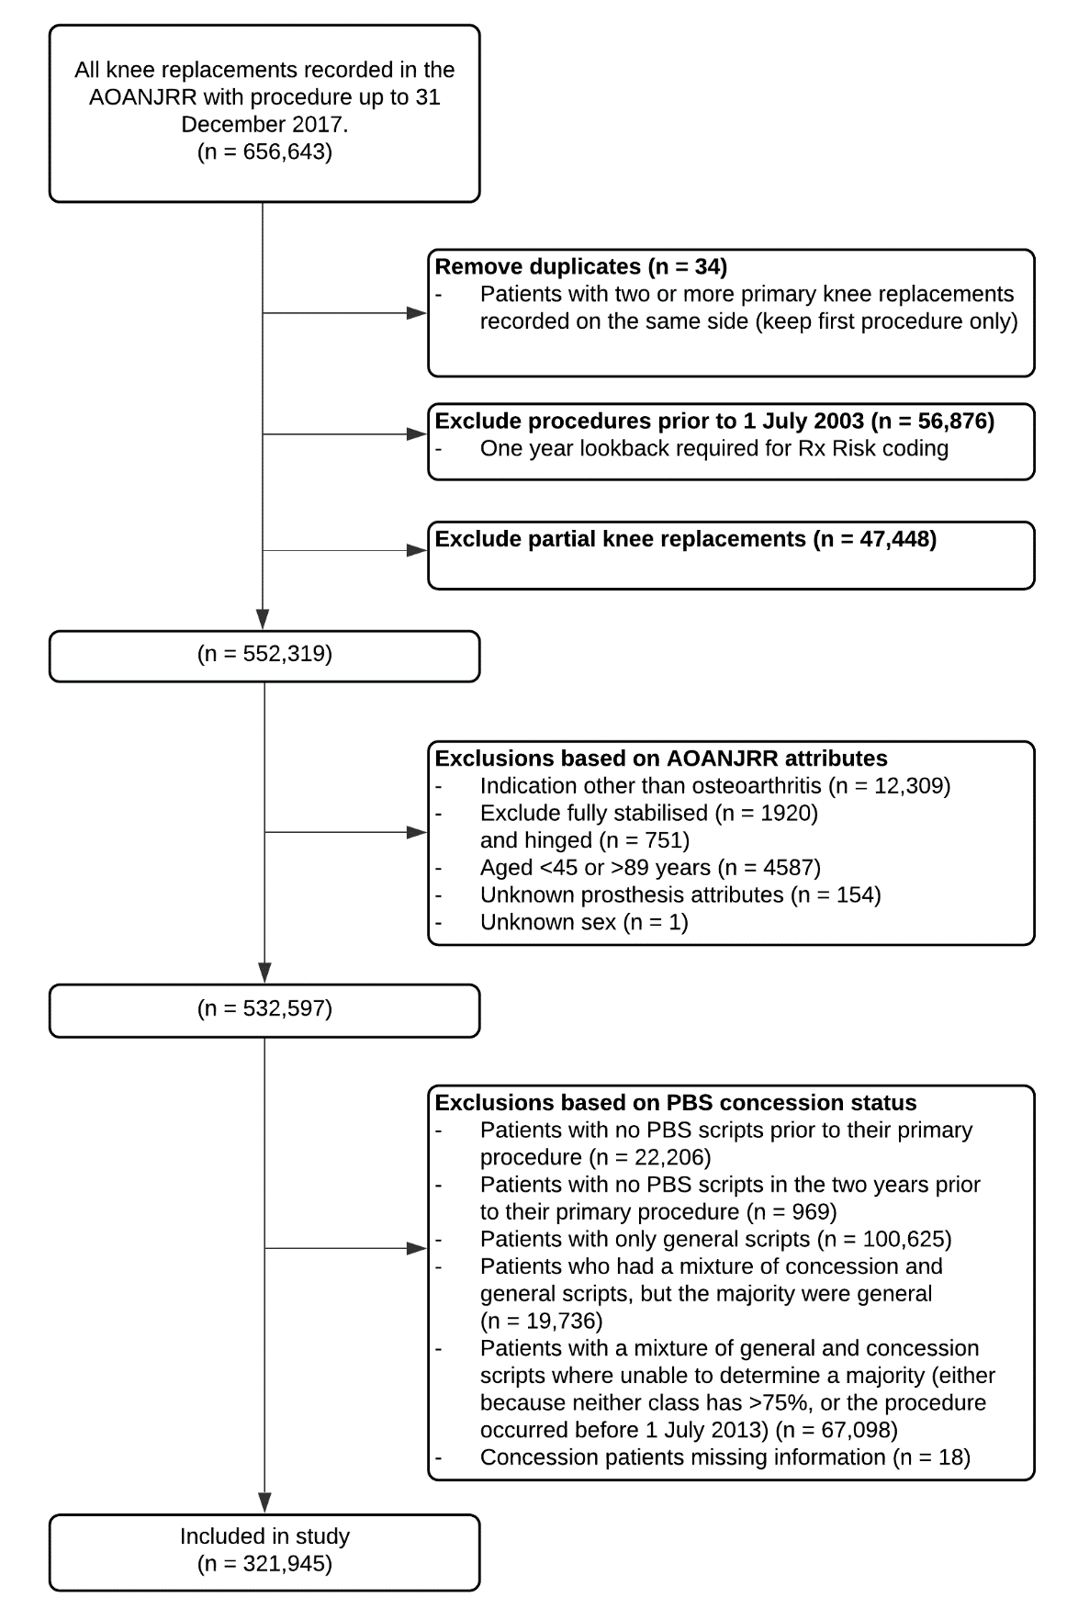

Figure 2: Flowchart showing inclusion criteria for primary THA procedures included in the study.
