Details of tuning random survival forest:
Two parameters for the random survival forests were tuned within each fold of cross-validation: mtry and nodesize. An initial grid search was performed using the entire dataset in order to narrow down the number of parameter values considered during cross-validation.
Initial tuning was performed by choosing values that minimised the out-of-bag error from forests grown using the entire dataset with rfsrc.fast with 100 trees (inbuilt function of randomForestSRC package that performs a fast approximation of the random survival forest using subsampling). To reduce computing time/memory usage, ntime was restricted to 17 discrete time points: (0.1, 0.2, 0.3, 0.4, 0.5, 0.6, 0.7, 0.8, 0.9, 1, 2, 3, 4, 5, 6, 7, 8). nsplit was set to 5 (there are only 49 distinct values of the continuous predictor age).
For THA, a grid search across 12 values of node size: 15, 50, 100, 200, 250, 500, 750, 1000, 1250, 1500, 1750, 2000. And 5 values of mtry: (3, 6, 10, 15, 20) for a total of 60 possible combinations. Based on these results, 4 values of nodesize (15, 350, 500, 650) and 2 values of mtry (10, 15) were considered when tuning within folds.
The minimum value used to build the RSF used for variable importance was nodesize=500 and mtry=15.
Figure 3: OOB Error for various values of mtry and nodesize for prediction of THA revision
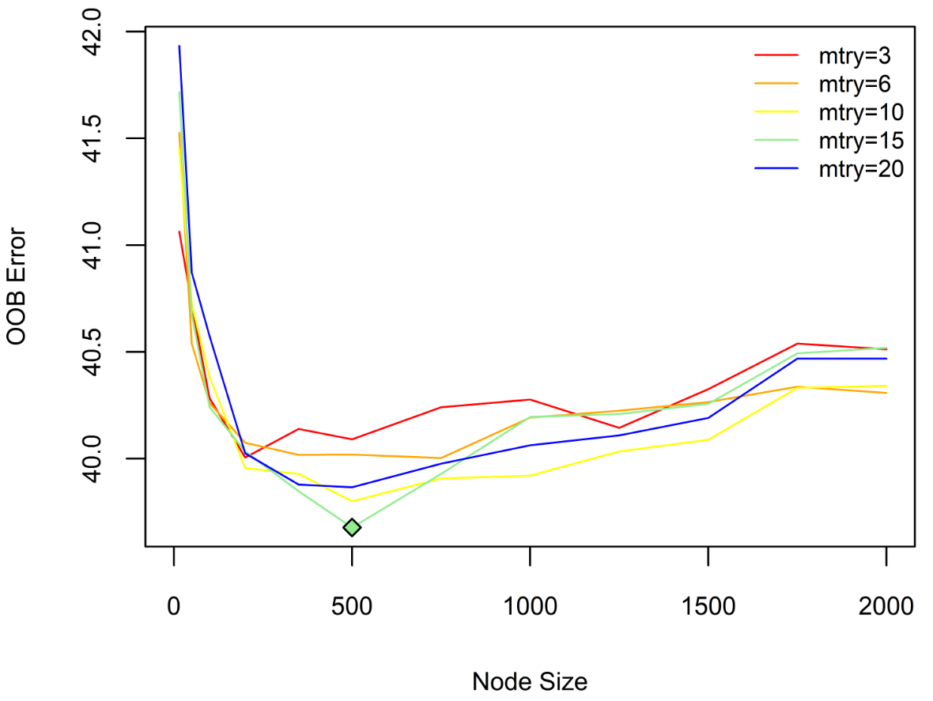

For TKA, a grid search across 8 values of node size (15, 50, 100, 200, 350, 500, 750, 1000) and 5 values of mtry (3, 6, 10, 15, 20) was performed, for a total of 40 possible combinations. Based on these results, within each fold, the RSF was tuned using 4 values of nodesize: 15, 100, 200, 400 – the minimum OOB error appeared to fall between 100-400, and 15 was included as it is the default value. The default value of mtry=6 was used in cross-validation.
Figure 4: OOB Error for various values of mtry and nodesize for prediction of TKA revision

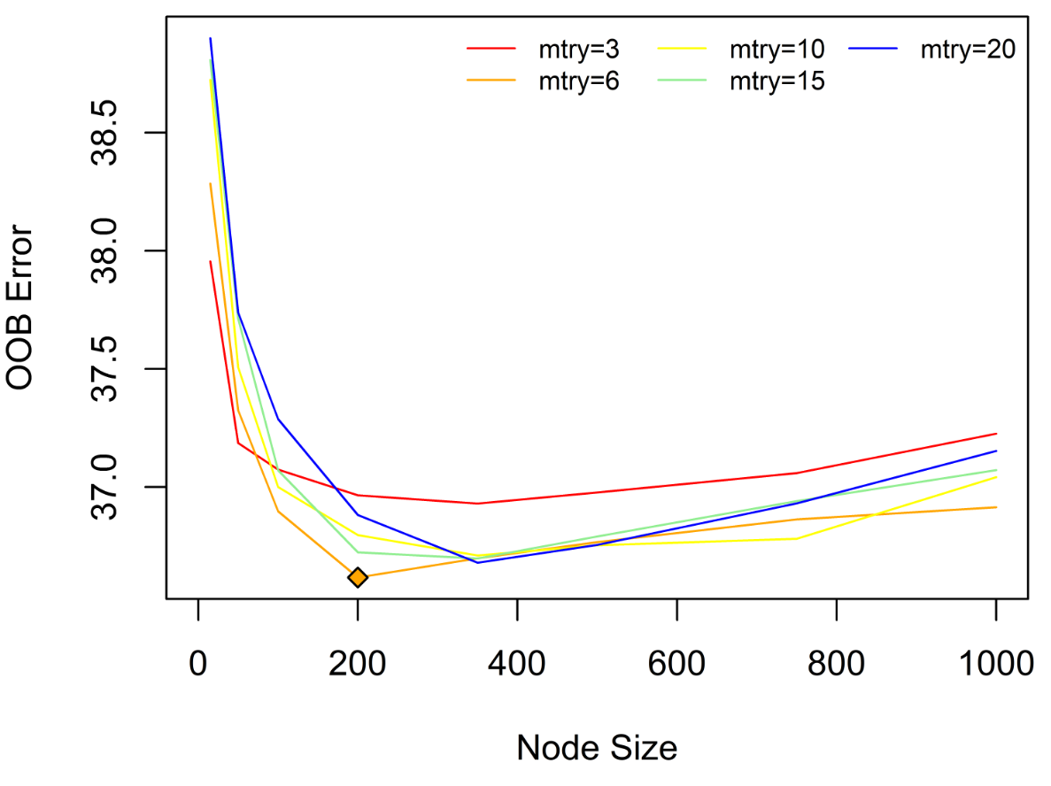
Within each fold, 200 trees were used for the tuning. This number was chosen because we examined the effect of adding more trees to the forest, and found that there was minimal gain in prediction accuracy after 200.

