Supplementary materials

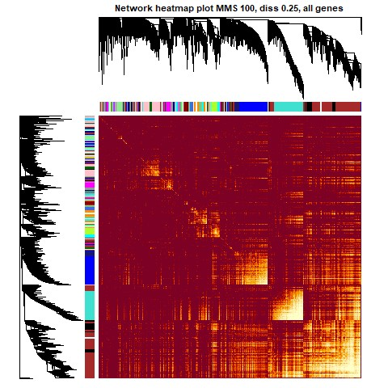
Figure S1 TOM plot of the merged gene count matrices of both infected ants and their cestodes. The colours representing the constructed modules roughly aligning with the highest correlations in the heatmap.

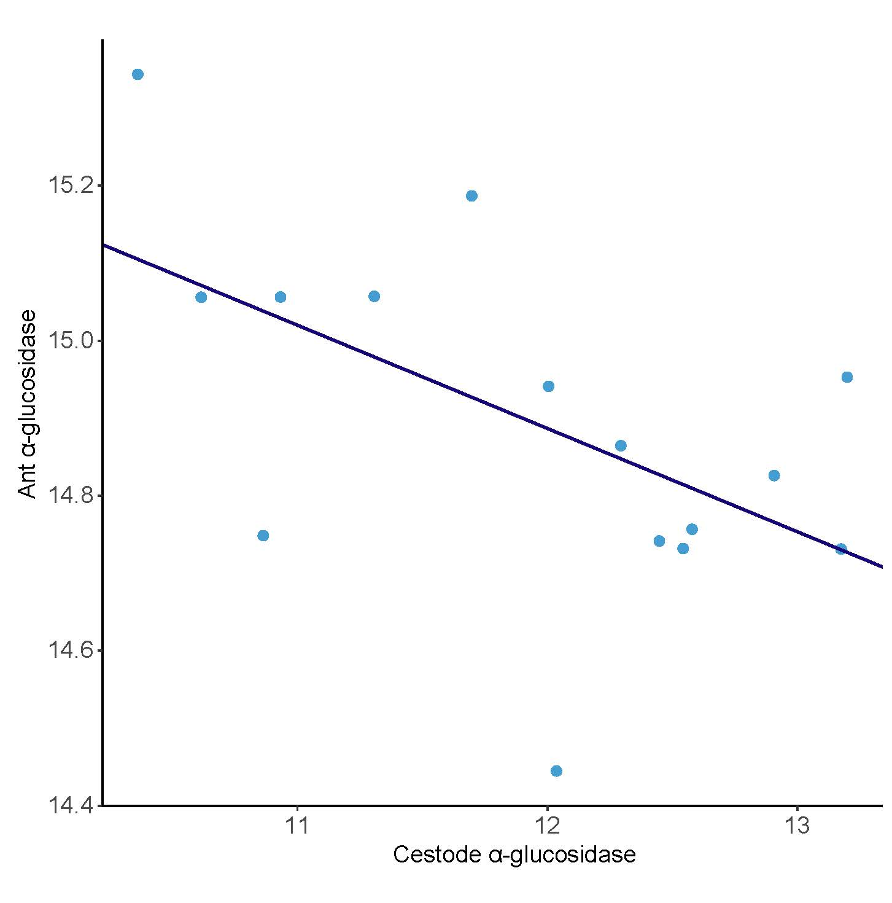
Figure S2 Cestode alpha-glucosidase and ant alpha-glucosidase plotted against each other after variance stabilizing transformation. Here we found a negative correlation with an R value of -0.113 and an intercept of 16.5 (p=0.032).

Table S1 overview of all the samples used in this paper with all information used for the analysis.
Colony | Infected sample name | Cestode sample name | Cestode number | Colony size
A | A6F | A6P | 8 | 77
C | C1F | C1P | 5 | 44
D | D5F | D5P | 7 | 164
F | F2F | F2P | 8 | 65
G | G1F | G1P | 8 | 93
H | H1F | H1P | 10 | 129
J | J8F | J8P | 7 | 72
K | K4F | K4P | 6 | 137
L | L18F | L18P | 7 | 177
M | M16F | M16P | 6 | 121
O | O1F | O1P | 7 | 86
P | P2F | P2P | 5 | 16
Q | Q4F | Q4P | 8 | 72
S | S3F | S3P | 13 | 17
T | T1F | T1P | 9 | 76

Table S2 overview of all GO terms found for all annotated genes in the proteome
GO ID | Term | Annotated | Significant | Expected | Fisher | Gene name
GO:0014878 | response to electrical stimulus involved in regulation of muscle adaptation | 3 | 2 | 0.06 | 0.0013 | Superoxide dismutase
GO:0070262 | peptidyl-serine dephosphorylation | 7 | 2 | 0.15 | 0.0089 | Superoxide dismutase
GO:0007099 | centriole replication | 18 | 3 | 0.39 | 0.0061 | Superoxide dismutase
GO:0046718 | viral entry into host cell | 18 | 3 | 0.39 | 0.0061 | Superoxide dismutase
GO:0098655 | cation transmembrane transport | 200 | 10 | 4.29 | 0.0054 | Superoxide dismutase
GO:0045956 | positive regulation of calcium ion-dependent exocytosis | 7 | 2 | 0.08 | 0.0023 | Disulfide isomerase
GO:0007187 | G protein-coupled receptor signaling pathway, coupled to cyclic nucleotide second messenger | 32 | 3 | 0.35 | 0.0047 | Disulfide isomerase
GO:0007618 | mating | 69 | 4 | 0.75 | 0.0062 | Disulfide isomerase
GO:0015705 | iodide transport | 2 | 2 | 0.08 | 0.0017 | Thioredoxin peroxidase
GO:0014878 | response to electrical stimulus involved in regulation of muscle adaptation | 3 | 2 | 0.13 | 0.0051 | Thioredoxin peroxidase
GO:0015866 | ADP transport | 3 | 2 | 0.13 | 0.0051 | Thioredoxin peroxidase
GO:0015867 | ATP transport | 3 | 2 | 0.13 | 0.0051 | Thioredoxin peroxidase
GO:0001178 | regulation of transcriptional start site selection at RNA polymerase II promoter | 3 | 2 | 0.13 | 0.0051 | Thioredoxin peroxidase
GO:0035970 | peptidyl-threonine dephosphorylation | 4 | 2 | 0.17 | 0.0099 | Thioredoxin peroxidase
GO:1990253 | cellular response to leucine starvation | 4 | 2 | 0.17 | 0.0099 | Thioredoxin peroxidase
GO:0070262 | peptidyl-serine dephosphorylation | 7 | 4 | 0.29 | 0.0006 | Thioredoxin peroxidase
GO:0060078 | regulation of postsynaptic membrane potential | 36 | 4 | 1.5 | 0.0098 | Thioredoxin peroxidase
GO:0034329 | cell junction assembly | 210 | 9 | 8.78 | 0.0018 | Thioredoxin peroxidase
GO:0043161 | proteasome-mediated ubiquitin-dependent protein catabolic process | 187 | 12 | 7.82 | 0.009 | Thioredoxin peroxidase
GO:0040039 | inductive cell migration | 7 | 5 | 1.48 | 0.006 | Lysosomal alpha glucosidase
GO:0032876 | negative regulation of DNA endoreduplication | 7 | 5 | 1.48 | 0.006 | Lysosomal alpha glucosidase
GO:0006369 | termination of RNA polymerase II transcription | 9 | 6 | 1.91 | 0.0041 | Lysosomal alpha glucosidase
GO:0030206 | chondroitin sulfate biosynthetic process | 10 | 6 | 2.12 | 0.0085 | Lysosomal alpha glucosidase
GO:0048145 | regulation of fibroblast proliferation | 21 | 7 | 4.45 | 0.002 | Lysosomal alpha glucosidase
GO:1901222 | regulation of NIK/NF-kappaB signaling | 23 | 7 | 4.87 | 0.0095 | Lysosomal alpha glucosidase
GO:0008362 | chitin-based embryonic cuticle biosynthetic process | 11 | 8 | 2.33 | 0.0004 | Lysosomal alpha glucosidase
GO:0000729 | DNA double-strand break processing | 18 | 9 | 3.81 | 0.0084 | Lysosomal alpha glucosidase
GO:0007112 | male meiosis cytokinesis | 22 | 10 | 4.66 | 0.0091 | Lysosomal alpha glucosidase
GO:0060840 | artery development | 37 | 10 | 7.84 | 0.0095 | Lysosomal alpha glucosidase
GO:0046329 | negative regulation of JNK cascade | 22 | 10 | 4.66 | 0.0096 | Lysosomal alpha glucosidase
GO:0006970 | response to osmotic stress | 33 | 12 | 6.99 | 0.0017 | Lysosomal alpha glucosidase
GO:0032456 | endocytic recycling | 32 | 12 | 6.78 | 0.0061 | Lysosomal alpha glucosidase
GO:0043001 | Golgi to plasma membrane protein transport | 32 | 13 | 6.78 | 0.0096 | Lysosomal alpha glucosidase
GO:0007249 | I-kappaB kinase/NF-kappaB signaling | 43 | 14 | 9.11 | 0.0016 | Lysosomal alpha glucosidase
GO:0090307 | mitotic spindle assembly | 40 | 16 | 8.47 | 0.0057 | Lysosomal alpha glucosidase
GO:0051260 | protein homooligomerization | 81 | 23 | 17.15 | 0.0061 | Lysosomal alpha glucosidase
GO:0061025 | membrane fusion | 71 | 24 | 15.03 | 0.0082 | Lysosomal alpha glucosidase
GO:0044403 | biological process involved in symbiotic interaction | 131 | 35 | 27.74 | 0.0077 | Lysosomal alpha glucosidase
GO:0048608 | reproductive structure development | 184 | 39 | 38.96 | 0.0059 | Lysosomal alpha glucosidase
GO:0070201 | regulation of establishment of protein localization | 200 | 48 | 42.35 | 0.0093 | Lysosomal alpha glucosidase
GO:0031175 | neuron projection development | 494 | 106 | 104.61 | 0.0005 | Lysosomal alpha glucosidase
GO:0032268 | regulation of cellular protein metabolic process | 711 | 174 | 150.56 | 0.01 | Lysosomal alpha glucosidase

Table S3 overview of all GO terms found for all unannotated genes in the proteome
GO ID | Term | Annotated | Significant | Expected | Fisher | Ranking in haemolymph expression
GO:0035204 | negative regulation of lamellocyte differentiation | 7 | 2 | 0.06 | 0.0013 | 2nd most expressed
GO:0010613 | positive regulation of cardiac muscle hypertrophy | 15 | 2 | 0.12 | 0.0062 | 2nd most expressed
GO:0060395 | SMAD protein signal transduction | 18 | 2 | 0.15 | 0.0089 | 2nd most expressed
GO:0045956 | positive regulation of calcium ion-dependent exocytosis | 7 | 2 | 0.01 | <0.0001 | 3rd most expressed
GO:0071422 | succinate transmembrane transport | 2 | 2 | 0.06 | 0.0008 | 4th most expressed
GO:0042713 | sperm ejaculation | 3 | 2 | 0.09 | 0.0024 | 4th most expressed
GO:0010873 | positive regulation of cholesterol esterification | 3 | 2 | 0.09 | 0.0024 | 4th most expressed
GO:1903699 | tarsal gland development | 3 | 2 | 0.09 | 0.0024 | 4th most expressed
GO:0043651 | linoleic acid metabolic process | 3 | 2 | 0.09 | 0.0024 | 4th most expressed
GO:1903966 | monounsaturated fatty acid biosynthetic process | 3 | 2 | 0.09 | 0.0024 | 4th most expressed
GO:0006723 | cuticle hydrocarbon biosynthetic process | 3 | 2 | 0.09 | 0.0024 | 4th most expressed
GO:0010378 | temperature compensation of the circadian clock | 4 | 2 | 0.11 | 0.0047 | 4th most expressed
GO:0070474 | positive regulation of uterine smooth muscle contraction | 4 | 2 | 0.11 | 0.0047 | 4th most expressed
GO:0035338 | long-chain fatty-acyl-CoA biosynthetic process | 4 | 2 | 0.11 | 0.0047 | 4th most expressed
GO:0032025 | response to cobalt ion | 4 | 2 | 0.11 | 0.0047 | 4th most expressed
GO:0036109 | alpha-linolenic acid metabolic process | 4 | 2 | 0.11 | 0.0047 | 4th most expressed
GO:1904058 | positive regulation of sensory perception of pain | 4 | 2 | 0.11 | 0.0047 | 4th most expressed
GO:0048133 | male germ-line stem cell asymmetric division | 5 | 2 | 0.14 | 0.0077 | 4th most expressed
GO:0034625 | fatty acid elongation, monounsaturated fatty acid | 5 | 2 | 0.14 | 0.0077 | 4th most expressed
GO:0034626 | fatty acid elongation, polyunsaturated fatty acid | 5 | 2 | 0.14 | 0.0077 | 4th most expressed
GO:0019367 | fatty acid elongation, saturated fatty acid | 5 | 2 | 0.14 | 0.0077 | 4th most expressed
GO:0035844 | cloaca development | 5 | 2 | 0.14 | 0.0077 | 4th most expressed
GO:0006572 | tyrosine catabolic process | 5 | 3 | 0.14 | 0.0002 | 4th most expressed
GO:0006559 | L-phenylalanine catabolic process | 6 | 3 | 0.17 | 0.0004 | 4th most expressed
GO:0019432 | triglyceride biosynthetic process | 19 | 4 | 0.55 | 0.0017 | 4th most expressed
GO:0016318 | ommatidial rotation | 25 | 5 | 0.72 | 0.0006 | 4th most expressed
GO:0090175 | regulation of establishment of planar polarity | 43 | 5 | 1.23 | 0.0041 | 4th most expressed
GO:0046949 | fatty-acyl-CoA biosynthetic process | 12 | 6 | 0.34 | <0.0001 | 4th most expressed
GO:0006572 | tyrosine catabolic process | 5 | 3 | 0.03 | <0.0001 | 6th most expressed
GO:0006559 | L-phenylalanine catabolic process | 6 | 3 | 0.04 | <0.0001 | 6th most expressed
GO:0042438 | melanin biosynthetic process | 12 | 2 | 0.11 | 0.0048 | 12th most expressed
GO:0050884 | neuromuscular process controlling posture | 13 | 2 | 0.12 | 0.0057 | 12th most expressed
GO:0010613 | positive regulation of cardiac muscle hypertrophy | 15 | 2 | 0.13 | 0.0075 | 12th most expressed
GO:0007628 | adult walking behavior | 27 | 3 | 0.24 | 0.0016 | 12th most expressed
GO:0060395 | SMAD protein signal transduction | 18 | 2 | 0.09 | 0.0035 | 13th most expressed

Supplemental methodology
As detailed in Sistermans et al. 2025 [13], colonies of Temnothorax nylanderi were gathered in the Lennebergwald in Mainz, Germany in late 2019 and early 2020. The ants relevant to our study were kept under standardized laboratory conditions and were dissected for their fat body and cestodes [13]. In total they yielded 15 infected ants and their corresponding parasites which are specified in table S1. Both parasite and host samples were placed in individual Eppendorf tubes containing 50 µL of trizol. RNA of these samples was extracted using the Qiagen RNeasy extraction kit. These samples were then sent to Novogene for RNA sequencing (for details regarding this procedure please be referred to Sistermans et al. 2025). Raw reads of Anomotaenia brevis were then mapped against their A. brevis genome combined with a T. nylanderi genome assembly [74] using STAR [75]. They then constructed a gene count matrix using htseq-count [76], filtering out all reads that mapped multiple times (filtering out potential contaminant reads). For T. nylanderi they first filtered raw reads against the genomes of A. brevis, humans and E. coli using fastqscreen [77] and then trimmed the reads using fastp [78]. Reads were then mapped against the earlier-mentioned T. nylanderi genome [74] using hisat [79] and created a gene count matrix as well as a genome-guided transcriptome assembly using stringtie [80]. BLAST annotation of both genomes was obtained using BLAST DIAMOND [81] and both GO and KEGG terms were obtained using eggNOG [82]. Besides raw reads (found on SRA, PRJNA1246159) all these data can be found on Dryad (DOI: 10.5061/dryad.8cz8w9h3b).

