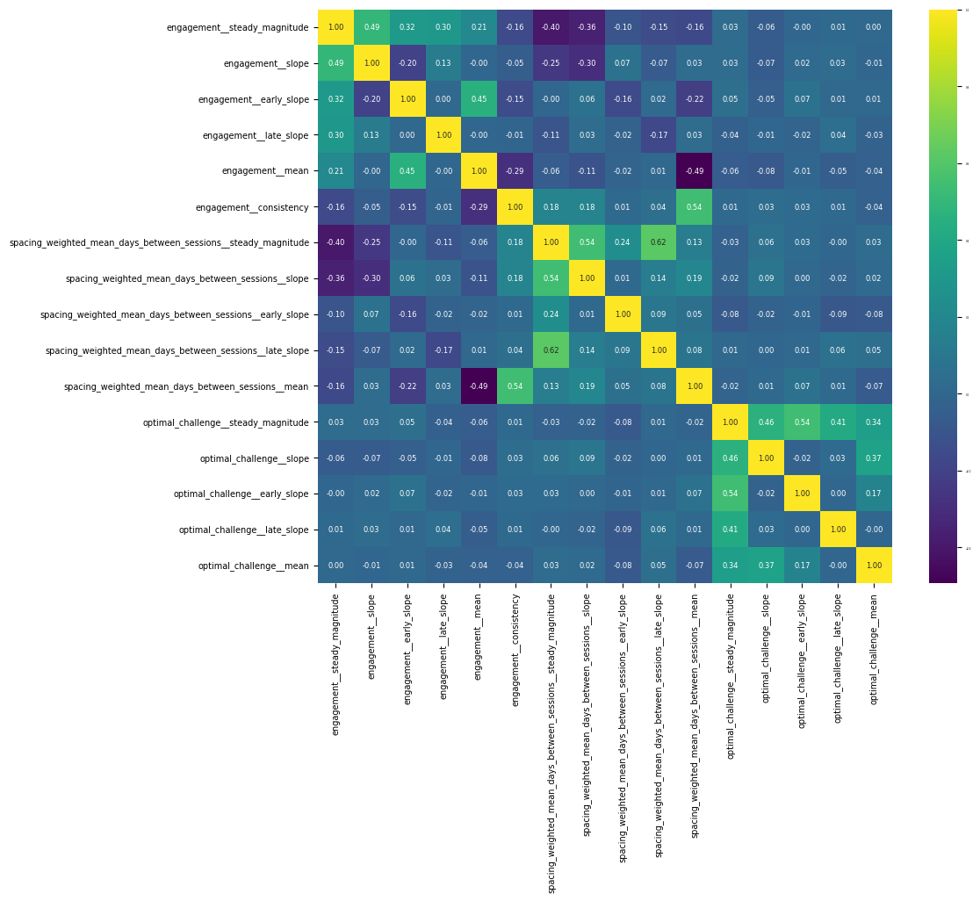
Appendix 1
Figure 1 . Feature correlation matrix. Pairwise Pearson correlation coefficients among all candidate features. The matrix was used to visually inspect and identify clusters of highly correlated variables prior to feature selection. One or two representative variables from each conceptual group (engagement, spacing, optimal challenge) were retained to reduce redundancy and mitigate potential multicollinearity.

