Sustainable Actinomycete Biofilters Enable Optimized Phenol Removal and Agricultural Reuse of Olive Mill Wastewater within a Circular Economy Framework

Omnia Alshamy¹, Sameh M. Mustafa¹, Alaaeldin Rashad¹, Amal A. Hassan¹, Abeer El Shahawy², Sahar Ahmed El-Shatoury¹ and Hesham Abdullah¹

¹Botany and Microbiology Dept, Suez Canal University, 41522 Ismailia, Egypt

²Department of Civil Engineering, Faculty of Engineering, Suez Canal University, P.O. Box 41522, Ismailia, Egypt

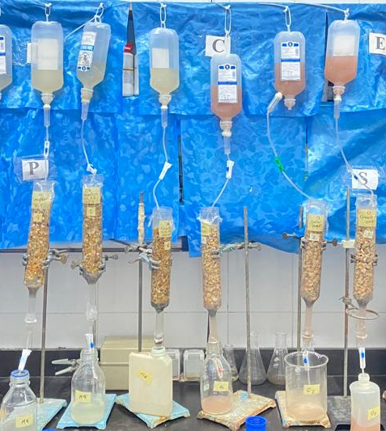

Figure S1. Experimental setup of percolating microcosms for olive mill wastewater treatment. The system consists of vertically arranged glass columns packed with supporting material and connected to influent reservoirs (top row) delivering raw wastewater and treatments (with/without casein or activated carbon) to the microcosm columns, under controlled flow. Effluents were collected at the bottom for subsequent analysis.

