Table of Contents

Polymerizable Deep Eutectic Solvents-Enabled High-Lignin-Density Networks for Rapid Multi-scale Fabrication of Multifunctional and Extreme Environment Adaptable Soft Devices

Xinlong Li, Na Luo, Zhiyang Li, Pengxian Li, Jian Chang, Lingtao Fang, Qiyao Huang, Bin Zhu, Yaokang Zhang, Xuechang Zhou, Zijian Zheng, Zhuang Xie*

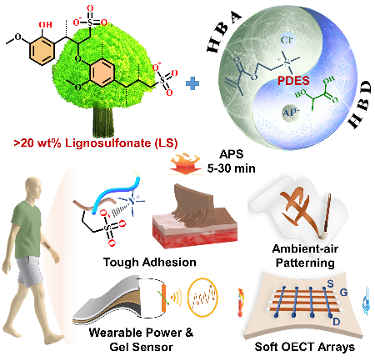

A polymerizable deep eutectic solvent (PDES) strategy utilizing a cationic monomer was developed to enable high-density (>20 wt%) lignosulfonate-interconnected dynamic networks, affording rapid ambient-air gelation across multi-scales, state-of-the-art mechanical/interfacial robustness, excellent photothermal and ion-conducting features. This facilitates in-situ manufacturing of wearable power/sensing devices and miniaturized organic electrochemical transistor (OECT) arrays, exhibiting well-maintained performances under extreme environmental conditions.

