Supplementary Information for
Mechanistic pathways of copper catalyst reconstruction in CO₂ electroreduction
Dexiang Chen^{1,3}, Guoqun Li^{1,3}, Xing Zhao¹, Yunjia Wei¹, Shuying Chen¹, Lei Yao¹, Zixuan Sun¹, Ruinan Wang¹, Xingce Fan¹, Zejun Li¹, Richen Lin², Qiang Li¹, Teng Qiu^{1,}*, and Qi Hao^{1,}*

¹Key Laboratory of Quantum Materials and Devices of Ministry of Education, School of Physics, Southeast University, Nanjing 211189, P.R. China.
²Key Laboratory of Energy Thermal Conversion and Control of Ministry of Education, School of Energy and Environment, Southeast University, Nanjing 211189, P.R. China.
³These authors contributed equally to this work.
*Corresponding author. Email: tqiu@seu.edu.cn (T.Q.); qihao@seu.edu.cn (Q.H.).

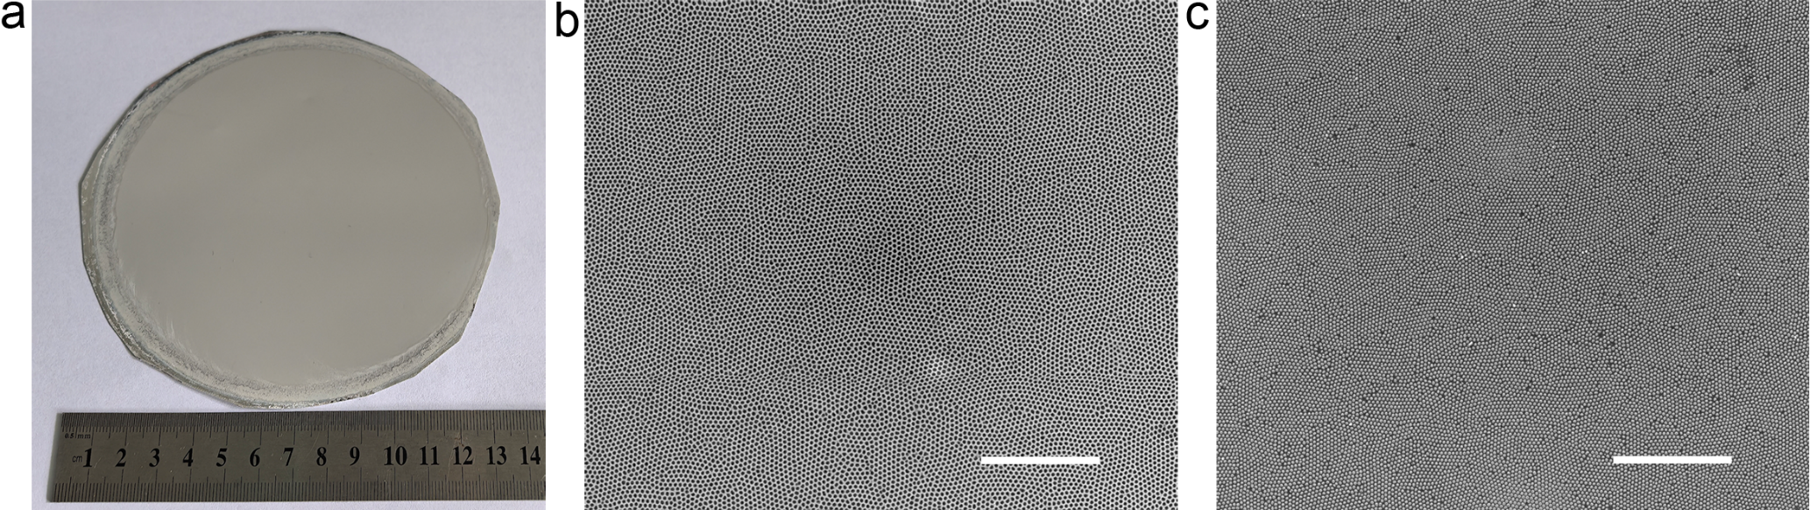
Supplementary Fig. 1. (a) Optical image of the as-prepared anodic aluminum oxide (AAO) on aluminum foil. (b-c) Large-area SEM images of the AAO sample (b) and Cu NP arrays fabricated using the AAO nanomask (c). The scale bars are 3 μm.
Centimeter-scale AAO membranes were produced and then peeled off from the aluminum foils by chemical etching. The membranes were cut into 1 cm × 1 cm pieces for use in all experiments. The large-area SEM image confirms the high reproducibility and uniformity of the Cu NP arrays. Additional technical details can be found in our previous publications^{1–3}.

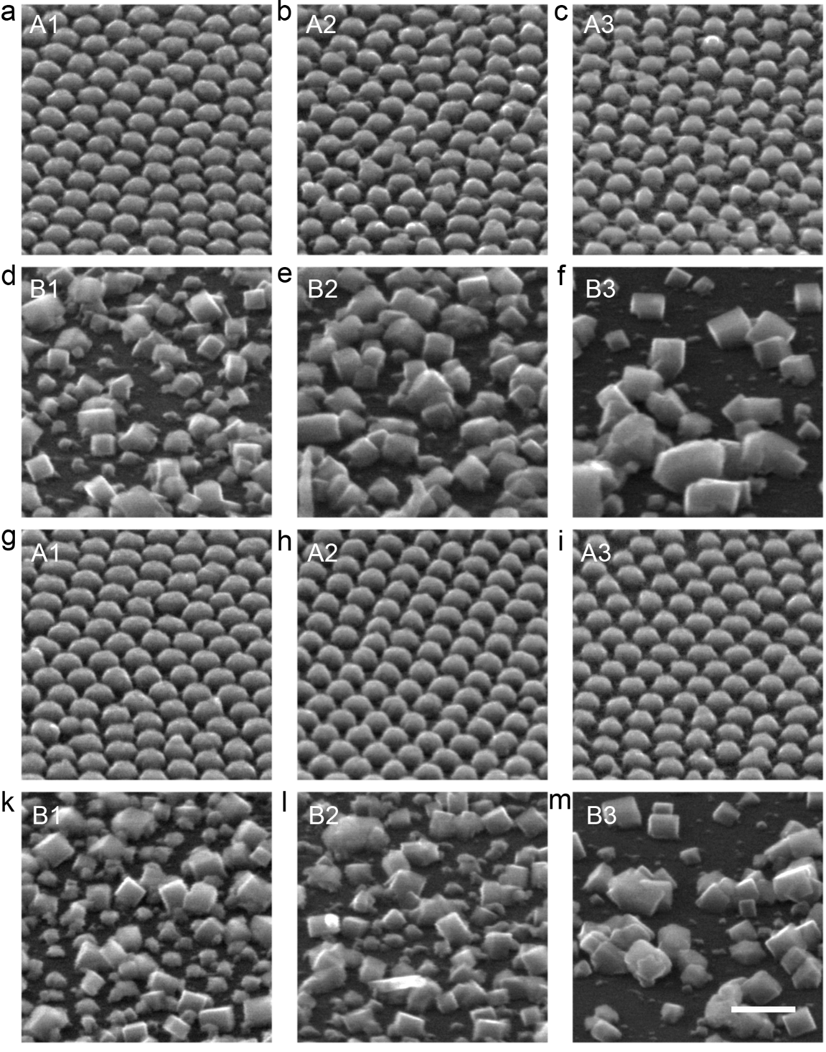
Supplementary Fig. 2. Side-view SEM images of Cu NPs after CO₂RR at different potentials. (a-f) Morphological evolution at -0.5 V, corresponding to Stage A (a-c, 5, 10 and 30 min) and Stage B (d-f, 10, 30 and 180 min). (g-m) Morphological evolution at -0.9 V under the same conditions. The experiments were independently repeated at least three times. Scale bars: 200 nm.
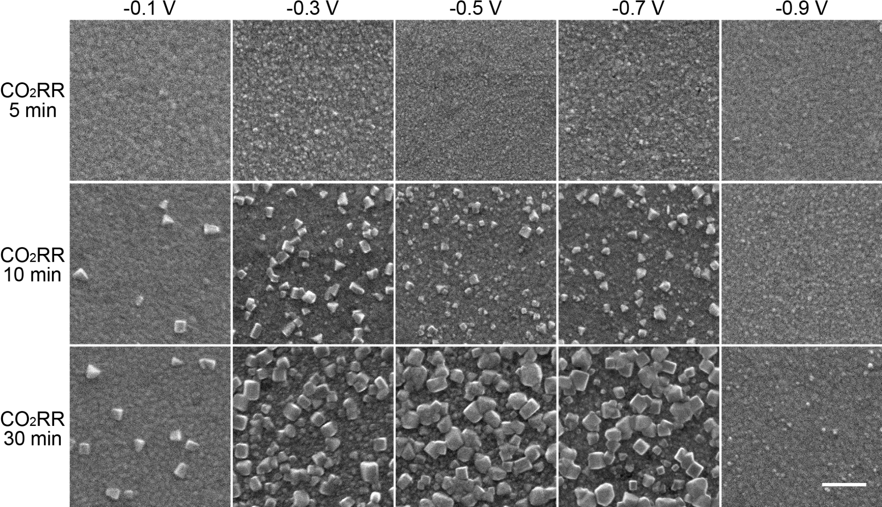
Supplementary Fig. 3. Morphological evolution of evaporated Cu film samples under CO₂RR conditions (Stage A). SEM images of Cu film samples recorded at different applied potentials (-0.1, -0.3, -0.5, -0.7, and -0.9 V) for reaction times of 5, 10, and 30 min. The Cu films were fabricated on silicon wafer substrates by E-beam evaporation using the same protocol as for the Cu NPs arrays. All samples were characterized immediately after electrolysis. The scale bar is 200 nm. The experiments were independently repeated at least three times.
To examine the generality of the reconstruction behavior, we extended our study to planar Cu films. The results exhibit a clear potential-dependent reconstruction, consistent with the findings observed with the Cu NP arrays. The resulting cubic structures were larger than those in the Cu NP arrays, likely due to increased reservoir of Cu atoms. We also performed similar experiments Cu films on carbon paper, which gave similar results and are therefore not shown here.
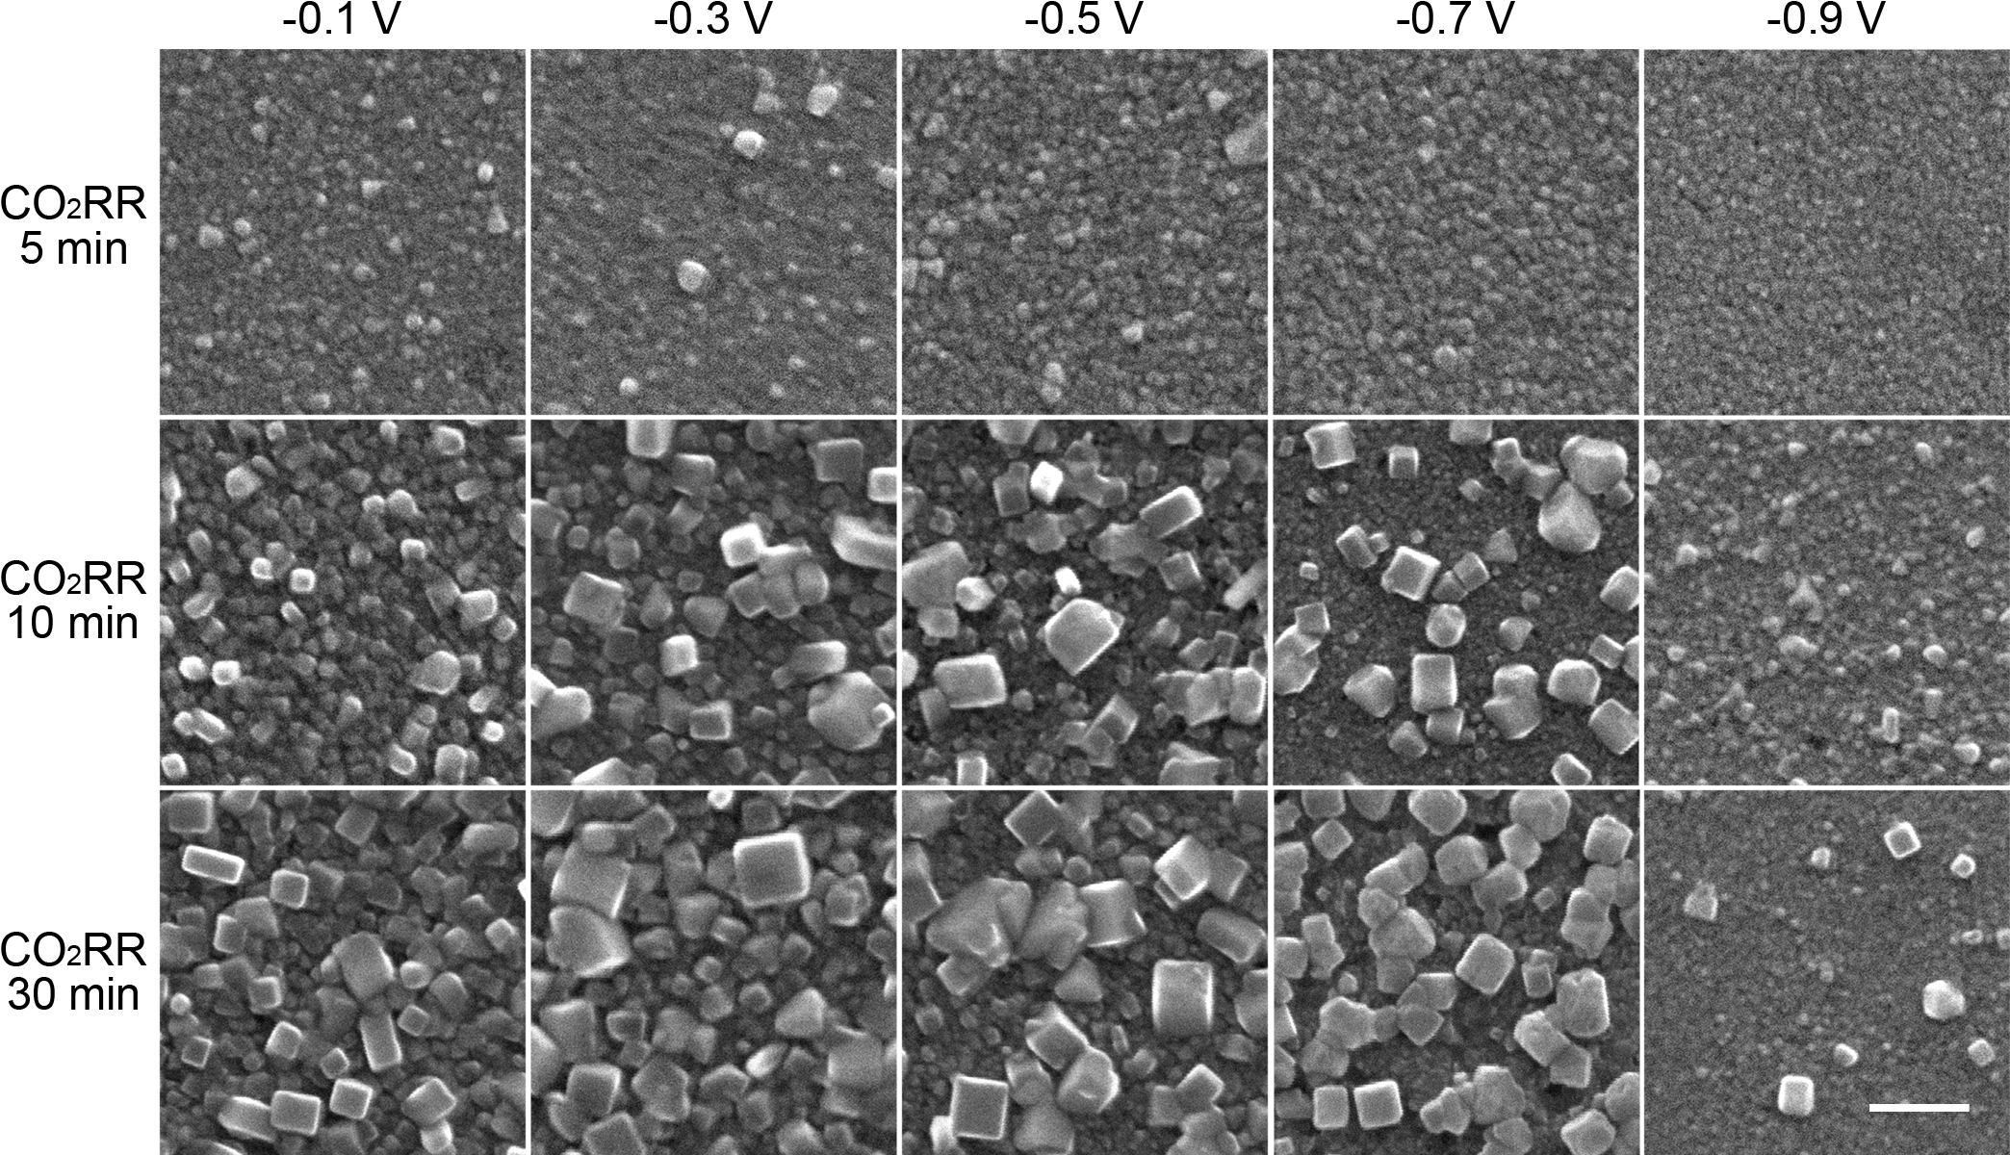
Supplementary Fig. 4. Morphological evolution of the evaporated Cu films during the OCP stage (Stage B). SEM images of the Cu film samples shown in Supplementary Fig. 3, each subjected to an additional fixed 30 min OCP treatment. The scale bar is 200 nm. The experiments were independently repeated at least three times.
The Cu film samples in Supplementary Fig. 3 were immersed in their corresponding electrolyte for OCP treatment, with the duration fixed at 30 min for all the samples. The results reveal that cubic structures grew in the electrolyte during the OCP stage. For samples subjected to 5 min of CO₂RR, the reconstruction during OCP was minimal. In contrast, samples that had undergone longer CO₂RR durations exhibited more pronounced reconstruction, even though the OCP duration was identical. This trend was generally consistent across different applied potentials, suggesting that the extent of prior CO₂RR treatment is important in initiating the reconstruction during the OCP stage.

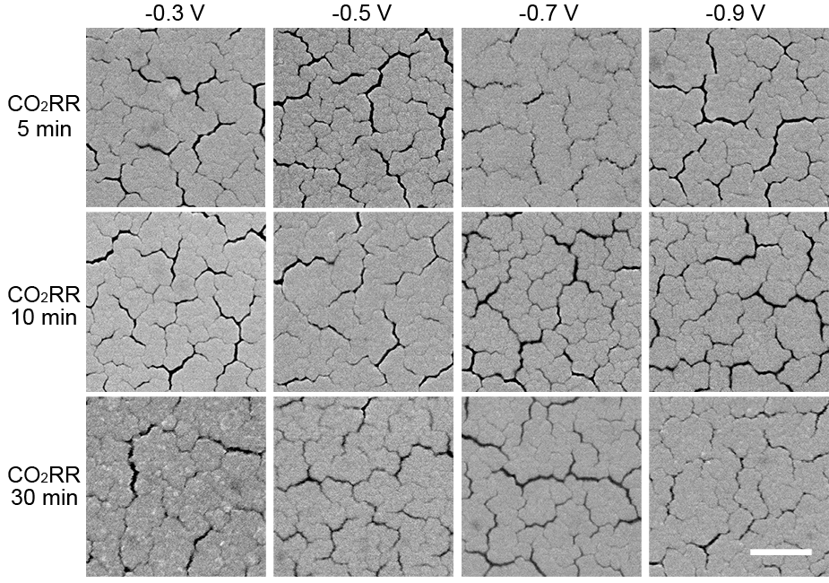
Supplementary Fig. 5. Morphological evolution of sputtered Cu films under CO₂RR conditions (Stage A). SEM images of sputtered Cu films recorded at different applied potentials (-0.3, -0.5, -0.7, and -0.9 V) for reaction times of 5, 10, and 30 min. All samples were characterized immediately after electrolysis. The scale bar is 500 nm. The experiments were independently repeated at least three times.
We further extended our study to sputtered Cu films. In contrast to evaporated films, structural changes during Stage A were less pronounced. This is likely due to the dense and compact microstructure of sputtered films, which reduces the number of grain boundaries and surface defect sites available for dissolution.
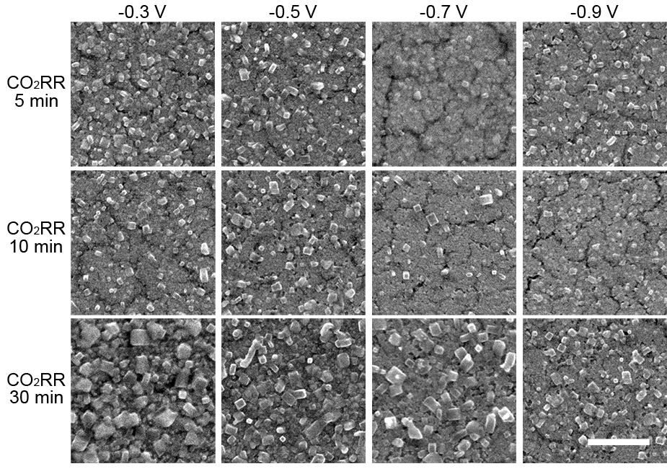
Supplementary Fig. 6. Morphological evolution of sputtered Cu films during the OCP stage. SEM images of the sputtered Cu film samples shown in Supplementary Fig. 5, each subjected to an additional fixed 30 min OCP treatment. The scale bar is 500 nm. The experiments were independently repeated at least three times.
From the SEM results in Supplementary Fig. 5 and 6, we found that though reconstruction during Stage A was minimal for the sputtered Cu films, it was still pronounced during the subsequent OCP stage. This implies that the initial nanostructures like cubes formed during CO₂RR are not the dominant factor initiating post-reaction growth. Taken together with the results in Supplementary Fig. 2-6, we deduce that sufficient CO₂RR pretreatment is essential to generate the conditions that facilitate cubic growth during OCP, whereas the value of applied potential appears to have only a minor influence. It should also be noted that the cube-like structures formed during CO₂RR in Stage A are metallic, whereas those formed during OCP are composed of Cu₂O, and the connection between these two types of structures remains unclear.

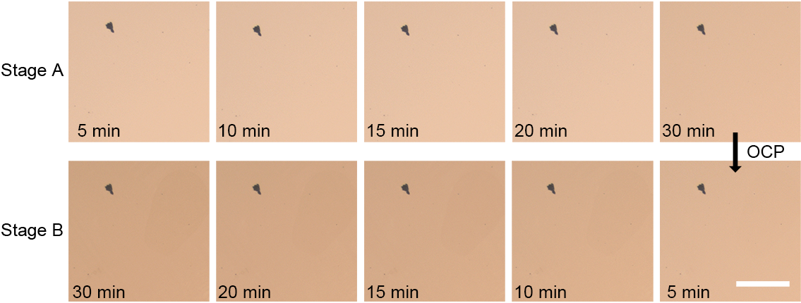
Supplementary Fig. 7. Optical images of a Cu film undergoing CO₂RR at -0.5 V for 30 min (Stage A), followed by 30 min OCP (Stage B). The scale bar is 100 μm.
During the experiments, we found that, for initially smooth metallic surfaces such as evaporated Cu films, the sample color correlates closely with the extent of reconstruction, providing a convenient visual indicator for cube growth without the need for SEM characterization. The gradual darkening is consistent with particle growth, likely arising from increased surface roughness that suppresses specular reflection and enhances scattering.

Supplementary Fig. 8. TEM characterization of the cubes formed during OCP (Stage B). (a) TEM image of a cube formed at OCP for 30 min, following prior CO₂RR exposure at -0.5 V for 30 min. (b, c) Corresponding elemental maps of Cu and O. (d-f) High-resolution TEM (HRTEM) images highlighting the lattice features of the Cu₂O phase.
The results suggest that the cubic structures observed in Stage B are predominantly composed of Cu₂O.

Supplementary Fig. 9. TEM characterization of cubes formed at OCP. (a) TEM image of the Cu₂O cube formed at OCP for 5 hours. (b) Selected-area electron diffraction (SAED) of the Cu₂O sample. (c-d) Morphology and elemental mapping of the cube. The sample underwent prior CO₂RR treatment at -0.5 V for 30 min before the OCP stage.
The results suggest that the cubic structures observed in Stage B are composed of single crystal Cu₂O.

Supplementary Fig. 10. SEM images of the evaporated Cu films stored under different conditions without prior CO₂RR exposure. (a) Pristine Cu film sample after evaporation. (b) After storage in ambient air for 1 month. (c) After storage in ambient air for 3 months. (d) After immersion in deionized water for 9 h. (e) After immersion in Ar-saturated 0.1 M KHCO₃ electrolyte for 9 h. (f) After immersion in CO₂-saturated 0.1 M KHCO₃ electrolyte for 9 h. The scale bars are 200 nm.
These control experiments reveal that oxidative reconstruction into cubic oxides proceeds very slowly without prior CO₂RR treatment, confirming that CO₂RR pretreatment significantly accelerates the transformation into Cu₂O cubes.

Supplementary Fig. 11. TEM characterization of the Cu NPs after CO₂RR at -0.5 V for 30 minutes. (a, b) HAADF-STEM image of the Cu NPs, and (c, d) corresponding elemental mappings. The samples were briefly exposed to the ambient air during transfer before TEM measurement.
The results reveal that highly defective and disordered Cu surfaces were formed during CO₂RR. These surfaces may potentially provide active sites to facilitate the formation of cubes during OCP. Elemental mapping shows that oxygen was enriched at the particle periphery but relatively depleted at the core, indicating the presence of a surface oxide shell rather than bulk oxidation of the entire particle. We surmise that CO₂RR may have generated new surface sites such as defect-rich domains or intermediate-modified terraces, which facilitate the formation of Cu₂O cubes.
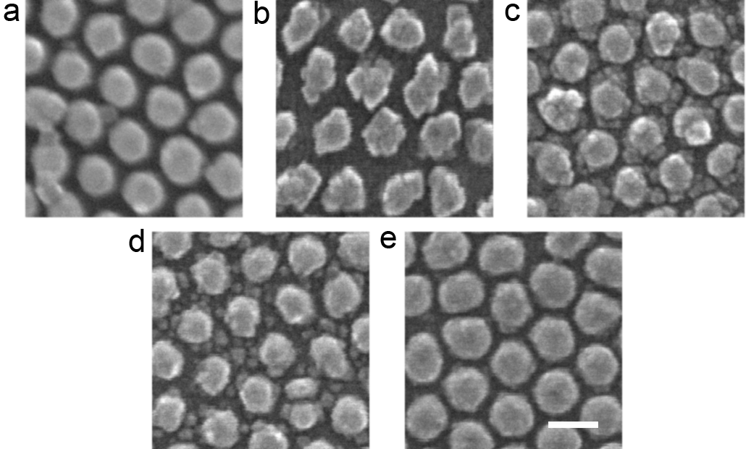
Supplementary Fig. 12. Morphological evolution of the Cu NP arrays after 60 min of CO₂RR at applied potentials of (a) -0.1 V, (b) -0.3 V, (c) -0.5 V, (d) -0.7 V, and (e) -0.9 V, followed by one month of storage under ambient conditions. The scale bar is 100 nm.
Compared with Figure 2a (A3) and Supplementary Fig. 2-6, the surface morphology exhibited limited changes after one month of air exposure, despite prior CO₂RR pretreatment. These results suggest that the electrolyte environment is essential for the formation of Cu₂O cubes, while the involvement of O₂ is not crucial. From our experience, oxidation-driven cube formation may also occur when samples are exposed to humid air with abundant Cu sources, but this process is mechanistically distinct from the redeposition observed at OCP in this work.

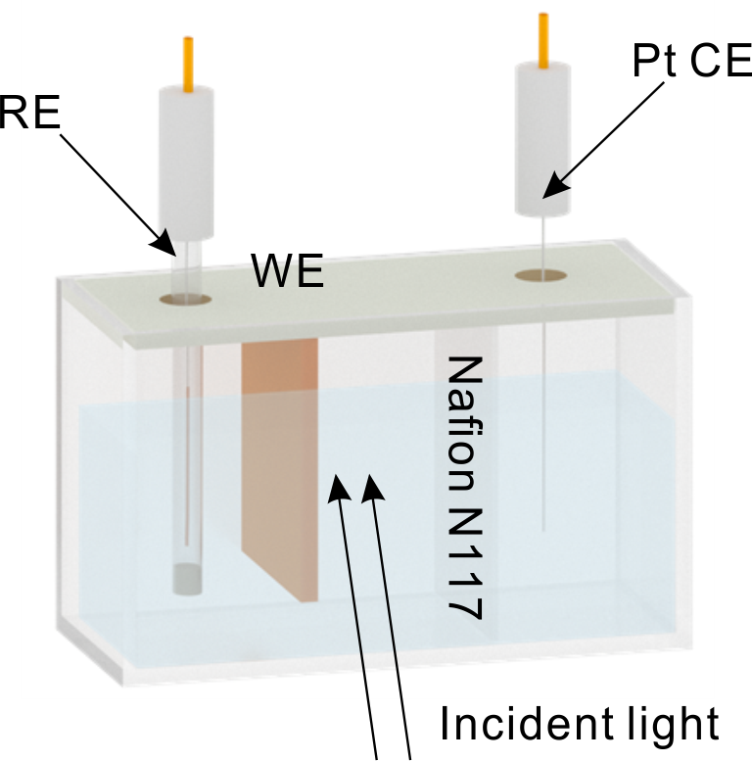
Supplementary Fig. 13. Schematic diagram of the custom-designed electrochemical cell for in situ UV-Vis spectroscopy measurements.
The cell consists of a transparent quartz window, a working electrode (WE) deposited onto a conductive substrate and positioned in close contact with the quartz window, a platinum wire counter electrode (CE), and an Ag/AgCl (3 M KCl) reference electrode (RE). A cation exchange membrane (Nafion N117) was used to separate the catholyte from the working electrode. Incident light passes perpendicularly through the quartz window and electrolyte, enabling in situ tracking of optical changes of the electrolyte.

Supplementary Fig. 14. (a-e) In situ UV-Vis absorption spectra collected during CO₂RR for the electrolyte containing 0.1 mM dmphen at -0.1 V (a), -0.3 V (b), -0.5 V (c), -0.7 V (d), and -0.9 V (e). The experiments were independently repeated at least three times.
2,9-dimethyl-1,10-phenanthroline (dmphen) was introduced as a selective chelating agent, which can form a stable and soluble complex with Cu⁺ (a), giving rise to a characteristic absorption band at ~455 nm.

Supplementary Fig. 15. Morphological evolution of the Cu NPs during CO₂RR in the presence of 0.1 mM dmphen at -0.5 V in Stage A. (a) Pristine Cu NPs, (b) after 5 min of reaction, and (c) after 60 min of reaction. The experiments were independently repeated at least three times.
In the presence of dmphen, the shrinkage of parent particles persisted, but the formation of secondary nanoparticles was completely suppressed. This suppression arises because dmphen selectively complexes with dissolved Cu⁺, preventing its redeposition. As a result, reconstruction under these conditions was limited to shrinkage of the parent particles, without the emergence of new secondary particles. These results confirm that the secondary nanoparticles observed in Stage A originated predominantly from a Cu⁺-mediated dissolution-redeposition pathway.

Supplementary Fig. 16. TEM image of the electrolyte after CO₂RR reaction at -0.9 V for 30 min, and corresponding elemental mapping.
The results reveal the presence of Cu clusters. We propose that under strongly reducing conditions, atomic Cu⁰ species are released, migrating and reorganizing into these clusters, which were responsible for the UV-Vis absorption band observed in the sub-400 nm region.

Supplementary Fig. 17. (a-e) Time-dependent UV-Vis spectra of the electrolyte in the absence of dmphen, recorded during CO₂RR at different applied potentials. (a) -0.1 V, (b) -0.3 V, (c) -0.5 V, (d) -0.7 V, and (e) -0.9 V. The experiments were independently repeated at least three times.
The spectra exhibit a characteristic absorption band in the sub-400 nm region, even without dmphen. The band intensity increased progressively with more negative applied potentials. These results confirm that the release of Cu⁰ species represents an intrinsic dissolution pathway under CO₂RR conditions.
Supplementary Fig. 18. Quantification of Cu content in 0.1 M KHCO₃ electrolyte after CO₂RR for 30 min under different applied potentials, as measured by ICP-MS. The results reflect the extent of Cu dissolution at each potential.

Supplementary Fig. 19. Time-dependent UV-Vis spectra of the electrolyte containing 0.1 mM dmphen at OCP, using (a) a pristine Cu NP sample without CO₂RR pretreatment, and for samples subjected to CO₂RR pretreatment at -0.1 V (b), -0.3 V (c), -0.5 V (d), -0.7 V (e), and -0.9 V (f) for 60 min. The experiments were independently repeated at least three times.
Supplementary Fig. 20. Calculated EM field distribution around the Cu NPs with varying dimensions by finite element method (FEM). (a, b) diameter 80 nm, height 65 nm (a, front view; b, top view), (c, d) diameter 70 nm, height 60 nm (c, front view; d, top view), (e, f) diameter 60 nm, height 55 nm (e, front view; f, top view) and (g, h) diameter 50 nm, height 50 nm (g, front view; h, top view).
Surface-enhanced Raman scattering (SERS) is a molecular sensing technique featuring molecular specificity and ultrahigh sensitivity. Its remarkable sensitivity arises from the localized surface plasmon resonance (LSPR), which can generate intense electromagnetic fields (so-called “hotspots”) upon laser excitation. Molecules located within these hotspots experience dramatic amplification of their inherently weak Raman scattering, enabling the detection of trace molecules down to the single-molecule level.
The electromagnetic enhancement in SERS can be attributed to two distinct mechanisms: (i) local field enhancement at the excitation frequency, which amplifies the incident electromagnetic field, and (ii) scattered field enhancement at the Raman frequency, which boosts the re-radiation of scattered photons. Consequently, the overall electromagnetic enhancement factor $G$ of SERS can be expressed as:
$$G=\frac{{\left|E_{L}\left(ω_{0}\right)\right|}^{2}}{{\left|E_{0}\left(ω_{0}\right)\right|}^{2}}\frac{{\left|E_{L}\left(ω_{R}\right)\right|}^{2}}{{\left|E_{0}\left(ω_{R}\right)\right|}^{2}}≈\frac{{\left|E_{L}\left(ω_{0}\right)\right|}^{4}}{{\left|E_{0}\left(ω_{0}\right)\right|}^{4}}$$
where $ω_{0}$ and $ω_{R}$ are the frequencies of the excitation and scattered light, respectively; $E_{0}$ represents the amplitude of the incident electric field, and $E_{L}$ corresponds to the locally enhanced field. Since the Raman shift $\left|{ω_{R}-ω}_{0}\right|$ is typically small, the two enhancement terms at $ω_{0}$ and $ω_{R}$ are approximately equal, leading to the widely adopted $E^{4}$ approximation for the SERS enhancement factor.
The near-field electromagnetic field decays rapidly with distance, approximately following $E∝1/d^{3}$. Consequently, only molecules within a few nanometers of the metallic surface experience substantial enhancement. Even a slight increase in distance (e.g., 1-2 nm) can lead to a drop in SERS intensity by several orders of magnitude. This strong distance dependence enables SERS to probe molecular signals at interfaces while effectively suppressing interferences from the bulk phase, making it a highly suitable technique for interfacial science studies in CO₂RR.

Supplementary Fig. 21. (a) Extinction spectra of the Cu NP arrays on quartz with varying diameters, and (b) corresponding FEM simulation spectra.
The LSPR modes are highly dependent on the size, shape, and spatial arrangement of the nanostructures. When the LSPR wavelength matches the excitation laser, the electromagnetic enhancement reaches its maximum. In general, the LSPR peak red-shifts as the particle size increases, allowing tuning of the LSPR response by adjusting the diameter of the Cu NPs. In this study, the diameter of the Cu NPs was precisely controlled by modulating the pore size of the AAO membrane. As shown in (a), the LSPR response of the Cu NPs was characterized using UV-Vis spectroscopy. Accordingly, the diameter of the Cu NPs was set to 80 nm to achieve effective coupling with the 633 nm excitation laser, thereby optimizing LSPRs efficiency. This coupling enhances the SERS performance, enabling the detection of trace intermediates during CO₂RR. It should be noted that the substrate was changed from quartz to wafer for CO₂RR studies, which increases the dielectric constant of the environment and causes the actual LSPR response to further red-shift.
In this study, the shrinkage of the Cu NPs during CO₂RR induces a blueshift in the LSPRs response, leading to a decoupling. As a result, the signal-to-noise ratio generally exhibits a gradual decrease over reaction time. Therefore, direct comparison of SERS intensities across samples, especially those subjected to CO₂RR for long durations, is not appropriate for quantifying intermediate concentrations. Notably, the actual system is more complex due to the growth of secondary particles. These newly formed structures can produce additional plasmonic coupling with the original Cu NPs, leading to extra SERS enhancement. For instance, while a planar Cu film yields no detectable SERS signal, the restructured surface offers measurable enhancement. Nevertheless, for Cu NPs undergoing CO₂RR, the overall signal-to-noise continues to decrease monotonically despite such secondary contributions.
Supplementary Fig. 22. Model structures of (a) Cu(111), (b) Cu(100), and (c) Cu(110).

Supplementary Fig. 23. Top views of adsorption structures on Cu(111), Cu(100), and Cu(110) with different *CO coverage.
Supplementary Fig. 24. Bader charge analysis of the average electron transfer per surface Cu atom to adsorbed *CO at different *CO coverages on (a) Cu(111), (b) Cu(100), and (c) Cu(110) surfaces.
Bader charge analysis was performed to quantify the charge transfer from surface Cu atoms to adsorbed *CO molecules. This enhanced electron donation from Cu atoms into the π antibonding orbitals of *CO weakens the local Cu-Cu metallic bonds, thereby facilitating the dissolution and structural reconstruction.
Supplementary Fig. 25. (a) CV curves of the Cu NPs during CO₂RR at -0.5 V for different reaction times, showing distinct OH⁻ adsorption peaks assigned to Cu(100), Cu(110), and Cu(111) facets at ~0.34 V, ~0.40 V, and ~0.46 V, respectively. (b) Deconvoluted OH⁻ adsorption peaks from (a). The data were obtained over multiple cycles.

Supplementary Fig. 26. (a) Fitted OH⁻ adsorption peaks of Cu NPs during CO₂RR at -0.9 V and (b) corresponding ratios of Cu(111), Cu(110), Cu(100) facets quantified by the charges associated with OH⁻ electroadsorption. (c) Fitted OH⁻ adsorption peaks of Cu NPs in Ar-saturated electrolyte at -0.5 V, and (d) corresponding facet ratios. The data were obtained over multiple cycles.
Supplementary Fig. 27. Morphological evolution of the Cu NP arrays after 30 min of CO₂RR with 0.1 mM 18-C-6 at applied potentials of (a) -0.1 V, (b) -0.3 V, (c) -0.5 V, (d) -0.7 V, and (e) -0.9 V. The scale bars are 200 nm.
The results suggest that the introduction of 18-C-6 suppressed the redeposition process.

Table S1: Raman bands and their respective assignments.
Raman Band (cm⁻¹) | 280^{4,5} | 360^{4,5} | 1016^{6,7} | 1068^{6,7} | 1386^{8,9} | 1440^{8,9} | ~2000^{10–13}
Assignment | δ(C-O) of *CO | v(Cu-CO) of *CO | HCO₃⁻ | CO₃²⁻ | v(C-O) of *COOH | v(O-CH-O) of *OCHO | v(C=O) of *CO
[a] δ: deformation, [b] v: stretching, [c] v_{as}: antisymmetrical stretching

Table S2: Adsorption energies of intermediates (*COO, *OCHO, *COOH, *OH, and *CO) in CO₂RR on Cu(111), Cu(100), Cu(110). All energies are in eV.

References
1. Yao, L. et al. Flexible plasmonic nanocavities: a universal platform for the identification of molecular orientations. Nanoscale 15, 6588–6595 (2023).
2. Wei, Y. et al. Probing Oxidation Mechanisms in Plasmonic Catalysis: Unraveling the Role of Reactive Oxygen Species. Nano Lett. 24, 2110–2117 (2024).
3. Wei, Y. et al. Tuning the Fermi Level of Silver Nanoparticles by Thiocyanate Ions for Plasmonic Catalysis. Nano Lett. 25, 13023–13030 (2025).
4. Zhan, C. et al. Revealing the CO Coverage-Driven C–C Coupling Mechanism for Electrochemical CO₂ Reduction on Cu₂ O Nanocubes via Operando Raman Spectroscopy. ACS Catal. 11, 7694–7701 (2021).
5. Herzog, A. et al. Operando Investigation of Ag‐Decorated Cu₂O Nanocube Catalysts with Enhanced CO₂ Electroreduction toward Liquid Products. Angew. Chem. Int. Ed. 60, 7426–7435 (2021).
6. Chernyshova, I. V., Somasundaran, P. & Ponnurangam, S. On the origin of the elusive first intermediate of CO₂ electroreduction. Proc. Natl. Acad. Sci. 115, (2018).
7. Zheng, M. et al. Electrocatalytic CO₂-to-C₂₊ with Ampere-Level Current on Heteroatom-Engineered Copper via Tuning *CO Intermediate Coverage. J. Am. Chem. Soc. 144, 14936–14944 (2022).
8. Shan, W. et al. In Situ Surface-Enhanced Raman Spectroscopic Evidence on the Origin of Selectivity in CO₂ Electrocatalytic Reduction. ACS Nano 14, 11363–11372 (2020).
9. Zhan, C. et al. Key intermediates and Cu active sites for CO₂ electroreduction to ethylene and ethanol. Nat. Energy 9, 1485–1496 (2024).
10. Ren, W., Xu, A., Chan, K. & Hu, X. A Cation Concentration Gradient Approach to Tune the Selectivity and Activity of CO₂ Electroreduction. Angew. Chem. Int. Ed. 61, e202214173 (2022).
11. Li, F.-Z. et al. Another role of CO-formation catalyst in acidic tandem CO₂ electroreduction: Local pH modulator. Joule 8, 1772–1789 (2024).
12. An, H. et al. Sub‐Second Time‐Resolved Surface‐Enhanced Raman Spectroscopy Reveals Dynamic CO Intermediates during Electrochemical CO₂ Reduction on Copper. Angewandte Chemie 133, 16712–16720 (2021).
13. Gunathunge, C. M., Li, J., Li, X., Hong, J. J. & Waegele, M. M. Revealing the Predominant Surface Facets of Rough Cu Electrodes under Electrochemical Conditions. ACS Catal. 10, 6908–6923 (2020).

