Study sites

Jankovich Cave (Bajót, Gerecse Mts., North Hungary)

Jankovich Cave is situated near Bajót (North Hungary), 330 m a.s.l. within the Upper Triassic Dachsteinian Limestone of the eastern slope of Öreg-kő Hill. It consists of a 27 m long north-south oriented outer section, a 15 m long northwest-southeast oriented inner corridor, and a dome (Fig. 1.). An almost 8 m wide chimney opens up to the top of the hill near the entrance.
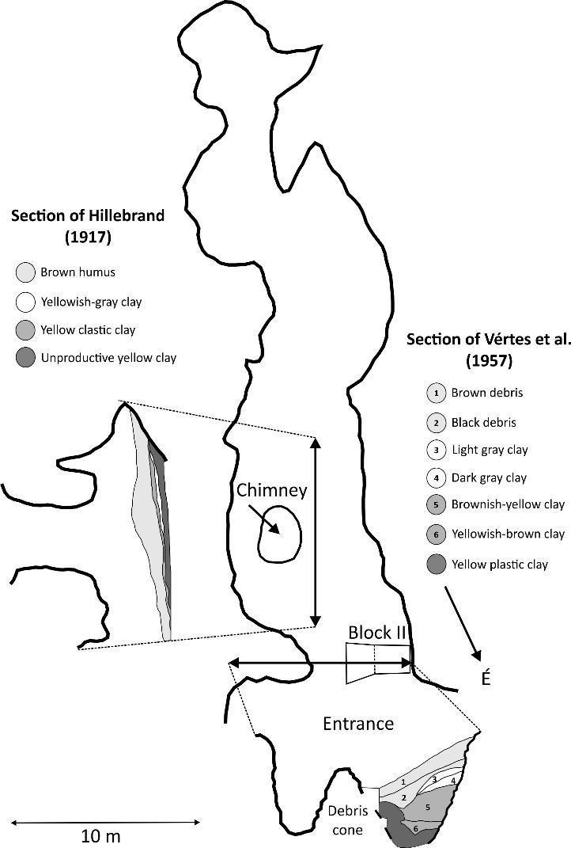
Several trenches (also called “blocks”) were excavated within the cave¹. According to Hillebrand², the stratigraphic section at the entrance consists of: a sterile yellow clay at the bottom, a yellow clastic clay with plentiful reindeer (Rangifer tarandus) bones and microfauna, a sterile yellowish-grey clay, and a brown humus on the top with Bronze Age ceramics. A red clastic clay layer was also found in the inner part of the cave intercalated between the sterile yellow clay at the bottom and the bone-rich yellow clastic clay. It lacks microfauna, but contains plentiful cave bear (Ursus spelaeus) bones fragments.
The main portion of the material we studied (212 specimens) was excavated by J. Hillebrand between 1913 and 1925, and later studied by Lambrecht and Kordos³. The bone-rich sediment was probably located in the middle and inner parts of the cave. An excavation carried out by D. Jánossy and S. Bököny in 1956 opened six “blocks” (ie. trenches), of which block II yielded a considerable faunal assemblage. A total of 47 specimens of trench 2 of 1956 also were involved in this article. All specimens from the site are stored at the Palaeontological Collections of the Mining and Geological Survey of Hungary.
Pollen analysis of the sediments was also done by Mihálz-Faragó¹. The quantity of the recovered pollen was poor, and contained only a few Pinus, Tilia, Betula, Salix, Alnus and Poaceae grains unsuitable for quantitative analysis.
Hollendonner studied the charcoals and reported the presence of elm (Ulmus), ash (Fraxinus) and oak in the "lower" layer group, and oak (Quercus) and pine (Pinus) in the "middle” layer group. The age and exact location of the charcoals in the sediment is unknown.

Figure 1. Layout (A) and schematic sections (B and C) of the Jankovich Cave (modified after Hillebrand² and Vértes et al.⁴
Rejtek I. Rock Shelter

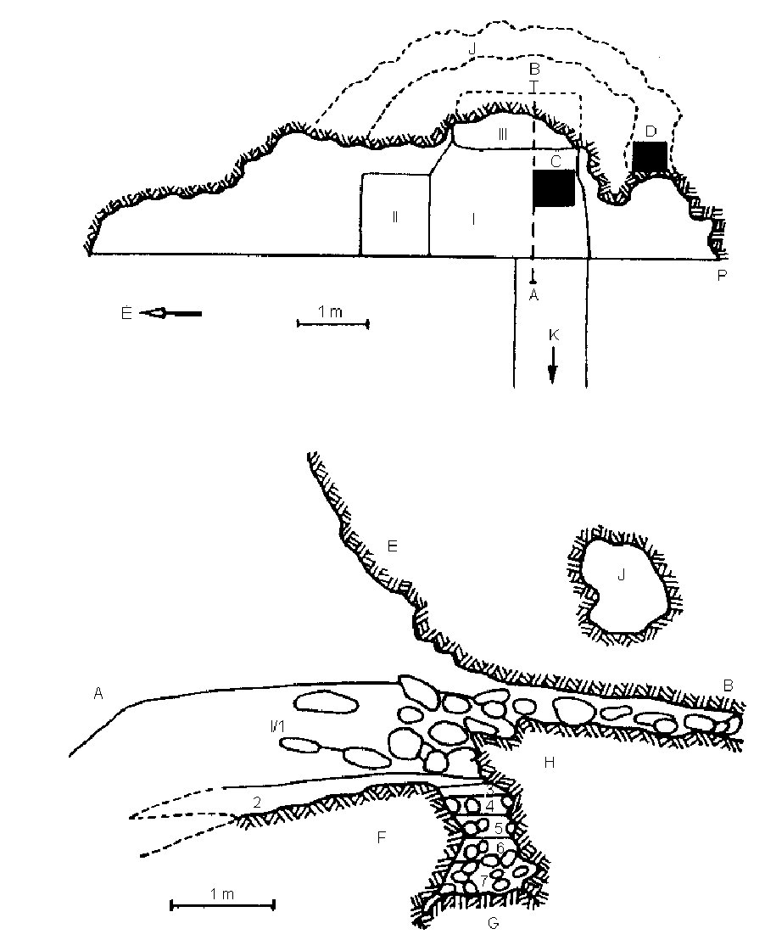
Rejtek I. Rock Shelter is situated in the central Bükk Mountains, east of the village Répáshuta in a valley. The rock shelter opens at the eastern slope of the valley ⁵. At the north-western end of the Szarvaskő Hill a 10-15 metres high rock mass can be found under which there are several rock shelters and clefts. One of them is the Rejtek I. Rock Shelter (Figure 2). It is formed in the well-stratified Middle Triassic Répáshuta Limestone. Its entrance facing west lies 8-10 metres above the valley-bottom. Its width is 9 metres in N—S direction, its ceiling height 1.60 m, and the cavity penetrates 2.50 metres into the parent rock. Behind the rock shelter there is a semi-circular lateral branch that has two entrances (Fig.2). Jánossy and Kordos ⁵ gives a detailed description of the excavation trenches (I-II-III) and also describes the harmonization and renumbering of sediment layers obtained from different sediment trenches. The site was first excavated in 1957 followed by a second field campaign in 1958 ⁶. An exceptional value of the site is the availability of a detailed investigation on the charcoal remains by Stieber⁷ and its mollusc fauna analyses by Krolopp ⁵ and Sümegi et al.⁸. Earlier studies furthermore emphasized that the sequence of layers in this rock shelter offers a great possibility to study the Pleistocene-Holocene transition of the vole fauna. The re-analysis of the mollusc fauna, including radiocarbon dating, and the charcoal material ⁸ suggested that sediment accumulation was nearly continuous from 13,000 ¹⁴C BP, with a break in the Younger Dryas until the Sub-Boreal. Our results suggest that the bone assemblages are mixed in the Holocene layers, therefore we did not interpret faunistic changes in these sediment layers. During the Younger Dryas we did not find hiatus in the sediment, our age-depth model is continuous and several bones were dated to this period. The study of the archaeological finds identified a few undiagnostic artefacts from the Pleistocene layers and a Mesolithic trapeze from the Early Holocene ⁹. July mean temperatures were also estimated by the vole thermometer method and using our new age-depth model derived cal BP year intervals, the results are:
200-220 cm = 13085-14157 cal yr BP = 17.2 °C
180-200 cm = 12347-13085 cal yr BP = 18.3 °C
160-180 cm = 11549-122347 cal yr BP = 17.3 °C
140-160 cm = 10851-11549 cal yr BP = 18.3 °C
There is no reconstruction above 140 cm in Block III ⁵. Overall the vole thermometer suggests about 1 °C fluctuation in July mean temperatures over the late glacial period, and generally 2-3 °C lower warmest month mean temperatures than today (between 17.2-18.3 °C)

Figure 2. Sketch map of the Rejtek I. Rock Shelter and longitudinal section of the excavation (A-B) with the excavation blocks ¹⁰. I-III: excavation blocks; 1-7: vertical layers; C&D: test holes in 1957-1958; E: rock wall; F& G: rock bottom and blocks of stones; H: rear rock wall and stone block; J: lateral branch; P: starting point of measurement.

Pollen sequences

In this study we used earlier published pollen records covering the Last Glacial Termination (20-9 ka cal BP) in the Carpathian Basin. Taŭl dintre Brazi (Lake Brazi) is an alpine lake that was formed in a glacial basin around 15,700 years ago in the Retezat Mts (South Carpathians, Romania)^{11,12}. The small lake (~0.5 ha; 1740 m a.s.l.; max. 1.1 m water depth) is surrounded by Norway spruce (Picea abies) and Arolla pine (Pinus cembra) forest today with Dwarf pine (P. mugo) thickets growing on the eastern lakeshore and floating moss carpet. Its significance lies in the extreme high resolution pollen analysis and dating of this locality. Its age-depth model is based on 22 ¹⁴C AMS dates and the Late Glacial part of the pollen record was studied in each cm for pollen resulting in a time resolution 20-100 yr per sample depending on the sediment accumulation rate. Apart from pollen, plant macrofossils, diatoms, Cladoceran shells and chironomids were also studied in its deposit together with a detailed geochemical study ^{13–18}. A chironomid-based temperature reconstruction is also available from this record ¹⁴. Lake St Anne (950 m a.s.l.) is set in the continental Eastern Carpathians in a nemoreal beech forest. It’s a cold microclimate volcanic crater lake today, formed by one of the latest eruption of Ciomadul volcano about 27,200 cal BP ¹⁹. The size of the lake is ~189,900 m2; maximum water depth is ~6 m, mean depth is ~3.1 m, mean width is ~310 m. Its pollen sequence is continuous since 26,500 cal BP with the last glacial termination part published by Magyari et al.^{20,21}. The area supported regionally diverse warm micro and meso-habitats during the Last Glacial maximum. Nagymohos Peat Bog (300 m a.s.l.; 3.2 ha) is situated in the foothill zone of the Northern Carpathians. Today nemoreal oak (Quercetum petraeae-cerris) and oak-hornbeam (Querco petraea-Carpinetum) forests cover the slopes around the peat bog that is dominated by Eriophoro vaginato-Sphagnetum vegetation and downy birch (Betula pubescens). The pollen record extends back to c. 27,000 cal yr BP and about 1.1 m thick peat accumulated in this basin between 14.7-26.95 ka cal BP ^{21–23}. The plant macrofossil record from this site demonstrates that during the LGM and last glacial termination forest tundra vegetation was present locally with arolla pine (P. cembra) tree stands growing on the mire surface in the lower part of the profile. Kokad mire (112m a.s.l.) is located in the Érmellék geographical region of the eastern Great Hungarian Plain. Rich in abandoned paleochannels, this region has been a mire land until the 1960’s when the area was canalised. During the Late Quaternary this region was fed by rivers that drained the Northeast Carpathians and the Apuseni Mountains. Before drainage, sand dune valleys were occupied by shallow eutrophic ponds, sedge and reed dominated mires, swamps and wet meadows in this region. Dune tops originally supported steppe oak forests (Melampyro debreceniensi-Quercetum roboris and Festuco rupicolae-Quercetum roboris) or sand steppes (Festuco vaginatae-Corynephoretum) depending on the ground water level. The 5.5 m long sediment in this mire extends back to c. 20 ka cal BP. Pollen accumulation is continuous in this sequence throughout the Late Pleniglacial and Holocene. Apart from pollen, plant macrofossils were also studied from this profile ^{18,24} and a pollen based July mean temperature reconstruction was also presented that is also used in this study. The most prominent feature of the record was the early post last glacial maximum (LGM) establishment (17,700 cal yr BP) and expansion (14,700 cal yr BP) of elm (Ulmus) and hazel (Corylus) supporting the phylogeographical evidence for extra-Mediterranean refugia in the Pannonian Basin. Magyari et al. (2019) studied several loess and lake archives together with the Kokad pollen sequence and confirmed that in this region of Europe the warming after Heinrich event 1 (around 16,200 cal yr BP) had similar amplitude to the late glacial warming.

Supplementary Table 1 AMS ¹⁴C dates obtained on fossil bones from Rejtek I Rock Shelter and Jankovich Cave and used for age-depth modelling of the sediment accumulation at both sites. Bone samples were taken from the collection of the Hungarian Natural History Museum in case of Rejtek I Rock Shelter; the site was excavated by Dénes Jánossy⁶, its fauna was first published by Jánossy and Kordos⁵, later revised by Jánossy¹⁰. Jankovich Cave was excavated several times ^{2–4}. The material studied in this paper comes from the 1950 excavation led by László Vértes (Block II)¹ and the 1956 excavation led by Dénes Jánossy and László Vértes. All specimens from the site are stored in the Palaeontological Collections of the Mining and Geological Survey of Hungary.

Species | Locality (layer) | C-14 age (BP) | ± | Calendar age 1σ (cal BP) | Calendar age 2σ  (cal BP)
Rejtek I. Rock Shelter
Sus scrofa | Rejtek, Block II, 90-120 cm (8) | 8768 | 50 | 9558-9927 | 9685-9890
Ochotona | Rejtek, Block III, 140-160 cm (9) | 10243 | 65 | 11714-12238 | 11915-12090
Meles meles | Rejtek, Block III, 140-160 cm (9) | 9727 | 50 | 11077-11242 | 11129-11219
Arvicola terrestris | Rejtek, Block III, 140-160 cm (9) | 9594 | 53 | 10746-11155 | 10788-10973
Arvicola terrestris | Rejtek, Block III, 160-180 cm (10) | 10392 | 62 | 12028-12434 | 12146-12397
Cricetus cricetus | Rejtek, Block III, 160-180 cm (10) | 10125 | 60 | 11591-12016 | 11616-11840
Microtus arvalis | Rejtek, Block III, 180-200 cm (11) | 11527 | 71 | 13206-13489 | 13302-13433
Cricetus cricetus | Rejtek, Block III, 180-200 cm (11) | 10342 | 61 | 11952-12420 | 12063-12240
Microtus arvalis | Rejtek, Block III, 220-220 cm (12) | 11792 | 76 | 13466-13757 | 13553-13725
Microtinae | Rejtek, Block III, 220-220 cm (12) | 11676 | 71 | 13349-13643 | 13439-13566
Lasiopodomys (Stenocranius) gregalis | Rejtek, Block III, 220-220 cm (12) | 11496 | 72 | 13181-13472 | 13278-13420
Jankovich Cave
Ochotona sp. | Jankovich Cave, Block II, 110-130 cm (5) | 12867 | 73 | 15216 - 15489 | 15130 - 15638
Rangifer tarandus | Jankovich Cave, Block II, 110-130 cm (5) | 12753 | 77 | 15084 - 15309 | 14885 - 15496
Spermophilus sp. | Jankovich Cave, Block II, 130-160 cm (6) | 13106 | 74 | 15590 - 15872 | 15401 - 15992
Dicrostonyx sp. | Jankovich Cave, Block II, 130-160 cm (6) | 13765 | 95 | 16457 - 16821 | 16314 - 16973
Ochotona sp. | Jankovich Cave, Block II, 150-170 cm (7) | 13535 | 79 | 16165 - 16430 | 16047 - 16588
Ochotona sp. | Jankovich Cave, Block II, 170-200 cm (8) | 13677 | 78 | 16334 - 16630 | 16232 - 16813
Ochotona sp. | Jankovich Cave, Block II, 200-220 cm (9) | 13967 | 85 | 16790 - 17106 | 16594 - 17243
Dicrostonyx sp. | Jankovich Cave, Block II, 220-250 cm (10) | 14454 | 90 | 17483 - 17749 | 17363 - 17897
Ochotona sp. | Jankovich Cave, Block II, 220-250 cm (10) | 14378 | 90 | 17389 - 17658 | 17224 - 17814

Supplementary Table 2 All AMS ¹⁴C dates obtained on bones from Jankovich Cave; dated material was in all case fossil bone. Recommended values for C/N ratios of bulk bone or tooth range from 2.9 to 3. ^{25,26} with collagen yields of 1% or greater ²⁷.

Species | Dated material | Locality (layer) | Collagen (%) | C/N  ratio | C-14 age (BP) | ± | Calendar age 1σ (cal BP) | Calendar age 2σ (cal BP)
Cricetus cricetus | tubular bone (1) | Jankovich Cave, Block II. 0-30 cm (1) | 9.3 | 3.3 | 9502 | 54 | 10679 - 10796 | 10588 - 10632
Ochotona sp. | mandible (1) | Jankovich Cave, Block II. 30-60 cm (2) | 11.0 | 3.4 | 14295 | 93 | 17264 - 17553 | 17109 - 17670
Ochotona sp. | mandible (1) | Jankovich Cave, Block II. 60-90 cm (3) | 7.5 | NA | 9679 | 100 | 10798 - 10851 | 10733 - 11245
Lasiopodomys (Stenocranius) gregalis | mandible (3) | Jankovich Cave, Block II. 90-110 cm (4) | 6.3 | 3.1 | 14372 | 92 | 17378 - 17653 | 17210 - 17808
Ochotona sp. | mandible (2) | Jankovich Cave, Block II. 90-110 cm (4) | 8.1 | 3.3 | 11297 | 65 | 13086 - 13208 | 13059 - 13280
Rangifer tarandus | tubular bone (1) | Jankovich Cave, Block II. 90-110 cm (4) | 3.6 | 3.3 | 16894 | 123 | 20210 - 20537 | 20043 - 20683
cf. Rupicapra rupicapra | bone (1) | Jankovich Cave, Block II. 90-110 cm (4) | 6.8 | 3.2 | 13243 | 76 | 15796 - 16041 | 15680 - 16167
Ochotona sp. | mandible (2) | Jankovich Cave, Block II. 110-130 cm (5) | 6.6 | 3.3 | 12867 | 73 | 15216 - 15489 | 15130 - 15638
Rangifer tarandus | phalange (1) | Jankovich Cave, Block II. 110-130 cm (5) | 3.7 | 3.4 | 12753 | 77 | 15084 - 15309 | 14885 - 15496
Spermophilus sp. | mandible (2) | Jankovich Cave, Block II. 130-160 cm (6) | 5.1 | 3.4 | 13106 | 74 | 15590 - 15872 | 15401 - 15992
Dicrostonyx sp. | mandible (3) | Jankovich Cave, Block II. 130-160 cm (6) | 5.5 | NA | 13765 | 95 | 16457 - 16821 | 16314 - 16973
Ochotona sp. | mandible (3) | Jankovich Cave, Block II. 150-170 cm (7) | 6.8 | 3.3 | 13535 | 79 | 16165 - 16430 | 16047 - 16588
Equus sp. | incisor (1) | Jankovich Cave, Block II. 150-170 cm (7) | 6.8 | 3.3 | 13967 | 89 | 16783 - 17110 | 16585 - 17258
Ochotona sp. | mandible (4) | Jankovich Cave, Block II. 170-200 cm (8) | 6.8 | 3.3 | 13677 | 78 | 16334 - 16630 | 16232 - 16813
Ochotona sp. | mandible (3) | Jankovich Cave, Block II. 200-220 cm (9) | 6.6 | 3.3 | 13967 | 85 | 16790 - 17106 | 16594 - 17243
Dicrostonyx sp. | mandible (4) | Jankovich Cave, Block II. 220-250 cm (10) | 5.9 | 3.4 | 14454 | 90 | 17483 - 17749 | 17363 - 17897
Ochotona sp. | mandible (3) | Jankovich Cave, Block II. 220-250 cm (10) | 7.6 | 3.3 | 14378 | 90 | 17389 - 17658 | 17224 - 17814
Ochotona sp. | mandible (3) | Jankovich Cave, Block II. 250-270 cm (11) | 7.0 | 3.3 | 18544 | 141 | 22261 - 22565 | 22002 - 22741
Ochotona sp. | mandible (5) | Jankovich Cave, Block I. 0-20 cm | 6.5 | 3.3 | 12987 | 72 | 15380 - 15671 | 15270 - 15788
Rangifer tarandus | humerus (1 fragment) | Jankovich Cave, Block I. 20-40 cm | 10.4 | 3.2 | 14613 | 88 | 17672 - 17911 | 17555 - 18014
Ursus spelaeus | incisor (1) | Jankovich Cave, Block IV. 0-0.3 cm (1) | 8.1 | 3.2 | 40000 BP<

Supplementary Table 3 All AMS ¹⁴C dates obtained on bones from Rejtek I Rock Shelter. The dated material was in all cases fossil bone. On the right side of the table AMS ¹⁴C dated fossil mollusc shells are ⁸ shown with the deviation compared to the new radiocarbon dates in the last column. The mollusc shell dates are generally younger than the bones in the Early Holocene layers. In contrast, the mollusc dates in the lowermost layer of Block III are older than the bone dates. Recommended values for C/N ratios of bulk bone or tooth range from 2.9 to 3. ^{25,26} with collagen yields of 1% or greater ²⁷.
 |  |  | this study |  |  |  |  |  | Sümegi et al. (2012)
Species | Locality (layer) |  | Collagen (%) | C/N ratio | C-14 age (BP) | ± | Calendar age 1σ (cal BP) | Calendar age 2σ (cal BP) | C-14 age (BP) | ± | deviation
Sus scrofa | Rejtek. Block II. 90-120 cm (8) |  | 14.8 | 3.5 | 8768 | 50 | 9558-9927 | 9685-9890
Clethrionomys glareolus | Rejtek. Block II. 90-120 cm (8) |  | 12.2 | 3.6 | 6959 | 49 | 7684-7871 | 7720-7843 | 4675 | 35 | 2284
Ochotona sp. | Rejtek. Block III. 140-160 cm (9) |  | 12.2 | 3.5 | 10243 | 65 | 11714-12238 | 11915-12090
Meles meles | Rejtek. Block III. 140-160 cm (9) |  | 20.9 | 3.5 | 9727 | 50 | 11077-11242 | 11129-11219
Arvicola terrestris | Rejtek. Block III. 140-160 cm (9) |  | 10.8 | 3.6 | 9594 | 53 | 10746-11155 | 10788-10973 | 8970 | 50 | 624
Arvicola terrestris | Rejtek. Block III. 160-180 cm (10) |  | 13.0 | 3.5 | 10392 | 62 | 12028-12434 | 12146-12397
Cricetus cricetus | Rejtek. Block III. 160-180 cm (10) |  | 12.5 | 3.4 | 10125 | 60 | 11591-12016 | 11616-11840 | 9790 | 40 | 335
Lagopus lagopus | Rejtek. Block III. 160-180 cm (10) |  | 18.9 | 3.4 | 12527 | 76 | 14607-15060 | 14306-15120
Microtus arvalis | Rejtek. Block III. 180-200 cm (11) |  | 11.1 | 3.4 | 11527 | 71 | 13206-13489 | 13302-13433
Cricetus cricetus | Rejtek. Block III. 180-200 cm (11) |  | 13.5 | 3.4 | 10342 | 61 | 11952-12420 | 12063-12240
Lagopus lagopus | Rejtek. Block III. 180-200 cm (11) |  | 10.5 | 3.5 | 12575 | 73 | 14427-15192 | 14745-15098 | 12260 | 50 | 315
Microtus arvalis | Rejtek. Block III. 220-220 cm (12) |  | 11.6 | 1.7* | 11792 | 76 | 13466-13757 | 13553-13725 | 12530 | 50 | -738
Microtinae | Rejtek. Block III. 220-220 cm (12) |  | 11.6 | 3.3 | 11676 | 71 | 13349-13643 | 13439-13566
Lasiopodomys (Stenocranius) gregalis | Rejtek. Block III. 220-220 cm (12) |  | 10.5 | 3.4 | 11496 | 72 | 13181-13472 | 13278-13420
Ochotona sp. | Jankovich Cave, Block II. 110-130 cm (5) |  | 6.6 | 3.3 | 12867 | 73 | 15216 - 15489 | 15130 - 15638
Rangifer tarandus | Jankovich Cave, Block II. 110-130 cm (5) |  | 3.7 | 3.4 | 12753 | 77 | 15084 - 15309 | 14885 - 15496
Spermophilus sp. | Jankovich Cave, Block II. 130-160 cm (6) |  | 5.1 | 3.4 | 13106 | 74 | 15590 - 15872 | 15401 - 15992
Dicrostonyx sp. | Jankovich Cave, Block II. 130-160 cm (6) |  | 5.5 | NA | 13765 | 95 | 16457 - 16821 | 16314 - 16973
Ochotona sp. | Jankovich Cave, Block II. 150-170 cm (7) |  | 6.8 | 3.3 | 13535 | 79 | 16165 - 16430 | 16047 - 16588
Ochotona sp. | Jankovich Cave, Block II. 170-200 cm (8) |  | 6.8 | 3.3 | 13677 | 78 | 16334 - 16630 | 16232 - 16813
Ochotona sp. | Jankovich Cave, Block II. 200-220 cm (9) |  | 6.6 | 3.3 | 13967 | 85 | 16790 - 17106 | 16594 - 17243
Dicrostonyx sp. | Jankovich Cave, Block II. 220-250 cm (10) |  | 5.9 | 3.4 | 14454 | 90 | 17483 - 17749 | 17363 - 17897
Ochotona sp. | Jankovich Cave, Block II. 220-250 cm (10) |  | 7.6 | 3.3 | 14378 | 90 | 17389 - 17658 | 17224 - 17814
*cautious

Supplementary Table 4 Radiocarbon dates obtained directly on woolly mammoth (Mammuthus primigenius) bones or on associated charcoal or mollusc remains at different sites in the Carpathian Basin. Sites for this study were selected to reflect the possibly youngest specimens in the Carpathian Basin. Bones presented in this study first were sampled in the mammoth bone collection of the Hungarian Natural History Museum, The Mátra Museum and the Tiszaföldvár Geographical Museum. Recommended values for C/N ratios of bulk bone or tooth range from 2.9 to 3. ^{25,26} with collagen yields of 1% or greater ²⁷.

Location | Sample | Laboratory code | Collagen (%) | C/N ratio | ¹⁴C age (BP) | Calendar age 2σ (cal BP) | Reference | Inventory number  (NHMUS)
Csajág | tooth | GdA-2011 | - | - | 13315±35 | 15830-16185 | Katona et al. (2010); Kovács et al. (2012)^{28,29} | -
Pilismarót - Clay Pit | tooth | DeA-13790 | 4.4 | 3.5 | 14845±98 | 17820-18330 | this study | V.60.630.
Feldebrő¹ | femur⸸ | DeA-13792 | 1.7 | 3.5 | 15314±103 | 18470-18880 | this study | uninventoried
Feldebrő¹ | femur⸸ | DeA-13793 | 1.6 | 3.5 | 15168±104 | 18140-18680 | this study | uninventoried
Szurdokpüspöki | rib | DeA-11625 | 3.7 | 3.4 | 15866±113 | 18880-19470 | this study | uninventoried
Budapest-Csillaghegy | mollusc² | Deb-3160 | - | - | 15935 ± 150 | 18880-19590 | Sümegi and Hertelendi (1998)³⁰ | -
Szeged-Öthalom | bone⸸ | Deb-3344 | - | - | 15916±168 | 18830-19605 | Sümegi and Krolopp (1995)³¹ | -
Esztergom - Gyurgyalag | charcoal⸸ | Deb-1160 | - | - | 16160±200 | 18195-19995 | Hertelendi (1991)³² | -
Tápiósüly | charcoal³ | Hv-1615 | - | - | 16750±400 | 19210-21235 | Geyh et al. (1969)³³ | -
Zók | tusk⁴ | AA-80678 | - | - | 17760±200 | 20905-21995 | Konrád et al. (2010)³⁴ | -
Zók | tusk⁴ | Deb-14677 | - | - | 20500±1500⁵ | 21174-27703 | Konrád et al. (2010)³⁴ | -
Mátraderecske | tooth | DeA-13760 | 3.9 | 3.2 | 20798±194 | 24490-25560 | this study | V.72.37.
Tarcal - Brickyard | tooth | DeA-13788 | 3.9 | 3.4 | 21106±193 | 24970-25860 | this study | uninventoried
Bodrogkeresztúr | tooth | DeA-13758 | 12.5 | 3.3 | 21275±188 | 25200-25940 | this study | V.60.634.
Petőfibánya Gravel Pit | tooth | DeA-14807 | 2.4 | NA | 22200±230 | 25970-27040 | this study | 80.9.1.
Feldebrő | tooth | DeA-14806 | 14.3 | NA | 22300±170 | 26090-27070 | this study | 78.9.
Bodrogkeresztúr-Henye | femur⸸ | Poz-95146 | - | - | 22620±210 | 26416-27401 | Wilczyński et al. (2020)³⁶ | -
Tarcal – Brickyard | tooth | DeA-13759 | 5.9 | 3.4 | 22599±217 | 26360-27390 | this study | uninventoried
Mende | charcoal | Mo-422 | - | - | 29800±600 | 32485-35005 | Vinogradov et al. (1968)³⁷ | -
Tata – Porhanyó Quarry | charred bone⸸⁶ | GrN-3023 | - | - | 33330±900 | 35490-39645 | Vogel and Waterbolk (1967)³⁸ | -
Kiskunlacháza | tooth | DeA-13791 | 1.1 | 3.9 | 37524±1103 | 39700-43480 | this study | V.72.90.
Tisza river | mandible | DeA-21340 | 3.2 |  | 39200±1000 | 42225-43410 | this study | 86.59.
Kiskunlacháza | tooth | DeA-13765 | 3.8 | 3.4 | 40000 < |  | this study | V.80.119.
Ócsa-Felsőbabád | tooth | DeA-13789 | 5.7 | 3.3 | 40000 < |  | this study | V.80.120.
Lágymányos | tooth | DeA-13766 | 5.1 | 3.5 | 40000 < |  | this study | V.72.15.
Gyoma. Tisza-meder | mandible | DeA-13784 | 6.7 | 3.6 | 40000 < |  | this study | V.79.29.
Tisza river | tooth | DeA-13782 | 4.6 | 3.5 | 40000 < |  | this study | V.63.25.
Törökbecse | mandible | DeA-13783 | 5.0 | 3.7 | 40000 < |  | this study | V.79.24.
Tisza river | mandible | DeA-11626 | 10.9 | 3.6 | 40000 < |  | this study | V.63.44.
Tisza river | mandible | DeA-13761 | 11.6 | 3.6 | 40000 < |  | this study | V.63.3.
Zebegény | tooth | DeA-13787 | 4.6 | 3.4 | 40000 < |  | this study | V.79.207.
Tisza river | tooth | DeA-21330 | 8,4 |  | 40000 < |  | this study | 86.6.
Tisza river | tooth | DeA-21332 | 7,8 |  | 40000 < |  | this study | 86.7.
Tisza river | tooth | DeA-21335 | 14,3 |  | 40000 < |  | this study | 86.16.
Tószeg, Tisza river | tooth | DeA-21337 | 6,7 |  | 40000 < |  | this study | 86.36.
Tisza river | mandible | DeA-21339 | 6,1 |  | 40000 < |  | this study | 86.64.
Zalaegerszeg, 2nd Brick Factory | tooth | DeA-21341 | 3,6 |  | 40000 < |  | this study | 55.42.1.
Zalaszentgrót (construction) | tooth | DeA-21342 | 8,4 |  | 40000 < |  | this study | 57.93.1.
Dunavarsány | tooth | na | <1% | - | - |  | this study | V.88.10.
Felsőzsolca | tooth | na | <1% | - | - |  | this study | V.63.1344.
Püspökhatvan | tusk | na | <1% | - | - |  | this study | V.72.126.
Tisza river | tooth | na | <1% | - | - |  | this study | V.63.56.
Heves – Gravel Pit | tooth | na | <1% | - | - |  | this study | 78.22.1.
Andráshida, Apátfalvi Gravel Pit | tooth | na | <1% | - | - |  | this study | 57.94.1.
Tisza river | tooth | na | <1% | - | - |  | this study | 86.11.1.
missing locality | tooth | na | <1% | - | - |  | this study | 86.49.
missing locality | tooth | na | <1% | - | - |  | this study | 59.314.1
Zalaszentmihályfa (Alsómajor) | tooth | na | <1% | - | - |  | this study | uninventoried
Pilismarót, Andráshida | tooth | na | <1% | - | - |  | this study | 50.01.2.
Zalaegerszeg, 1st Brick Factory | tooth | na | <1% | - | - |  | this study | 57.92.1.
⸸in archaeological context
¹same locality
²located ca. 0.2 m under mammoth remain in archaeological layer
³ located ca. 3.0 m above mammoth remain
⁴same tusk
⁵conventional ¹⁴C dating
⁶from archaeological layer sandwiched by travertine beds dated to ca. 100 ka
Supplementary Table 5 Radiocarbon dates obtained either directly on reindeer (Rangifer tarandus) bones or charcoal pieces from the same sediment layer at different archaeological sites in the Carpathian Basin. Sites were selected to reflect the youngest dated specimens/sites in the Carpathian Basin. Note that earlier ¹⁴C dates from Jankovich Cave published in Pazonyi³⁹ were obtained from unidentified mammal bone fragments.

Site | Dated material | ¹⁴C age | Calendar age 2σ (98%) (cal BP) | Reference
Jankovich Cave | bone | 11720 ± 190 | 13170-14000 | Pazonyi (2006)³⁹
Jankovich Cave | bone | 12440 ± 230 | 13810-15310 | Pazonyi (2006)³⁹
Zöld Cave layer 3 | charcoal | 12702±55 | 14974-15304 | Béres et al. (2021)⁴⁰
Jankovich Cave, Block II. 110-130 cm (layer 5) | bone | 12753±77 | 14885-15495 | this study
Zöld Cave layer 3 | bone | 13110±90 | 15415-16008 | Béres et al. (2021)⁴⁰
Jankovich Cave, Block I. 20-40 cm | bone | 14613±88 | 17555-18015 | this study
Arka | charcoal | 17050 ± 350 | 19700-21505 | Vogel and Waterbolk (1964)⁴¹
Jankovich Cave, Block II. 90-110 cm (layer 4) | bone | 16894±123 | 20045-20685 | this study
Ságvár | charcoal | 17760 ± 350 | 20620-22340 | Vogel and Waterbolk (1964)⁴¹
Jászfelsőszentgyörgy | bone | 18500 ± 400 | 21380-23340 | Hertelendi (1993)⁴²
Herman Ottó Cave layer 5 | bone | 18480±90 | 22198-22585 | Szolyák (2009)⁴³
Herman Ottó Cave layer 5 | bone | 18650 ± 90 | 22385-22885 | Szolyák (2009)⁴³
Ságvár | charcoal | 18900 ± 100 | 22490-23025 | Vogel and Waterbolk (1964)⁴¹
Herman Ottó Cave layer 5 | bone | 24290±140 | 27995-28820 | Szolyák (2009)⁴³
Pilisszántó I Rockshelter lower layer | bone | 24990±270 | 28740-29920 | Wilczyński et al. (2020)³⁶
Pilisszántó I Rockshelter lower layer | bone | 25150±280 | 28865-30000 | Wilczyński et al. (2020)³⁶
Peskő Cave | bone | 35200 ± 670 | 38425-41230 | Vogel and Waterbolk (1972)⁴⁴

Supplementary Figure 1 Location of Jankovich Cave in Hungary and sketch map of the cave interior with the location of the excavation blocks.

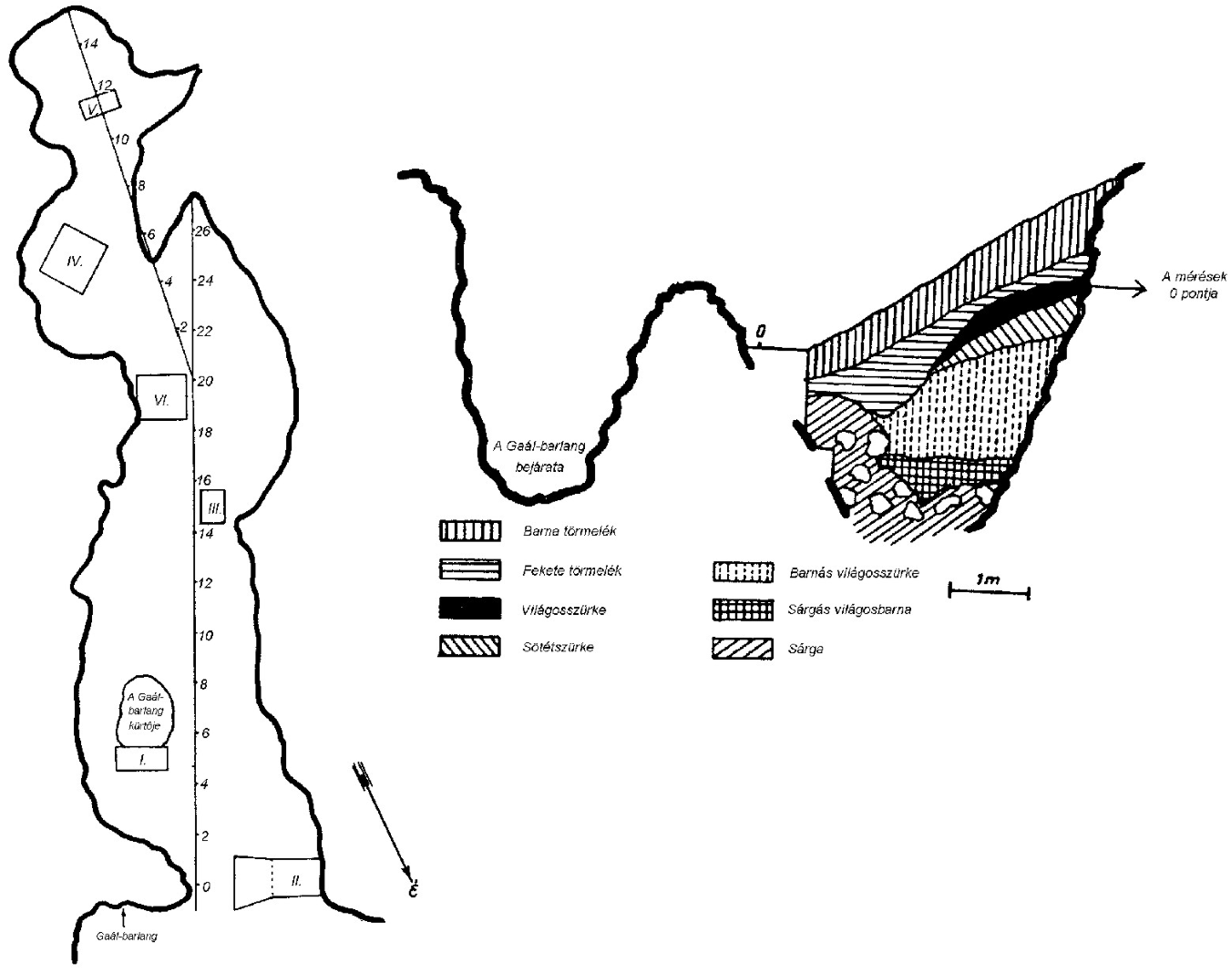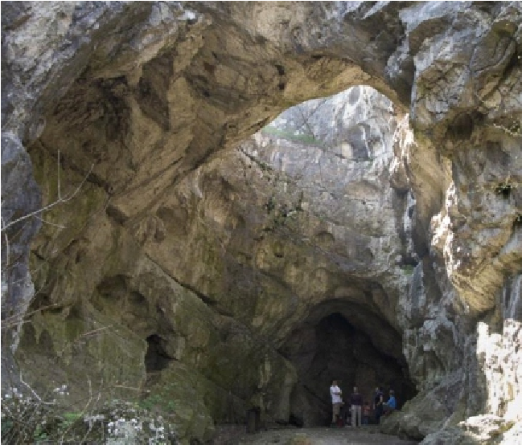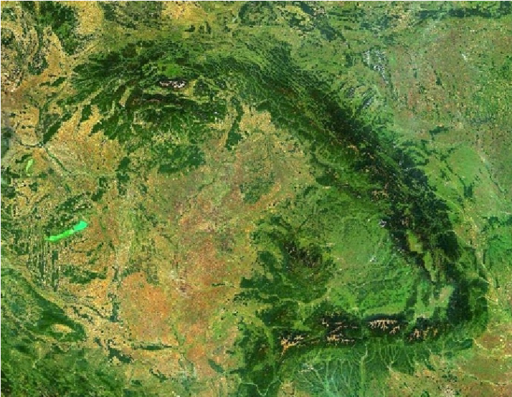
Block
II
Jankovich Cave
Sketch map of Jankovich Cave
and its cross section with the
excavation blocks (Vértes
et al
., 1957)

Supplementary Figure 2 Location of Rejtek I. Rock Shelter in Hungary and sketch map of the cave interior with the location of the excavation blocks.

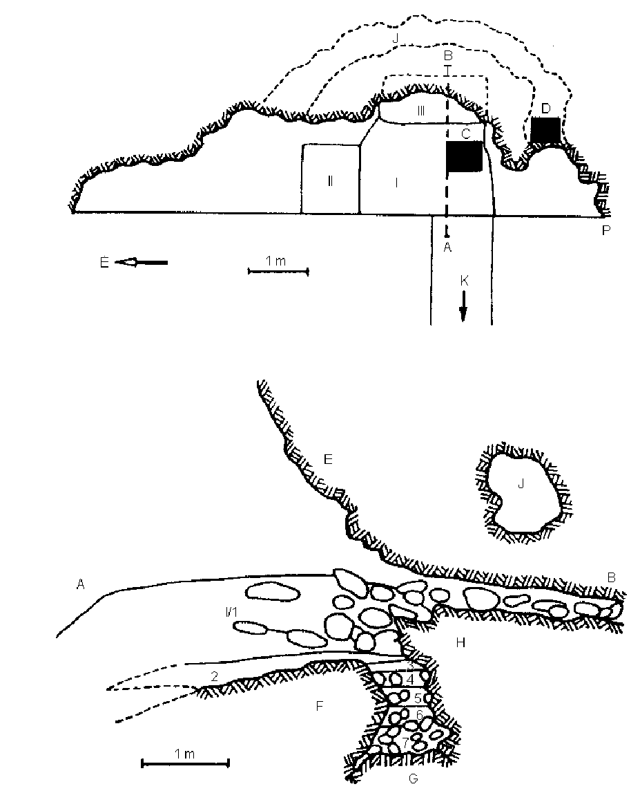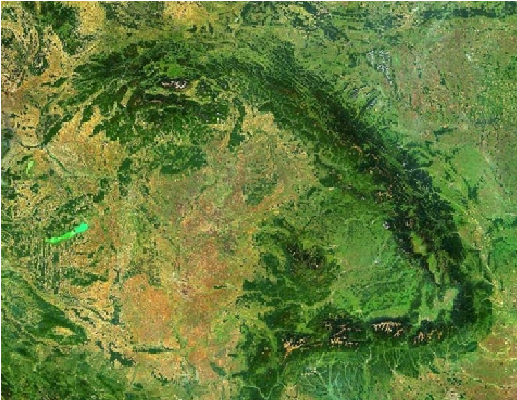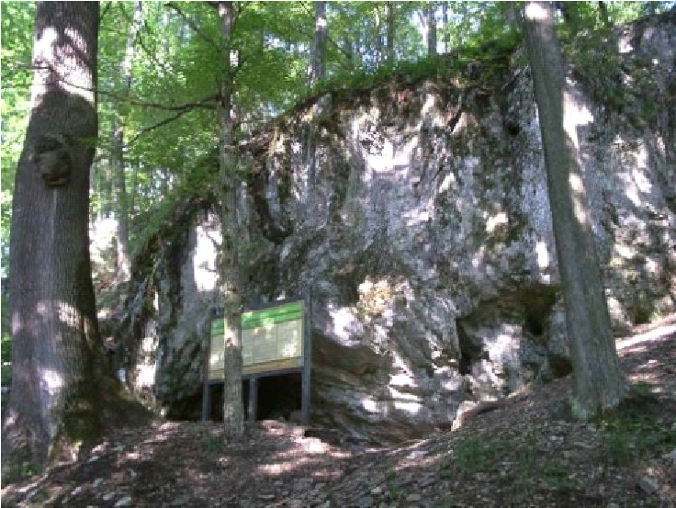
I
–
III
=
excava on
blocks
;
1
–
7
=
ver cal
layers
;
C
&
D
=
test
holes
in
1957
–
1958
;
E
=
rock
wall
;
F
és
G
=
rock
bo om
and
blocks
of
stones
k
;
H
=
rear
rock
wall
and
stone
block
;
J
=
lateral
branch
;
P
=
stra ng
point
of
measurement
blocks
II
and III
Sketch map of the Rejtek I. Rock Shelter
and longitudinal section of the excavation
1986)
A-B) with the excavation blocks (Jánossy,
(
Rejtek Rock Shelter

Supplementary Figure 3 Micromammal and tree vegetation compositional changes along the Rejtek I. Rock shelter sediment profile based on bone assemblage and charcoal studies^{5,6,45}.

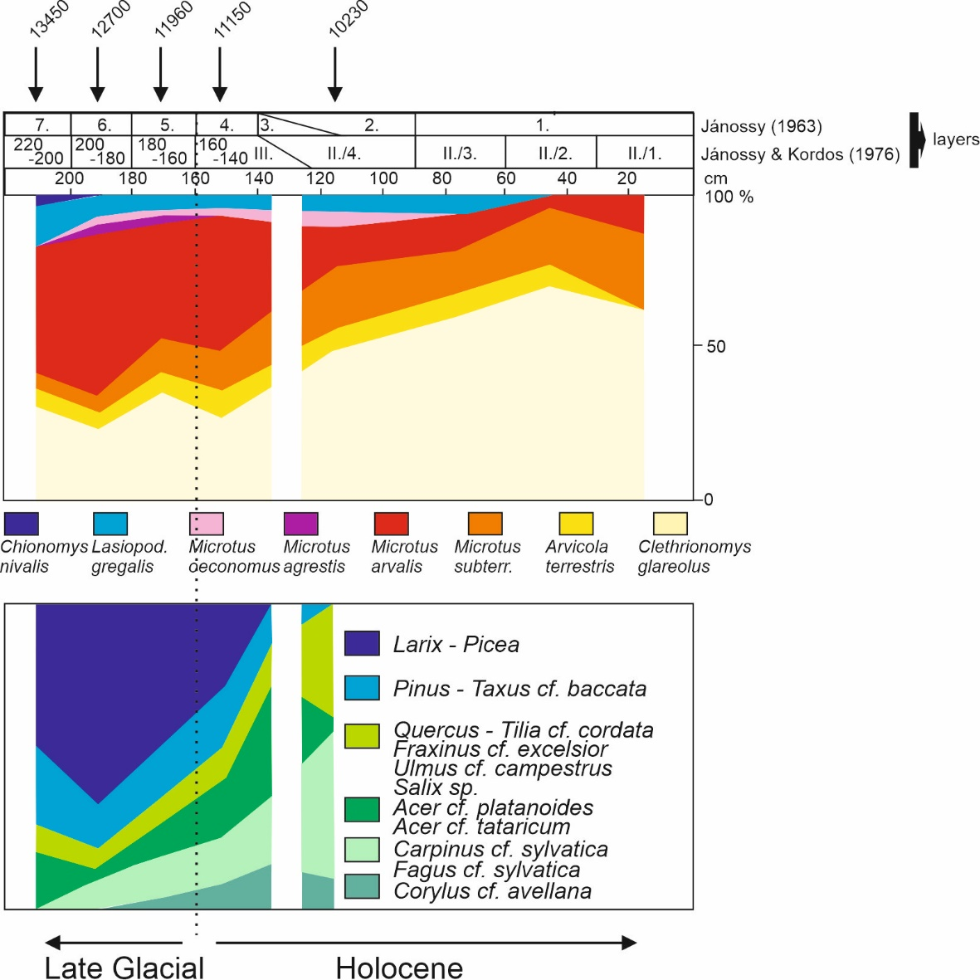

Supplementary Figure 4 Bayesian age-depth models from Rejtek I. Rock Shelter and Jankovich Cave based on radiocarbon data in Suppl. Table 1.

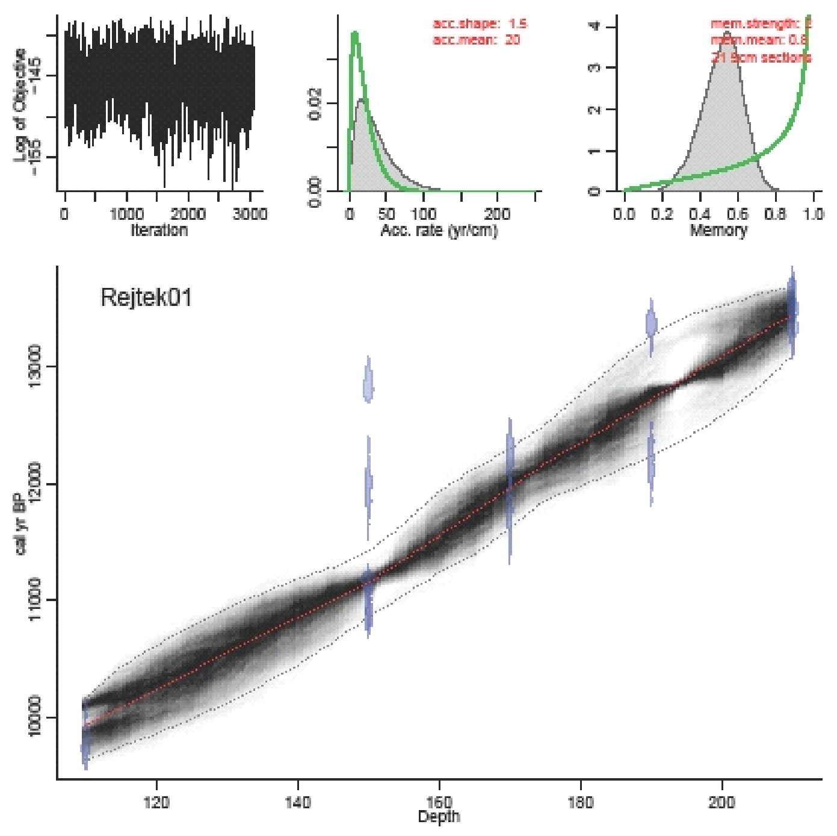
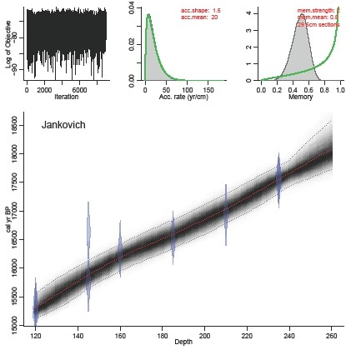
Supplementary Figure 5 Vole community changes (relative frequencies) in Jankovich Cave plotted against age. On the right side of the figure δ¹⁸O record of the NGRIP ice core is shown along the GICC05 age model and ice core event stratigraphy⁴⁶; YD: Younger Dryas; HE-1: Heinrich-event 1
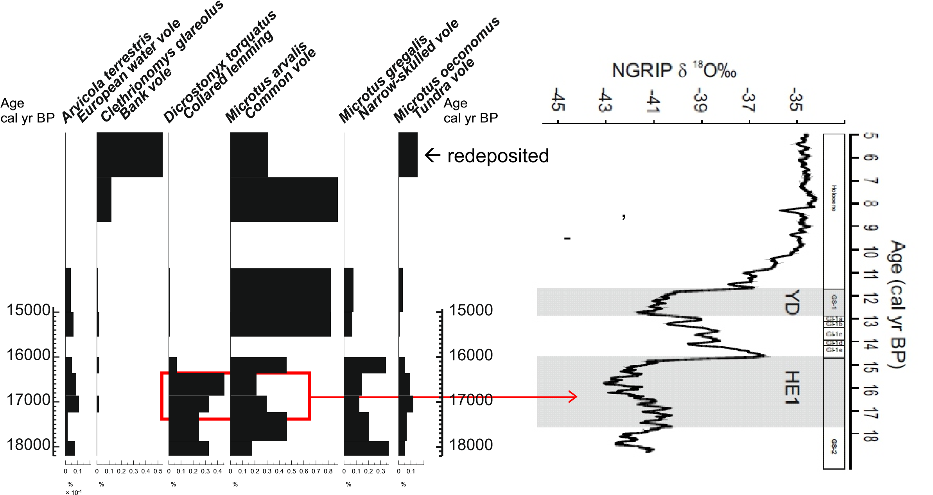

Supplementary Figure 6 Vole and rodent community changes (relative frequencies) in Rejtek I. Rock Shelter plotted against age.

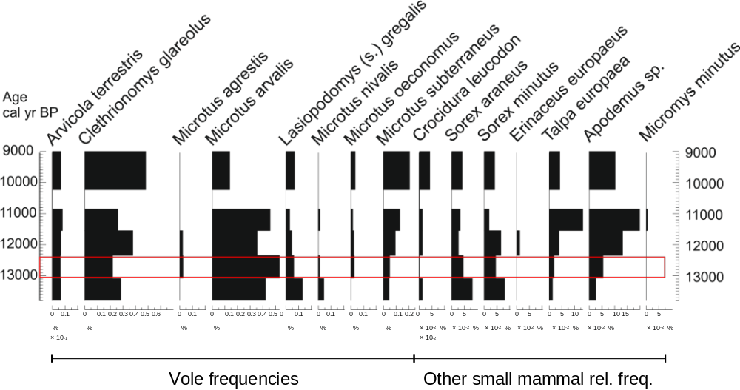

Supplementary Figure 7 2σ calibrated age ranges of Late Pleniglacial reindeer (Rangifer tarandus) bones and associated charcoal material from archaeological sites in the Carpathian Basin based on data published in Suppl. Table 5; median ages are presented as horizontal red squares, the lilac bar represents OxCal Phase estimate for the last appearance of reindeer

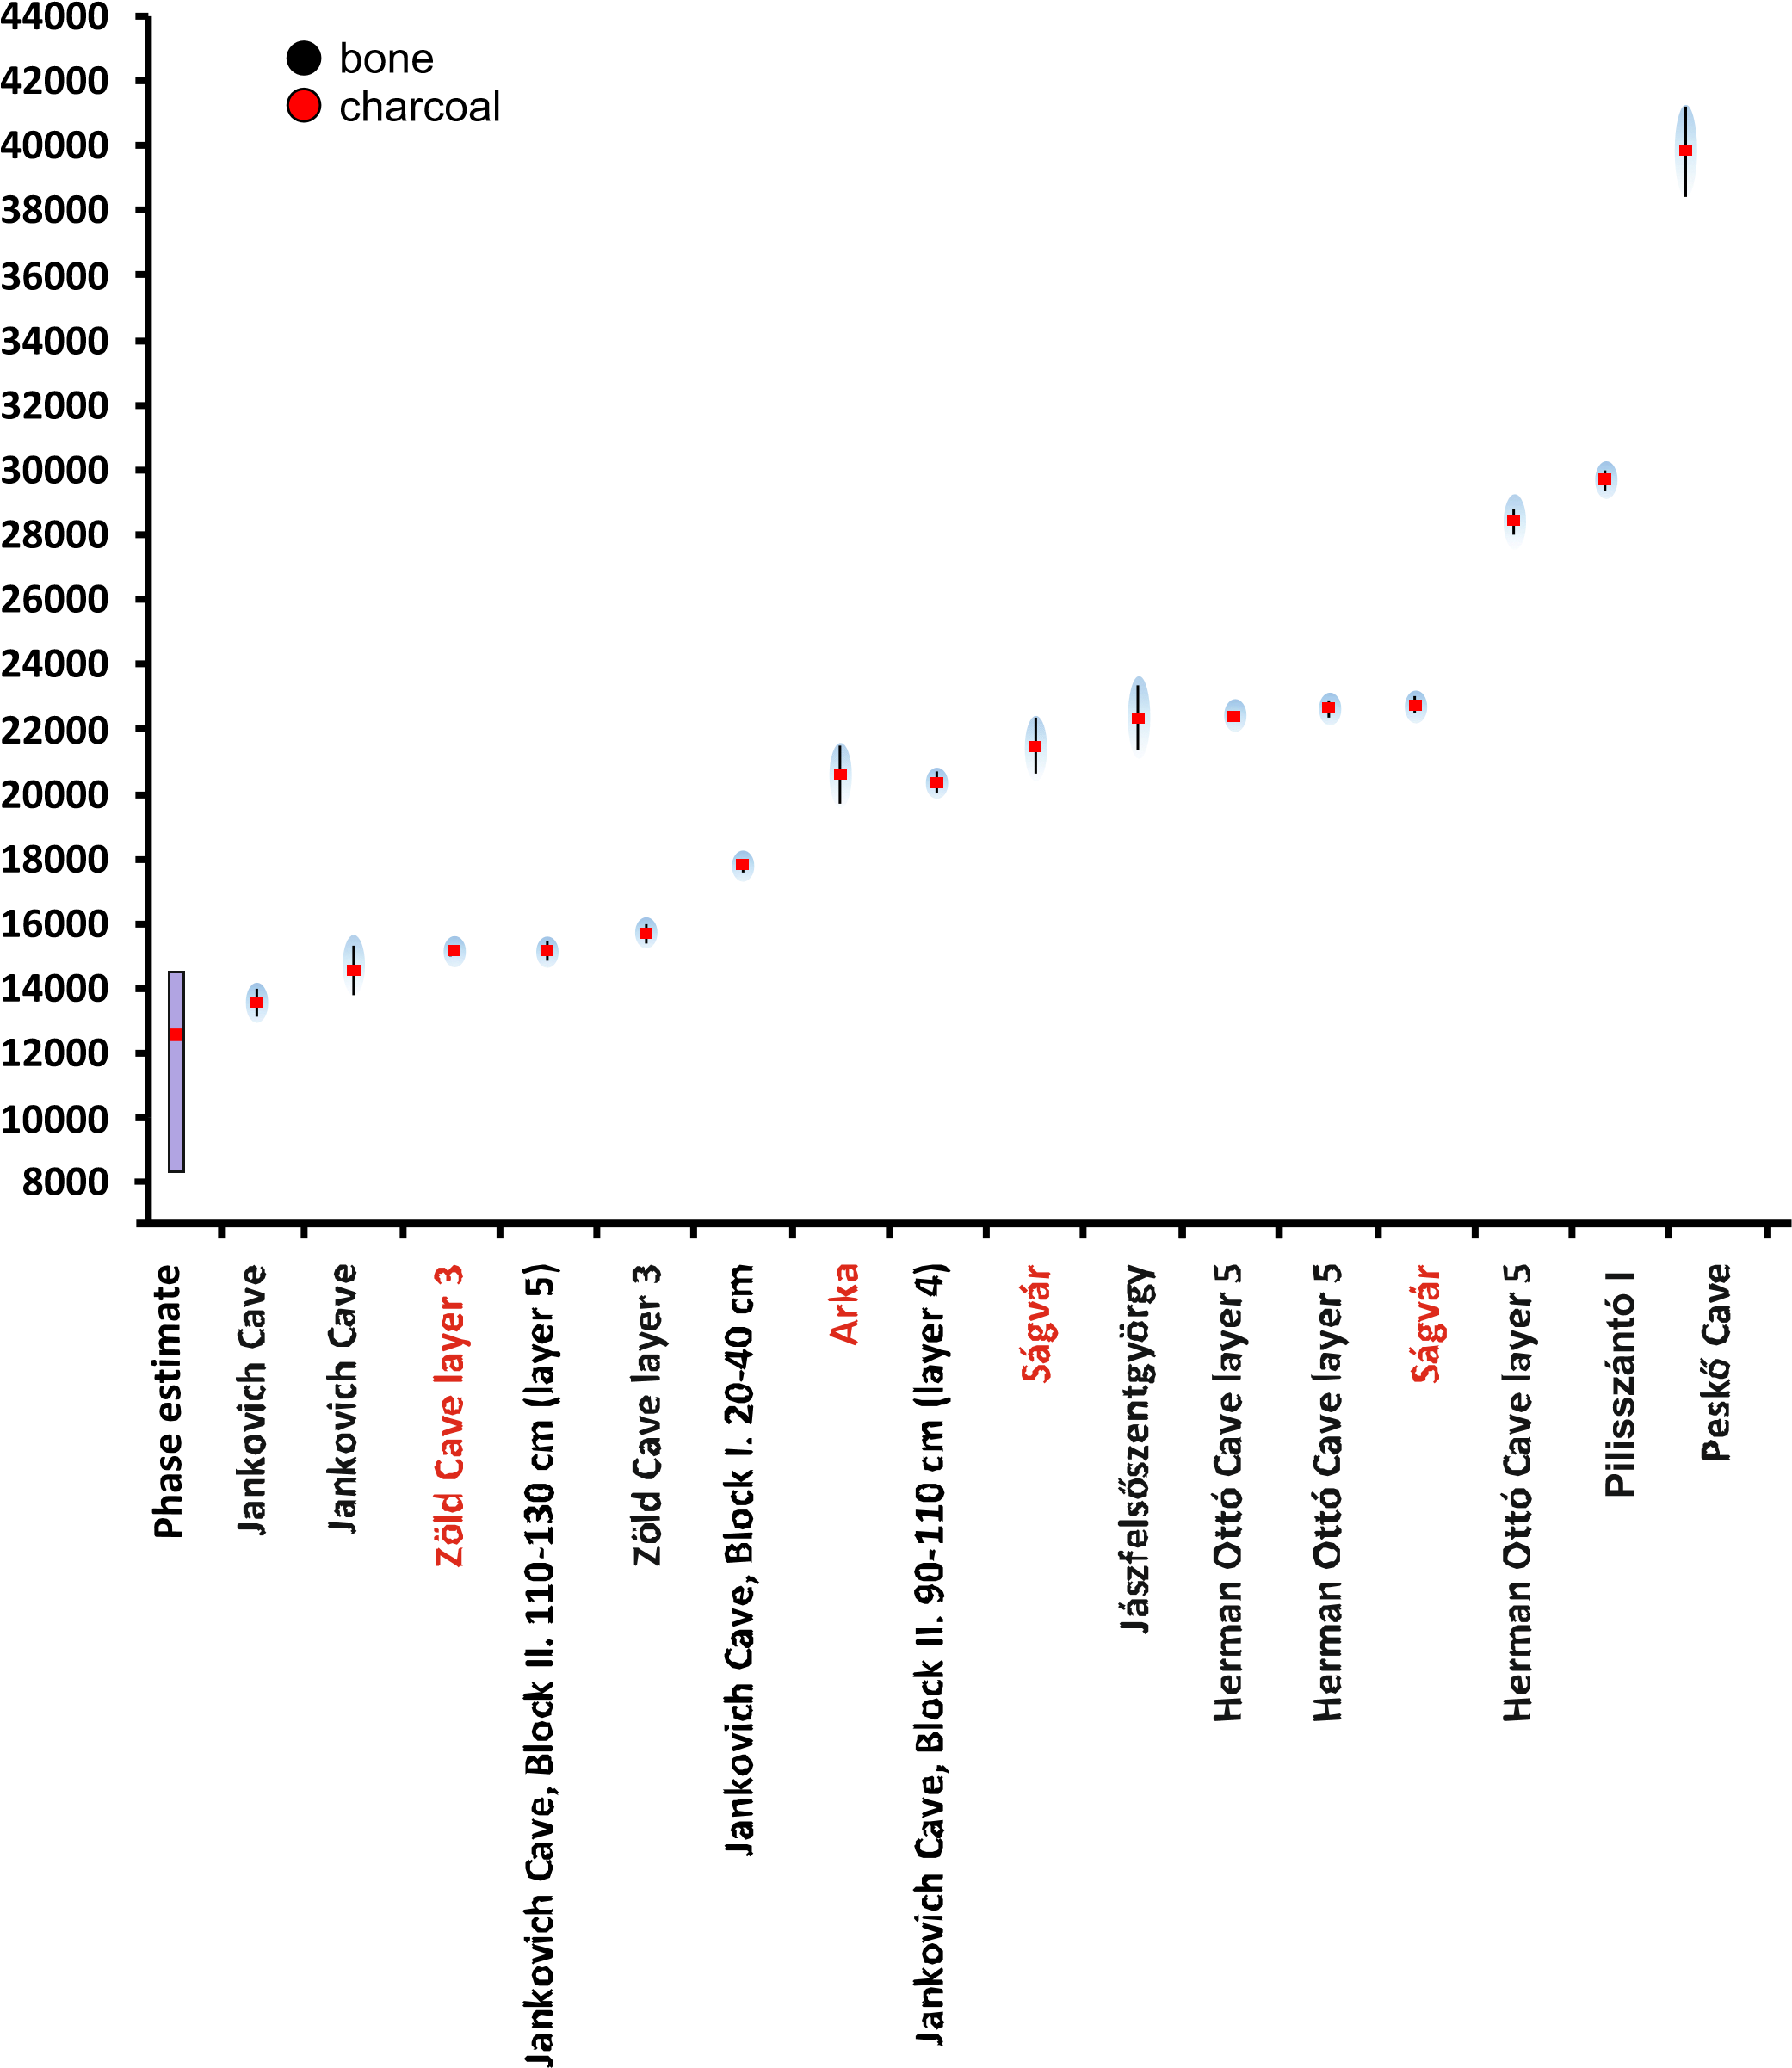

Age (cal yr BP)
Supplementary Figure 8 2σ calibrated age ranges of woolly mammoth (Mammuthus primigenius) bones and associated charcoal material from archaeological sites in the Carpathian Basin based on data published in Suppl. Table 4; median ages are presented as horizontal red squares, the lilac bar represents OxCal Phase estimate for the last appearance of woolly mammoth; the lower figure shows the δ¹⁸O record of the NGRIP ice core along the GICC05 age model⁴⁶ with grey shaded rectangles highlighting periods of apparent woolly mammoth absence in the Carpathian Basin.

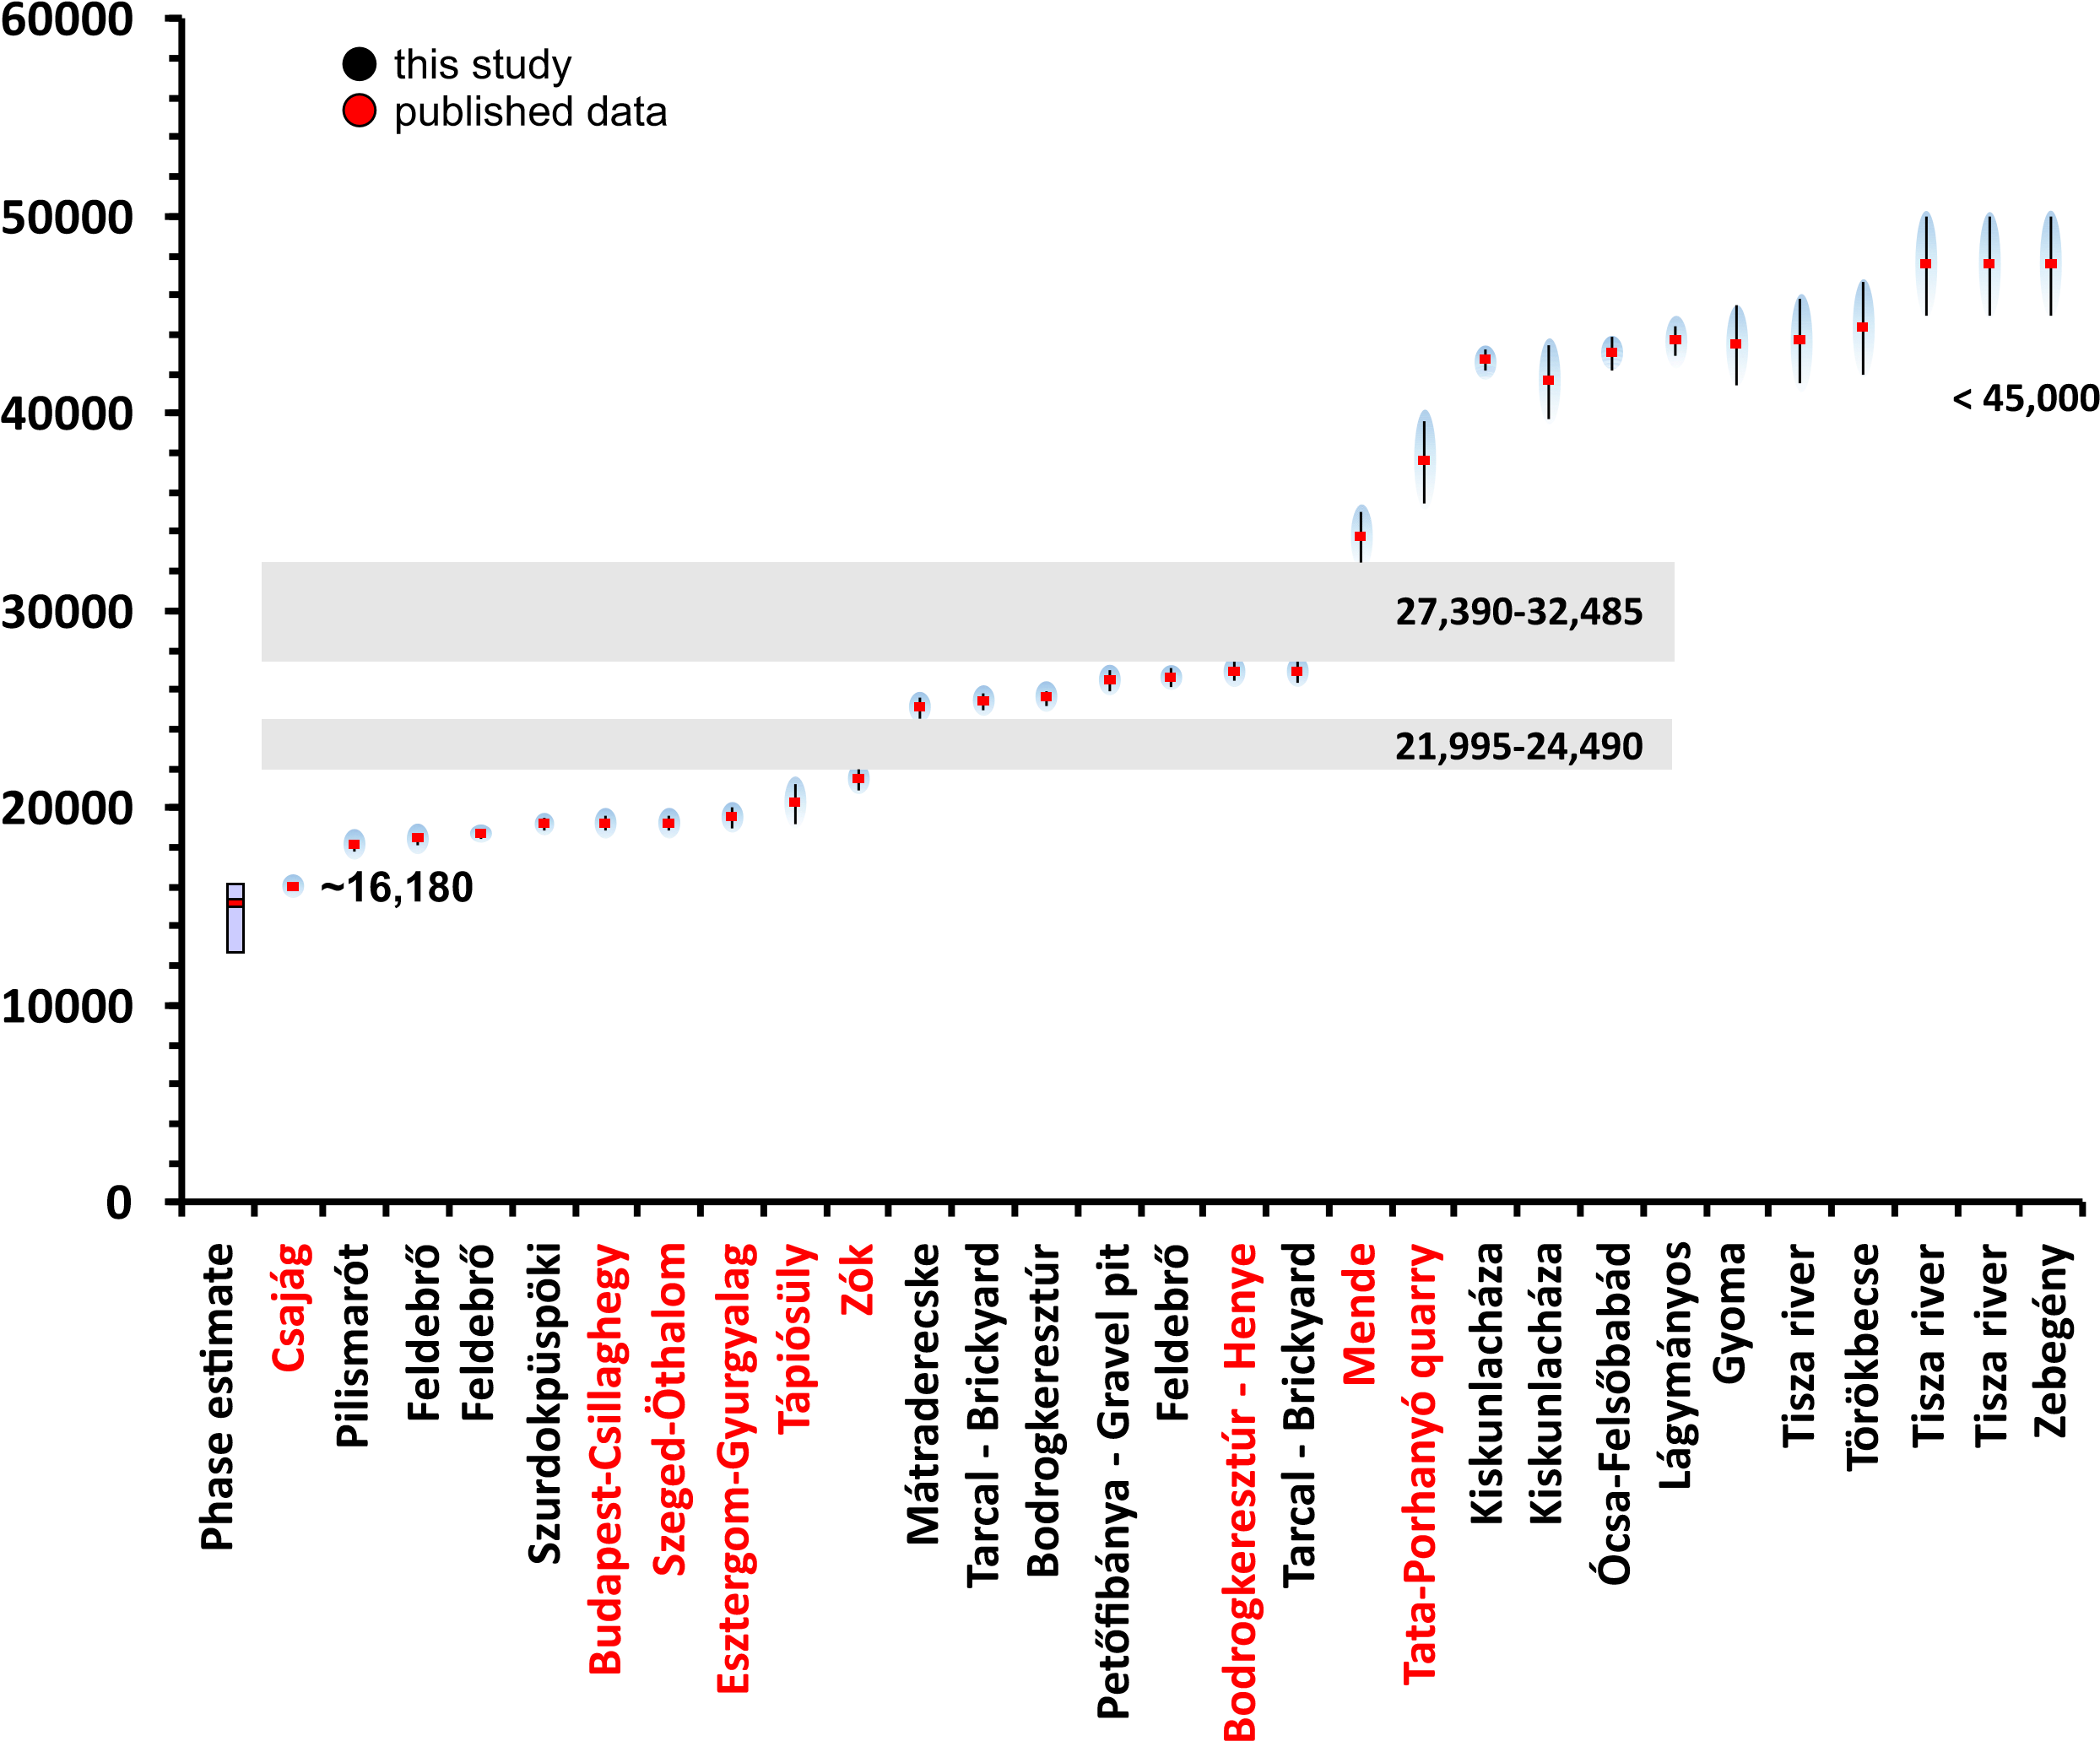

Age (cal yr BP)

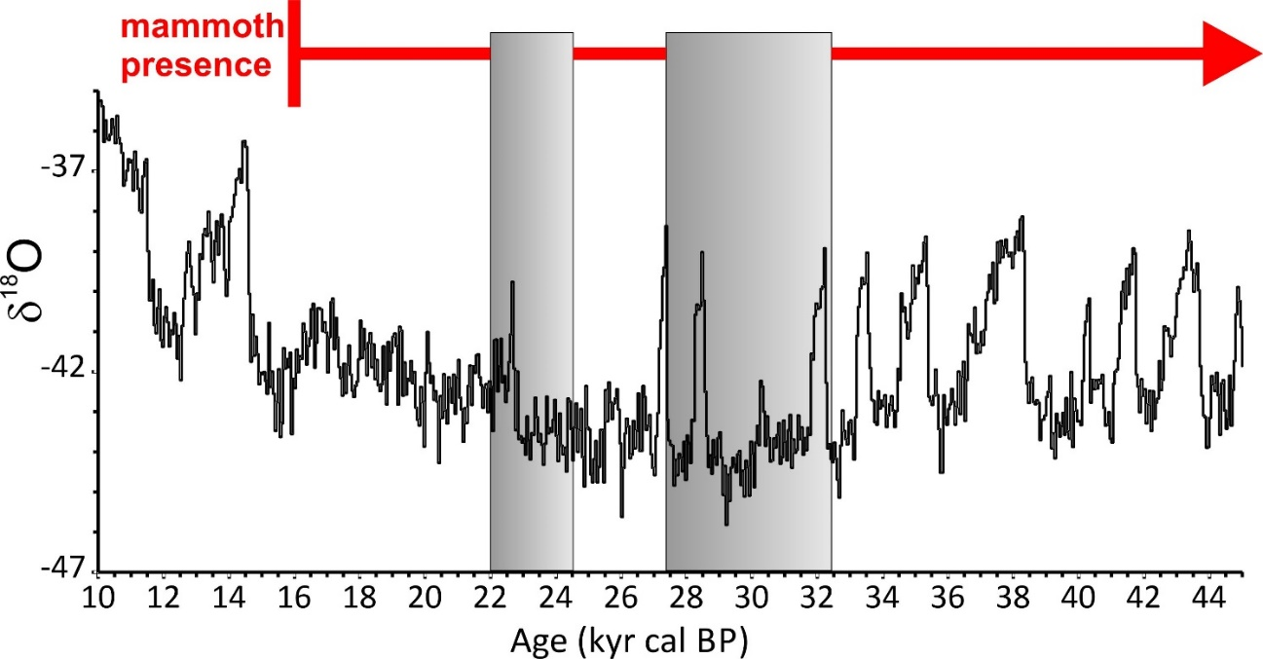
References
1. Vértes, L. Neuere Forschungen in der Jankovich-Höhle. Folia Archaeol. 9, 3–16 (1957).
2. Hillebrand, J. Az 1916. évi barlangkutatásaim eredményéről. Barlangkutatás 5, 98–108 (1917).
3. Lambrecht, K. & Kormos, T. A bajóti Öregkő nagy barlangjának faunája. Die Fauna der Öregköhöhle bei Bajót. Barlangkutatás 2, 77–80 (1914).
4. Vértes, L., Kretzoi, M. & Herrmann, M. Neuere Forschungen in der Jankovich-Höhle. Folia Archaeol. 9, 3–23 (1957).
5. Jánossy, D. & Kordos, L. Pleistocene-Holocene Mollusc and Vertebrate Fauna of two caves in Hungary. Ann. Hist. Musei Natl. Hungarici 68, 5–29 (1976).
6. Jánossy, D. Vorläufige Ergebnisse der Ausgrabungen in der Felsnische Rejtek I. (Bükkgebirge, Gem. Répáshuta). Karszt- és Barlangkutatás 3, 49–58 (1961).
7. Stieber, J. A hazai későglaciális vegetációtörténet anthrakotómiai vizsgálatok alapján. Földtani Közlöny 99, 188–193 (1969).
8. Sümegi, P., Rudner, E. & Törőcsik, T. Environmental and chronological reconstruction problems during the Pleistocene/Holocene transition in Hungary (Magyarország pleisztocén végi és kora holocén környezeti változások kronológiai, tér és időbeli rekonstrukciós problémái). in Őskoros kutatók IV. összejövetelének konferenciakötete (ed. Kolozsi, B.) 279–298 (Hajdú-Bihar Megyei Múzeumok Igazgatósága, 2012).
9. Vértes, L. Az őskőkor és az átmeneti kőkor emlékei Magyarországon. (Akadémiai Kiadó, 1965).
10. Jánossy, D. Pleistocene vertebrate faunas of Hungary. Journal of Chemical Information and Modeling (Akadémiai Kiadó, 1986).
11. Magyari, E. et al. Radiocarbon chronology of glacial lake sediments in the Retezat Mts (South Carpathians, Romania): A window to Late Glacial and Holocene climatic and paleoenvironmental changes. Cent. Eur. Geol. 52, 225–248 (2009).
12. Magyari, E. K. et al. Rapid vegetation response to Lateglacial and early Holocene climatic fluctuation in the South Carpathian Mountains (Romania). Quat. Sci. Rev. 35, 116–130 (2012).
13. Korponai, J. et al. Cladocera response to Late Glacial to Early Holocene climate change in a South Carpathian mountain lake. Hydrobiologia 676, 223–235 (2011).
14. Tóth, M. et al. A chironomid-based reconstruction of late glacial summer temperatures in the southern Carpathians (Romania). Quat. Res. 77, 122–131 (2012).
15. Buczkó, K. et al. Responses of diatoms to the Younger Dryas climatic reversal in a South Carpathian mountain lake (Romania). J. Paleolimnol. 48, 417–431 (2012).
16. Braun, M. et al. Using linear discriminant analysis (LDA) of bulk lake sediment geochemical data to reconstruct lateglacial climate changes in the South Carpathian Mountains. Quat. Int. 293, 114–122 (2013).
17. Hubay, K. et al. Reconstruction of paleoenvironmental changes using geochemical data from South Carpathian Mountains. EGU2020-13551 (2020).
18. Vincze, I. et al. Paleoclimate reconstruction and mire development in the Eastern Great Hungarian Plain for the last 20,000 years. Rev. Palaeobot. Palynol. 271, 104112 (2019).
19. Karátson, D. et al. The latest explosive eruptions of Ciomadul (Csomád) volcano, East Carpathians - A tephrostratigraphic approach for the 51-29 ka BP time interval. J. Volcanol. Geotherm. Res. 319, 29–51 (2016).
20. Magyari, E. K. et al. Vegetation and environmental responses to climate forcing during the Last Glacial Maximum and deglaciation in the East Carpathians: Attenuated response to maximum cooling and increased biomass burning. Quat. Sci. Rev. 106, 278–298 (2014).
21. Magyari, E. K. et al. Late Pleniglacial vegetation in eastern-central Europe: Are there modern analogues in Siberia? Quat. Sci. Rev. 95, 60–79 (2014).
22. Magyari, E., Jakab, G., Rudner, E. & Sümegi, P. Palynological and plant macrofossil data on Late Pleistocene short-term climatic oscillations in NE-Hungary. Acta Palaeobot. Suppl. 2, 491–502 (1999).
23. Magyari, E., Sümegi, P., Braun, M., Jakab, G. & Molnár, M. Retarded wetland succession: Anthropogenic and climatic signals in a holocene peat bog profile from north-east hungary. J. Ecol. 89, 1019–1032 (2001).
24. Magyari, E. K. et al. Warm Younger Dryas summers and early late glacial spread of temperate deciduous trees in the Pannonian Basin during the last glacial termination (20-9 kyr cal BP). Quat. Sci. Rev. 225, (2019).
25. Ramsey, C. B., Higham, T., Bowles, A. & Hedges, R. Improvements to the pretreatment of bone at Oxford. Radiocarbon 46, 155–163 (2004).
26. van der Plicht, J. & Palstra, S. W. L. Radiocarbon and mammoth bones: What’s in a date. Quat. Int. 406, 246–251 (2016).
27. Van Klinken, G. J. Bone collagen quality indicators for palaeodietary and radiocarbon measurements. J. Archaeol. Sci. 26, 687–695 (1999).
28. Katona, L., Kovács, J., Kordos, L., Linkai, I. & Magyari, Á. Two young woolly mammoths findings near Lake Balaton, Hungary. Quat. Hors-série 3 75–77 (2010).
29. Kovács, J., Moravcová, M., Újvári, G. & Pintér, A. G. Reconstructing the paleoenvironment of East Central Europe in the Late Pleistocene using the oxygen and carbon isotopic signal of tooth in large mammal remains. Quat. Int. 276–277, 145–154 (2012).
30. Sümegi, P. & Hertelendi, E. Reconstruction of microenvironmental changes in the Kopasz Hill loess area at Tokaj (Hungary) between 15 and 70 ka BP. Radiocarbon 40, 855–863 (1998).
31. Sümegi, P. & Krolopp, E. A magyarországi würm korú löszök képződésének paleoökológiai rekonstrukciója Mollusca-fauna alapján. Földtani Közlöny 125, 125–148 (1995).
32. Hertelendi, E. Radiocarbon dating of a wood sampl e from an excavation near Esztergom-Gyurgyalag. Acta Archaeol. Acad. Sci. Hungaricae 43, 271–272 (1991).
33. Geyh, M. A., Schweitzer, F., Vértes, L. & Vogel, I. C. Neue chronologische Angaben der Würm-Vereisung in Ungarn. Földrajzi Közlemények 18, 5–18 (1969).
34. Konrád, G., Kovács, J., Halász, A., Sebe, K. & Pálffy, H. Late Quaternary woolly mammoth (Mammuthus primigenius Blum) remains from southern Transdanubia, Hungary. Comptes Rendus - Palevol 9, 47–54 (2010).
35. Wilczyński, J. et al. Mammoth hunting strategies during the Late Gravettian in Central Europe as determined from case studies of Milovice I (Czech Republic) and Kraków Spadzista (Poland). Quat. Sci. Rev. 223, (2019).
36. Wilczyński, J. et al. New Radiocarbon Dates for the Late Gravettian in Eastern Central Europe. Radiocarbon 62, 243–259 (2020).
37. Vinogradov, A. P., Devirts, A. L., Dobkina, E. I. & Markova, N. G. Radiocarbon dating in the Vernadsky Institute V. Radiocarbon 10, 454–464 (1968).
38. Vogel, J. C. & Waterbolk, H. T. Groningen Radiocarbon Dates VII. Radiocarbon 9, 107–155 (1967).
39. Pazonyi, P. A Kárpát-medence kvarter emlősfauna közösségeinek paleoökológiai és rétegtani vizsgálata. (Palaeoecology and stratigraphy of Quaternary mammalian communities in the Carpath ian Basin.). (Eötvös Loránd University, 2006).
40. Béres, S. et al. Zöld Cave and the Late Epigravettian in Eastern Central Europe. Quat. Int. 587–588, 158–171 (2021).
41. Vogel, J. C. & Waterbolk, H. T. Groningen radiocarbon dates V. Radiocarbon 6, 349–369 (1964).
42. Vörös, I. Faunal remains from the Gravettian reindeer hunters’ campsite at Sagvar. Folia Archaeol. 3, 43–71 (1982).
43. Hertelendi, E. Radiocarbon age of a bone sample from the upper paleolithic settlement near Jászfelsőszentgyörgy. Tiscium 8, 61–62 (1993).
44. Szolyák, P. New Radiocarbon Data with Stratigraphical, Climatic and Archaeological Contexts to the Palaeolithic Assemblage of Herman Ottó Cave, Miskolc-Alsóhámor, Northeast Hungary. Praehistoria 9–10, 213–224 (2009).
45. Vogel, J. C. & Waterbolk, H. T. Groningen radiocarbon dates X. Radiocarbon 14, 6–110 (1972).
46. Stieber, J. A magyarországi felsőpleisztocén vegetáció-története az anthrakotómiai eredmények (1957-ig) tükrében. Földtani Közlöny 97, (1967).
47. Rasmussen, S. O. et al. A stratigraphic framework for abrupt climatic changes during the Last Glacial period based on three synchronized Greenland ice-core records: Refining and extending the INTIMATE event stratigraphy. Quat. Sci. Rev. 106, 14–28 (2014).

