Pediatric Cancer Predisposition Documentation Tool - PERCEPT
Trial name
Principle investigator, address
.: +XX-XXXX-XXXX (Study centre); -XXXX(Study documentation); Fax: -XXXX
Please ensure patient’s written consent for transfer and documentation of clinical data before sending the form!
Patient-ID (study number) Birth date
|__|__|__|__|__|__| |__|__| |__|__| |__|__|__| |__|__| |__|__| |__|__|__|__|
Study Country Hospital Number Day Month Year

Genetic Medical Counseling

Date of genetic counseling: |__|__| |__|__| |__|__|__|__|
Name of Pediatric Oncologist: __________________________________________________________________
Dept./Clinic: ________________________________________________________________________________
Street: _____________________________________ City: ________________________________________
Phone: _____________________________________ FAX: _________________________________________
Name of Human Geneticist: ____________________________________________________________________
Dept. / Institution: ____________________________________________________________________________
Street: _____________________________________ City: ________________________________________
Phone: _____________________________________ FAX: ________________________________________

Current malignancy

Date of diagnosis: |__|__| |__|__| |__|__|__|__| Diagnosis: ____________________________________
Tumor site(s): __________________________ ICD: _____________ Histology: ________________
Metastases at time of diagnosis: No Yes, where ______________________________________
Multiple primary tumors: No Yes, bilateral multifocal metachronous secondary
Type of therapy: Resection Chemotherapy Radiotherapy
Unusual therapy toxicity: No Yes, Mucositis III/IV° Myelosuppression
Cardiomyopathy Neurological toxicity Nephrotoxicity Other: _________________
Genetic aberration in tumor suggesting germline mutation No Yes, __________________

Previous malignancies

Date of diagnosis: |__|__| |__|__| |__|__|__|__| Diagnosis: ____________________________________
Tumor site(s): __________________________ ICD: _____________ Histology: ________________
Metastases at time of diagnosis: No Yes, where ______________________________________
Multiple primary tumors: No Yes, bilateral multifocal metachronous secondary
Type of therapy: Resection Chemotherapy Radiotherapy
Unusual therapy toxicity: No Yes, Mucositis III/IV° Myelosuppression
Cardiomyopathy Neurological toxicity Nephrotoxicity Other: _________________
Genetic aberration in tumor suggesting germline mutation No Yes, __________________
Previous genetic testing performed? No Yes, CNV ________ NGS-panel _____________
WES ________ Other _________________

Date of diagnosis: |__|__| |__|__| |__|__|__|__| Diagnosis: ____________________________________
Tumor site(s): __________________________ ICD: _____________ Histology: ________________
Metastases at time of diagnosis: No Yes, where ______________________________________
Multiple primary tumors: No Yes, bilateral multifocal metachronous secondary
Type of therapy: Resection Chemotherapy Radiotherapy
Unusual therapy toxicity: No Yes, Mucositis III/IV° Myelosuppression
Cardiomyopathy Neurological toxicity Nephrotoxicity Other: _________________
Genetic aberration in tumor suggesting germline mutation No Yes, __________________

Pregnancy / birth
In-vitro-Fertilization (IVF): No Yes
Intracytoplasm. sperm injection (ICSI) No Yes
Pregnancy noticeable: No Yes, because of:
Growth retardation starting ___________________ week of pregnancy
Infection in pregnancy: _______________________________________
Teratogen: _____________________ Other: ____________________

Birth: Week of gestation: _________ Spontaneous Caesarean section, reason:____________________
Weight: at birth ___________ g / _____ P. APGAR ____/____/_____
Height: at birth __________ cm / _____ P. umbilical cord pH: __ , ______
Head circum.: at birth __________ cm / _____ P.

Number of siblings: ____ Twins: No Yes, identical / Yes, fraternal/ Yes, unknown

Medical History / Clinical examination

Neonatal period: No abnormalities
Failure to thrive Feeding difficulties
Neonatal respiratory distress Neonatal hypotonia
Prolonged jaundice Hypoglycemia
Other: _________________________________________________________

Known syndrome: No Yes,:______________________________________________________
Malformation: No Yes,:______________________________________________________
Hemihypertrophy: No Yes,:______________________________________________________
Macroglossia No Yes,:______________________________________________________

Immunodeficiency: No Yes,:______________________________________________________
Red flags for pathological susceptibility for infections:
Infections with unusual or opportunistic pathogens Granulomas
Unusual development (protracted, complicated) Unusual localization
Repeated invasive infections Severe intensity
Red flags for immune dysregulations:
Chronic inflammatory intestinal disease Recurrent fever
Lymphoproliferative disorder Unusual eczema Autoimmunity

Chronic disease: No Yes,:______________________________________________________
Endocrine abnormalities: No Yes,:______________________________________________________
Haematological abnormalities: No Yes,:______________________________________________________

Skin abnormalities: None
Café-au-lait-spots; number _____ Telangiectasia
Naevus flammeus Blue nevus
Leukoderma Atrophy
Poikiloderma Vascular lesions
Hyperkeratosis Hypertrichosis
Hypersensitivity to sun Partial albinism
Hyperpigmentation Hypopigmentation
Axillary/groin hyperpigmentation A/G hypopigmentation
Spontaneous hematoma Palmar/ Plantar pits
Abnormality of the nails (Absent fingernail/toenail; nail dystrophy)
Skin tumors (Lipoma, Fibroma, other), which: ___________________________

Abnormality of dental morphology: No Yes,:____________________________________________

Visual impairment: No Yes,:______________________________________________________
Ophthalmic exam? No Yes, Normal Abnormal:_____________________________

Hearing impairment: No Yes,:______________________________________________________
Audiogram performed? No Yes, Normal Abnormal:_____________________________

Development: Normal Abnormal,
Language development: Normal Abnormal,
Expressive language delay: Mild Moderate Severe
Receptive language delay: Mild Moderate Severe

Motor development: Normal Abnormal,
Fine motor delay: Mild Moderate Severe
Gross motor delay: Mild Moderate Severe

Social development: Normal Abnormal,
Behavior: Normal Hyperactivity Aggressive behavior Other:______________________

Early child care/school:___________________________________________________________________

Neurological abnormalities: No Yes,
Ataxia Cranial nerve palsy Seizures
Other,:_______________________________________________

Patellar reflex: Normal Decreased Hyperactive Myoclonus

Muscular tonus: Normal Hypotonia Hypertonia

Other abnormalities: Goiter Hernia of the abdominal wall
Other:__________________________________________________________

Elements of Morphology

Skull: Microcephaly Macrocephaly Trigonocephaly
Brachycephaly Dolichocephaly Turricephaly

Forehead: Prominent High Wide
Low Narrow Naevus flammeus
Frontal upsweep of hair Widows peak Sloping

Profile: Flat face Sloping Midface hypoplasia

Eyebrow: Highly arched Thick Broad
Sparse eyebrow Medial flaring Periorbital thickness

Eyes: Small Big Deeply set
Proptosis Long eye lashes Phimosis
Ptosis Epicanthus (inversus) Blue sclera
Hypertelorism Hypotelorism Eye coloboma
Iris Heterochromasia Strabism Cataract
Exophthalmus Keratoconus Aniridia
Severe Photosensitivity Visible nerve fibers on cornea

Glabella: Depressed Prominent Abnormality: _________________
Bridge: High Wide Flattened
Long Short

Nose : Bulbous nose Prominent Prominent columella
Overhanging nasal tip Choanal atresia Underdeveloped nasal alae

Philtrum: Long Short Flattened
Elapsed Deep Wide

Mouth: Leucoplakia Oral pigmentation Oral tumor
Abnormal oral mucosa Abnormal teeth Downturned mouth

Tongue: Large Lobated Protruding

Palate: High Narrow bifid uvula/ wide uvula cleft

Lips: Thick upper vermilion Thin upper vermilion
Thick lower vermilion Thin lower vermilion pits

Chin: Small Wide Retrognathia
Protruding Pointed Chin dimple

Ears: Small Big Low
Cloddy Prominent Over-folded
Less folded Square Rotated backwards
Pits of the ear lobe Pits of the helices Pre-auricular appendage/dimple

Neck: Short Long Wide
Pterygium Asymmetry: ______________________________________

Hair: Brittle hair Color: ___________________________________________

Thorax: Pectus carinatum Pectus excavatum Hypoplastic nipples Inverted nipples Supernumerary nipples

Spine: Scoliosis Kyphosis Lordosis
Pelvis: Hip dysplasia Sacral dimple

Extremities: Left/Right Asymmetry: Arm Leg
Length Circumference
Rhizomelia Mesomelia
Joint Hyper-extensibility Limited joint extension
Inhibition of pronation / supination Bayonet-like deformity of forearm
Short fibula Tibia dysplasia Radial dysplasia
Patella dysplasia Easy bruising Tendency to fracture

Finger: Tapered Short Long
Clinodactyly Camptodactyly Syndactyly
Hand polydactyly preaxial Hand polydactyly postaxial
Broad thumb Absent thumb
Transverse palmar crease: Atypical Sydney

Feet: Pes planus Pes cavus Broad foot
Short foot Foot polydactyly Oligodactyly
Toe syndactyly Broad hallux Sandal gap

Urogenital: Abnormal genital pigmentation Ambiguous genitalia
Other urogenital abnormalities: _________________________________________________

Other abnormalities: __________________________________________________________________________

Previous examinations

Previous genetic testing? No Yes,
Chromosome analysis,
Normal Abnormal: __________________________________
Molecular genetic analysis,
Specific test: __________________________________________
Normal Abnormal: __________________________________
Copy Number Variant analysis,
Specific test: __________________________________________
Molecular genetic Panel analysis,
Whole genome sequencing
Whole exome sequencing
TruSight Cancer Panel
Other Panel: _____________________________________
Normal Abnormal: __________________________________

Diagnosis ICD-O-3: ________________________ Date of diagnosis: ___ . ____ . ______

Previous Genetic counselling? No Yes, Date: ___ . ____ . ______
Institute: ___________________________________________________________________________________

Specific surveillance program discussed? No Yes, which? ________________________________
_____________________________________________
MRI of the head? No Yes, no abnormality detected
Yes, result __________________________________
X-ray examinations? No Yes, no abnormality detected
Yes, result __________________________________
Ultrasound of the abdomen? No Yes, no abnormality detected
Yes, result __________________________________
Ultrasound of the kidneys? No Yes, no abnormality detected
Yes, result __________________________________
Other examinations? No Yes, _______________________________________

Family History

Ethnical background: Mother _______________________Father _______________________________________

Parental Consanguinity? No Yes; _______________________________________

Are there malignant diseases in the family? No Yes, see below.

Are there family members affected by more than one type of cancer in the same individual?
No Yes; _______________________________________

How many family members are affected by any kind of cancer?
______, please specify below (unless not indicated in the family tree)

Who is affected? ________________________________________________________ Number. ____________
Diagnosis: _____________________________________________________________ Age at diagnosis:______

Who is affected? ________________________________________________________ Number. ____________
Diagnosis: _____________________________________________________________ Age at diagnosis:______

Who is affected? ________________________________________________________ Number. ____________
Diagnosis: _____________________________________________________________ Age at diagnosis:______

Who is affected? ________________________________________________________ Number. ____________
Diagnosis: _____________________________________________________________ Age at diagnosis:______

Who is affected? ________________________________________________________ Number. ____________
Diagnosis: _____________________________________________________________ Age at diagnosis:______

Who is affected? ________________________________________________________ Number. ____________
Diagnosis: _____________________________________________________________ Age at diagnosis:______

Is there a known (tumor predisposition) syndrome in the family?
No Yes, Li-Fraumeni syndrome MEN Typ I, MEN Typ IIa, MEN Typ IIb
Neurofibromatosis Type I Neurofibromatosis Type II
Familial adenomatous polyp. Coli Lynch syndrome (HNPCC)
Tuberous Sclerosis Other: ________________________________
Based on: Clinical diagnosis
Molecular testing with mutation: ______________________ in _______________gene

Family tree

Please draw a family tree. Refer to nomenclature at page 10.

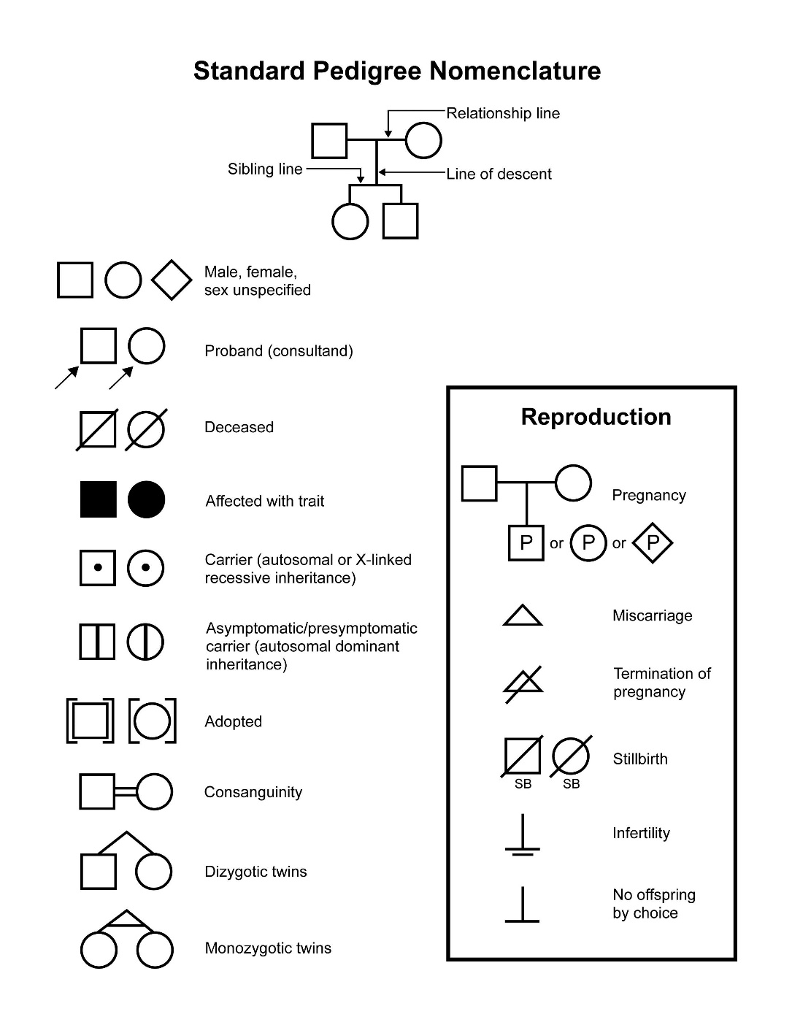

- Describe at least 4 generations (grand grandparents of the patient)

- Ask for unclear death and stillborn

- Ask for cause of death and age at death

- Number affected family members

Source: National cancer Institute (http://www.cancer.gov/)

