Supplementary material
Calcium Metal Anchoring on Graphitic Carbon Nitride: d-Orbital Effects and Electronic Stabilization - A DFT Investigation

Nithya Devi Ramasamy¹, Karthik Krishnasamy², Thangavel Subramani^{3,∗}
¹Basic Engineerng, Government Polytechnic College, Coimbatore, 641014, Tamil Nadu, India
²Department of Chemistry, Nandha Arts and Science College, Erode, 638052, Tamil Nadu, India
³Department of Chemistry, Chikkaiah Government Arts and Science College, Erode, 638004, Tamil Nadu, India

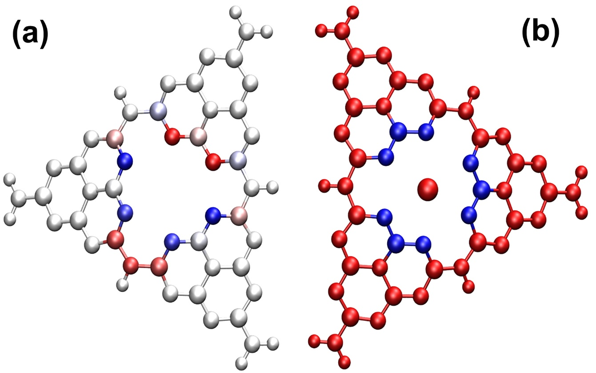
Figure S1: Planar Arrangement of N’s in Nitrogen Ring of (a) g-C₃N₄ and (b) Ca/g-C₃N₄.

Table S1: MPP values of g-C₃N₄ and Ca/g-C₃N₄.

Atoms | MPP (Å)
Atoms | g-C₃N₄ | Ca/g-C₃N₄
N3 | -0.3535 | 0.2837
N7 | -0.3610 | 0.2217
N16 | 0.3995 | 0.3129
N25 | 0.3298 | 0.3151
N34 | 0.4002 | 0.2760
N38 | 0.3256 | 0.2232

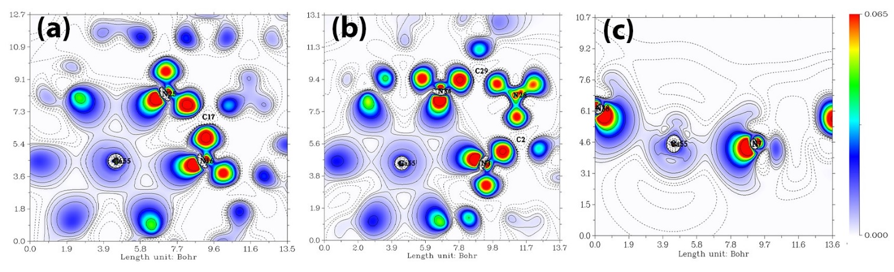
Figure S2: Deformation Electron Density Contour Map of (a) N16-Ca55-N25 (b) N3-Ca55-N34 and (c) N7-Ca55-N38 in Ca/g-C₃N₄.
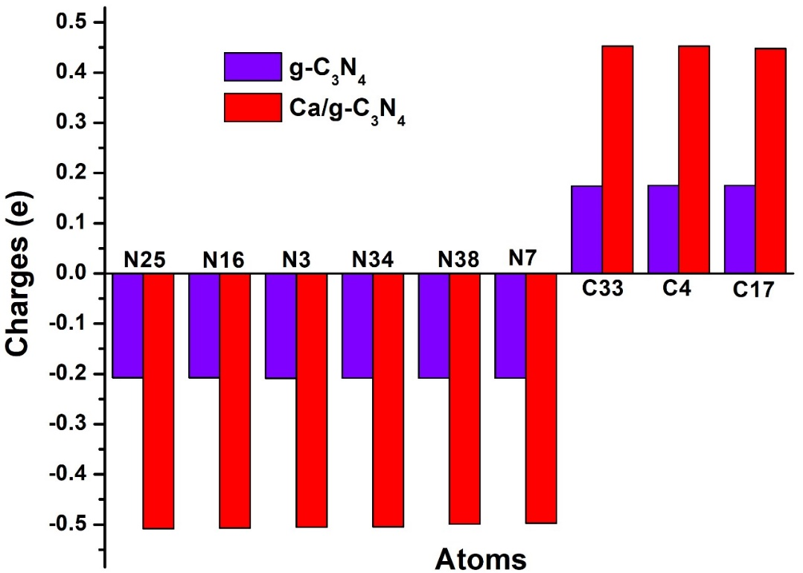
Figure S3: Mulliken Charge Analysis of Selected Atoms in Nitrogen Ring of g-C₃N₄ and Ca/g-C₃N₄.

Table S2: Mulliken Charge Analysis of Selected Atoms in Nitrogen Ring of g-C₃N₄ and Ca/g-C₃N₄.
Atoms | Mulliken Charges
Atoms | g-C₃N₄ | Ca/g-C₃N₄
N25 | -0.2161 | -0.5081
N16 | -0.2321 | -0.5070
N3 | -0.2468 | -0.5052
N34 | -0.2306 | -0.5044
N38 | -0.2157 | -0.4989
N7 | -0.2453 | -0.4973
C33 | 0.1786 | 0.4526
C4 | 0.1789 | 0.4526
C17 | 0.1776 | 0.4477

