Supplementary Information
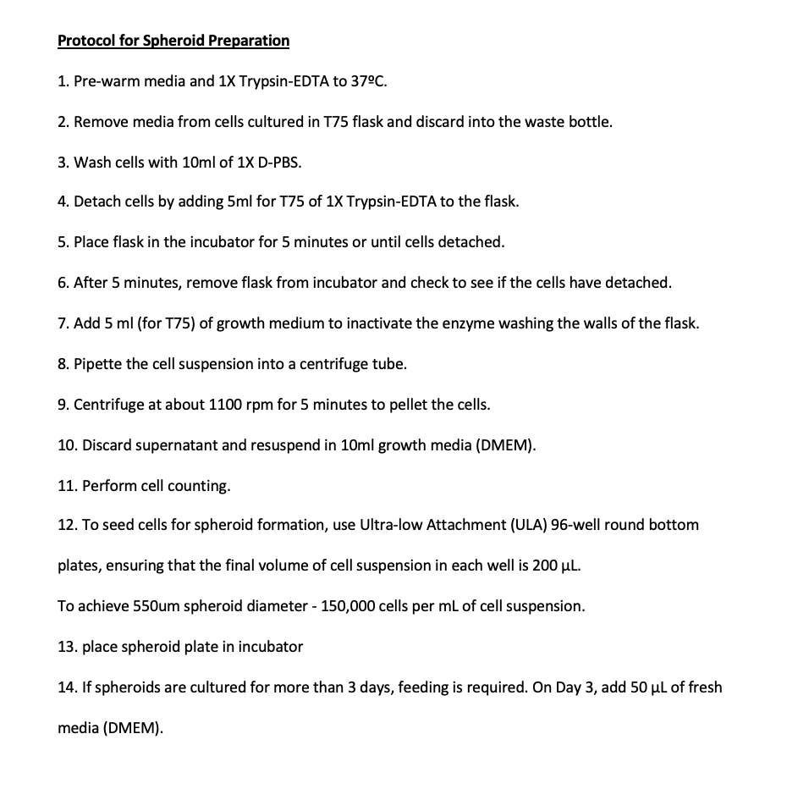

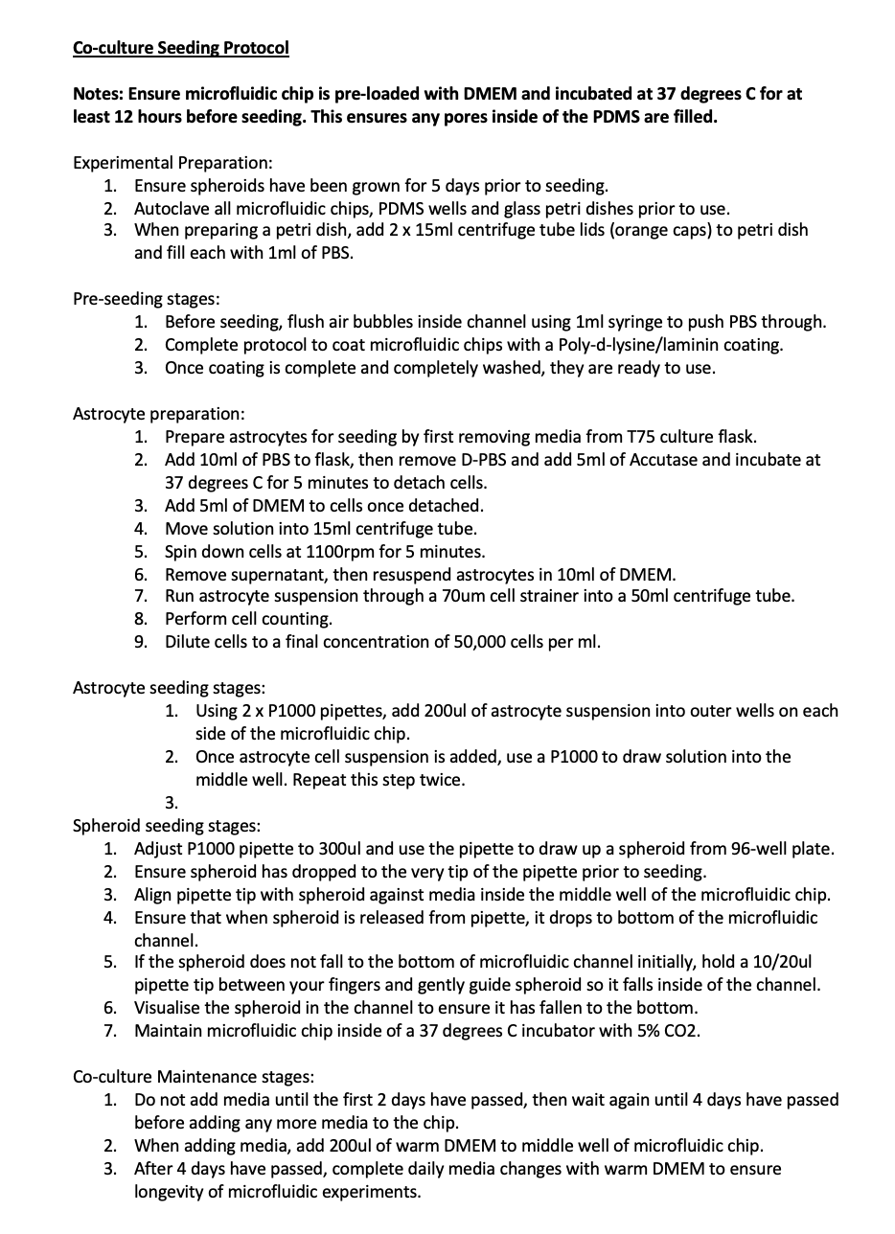

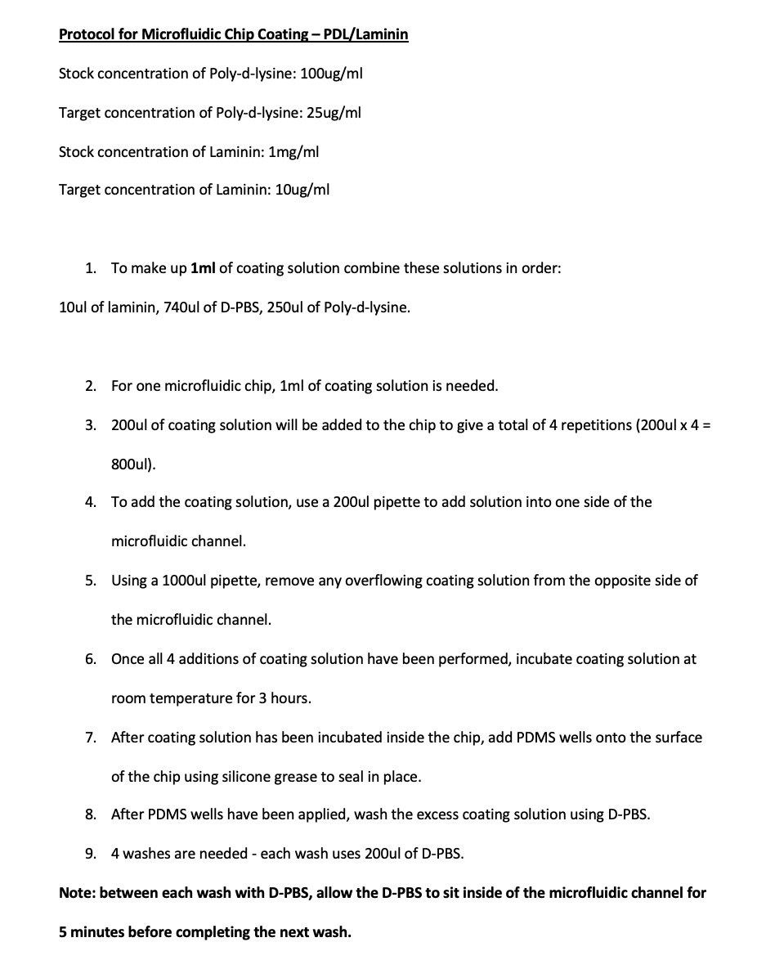

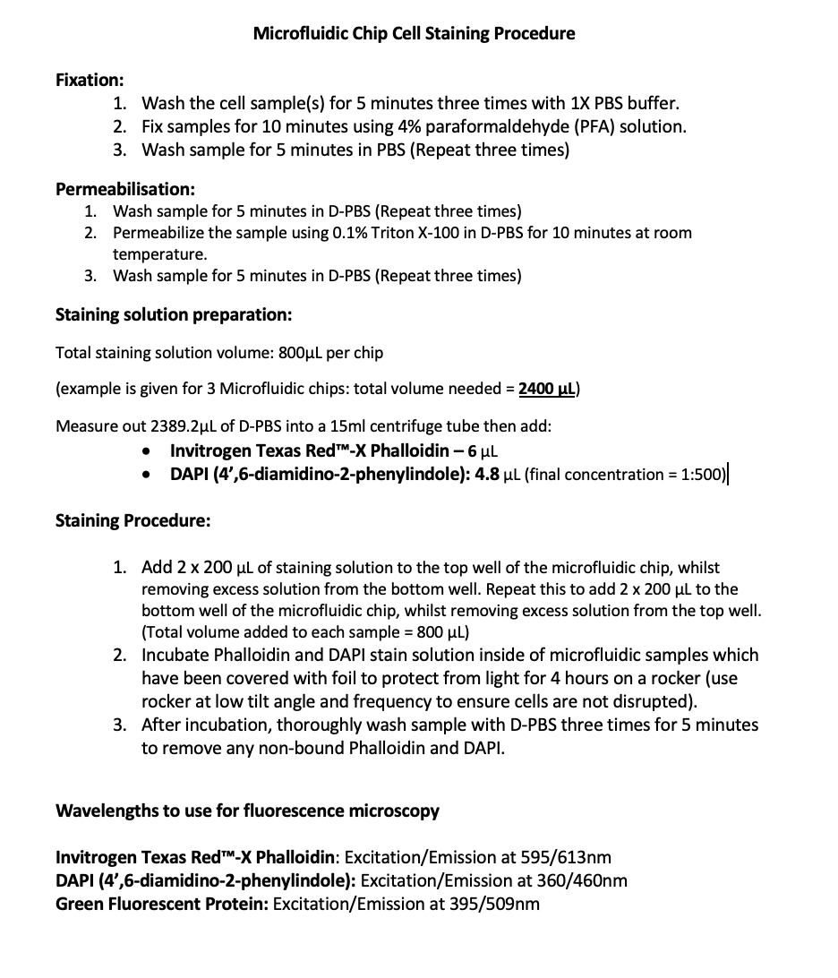

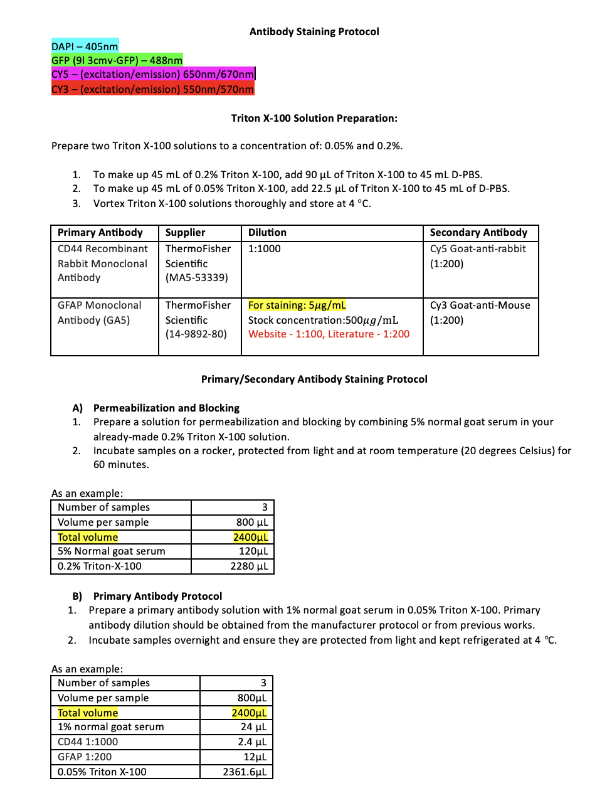

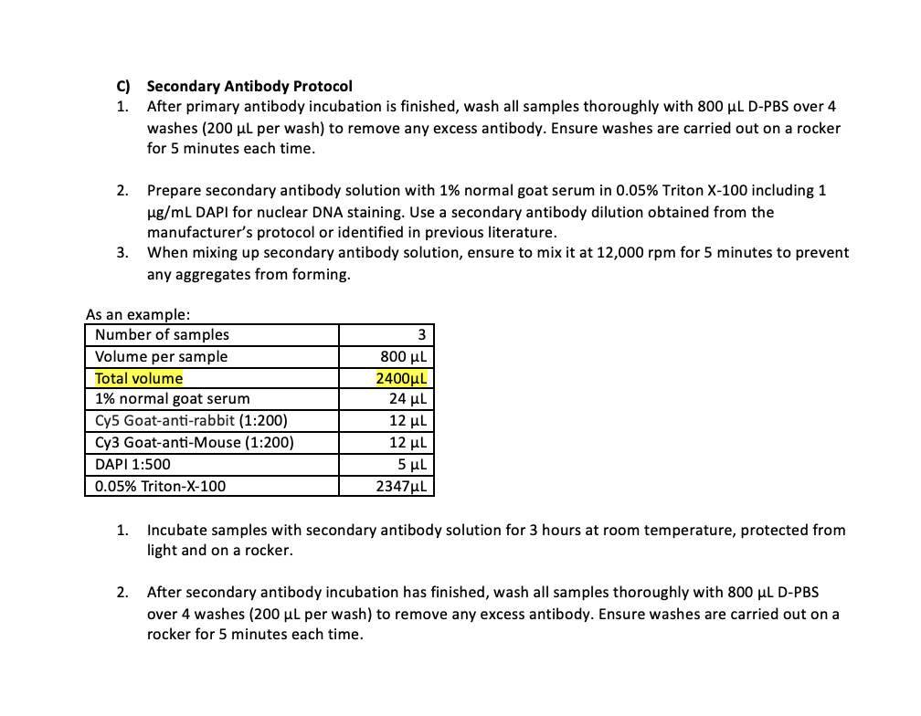

Materials

Cell Lines:
Rat glioblastoma cells – 9L/3cmv-GFP cell line
Rat glioma cells – 9L/lacZ cell line
Rat astrocytes – CTX TNA2 cell line – UK Health Security Agency

Cell culture:
Dulbecco's Modified Eagle Medium (DMEM) – ThermoFisher Scientific
Dulbecco’s Phosphate buffered saline (D-PBS) - ThermoFisher scientific
Corning 96-well spheroid microplate – Sigma-Aldrich
Fetal Bovine Serum – ThermoFisher Scientific
Poly-D-Lysine - ThermoFisher Scientific
Laminin - ThermoFisher Scientific

Staining:
Paraformaldehyde (PFA) 4% - Sigma-Aldrich
Triton™ X-100 – Sigma-Aldrich
Bovine Serum Albumin (BSA) – ThermoFisher Scientific
DAPI 10mg – ThermoFisher Scientific
Texas-Red Phalloidin – ThermoFisher Scientific
Normal Goat Serum – ThermoFisher Scientific

Antibodies:
CD44 Recombinant Rabbit Monoclonal Antibody - Invitrogen
GFAP Mouse Monoclonal Antibody (GA5) – Invitrogen
Cy™5 AffiniPure Goat-Anti-Rabbit IgG – Jackson ImmunoResearch
Cy™3 AffiniPure Goat-Anti-Mouse IgG - Jackson ImmunoResearch

Additional Equipment:
Nikon CSU-W1 SoRa Spinning Disc Confocal microscope
Nikon Elements Viewer software
Profilometer: Profilm3D®
ImageJ (Fiji) Computer Program
SYLGARD 184 Silicone Elastomer Kit
KORASILON-paste – Sigma-Aldrich

Experimental Optimisations

Optimisation 1: Due to the porosity of the PDMS material, this initially led to excessive media evaporation and air bubble formation, leading to loss of cell viability. To remedy this, microfluidic chips were pre-incubated with DMEM media for 24 hours before cell seeding.

Optimisation 2: Media changes were carried out once every 48 hours for the first two changes, then increased to once every 24 hours. This was to allow adequate time for cells to adhere and grow so that they did not detach during future media changes.

Supplementary Figures

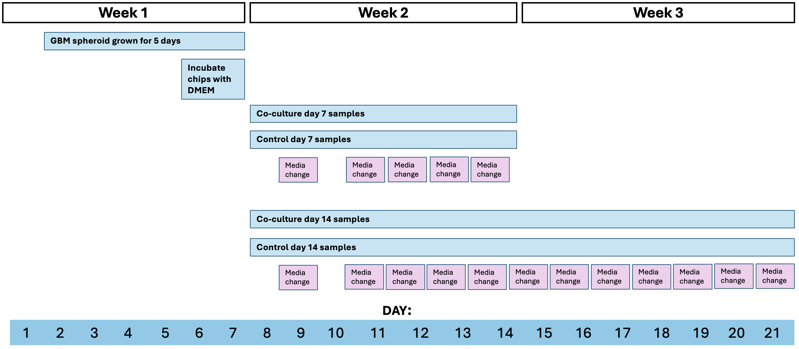
Fig S0 Experimental timeline for co-culture and control experiments inside of the microfluidic platform, including the frequency of culture media replenishment.
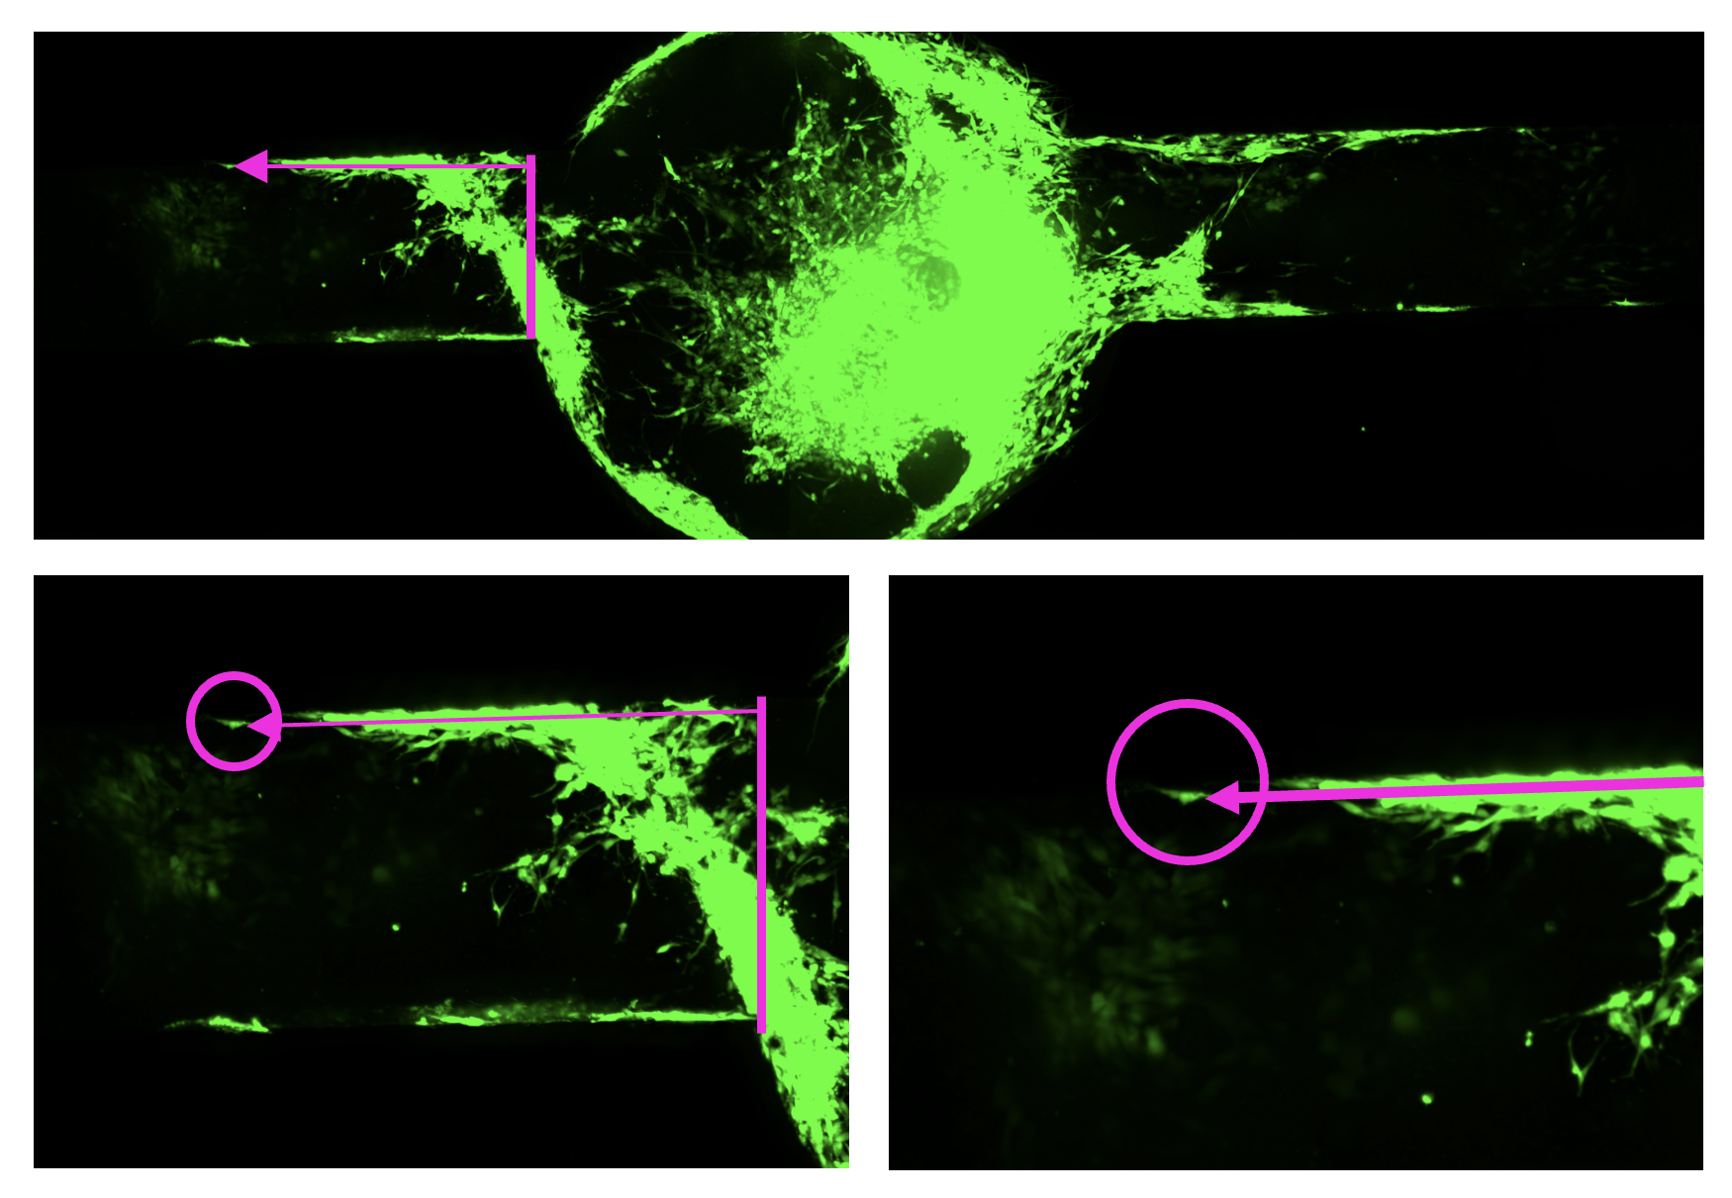Fig S1 Images showing how the spheroid outgrowth experimental data was calculated from fluorescent imaging data which was analysed inside of ImageJ software.

Spheroid outgrowth measurements were taken using ImageJ to analyse fluorescent images. As the outgrowth was purely obtained from spheroids, only GFP channels were used to identify the glioma cells, which had grown out into the microfluidic channel. Firstly, the entrance to the microfluidic channel was identified, and measurements were taken from the channel entrance to any visible cells which have grown to the furthest observable regions of outgrowth on the image, as shown in the top image. For each sample, measurements were taken of the 20 furthest visible points of outgrowth on each side of the channel (n = 40), which were averaged to produce a mean outgrowth value.

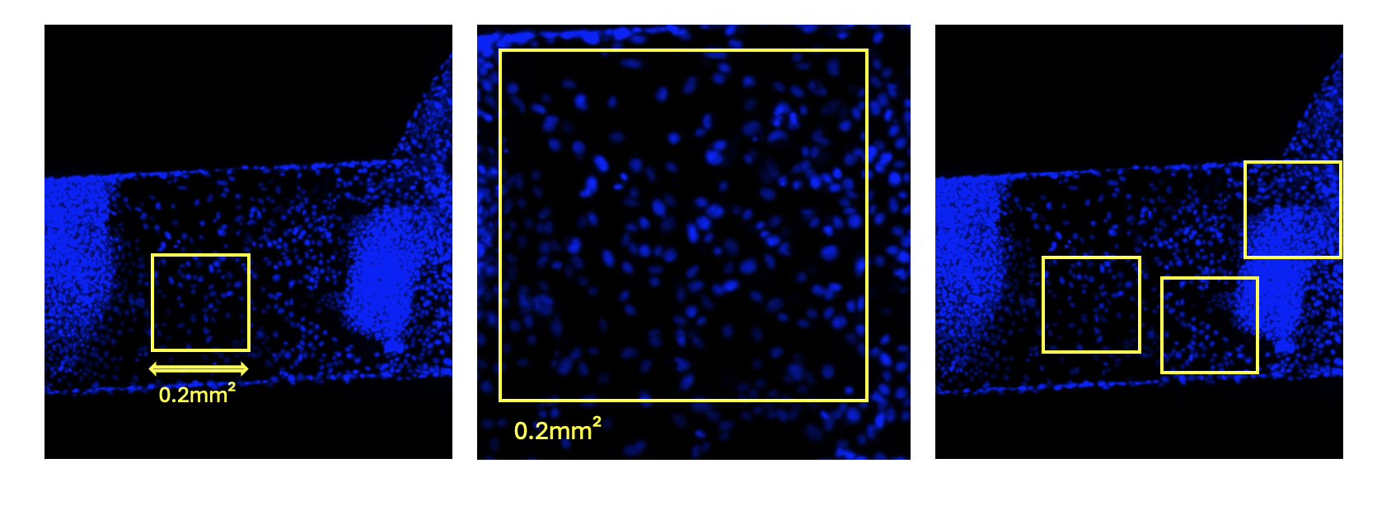
Fig S2 Images showing how the cell density experimental data was quantified using fluorescent imaging inside of ImageJ software.

Cell density data was calculated from fluorescent images showing the nuclear DNA, stained with DAPI nuclear stain, for all culture types. Within ImageJ, a set size region of the image was selected (0.2mm²), and the cell population was counted in the designated area of the image using ImageJ functions. This was repeated across several different regions of a given image to provide an average cell count for the culture type. Once the average cell counts per 0.2mm² area were calculated, the image area was scaled up by a factor of 5 to produce cell density values for the number of cells/mm².
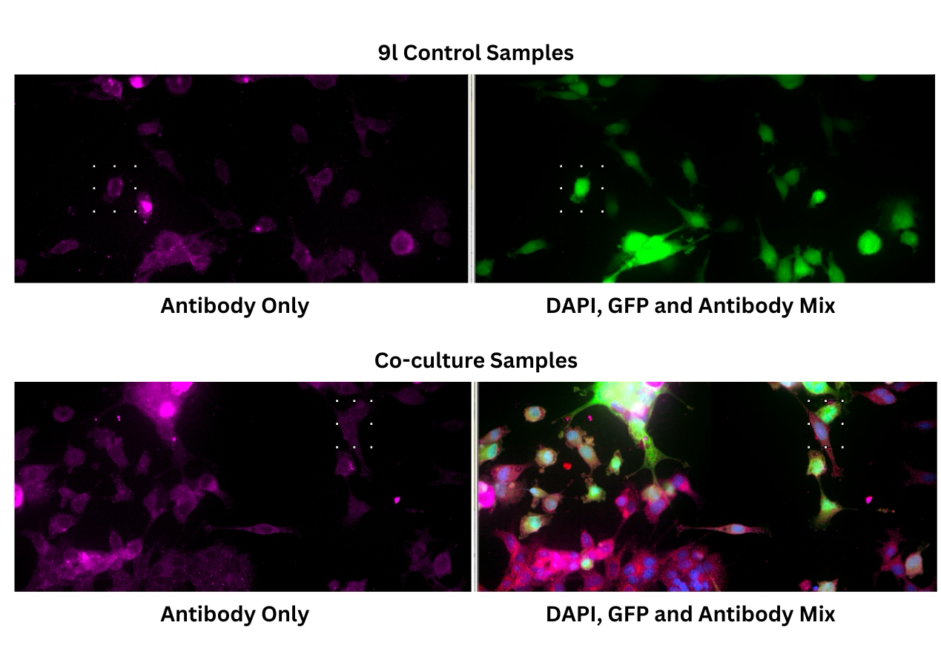

Fig S3 Images showing how the antibody staining experimental data was quantified using fluorescent imaging inside of ImageJ software.

Relative intensities of antibody levels for CD44 and GFAP were quantified using the “ROI” and “measure” functions in ImageJ. For control samples, a region of interest (ROI) was applied to a single cell (top right image), and the same ROI was applied to the colour channel, which corresponded with staining with the antibody of interest (top left image). The “measure” tool in ImageJ was applied to the ROI to obtain a relative value of colour intensity. The ROI measurements were repeated 10 times for each image and averaged to provide a mean intensity value. In co-culture samples, the same method was applied, except the ROIs were applied to visible points of contact between one glioma cell and an astrocyte cell (bottom right image), to assess whether their direct contact in co-culture resulted in increased relative colour intensity, indicating increased antibody expression.

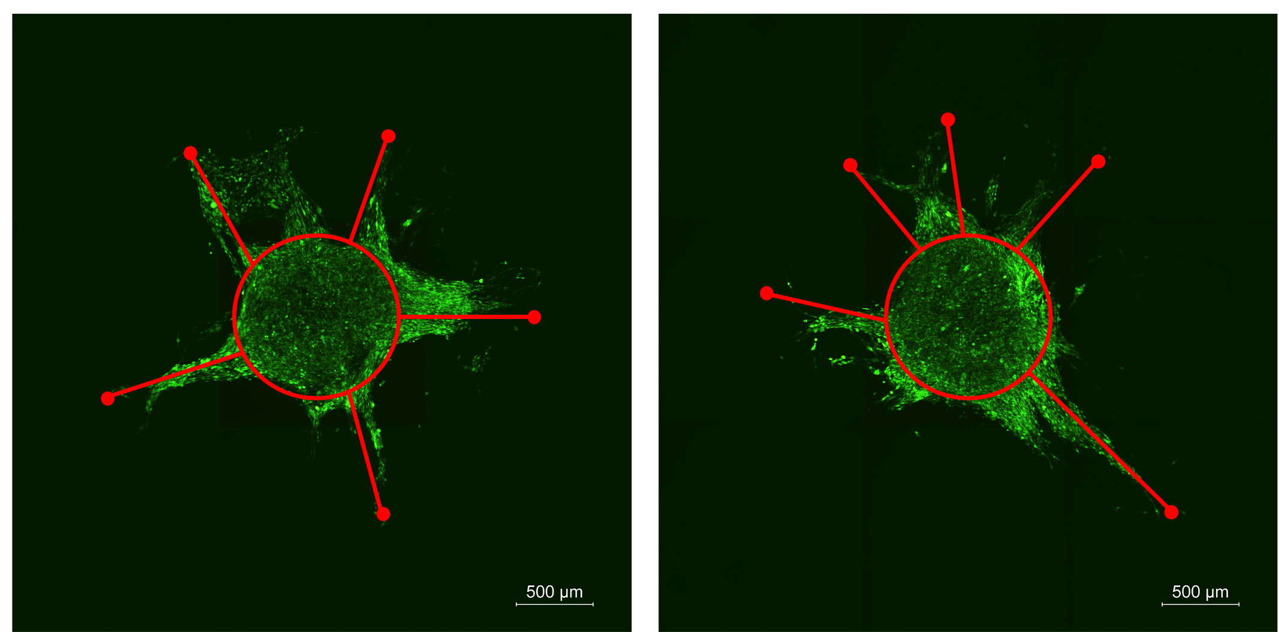
Fig S4: GFP signal (glioma cells – 9L/3cmv-GFP) from supplementary co-culture experiments which were carried out in a 96-well plate. The images illustrate how spheroid outgrowth is measured but due to the multi-directional growth, outgrowth cannot be easily measured from a set starting point.

