Supporting Information
Polyanionic Halide Glasses: A New Family of Sodium Superionic Conductors
Yuan Tan¹, Boyu Wang¹, Md Salman Rabbi Limon², Abrar Fahim Navid², Jiaqi Ke¹, Jordan Gatts¹, Tianyi Li³, Shiwen Wu⁴, Hien Nguyen⁵, Kyeongjae Cho¹, Zeeshan Ahmad^{2*}, Laisuo Su^{1*}
¹ Department of Materials Science and Engineering, University of Texas at Dallas, Richardson, Texas 75080, United States
² Department of Mechanical Engineering, Texas Tech University, Lubbock, Texas 79409, United States
³ X-ray Science Division, Argonne National Laboratory, Lemont, Illinois 60439, United States
⁴ Department of Chemistry and Biochemistry, Northern Illinois University, DeKalb, Illinois 60115, United States
⁵ Department of Chemistry and Biochemistry, The University of Texas at Dallas, Richardson, Texas 75080, United States
*Email: Zeeahmad@ttu.edu, Laisuo.su@utdallas.edu

Experimental Section
Materials synthesis
The xNa₂CO₃-MH₅ (M = Ta, Nb; H = Cl, Br) solid electrolytes were synthesized via a high-energy mechanochemical process. In a typical synthesis, stoichiometric mixtures of the precursors, Na₂CO₃, TaCl₅, TaBr₅, and NbCl₅, were loaded into a 100 mL ZrO₂ jar with ZrO₂ balls. The ball-to-powder mass ratio was 60:1, with a total powder mass of approximately 1 g. The mixture was ball-milled (Planetary Ball Mill, Tmax) at a rotational speed of 250 rpm for 20-30 hours under an argon atmosphere. The milling program consisted of repeated cycles of 15 minutes of milling followed by a 15-minute rest period to manage the temperature. Na₃PS₄ powders, used as the anolyte, were prepared by ball-milling a stoichiometric mixture of Na₂S and P₂S₅ at 250 rpm for 12 h with a ball-to-powder mass ratio of 20:1, followed by heat treatment at 280 °C for 1 h under an argon atmosphere. For the preparation of the Na₂Sn anode, Na metal and Sn powder were mixed in a steel jar and ball-milled at 150 rpm for 20 h to obtain a homogeneous product. All precursors and synthesized powders were handled exclusively in an Ar-filled glovebox with H₂O and O₂ concentrations maintained below 0.3 ppm.

Materials characterization
The structural properties of the powders were investigated using powder X-ray diffraction (XRD) with a Philips X’Pert diffractometer, employing Cu-Kα radiation (λ = 1.5406 Å) at an operating voltage of 45 kV and a current of 40 mA. To minimize air exposure, samples were mounted in a zero-background holder and sealed with a Kapton film. Data were collected from 5° to 90° (2θ) at ambient temperature. A Bruker 600 MHz spectrometer was used to obtain ²³Na nuclear magnetic resonance (NMR) spectra. To analyze vibrational modes, Raman spectra were collected at room temperature using a Horiba Raman Microscope system with an excitation wavelength of 532 nm and an Ar laser.

Electrochemical characterization
Electrochemical impedance spectroscopy (EIS) was used to determine the ionic conductivity of the solid electrolytes (SEs). Measurements were performed at 30 °C using a Metrohm Autolab, with a 10 mV potential perturbation applied across a frequency range of 10 MHz to 1 Hz. To calculate the activation energy, impedance was measured in a controlled microclimate chamber at various temperatures ranging from 30 to −10 °C. For all tests, the as-prepared powders were pressed into pellets 10 mm in diameter at 325 MPa, using stainless steel rods as blocking electrodes. The cell consisted of a Na₂Sn anode, a Na₃PS₄ solid-state electrolyte, and a composite cathode made of NCOTC blended with 30% super P carbon black. LSV scans were run on a Biologic SP-200 from -0.5 to 6 V at a rate of 0.1 mV/s.
An all-solid-state battery with the configuration doped-Na_{2/3}Ni_{1/3}Mn_{2/3}O₂ || 1/2Na₂CO₃-TaCl₅ || Na₃PS₄ || Na₂Sn was fabricated for performance evaluation. The composite cathode was prepared by ball milling doped-Na_{2/3}Ni_{1/3}Mn_{2/3}O₂, 1/2Na₂CO₃-TaCl₅, and Super P (SP) in a 50:50:3 weight ratio for 1 hour at 200 rpm. The full cell was assembled by sequentially co-pressing the layers under 300 MPa of pressure in the following order: 50 mg of the Na₂Sn anode, 70 mg of the Na₃PS₄ anolyte, 70 mg of the 1/2Na₂CO₃-TaCl₅ catholyte, and 10 mg of the composite cathode. The assembled all-solid-state battery was then cycled between 2.5 V and 4.3 V (vs. Na⁺/Na₂Sn). All specific capacity calculations were based on the active mass of the doped-Na_{2/3}Ni_{1/3}Mn_{2/3}O₂ cathode material.

Density functional theory
DFT simulations were conducted using the Quantum ESPRESSO package^{1,2}. For all calculations, we used the Perdew-Burke-Ernzerhof (PBE) functional and norm-conserving pseudopotentials from the PSEUDO DOJO library^{3,4}. DFT-D3 dispersion corrections using the scheme proposed by Grimme et al. were incorporated to account for van der Waals dispersion forces in the structures⁵. We used a 2 × 2 × 2 k-point grid for a 72-atom cell of (Na₂CO₃)-(TaCl₅)₂ to achieve an accurate representation of the electronic structure. Convergence criteria for self-consistency in the calculation of energy and forces were set to 10⁻⁴ Ry and 10⁻³ Ry/Bohr, respectively. We set the energy cutoffs for wave functions to 80 Ry.
All models were relaxed using a variable-cell relaxation calculation with DFT in Quantum ESPRESSO. Two structures emerged as the lowest in energy and differ only slightly in energy, suggesting that both structures could exist under ambient conditions.

Molecular dynamics simulations
We first relaxed the structure, then ran molecular dynamics with a Neural Equivariant Interatomic Potential (NequIP) trained on DFT data, largely from ab-initio MD trajectories⁶. The trained model was used in the LAMMPS code to perform ML-MD. Simulations were performed in the NVT ensemble using a Nosé–Hoover thermostat. We increased the temperature from 1 K to 300 K over 24 ps in a step-and-hold pattern, raising it by 50 K over 2 ps, holding steady for 2 ps, then repeating the cycle until 300 K was reached. After stabilization at 300 K, the system was simulated for 100 ps as a production run. From the final trajectory, we computed time-averaged RDFs using the last 50% of frames to minimize equilibration bias (Fig. 2g). The mean squared displacement was calculated for all atoms, and that for Na appeared to be the highest, supporting its higher conductivity in the material, as seen in Fig. S1.

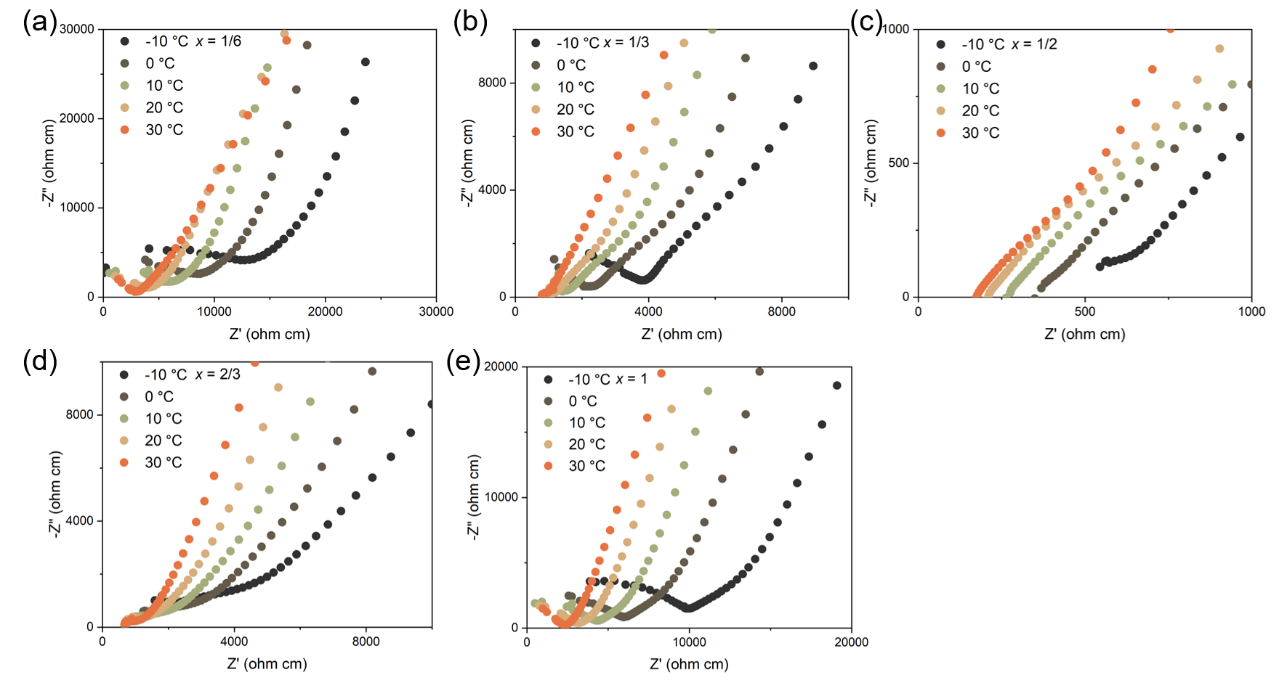
Figure S1. Variable-temperature Nyquist plots for the xNa₂CO₃-TaCl₅ SSEs.

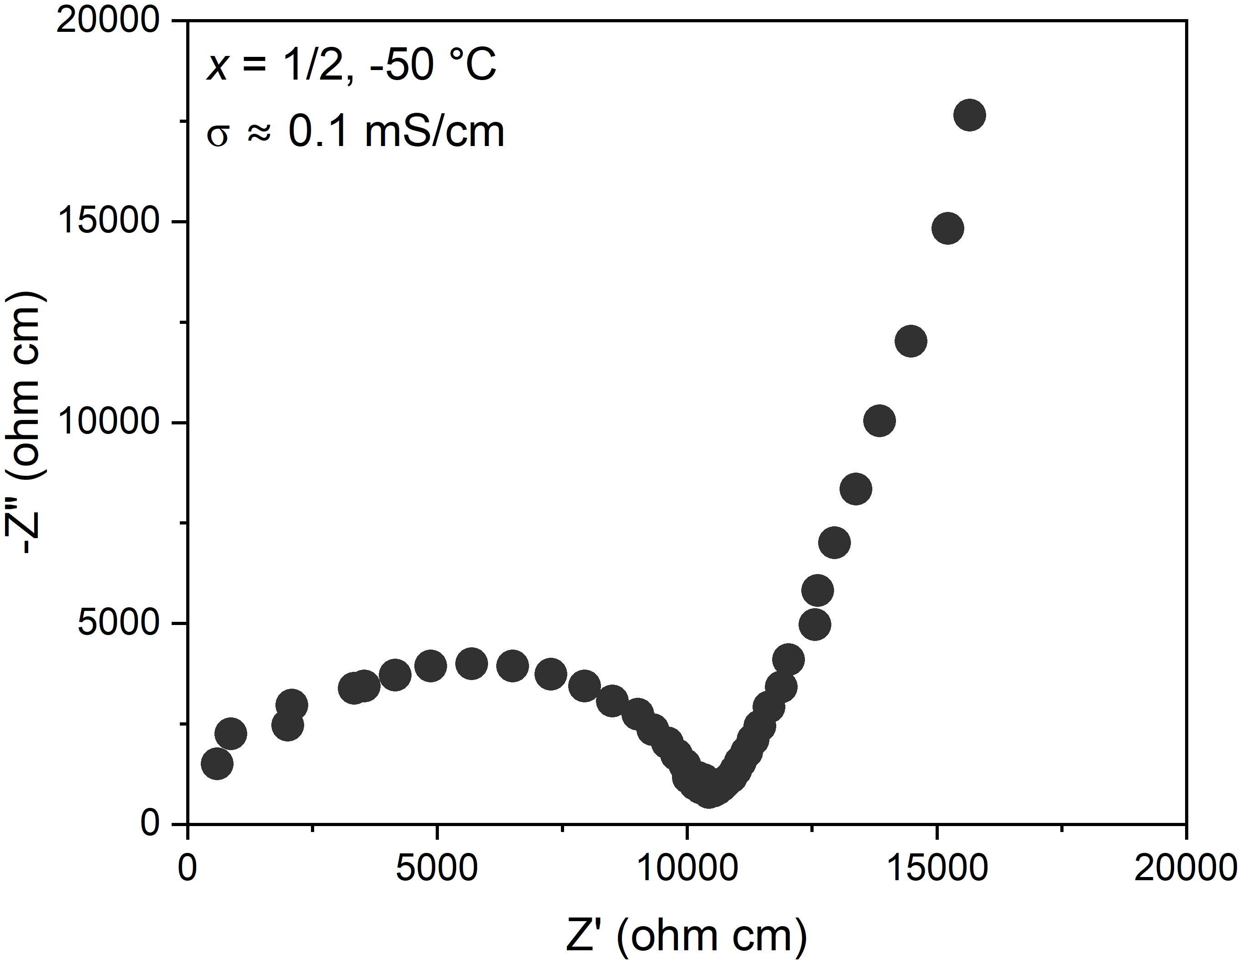
Figure S2. Nyquist plot of the 1/2Na₂CO₃-TaCl₅ SSE at -50 °C.

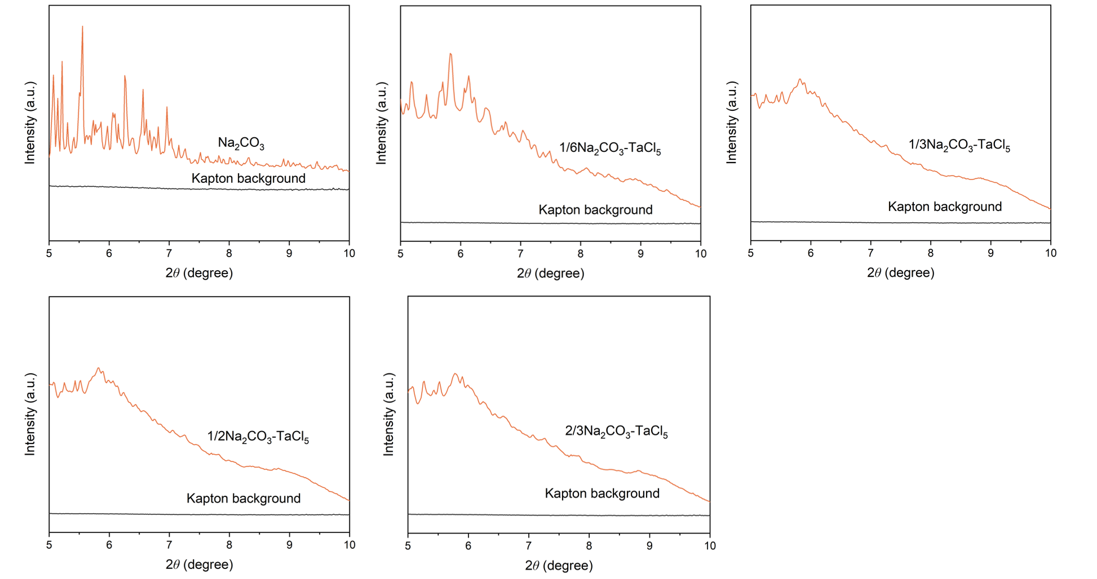
Figure S3. Synchrotron X-ray diffraction patterns of Na₂CO₃ and the xNa₂CO₃-TaCl₅ SSEs.

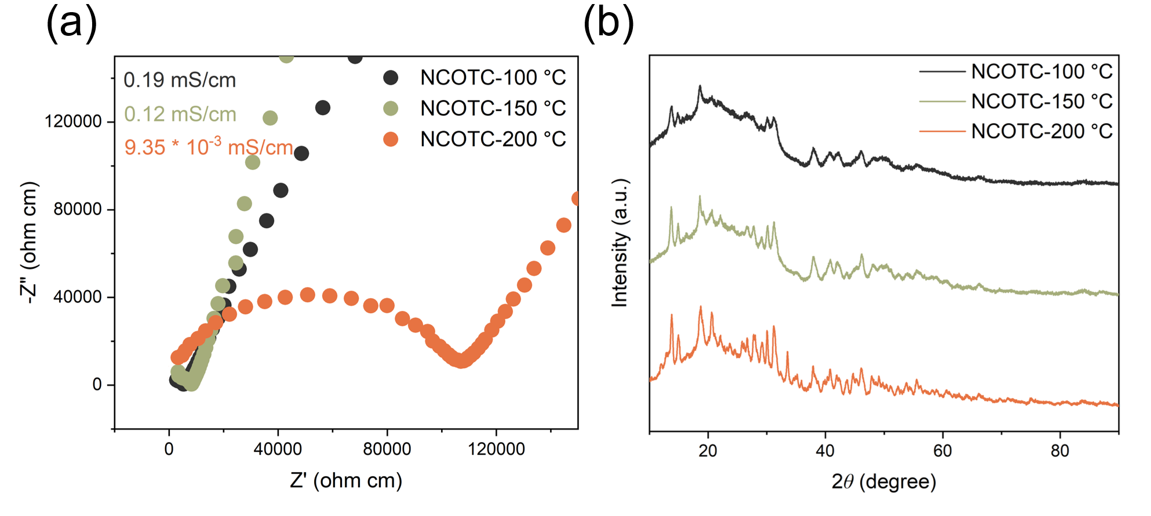
Figure S4. (a) Room-temperature EIS Nyquist plots of the 1/2Na₂CO₃-TaCl₅ SSE after annealing at 100 °C, 150 °C, and 200 °C, and (b) corresponding XRD patterns.

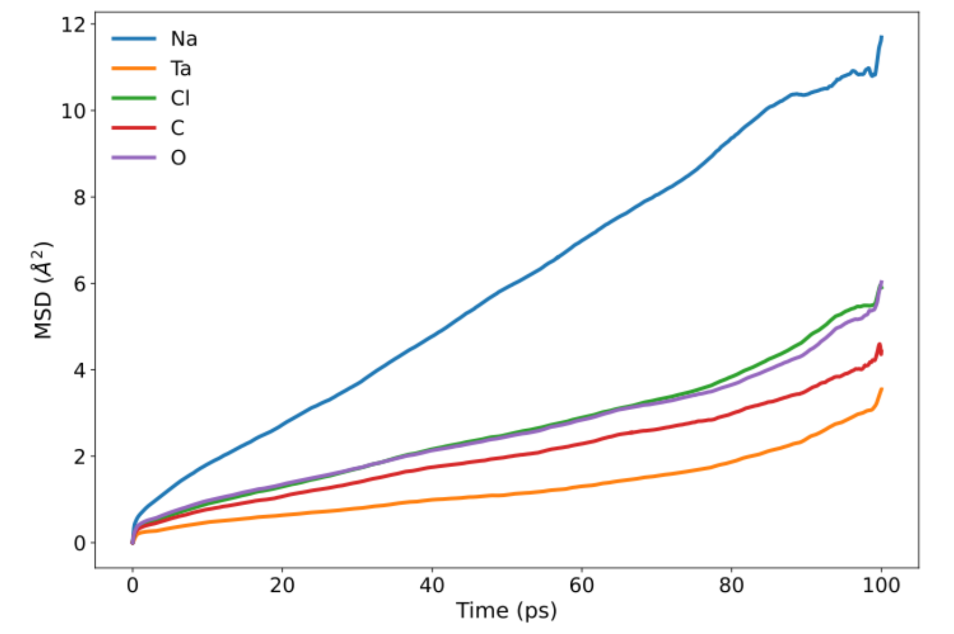
Figure S5. Mean squared displacement of the ions in (Na₂CO₃)-(TaCl₅)₂ obtained from ML-MD simulations showing fast ion conduction.
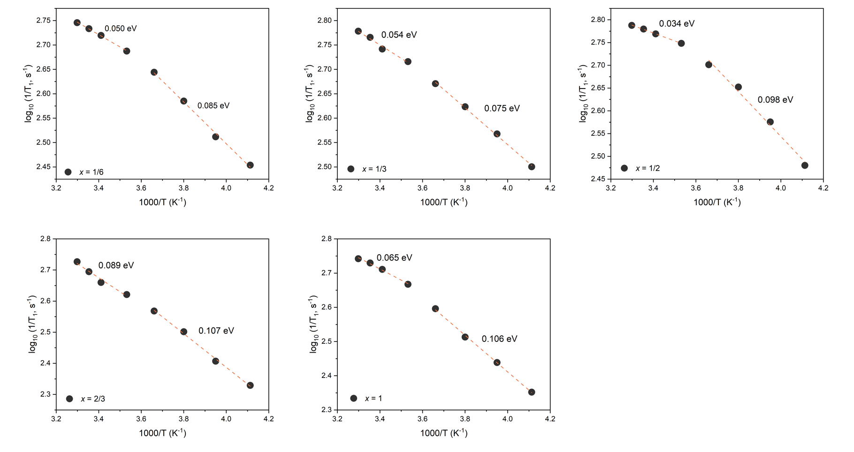
Figure S6. Temperature-dependent ²³Na spin-lattice relaxation rates for the xNa₂CO₃-TaCl₅ SSEs.
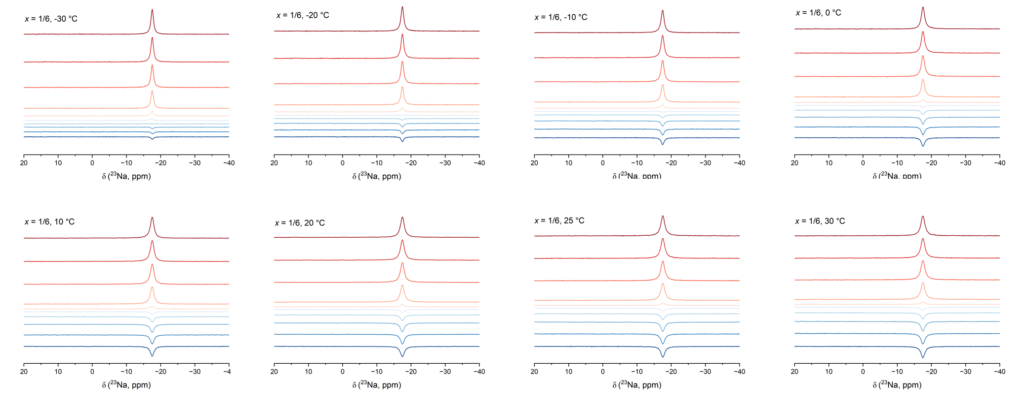
Figure S7. Stacked plot of ²³Na NMR spectra for the x = 1/6 sample from an inversion recovery experiment at various temperatures.

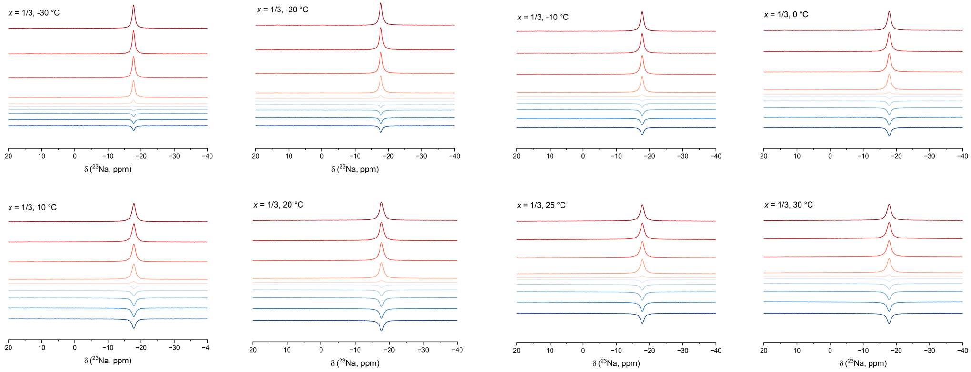
Figure S8. Stacked plot of ²³Na NMR spectra for the x = 1/3 sample from an inversion recovery experiment at various temperatures.

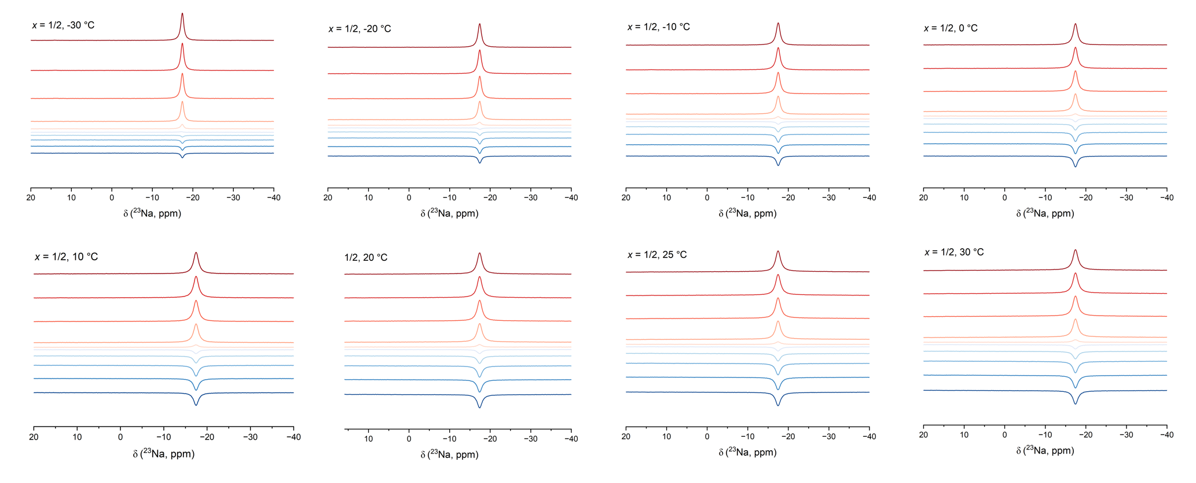
Figure S9. Stacked plot of ²³Na NMR spectra for the x = 1/2 sample from an inversion recovery experiment at various temperatures.

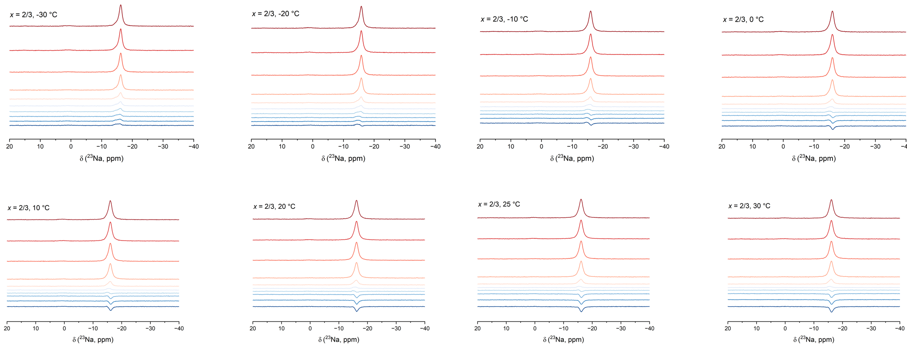
Figure S10. Stacked plot of ²³Na NMR spectra for the x = 2/3 sample from an inversion recovery experiment at various temperatures.

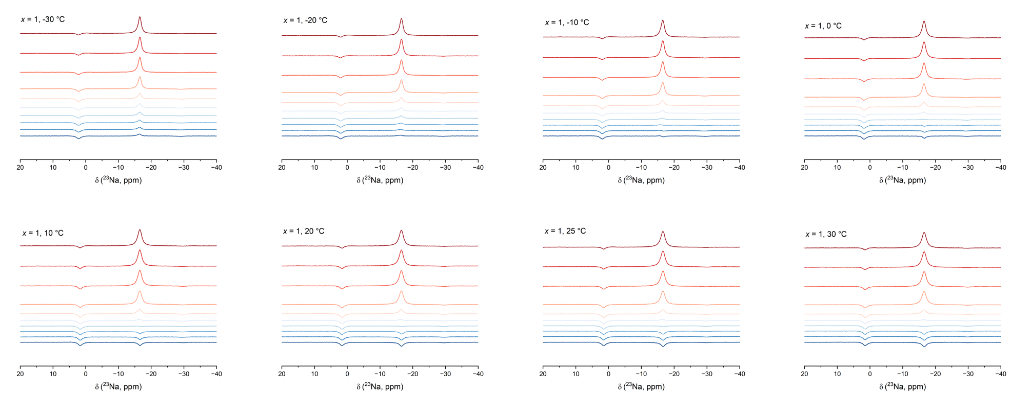
Figure S11. Stacked plot of ²³Na NMR spectra for the x = 1 sample from an inversion recovery experiment at various temperatures.

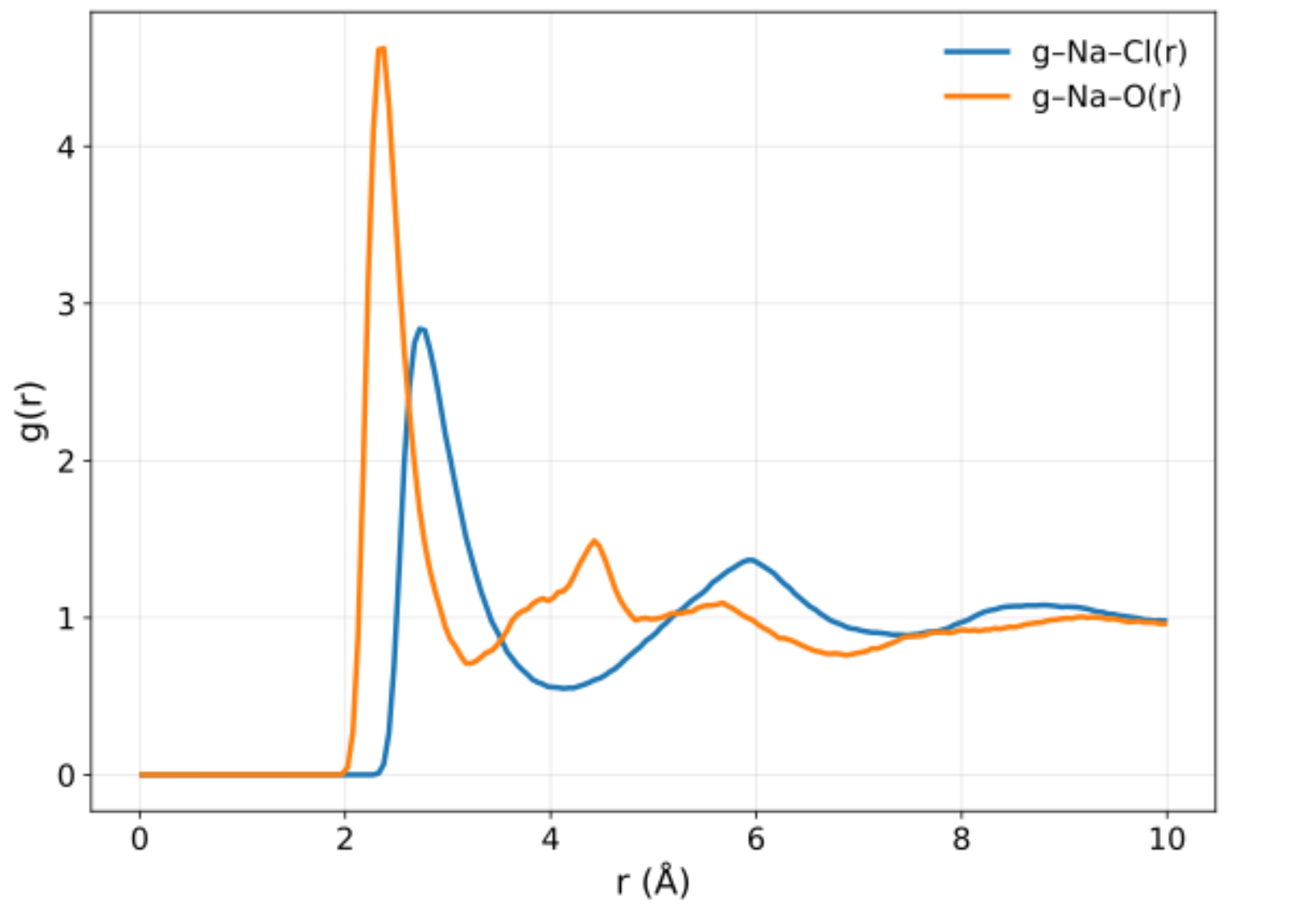
Figure S12. Na-Cl and Na-O partial radial distribution functions, showing similar bond distances.

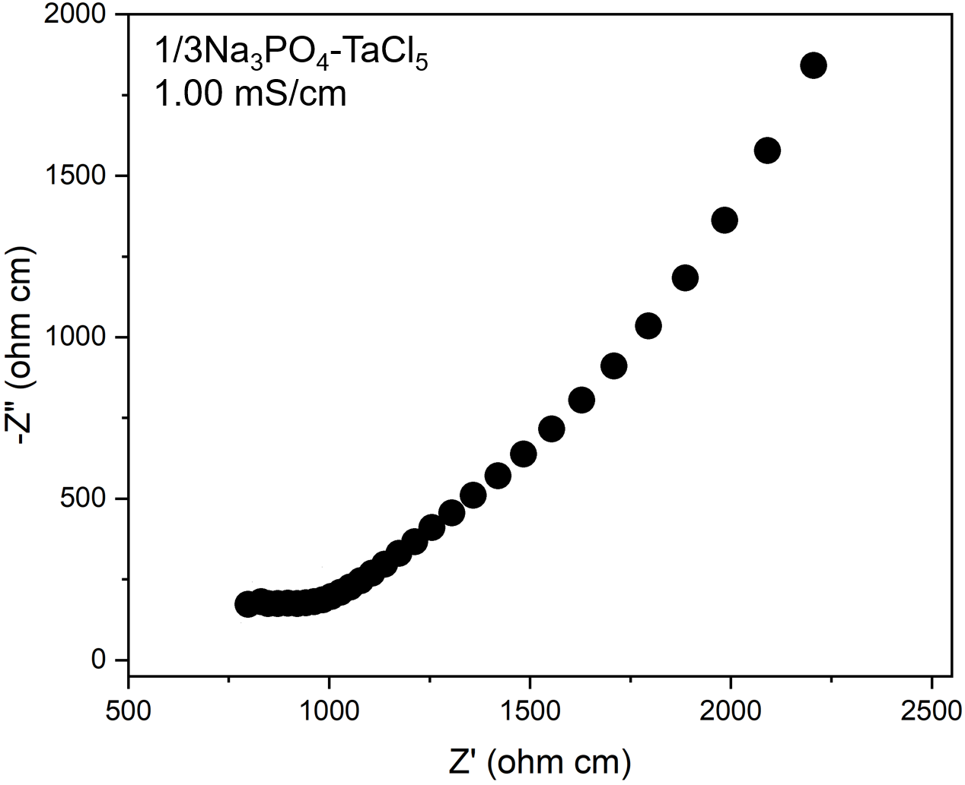
Figure S13. (a) Nyquist plot of 1/3Na₃PO₄-NbCl₅.

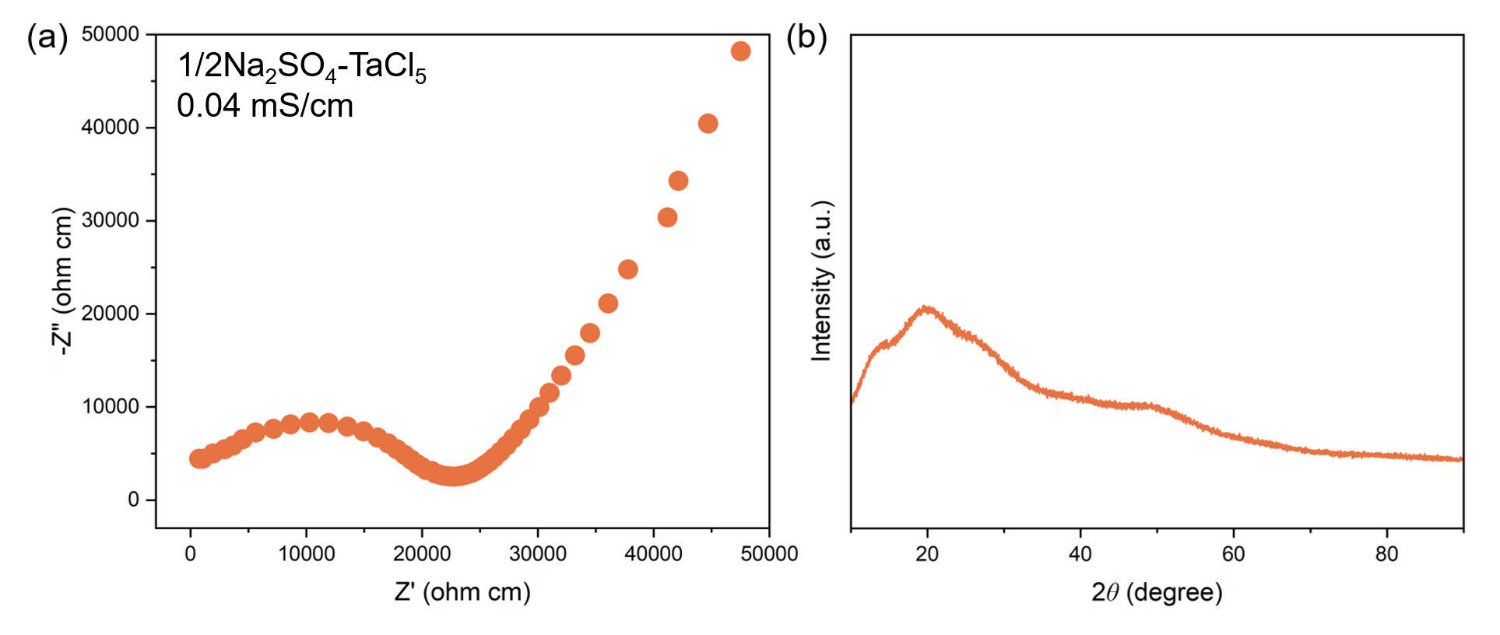
Figure S14. (a) Nyquist plot and (b) XRD pattern of 1/2Na₂SO₄-NbCl₅.

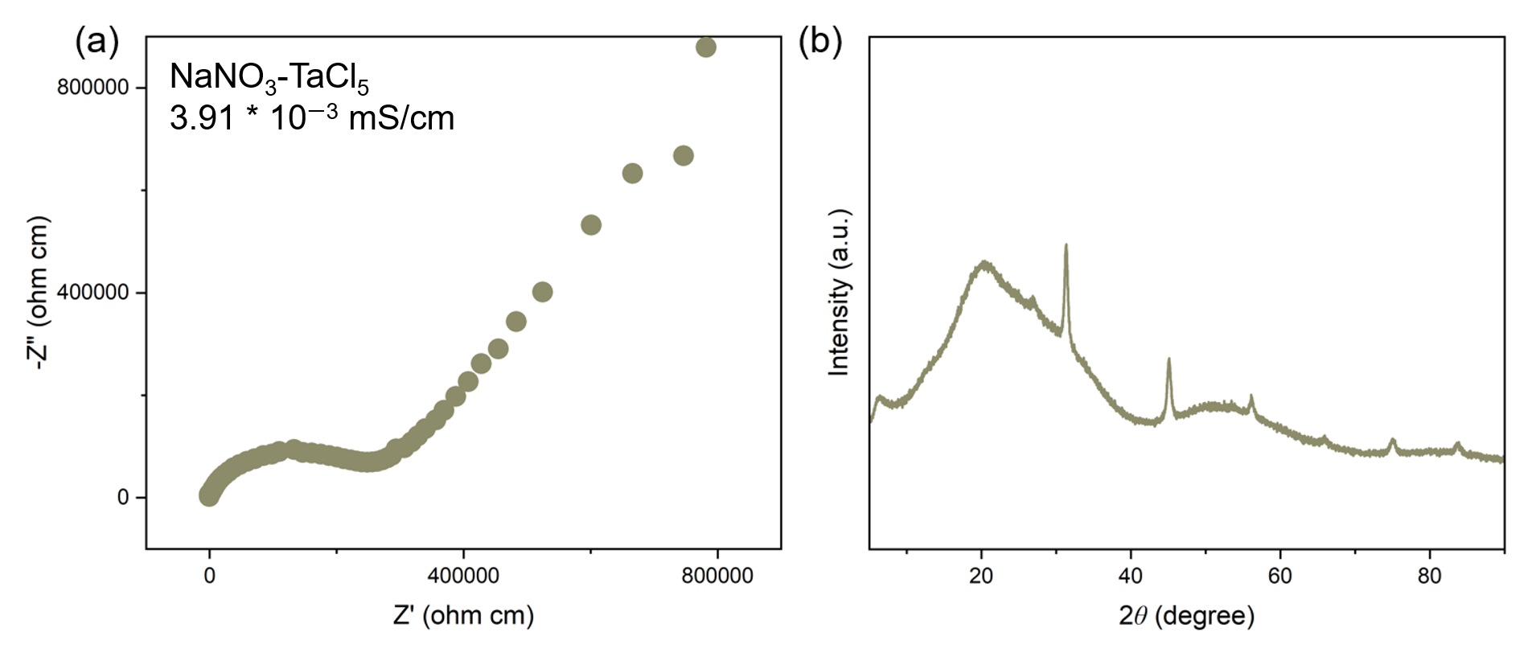
Figure S15. (a) Nyquist plot and (b) XRD pattern of NaNO₃-NbCl₅.

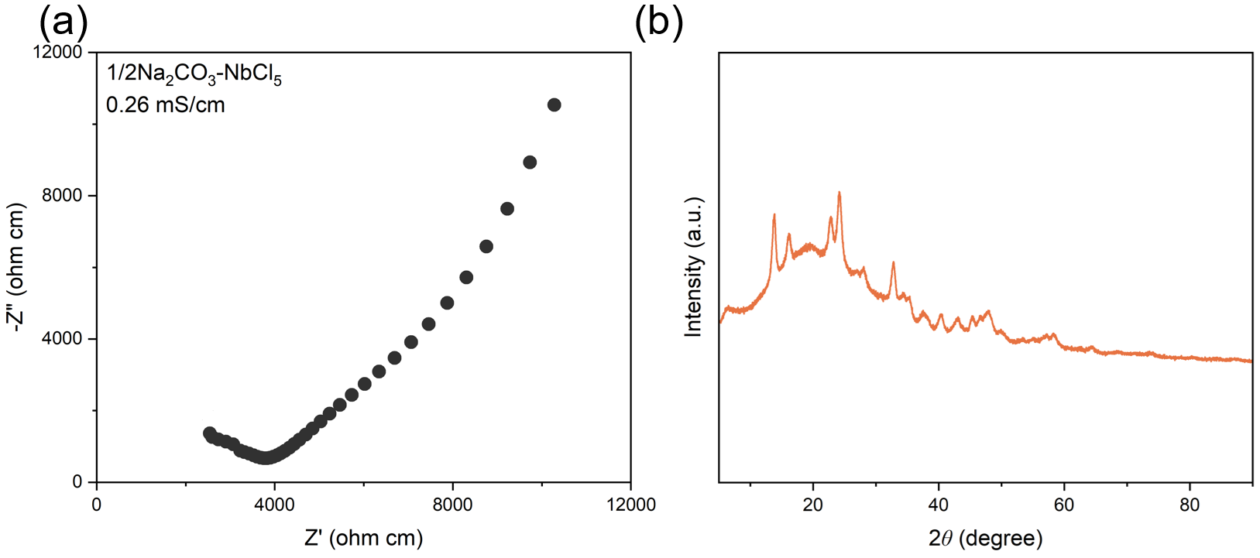
Figure S16. (a) Nyquist plot and (b) XRD pattern of 1/2Na₂CO₃-NbCl₅.

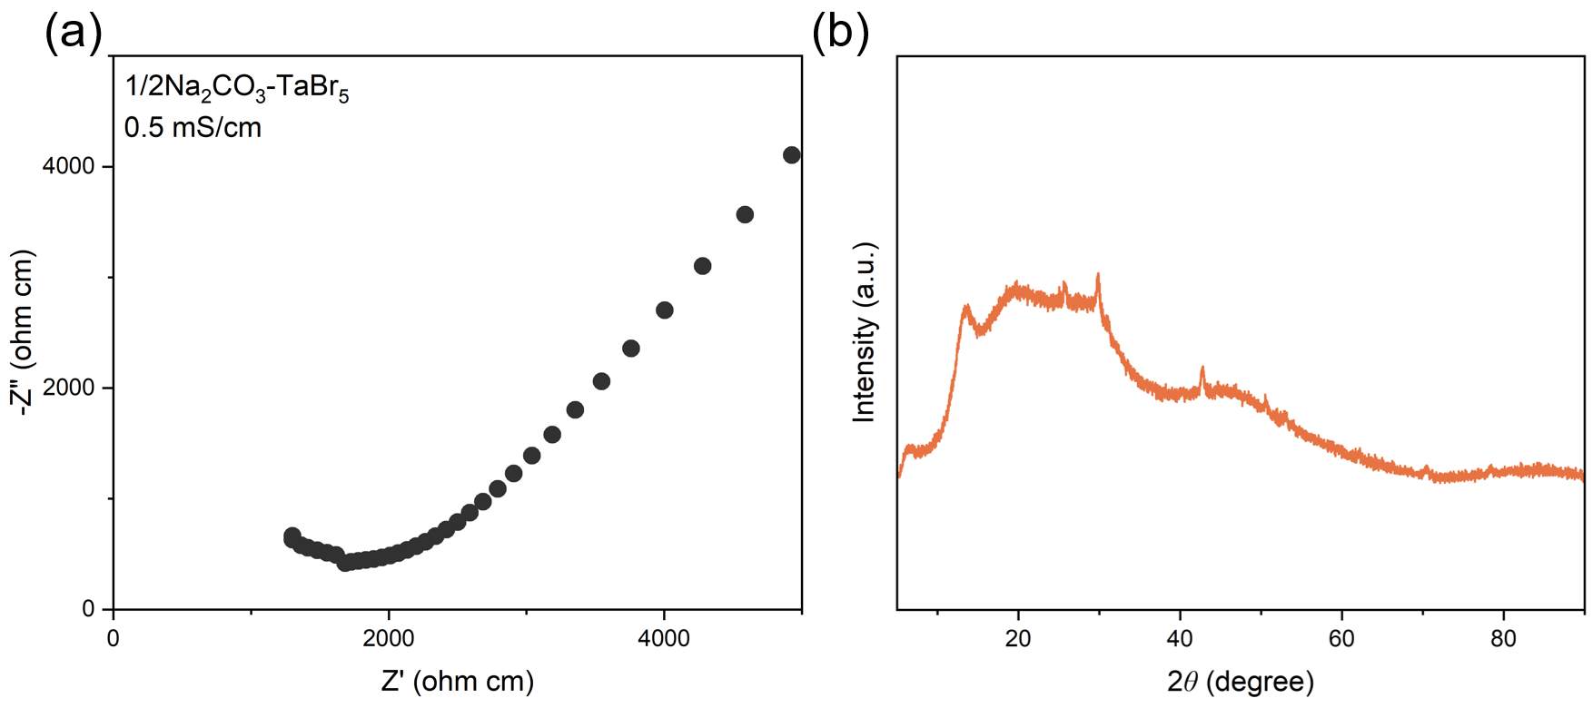
Figure S17. (a) Nyquist plot and (b) XRD pattern of 1/2Na₂CO₃-TaBr₅.

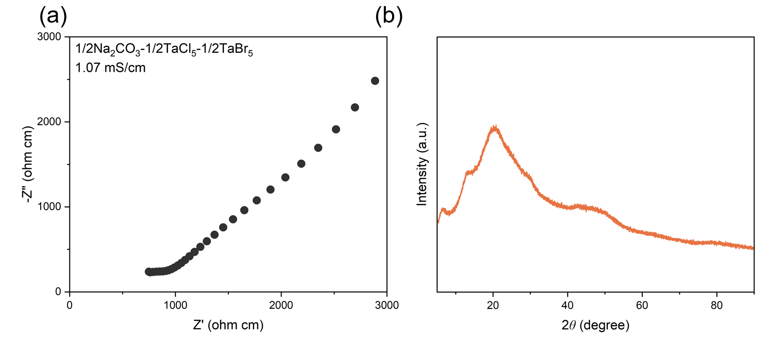
Figure S18. (a) Nyquist plot and (b) XRD pattern of 1/2Na₂CO₃-1/2TaCl₅-1/2TaBr₅.

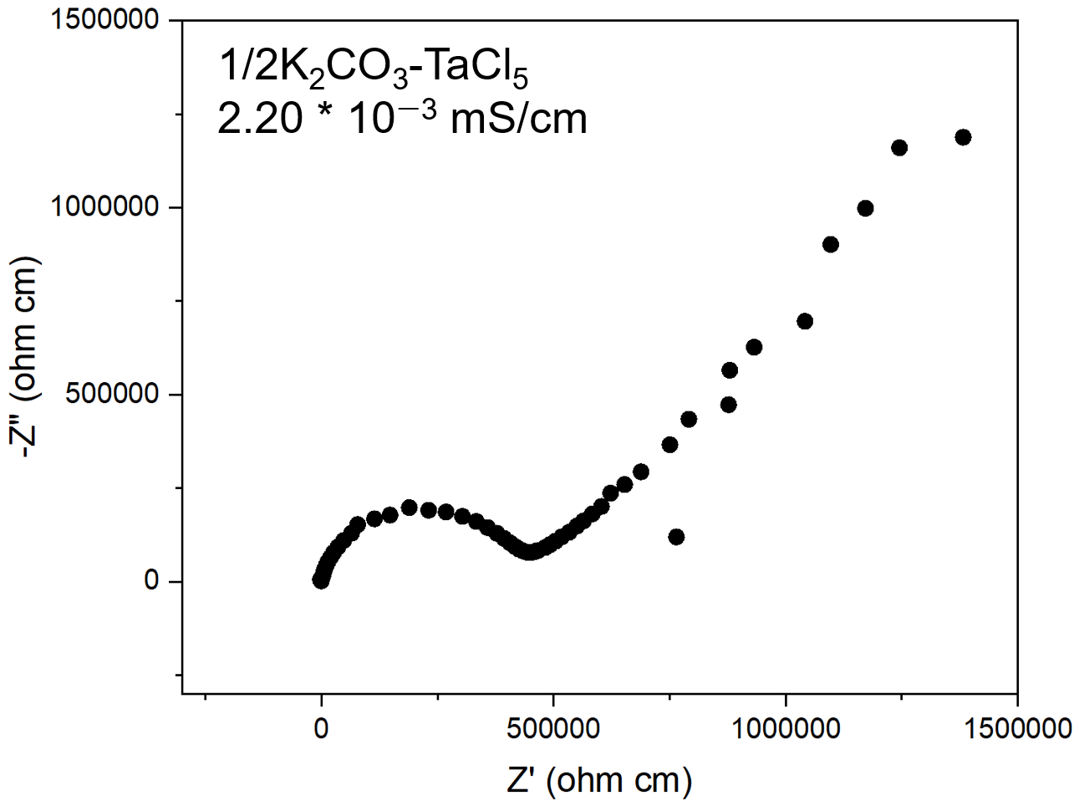
Figure S19. (a) Nyquist plot of 1/2K₂CO₃-TaCl₅.

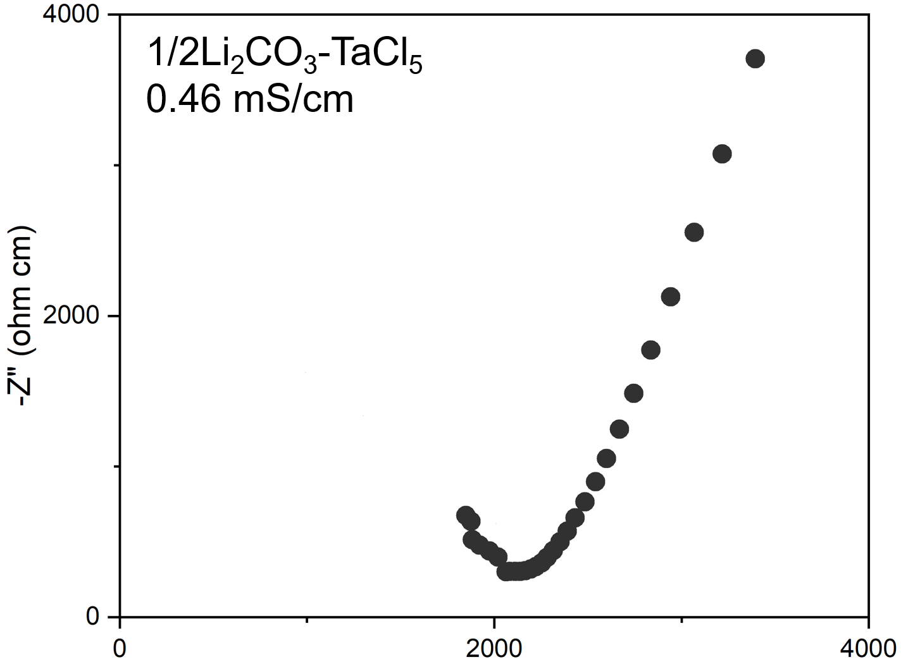
Figure S20. (a) Nyquist plot of 1/2Li₂CO₃-TaCl₅.

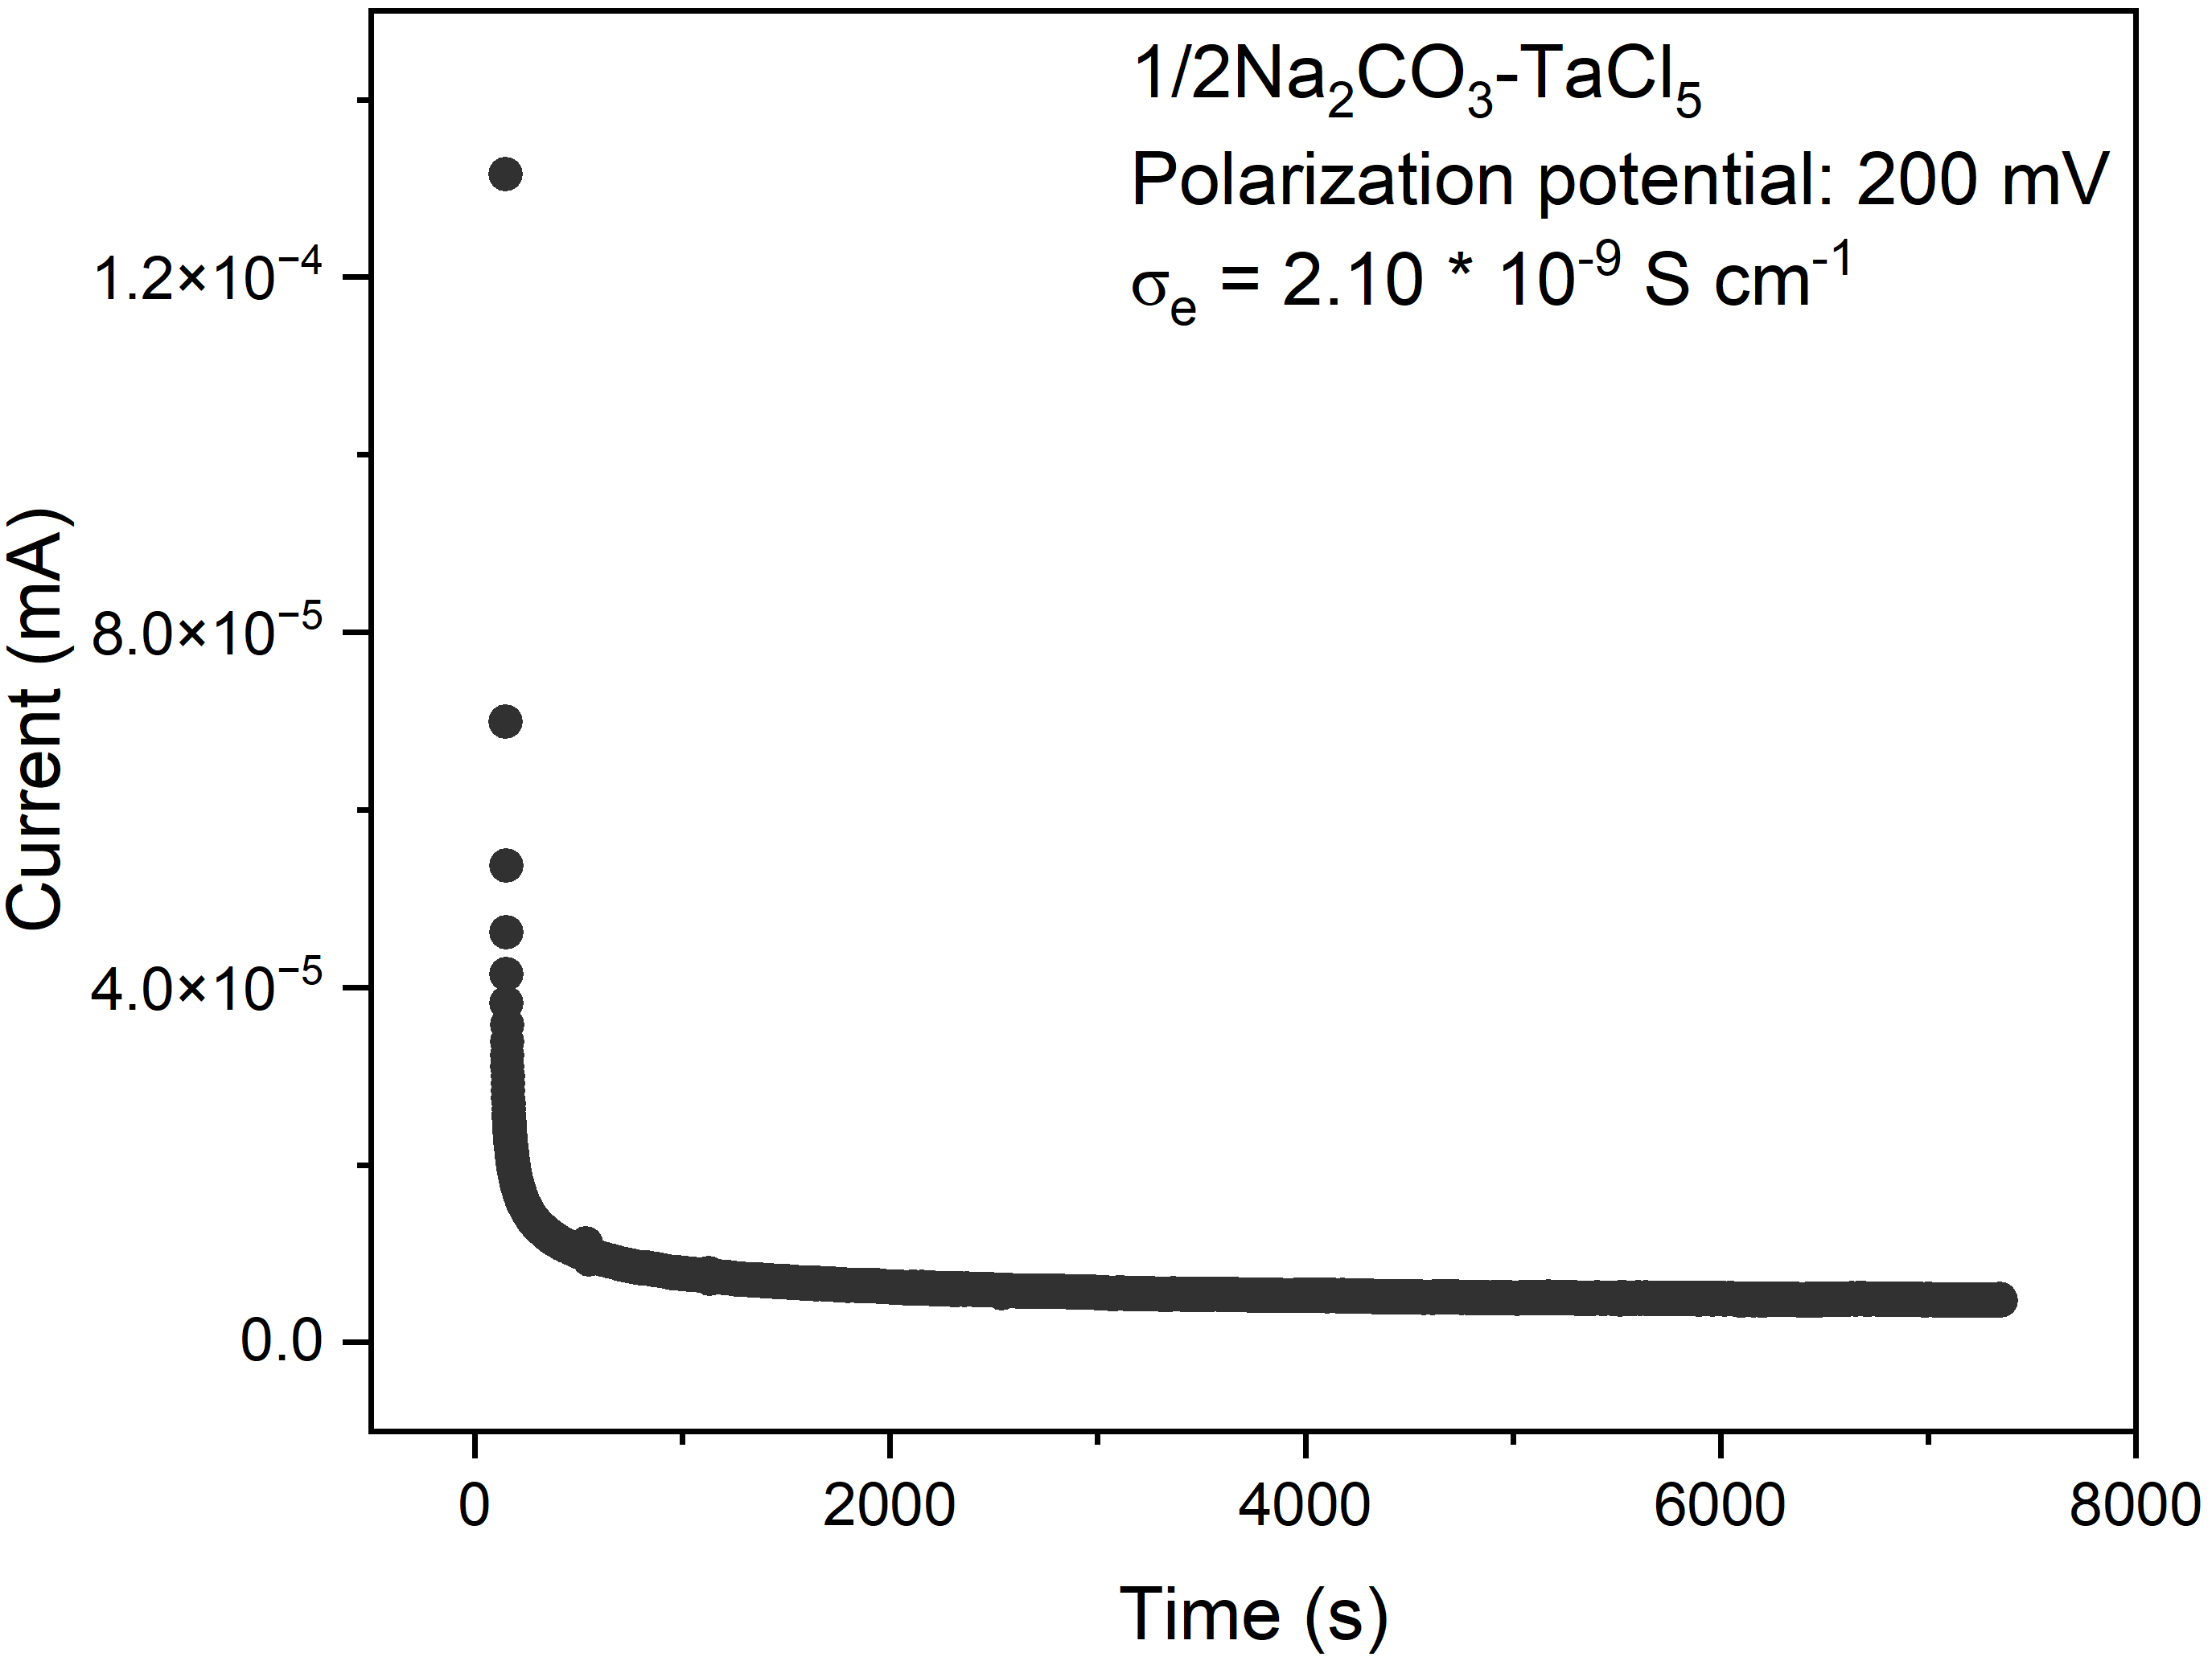
Figure S21. DC polarization curve of the NCOTC SSE for electronic conductivity measurement.
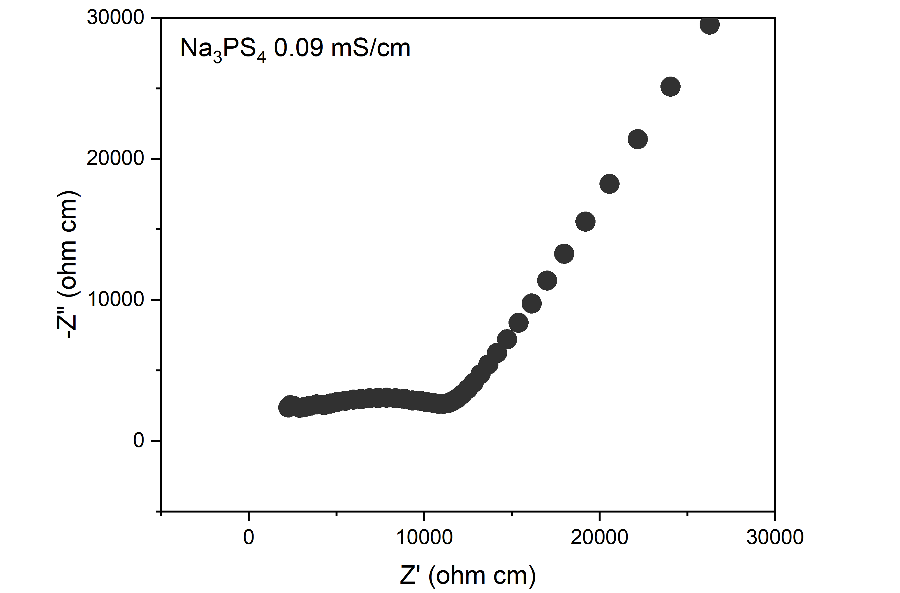
Figure S22. Nyquist plot of Na₃PS₄ SSE.
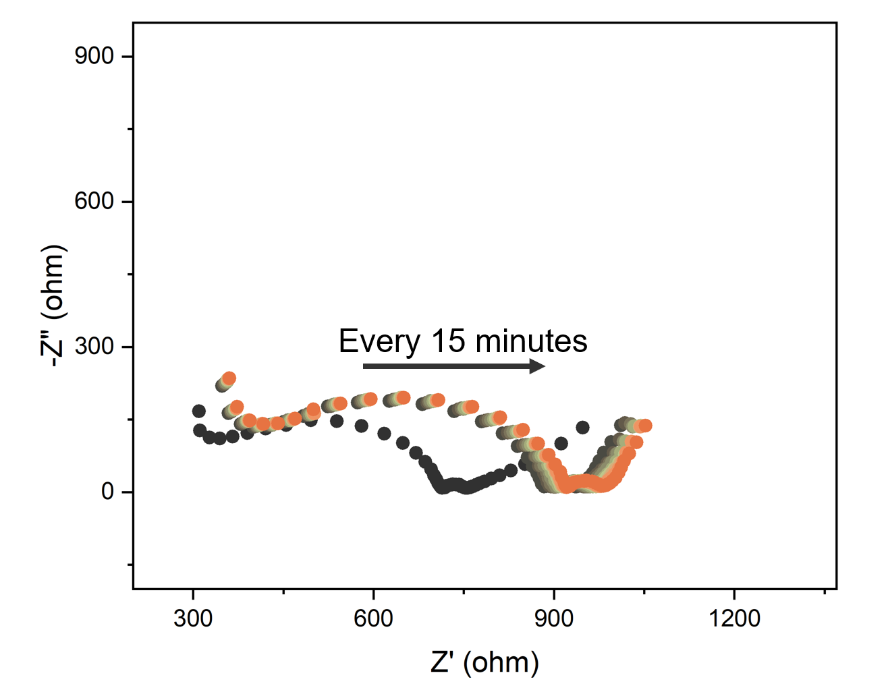
Figure S23. Time-resolved EIS Nyquist plots of the full ASSNIB recorded after assembly.

1. Giannozzi, P. et al. QUANTUM ESPRESSO: a modular and open-source software project for quantumsimulations of materials. Journal of Physics: Condensed Matter 21, 395502 (2009).
2. Giannozzi, P. et al. Advanced capabilities for materials modelling with Quantum ESPRESSO. Journal of Physics: Condensed Matter 29, 465901 (2017).
3. Perdew, J. P., Burke, K. & Ernzerhof, M. Generalized Gradient Approximation Made Simple. Phys Rev Lett 77, 3865 (1996).
4. van Setten, M. J. et al. The PseudoDojo: Training and grading a 85 element optimized norm-conserving pseudopotential table. Comput Phys Commun 226, 39–54 (2018).
5. Grimme, S., Antony, J., Ehrlich, S. & Krieg, H. A consistent and accurate ab initio parametrization of density functional dispersion correction (DFT-D) for the 94 elements H-Pu. J Chem Phys 132, 154104 (2010).
6. Batzner, S. et al. E(3)-Equivariant Graph Neural Networks for Data-Efficient and Accurate Interatomic Potentials. Nature Communications 2022 13:1 13, 1–11 (2021).

