Supplementary File
Figure 1. Nitrate analysis of beetroot juice drink

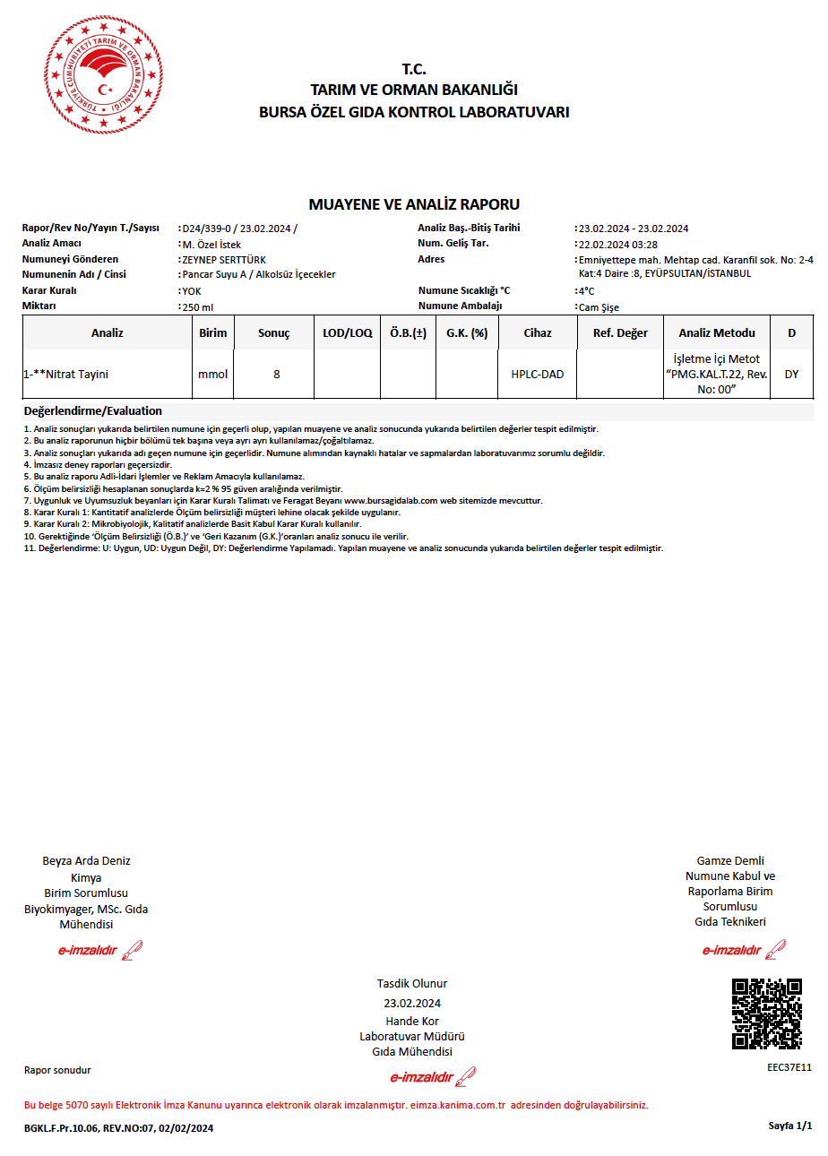
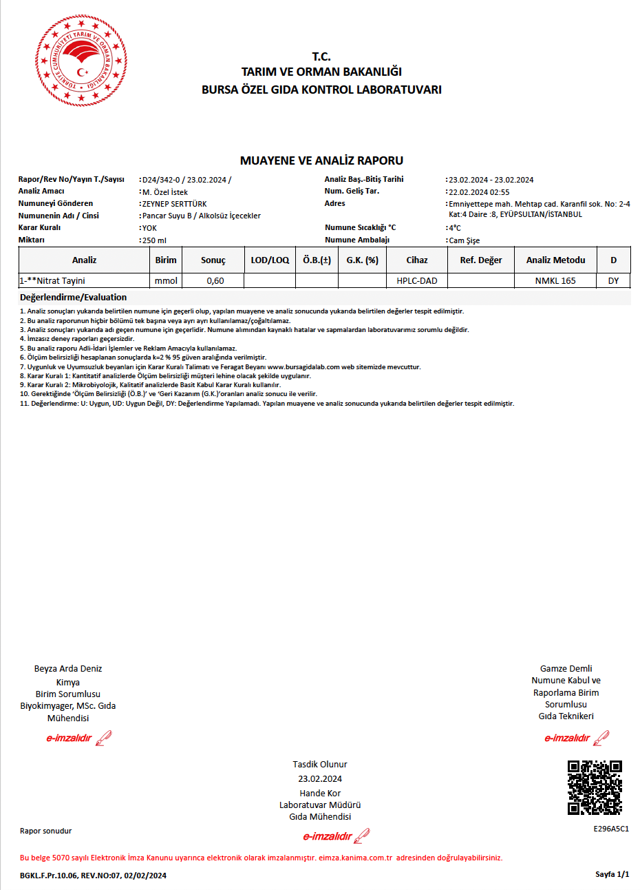
Figure 2. Nitrate analysis of placebo drink

